Event Ticketing System

**A Mini Project Report**

**Submitted by DHIVYA J**

**23CDR038**

**GOKULA PRIYA SURESH**

**23CDL188**

**22CDT41 - DATABASE MANAGEMENT SYSTEMS**



**DEPARTMENT OF COMPUTER SCIENCE AND DESIGN**

KONGU ENGINEERING COLLEGE

**(Autonomous)**

**PERUNDURAI ERODE-638060**

MAY 2025

Problem Statement:

Event Ticketing System (Small Scale): Allows organizers to create events and sell tickets. (RDBMS: Events, Tickets, Orders, Attendees; Backend: Ticket creation, order processing (simulated), attendee management).

Github Link:

https://github.com/dhivya2206/event

https://github.com/KEC-05/event

Modules and Description:

1. **db.php – Database Connection Module**

Establishes a connection to the MySQL database. It is included in all other PHP scripts to provide access to the database.

1. **get_events.php –** **Event Retrieval Module**

Fetches all menu items from the menu_items table and returns them as a JSON array to populate the menu dropdown on the frontend.

1. **get_tickets.php** – **Ticket Booking History Module**

Retrieves a list of past ticket bookings by joining the tickets and users tables. Used to populate the booking history for the admin or users.

1. **book_ticket.php** – **Ticket Booking Module**

Handles new order submission:

* + Inserts user details into the users table (if not already present).
  + Creates a new ticket entry in the tickets table.
  + Records each selected ticket category (e.g., VIP, General) in the ticket_items table.
  + Stores delivery/email details if the ticket is to be sent digitally or physically.

1. **get_ticket_details.php –** **Ticket Detail Fetching Module**

Retrieves details of a specific ticket booking including event name, ticket category, quantity, and price. Used for showing the booking breakdown.

1. **index.html (or index.php) – Frontend User Interface**

Main interface for users or booking agents to:

* + View available events.
  + Enter user details.
  + Select event and ticket categories with quantities.
  + Submit and view bookings.
  + Display total cost and booking breakdown.
  + Includes JavaScript to interact with the backend via AJAX.

1. **Database Tables (MySQL Schema Module)**

Tables used:

| **Table Name** | **Columns** |
| --- | --- |
| users | id, name, email, phone |
| events | id, name, location, event_date, description |
| tickets | id, user_id, event_id, booking_time, total, delivery_type |
| ticket_items | id, ticket_id, ticket_type, quantity, price |
| delivery_details | id, ticket_id, delivery_address, email |

ER Diagram:

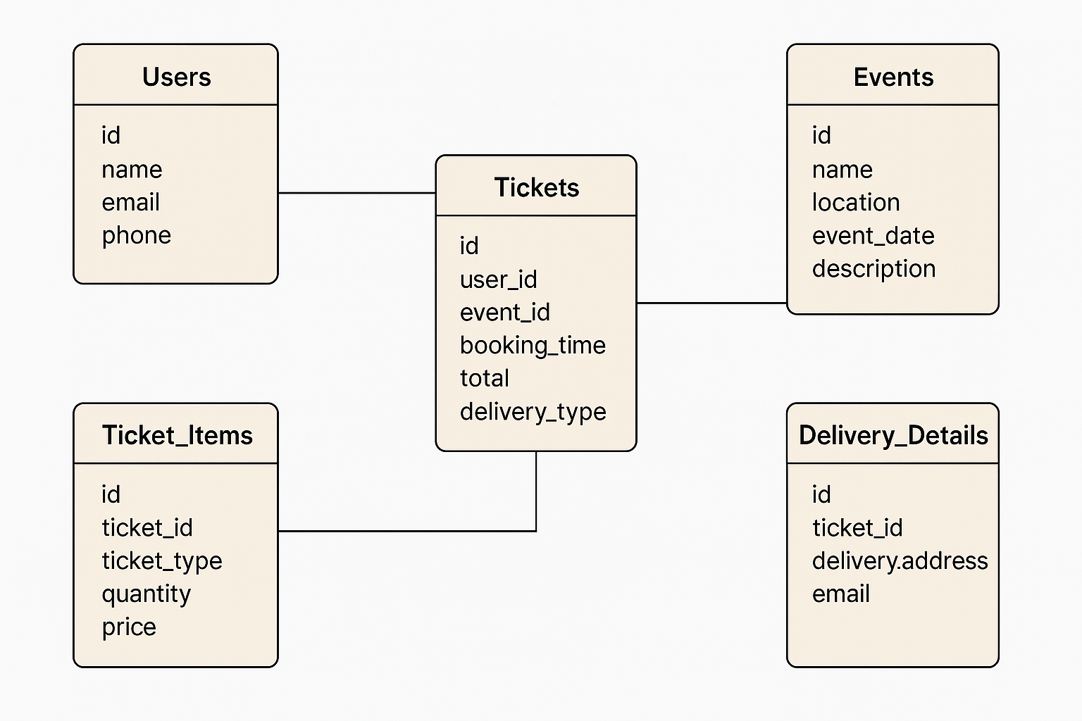

Programming Tools:

**1. XAMPP: Local Development Environment**

XAMPP provides the platform to run your PHP-based event ticketing system locally. It includes:

* **Apache**: Runs your PHP scripts (e.g., booking tickets, fetching events).
* **MySQL**: Stores event, user, and ticket data.
* **phpMyAdmin**: Easy web interface for managing the MySQL database.

You place your project in htdocs and access it at <http://localhost/your-project-> name.

**2. SQL: SQL (Structured Query Language)**

used to interact with the **MySQL database** for:

1. **Storing Data**
   * statements add users, ticket bookings, and ticket items.
2. **Retrieving Data**
   * queries fetch available events, ticket history, and booking details.
3. **Organizing Relationships**
   * JOIN operations link users, events, tickets, and delivery data.
4. **Calculating Totals**
   * SQL queries compute total ticket cost using quantity × price.

3. **PHP (Hypertext Preprocessor)**

PHP powers the backend logic of the event ticketing system. It:

1. **Connects to the Database**
   * Uses MYSQLi or PDO to run queries securely.
2. **Processes Ticket Bookings**
   * Adds new users, creates ticket entries, and records ticket categories.
3. **Handles API Requests**
   * Scripts like get_events.php, book_ticket.php, and get_tickets.php return JSON responses for the frontend.
4. **Sends and Receives Data**
   * Accepts event selections and user info, processes them, and returns booking results.

VS CODE:

* + **Write and Edit Code**
    - Create and manage HTML, CSS, JavaScript, PHP, and SQL files.
  + **Project Management**

• Organize project folders and files easily.

* + **Syntax Highlighting & Autocomplete**
    - Helps avoid errors with real-time suggestions.
  + **Extensions & Debugging**
    - Use extensions like PHP IntelliSense and MySQL support for productivity.

1. HTML,CSS,JAVA SCRIPT:

|  |  |
| --- | --- |
| **Technology** | **Use in Your Project** |
| **HTML** | Builds the structure: event list, booking forms, history tables. |
| **CSS** | Styles the pages with fonts, layouts, and colors for a polished look. |
| **JavaScript** | Adds interactivity – event selection, dynamic price calculation, and sending booking data via AJAX. |

Database Design:

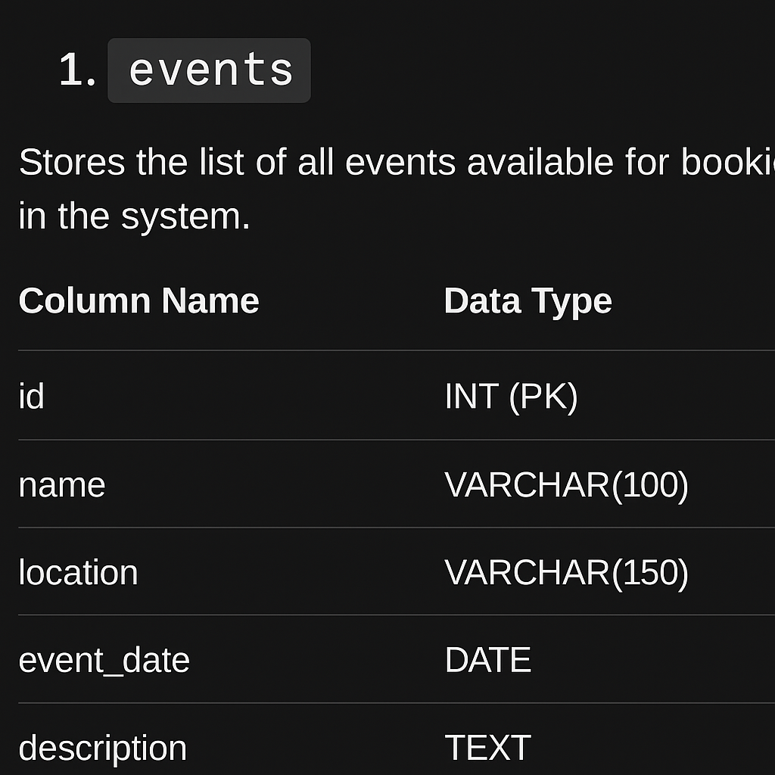

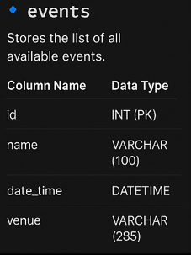

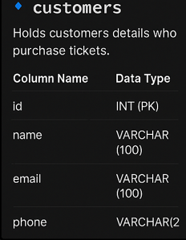

.

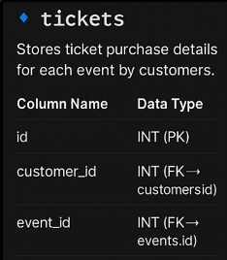

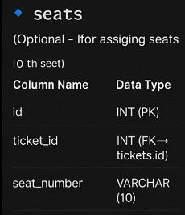

Query:

1 .CREATE DATABASE

event_ticketing_db;

USE event_ticketing_db;

2 . CREATE TABLE events (

id INT AUTO_INCREMENT PRIMARY KEY,

name VARCHAR(100),

description TEXT,

date DATETIME,

venue VARCHAR(255),

total_seats INT

);

3 .

CREATE TABLE customers (

id INT AUTO_INCREMENT PRIMARY KEY,

name VARCHAR(100),

phone VARCHAR(20),

email VARCHAR(100)

);

4 . CREATE TABLE tickets (

id INT AUTO_INCREMENT PRIMARY KEY,

event_id INT,

customer_id INT,

booking_time DATETIME,

seat_number VARCHAR(10),

price DECIMAL(8,2),

status ENUM('Booked', 'Cancelled') DEFAULT 'Booked',

FOREIGN KEY (event_id) REFERENCES events(id),

FOREIGN KEY

(customer_id) REFERENCES customers(id)

);

5 . CREATE TABLE ticket_items (

id INT AUTO_INCREMENT PRIMARY KEY,

ticket_id INT,

ticket_type VARCHAR(50), -- e.g., 'VIP', 'General', 'Balcony'

quantity INT,

price DECIMAL(6,2),

FOREIGN KEY (ticket_id) REFERENCES tickets(id)

);

6 . CREATE TABLE ticket_delivery_details (

id INT AUTO_INCREMENT PRIMARY KEY,

ticket_id INT,

delivery_method ENUM('Email', 'Mobile', 'Courier') NOT NULL,

delivery_address VARCHAR(255),

FOREIGN KEY (ticket_id) REFERENCES tickets(id)

);

7 . INSERT INTO events (name, date, venue, ticket_price) VALUES

('Music Fest 2025', '2025-06-10', 'Open Grounds, City Center', 500.00),

('Tech Expo', '2025-07-05', 'Convention Hall A', 300.00),

('Stand-up Comedy Night', '2025-06-15', 'The Laugh Club', 400.00),

('Startup Summit', '2025-08-01', 'Biz Hub Arena', 600.00),

('Dance Show', '2025-06-20',

'Downtown Theater', 350.00);

Placing Order :

1 . INSERT INTO customers (name, phone, email) VALUES (?, ?, ?);

2 . INSERT INTO tickets (customer_id, event_id, purchase_time, total, ticket_type, seat_number)

VALUES (?, ?, ?, ?, ?, ?);

3 . INSERT INTO ticket_items (ticket_id, event_id, quantity, price)

VALUES (?, ?, ?, ?);

4 . INSERT INTO ticket_delivery_details (ticket_id, delivery_method, delivery_address)

VALUES (?, ?, ?);

Coding:

PHP:

<?php

$host = "localhost";

$user = "root";

$pass = "";

$db = "event_ticketing_db";

$conn = new mysqli($host, $user, $pass, $db);

if ($conn->connect_error) {

die("Connection failed: " . $conn->connect_error);

}

?>

GET_EVENTS.PHP:

<?php

header('Content-Type: application/json');

include 'db.php';

$sql = "SELECT * FROM events";

$result = $conn->query($sql);

$events = array();

while($row = $result->fetch_assoc()) {

$events[] = $row;

}

echo json_encode($events);

$conn->close();

?>

GET_TICKET_DETAILS.PHP

<?php

header('Content-Type: application/json');

include 'db.php';

$ticket_id = intval($_GET['ticket_id']);

$sql = "SELECT e.name, ti.quantity, ti.price

FROM ticket_items ti

JOIN events e ON ti.event_id = e.id

WHERE ti.ticket_id = $ticket_id";

$result = $conn->query($sql);

$items = array();

while($row = $result->fetch_assoc()) {

$items[] = $row;

}

echo json_encode($items);

$conn->close();

?>

GET_TICKET.PHP:

<?php

header('Content-Type: application/json');

include 'db.php';

$ticket_id = intval($_GET['ticket_id']);

$sql = "SELECT t.id, c.name AS customer_name, c.phone, c.email,

t.purchase_time, t.total, t.ticket_type, t.seat_number,

e.name AS event_name, e.date, e.venue

FROM tickets t

JOIN customers c ON t.customer_id = c.id

JOIN events e ON t.event_id = e.id

WHERE t.id = $ticket_id";

$result = $conn->query($sql);

$ticket = array();

if($row = $result->fetch_assoc()) {

$ticket = $row;

}

echo json_encode($ticket);

$conn->close();

?>

INDEX.HTML:

<!DOCTYPE html>

<html lang="en">

<head>

<meta charset="UTF-8">

<title>Event Ticketing System</title>

<style>

body {

font-family: 'Segoe UI', sans-serif;

background: #f5f7fa;

margin: 0;

padding: 0;

}

header {

background-color: #6c5ce7;

color: white;

padding: 20px 0;

text-align: center;

box-shadow: 0 4px 10px rgba(0, 0, 0, 0.2);

}

header h1 {

margin: 0;

font-size: 36px;

letter-spacing: 1px;

}

nav {

background-color: #fff;

display: flex;

justify-content: center;

gap: 20px;

padding: 15px 0;

box-shadow: 0 2px 5px rgba(0,0,0,0.1);

}

nav a {

text-decoration: none;

color: white;

font-weight: bold;

font-size: 16px;

padding: 10px 18px;

border-radius: 30px;

background: linear-gradient(45deg, #6c5ce7, #a29bfe);

box-shadow: 0 4px 12px rgba(108, 92, 231, 0.4);

transition: transform 0.2s ease, box-shadow 0.3s ease;

}

nav a:hover {

transform: scale(1.08);

box-shadow: 0 6px 18px rgba(108, 92, 231, 0.6);

}

.container {

text-align: center;

margin-top: 60px;

padding: 20px;

}

.welcome-text {

animation: fadeIn 2s ease-in-out;

}

.welcome-text h2 {

font-size: 32px;

font-weight: bold;

color: #333;

}

.welcome-text .highlight {

background: linear-gradient(90deg, #6c5ce7, #a29bfe);

-webkit-background-clip: text;

-webkit-text-fill-color: transparent;

animation: shimmer 2s infinite linear;

display: inline-block;

}

.welcome-text p {

font-size: 18px;

color: #666;

margin-top: 15px;

}

@keyframes shimmer {

0% {

background-position: -300px 0;

}

100% {

background-position: 300px 0;

}

}

@keyframes fadeIn {

from {

opacity: 0;

transform: translateY(20px);

}

to {

opacity: 1;

transform: translateY(0);

}

}

</style>

</head>

<body>

<header>

<h1>🎫 Event Ticketing System</h1>

</header>

<nav>

<a href="create.php">➕ Create Event</a>

<a href="view.php">📋 View Events</a>

<a href="book.php">🎫 Book Tickets</a>

<a href="view_bookings.php">🗂️ View Bookings</a>

<a href="contact.php">📞 Contact</a>

</nav>

<div class="container">

<div class="welcome-text">

<h2>👋 Welcome to Your <span class="highlight">Event World</span>!</h2>

<p>Plan, Book & Enjoy Your Events Effortlessly ✨</p>

</div>

</div>

</body>

</html>

OUTPUT:

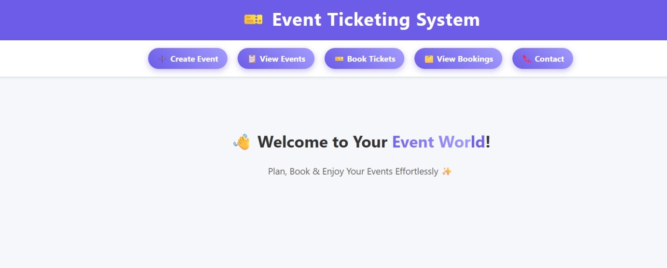

CREATE.PHP:

<!DOCTYPE html>

<html lang="en">

<head>

<meta charset="UTF-8">

<meta name="viewport" content="width=device-width, initial-scale=1.0">

<title>Create Event</title>

<style>

body {

font-family: Arial, sans-serif;

background-color: #f7f7f7;

margin: 0;

padding: 0;

}

header {

background-color: #2c3e50;

color: white;

padding: 20px;

text-align: center;

}

nav ul {

list-style: none;

padding: 0;

margin: 10px 0 0 0;

display: flex;

justify-content: center;

}

nav ul li {

margin: 0 15px;

}

nav ul li a {

text-decoration: none;

color: white;

font-weight: bold;

}

nav ul li a:hover {

text-decoration: underline;

}

section {

max-width: 600px;

background-color: white;

margin: 30px auto;

padding: 20px;

border-radius: 8px;

box-shadow: 0 4px 10px rgba(0, 0, 0, 0.1);

}

form label {

display: block;

margin-top: 15px;

font-weight: bold;

}

input[type="text"],

input[type="date"],

input[type="time"],

input[type="number"],

textarea {

width: 100%;

padding: 8px;

margin-top: 5px;

border: 1px solid #ccc;

border-radius: 5px;

}

textarea {

resize: vertical;

}

.submit-btn {

margin-top: 20px;

padding: 10px 20px;

background-color: #2980b9;

color: white;

border: none;

border-radius: 5px;

cursor: pointer;

font-size: 16px;

}

.submit-btn:hover {

background-color: #1c5980;

}

</style>

</head>

<body>

<header>

<h1>Create New Event</h1>

<nav>

<ul>

<li><a href="index.php">Home</a></li>

<li><a href="create.php">Create Event</a></li>

<li><a href="view.php">View Events</a></li>

<li><a href="book.php">Book Tickets</a></li>

<li><a href="contact.php">Contact</a></li>

</ul>

</nav>

</header>

<section>

<form action="insert.php" method="post">

<label>Event Name:</label>

<input type="text" name="name" required>

<label>Description:</label>

<textarea name="description" required></textarea>

<label>Date:</label>

<input type="date" name="event_date" required>

<label>Time:</label>

<input type="time" name="event_time" required>

<label>Location:</label>

<input type="text" name="location" required>

<label>Category:</label>

<input type="text" name="category" required>

<label>Price (₹):</label>

<input type="number" name="price" step="0.01" required>

<input type="submit" value="Create Event" class="submit-btn">

</form>

</section>

</body>

</html>

Output:

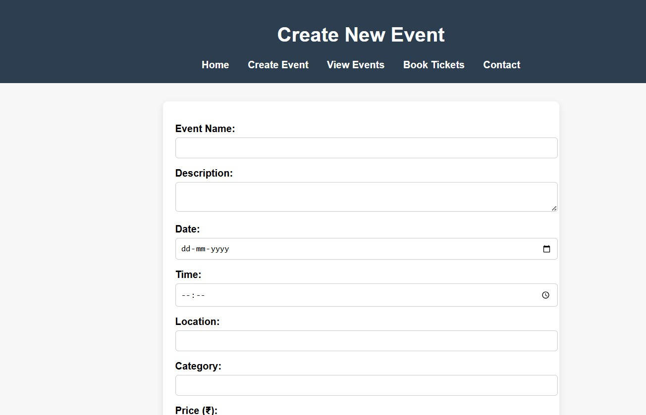

INSERT.PHP

<?php

// 1. Connect to the database

$conn = new mysqli("localhost", "root", "", "event_ticketing_system");

// 2. Check connection

if ($conn->connect_error) {

die("❌ Connection failed: " . $conn->connect_error);

}

// 3. Get form values

$name = $_POST['name'];

$description = $_POST['description'];

$event_date = $_POST['event_date'];

$event_time = $_POST['event_time'];

$location = $_POST['location'];

$category = $_POST['category'];

$price = $_POST['price'];

// 4. Prepare SQL statement

$sql = "INSERT INTO events (name, description, event_date, event_time, location, category, price)

VALUES (?, ?, ?, ?, ?, ?, ?)";

$stmt = $conn->prepare($sql);

// 5. Check if prepare() failed

if (!$stmt) {

die("❌ Prepare failed: " . $conn->error);

}

// 6. Bind parameters

$stmt->bind_param("ssssssd", $name, $description, $event_date, $event_time, $location, $category, $price);

// 7. Execute the statement

if ($stmt->execute()) {

echo "🎉 Event created successfully!<br>";

echo "<a href='view.php'>View Events</a>";

} else {

echo "❌ Error: " . $stmt->error;

}

// 8. Close everything

$stmt->close();

$conn->close();

?>

INSERT.PHP

<?php

// 1. Connect to the database

$conn = new mysqli("localhost", "root", "", "event_ticketing_system");

// 2. Check connection

if ($conn->connect_error) {

die("❌ Connection failed: " . $conn->connect_error);

}

// 3. Get form values

$name = $_POST['name'];

$description = $_POST['description'];

$event_date = $_POST['event_date'];

$event_time = $_POST['event_time'];

$location = $_POST['location'];

$category = $_POST['category'];

$price = $_POST['price'];

// 4. Prepare SQL statement

$sql = "INSERT INTO events (name, description, event_date, event_time, location, category, price)

VALUES (?, ?, ?, ?, ?, ?, ?)";

$stmt = $conn->prepare($sql);

// 5. Check if prepare() failed

if (!$stmt) {

die("❌ Prepare failed: " . $conn->error);

}

// 6. Bind parameters

$stmt->bind_param("ssssssd", $name, $description, $event_date, $event_time, $location, $category, $price);

// 7. Execute the statement

if ($stmt->execute()) {

echo "🎉 Event created successfully!<br>";

echo "<a href='view.php'>View Events</a>";

} else {

echo "❌ Error: " . $stmt->error;

}

// 8. Close everything

$stmt->close();

$conn->close();

?>

OUTPUT:

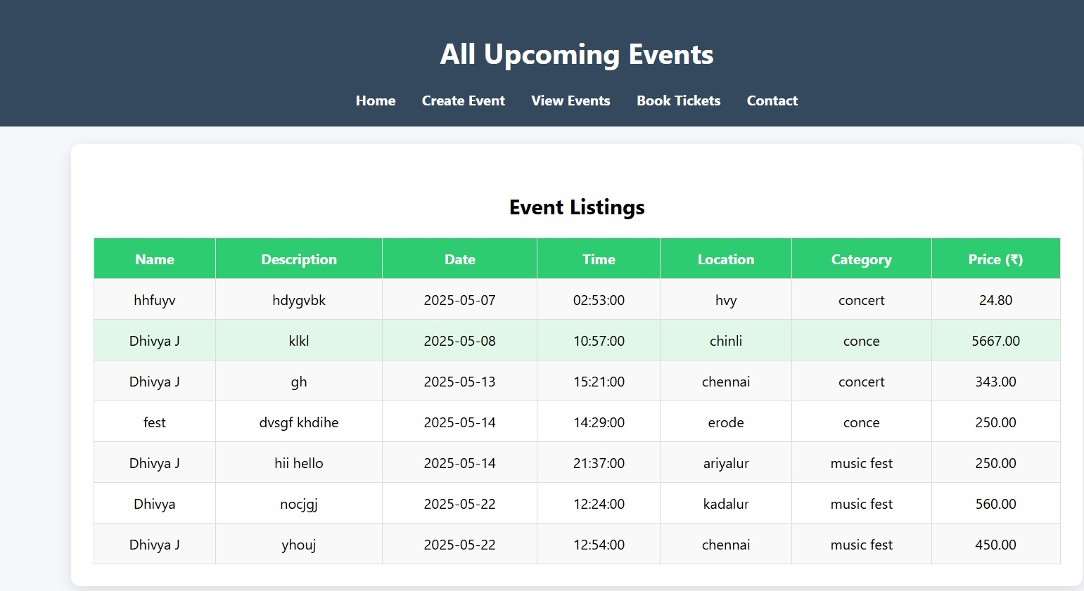

BOOK.PHP

<!DOCTYPE html>

<html lang="en">

<head>

<meta charset="UTF-8">

<meta name="viewport" content="width=device-width, initial-scale=1.0">

<title>Book Tickets</title>

<style>

body {

font-family: Arial, sans-serif;

background-color: #f0f2f5;

margin: 0;

padding: 0;

}

header {

background-color: #2c3e50;

color: white;

padding: 20px;

text-align: center;

}

nav ul {

list-style: none;

padding: 0;

margin: 10px 0 0 0;

display: flex;

justify-content: center;

}

nav ul li {

margin: 0 15px;

}

nav ul li a {

text-decoration: none;

color: white;

font-weight: bold;

}

nav ul li a:hover {

text-decoration: underline;

}

section {

max-width: 650px;

background-color: white;

margin: 30px auto;

padding: 25px;

border-radius: 10px;

box-shadow: 0 4px 10px rgba(0, 0, 0, 0.1);

}

form label {

display: block;

margin-top: 15px;

font-weight: bold;

}

input[type="text"],

input[type="email"],

input[type="number"],

input[type="tel"],

select,

textarea {

width: 100%;

padding: 10px;

margin-top: 5px;

border: 1px solid #ccc;

border-radius: 5px;

}

textarea {

resize: vertical;

}

.submit-btn {

margin-top: 20px;

padding: 12px 20px;

background-color: #27ae60;

color: white;

border: none;

border-radius: 5px;

cursor: pointer;

font-size: 17px;

}

.submit-btn:hover {

background-color: #1e8449;

}

</style>

</head>

<body>

<header>

<h1>Book Tickets</h1>

<nav>

<ul>

<li><a href="index.php">Home</a></li>

<li><a href="create.php">Create Event</a></li>

<li><a href="view.php">View Events</a></li>

<li><a href="book.php">Book Tickets</a></li>

<li><a href="contact.php">Contact</a></li>

</ul>

</nav>

</header>

<section>

<form action="book_insert.php" method="post">

<label>Your Name:</label>

<input type="text" name="username" required>

<label>Email Address:</label>

<input type="email" name="email" required>

<label>Phone Number:</label>

<input type="tel" name="phone" pattern="[0-9]{10}" placeholder="10-digit number" required>

<label>Select Event:</label>

<select name="event_name" required>

<option value="">-- Choose Event --</option>

<option value="Music Concert">Music Concert</option>

<option value="Tech Conference">Tech Conference</option>

<option value="Art Exhibition">Art Exhibition</option>

<option value="Stand-up Comedy">Stand-up Comedy</option>

<option value="Food Festival">Food Festival</option>

<option value="Movie Premiere">Movie Premiere</option>

<option value="Startup Meetup">Startup Meetup</option>

<option value="Charity Run">Charity Run</option>

<option value="Workshop: AI Basics">Workshop: AI Basics</option>

<option value="Carnival Night">Carnival Night</option>

</select>

<label>Preferred Seating:</label>

<select name="seating" required>

<option value="">-- Select Seating --</option>

<option value="Front">Front</option>

<option value="Middle">Middle</option>

<option value="Back">Back</option>

</select>

<label>Number of Tickets:</label>

<input type="number" name="tickets" min="1"

required>

<label>Special Requests:</label>

<textarea name="requests" placeholder="Mention if any..."></textarea>

<input type="submit" value="Book Now" class="submit-btn">

</form>

</section>

</body>

</html>

BOOK INSERT.PHP

<?php

// DB connection

$conn = new mysqli("localhost", "root", "", "event_ticketing_system");

if ($conn->connect_error) {

die("Connection failed: " . $conn->connect_error);

}

// Get form data

$username = $_POST['username'];

$email = $_POST['email'];

$phone = $_POST['phone'];

$event_name = $_POST['event_name'];

$seating = $_POST['seating'];

$tickets = $_POST['tickets'];

$requests = $_POST['requests'];

// Insert into database

$sql = "INSERT INTO bookings (username, email, phone, event_name, seating, tickets, requests)

VALUES (?, ?, ?, ?, ?, ?, ?)";

$stmt = $conn->prepare($sql);

$stmt->bind_param("sssssis", $username, $email, $phone, $event_name, $seating, $tickets, $requests);

if ($stmt->execute()) {

echo "🎉 Tickets booked successfully!";

echo "<br><a href='view_bookings.php'>View All Bookings</a>";

} else {

echo "❌ Error: " . $stmt->error;

}

$stmt->close();

$conn->close();

?>

OUTPUT:

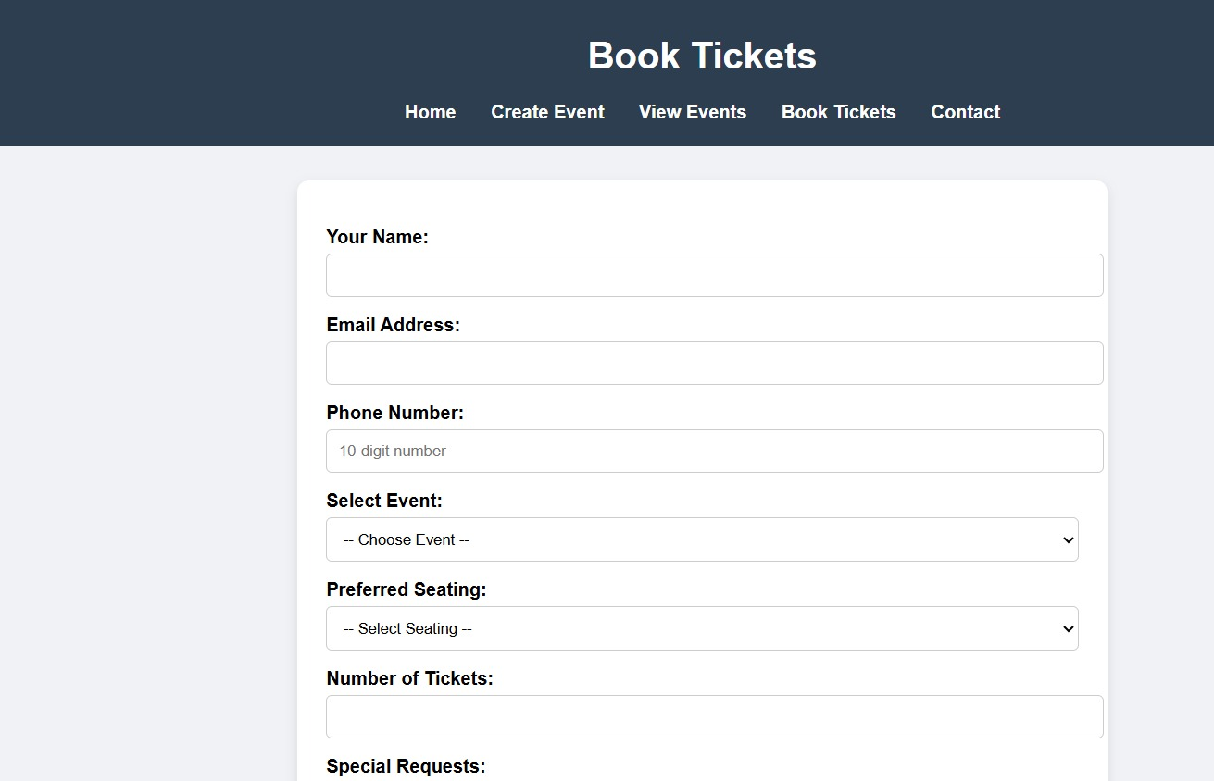

VIEW.PHP

<?php

// view.php

// DB connection (update with your DB credentials)

$conn = new mysqli("localhost", "root", "", "event_ticketing_system");

if ($conn->connect_error) {

die("Connection failed: " . $conn->connect_error);

}

// Fetch all events

$sql = "SELECT * FROM events ORDER BY event_date ASC";

$result = $conn->query($sql);

?>

<!DOCTYPE html>

<html lang="en">

<head>

<meta charset="UTF-8">

<title>View Events</title>

<style>

body {

font-family: 'Segoe UI', sans-serif;

background-color: #f5f7fa;

margin: 0;

padding: 0;

}

header {

background-color: #34495e;

color: white;

padding: 20px;

text-align: center;

}

nav ul {

list-style: none;

padding: 0;

margin: 10px 0 0 0;

display: flex;

justify-content: center;

}

nav ul li {

margin: 0 15px;

}

nav ul li a {

text-decoration: none;

color: white;

font-weight: bold;

}

nav ul li a:hover {

text-decoration: underline;

}

h2 {

text-align: center;

margin-top: 30px;

}

.container {

width: 90%;

max-width: 1100px;

margin: 20px auto;

background: white;

padding: 25px;

border-radius: 10px;

box-shadow: 0 5px 15px rgba(0,0,0,0.1);

}

table {

width: 100%;

border-collapse: collapse;

margin-top: 10px;

}

th, td {

padding: 12px 15px;

border: 1px solid #ddd;

text-align: center;

}

th {

background-color: #2ecc71;

color: white;

}

tr:nth-child(even) {

background-color: #f9f9f9;

}

tr:hover {

background-color: #e1f7e7;

}

</style>

</head>

<body>

<header>

<h1>All Upcoming Events</h1>

<nav>

<ul>

<li><a href="index.php">Home</a></li>

<li><a href="create.php">Create Event</a></li>

<li><a href="view.php">View Events</a></li>

<li><a href="book.php">Book Tickets</a></li>

<li><a href="contact.php">Contact</a></li>

</ul>

</nav>

</header>

<div class="container">

<h2>Event Listings</h2>

<?php if ($result->num_rows > 0): ?>

<table>

<tr>

<th>Name</th>

<th>Description</th>

<th>Date</th>

<th>Time</th>

<th>Location</th>

<th>Category</th>

<th>Price (₹)</th>

</tr>

<?php while($row = $result->fetch_assoc()): ?>

<tr>

<td><?= $row["name"] ?></td>

<td><?= $row["description"] ?></td>

<td><?= $row["event_date"] ?></td>

<td><?= $row["event_time"] ?></td>

<td><?= $row["location"] ?></td>

<td><?= $row["category"] ?></td>

<td><?= $row["price"] ?></td>

</tr>

<?php endwhile; ?>

</table>

<?php else: ?>

<p style="text-align:center;">No events found.</p>

<?php endif; ?>

</div>

</body>

</html>

<?php $conn->close(); ?>

VIEW_BOOKING.PHP

<head>

<meta charset="UTF-8">

<title>Book Tickets</title>

<style>

/* Copy and paste the CSS code here */

/* General Styles */

body {

font-family: 'Arial', sans-serif;

background-color: #f4f7fa;

margin: 0;

padding: 0;

box-sizing: border-box;

}

/* Header */

header {

background-color: #2c3e50;

color: #fff;

padding: 20px;

text-align: center;

}

header h1 {

margin: 0;

font-size: 2.5rem;

}

/* Navigation */

nav ul {

list-style: none;

padding: 0;

display: flex;

justify-content: center;

margin-top: 15px;

}

nav ul li {

margin: 0 20px;

}

nav ul li a {

text-decoration: none;

color: #fff;

font-size: 1.1rem;

font-weight: bold;

}

nav ul li a:hover {

text-decoration: underline;

}

/* Form Styling for book.php */

.container {

max-width: 800px;

margin: 50px auto;

background: #fff;

padding: 30px;

border-radius: 10px;

box-shadow: 0 4px 12px rgba(0, 0, 0, 0.1);

}

h2 {

text-align: center;

font-size: 2rem;

color: #34495e;

margin-bottom: 20px;

}

form {

display: grid;

gap: 20px;

}

input[type="text"], input[type="email"], input[type="number"], textarea {

width: 100%;

padding: 10px;

border: 1px solid #ddd;

border-radius: 5px;

font-size: 1rem;

}

input[type="submit"] {

background-color: #2ecc71;

color: #fff;

font-size: 1.2rem;

padding: 15px;

border: none;

border-radius: 5px;

cursor: pointer;

}

input[type="submit"]:hover {

background-color: #27ae60;

}

/* Table for view_bookings.php */

table {

width: 100%;

border-collapse: collapse;

margin-top: 20px;

}

table th, table td {

padding: 12px;

border: 1px solid #ddd;

text-align: left;

font-size: 1rem;

}

table th {

background-color: #2ecc71;

color: white;

}

table tr:nth-child(even) {

background-color: #f9f9f9;

}

table tr:hover {

background-color: #e0f2e0;

}

/* No Bookings Found Message */

.no-bookings {

text-align: center;

font-size: 1.2rem;

color: #f39c12;

margin-top: 20px;

}

/* Footer */

footer {

background-color: #34495e;

color: #fff;

text-align: center;

padding: 15px;

position: fixed;

width: 100%;

bottom: 0;

}

</style>

</head>

<head>

<meta charset="UTF-8">

<title>Book Tickets</title>

<style>

/* Copy and paste the CSS code here */

/* General Styles */

body {

font-family: 'Arial', sans-serif;

background-color: #f4f7fa;

margin: 0;

padding: 0;

box-sizing: border-box;

}

/* Header */

header {

background-color: #2c3e50;

color: #fff;

padding: 20px;

text-align: center;

}

header h1 {

margin: 0;

font-size: 2.5rem;

}

/* Navigation */

nav ul {

list-style: none;

padding: 0;

display: flex;

justify-content: center;

margin-top: 15px;

}

nav ul li {

margin: 0 20px;

}

nav ul li a {

text-decoration: none;

color: #fff;

font-size: 1.1rem;

font-weight: bold;

}

nav ul li a:hover {

text-decoration: underline;

}

/* Form Styling for book.php */

.container {

max-width: 800px;

margin: 50px auto;

background: #fff;

padding: 30px;

border-radius: 10px;

box-shadow: 0 4px 12px rgba(0, 0, 0, 0.1);

}

h2 {

text-align: center;

font-size: 2rem;

color: #34495e;

margin-bottom: 20px;

}

form {

display: grid;

gap: 20px;

}

input[type="text"], input[type="email"], input[type="number"], textarea {

width: 100%;

padding: 10px;

border: 1px solid #ddd;

border-radius: 5px;

font-size: 1rem;

}

input[type="submit"] {

background-color: #2ecc71;

color: #fff;

font-size: 1.2rem;

padding: 15px;

border: none;

border-radius: 5px;

cursor: pointer;

}

input[type="submit"]:hover {

background-color: #27ae60;

}

/* Table for view_bookings.php */

table {

width: 100%;

border-collapse: collapse;

margin-top: 20px;

}

table th, table td {

padding: 12px;

border: 1px solid #ddd;

text-align: left;

font-size: 1rem;

}

table th {

background-color: #2ecc71;

color: white;

}

table tr:nth-child(even) {

background-color: #f9f9f9;

}

table tr:hover {

background-color: #e0f2e0;

}

/* No Bookings Found Message */

.no-bookings {

text-align: center;

font-size: 1.2rem;

color: #f39c12;

margin-top: 20px;

}

/* Footer */

footer {

background-color: #34495e;

color: #fff;

text-align: center;

padding: 15px;

position: fixed;

width: 100%;

bottom: 0;

}

</style>

</head>

CONTACT.PHP

<!DOCTYPE html>

<html lang="en">

<head>

<meta charset="UTF-8">

<meta name="viewport" content="width=device-width, initial-scale=1.0">

<title>Contact</title>

<style>

body {

font-family: Arial, sans-serif;

background-color: #f7f7f7;

margin: 0;

padding: 0;

}

header {

background-color: #2c3e50;

color: white;

padding: 20px;

text-align: center;

}

nav ul {

list-style: none;

padding: 0;

margin: 10px 0 0 0;

display: flex;

justify-content: center;

}

nav ul li {

margin: 0 15px;

}

nav ul li a {

text-decoration: none;

color: white;

font-weight: bold;

}

nav ul li a:hover {

text-decoration: underline;

}

section {

max-width: 600px;

background-color: white;

margin: 30px auto;

padding: 20px;

border-radius: 8px;

box-shadow: 0 4px 10px rgba(0, 0, 0, 0.1);

}

form label {

display: block;

margin-top: 15px;

font-weight: bold;

}

input[type="text"],

input[type="email"],

textarea {

width: 100%;

padding: 8px;

margin-top: 5px;

border: 1px solid #ccc;

border-radius: 5px;

}

textarea {

resize: vertical;

}

.submit-btn {

margin-top: 20px;

padding: 10px 20px;

background-color: #2980b9;

color: white;

border: none;

border-radius: 5px;

cursor: pointer;

font-size: 16px;

}

.submit-btn:hover {

background-color: #1c5980;

}

</style>

</head>

<body>

<header>

<h1>Contact Us</h1>

<nav>

<ul>

<li><a href="index.php">Home</a></li>

<li><a href="create.php">Create Event</a></li>

<li><a href="view.php">View Events</a></li>

<li><a href="book.php">Book Tickets</a></li>

<li><a href="contact.php">Contact</a></li>

</ul>

</nav>

</header>

<section>

<form method="POST" action="" autocomplete="on">

<label for="name">Name:</label>

<input type="text" id="name" name="name" placeholder="Your full name" required maxlength="50">

<label for="email">Email:</label>

<input type="email" id="email" name="email" placeholder="you@example.com" required maxlength="100">

<label for="message">Message:</label>

<textarea id="message" name="message" placeholder="Write your message here..." required maxlength="500"></textarea>

<input type="submit" value="Send Message" class="submit-btn">

</form>

</section>

</body>

</html>

OUTPUT:

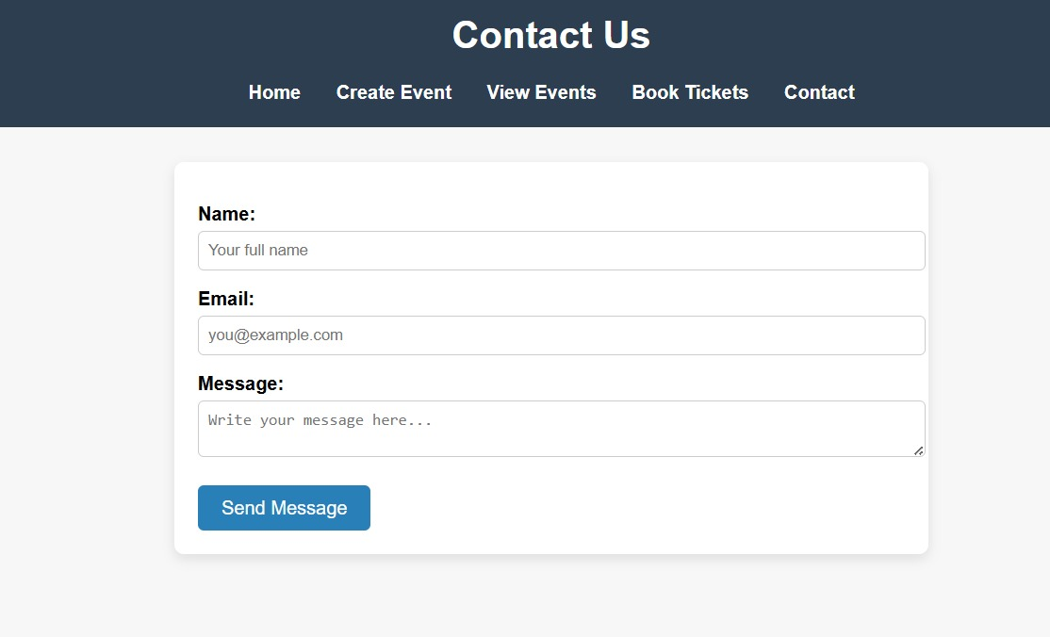

Reference:

1. **Data base Book Name in IEE format: Refference Book :**

Database System Concepts by Abraham Silberschatz, Henry F. Korth, and S. Sudarshan

1. **URL: https://dev.mysql.com/doc/**
2. **URL: https://**[**www.php.net/manual/en/**](http://www.php.net/manual/en/)
3. **URL: https://developer.mozilla.org**