Day 6 – Functions,Aggregation,Grouping and Joins- SQL Server 2025 and MangoDB 8.0
Set 1 – Retail Sales Reporting

Name | Parameswari K
Date | 12.10.2026
Tasks covered | Task 1 (8 SQL Queries), Task 2 (SQL String, Date and Numeric Functions), Task 3 (NULL Handling using COUNT and AVG), Task 4 (MongoDB Aggregation Pipelines).
Sample Data Used
Task 1 – Eight SQL queries (Top 5 products, monthly sales, customer orders, LEFT JOIN, average basket value and more).

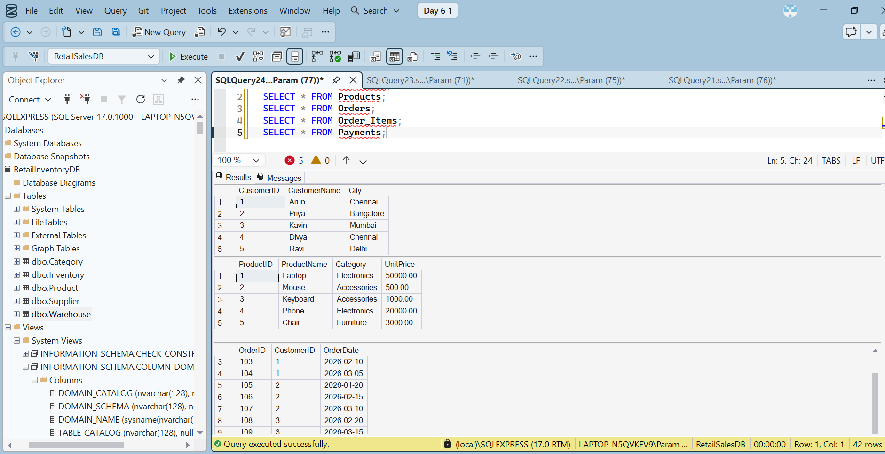
Query 1: Top 5 Products by Revenue
Aim: Find the five products that generated the highest sales revenue.
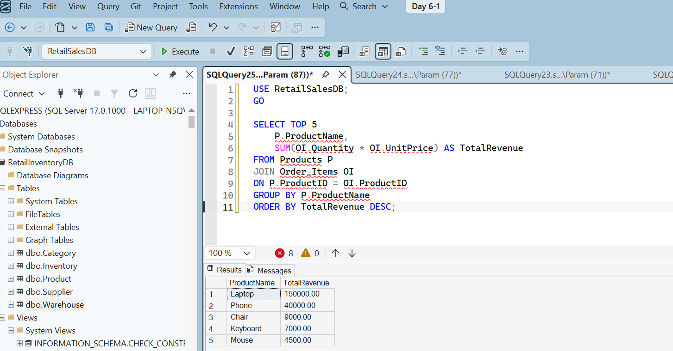
Understand the query
- TOP 5 – Displays five products.
- JOIN – Combines Products and Order_Items tables.
- SUM() – Calculates total revenue.
- GROUP BY – Groups the
Query 2: Monthly Sales Report.
Aim : Calculate the total sales revenue for each month.
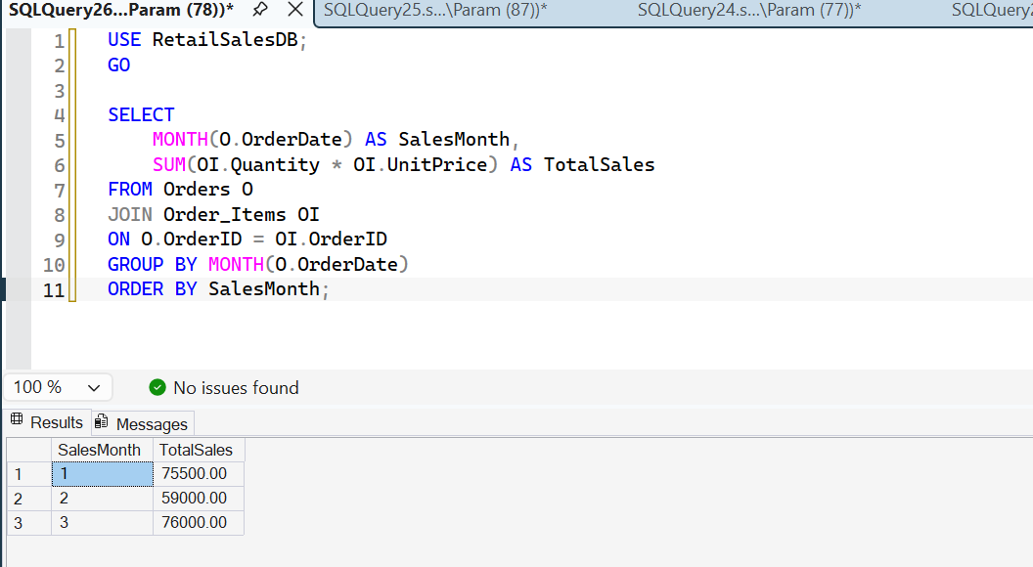
- MONTH() – Extracts the month from the order date.
- JOIN – Combines Orders and Order_Items.
- SUM() – Calculates total sales.
- GROUP BY – Groups sales month-wise.
- ORDER BY – Sorts months
Query 3: Customer-wise Total Orders.
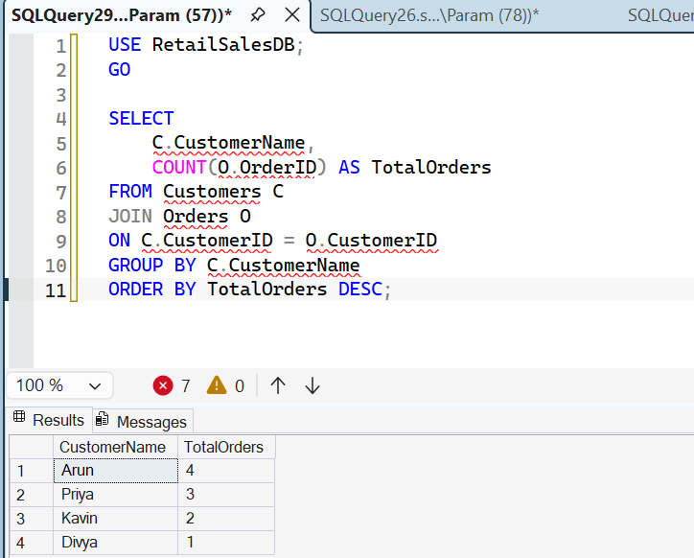
Query 4: Customers with More Than 2 Orders

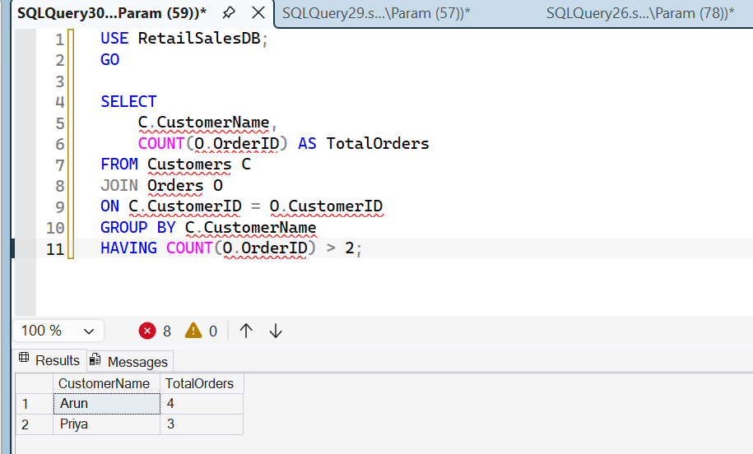
Query 5: Display Orders with Customer Names
c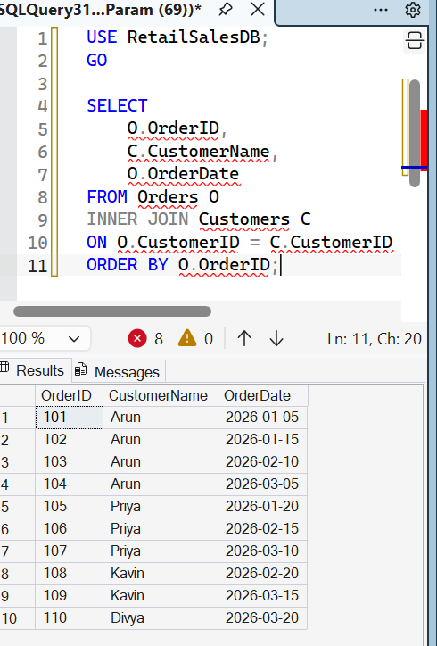
Query 6: Orders Without Payments
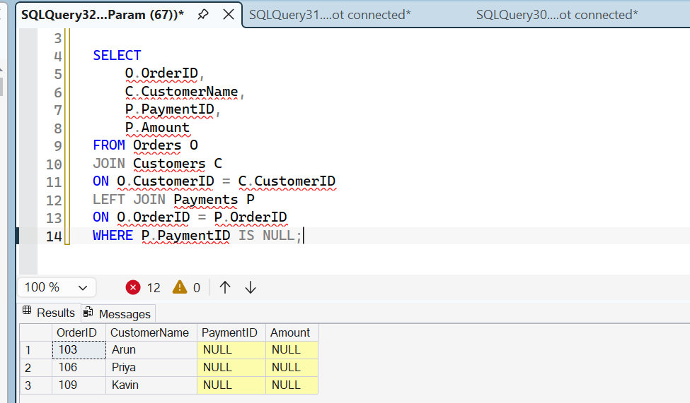
Query 7: Total Revenue by Product Category
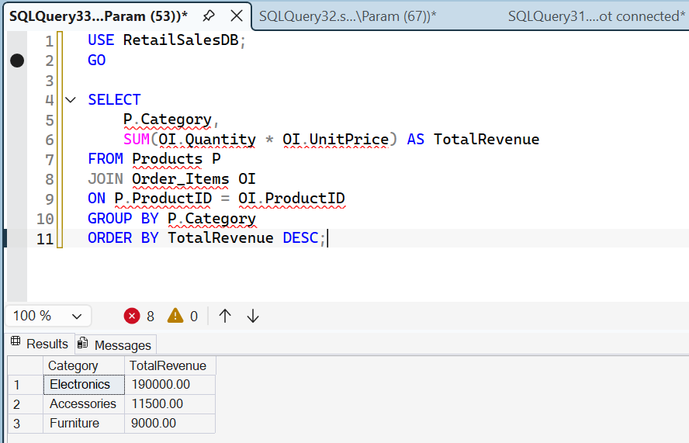

Query 8: Average Order Value
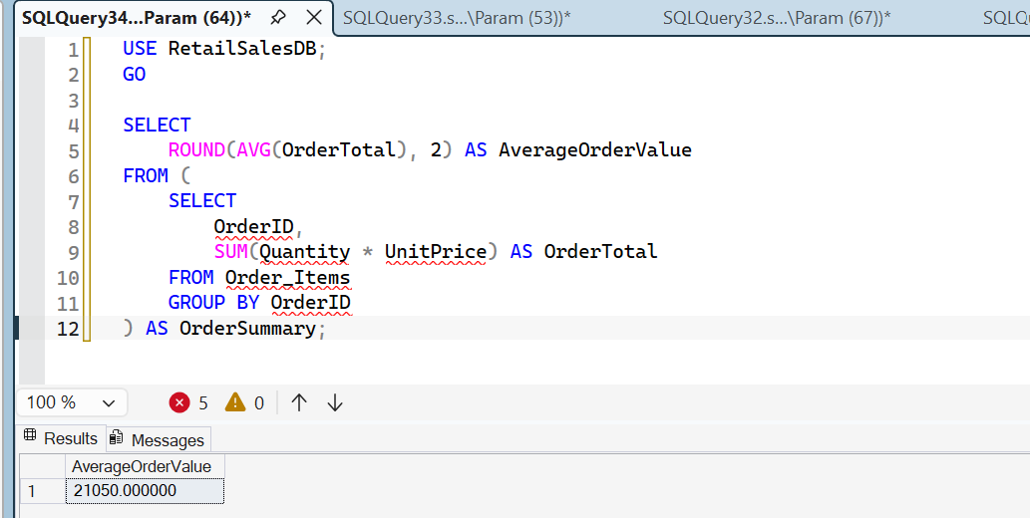

Task 2 – String, Date and Numeric Functions (UPPER, CONCAT, DATEDIFF, FORMAT and ROUND).

In this task, we will demonstrate five SQL functions:
- UPPER() – Converts text into uppercase.
- CONCAT() – Combines text.
- DATEDIFF() – Finds the difference between dates.
- FORMAT() – Formats date or numeric values.
- ROUND() – Rounds numeric values.

USE RetailSalesDB;
GO
-- 1. UPPER Function
SELECT UPPER(CustomerName) AS UppercaseName
FROM Customers;

-- 2. CONCAT Function
SELECT CONCAT(CustomerName, ' - ', City) AS CustomerDetails
FROM Customers;

-- 3. DATEDIFF Function
SELECT
OrderID,
DATEDIFF(DAY, OrderDate, '2026-04-01') AS DaysDifference
FROM Orders;

-- 4. FORMAT Function
SELECT
OrderID,
FORMAT(OrderDate, 'dd-MM-yyyy') AS FormattedDate
FROM Orders;

-- 5. ROUND Function
SELECT
ProductName,
UnitPrice,
ROUND(UnitPrice * 1.18, 2) AS PriceWithTax
FROM Products;
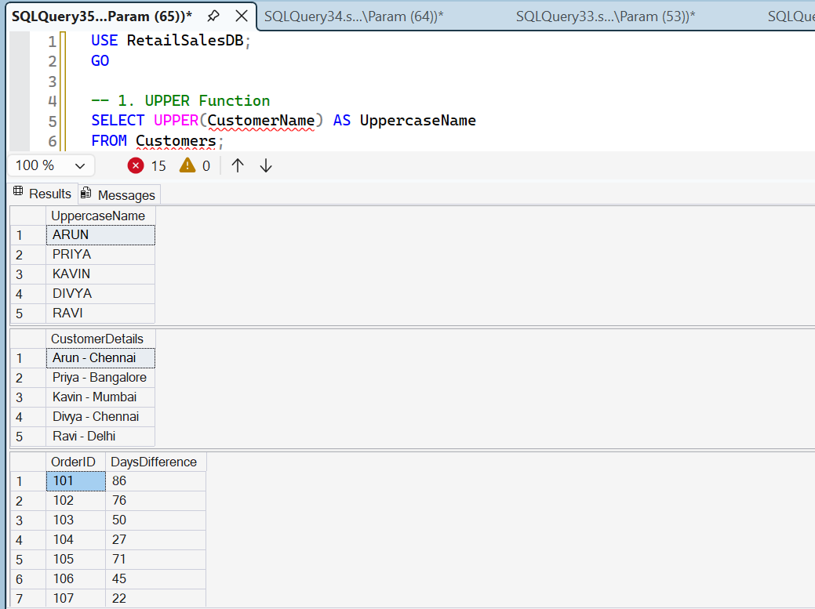
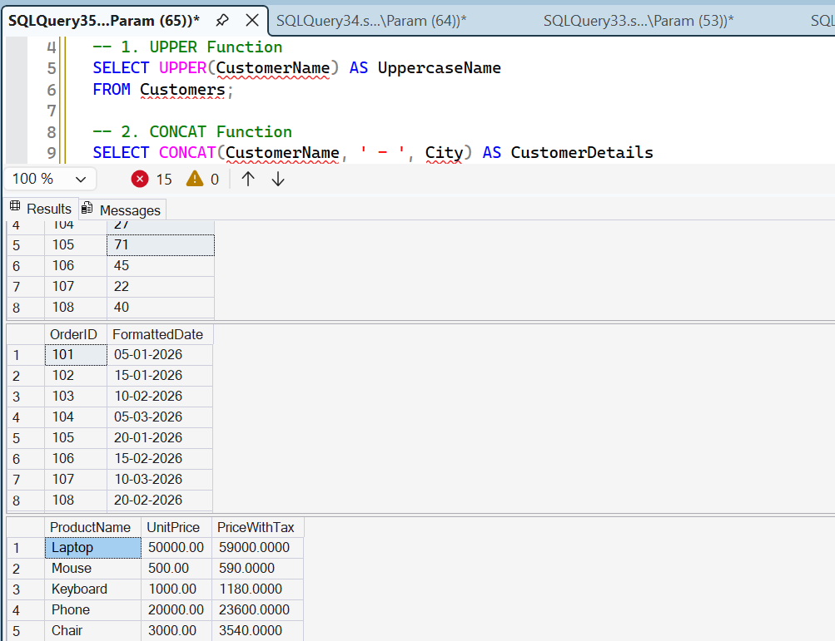
These functions help format customer names, combine customer details, calculate date differences and format prices.

Task 3 – Demonstrate NULL Behaviour Using COUNT() and AVG()

In this task, we will understand how SQL handles NULL values when using aggregate functions.
We will use the existing Payments table.

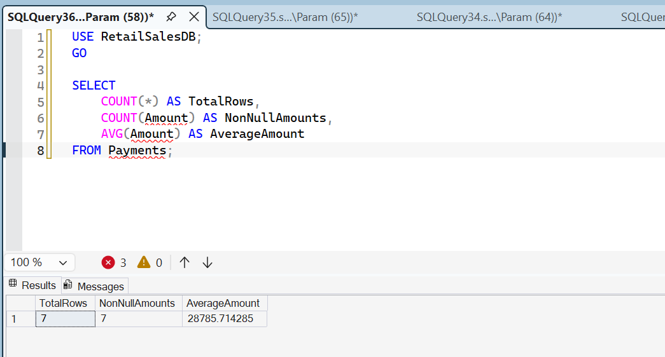

Demonstrate NULL behaviour
Currently, all seven payment amounts contain values. Let's insert one payment with a NULL amount.
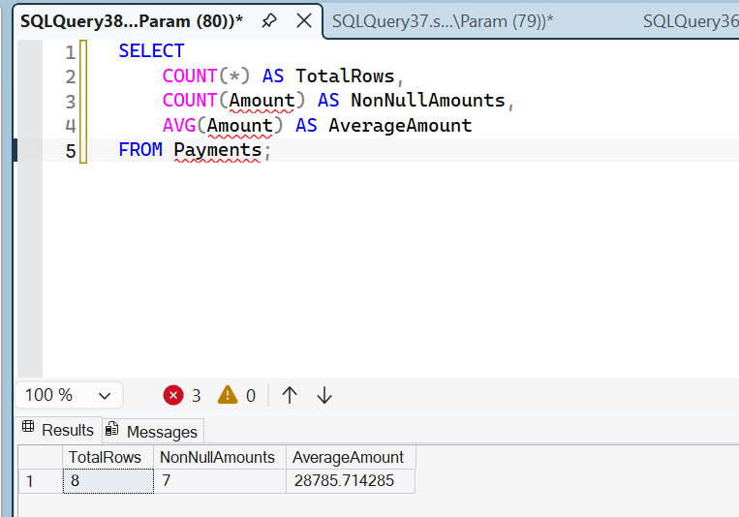
- COUNT(*) counts all rows, including rows containing NULL.
- COUNT(Amount) counts only non-NULL amounts.
- AVG(Amount) ignores NULL values when calculating the average.
Task 4 – MongoDB Aggregation Pipelines
We will create 3 simple aggregation pipelines using:
- $match – Filters documents.
- $group – Groups documents and calculates values.
- $sort – Sorts the results.
We will use your existing MongoDB database and collection:
- Database: RetailInventoryDB
- Collection: reviews

Pipeline 1 – Count Reviews by Rating
[
{
"$match": {
"Rating": { "$gte": 4 }
}
},
{
"$group": {
"_id": "$Rating",
"TotalReviews": { "$sum": 1 }
}
},
{
"$sort": {
"_id": -1
}
}
]
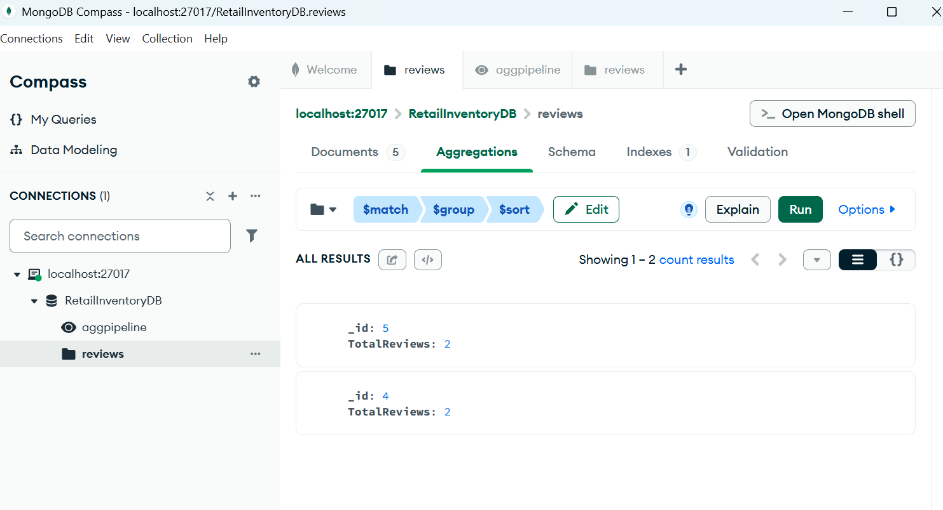
Pipeline 2 – Average Rating by Product
[
{
"$match": {
"Rating": { "$gte": 3 }
}
},
{
"$group": {
"_id": "$SKU",
"AverageRating": { "$avg": "$Rating" }
}
},
{
"$sort": {
"AverageRating": -1
}
}
]
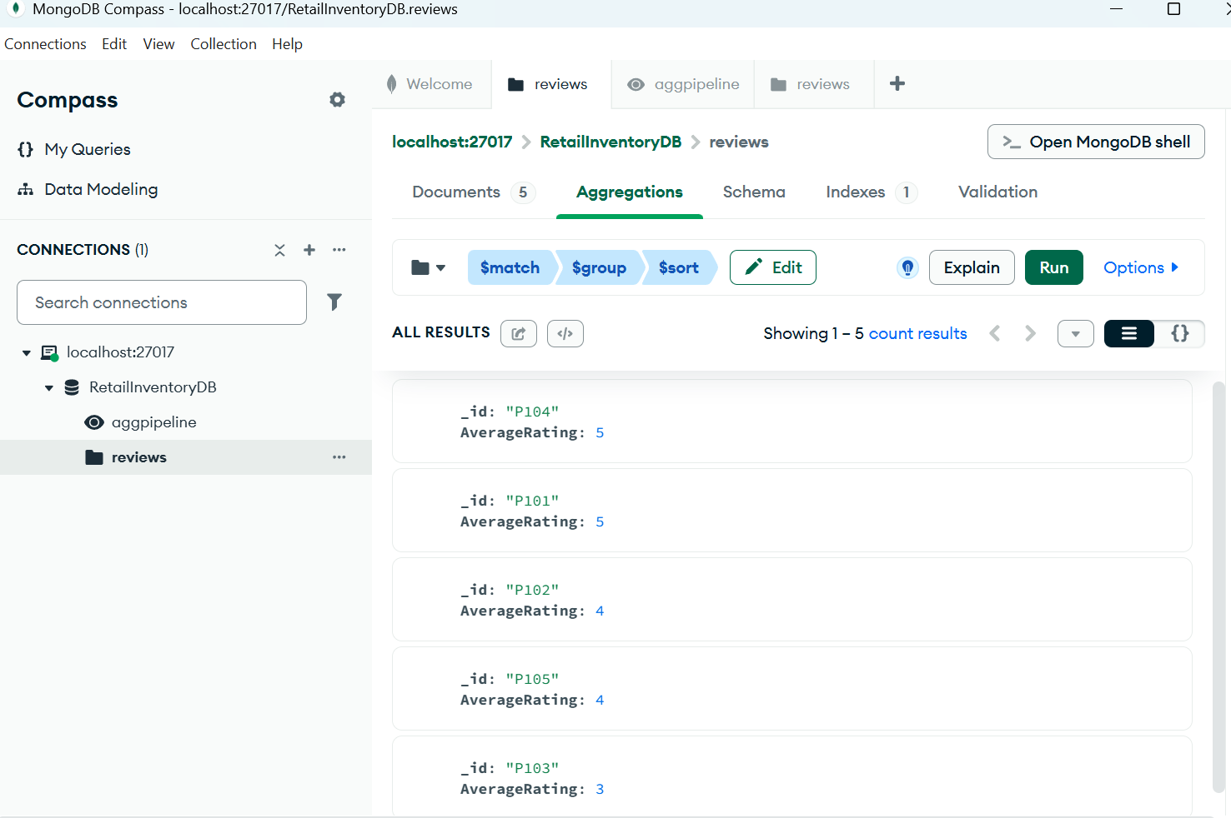
Pipeline 3 – Find Customers Who Gave 5-Star Reviews

[
{
"$match": {
"Rating": 5
}
},
{
"$group": {
"_id": "$CustomerName",
"TotalReviews": { "$sum": 1 }
}
},
{
"$sort": {
"TotalReviews": -1
}
}
]


