Day 4 – Doing Scrum – Sprint Simulation

Set 1 – Digital Wallet Application – Mid-Sprint Change

Task 1: Average velocity, sprint selection and Sprint Goal
Average velocity = (21 + 24 + 23) / 3 = 68 / 3 = 22.67, so I plan for about 23 points in this 10-day sprint with five developers.
Product backlog used for the exercise, in priority order:
ID | Story | Points | Selected for sprint
W1 | Register and verify a wallet account | 5 | Yes
W2 | Add money to wallet from bank using UPI | 5 | Yes
W3 | Send money to another wallet user | 8 | Yes
W5 | Set a transaction PIN | 3 | Yes
W6 | Low balance alert | 2 | Yes
W4 | View transaction history | 3 | No
W7 | Scan QR code to pay | 5 | No
W8 | Split a bill with friends | 8 | No
 | Total selected | 23

Sprint Goal: By the end of day 10, a new user can register, add money using UPI, set a PIN and send money to another wallet user, with all selected stories meeting the Definition of Done and no critical defects open in the staging environment.

Task 2: Tasks with hour estimates on the sprint board
I broke W3, W2 and W5 into tasks. All tasks start in the To Do column on day 1.
Story | Task | Owner | Hours | Board status
W3 | Build send-money screen | Arun | 6 | To Do
W3 | Build transfer API | Arun | 10 | To Do
W3 | Balance check and limit validation | Bala | 4 | To Do
W3 | Ledger entries in database | Chitra | 6 | To Do
W3 | Unit tests | Arun | 6 | To Do
W3 | Integration tests | Esha | 6 | To Do
W3 | Code review | Dinesh | 3 | To Do
W2 | UPI gateway integration | Bala | 8 | To Do
W2 | Add-money screen | Esha | 5 | To Do
W2 | Payment webhook handling | Bala | 6 | To Do
W2 | Tests | Esha | 6 | To Do
W2 | Code review | Dinesh | 3 | To Do
W5 | PIN setup screen | Dinesh | 4 | To Do
W5 | Encrypted PIN storage | Chitra | 5 | To Do
W5 | PIN verification API | Chitra | 4 | To Do
W5 | Tests | Dinesh | 4 | To Do
 | Total estimated hours |  | 86

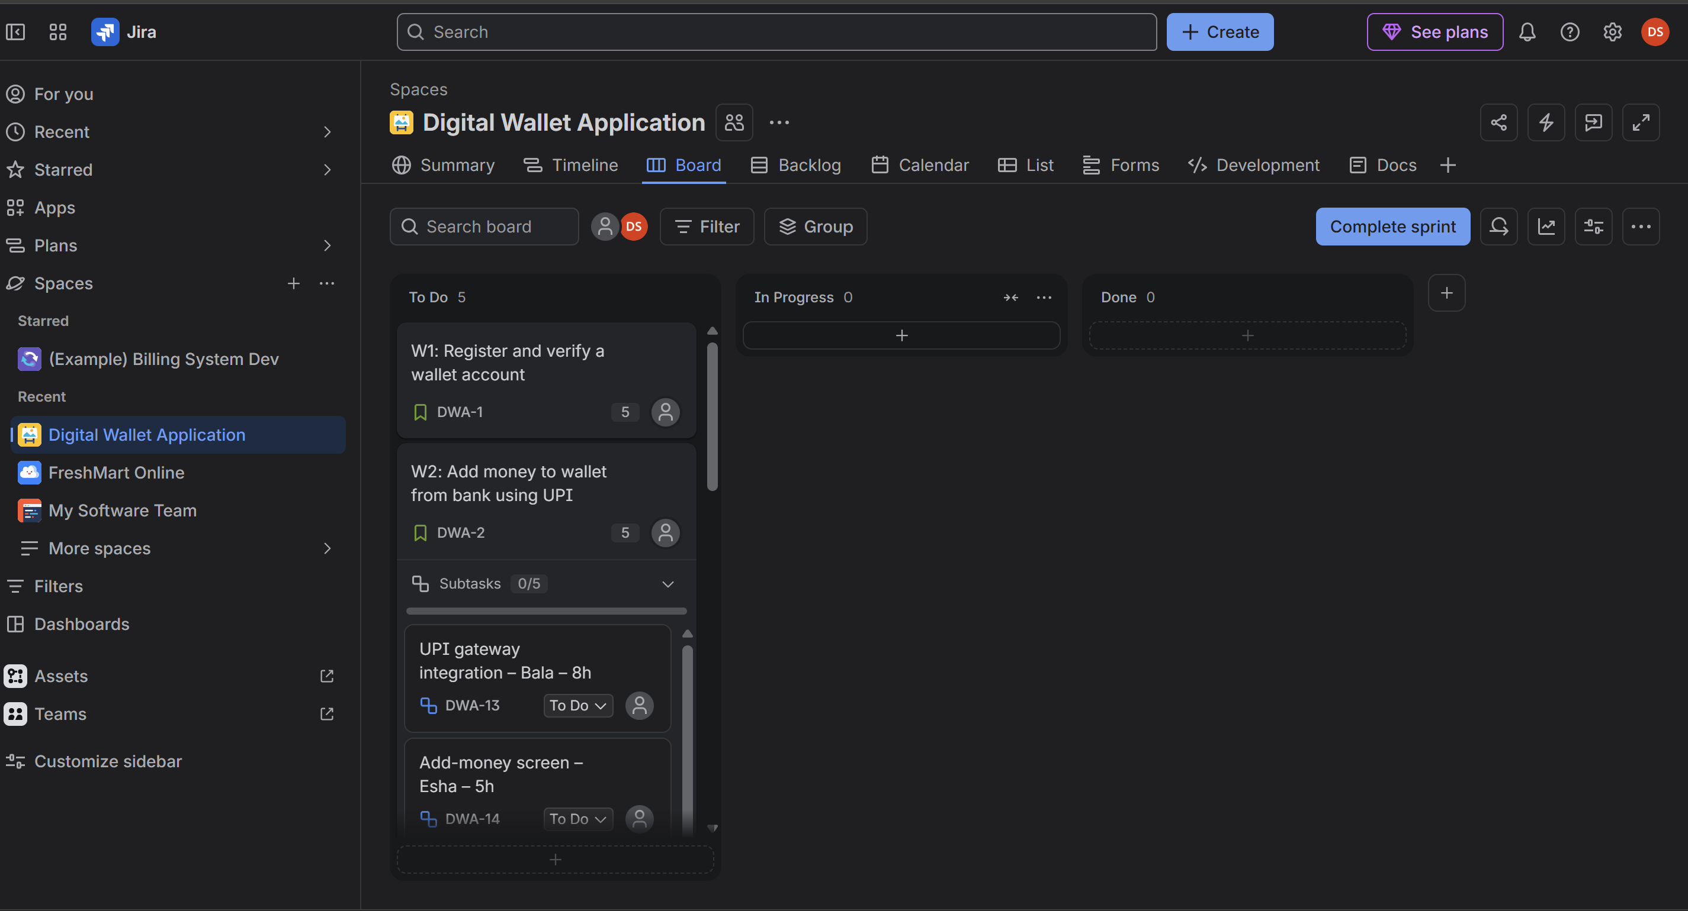
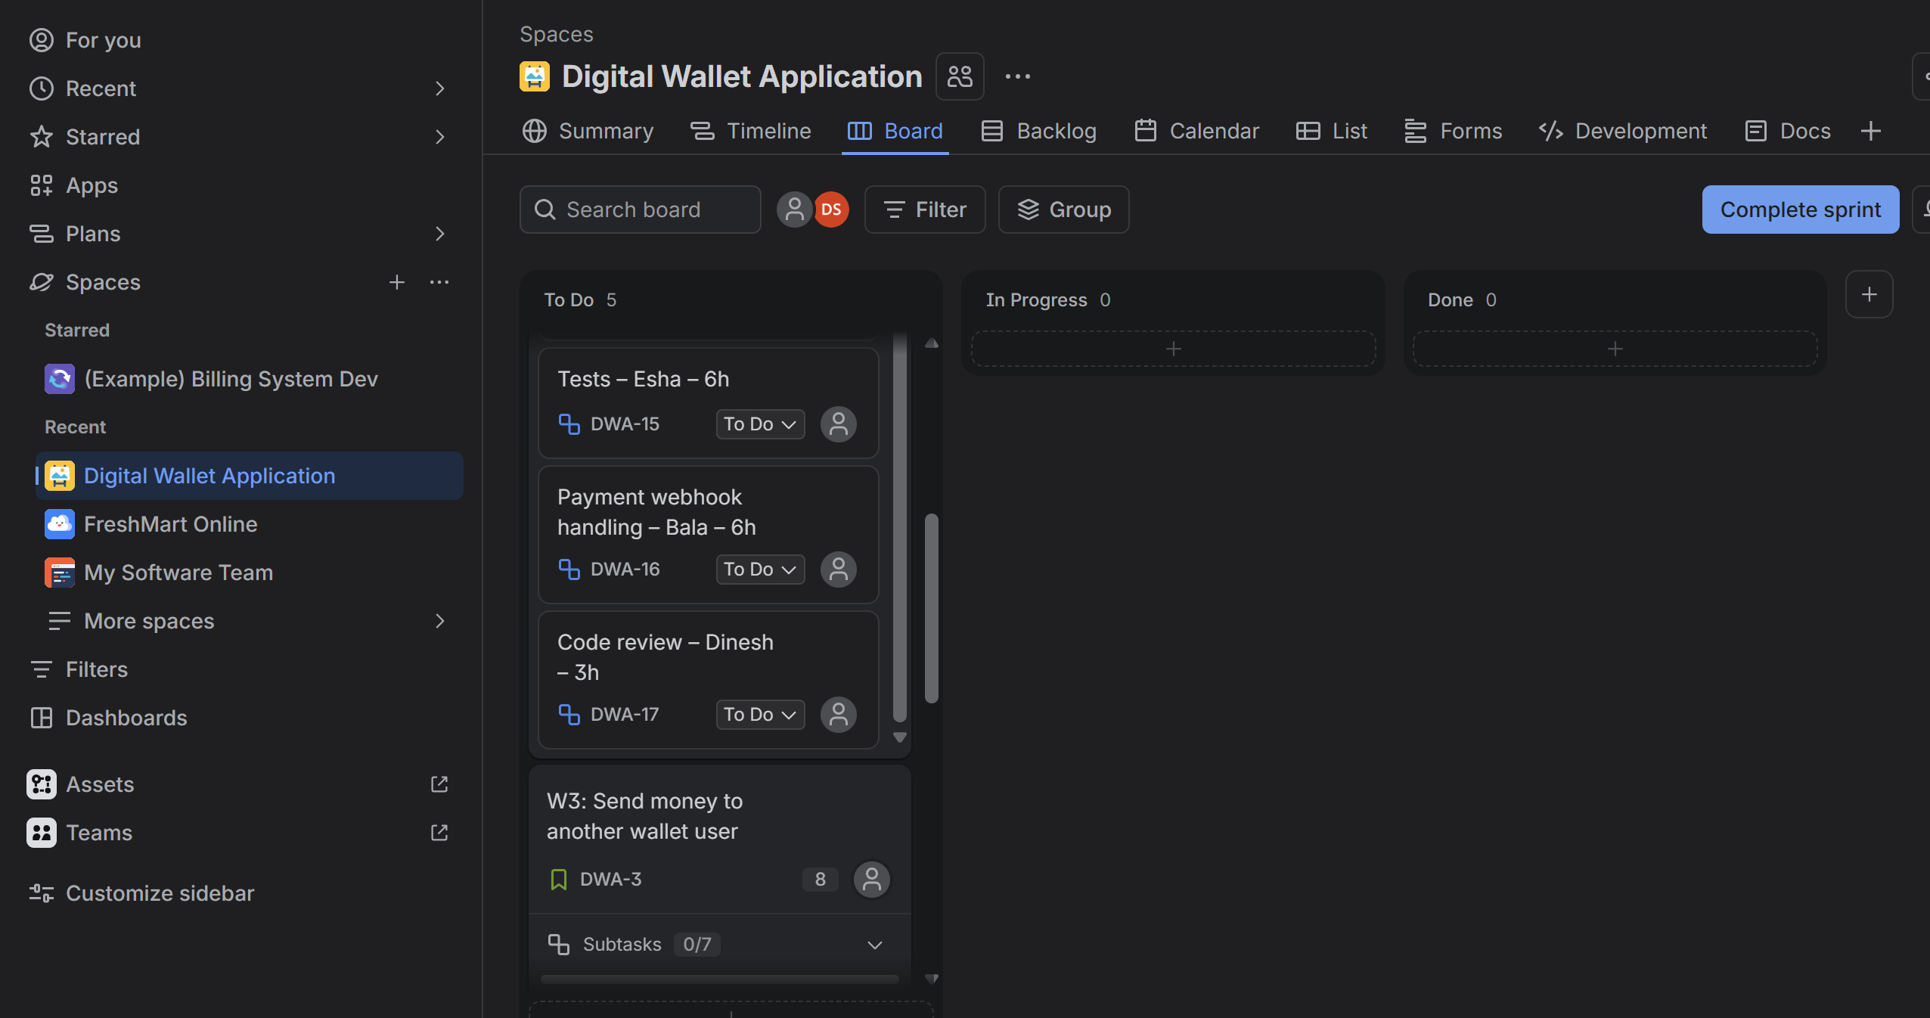
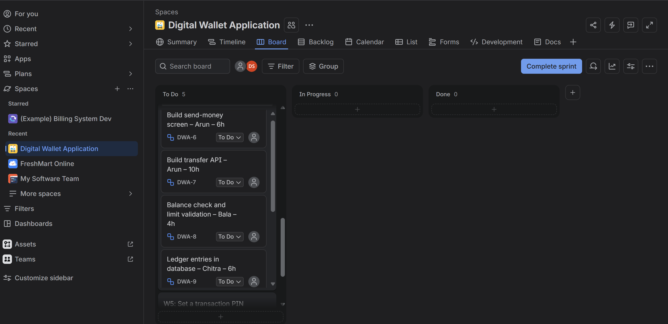
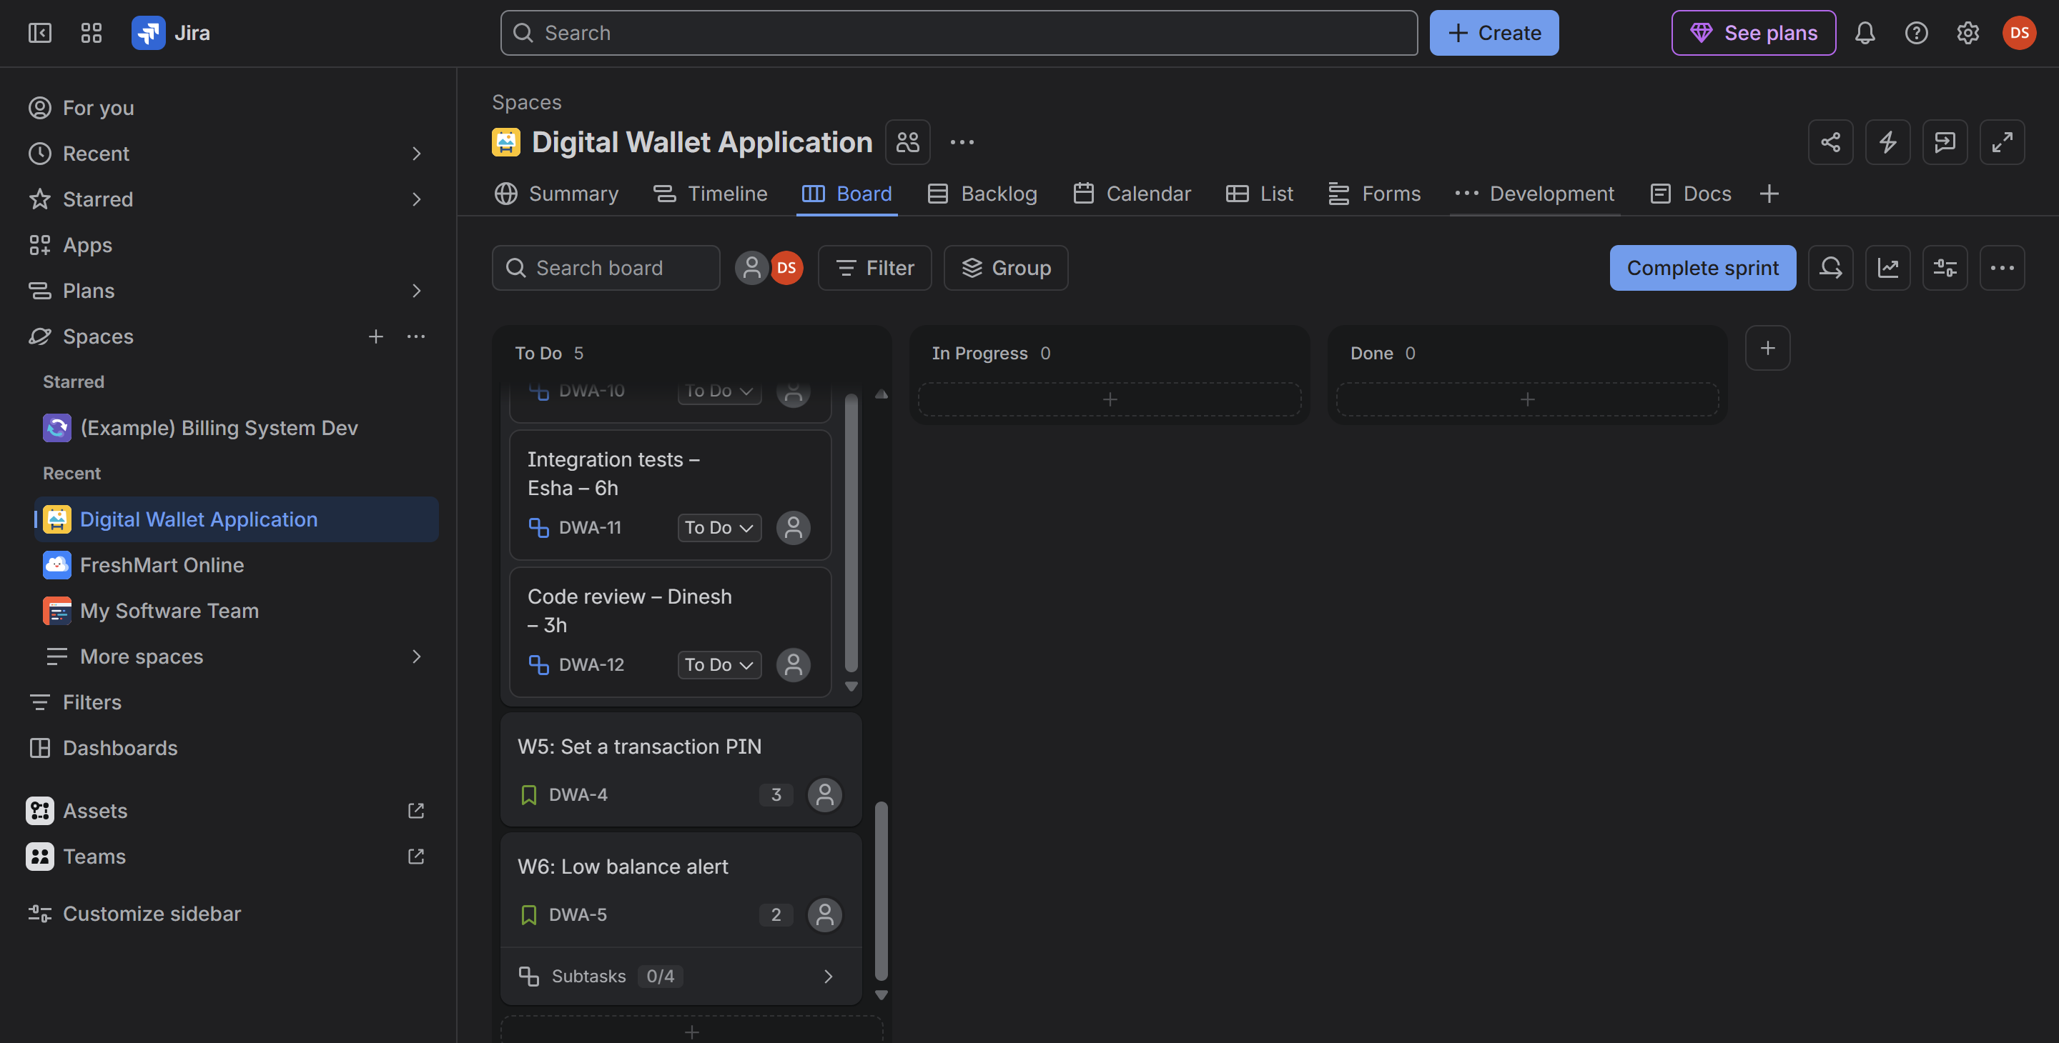

Task 3: Daily stand-up on day 3
Member | Yesterday | Today | Impediment
Arun | Finished the transfer API request and response format and the balance validation. | Start the ledger entries and write unit tests for the transfer API. | None.
Bala | Connected the UPI gateway in the test environment. | Work on the payment webhook handling. | UPI sandbox keys have expired. Waiting for the bank team to send new ones.
Chitra | Built the PIN setup screen with Dinesh and agreed on the data model. | Start the encrypted PIN storage. | The security team has not yet approved the hashing library, so I can't finish storage.

Impediment log
ID | Description | Raised by | Day | Owner | Status
IMP-1 | UPI sandbox keys expired, add-money cannot be tested. | Bala | 3 | Scrum Master | Open
IMP-2 | Hashing library for PIN storage awaiting security approval. | Chitra | 3 | Scrum Master | Open

Task 4: Re-prioritising after the refund-to-wallet request (day 4)
The full refund-to-wallet feature is about 8 points, which would not fit without breaking the Sprint Goal. The team and the Product Owner agreed to take a thin first slice, R1: automatically refund a failed transfer to the sender's wallet (2 points), and keep the rest in the backlog.
Change | Detail
Added | R1: Refund a failed transfer back to the sender's wallet (2 points).
Removed | W6: Low balance alert (2 points). It goes back to the top of the product backlog for the next sprint.
Left in backlog | The remaining refund work (refund to bank, partial refunds and refund history), about 6 points, placed high in the product backlog.
Net effect | The sprint commitment stays at 23 points and the Sprint Goal does not change.

Who decides: the Product Owner decides what goes in and what comes out, because they own the backlog and its order. The Developers decide whether the new slice fits and how big it is, since they own the sprint plan. The Scrum Master facilitates the talk and protects the team from adding work without removing something.

Task 5: Sprint burndown (10 days)
Completed-points table used (23 points committed, ideal burn of 2.3 points per day):
Day | Completed that day | Remaining points | Ideal remaining
1 | 0 | 23 | 20.7
2 | 0 | 23 | 18.4
3 | 0 | 23 | 16.1
4 | 0 | 23 | 13.8
5 | 3 (W5) | 20 | 11.5
6 | 0 | 20 | 9.2
7 | 5 (W2) | 15 | 6.9
8 | 2 (R1) | 13 | 4.6
9 | 5 (W1) | 8 | 2.3
10 | 8 (W3) | 0 | 0

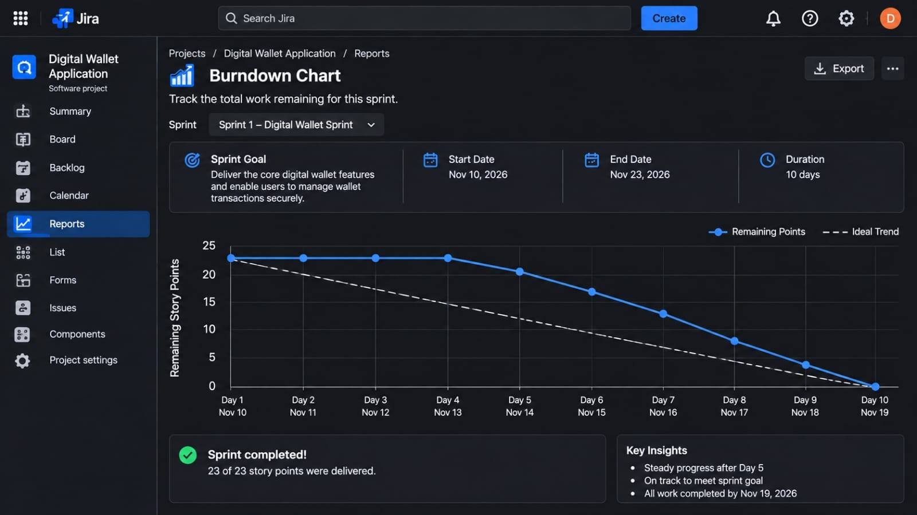
Interpretation: the line stayed flat for the first four days, so we were behind the ideal line for most of the sprint. The reasons were that work started on many stories at once, and the UPI and PIN impediments slowed things down. Most of the points were finished in the last three days, and the biggest story (W3, 8 points) closed only on day 10. We did meet the commitment, but with a lot of risk. To improve, we should work on fewer stories at the same time and finish stories one by one.

Task 6: Retrospective and Definition of Done to build pipeline
What went well | What to improve
The team swarmed on W3 in the last days and finished it on time. The Product Owner agreed quickly to the smaller refund slice. Stand-ups stayed short and surfaced the blockers early. | Stories were finished too late, so the burndown stayed flat until day 5. Too many stories were in progress at the same time. Sandbox keys and library approvals were not arranged before the sprint started.

No. | Action item | Owner | By when
1 | Limit work in progress to a maximum of three stories at any time and track it on the board. | Scrum Master | From day 1 of the next sprint
2 | Check test keys, access and approvals for every selected story before sprint planning ends. | Dinesh | Before the next sprint planning

Definition of Done mapped to the build pipeline:
Stage | What happens | DoD items covered
Build | Code is compiled and packaged automatically on every push, and a linter checks the style. | Code builds without errors and passes lint checks.
Test | Unit and integration tests run automatically on the build. | Unit tests pass and acceptance criteria are tested.
Review | A pull request needs at least one developer's approval, and the test results are checked. | Peer code review is done and no critical defects are open.
Merge | The change is merged into the main branch and deployed to staging. | Feature is in staging and ready for the Product Owner to accept.

Set 2 – Airline Web Check-in – Blocked Dependency

Task 1: Team capacity and sprint commitment
Team capacity = 6 members x 8 working days = 48 person-days.
With a 70 percent focus factor: 48 x 0.70 = 33.6 effective person-days.
I assume that for this team one story point is roughly one effective person-day. That gives a capacity of about 33 points. Because the payment sandbox problem adds risk, I commit to 31 points and keep a small buffer.

Task 2: Sprint Goal, selected stories and Definition of Ready check
Sprint Goal: By the end of the sprint, passengers can complete web check-in with their booking reference, enter travel documents, choose a seat, upgrade it with payment and download their boarding pass.
ID | Selected story | Points | Ready?
A1 | Check in online using the booking reference | 5 | Yes
A7 | Enter passport and travel document details | 5 | Yes
A2 | Select a seat from the seat map | 8 | Yes
A4 | Download the digital boarding pass | 5 | Yes
A3 | Upgrade seat with payment | 8 | Yes, at risk
 | Total committed | 31

Definition of Ready check:
ID | Clear acceptance criteria | Estimated | Dependencies known | Design ready | Testable | Ready
A1 | Yes | Yes | Yes | Yes | Yes | Yes
A7 | Yes | Yes | Yes | Yes | Yes | Yes
A2 | Yes | Yes | Yes | Yes | Yes | Yes
A4 | Yes | Yes | Yes | Yes | Yes | Yes
A3 | Yes | Yes | Payment sandbox | Yes | Needs sandbox | At risk

Task 3: Impediment log and how the Scrum Master removes it
Field | Entry
ID | IMP-01
Description | The payment-gateway sandbox needed for the seat-upgrade story (A3) has become unavailable.
Impact | A3 (8 points) cannot be tested end to end, so the Sprint Goal is at risk. The other stories are not affected.
Owner | Scrum Master (raised by the developer working on A3).
Escalation path | Developer, then Scrum Master, then gateway vendor support, then the vendor account manager and the IT or engineering manager, and finally the Product Owner for a scope decision.
Expected resolution | Within 2 working days.
Status | Open

How the Scrum Master would remove it:
- Raise a priority ticket with the gateway vendor the same day and ask for an estimated time to restore.
- If there is no reply within four hours, escalate to the vendor's account manager and to our IT manager.
- Meanwhile, ask the developer to build against a mock of the gateway API, so the work keeps moving and only the final check needs the real sandbox.
- Tell the Product Owner about the risk now. If the sandbox is not back by day 6, the option is to demo A3 with the mock and move the real payment test to the next sprint.
- Keep the impediment visible on the board and give an update at every stand-up until it is closed.

Task 4: Refinement of next sprint's top five stories
ID | Story | Before | After
B1 | Choose a meal preference | 3 | 3
B2 | Change seat after check-in | 5 | 5
B3 | Check in my whole group on one booking | 13 | Split into B3a, B3b, B3c
B4 | Add boarding pass to a mobile wallet | 8 | 8
B5 | Buy extra baggage during check-in | 5 | 5 (also needs the payment sandbox)

B3 was too big for one sprint, so I split it into slices that each work end to end:
ID | Slice | Estimate | Notes
B3a | Check in two adults on the same booking | 5 | First slice
B3b | Add children and infants to the group check-in | 3
B3c | Seat the group together | 3

The original 13 points becomes 11 after re-estimating, because the unknowns became clearer once the story was cut into smaller pieces.

Task 5: Sprint Review agenda and demonstration script
No. | Agenda item | Led by | Time
1 | Welcome and Sprint Goal | Product Owner | 5 min
2 | Demo: A1 check-in with booking reference | Developer | 8 min
3 | Demo: A7 travel document details | Developer | 5 min
4 | Demo: A2 seat selection | Developer | 10 min
5 | Demo: A4 boarding pass download | Developer | 7 min
6 | Status of A3 seat upgrade and the sandbox impediment | Scrum Master | 8 min
7 | Stakeholder feedback | Everyone | 10 min
8 | Backlog update and next sprint preview | Product Owner | 7 min
 | Total |  | 60 min

Story | Demo script | Acceptance criteria shown
A1 | Open web check-in, enter a valid booking reference and last name, then press Continue. | Given a valid booking, when the passenger enters it, then the passenger details page opens. An invalid reference shows an error.
A7 | Enter passport number and expiry date, then save. | Given a passenger on the details page, when valid documents are saved, then the page moves to seat selection.
A2 | Open the seat map, choose seat 14C and confirm. | Given available seats, when a seat is chosen, then it is held for the passenger and shown as taken to others.
A4 | Complete check-in and download the boarding pass. | Given check-in is complete, when the passenger taps Download, then a PDF with name, flight, seat and barcode is saved.
A3 | Show the upgrade flow and the payment step. If the sandbox is back, pay live. If not, show the mock and state clearly that the real payment test is not done. | Given a paid upgrade, when payment succeeds, then the new seat is confirmed. The story is counted as Done only if this is tested with the real gateway.

Task 6: Written asynchronous stand-up (two time zones)
Setup: three team members are in Chennai (IST) and three in London (GMT), so the live overlap is only about three hours. Everyone posts in the team channel thread before 10:00 their local time, using this format: Yesterday, Today, Blocked, Need help from.
Member | Yesterday | Today | Blocked / Need help
Meena (Chennai) | Finished the seat map UI for A2. | Connect seat selection to the seat-hold API. | None.
Karthik (Chennai) | Started the boarding pass PDF for A4. | Add the barcode to the PDF. | Need the barcode format from the airline systems team.
Oliver (London) | Built the A3 payment screen against the mock gateway. | Write tests for the payment error cases. | Blocked: gateway sandbox is still down (IMP-01). Need help from the Scrum Master.

Aspect | Live stand-up | Written async stand-up
Timing | Everyone must be present at the same time, which is hard across two time zones. | Each person posts at a convenient time, so no one joins late at night.
Speed of answers | Questions are answered on the spot. | Replies can take hours, so a blocker can wait until the other zone wakes up.
Depth of discussion | Easy to discuss and decide quickly. | Harder to discuss. Long talks move to a short follow-up call.
Record | Nothing is written unless someone takes notes. | Everything stays in writing and can be searched later.
Team feel | Better for connection and trust. | Can feel distant, so some live time is still useful once a week.

Set 3 – E-Learning Platform – Scope Change Handling

Task 1: Sprint planning and Sprint Goal
Velocity is 30 points, so I commit to 29 points and keep a one-point buffer.
Product backlog used for the exercise, in priority order:
ID | Story | Points | Selected for sprint
E1 | Course catalogue and search | 5 | Yes
E2 | Enrol in a course | 5 | Yes
E3 | Video lesson player with saved progress | 8 | Yes
E4 | Quiz with automatic grading | 8 | Yes
E7 | Course ratings and reviews | 3 | Yes
E5 | Learner dashboard | 5 | No
E6 | Discussion forum | 8 | No
 | Total selected | 29

Sprint Goal: By the end of day 10, a learner can find a course, enrol, watch lessons with saved progress and take an auto-graded quiz, with all four core stories (E1 to E4) Done and no critical defects, so the platform is ready for the launch.

Task 2: Impact of the certificate download request (day 6)
By day 6, 60 percent of the sprint time is gone, and E1 and E2 are done. E3 is in progress and E4 has started. A full certificate feature is about 5 points. It also depends on the quiz (E4), because a certificate is only issued after a learner passes.
Question | Decision
What can be swapped out | E7 Course ratings and reviews (3 points). It is the lowest-value story and is not part of the Sprint Goal.
What is added | C1: Download a PDF certificate with the learner's name and course title, for learners who passed the quiz (3 points). This is a thin slice of the full request.
What must wait | Custom certificate designs, a verification QR code and sharing to social media (about 2 points). These go to the top of the product backlog for the next sprint. E5 and E6 are unchanged.
Net effect | 3 points removed (E7) and 3 points added (C1), so the commitment stays at 29.

How the Sprint Goal is protected: the goal stays the same. C1 is placed last in the sprint because it needs E4 to be finished first. If E4 slips, C1 is dropped first, and E4 is never sacrificed for it. The Product Owner approves the swap, the Developers confirm they can take it, and the Scrum Master makes sure nothing else is added without removing something of equal size. The change is made visible on the board.

Task 3: Stand-up statements for a blocked developer
Developer (working on E3, the lesson player):
Yesterday: I finished the video player screen and connected it to mock data.
Today: I will test playback on different browsers and fix any layout problems.
Impediment: I can't save lesson progress because the API contract for the progress endpoint is missing. I don't have the request and response format from the backend team, so I can't finish that part of E3.
Scrum Master's follow-up action:
- Speak to the backend lead right after the stand-up and ask for a draft of the API contract today.
- Set up a 30-minute call between the frontend developer and the backend lead this afternoon to agree the request and response format.
- Ask the developer to keep working against the agreed draft on mock data, so no time is lost.
- Add it to the impediment log and check back at the end of the day.
- If the contract is still missing at tomorrow's stand-up, escalate to the engineering manager and inform the Product Owner about the risk to E3.

Task 4: Velocity calculation
ID | Story | Points | Status | Counted
E1 | Course catalogue and search | 5 | Done | 5
E2 | Enrol in a course | 5 | Done | 5
E3 | Video lesson player | 8 | Done | 8
E4 | Quiz with auto grading | 8 | 80 percent done | 0
C1 | Certificate download (slice) | 3 | Done | 3
 | Sprint velocity | 29 committed |  | 21

Velocity for this sprint is 21 points. E4 is 80 percent done, but it is not counted. Velocity only counts stories that meet the Definition of Done, because a story that is almost finished gives the customer nothing usable, and counting it would make the team look faster than it really is (it would show 27.4 instead of 21). The remaining 20 percent of E4 is re-estimated, about 2 points, and carried over to the next sprint. It is counted there once it is Done.

Task 5: Retrospective (Start, Stop, Continue)
Category | Our points
Start | Agreeing API contracts before the sprint begins. Checking the impact of every mid-sprint request in writing.
Stop | Taking in mid-sprint requests without removing something of the same size. Starting several big stories at the same time.
Continue | Short daily stand-ups that bring out blockers. The Product Owner and team negotiating scope openly. Swarming on the quiz story.

Three SMART action items:
No. | Action (specific and measurable) | Owner | Due | Measure
1 | Add "API contract agreed" to the Definition of Ready. | Scrum Master | Next refinement session | 100% of selected stories have a contract linked
2 | Follow a swap rule: any mid-sprint request must replace work of equal points and be approved by the Product Owner the same day. | Product Owner | From next sprint | 0 additions without a swap
3 | Limit work in progress to two stories at once and finish any story above 5 points by day 7. | Tech lead | Review at next retro | No story above 5 points still open after day 8

Task 6: How automation supports the Definition of Done
The Definition of Done is only useful if it is checked the same way every time, and automation does that without depending on anyone's memory. Unit tests run on every push and prove that new code works and old code is not broken. A linter catches style problems and common mistakes before a reviewer has to spend time on them. The pipeline joins these steps: it builds the code, runs the tests and linting, and blocks the merge if anything fails. That means a story can only be called Done when the checks have passed, not when someone feels it is finished. It also gives quick feedback, so defects are found within minutes instead of at the end of the sprint, and the team can show the Product Owner a working, tested increment at each review.

