Day 3 – Agile and Scrum – Foundations and Backlog Workshop

Set 1 – Online Grocery Delivery Application

Task 1: Product vision and Scrum roles
Product vision: For busy families and working people who don't have time for weekly store trips, FreshMart Online is a grocery ordering and home-delivery app that lets them browse the full supermarket range, pick a delivery slot and get fresh groceries at their door. Unlike phoning in an order or walking into the store, our app shows live stock, clear prices and the order status from checkout till delivery.
Scrum role | What they do in this project | Anti-pattern
Product Owner | Owns the backlog and decides priority. Here it would be someone from the supermarket's category or e-commerce team. | The Product Owner is a committee, or is rarely available, so developers wait days for answers or end up guessing requirements.
Scrum Master | Coaches the team on Scrum, runs the events smoothly and removes blockers. | Acting like a project manager: assigning tasks to people and chasing daily status instead of letting the team self-organise.
Developers | Design, build and test a working increment every sprint. | Working in silos (front-end, back-end and testing as separate hand-offs), so nobody owns the sprint goal together.

Task 2: Epics and user stories
I picked three epics: E1 Browse and Search, E2 Cart and Checkout, and E3 Delivery Tracking, with four stories under each (12 in total).
ID | Epic | User story
US1 | E1 | As a shopper, I want to browse products by category (fruits, dairy, snacks) so that I can find what I need without typing.
US2 | E1 | As a shopper, I want to search for a product by name so that I can find it quickly.
US3 | E1 | As a shopper, I want to filter results by price and brand so that I can pick what suits my budget.
US4 | E1 | As a shopper, I want to see a product's price, weight and stock status so that I know exactly what I am buying.
US5 | E2 | As a shopper, I want to add a product to my cart so that I can buy several items in one order.
US6 | E2 | As a shopper, I want to change the quantity or remove an item in my cart so that I only pay for what I need.
US7 | E2 | As a shopper, I want to choose a delivery slot at checkout so that the groceries arrive when I am at home.
US8 | E2 | As a shopper, I want to pay online so that I don't have to carry cash.
US9 | E3 | As a shopper, I want an order confirmation message after checkout so that I know my order is placed.
US10 | E3 | As a shopper, I want to track my delivery partner live on a map so that I know exactly when my order will arrive.
US11 | E3 | As a shopper, I want to see my past orders so that I can reorder items easily.
US12 | E3 | As a shopper, I want to cancel my order before it is dispatched so that I'm not stuck with something I no longer need.

Task 3: INVEST check
ID | Result | Comment
US1, US2, US3, US4 | Pass | Independent, small, clear value and easy to test.
US5, US6, US7 | Pass | Each can be finished inside one sprint and checked with a simple demo.
US8 | Fails S and E | "Pay online" hides UPI, cards, wallets, failed payments and refunds. It is too big to estimate honestly.
US9 | Pass | Small and testable.
US10 | Fails I and S | Depends on a delivery partner app and a maps service that don't exist yet, and it is too large for one sprint.
US11, US12 | Pass | Small, valuable and testable.

Rewritten stories (the two that failed):
- US8a: As a shopper, I want to pay using UPI at checkout so that my payment is done in a few seconds.
- US8b: As a shopper, I want to pay using a debit or credit card so that I have another option if I don't use UPI.
- US10 (rewritten): As a shopper, I want to see my order status (Packed, Out for delivery, Delivered) so that I know roughly when to expect it. The live map view moves to a later release, once the delivery partner app is ready.

Task 4: Acceptance criteria (Given / When / Then)
US2 – Search products by name
Given I am on the home screen
When I type "milk" in the search bar
Then I see a list of milk products with price and stock status
US5 – Add a product to the cart
Given I am viewing a product that is in stock
When I tap "Add to cart"
Then the item appears in my cart with quantity 1
And the cart icon shows the updated item count
US7 – Choose a delivery slot
Given I have items in my cart and I am on the checkout page
When I select an available slot for tomorrow
Then the slot is shown in my order summary and reserved for me
US8a – Pay using UPI (success)
Given I am on the payment page with a valid cart
When I pay through my UPI app and the payment is approved
Then my order is placed and I see the confirmation screen
US8a – Pay using UPI (negative scenario: payment fails)
Given I am on the payment page
When my UPI payment fails or times out
Then no order is placed and I see a clear "Payment failed" message
And my cart is kept as it was so I can retry
US12 – Cancel an order
Given my order status is "Packed" and not yet dispatched
When I tap "Cancel order" and confirm
Then the order is cancelled and my refund is started

Task 5: MoSCoW, Fibonacci points and Planning Poker
Reference story: I chose US5 (Add to cart) as the reference and gave it 3 points. It is small and well understood, needs no outside integration, and everybody on the team could picture the work. Every other story was compared against it: smaller than US5 gets 1 or 2, similar gets 3, more work or more unknowns gets 5 or 8.
ID | Story | MoSCoW | Story points
US1 | Browse by category | Must have | 3
US2 | Search by name | Must have | 5
US3 | Filter by price and brand | Should have | 5
US4 | Product details and stock | Must have | 2
US5 | Add to cart (reference) | Must have | 3
US6 | Edit or remove cart items | Must have | 2
US7 | Choose delivery slot | Must have | 5
US8a | Pay using UPI | Must have | 5
US8b | Pay using card | Should have | 3
US9 | Order confirmation message | Should have | 2
US10 | Order status updates | Should have | 3
US11 | Past orders | Could have | 2
US12 | Cancel order | Should have | 3
 | Total |  | 43

Planning Poker round (US7): the first votes were 3, 5, 5 and 8. The developer who voted 3 thought it was just a dropdown. The one who voted 8 pointed out that slots need capacity limits so they don't get over-booked. After talking it through we all settled on 5. Live map tracking is in the Won't have list for this release.

Task 6: JIRA board, Definition of Ready and Definition of Done
Board setup: I created a Scrum project called FreshMart Online, added the three epics (Browse and Search, Cart and Checkout, Delivery Tracking), created all the stories under their epics with story points, and kept the board columns as To Do, In Progress and Done. The Definition of Ready and Definition of Done are recorded in the project description.
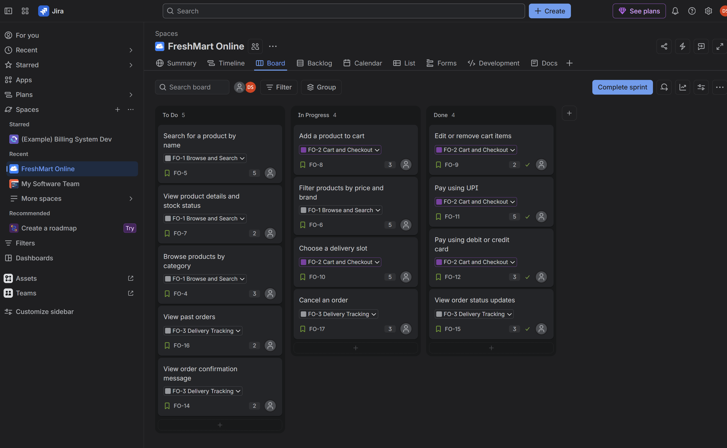

Definition of Ready
- The story is written in the As a / I want / so that format.
- Acceptance criteria are written and agreed with the Product Owner.
- The story passes the INVEST checklist.
- Dependencies are identified and not blocking.
- The team has estimated it in story points.
- Designs or wireframes are available where the screen is new.

Definition of Done
- Code is written and peer reviewed.
- Unit tests are written and passing.
- All acceptance criteria are tested and passed by QA.
- No open critical or high-priority bugs.
- Feature is deployed to the staging environment.
- Product Owner has accepted the story in the sprint review.

Set 2 – Insurance Claims Portal

Task 1: Product vision and Waterfall versus Agile
Product vision: For policyholders who find claim filing slow and paper-heavy, the Insurance Claims Portal is a self-service web portal where they can lodge a claim, upload their documents and track the settlement in one place. Unlike visiting a branch or chasing an agent on the phone, the portal gives a reference number, a clear status at every step and timely notifications until the money reaches the customer.
Aspect | Waterfall | Agile
Requirements | Fixed in the beginning | Refined every sprint
Delivery | One big release at the end | Working increments every 2 weeks
Customer feedback | Only after the build is over | At every sprint review
Handling change | Slow and expensive | Expected and welcomed
Risk | Problems show up late, during testing | Problems show up early, in small pieces

Why Agile suits this programme: claim rules, document needs and regulations change often in insurance, and customers want to see progress early. With Agile we can release claim registration first, get real feedback, and then add upload, tracking and notifications, instead of waiting a year to find out that something was misunderstood.

Task 2: Epics and user stories
Four epics: E1 Claim Registration, E2 Document Upload, E3 Claim Tracking and E4 Settlement Notifications, with 13 stories in total.
ID | Epic | User story
CR1 | E1 | As a policyholder, I want to register a claim online with all the required details so that I don't have to visit a branch.
CR2 | E1 | As a policyholder, I want to save my claim as a draft so that I can finish it later.
CR3 | E1 | As a policyholder, I want to review my details before final submission so that I can correct mistakes.
CR4 | E1 | As a policyholder, I want the portal to check that my policy is active when I start a claim so that I know early if I am eligible.
DU1 | E2 | As a policyholder, I want to upload photos and PDF documents to my claim so that the insurer can verify it.
DU2 | E2 | As a policyholder, I want to remove or replace an uploaded file so that I can fix a wrong upload.
DU3 | E2 | As a policyholder, I want to see a checklist of documents needed for my claim type so that I don't miss anything.
CT1 | E3 | As a policyholder, I want to see all my claims with their current status in one list so that I don't have to call the insurer.
CT2 | E3 | As a policyholder, I want to open a claim and see a timeline of what has happened so far so that I understand where it stands.
CT3 | E3 | As a policyholder, I want to see the name and contact of the officer handling my claim so that I know whom to ask.
SN1 | E4 | As a policyholder, I want to be notified by email and SMS every time my claim status changes so that I stay informed.
SN2 | E4 | As a policyholder, I want to be notified when the settlement amount is approved so that I know how much I will receive.
SN3 | E4 | As a policyholder, I want to be notified when the payment is credited so that I can confirm I received it.

Task 3: INVEST review and vertical splitting
Most stories passed. Two were too large (the S in INVEST), so I split them:
ID | Problem | Vertical split
CR1 | Registering a claim covers the form, validation, different claim types, saving and the reference number. Too big for one sprint. | CR1a: Register a claim with policy number, incident date and description, and get a reference number. CR1b: Add details specific to the claim type (motor or health).
SN1 | Email and SMS use two different providers and templates, so it is two pieces of work in one story. | SN1a: Notify by email on every status change. SN1b: Notify by SMS on every status change.

Why vertical and not by technical layer: a technical split would give us stories like "build the claim form screen", "build the claim API" and "create the claims table". None of those gives the customer anything usable on its own, and nothing can be demoed until all three are done. A vertical slice cuts through the screen, logic and database together, so CR1a is a real working feature at the end of the sprint. After splitting we have 15 stories.

Task 4: Acceptance criteria for Claim Registration
CR1a – Register a claim (success)
Given I am logged in and have an active policy
When I enter my policy number, incident date and description and submit
Then the claim is created
And I see a unique claim reference number on screen
CR1a – Mandatory field missing (validation failure)
Given I am on the claim registration form
When I submit without filling the incident date
Then the claim is not created
And I see an error next to the incident date saying it is required
CR2 – Save as draft
Given I have filled part of the claim form
When I click "Save as draft"
Then my details are saved and I can find the draft in my claims list to continue later
CR4 – Policy check (validation failure: expired policy)
Given my policy expired last month
When I start a new claim with that policy number
Then I am stopped from continuing
And I see a message saying the policy is not active, with a contact option
CR4 – Policy check (validation failure: wrong policy number)
Given I am on the claim form
When I enter a policy number that doesn't exist
Then I see "Policy number not found" and the form does not move to the next step

Task 5: Planning Poker estimates
Values used: 1, 2, 3, 5, 8, 13.
ID | Story | Story points
CR1a | Register claim with basic details | 5
CR1b | Claim-type specific details | 5
CR2 | Save as draft | 3
CR3 | Review before submission | 2
CR4 | Policy check | 3
DU1 | Upload photos and PDFs | 8
DU2 | Remove or replace file | 2
DU3 | Document checklist | 1
CT1 | Claims list with status | 3
CT2 | Claim timeline | 5
CT3 | Officer contact details | 1
SN1a | Email notification on status change | 3
SN1b | SMS notification on status change | 3
SN2 | Settlement approved notification | 2
SN3 | Payment credited notification | 3
 | Total backlog size | 49

Outlier discussion (DU1): the first round was 3, 5, 5 and 13. The developer who voted 3 assumed it was a basic file upload. The one who voted 13 raised file size limits, virus scanning and secure storage for sensitive documents. Once everyone had heard that, we revoted and agreed on 8.

Task 6: JIRA project
I created a JIRA Scrum project for the portal with the four epics and all 15 stories linked to them. The board uses these story states: To Do, In Progress, In Review and Done.
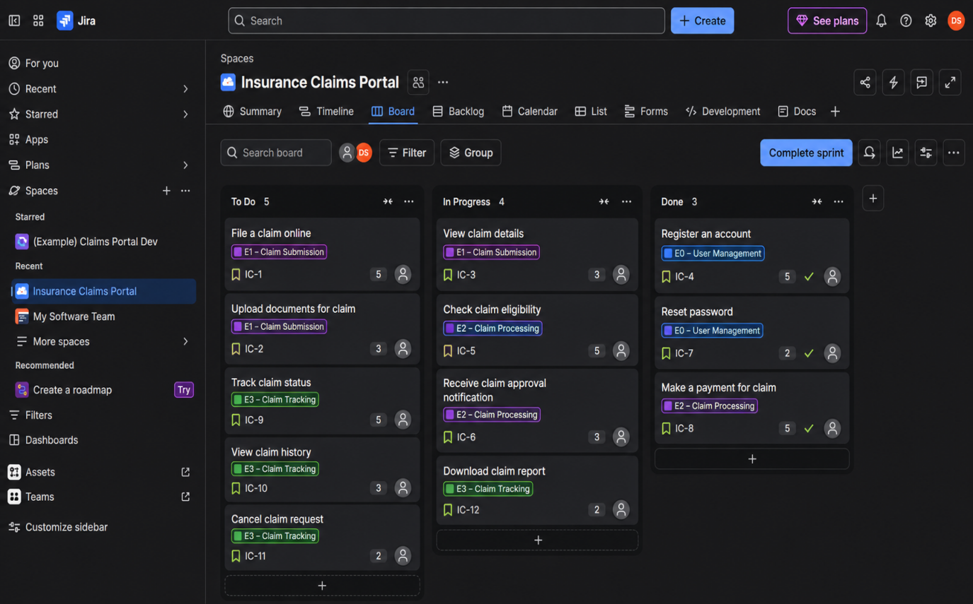

Definition of Done (attached to the project)
- Code is complete and has been peer reviewed.
- Unit and integration tests pass.
- Acceptance criteria are verified by QA.
- No open critical or high-priority defects.
- Sensitive data handling (uploads, policy details) is checked for security.
- Deployed to staging and accepted by the Product Owner.

Deliverable note: roles, events and artifacts used
Roles. The Product Owner (an insurance business lead) owns the backlog and decides priority. The Scrum Master coaches the team and removes blockers such as waiting on the payment gateway details. The Developers, including testers, build and test each increment.
Events. Sprint Planning to pick stories and set a sprint goal, a 15-minute Daily Scrum to sync and flag blockers, the Sprint Review to show working features such as claim registration to stakeholders, and the Sprint Retrospective to improve how we work.
Artifacts. The Product Backlog (all 15 stories ordered by priority) with the product goal, the Sprint Backlog (the stories picked for the sprint plus the plan to deliver them), and the Increment, which is the working, Done portal feature at the end of each sprint.

Set 3 – Hospital Appointment Booking Application

Task 1: Vision statement and stakeholders
Product vision: For patients who are tired of standing in queues or calling the front desk, our hospital app lets them book, reschedule and cancel doctor appointments from their phone and reminds them before the visit. Unlike the current phone-and-counter process, the app shows real doctor availability, so nobody waits for a slot that doesn't exist.
Stakeholder | Scrum mapping | Why
Hospital operations head | Product Owner | Decides what the app must do, orders the backlog and is accountable for its value.
Patients | Customer | Main users of the app and the source of most feedback.
Doctors | Customer | Use the app to manage their schedule and give feedback on it.
Reception staff | Customer | Deal with bookings every day and are affected by any change.
Delivery lead or agile coach | Scrum Master | Helps the team follow Scrum and clears obstacles.
Mobile and backend developers, QA, UI designer | Developers | Build, test and deliver the app increment.
Hospital IT team | Developers (supporting) | Help with integration to the existing hospital systems.

Task 2: Epics and user stories
Four epics: E1 Booking, E2 Rescheduling and Cancellation, E3 Reminders and E4 Doctor Schedule Management, with 13 stories.
ID | Epic | User story
B1 | E1 | As a patient, I want to search doctors by name or specialty so that I can find the right one.
B2 | E1 | As a patient, I want to see available slots quickly so that booking is easy.
B3 | E1 | As a patient, I want to book a slot with a doctor so that my visit is confirmed.
B4 | E1 | As a patient, I want a booking confirmation with the date, time and doctor so that I have proof of my appointment.
R1 | E2 | As a patient, I want to reschedule my appointment to another slot so that I can adjust when something clashes.
R2 | E2 | As a patient, I want to cancel my appointment so that I don't hold a slot I can't use.
R3 | E2 | As a patient, I want a cancelled slot to open up again for others so that doctor time isn't wasted.
N1 | E3 | As a patient, I want a reminder 24 hours before my appointment so that I don't forget.
N2 | E3 | As a patient, I want a reminder 1 hour before my appointment so that I reach on time.
N3 | E3 | As a patient, I want to be told when my doctor goes on leave so that I can rebook.
D1 | E4 | As a doctor, I want to set my weekly availability so that patients only see slots I can attend.
D2 | E4 | As a doctor, I want to block out my leave days so that no appointments are booked on them.
D3 | E4 | As a doctor, I want to see my day's appointment list so that I can prepare.

Task 3: INVEST review and rewrites
ID | INVEST result | Action
B1, B3, B4 | Pass | No change.
B2 | Fails T (Testable) | "Quickly" can't be measured. Rewritten below.
R1, R2 | Pass | No change.
R3 | Fails I (Independent) | It can't be built or tested without R2. Merged into R2 as an acceptance criterion and replaced by a new story.
N1, N2 | Pass | No change.
N3 | Fails I (Independent) | Depends on D2 (leave days) being built first. Rewritten below.
D1, D2, D3 | Pass | No change.

Rewritten stories:
- B2: As a patient, I want to see the open slots for my chosen doctor and date, loaded within 3 seconds, so that I can book without waiting.
- R3 (new): As a patient, I want to view my upcoming and past appointments in one list so that I can choose which one to change.
- N3: As a patient, I want to be notified when the hospital cancels my appointment so that I can book a new one.

Task 4: Acceptance criteria for booking and cancellation
B3 – Book a slot (success)
Given I have chosen a doctor and an open slot
When I tap "Confirm booking"
Then the appointment is saved against my account
And the slot is marked as taken for other patients
B3 – Slot already taken
Given another patient booked the same slot a moment before me
When I tap "Confirm booking"
Then I see a message that the slot is no longer available
And I am shown the next open slots for the same doctor
R2 – Cancel an appointment (success)
Given I have an upcoming appointment
When I tap "Cancel" and confirm
Then the appointment status changes to Cancelled
And the slot becomes available again for other patients
R2 – Cancel after the appointment time (negative)
Given my appointment time has already passed
When I try to cancel it
Then I see a message that past appointments cannot be cancelled and the status stays the same

Task 5: Prioritisation, Planning Poker and story points
I ranked stories by business value against effort, so high value and low effort comes first.
ID | Story | Value | Points | Priority
B3 | Book a slot | High | 5 | 1
B2 | See open slots | High | 3 | 2
B1 | Search doctors | High | 3 | 3
D1 | Doctor weekly availability | High | 5 | 4
R2 | Cancel appointment | High | 3 | 5
N1 | 24-hour reminder | High | 3 | 6
B4 | Booking confirmation | Medium | 2 | 7
R1 | Reschedule appointment | Medium | 5 | 8
D2 | Doctor leave days | Medium | 3 | 9
N3 | Hospital cancellation notice | Medium | 3 | 10
R3 | My appointments list | Low | 2 | 11
N2 | 1-hour reminder | Low | 2 | 12
D3 | Doctor daily list | Low | 2 | 13
 | Total |  | 41

Planning Poker round (B3): the votes were 3, 5, 5 and 8. The person who voted 8 was worried about two people booking the same slot at the same time. The person who voted 3 hadn't thought about that. After discussing it we agreed on 5.
Story point versus hour: an hour is a fixed amount of time and changes from person to person, since a senior developer and a fresher will take different hours for the same task. A story point measures the relative size of a story, covering effort, complexity and uncertainty together, compared to other stories. The team's speed in points per sprint (velocity) then tells us how much we can plan, without arguing about hours.

Task 6: JIRA backlog, DoR and DoD
I published the backlog in JIRA with the four epics and all 13 stories, each with its story points and priority order, and recorded the DoR and DoD in the project.
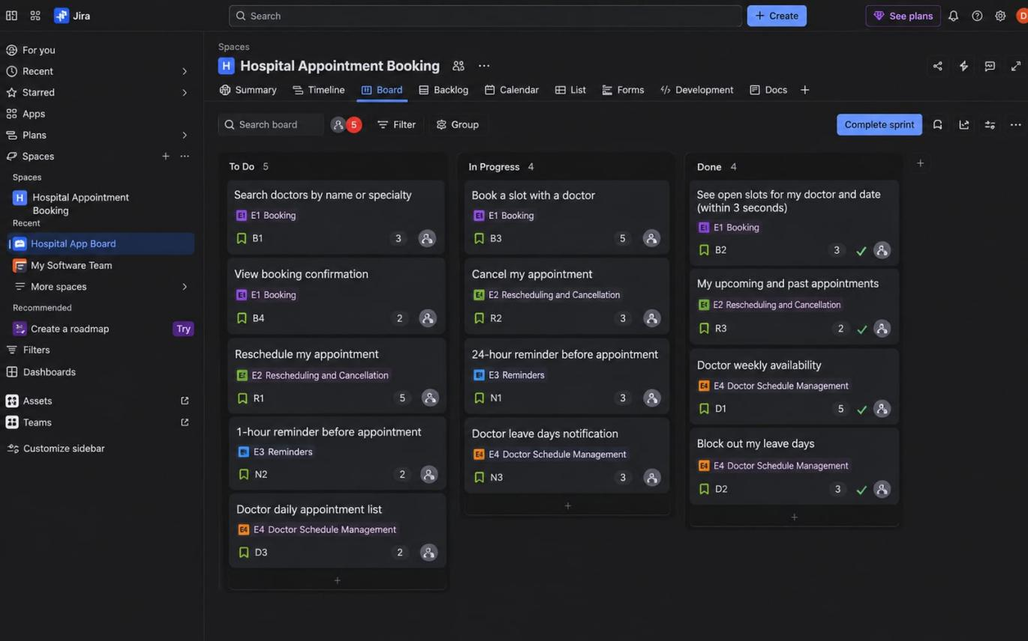

Definition of Ready
- Story is written in the As a / I want / so that format.
- Acceptance criteria are written and clear.
- Story has passed the INVEST check.
- Team has estimated the story in points.
- Dependencies on other stories or hospital systems are identified.
- UI wireframe for the screen is available.
- Product Owner is available to answer questions.

Definition of Done
- Code is complete and peer reviewed.
- Unit tests are written and passing.
- Acceptance criteria are tested and passed by QA.
- Works on both Android and iOS.
- No open critical or high-priority bugs.
- Patient data handling is checked for privacy and security.
- Deployed to staging and accepted by the Product Owner.

