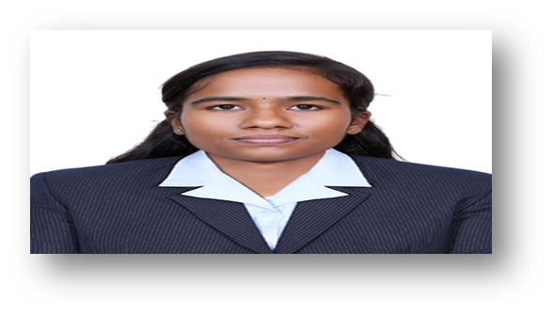 RESUME

**M.DHIVYABHARATHI,**

**Electronics and communication engineer.**

**17-1/53,Anna nagar,Singampunari*,***

**Contact No:9361505186,**

Email-[**dhivyabharathi0905@gmail.com**](mailto:dhivyabharathi0905@gmail.com)**.**

**LinkedIn:https://www.linkedin.com/in/dhivyabharathi-m-119929293**

**Educational qualification:**

* **I am pursuing BE,Electronics and Communication Engineering in Sri Krishna college of technology,Coimbatore.**
* **I completed my HSC in Pari vallal matriculation higher secondary school,Singampunari with 90%.**
* **I completed my SSLC in Pari vallal matriculation higher secondary school,Singampunari with 100%.**

**Programming skills:**

* **Java.**
* **HTML**
* **C++**

**Additional courses:**

* **Coursera-Energy and Environment.**
* **Coursera-Simple linear regression for the absolute beginner.**
* **Infosys springboard-Java for Beginners.**

**Area of Interest:**

* **Signals and systems.**
* **Digital system design.**

**Project experience:**

* **Participated in Smart India Hackathon(SIH) and explained our project A Smart AI based traffic light system .**

**Strength:**

* **Leadership quality.**
* **Communication skills.**
* **Team work.**
* **Time management.**

**Languages known:**

* **Tamil.**
* **English.**

**Hobbies:**

* **Video editing.**
* **Poster making.**
* **Drwaing.**