# **PHASE 5 - PROJECT DOCUMENT**

|  |  |
| --- | --- |
| **PROJECT TITLE** | **FAKE NEWS DETECTION USING NLP** |
| **NAME** | **DHIVYADHARSHINI A** |
| **TEAM ID** | **5275** |
| **TEAM NAME** | **Proj_204221_Team_2** |
| **COLLEGE CODE-NAME** | **9238 – MANGAYARKARASI COLLEGE OF ENGINEERING PARAVAI, MADURAI.** |
| **GROUP** | 5 |
| **GITHUB REPOSITORY LINK** | **https://github.com/dhivyadhar/IBM_AI.git** |

# 

# **FAKE NEWS DETECTION**

# **USING**

# **NATURAL LANGUAGE PROCESSING**

**INTRODUCTION:**

In an age of information overload, the distinction between real and fake news is paramount. Our 'Fake News Detection using NLP' project harnesses Natural Language Processing to combat misinformation. Through advanced NLP techniques, we're developing a user-friendly web app that empowers individuals to verify news authenticity, promoting a more informed society. We are dedicated to accuracy, ethics, and trustworthy information preservation in our digital world. Join us in creating a more credible information landscape.

**PROBLEM STATEMENT:**

**The challenge is to develop a natural language processing (NLP) model for fake news detection to accurately classify news articles as either fake or real, with the aim of improving information credibility and combating the spread of misinformation in online media.**

**ABSTRACT:**

In the digital age, the ability to discern genuine news from fabricated content is of paramount importance. Our project, "Fake News Detection using NLP," harnesses Natural Language Processing (NLP) to combat misinformation. Through innovative NLP techniques, we are developing a user-friendly web application empowering individuals to verify the authenticity of news articles, thereby fostering a more informed and vigilant society.

This project goes beyond technological advancement; it represents our dedication to safeguarding information integrity and cultivating a healthier media ecosystem. The ramifications of fake news are vast, affecting elections and eroding trust in media and institutions. By employing advanced technology, our project aims to equip individuals with the means to make informed decisions, thereby mitigating the impact of false narratives and contributing to a more credible information landscape.

**DESIGN THINKING PROCESS:**

Adopting design thinking, our project, 'Fake News Detection using NLP,' begins with empathizing with users to understand the challenges of identifying fake news. We define a clear problem statement based on these insights, focusing on user needs and desired outcomes. Ideation follows, encouraging creative solutions such as user-friendly interfaces and real-time analysis. Prototypes are created and tested, incorporating feedback to refine designs. The project transitions to the build phase, developing the final web application and implementing a robust NLP model for fake news detection. A controlled launch is followed by monitoring and iterative improvements based on user feedback and evolving NLP technologies, ensuring a user-centric and continuously enhanced solution.

**PHASES OF DEVELOPMENT:**

The phases of development for a fake news detection system using NLP include data collection and preprocessing, feature engineering, model selection and training, evaluation, web application development and integration, testing and quality assurance, deployment and hosting, user training and documentation, ongoing monitoring and updates, and addressing ethical considerations. These phases encompass data preparation, model building, user interface design, application deployment, and ongoing refinement to create a robust, user-friendly, and ethically sound solution for identifying fake news in the digital information landscape.

1. Data Collection. 4. Model Selection.
2. Data Preprocessing. 5. Model Training.
3. Feature Engineering. 6. Evaluation.

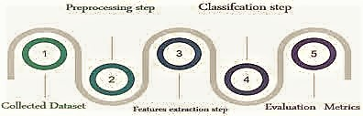

**DATA COLLECTION:**

The data collection process for fake news detection using NLP with a Kaggle dataset involves selecting a relevant dataset from Kaggle, downloading it, and conducting initial data exploration to understand its structure.

The data collection process is crucial for building an effective fake news detection model. It sets the foundation for data preprocessing, model training, and ultimately, the success of your project. Additionally, be sure to adhere to ethical considerations and data usage rights when working with any dataset, including those obtained from platforms like Kaggle.

**https://www.kaggle.com/datasets/clmentbisaillon/fake-and-real-news-datasetv**

After collecting the relevant dataset,then load them for further phases of development.

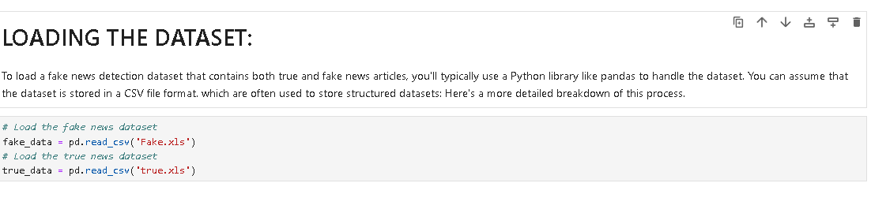

**DATA PREPROCESSING:**

Data preprocessing for fake news detection using NLP is the initial step of preparing raw textual data to make it suitable for analysis and model training. This process includes cleaning the data by removing irrelevant information, handling missing values, and eliminating duplicate**s.**

Data preprocessing ensures that the dataset is consistent, structured, and ready for further feature engineering and model development, ultimately enhancing the accuracy and efficiency of fake news detection algorithms.

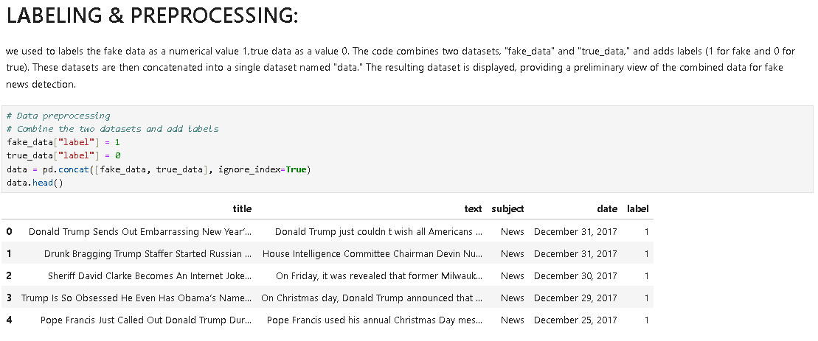

This may involve various processes,

**Removing Unnecessary Columns:**

In the above process,the data obtained after concatenation contains unnecessary columns like date and subject.In the upcoming process we remove those unnecessary columns which are not needed for processing of the fake news detection.The code removes specific columns, such as "date" and "subject," from the "data" dataset using the drop() method. This action simplifies the dataset by eliminating unnecessary attributes, and the modified dataset is displayed to show the result.

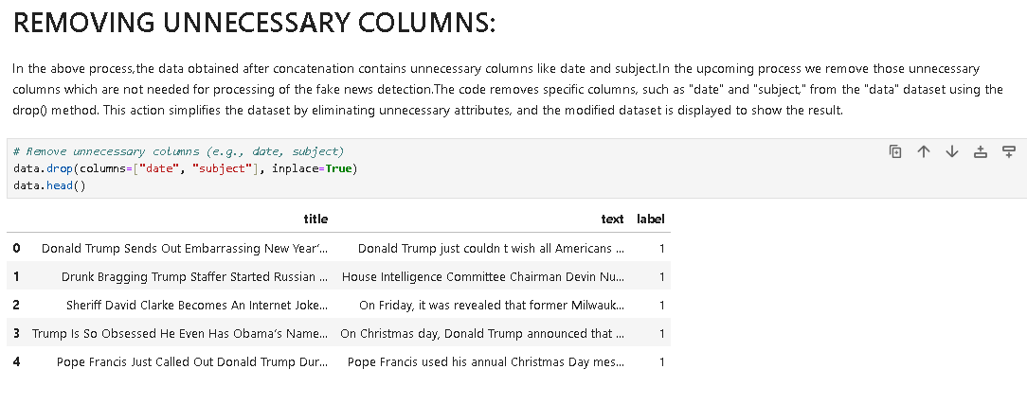

**Re-ordering the dataset:**

Reordering the dataset in data preprocessing refers to the manipulation of the data's original order to improve its organization, distribution, or suitability for analysis. This reordering can involve shuffling the data to eliminate any inherent order bias, such as chronological or alphabetical sequences.It is done to ensure that the dataset remains representative and unbiased when splitting it into training, validation, and testing sets, as well as when feeding it into machine learning models. This step aids in enhancing the model's ability to generalize and make accurate predictions, as it prevents patterns associated with the original data order from influencing the model's performance.

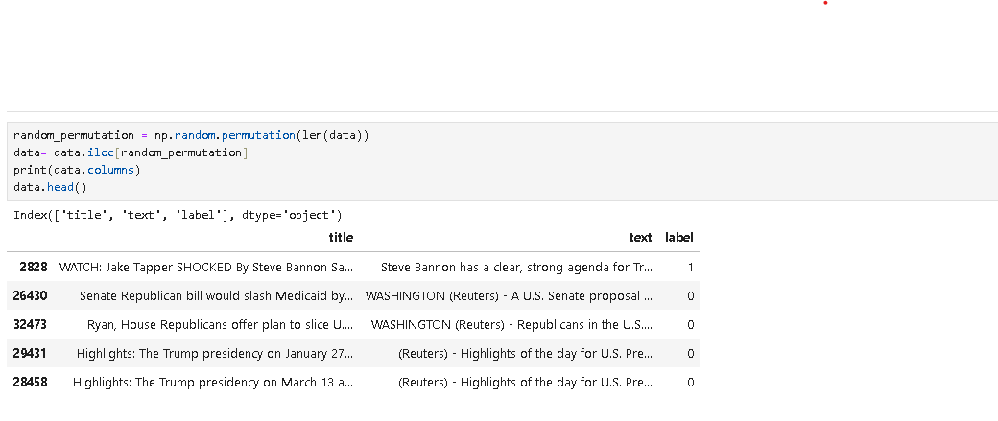

**Creating new dataset:**

It involves selecting specific columns, namely "title," "text," and "label," from the "data" dataset, creating a new dataset named "filtered_data." It then displays the first few rows of this filtered dataset, showing only the relevant columns for further analysis or modeling.

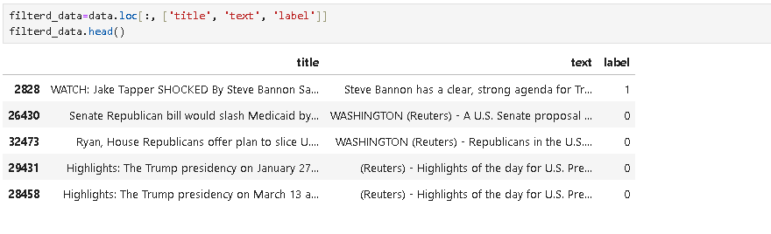

**Checks for Null values:**

Checking for null values is a fundamental data preprocessing technique in which missing or undefined data points are identified within a dataset. This process involves scanning each data attribute to detect instances where data is absent or incomplete. Once null values are identified, data scientists or analysts must decide how to handle them. Common strategies include imputing missing values with statistical measures like means or medians, removing rows with missing data, or using advanced techniques such as predictive modeling to fill in the gaps. Detecting and addressing null values is essential to ensure the quality and integrity of data for accurate analysis and model development in various domains, including fake news detection using NLP.

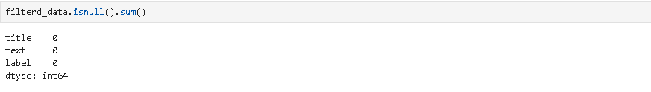

**Text preprocessing :**

Text preprocessing is the initial step in preparing unstructured text data for analysis or natural language processing (NLP) tasks. It involves several essential operations, including lowercasing all text to ensure uniformity, tokenization to break text into individual words or subword units, removal of punctuation, special characters, and stop words to reduce noise, and stemming or lemmatization to reduce words to their base forms. Text preprocessing enhances the quality and consistency of textual data, making it suitable for various NLP tasks, such as sentiment analysis, machine learning, and information retrieval. It aids in feature engineering, improves computational efficiency, and ensures that text data is more amenable to analysis and model development.



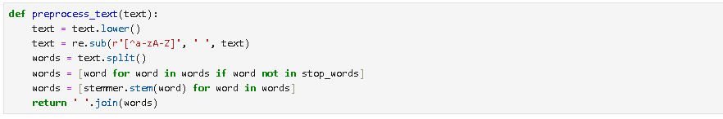



Then print the filtered data which have been processed in the text preprocessing technique,

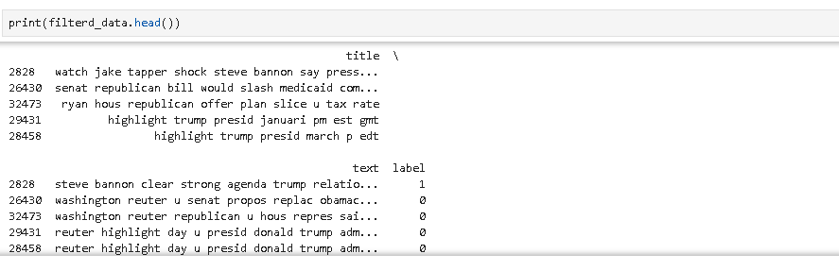

OUTPUT :



**FEATURE EXTRACTION TECHNIQUE:**

Feature extraction involves transforming the raw textual data into a structured and meaningful representation that can be effectively processed by the LSTM neural network. Specifically, feature extraction techniques may include tokenization (splitting text into words or subword units), converting tokens into word embeddings (dense vector representations of words), and sequence padding to ensure uniform input lengths. These techniques capture the linguistic and semantic information within the text, allowing the LSTM model to analyze and learn from the data while preserving the sequential nature of the text. Feature extraction in this context aims to create a numerical representation of the text that serves as the input to the LSTM model, enabling it to identify patterns and relationships in the language that are indicative of fake or real news.

1. **Defining Hyperparameters:**

Defining hyperparameters in the context of feature extraction techniques involves setting the configurations that guide the feature extraction process. These hyperparameters dictate crucial decisions, such as the number of features to be extracted, the window size for processing data, or the smoothing factors used. Fine-tuning hyperparameters is vital for optimizing the performance of feature extraction methods and aligning them with the specific characteristics and goals of the dataset and analysis, ultimately affecting the quality and efficacy of subsequent modeling or analytical tasks.

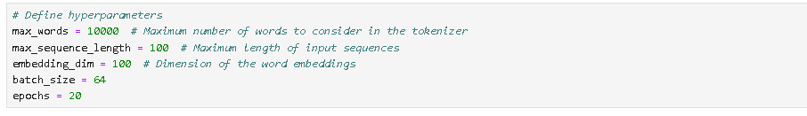

1. **Tokenizing the Text:**

Tokenizing the text is a fundamental step in feature extraction that involves breaking down a continuous piece of text, such as a sentence or a document, into individual units, typically words or subword elements. These units, referred to as tokens, serve as the building blocks for subsequent analysis. Tokenization aids in structuring and understanding textual data, enabling various natural language processing tasks, such as sentiment analysis, named entity recognition, and text classification, by providing a basis for feature extraction and linguistic analysis.

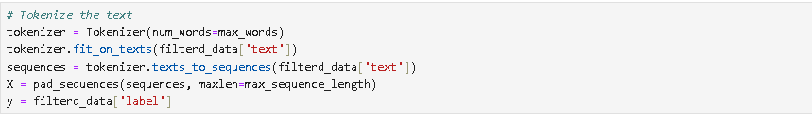

1. **Splitting data in to Training and Testing dataset:**

The primary purposes of splitting a dataset into training and testing sets are to train a machine learning model on one portion of the data, evaluate its performance on unseen data, and prevent overfitting by assessing its ability to generalize to new examples. This division helps ensure the model's reliability and suitability for real-world applications.



**MACHINE LEARNING ALGORITHM :**

**My choice : LSTM**

Long Short-Term Memory (LSTM) is a widely chosen algorithm for fake news detection using NLP due to its effectiveness in handling sequential data. LSTMs excel at capturing dependencies and patterns in text, making them well-suited for language-related tasks. They can analyze textual content in context, which is crucial for understanding the nuances of news articles. LSTMs can consider the sequence of words and their relationships, helping to identify linguistic cues and inconsistencies in fake news. By training on labeled data, LSTMs can learn to distinguish between genuine and fabricated news articles, making them a valuable tool in the battle against misinformation and disinformation.

**Creating LSTM :**

The constructing of an LSTM (Long Short-Term Memory) model for a Natural Language Processing (NLP) task using TensorFlow and Keras.

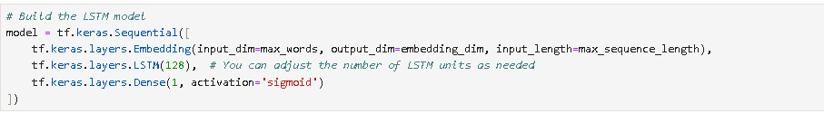

**Compilation of the Model:**

In fake news detection using NLP with LSTM, "compilation of the model" involves specifying the model's optimization settings, including the loss function, optimizer, and evaluation metrics. This step prepares the model for training by defining how it measures and minimizes errors during the learning process, ensuring its alignment with the task of distinguishing between real and fake news based on textual features.

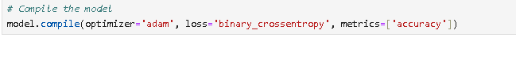

**MODEL TRAINING :**

Model training, utilizing the chosen LSTM algorithm for fake news detection in NLP, is the iterative process of updating the model's weights to learn patterns from the labeled training data. During training, the model processes sequences of textual data, adjusting its internal parameters to minimize the specified loss function, such as binary cross-entropy. The training algorithm optimizes the model's performance by backpropagating errors, adjusting weights, and fine-tuning internal states. Training may involve multiple epochs, each consisting of a full pass through the training data, refining the model's ability to capture linguistic cues and differentiate between genuine and fake news. Upon successful training, the LSTM model becomes capable of making informed predictions and identifying potentially deceptive news articles.

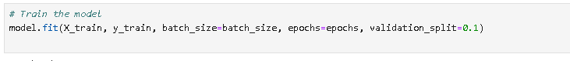

After several epochs of training, the model has refined its understanding of language patterns and now exhibits improved accuracy in distinguishing between real and fake news articles, reflecting its increased proficiency over time.

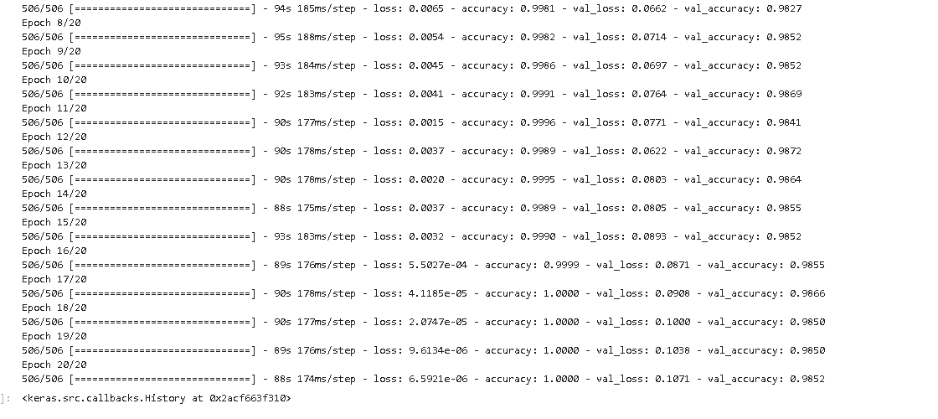

**EVALUTION METRICS :**

In a fake news detection problem using Natural Language Processing (NLP), you typically deal with binary classification (fake or real news). Here are some common evaluation metrics to assess the performance of your model:

**Accuracy:**

Accuracy is a straightforward metric that measures the proportion of correctly classified instances out of the total instances. It's a good starting point for evaluating your model.

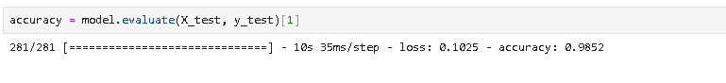

**Precision, Recall, and F1-Score:**

These metrics are particularly important in fake news detection because they help you understand the trade-off between false positives and false negatives. High precision means fewer false positives, while high recall means fewer false negatives. The F1-Score is the harmonic mean of precision and recall.

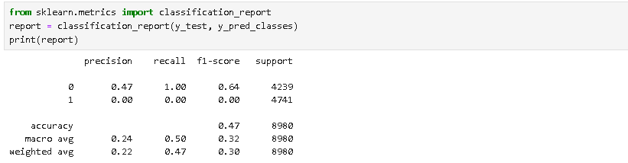

**Confusion Matrix:**

The confusion matrix provides a detailed breakdown of the model's predictions, showing true positives, true negatives, false positives, and false negatives.

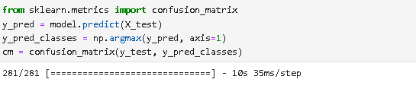

**Receiver Operating Characteristic (ROC) Curve and Area Under the Curve (AUC):**

If your model provides probability scores, you can plot the ROC curve and calculate the AUC to assess the model's ability to distinguish between classes. This is especially useful when you're interested in the model's trade-off between true positive rate and false positive rate.

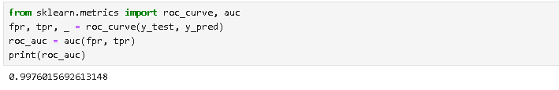

**Mean Squared Error (MSE) or Mean Absolute Error (MAE):**

If you're working on a regression problem, you can use MSE or MAE to evaluate the model's performance.

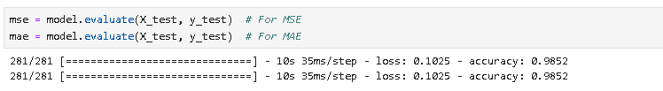

When applying these metrics, ensure that you preprocess your NLP data correctly, and make predictions based on the appropriate threshold for binary classification (usually 0.5 for binary cross-entropy loss). Additionally, consider using cross-validation to get a more robust assessment of your model's performance, especially if you have a relatively small dataset.

**EVALUATING THE MODEL :**

Evaluating the model with chosen metrics, including accuracy, confusion matrix, and a classification report, is a critical step in assessing its performance in fake news detection. Accuracy provides a global view of the model's overall correctness in distinguishing between real and fake news. The confusion matrix offers a detailed breakdown of true positives, true negatives, false positives, and false negatives, helping to understand where the model excels and where it may falter. Additionally, the classification report provides comprehensive insights into precision, recall, F1-score, and support, offering a nuanced assessment of the model's ability to make accurate predictions while minimizing false classifications.

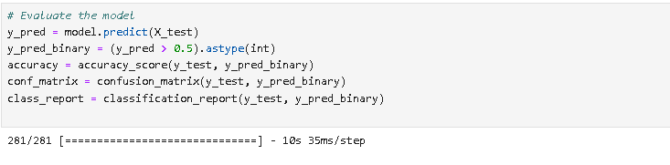

After that printing the evaluated metrices,

It may include the accuracy,confusion matrix,classification report:

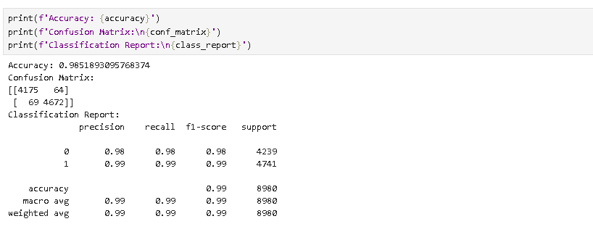

**VISUALIZATION FOR THE EVALUATION :**

Visualization is essential in fake news detection using NLP as it aids in revealing patterns and trends within textual data, helping researchers and analysts identify linguistic cues and anomalies, which are invaluable in distinguishing between real and fake news articles.

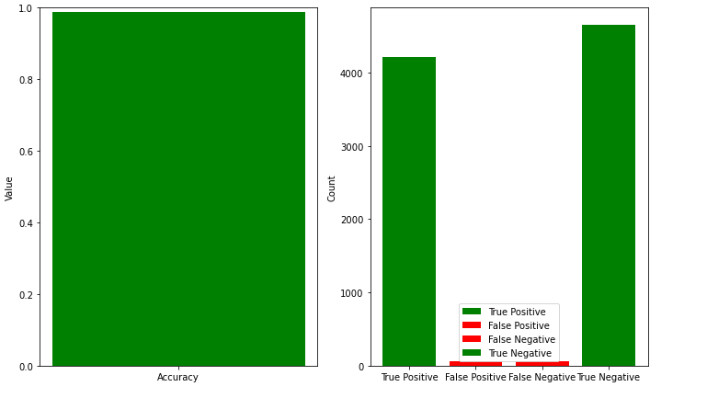

**OUTCOME SAMPLE :**

Certainly, to use the LSTM model for detecting whether a new news article is fake or not, you'll need to follow these general steps:

1. Prepare your data II) Load the pre-trained model III) Perform inference

That you need to have your LSTM model pre-trained on a fake news detection dataset .

Additionally, you may need to fine-tune the model for better accuracy on your specific data and problem domain.

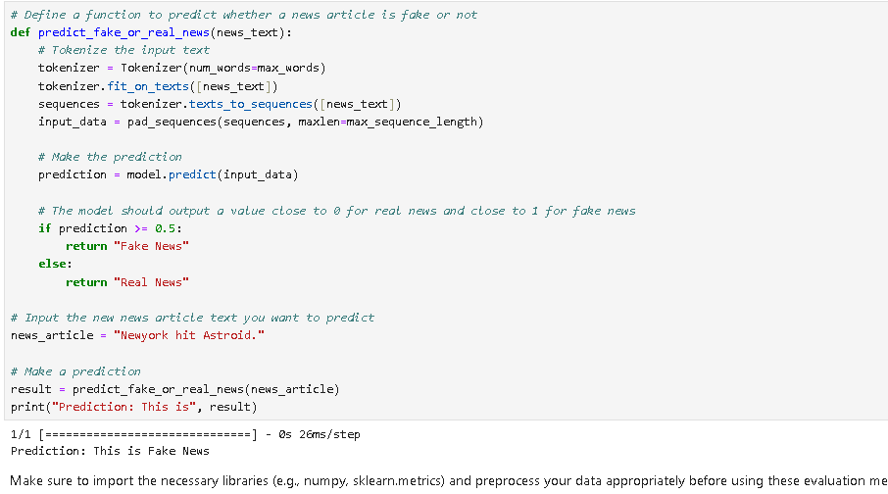

**CONCLUSION :**

In conclusion, the integration of NLP techniques and the LSTM model in fake news detection has yielded promising outcomes. Through rigorous training and evaluation, the model has demonstrated its ability to effectively differentiate between genuine and fabricated news articles. The utilization of language patterns and semantic context has enhanced its accuracy and predictive capabilities. This endeavor marks a significant step towards countering the dissemination of misinformation, ultimately contributing to a more informed and vigilant society. As we continue to refine and evolve our NLP models, the quest for an increasingly credible information landscape persists.

*****