**COURSE REVIEW PORTAL**



**B.Tech/III Year CSE/V Semester**

**15CSE302/Database Management Systems**

**Project Review -1**

|  |  |
| --- | --- |
| Roll no | Name |
| CB.EN.U4CSE18114 | **DHIVYA GANESHAN** |
| CB.EN.U4CSE18115 | **ELAVENIL.P** |
| CB.EN.U4CSE18171 | **DIVYA SHANKAR** |
| CB.EN.U4CSE18172 | **KEERTHIKA.S** |

**Amrita School of Engineering, Coimbatore**

**Department of Computer Science and Engineering**

**2020 -2021 Odd Semester**

**Table of Contents**

**Title Page number**

**Chapter 1 Introduction 3**

**Abstract 4**

**Chapter 2 Logical Database Design ER Diagram 5**

**Entities 5**

**Attributes 5**

**Relationships 5**

**Chapter 3 ER to Relational Schema Mapping 6**

**Chapter 4 User Interface Screens 7**

**References 8**

# Chapter 1 Introduction

This database system will be used to connect students to view various courses and make their selection process easier depending on the reviews and feedback collected from students who have previously attended the courses. There are three types of users namely students, faculty and moderator. Faculty clarifies the doubt posted by students in the discussion forum regarding the course. Students are also able to see how a particular course helps in providing job opportunities by feedback gathered from alumni.

# 

**Abstract**

Universities offer a variety of electives to students. It is often difficult  for students to pick the right elective. To make the elective selection process easier for students, we have a review portal database project, which collects review or feedback of courses from students who have previously attended the courses and neatly presents it in a review page. It provides general information about a course which includes the learning outcome and the syllabus of the course. Along with that student can be able to view the reference materials for that particular course. Students can also check the prerequisite for the particular course they are willing to choose. They can have a glance about the difficulty level for each course .They can know about the credits and marks distribution of topics split within that course. Along with this, it allows students to post questions regarding a course and allow faculties to answer them. Students can get to know about the quality of teaching by a particular faculty from the other students who completed the course. To see how a particular course helps in a job or work environment, feedback is gathered from alumni students through the mail, compiled together and displayed as insights of the course.

**Moderator Login**:

                   View all student records.

                   View all faculty records.

                   Update change in syllabus or faculty when required.

**Student Login**:

                   View all the course details.

                   Can post the doubts in the form of questions.

                   View the faculty ratings and course ratings given by alumni.

**Faculty Login**:

                    Faculty cannot access the faculty ratings

                    Can view and answer the questions posted by students

**Chapter 2 Logical Database Design ER Diagram**

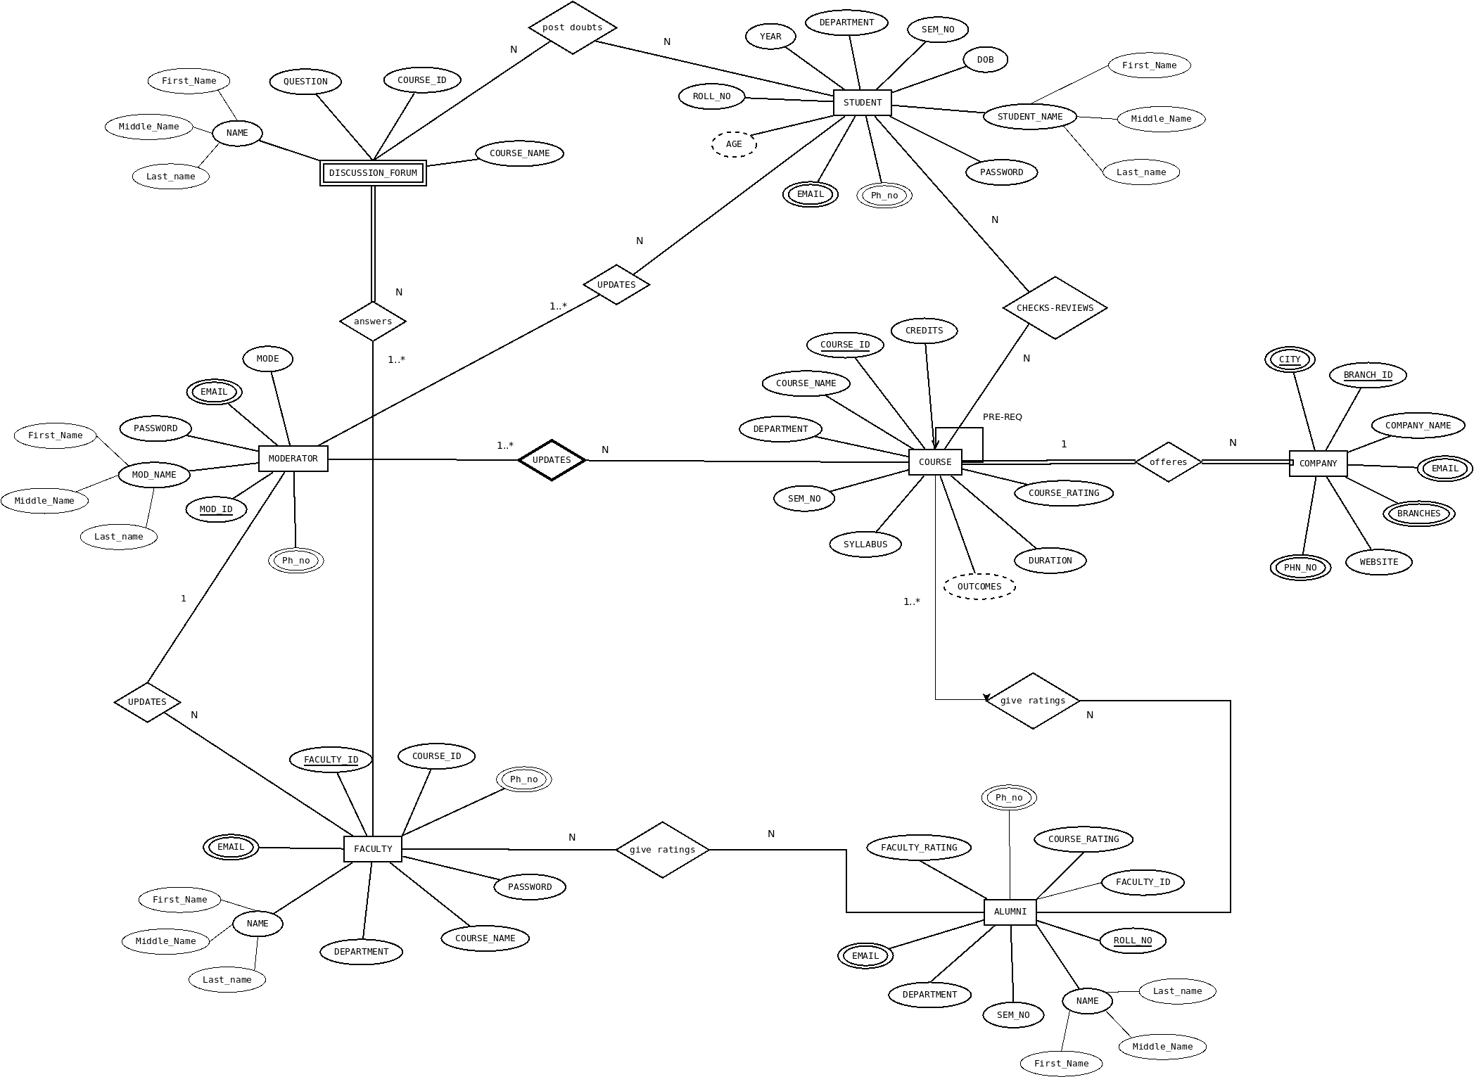

## Entities

* DISCUSSION FORUM
* FACULTY
* COURSE
* COMPANIES
* ALUMNI
* MODERATOR
* STUDENT

## Attributes

* DISCUSSION FORUM(FIRST_NAME,MIDDLE_NAME,LAST_NAME, COURSE_ID, COURSE_NAME, QUESTION)
* FACULTY(FIRST_NAME,MIDDLE_NAME,LAST_NAME

,DEPARTMENT,COURSE_ID,COURSE_NAME,FACULTY_ID,PASSWORD,PHN_NO, EMAIL)

* COURSE(COURSE_ID,COURSE_NAME,DEPARTMENT,SEM_NO,SYLLABUS,OUTCOMES,DURATION, COURSE_RATING, CREDITS)
* COMPANIES(COMPANY_NAME,BRANCH_ID,BRANCHES,EMAIL,CITY,PHN_NO,WEBSITE)
* ALUMNI(FIRST_NAME,MIDDLE_NAME,LAST_NAME,ROLL_NO,EMAIL,DEPARTMENT,SEM_NO,COURSE_RATING,FACULTY_RATING, RATING)
* MODERATOR(MODE,MOD_ID,FIRST_NAME,MIDDLE_NAME,LAST_NAME,EMAIL,PASSWORD,PHN_NO)
* STUDENT(ROLL_NO,STUDENT_NAME,AGE,YEAR,DEPARTMENT,SEM_NO,DOB,PASSWORD,PHN_NO,EMAIL)

## Relationships

* STUDENT post doubts in DISCUSSION FORUM.
* ALUMNI gives ratings to FACULTY.
* ALUMNI gives ratings to COURSE.
* MODERATOR updates STUDENT.
* MODERATOR updates COURSE.
* STUDENT check reviews in COURSE.

**Chapter 3 ER to Relational Schema Mapping**

* STUDENT TO DISCUSSION FORUM.
  + STUDENT(ROLL_NO,STUDENT_NAME,AGE,YEAR,DEPARTMENT,SEM_NO,DOB,PASSWORD,PHN_NO,EMAIL)
  + DISCUSSION FORUM (NAME, COURSE_ID, COURSE_NAME, QUESTION)
* ALUMNI TO FACULTY.
  + ALUMNI (NAME, ROLL_NO, EMAIL, DEPARTMENT, SEM_NO,
  + COURSE_RATING, FACULTY_RATING, RATING)
  + FACULTY (NAME, DEPARTMENT, COURSE_ID, COURSE_NAME,
  + FACULTY_ID, PASSWORD, PHN_NO, EMAIL)
* ALUMNI TO COURSE.
  + ALUMNI (NAME, ROLL_NO, EMAIL, DEPARTMENT, SEM_NO, COURSE_RATING, FACULTY_RATING, RATING)
  + COURSE (COURSE_ID, COURSE_NAME, DEPARTMENT, SEM_NO, SYLLABUS, OUTCOMES, DURATION, COURSE_RATING, CREDITS).
* MODERATOR TO STUDENT.
  + MODERATOR(MODE,MOD_ID,MOD_NAME,EMAIL,PASSWORD,PHN_NO)
  + STUDENT(ROLL_NO,STUDENT_NAME,AGE,YEAR,DEPARTMENT,SEM_NO,DOB,PASSWORD,PHN_NO,EMAIL)
* MODERATOR TO COURSE.
  + MODERATOR(MODE,MOD_ID,MOD_NAME,EMAIL,PASSWORD,PHN_NO)
  + COURSE(COURSE_ID,COURSE_NAME,DEPARTMENT,SEM_NO,SYLLABUS,OUTCOMES,
    - DURATION,COURSE_RATING,CREDITS)
* STUDENT TO COURSE
  + STUDENT(ROLL_NO,STUDENT_NAME,AGE,YEAR,DEPARTMENT,SEM_NO,DOB,PASSWORD,PHN_NO,EMAIL)
  + COURSE(COURSE_ID,COURSE_NAME,DEPARTMENT,SEM_NO,SYLLABUS,OUTCOMES,DURATION,

COURSE_RATING,CREDITS)

**Chapter4:UserInterfaceScreens**

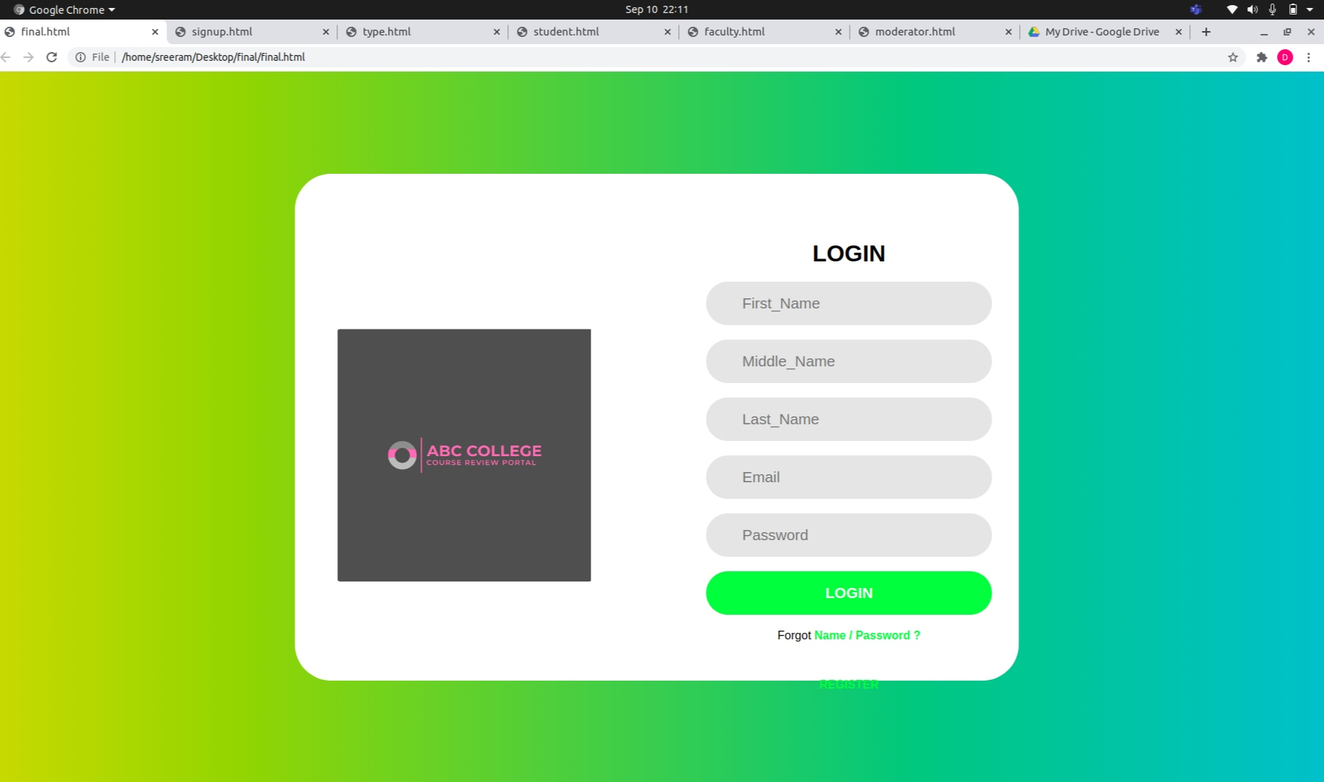

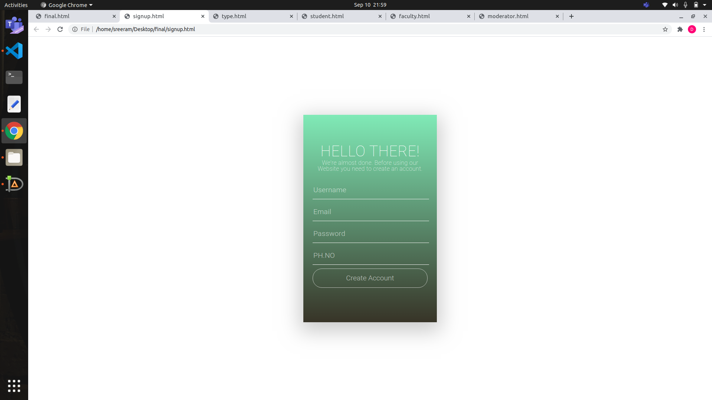

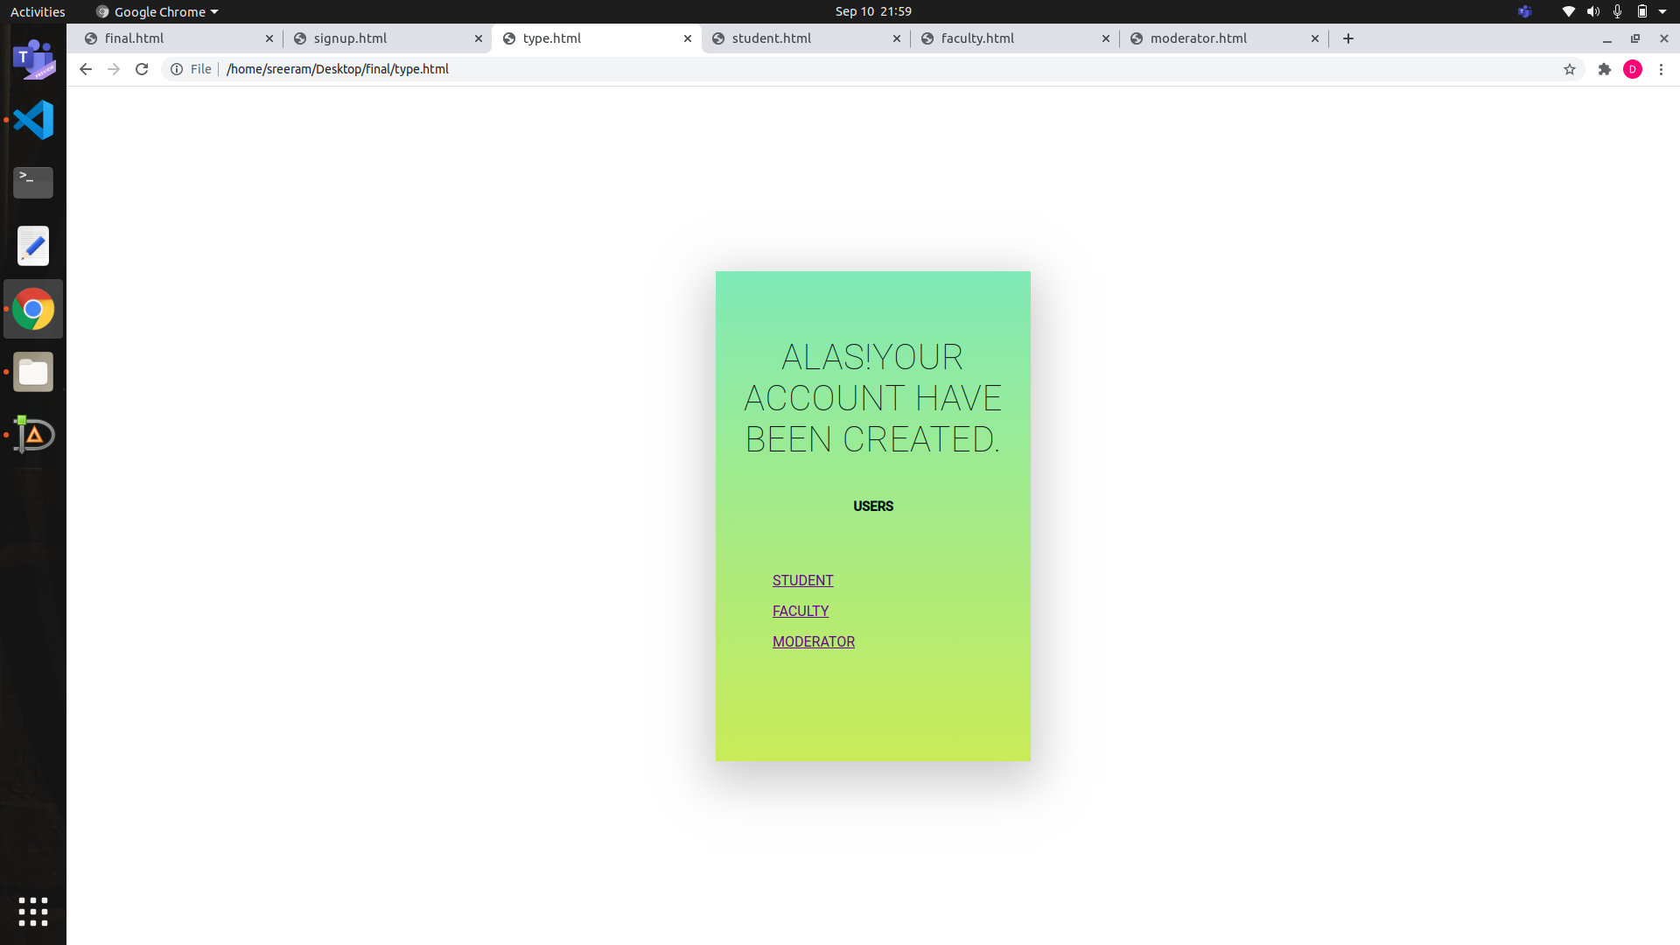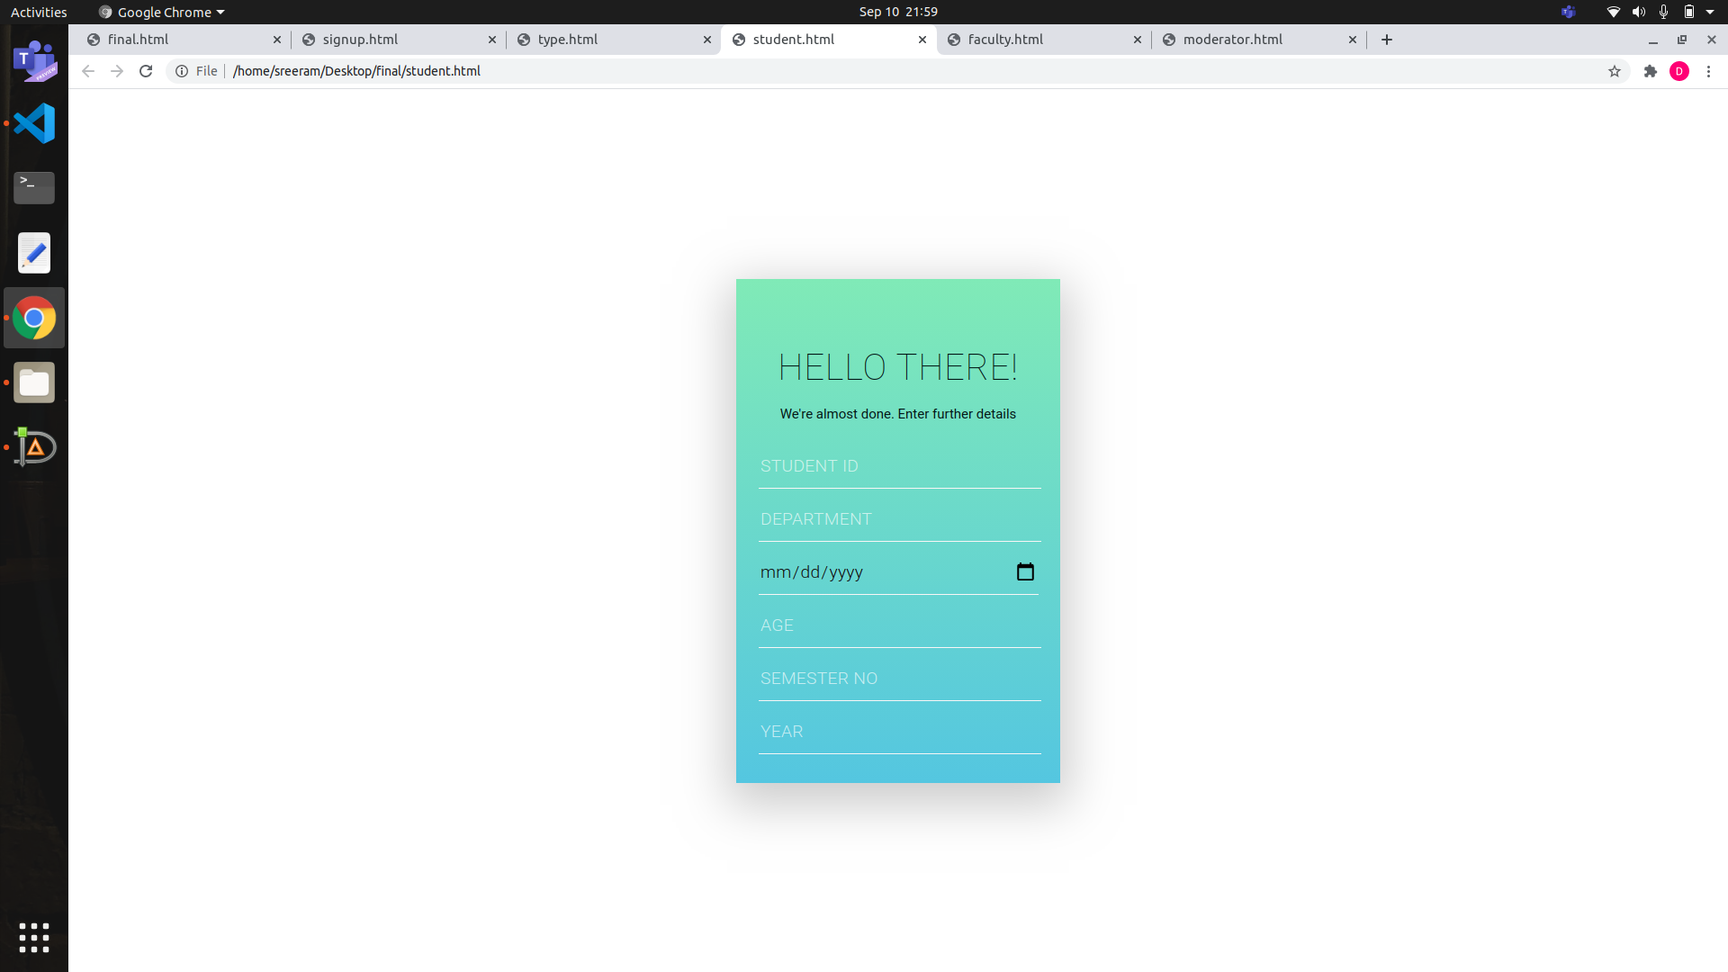

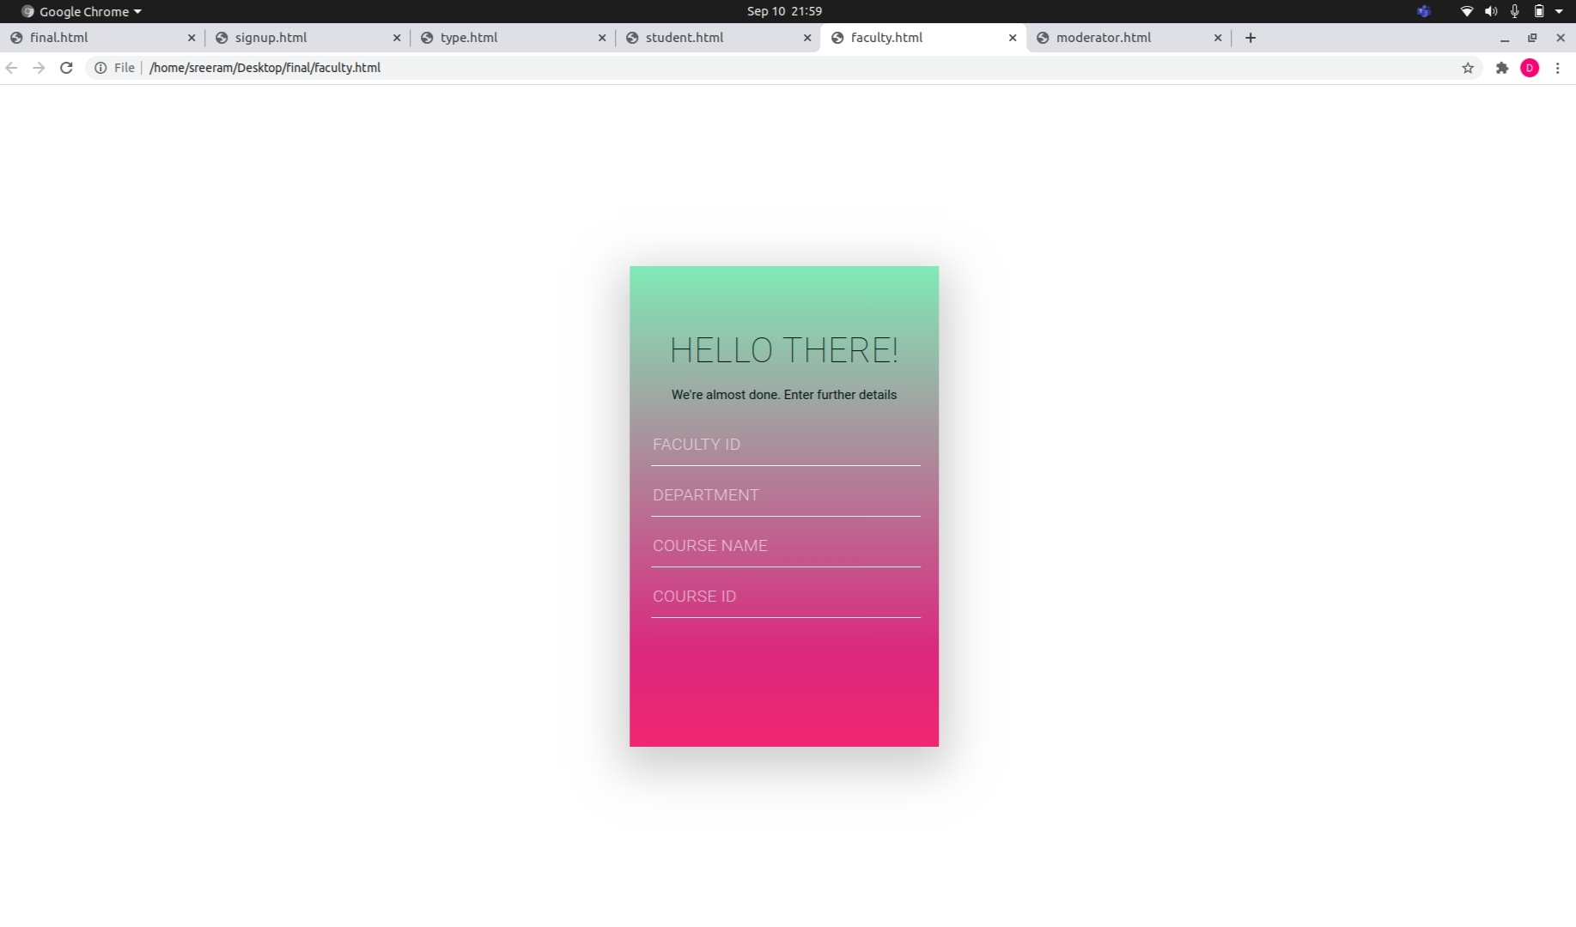

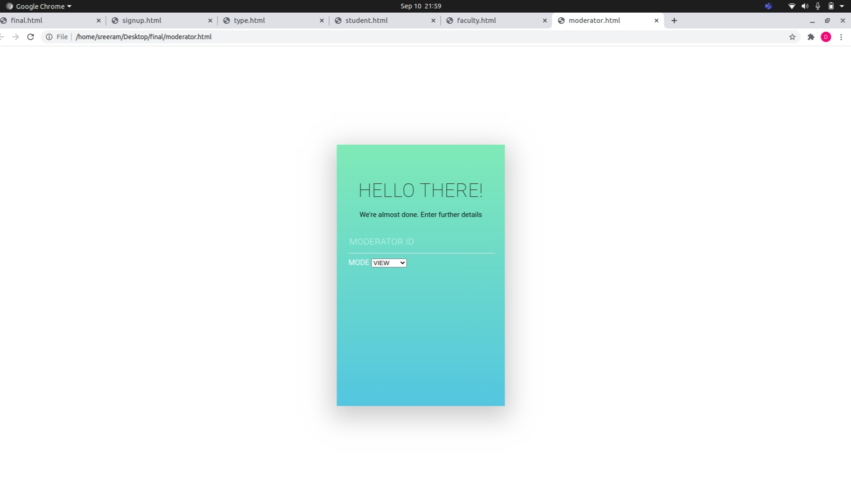

**ch:5 relational modelling**

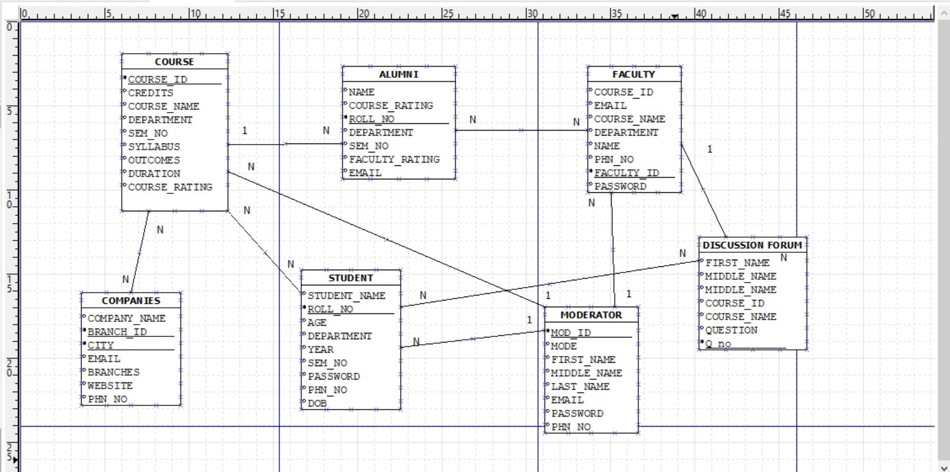

References

**Books reference format**

**[1] Abraham Silberschatz , Henry F. Korth, S. Sudarshan : Database System Concepts, 6th Edition: McGraw-Hill, 2016**

**Websites reference format**

**[1] “Introduction to ER diagram”, Geeks for geeks, 31-Aug-2020. URL:** [**https://www.geeksforgeeks.org/introduction-of-er-model/**](https://www.geeksforgeeks.org/introduction-of-er-model/)

**[2] “Entity Relationship diagram”, smart draw, 01-Sep-2020. URL:** [**https://www.smartdraw.com/entity-relationship-diagram/**](https://www.smartdraw.com/entity-relationship-diagram/)

**[3] https://www.w3schools.com/html/html_intro.asp**

**[4] https://www.tutorialspoint.com/html/index.htm**

{