**/************************************/**

**/ Name: Divya Pramasani Mohandoss /**

**/ Class: CS6070 /**

**/ Term: Fall 2020 /**

**/ Lab #: 4 /**

**/***********************************/**

**Functional Dependencies**

1. **/* Consider the table:**

**STAFF_MEETING (EmployeeName, ProjectName, Date)*/**

(ProjectName, Date) ⟶EmployeeName

ProjectName ⟶EmployeeName

1. **/*Consider the table:**

**STUDENT (Number, Name, Dorm, RoomType, DormCost, Club, ClubCost, Sibling,**

**Nickname)*/**

Number ⟶ (Name, Dorm, RoomType)

Number ⟶ Sibling

Number ⟶ Nickname

Club ⟶ ClubCost

RoomType ⟶ DormCost

**Normalization**

1. **/* Normalize the following table into a set of tables that puts them into 3NF*/**

**/* a) Identify functional dependencies. */**

Eid ⟶ (Ename, Pid)

Pid ⟶ (Pname, Mid)

Mid⟶ Mname

**/* b) Normalize the listing into 3NF. */**

EMPLOYEE(Eid, Ename, Pid)

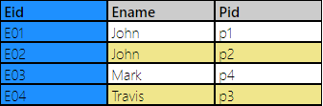

PROJECT(Pid, Pname, Mid)

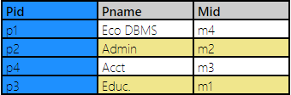

MANAGER(Mid, Mname)

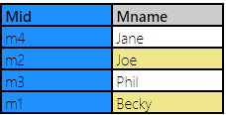

1. **/*Normalize the Veterinary Office List shown in the figure below.*/**

**/* a) Identify functional dependencies. */**

PetName ⟶ (Type, Breed, DOB, OwnerPhone)

OwnerPhone ⟶ (Owner, OwnerEmail)

(PetName, Date) ⟶ (Service, Charge)

**/* b) Normalize the listing into 3NF. */**

OWNER (OwnerPhone, Owner, OwnerEmail)

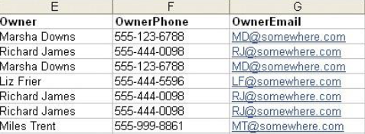



PET (PetName, Type, Breed, DOB, OwnerPhone)

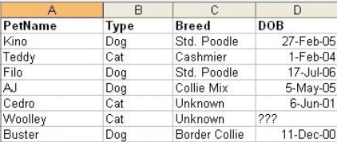 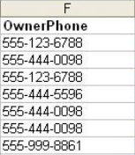



SERVICE (PetName, Date, Service, Charge)

 



1. **/* Normalization Matching. Indicate which normal form, each of the following conditions represents. [1NF, 2NF, 3NF, 4NF]*/**

|  |  |  |
| --- | --- | --- |
| Sno. |  | **Normal Form** |
| 1 | No Partial Dependencies | 2NF |
| 2 | No multi-value attributes | 1NF |
| 3 | No dependency between non-key attributes | 3NF |
| 4 | All attributes are dependent on the key | 1NF |
| 5 | All attributes are dependent on the whole key | 2NF |
| 6 | All attributes are dependent on nothing but the key. | 3NF |
| 7 | Similar to BCNF | 3NF |
| 8 | No transitive dependencies | 3NF |
| 9 | For a table to be considered a relation, it must at least satisfy | 1NF |

1. **/* For the following, answer whether Tables are in 3NF? */**

/*If No, State the normalization rule that is violated. Rules can be:

A) No multi-valued attribute

B) Not dependent on the whole primary key

C) Dependencies between non-key attributes. */

**1) Employee (ssn, Name, Salary, Address, ListOfSkills)**

No, Violates Rule: A

**2) Vehicle (LicensePlate, Brand, Model, PurchasePrice, Year, OwnerSSN, OwnerName)**

No, Violates Rule: C

**3) Employee (ssn, Name, Salary, did)**

Yes, Employee is in 3NF

**4) Customer (Cust_Id, Name, Salesperson, Region) where Salesperson determines Region.**

No, Violates Rule: C

**5) Component (ItemNo, ComponentNo, ItemName, Quantity) where ItemNo -> ItemName**

No, Violates Rule: B