DHIVYESH R K

2021BCS0084

ICS 222 OBJECT ORIENTED ANALYSIS AND DESIGN

LAB ASSIGNMENT - 2

1. 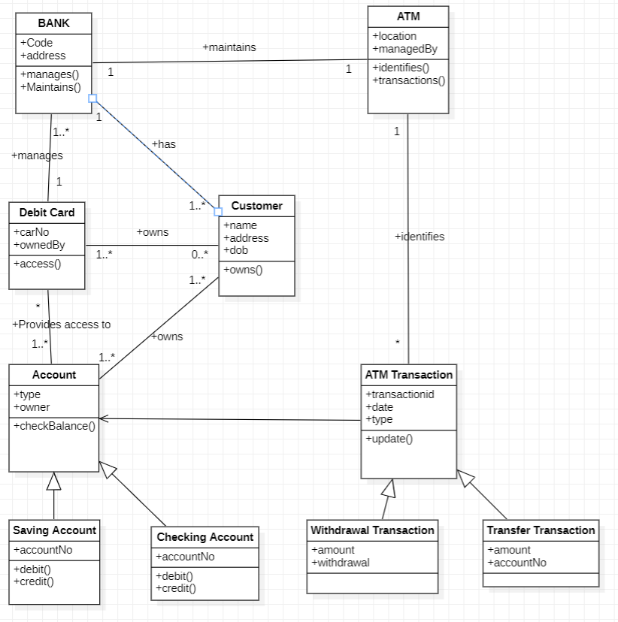
2. 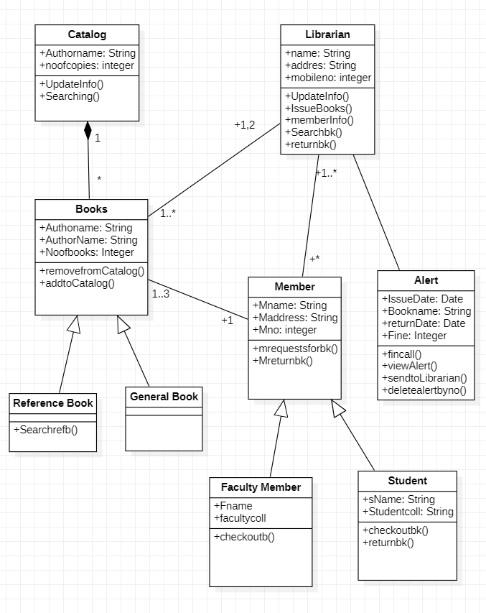
3. 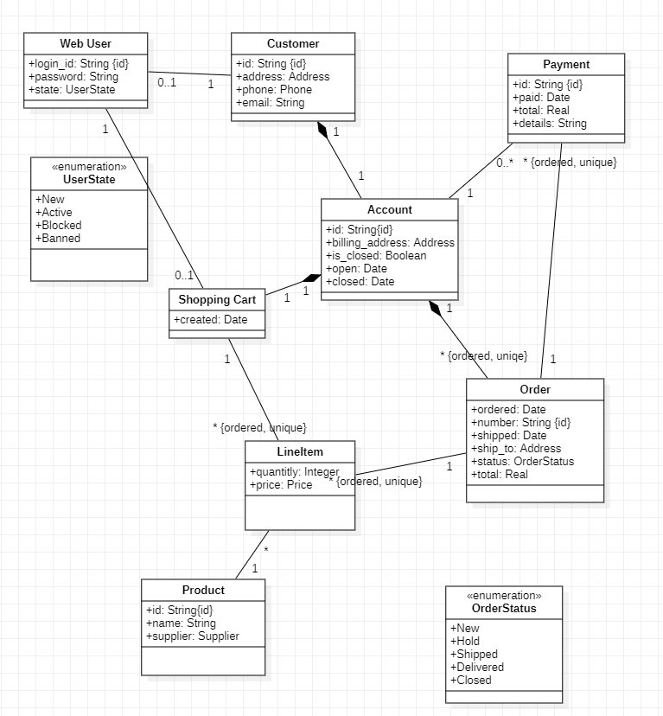
4. 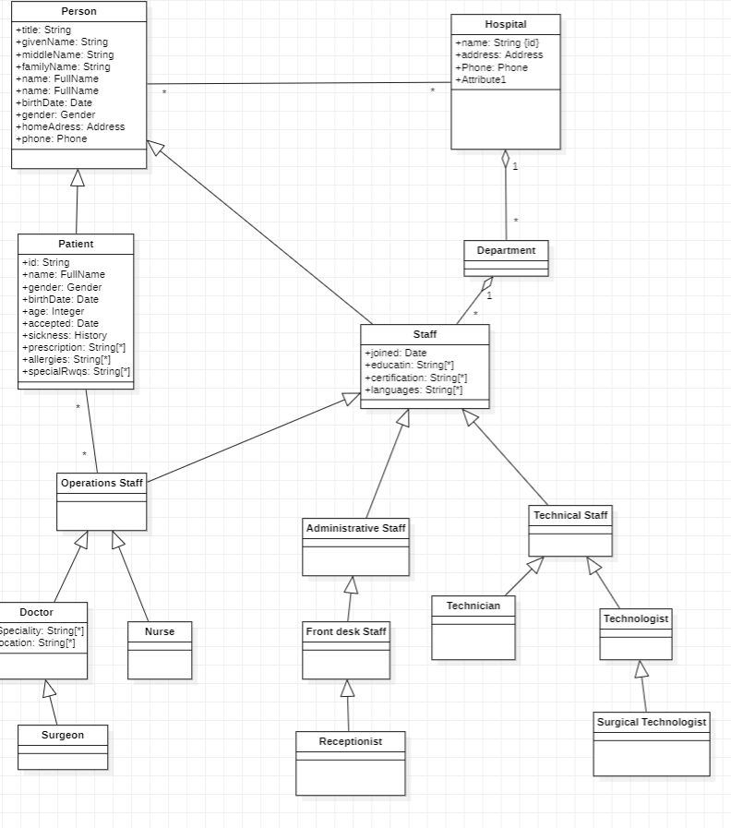
5. 