Financial Document Intelligence & RAG on Azure
An end-to-end delivery plan: ingestion through evaluation, with the RAGAS metric suite promoted from an offline notebook into a first-class product surface.
Corpus | 100–300 SEC filings
Segments | 9 phases
Effort | 6–7 weeks p/t
Backend | FastAPI · Python 3.12
Frontend | Next.js 15 · TS
Eval | RAGAS + Azure AI Eval

Contents
- 1. Scope & the gap
- 2. System architecture
- 3. Tech stack
- 4. Repo & services
- 5. Backend design
- 6. Frontend design
- 7. Evaluation engine
- 8. RAGAS metric suite
- 9. Evaluation UI
- 10. Security & ops
- 11. Phased build
- 12. Cost & risk

1. What exists, and what this plan adds
The existing build guide is a strong pipeline design — parsing, chunking, indexing, hybrid retrieval, citations. It is not yet an application plan. Three things are missing, and they are the three that turn a notebook into a portfolio piece.
There is no application layer. The guide ends at "answer + inline citations" with no API contract, no session model, no streaming design, and no document viewer to render a citation back to a page and bounding box.
Evaluation is specified as a script. RAGAS is named, metrics are listed, and the ablation table is described as a README artifact. But an eval run that lives in a CSV is invisible — you can't compare two configs at a glance, can't see which question type is dragging the mean down, and can't show it to anyone. This plan makes evaluation a product surface with its own data model, service, and five screens.
Nothing is measured in production. Offline eval on a 60-question golden set tells you nothing about the queries real users actually type. The plan adds online sampled evaluation writing into the same metric store as the offline runs.
Scope change worth naming
The guide budgets 3–4 weeks. Adding a real frontend, an evaluation service, and the eval dashboard puts this at 6–7 weeks part-time. If time is fixed at four weeks, cut the finance add-ons (Phase 9) and the online eval loop, not the eval dashboard — the dashboard is the differentiating artifact.

Design principles this plan holds to
- Every config is named and versioned. Retrieval is parameterised by a RetrievalConfig record (chunker, k, fusion, ranker, model deployments). Every answer and every eval result carries its config id. Ablations become a database query, not a manual bookkeeping exercise.
- The trace is the unit of work. One query produces one trace: query, filters, per-retriever candidates with scores, fused set, prompt, response, citations, validation outcome, token counts, stage latencies. Offline eval, online eval, the debug UI, and App Insights all read the same object.
- Metrics are rows, not columns. Storing (run_id, question_id, metric_name, value, reason) long-form means adding a RAGAS metric needs no migration and no UI change.
- The judge is never the generator. A stronger, separately-deployed model scores answers, to avoid self-preference bias inflating faithfulness.

2. The two planes and the spine between them
Ingestion is a queue-driven batch job; query is a streaming request path. They share exactly one thing — the search index — and are deployed, scaled, and failed independently.
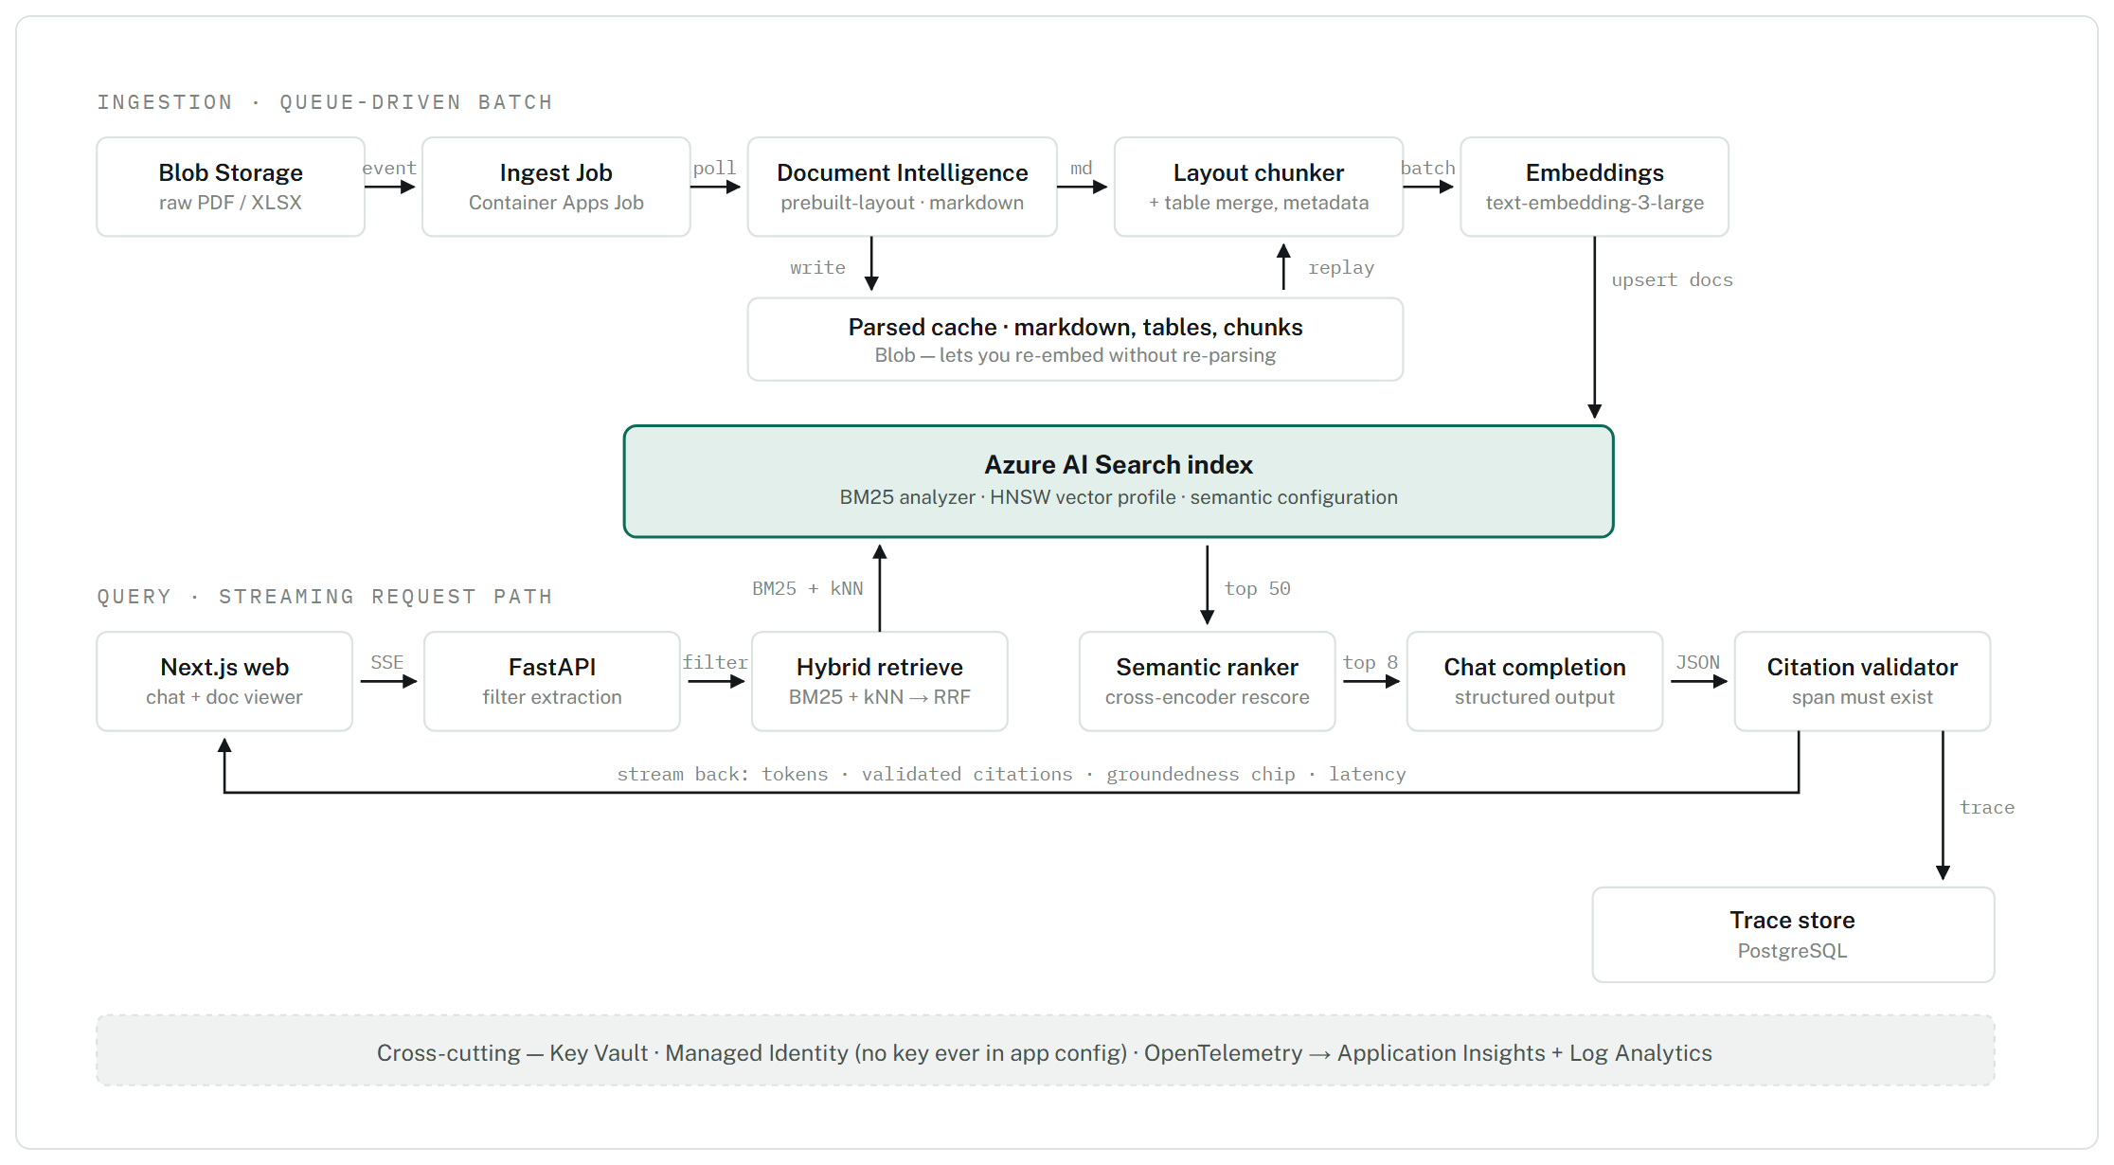
Figure 1. The parsed cache is the difference between a two-hour re-index and a ten-minute one: parsing is the slow, billed, non-deterministic step, so its output is persisted before chunking. Note that retrieval makes one call to the index carrying both a text query and a vector query — Azure AI Search performs the RRF fusion server-side; you do not fuse two responses in application code.

3. Technology choices, and what each one is doing for you
Two languages, one cloud. Python owns everything touching documents, retrieval and evaluation; TypeScript owns the browser. No shared runtime, no ORM in the frontend, one typed contract between them generated from OpenAPI.
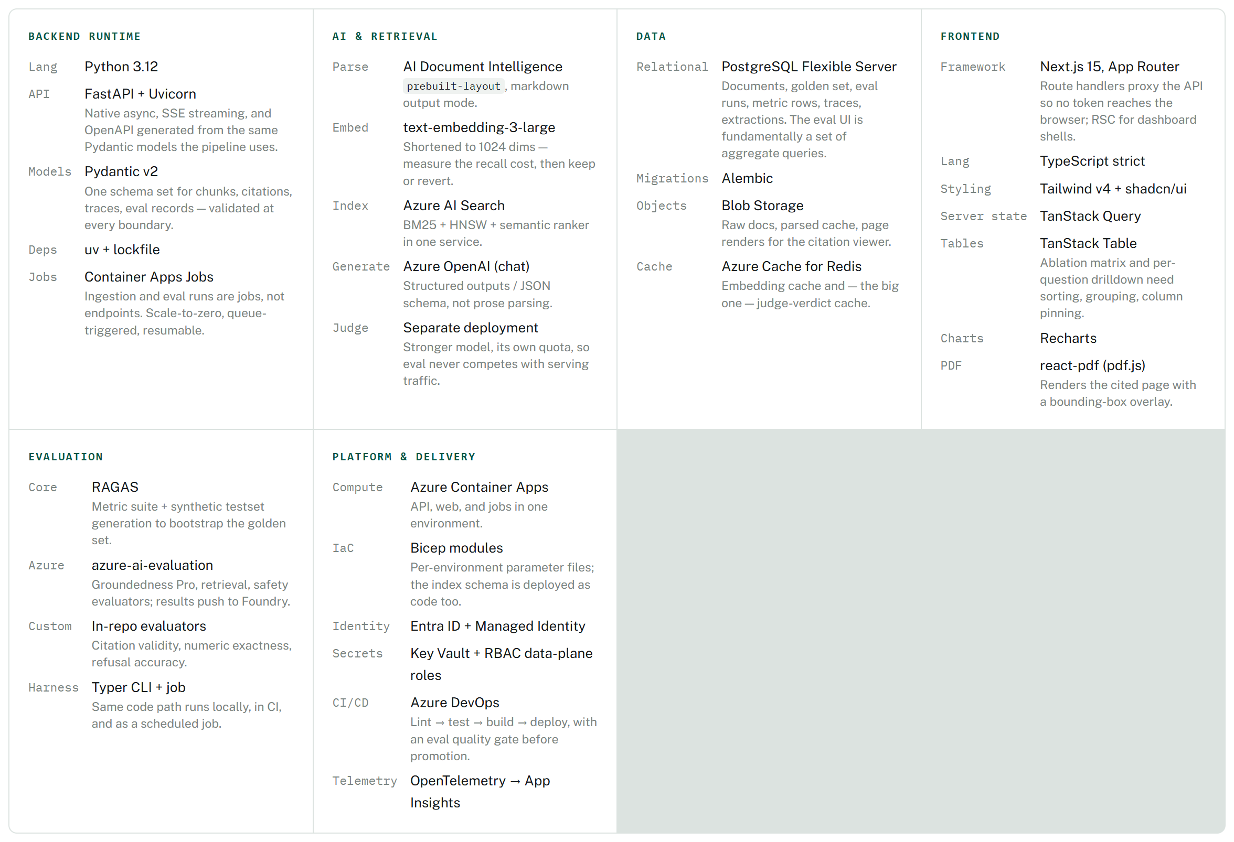
Table 1. Deliberate omissions: no LangChain or LlamaIndex in the request path — the pipeline is six explicit steps and a framework would only obscure the retrieval call you most want to control. RAGAS pulls LangChain in as a dependency for its judge wrappers; that is confined to the eval service.

Choices worth defending out loud
Decision | Chosen | Rejected alternative | Reasoning
Vector store | Azure AI Search | pgvector, Qdrant | You need BM25, vectors, RRF and a hosted cross-encoder in one hop. pgvector gives you vectors and then you are hand-building fusion and reranking.
Metadata DB | PostgreSQL | Cosmos DB | The eval surface is aggregation-heavy — group by config, question type, metric. That is SQL's home turf, and it keeps eval cost near zero.
Streaming | Typed SSE events | Plain token stream | The client needs more than tokens: citation objects, validation verdicts, and stage timings arrive as distinct event types the UI renders differently.
Ingestion | Queue + job | Search indexer + skillset | The built-in indexer is faster to stand up but you lose control of chunking, and cross-page table merging is not expressible in a skillset.
Frontend host | Container Apps | Static Web Apps | One environment, one identity model, one deployment pipeline for web and API.

4. Repository and service boundaries
One repo, four deployables, one shared Python library. The library is the important part: the chunker, the retrieval client, and the citation validator are imported identically by the API, the ingest job, and the eval runner — so an eval measures the code that actually serves traffic, not a reimplementation of it.
azure-rag/
├── apps/
│ ├── api/ FastAPI — chat, search, documents, eval read API
│ ├── web/ Next.js — chat UI + evaluation dashboard
│ ├── ingest/ Container Apps Job — queue consumer, resumable
│ └── evaluator/ Container Apps Job + Typer CLI — offline & online eval
├── libs/rag_core/
│ ├── parsing/ DI client, table reconciliation, xlsx adapter
│ ├── chunking/ layout chunker, context-header builder
│ ├── indexing/ index schema as code, embedder, upserter
│ ├── retrieval/ hybrid query builder, filter extraction, RetrievalConfig
│ ├── generation/ prompt templates, structured output schema
│ ├── citations/ validator — the programmatic hallucination check
│ ├── evaluation/ RAGAS wiring, custom metrics, run orchestration
│ └── telemetry/ OTel spans, trace model, cost accounting
├── evals/
│ ├── golden_set.yaml 60–80 curated Q/A with gold chunk ids
│ ├── configs/ named RetrievalConfig variants for ablation
│ └── thresholds.yaml CI gate limits
├── infra/ Bicep modules + per-env parameters
└── .azure-pipelines/ ci.yml, cd.yml, eval-gate.yml, nightly-eval.yml

5. API surface and data contracts
Three groups of endpoints: the chat path, the corpus path, and the evaluation path. The evaluation endpoints are read-heavy and exist purely to feed the dashboard.

Chat & retrieval
Method | Endpoint | Purpose
POST | /api/chat | SSE. Events: token, citations, validation, trace, done. Accepts an optional config_id so the UI can A/B a retrieval variant live.
POST | /api/search | Retrieval only, no generation. Returns each candidate with its BM25 rank, vector rank, RRF score and semantic rerank score. This powers the debug panel and is how you diagnose a bad answer.
GET | /api/traces/{trace_id} | Full trace for one answer — prompt, context set, timings, tokens, cost, validation outcome.

Corpus
Method | Endpoint | Purpose
POST | /api/ingest | Enqueue documents. Returns a job id; ingestion itself is a job, not a request.
GET | /api/ingest/jobs/{id} | Per-document status: queued, parsing, chunked, embedded, indexed, failed — with the resume point.
GET | /api/documents | Filter by company, ticker, doc_type, fiscal_year. Backs the corpus browser and the filter chips.
GET | /api/documents/{id}/pages/{n} | Rendered page image plus the bounding regions for a given chunk — the citation viewer highlights the source span on the page.

Evaluation
Method | Endpoint | Purpose
GET | /api/eval/golden-set | List and edit questions; each carries type, gold answer, gold chunk ids, and an answerable flag.
POST | /api/eval/runs | Start a run: config id(s), question subset, metric set. Fans out to the evaluator job.
GET | /api/eval/runs | Run history with aggregate scores — the run-history chart and the regression alert both read this.
GET | /api/eval/runs/{id}/summary | Aggregates pivoted by metric, and by metric × question type. The segment breakdown is the whole point.
GET | /api/eval/runs/{id}/questions | Per-question rows with every metric value, the judge's reason string, and the retrieved context.
GET | /api/eval/compare | N configs × M metrics, with cost and p95 latency per config. Renders the ablation matrix directly.
GET | /api/eval/live | Rolling online metrics from sampled production traffic over a time window.

Core data model
Nine tables. The two that carry the design are retrieval_config and eval_metric_value.
Table | Key columns | Why it exists
document | id, company, ticker, doc_type, fiscal_year, fiscal_quarter, source_url, page_count, parse_status | Corpus registry and ingestion state machine.
chunk | id, doc_id, section_path, page_start, page_end, contains_table, token_count, content_hash | Mirror of what is in the index, so you can join, audit and diff without querying Search.
retrieval_config | id, name, chunk_size, overlap, top_k, use_bm25, use_vector, use_semantic_ranker, embed_model, embed_dims, gen_model, prompt_version | The ablation axis. Every trace and every eval result references one. Comparing configs is a group-by.
trace | id, config_id, query, filters, retrieved (jsonb), answer, citations (jsonb), stage latencies, tokens, cost, refused | One row per answered query, online or offline. The single source for debugging and online eval.
golden_question | id, question, gold_answer, gold_chunk_ids, q_type, answerable, difficulty | The curated set. q_type drives the segment breakdown.
eval_run | id, config_id, question_set, metric_set, judge_model, started_at, status, trigger | One execution. trigger distinguishes manual, nightly, CI-gate and online.
eval_result | id, run_id, question_id, trace_id | Joins a question to the answer that was produced for it in that run.
eval_metric_value | result_id, metric_name, value, reason, judge_tokens | Long-form. New metric = new rows, never a migration. reason stores the judge's justification so the UI can show why a score is low.
extraction | doc_id, field, value, unit, source_chunk_id, identity_check_passed | Structured financials with accounting-identity validation.
The citation validator, concretely
The model returns {answer, citations: [{chunk_id, quoted_span}]}. For each citation: assert chunk_id was in the context set actually sent; normalise whitespace, quotes and digit separators on both sides; assert quoted_span occurs in that chunk's text. Failures are dropped from the rendered answer, counted into citation_validation_failures, and emitted as a validation SSE event so the UI can badge the answer honestly. This runs in single-digit milliseconds and needs no model call — it is the cheapest hallucination check available and it becomes one of your headline metrics.

6. Two applications behind one shell
The web app has two audiences that happen to be the same person: someone asking questions of the corpus, and someone tuning the system that answers them. They get separate route groups and share only the design system and the trace viewer.
Route | Screen | What it does
/ | Ask | Streaming chat. Answer text with inline superscript citation markers; hovering one previews the quoted span, clicking opens the source page. Filter chips (company, fiscal year, doc type) above the composer, pre-filled from what the query parser extracted so the user can see and correct the filter.
/ | Answer footer | Per-answer quality strip: groundedness chip, citations validated n/n, chunks retrieved, latency, tokens, cost. This is evaluation in the product, not just in the dashboard.
/sources/[docId] | Document viewer | pdf.js render with the cited region boxed on the page; section outline from section_path; jump-to-page from any citation.
/corpus | Corpus browser | Faceted list of ingested documents, parse status, chunk counts, and re-ingest action.
/debug/[traceId] | Retrieval inspector | Side-by-side BM25 / vector / RRF / semantic-rank orderings for one query, showing exactly where a chunk gained or lost position. The fastest way to answer "why did it say that".
/eval | Quality overview | Latest run KPIs vs previous, run-history trend, gate status. Detailed in the next section.
/eval/runs/[id] | Run detail | Metric table, score distributions, breakdown by question type.
/eval/compare | Ablation matrix | Configs × metrics with cost and latency columns.
/eval/questions/[id] | Question drilldown | Gold vs generated answer, retrieved context with gold-chunk marking, per-metric scores with judge reasoning.
/eval/live | Production quality | Rolling metrics on sampled real traffic.

Streaming contract
The client renders four event types differently, which is why a bare token stream is insufficient:
- token — appended to the answer body.
- citations — arrives once the structured output completes; markers become interactive at this point.
- validation — per-citation pass/fail; failed markers render struck through with a tooltip rather than silently disappearing.
- trace — timings, tokens, cost; populates the answer footer and links to the inspector.
Refusals are a first-class response, not an error: when the context does not support an answer the model returns an empty citation list and a refusal flag, and the UI shows a distinct "not found in corpus" state with the filters that were applied — which is usually the actual problem.

7. Three producers, one metric store
Offline runs, online sampling, and the CI gate are the same evaluator invoked three ways. They write identical rows, which is what makes "did last night's change help?" and "is production still healthy?" the same query.
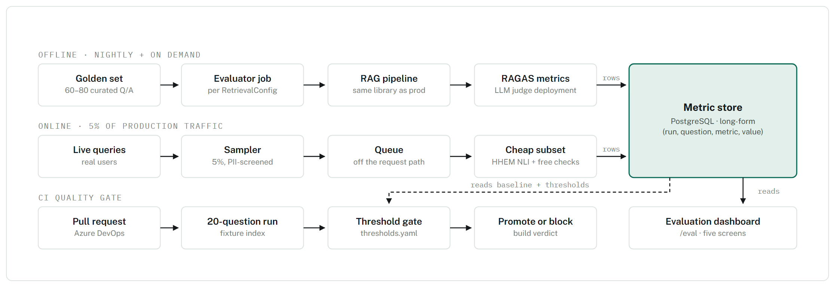
Figure 2. The offline path calls the same rag_core pipeline that serves production, so an eval score is a statement about shipped code. The online path deliberately runs a cheaper metric subset — an NLI cross-encoder for faithfulness plus the free deterministic checks — because paying an LLM judge on 5% of live traffic is how eval budgets get out of hand. The CI gate reads rather than writes: it compares this build's 20-question run against the stored baseline.

Building the golden set without spending a week on it
Bootstrap with RAGAS's TestsetGenerator, which builds a knowledge graph over the parsed documents and synthesises single-hop and multi-hop queries with references. Generate ~150 candidates, then curate down to 60–80 by hand — fixing wrong references, deleting the trivial, and recording gold chunk ids. Keep a provenance column marking synthetic vs. human-authored; synthetic questions skew easy and you want to be able to report the split.
Then add by hand the two categories generators are bad at, because they are the two that expose real failures:
- Table-dependent questions — "which segment had the largest operating income in FY23". Requires the table to have survived parsing, chunking, and the ranker's truncation window intact.
- Unanswerable questions — both the absurd ("the CEO's home address") and the plausible-but-absent ("FY26 guidance" in an FY23 filing). The second is far harder and is where hallucination actually happens.
Target mix: 30% single-fact, 25% multi-hop, 25% table-dependent, 20% unanswerable.

8. The RAGAS suite, and what each metric actually catches
Run the full suite nightly; run the cheap deterministic subset in CI and online. Every metric below is surfaced in the UI — the tables here are the metric registry the dashboard renders from.

Retrieval quality — is the right context reaching the model
Metric | Needs | Cost | What it catches here
LLMContextPrecisionWithReference | question, contexts, reference | LLM | Rank-weighted share of retrieved chunks that are relevant. Falls when top_k is too generous and filler pushes the real answer past the semantic ranker's read window.
LLMContextPrecisionWithoutReference | question, contexts, response | LLM | Same idea using the generated answer instead of a gold one — the version you can run on production traffic.
NonLLMContextPrecisionWithReference | contexts, reference_contexts | free | String-distance version. Deterministic and instant, so it belongs in the CI gate.
LLMContextRecall | question, contexts, reference | LLM | Whether every claim in the gold answer is supported by something retrieved. The metric that exposes a chunker splitting an answer across a boundary.
NonLLMContextRecall | contexts, reference_contexts | free | Gold chunk ids vs. retrieved ids — effectively hit-rate@k. Cheap regression tripwire.
ContextEntityRecall | contexts, reference | LLM | Entity coverage. Unusually informative on this corpus: tickers, fiscal periods and segment names are exactly the entities a vector-only retriever drops.
NoiseSensitivity | question, contexts, response, reference | LLM | How often the answer absorbs claims from irrelevant retrieved chunks. This is the specific risk hybrid retrieval creates by widening the candidate set — measure it before and after adding RRF.

Generation quality — is the answer supported and useful
Metric | Needs | Cost | What it catches here
Faithfulness | question, contexts, response | LLM | Decomposes the answer into claims and verifies each against the context. Your headline number and the CI gate's primary threshold.
FaithfulnesswithHHEM | contexts, response | NLI model | Same judgement from a hosted NLI cross-encoder instead of an LLM. Roughly two orders of magnitude cheaper — this is what the online 5% sample runs.
ResponseRelevancy | question, response | LLM + embed | Reverse-generates questions from the answer and compares to the original. Catches padded, evasive, or partially-answered responses that faithfulness happily passes.
ResponseGroundedness | contexts, response | LLM | Direct groundedness score; overlaps faithfulness but is cheaper and single-pass.

Correctness against a reference answer
Metric | Needs | Cost | What it catches here
FactualCorrectness | response, reference | LLM | Claim-level precision / recall / F1 against the gold answer. The best single "is it right" number; report the mode (precision vs. F1) you used.
SemanticSimilarity | response, reference | embed | Embedding cosine to the gold answer. Cheap, but generous — never quote it alone.
AnswerAccuracy / AnswerCorrectness | response, reference | LLM + embed | Blends factual and semantic agreement into one score for trend-watching.
ExactMatch, StringPresence | response, reference | free | Underrated on this corpus: assert the gold figure string ("$211.9 billion") is present. Zero cost, no judge variance.
BleuScore, RougeScore, NonLLMStringSimilarity | response, reference | free | Lexical baselines. Worth logging so you can show that LLM judges are telling you something the cheap metrics don't.

Custom evaluators — where the domain shows up
These are project-specific and are the ones that will distinguish the work. The first four are deterministic and free.
Metric | Definition | Why it matters
citation_validity | Share of returned citations whose chunk_id was in context and whose quoted_span occurs verbatim in that chunk. | Programmatic hallucination detection. Gate at 0.95+.
citation_precision / recall | Cited chunks vs. the question's gold chunk ids. | Distinguishes "cited something real" from "cited the right thing".
numeric_exactness | Parse figures from the answer, normalise scale and unit ($M vs $B, basis points vs %), compare to gold within tolerance. | The failure mode that matters most in finance and that no generic metric measures. A 1000× scale error scores well on semantic similarity.
fiscal_period_correctness | Does the period the answer describes match the period asked about? | The exact error vector-only retrieval produces — right company, wrong year.
refusal_accuracy | On the unanswerable subset: correct refusals. Reported alongside false-refusal rate on the answerable subset. | Both directions. A system that refuses everything scores 1.0 on one and is useless.
table_faithfulness | Faithfulness restricted to questions whose gold chunk has contains_table = true. | A segment cut, not a new metric — and typically the ugliest number on the board. Surfacing it is the point.
AspectCritic / RubricsScore | RAGAS general-purpose judges with your own rubric. | Powers the manager-letter tone score against a 1–5 anchored rubric rather than bare positive/negative.

Azure AI Evaluation SDK — the complementary set
Run alongside RAGAS, not instead of it. Its value is the service-backed evaluators and the fact that results land in Microsoft Foundry, which is worth a screenshot.
Evaluator | Adds over RAGAS
GroundednessProEvaluator | Service-hosted groundedness with a reasoning string; a second opinion from a judge you didn't prompt yourself, which is useful when your own judge looks suspiciously generous.
RetrievalEvaluator, DocumentRetrievalEvaluator | NDCG, XDCG, fidelity and "holes" against graded relevance judgements — proper IR metrics rather than binary relevance.
Relevance / Coherence / Fluency / Similarity | Presentation-quality dimensions RAGAS does not cover.
ResponseCompleteness | Partial-answer detection on multi-hop questions.
IndirectAttackEvaluator (XPIA) | Genuinely relevant here. You ingest third-party PDFs; indirect prompt injection through document content is a real threat model for this system. Almost nobody tests it.
ContentSafety, ProtectedMaterial | Baseline safety coverage for the deployed endpoint.

Operational metrics — logged per request, charted per day
- Latency, split by stage: retrieval_ms, rerank_ms, generation_ms, validation_ms at p50/p95/p99. An aggregate number hides that the semantic ranker is your tail.
- Spend: prompt and completion tokens, embedding tokens, estimated cost per query, and judge cost per eval run — track that separately or it will surprise you.
- Behaviour: refusal rate, citation failure rate, chunks retrieved, filter-extraction hit rate, cache hit rate.
- Freshness: index lag, documents failing parse, chunks pending re-embed.
Budget the judge, seriously
Faithfulness alone makes several judge calls per question (one to decompose claims, then verification). A full suite over 80 questions across 4 ablation configs is on the order of 5,000–8,000 judge calls per sweep. Three mitigations, all cheap to build: cache verdicts keyed on hash(question, answer, contexts, metric, judge_model) so re-runs cost nothing; use the free deterministic metrics for CI; and reserve the LLM suite for nightly and for deliberate sweeps.

9. Putting the metrics on screen
Five screens. The design rule throughout: never show a mean without the segment breakdown underneath it, and never show a score without the threshold it is being judged against.
Below is the Quality overview at /eval, the screen that answers "is it good, and is it getting better".
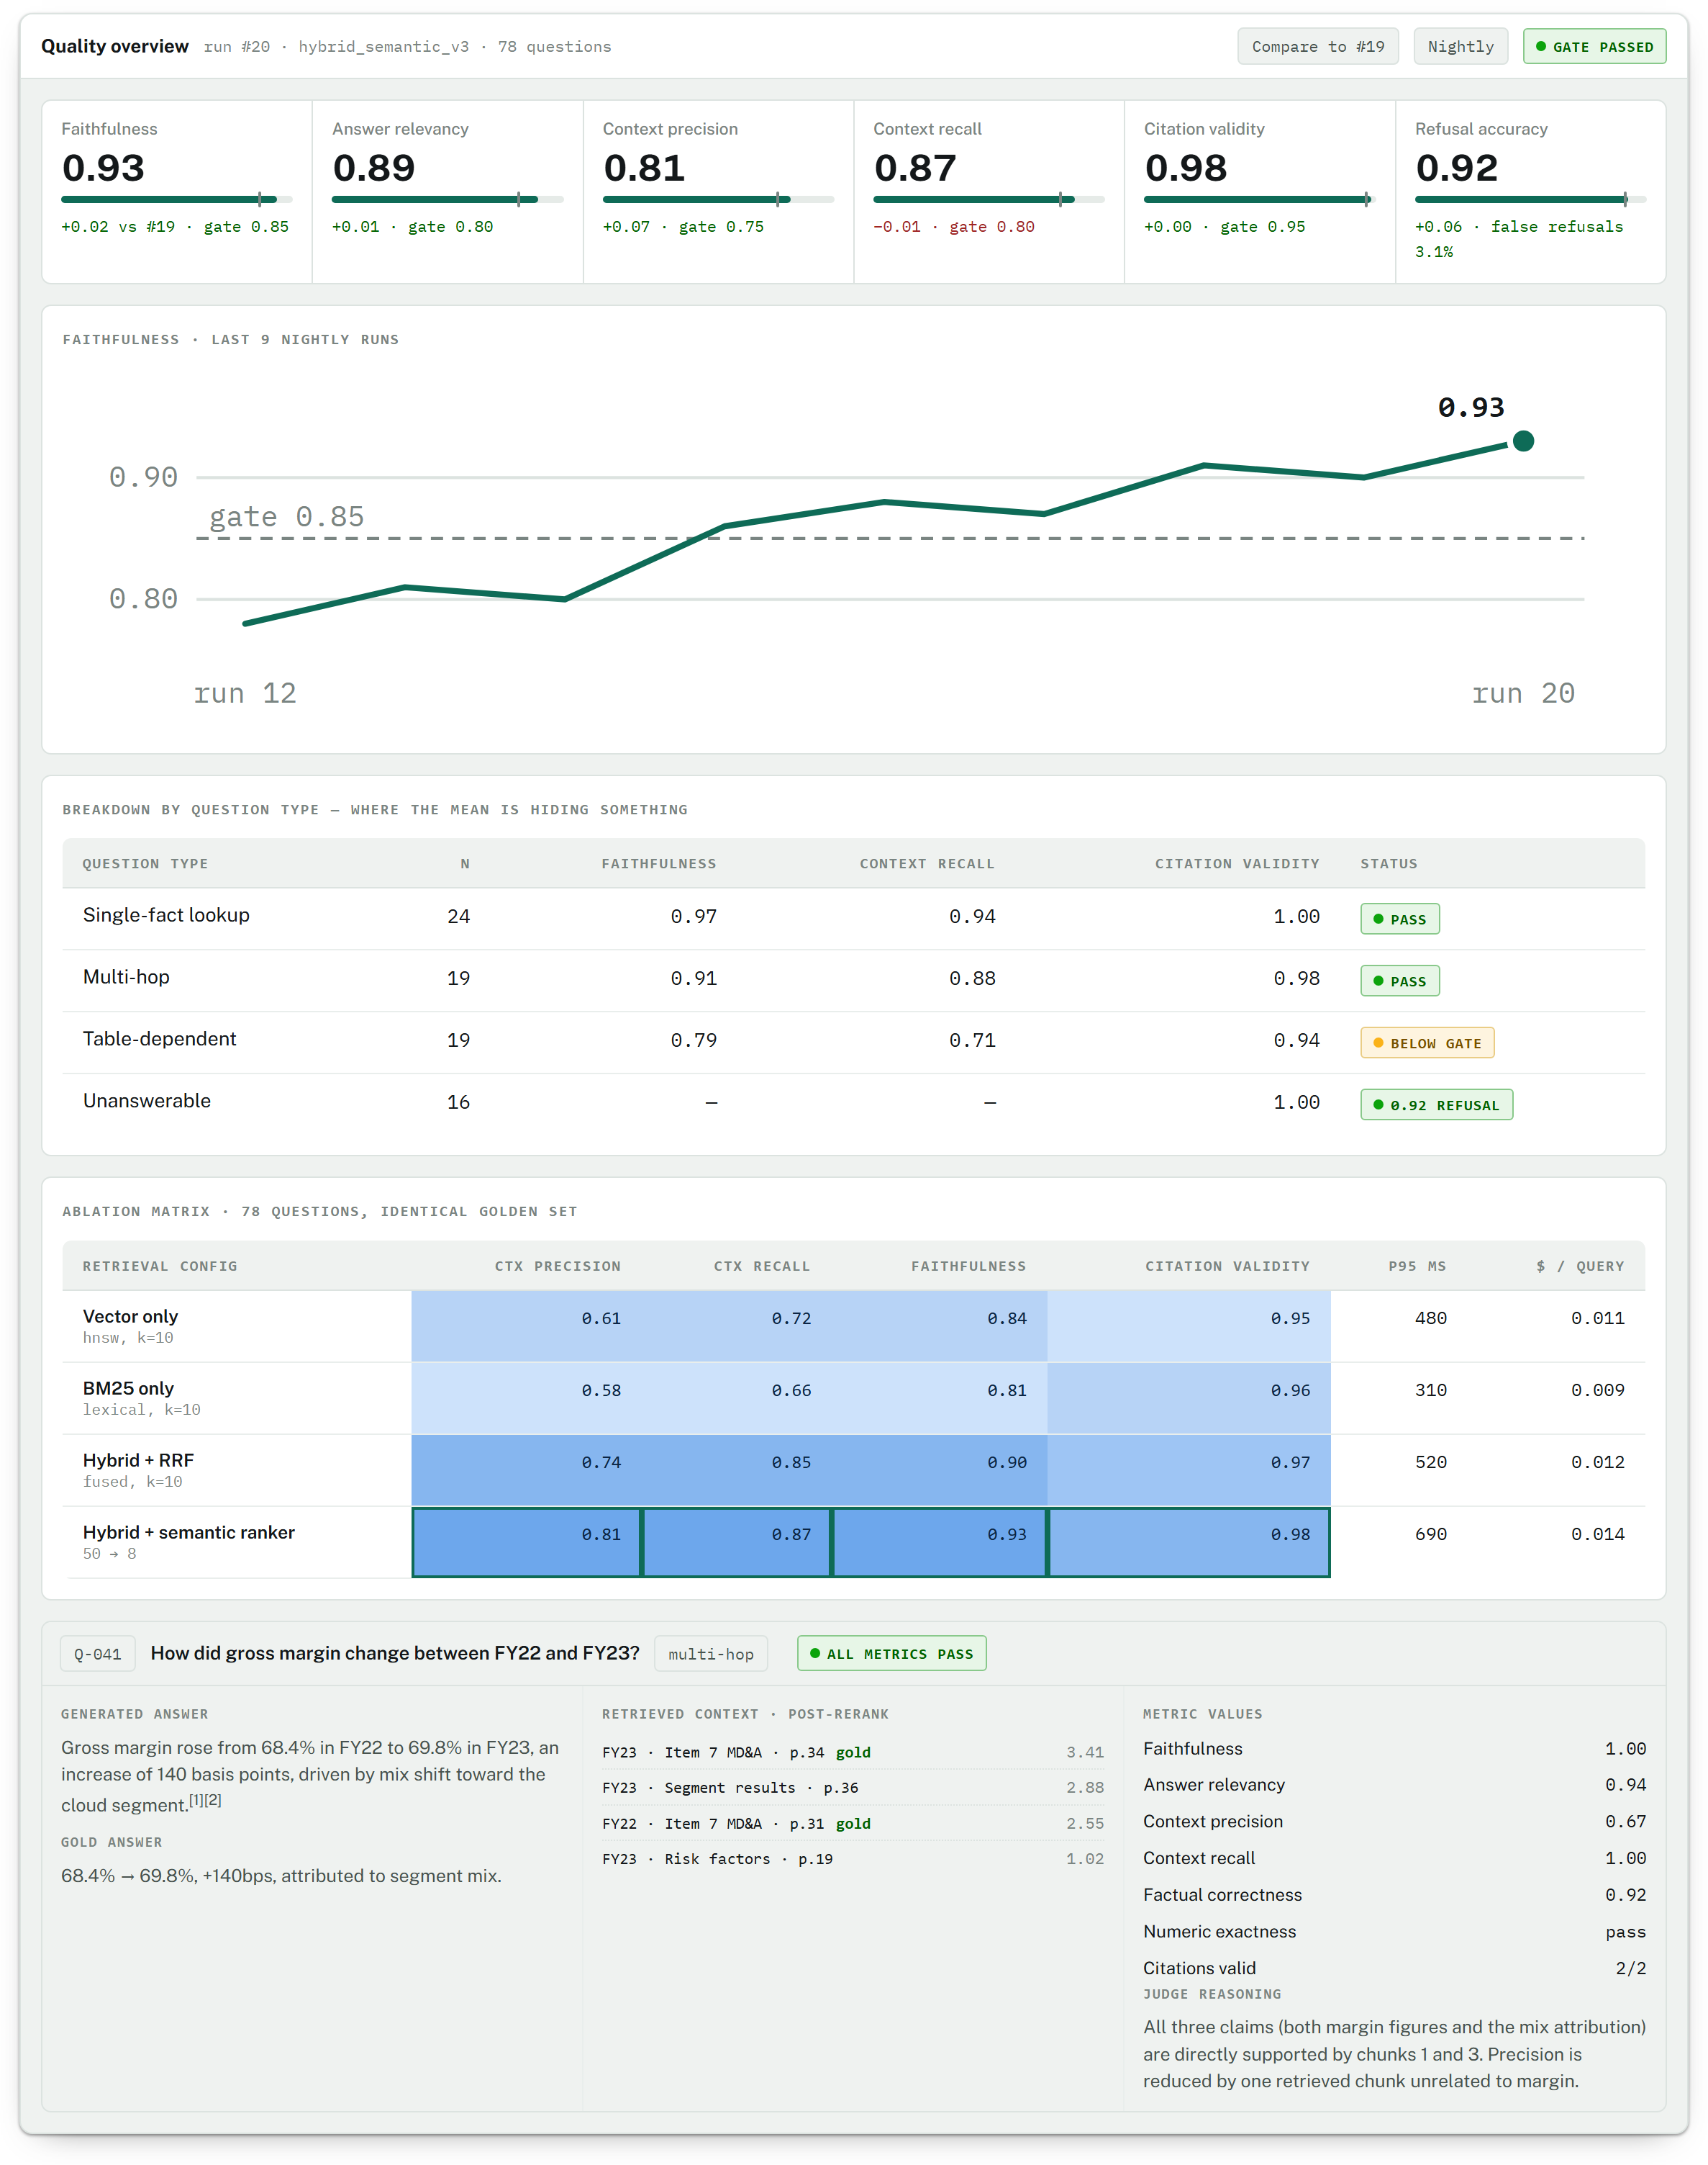
Illustrative layout — figures are examples, not measured results
Figure 3. Three deliberate choices. Threshold markers (the notch on each meter) mean a score is never presented without the bar it must clear. The type breakdown sits directly under the headline KPIs: overall faithfulness of 0.93 looks finished until table-dependent questions show 0.79, which is the actual next piece of work. And in the ablation matrix, only the quality columns are tinted — latency and cost are left plain, because a ramp where darker means "more" would read as "better" on two columns where lower wins.

The other four screens
- Run detail — every metric with its distribution, not just its mean. A metric averaging 0.85 because half the questions score 1.0 and half score 0.7 is a different system from one where everything scores 0.85, and only the histogram tells you which you have.
- Compare — two runs side by side with per-question deltas sorted by regression. After a prompt change this is the screen you actually use: it lists the six questions that got worse.
- Question drilldown — the panel shown above, full page, with the raw prompt and the per-retriever rank history for each chunk.
- Production quality — rolling window over sampled live traffic: faithfulness (NLI), citation failure rate, refusal rate, cost per query, and the top queries by low score. This is where you find out that real users ask things your golden set never imagined.

10. Security, observability, delivery

Security
- No keys in application code or config. DefaultAzureCredential everywhere; the Container App's managed identity holds Search Index Data Reader, Cognitive Services OpenAI User, and Storage Blob Data Reader. Admin keys are used exactly once, by the deployment pipeline, from Key Vault.
- Users authenticate with Entra ID; the API validates the token and applies document-level filters from the user's claims, so per-user corpus scoping is enforced in the $filter, not in the prompt.
- Treat ingested documents as untrusted input. They are third-party PDFs entering an LLM context window. Run the indirect-attack evaluator over a sample, and never let retrieved content reach a system-role message.
- Private Endpoints on Search, OpenAI and Postgres if you want the full enterprise posture.

Observability
OpenTelemetry spans per stage, exported to Application Insights, with custom dimensions on every request: config_id, retrieval_latency_ms, rerank_latency_ms, generation_latency_ms, chunks_retrieved, prompt_tokens, completion_tokens, estimated_cost, citation_validation_failures, refusal, filter_extracted, model_deployment.
Then four KQL queries worth building and screenshotting: p95 latency by stage over time; token spend per day by deployment; citation-failure rate as a 7-day trend; and refusal rate split by whether a metadata filter was applied — that last one usually reveals that over-aggressive filtering, not the model, is causing refusals.

CI/CD with a quality gate
Pipeline stages: lint → unit tests (chunker boundaries, table reconciliation, citation validator, metadata extraction, numeric normalisation) → integration tests against a small fixture index → build containers → eval gate → deploy.
The gate runs 20 questions against the fixture index and fails the build if any threshold in thresholds.yaml is breached: faithfulness < 0.85, citation validity < 0.95, context recall more than 3 points below the stored baseline, or p95 latency above budget. Use only free and NLI-based metrics here so the gate costs cents and runs in under two minutes.
A nightly pipeline runs the full LLM suite over the complete golden set across all configs and writes a new baseline. Wire a failure to a notification — a regression you don't hear about is a regression you ship.

11. Nine phases, each with an exit test
The order is chosen so that nothing is tuned before it can be measured — but also so the eval harness is not built before there is anything to evaluate. Phases 5 and 6 are the ones people skip; they are the ones worth protecting.

Phase 0 — Foundation (3 days)
Monorepo, uv workspace, Bicep modules for resource group, Storage, AI Search, Azure OpenAI, PostgreSQL, Key Vault and the Container Apps environment. Entra app registration. CI skeleton.
Exit test: One command stands up an empty but complete environment, and the API's health check performs a managed-identity-authenticated call to Search.

Phase 1 — Ingestion & parsing (week 1)
Blob layout, Event Grid → queue → job, Document Intelligence prebuilt-layout with async polling and resume, cross-page table reconciliation, the openpyxl path for spreadsheets, parsed cache.
Exit test: 200 documents parsed; unit tests merge ten known page-spanning tables correctly; re-running the job over the same corpus is a no-op.

Phase 2 — Chunking & indexing (week 1–2)
Layout-aware chunker with the never-split-a-table rule and context headers, full metadata set, index schema deployed as code, batched embedder with exponential backoff, upsert path.
Exit test: Chunk size is a RetrievalConfig parameter, and a full re-embed from the parsed cache completes without re-parsing a single document.

Phase 3 — Retrieval, generation, citations (week 2–3)
Single-request hybrid query with RRF, filter extraction, semantic ranker, citation-constrained prompt with structured output, the programmatic validator, trace persistence.
Exit test: A test that injects a fabricated citation into a model response is caught and dropped by the validator; /api/search returns per-retriever scores for every candidate.

Phase 4 — Chat frontend (week 3)
Next.js shell, streaming chat with typed SSE events, interactive citation markers, pdf.js document viewer with bounding-box overlay, corpus browser, per-answer quality footer.
Exit test: Clicking any citation opens the correct document page with the cited region highlighted.

Phase 5 — Golden set & eval harness (week 4)
RAGAS testset generation, curation to 60–80 questions with the four-type mix, RAGAS wired to a dedicated judge deployment, custom evaluators, judge-verdict cache, run persistence, Typer CLI.
Exit test: A single command produces a complete stored run; two runs of different configs are comparable with one SQL query.

Phase 6 — Evaluation UI (week 4–5)
The five screens: overview with thresholds and trend, run detail with distributions and segment breakdown, ablation matrix, comparison view sorted by regression, question drilldown.
Exit test: Every number on screen comes from the API; no static fixtures remain in the frontend.

Phase 7 — Ablations & tuning (week 5)
Four retrieval configs; chunk-size sweep at 300 / 500 / 800 / 1200; embedding dimensions 3072 vs 1024; optional local cross-encoder after the semantic ranker.
Exit test: The results table exists and the negative results are kept in it — "the cross-encoder cost 180ms and gained 0.004" is a finding, not a failure.

Phase 8 — Production wrap (week 6)
Key Vault, managed identity and RBAC data-plane roles; OpenTelemetry to App Insights; KQL dashboard; Azure DevOps CI/CD with the eval gate; online 5% sampling loop.
Exit test: Deliberately open a PR that degrades the prompt, and show the pipeline blocking it on the faithfulness threshold. That screenshot is the single best artifact in the project.

Phase 9 — Finance capabilities (week 6–7)
Document classification (few-shot LLM vs. fine-tuned DistilBERT, compared on accuracy and cost per document); structured extraction into a typed model validated by accounting identities; manager-letter summarisation with an anchored 1–5 tone rubric tracked per author over time.
Exit test: Extraction flags identity violations rather than silently accepting them, and the classifier comparison table shows both accuracy and unit cost.

12. What it costs and what will bite

Running cost, order of magnitude
For a 200-document corpus at roughly 80 pages each. Verify every figure against current Azure pricing for your region before committing — these are planning estimates for sizing decisions, not quotes.
Item | Shape | Rough scale | Note
Document Intelligence | one-off, per page | ~16,000 pages | The largest single ingestion cost. Reason enough for the parsed cache.
Embeddings | one-off, per token | ~10M tokens | Trivially cheap next to parsing. Re-embedding is affordable; re-parsing is not.
AI Search | monthly, tier | Basic + semantic | Fixed floor. The semantic ranker is separately billed — enable deliberately.
Generation | per query | low | Dev traffic only; dominated by context size, so chunk size drives it.
LLM judge (eval) | per sweep | 5,000–8,000 calls | The variable that surprises people. Cache verdicts; keep CI on free metrics.
PostgreSQL, Container Apps, Blob | monthly | small | Burstable tier and scale-to-zero.

Risks, in the order they will actually hurt
Risk | Mitigation
Azure OpenAI TPM quota is per-region and per-deployment; bulk embedding hits it immediately. | Check allocation before sizing the ingest job. Batch, back off exponentially, and give the judge its own deployment so eval never starves serving.
Document Intelligence async polling fails mid-run and restarts the whole corpus. | Per-document state machine with a resume point; the parsed cache makes a restart cheap.
Tables spanning page breaks return as two tables. | Explicit reconciliation on column count and header match, with unit tests over known cases.
The semantic ranker reads only ~2,000 tokens of the content field and silently truncates. | Keep chunks in the 500–800 token band; assert an upper bound in the chunker's tests.
LLM judges are non-deterministic; a 0.02 movement may be noise. | Fix judge temperature and version, pin the model deployment, and run the gate on a threshold band rather than exact equality. Record judge model on every run.
Tuning against 78 questions overfits to them. | Hold out 20 questions never used for tuning; report on both. Add production queries found by online eval back into the set over time.
Eval cost grows quietly with every added metric and config. | Judge-verdict cache, deterministic metrics in CI, full suite nightly only.
Indirect prompt injection through ingested third-party documents. | Retrieved content never enters a system message; run the XPIA evaluator over a sample of the corpus.
Portal naming drift — the console is now branded Microsoft Foundry (renamed from Azure AI Foundry, Jan 2026). | Write both forms in the README and CV. Azure AI Search and Azure AI Document Intelligence kept their names.
If you build only three things
The ablation matrix with real numbers, the citation validator, and the CI pipeline blocking a build on a faithfulness threshold. Everything else in this plan is supporting structure for those three — they are the parts that demonstrate you can operate a RAG system rather than assemble one.

