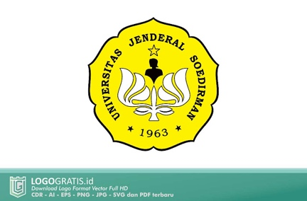 | UNIVERSITAS JENDERAL SOEDIRMAN | No : KKA-SA-2024  Tgl pemberlakuan: 22 Juli 2024
PROGRAM KERJA AUDIT MUTU INTERNAL
BIDANG AKADEMIK

Tanggal Audit | ${date}
Auditan | ${unit}
Auditor | ${auditor#1}  ${auditor#2}  ${auditor#3}

No. | Referensi (standar) | Pertanyaan | Keterangan
${no} | ${kode} | ${pernyataan} | ${catatan}

