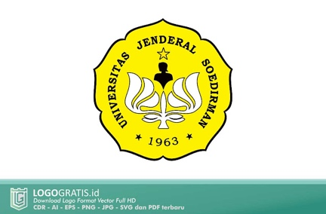 | UNIVERSITAS JENDERAL SOEDIRMAN | No : KKA-SA-2024  Tgl pemberlakuan: 22 Juli 2024
LAPORAN
HASIL AUDIT INTERNAL MUTU AKADEMIK (AIMA)

Tanggal Audit | ${date}
Prodi/Fakultas/Unit | ${unit}
Auditan | ${auditee}
Auditor | ${nomor#1} ${auditor#1}  ${nomor#2} ${auditor#2}  ${nomor#3} ${auditor#3}
HAL-HAL POSITIF YANG TERIDENTIFIKASI
No | Kelebihan | Ruang Peningkatan
${no} | ${kelebihan} | ${ruang}
RINGKASAN TEMUAN AUDIT
No | Deskripsi / Uraian Temuan | Kategori Temuan
 |  | Observasi | KTS Minor | KTS Mayor
${noTemuan} | ${temuan} | ${observasi} | ${minor} | ${mayor}
KESIMPULAN

 | Purwokerto, ${date}
Auditan,  ${image_auditee}  ${auditee} | ${no_auditor#1}  ${image_auditor#1}  ${auditor#1}
${no_auditor#2}

${image_auditor#2}

${auditor#2}
${no_auditor#3}

${image_auditor#3}

${auditor#3}

