WIPRO PJP INTERNSHIP

**Project Title - ATM**

# Project done by :

|  |  |  |
| --- | --- | --- |
| **NAME** | **EMPLOYEE ID** | **SUPERSET ID** |
| **Uma S** | **40120968** | **1265077** |
| **Vikasini D** | **40120895** | **1270862** |
| **Logeshwaran B** | **40117163** | **1568240** |
| **Lakshmi pavani** | **40120850** | **1390644** |
| **Rohini D** | **40120264** | **1354805** |
| **Dhayananth P** | **40120777** | **1260299** |
| **Dhiyaneswaran T** | **40120852** | **1260993** |
| **kollana Bharat kalyan** | **40118925** | **1120934** |
| **Mouliswari darsiguntla** | **40119956** | **1130960** |
| **Esa Kavya** | **40119840** | **1120934** |

**ABSTRACT**

The ATM System is a project that allows people to access their bank accounts and withdraw money. When a user needs to make a cash withdrawal, they can input their PIN number and the amount to be withdrawn will be displayed. The sum will be debited from their account once their withdrawal was completed. The ATM system is written in HTML, CSS, and JAVASCRIPT, using ORACLE as the back-end database. One consumer will be served at a time by the ATM. Each transaction will need a consumer to input their ATM Card number and personal identification number (PIN), both of which will be submitted to the database for validation. After that, the customer will be able to complete one or more transactions. A customer must also be able to inquire about their account balance. Each transaction will be communicated to the database, which h will verify that it was approved by the database. A second message will be issued after the transaction has been physically completed in the case of a cash withdrawal. Customers can also update their PIN and get their mini statements here. After logging in with the credentials, the admin can view the customer's transaction data.

## REGISTRATION PAGE

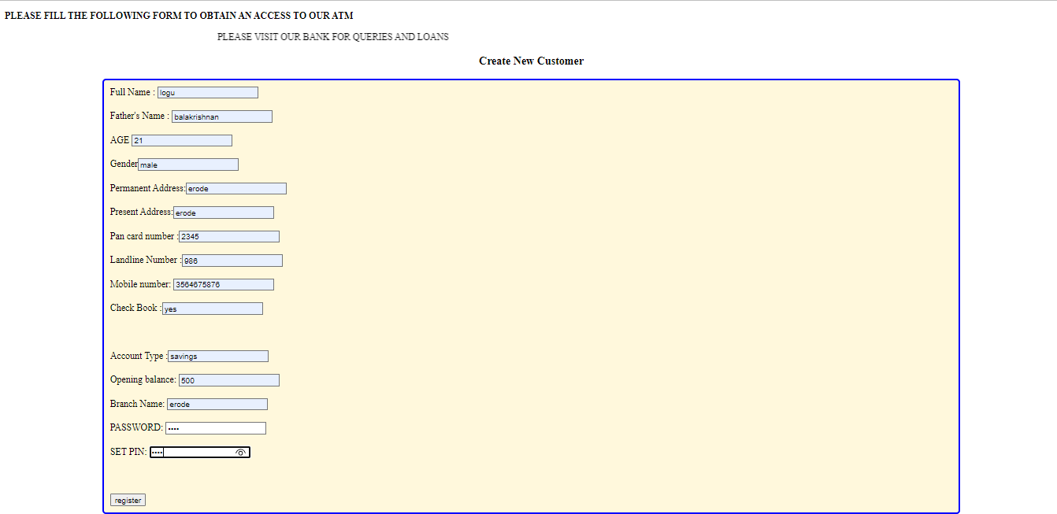

**LOGIN PAGE**

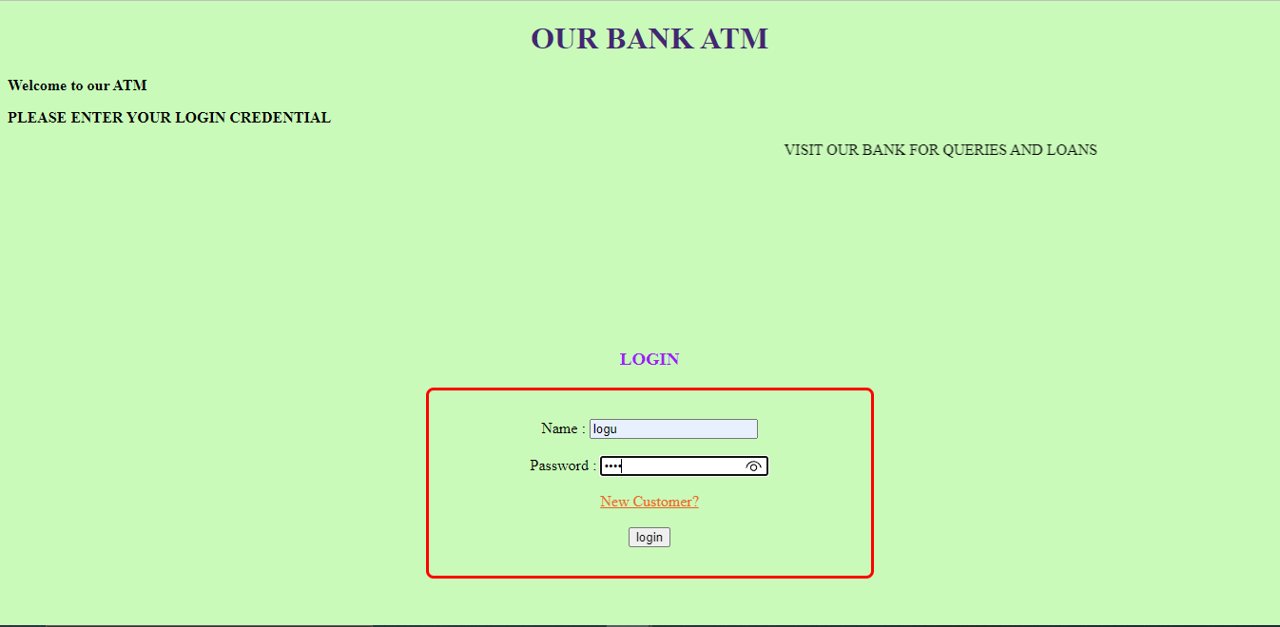

## ADMIN CONTROL

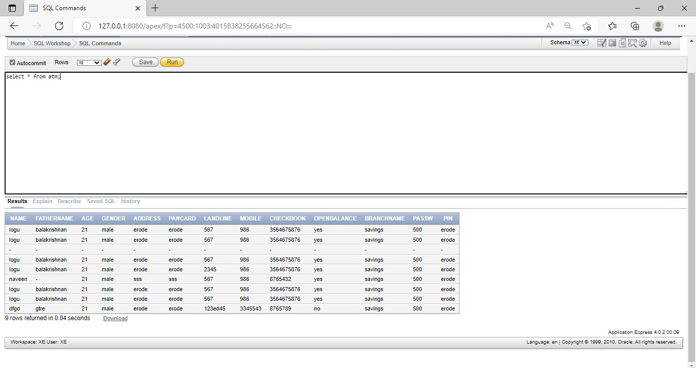

**OPTIONS FOR CUSTOMERS**

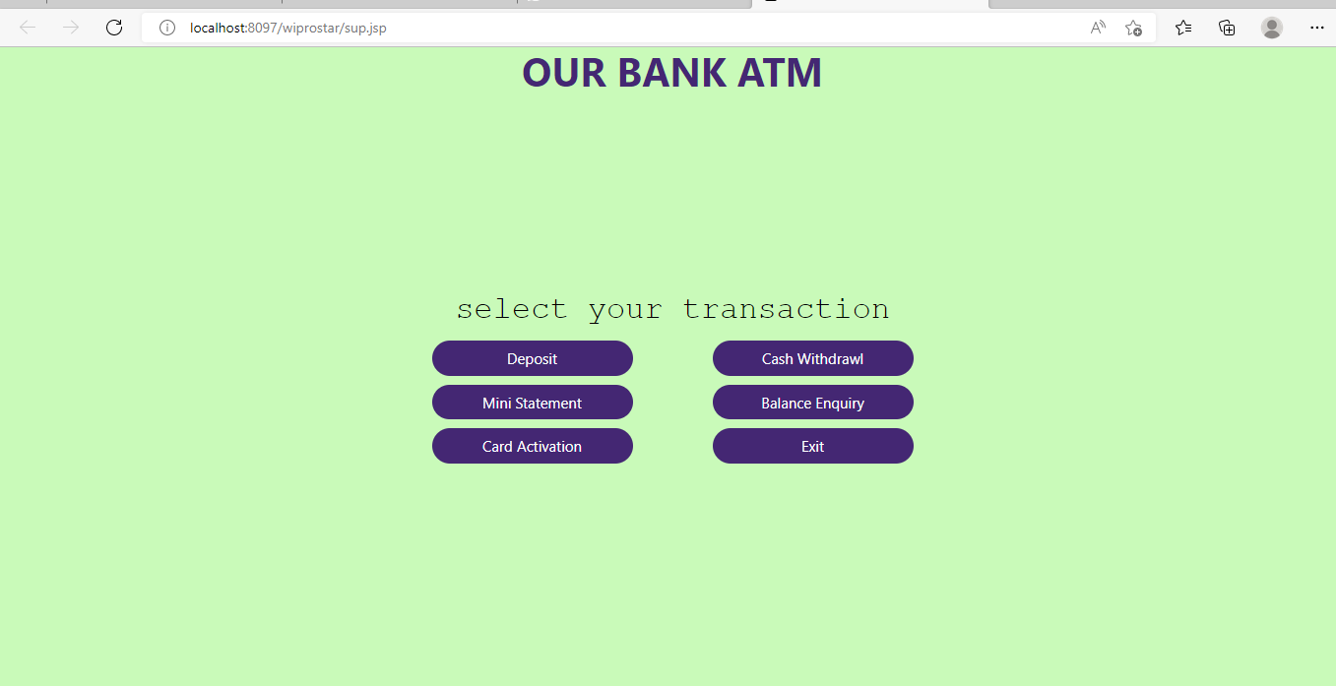

## CUSTOMER DEPOSIT PANEL

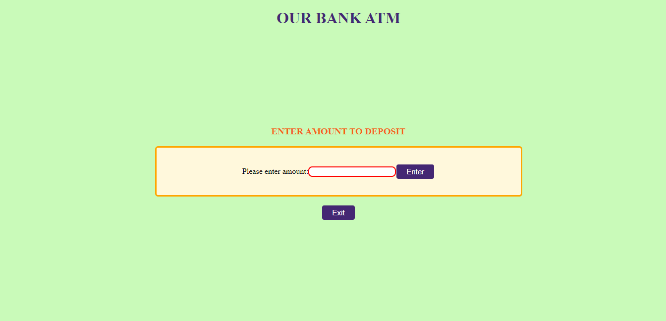

**CUSTOMER’S MINI STATEMENT**

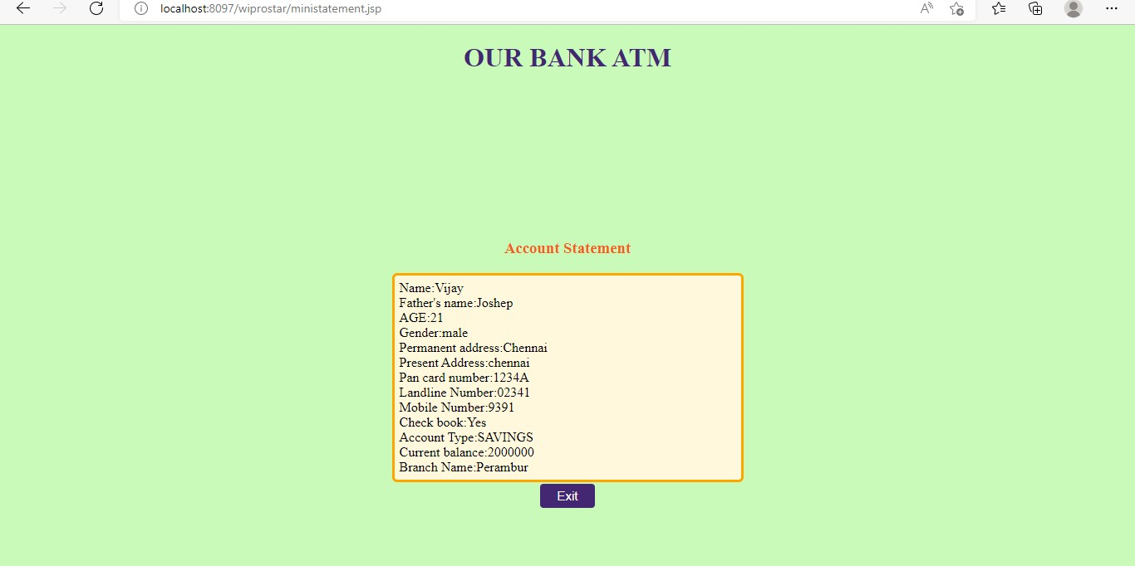

**SOURCE CODE**

### Register for new customer

import java.io.IOException; import java.io.PrintWriter; import java.sql.Connection; import java.sql.DriverManager;

import java.sql.PreparedStatement; import javax.servlet.ServletException;

import javax.servlet.annotation.WebServlet; import javax.servlet.http.HttpServlet;

import javax.servlet.http.HttpServletRequest; import javax.servlet.http.HttpServletResponse; @WebServlet("/wipro")

public class wipro extends HttpServlet { private static final long serialVersionUID = 1L;

protected void doPost(HttpServletRequest request, HttpServletResponse response) throws ServletException, IOException {

response.setContentType("text/html"); PrintWriter out = response.getWriter(); String n=request.getParameter("userN"); String p=request.getParameter("userF"); String e=request.getParameter("userD"); String c=request.getParameter("userG"); String a=request.getParameter("userPA"); String b=request.getParameter("userAD"); String d=request.getParameter("userP"); String f=request.getParameter("userL"); String g=request.getParameter("userM"); String h=request.getParameter("userC"); String i=request.getParameter("userA"); String j=request.getParameter("userBA"); String k=request.getParameter("userB"); try{

Class.forName("oracle.jdbc.driver.OracleDriver");

Connection conn=DriverManager.getConnection("jdbc:oracle:thin:@localhost:1521:XE","XE"," xe");

out.print(conn);

PreparedStatement ps=conn.prepareStatement("insert into atm values(?,?,?,?,?,?,?,?,?,?,?,?,?)");

ps.setString(1,n); ps.setString(2,p);

ps.setString(3,e); ps.setString(4,c); ps.setString(5,a); ps.setString(6,b); ps.setString(7,d); ps.setString(8,f); ps.setString(9,g); ps.setString(10,h); ps.setString(11,i); ps.setString(12,j); ps.setString(13,k); ps.executeUpdate();

response.sendRedirect("login.jsp"); out.flush();

out.close();

}catch(Exception e2) { out.print(e2);

}

}

# -----------------------------------------------------------------

### DATA INSERTING INTO ORACLE THROUGH SERVLET:

<%@ page language="java" contentType="text/html; charset=ISO-8859-1" pageEncoding="ISO-8859-1"%>

<!DOCTYPE html PUBLIC "-//W3C//DTD HTML 4.01 Transitional//EN" "<http://www.w3.org/TR/html4/loose.dtd>">

<html>

<head>

<meta http-equiv="Content-Type" content="text/html; charset=ISO-8859-1">

<title>REGESTRATION</title>

<center><h1>OUR BANK ATM</h1></center>

</head>

<body>

<p><b>Welcome to our ATM</b></p>

<p><b>PLEASE FILL THE FOLLOWING FORM TO OBTAIN AN ACCESS TO OUR ATM</b>

</p>

<marquee>PLEASE VISIT OUR BANK FOR QUERIES AND LOANS</marquee>

<center><h3><b>Create New Customer</b></h3></center>

<div class="container">

<form action="register" method="post">

<label>Full Name : </label><input type="text" name="userN" required ><br><br>

<label>Father's Name : </label><input type="text" name="userF" required ><br><br>

<label>AGE </label><input type="text" name="userD" required ><br><br>

<label>Gender</label><input type="text" name="userG" required

/>

<br><br>

<label>Permanent Address:</label><input type="text" name="userPA"

required ><br><br>

<label>Present Address:</label><input type="text" name="userAD" required ><br><br>

<label>Pan card number :</label><input type="text" name="userP" required ><br><br>

<label>Landline Number :</label><input type="text" name="userL" required ><br><br>

<label>Mobile number: </label><input type="text" name="userM" required ><br><br>

<label>Check Book :</label><input type="text" name="userC" required

/><br><br>

<br><br>

<label>Account Type :</label><input type="text" name="userA" required/><br><br>

<label>Opening balance: </label><input type="text" name="userBA" required ><br><br>

<label>Branch Name: </label><input type="text" name="userB" required ><br><br>

<label>PASSWORD: </label><input type="password" name="userBB" required ><br><br>

<label>SET PIN: </label><input type="password" name="userAC" required><br><br>

<br/><br/>

<input type="submit" value="register"/>

</form>

</div>

</body>

<style>

.body {

background-color:solid orange;

}

h1{

color: #442773;

}

.container{

margin: auto; width: 80%;

border: 3px solid blue; padding: 10px;

background-color: cornsilk; margin-bottom: 5px; border-radius: 6px;

}

.radio{

margin: auto; width: 50%;

border: 2px solid rgb(162, 156, 156); border-radius: 4px;

padding: 2px; float: left;

}

</style>

</html>

# -----------------------------------------------------------------

### LOGIN TO ACCOUNT DETAILS:

<%@ page language="java" contentType="text/html; charset=ISO-8859-1" pageEncoding="ISO-8859-1"%>

<!DOCTYPE html PUBLIC "-//W3C//DTD HTML 4.01 Transitional//EN" "<http://www.w3.org/TR/html4/loose.dtd>">

<html>

<head>

<meta http-equiv="Content-Type" content="text/html; charset=ISO-8859-1">

<title>LOGIN</title>

<center><h1><b>OUR BANK ATM</b></h1></center>

</head>

<body>

<p><b>Welcome to our ATM</b></p>

<p><b>PLEASE ENTER YOUR LOGIN CREDENTIAL</b>

</p>

<marquee>VISIT OUR BANK FOR QUERIES AND LOANS</marquee>

<center>

<h3><b>LOGIN</b></h3>

<div class="container">

<form action="sup.jsp">

<label>Name : </label><input type="text" name="userN"

required><br><br>

<label>Password : </label><input type="password" name="userP" required> <br><br>

<a href="index.jsp">New Customer?</a><br><br>

<center><input type="submit" value="login"/></center>

</form>

</div> <br>

</center>

</body>

<style>

body{background-color: #c9fab9 ;} h1{

color: #442773;

}

h3{

margin-top: 200px; color: #a21df4;

}

.container{ margin: auto; width: 30%;

border: 3px solid red; padding: 30px;

background-color: Very pale blue; margin-bottom: 7px;

border-radius: 8px;

}

.radio{

margin: auto; width: 80%;

border: 2px solid rgb(162, 156, 156); border-radius: 4px;

padding: 2px; float: left;

}

.button {

background-color: #442773 border: none;

color: white; padding: 6px 20px; text-align: center; text-decoration: none; display: inline-block; margin: 2px 1px;

border-radius: 4px; cursor: pointer;

}

.button1 {font-size: 15px;} a{

color: #f45d1d;

}

</style>

</html>

# -----------------------------------------------------------------

### MINI STATEMENT DETAILS:

<%@ page language="java" contentType="text/html; charset=ISO-8859-1" pageEncoding="ISO-8859-1"%>

<!DOCTYPE html PUBLIC "-//W3C//DTD HTML 4.01 Transitional//EN" "<http://www.w3.org/TR/html4/loose.dtd>">

<html>

<head>

<meta http-equiv="Content-Type" content="text/html; charset=ISO-8859-1">

<title>LOGIN</title>

<center><h1><b>OUR BANK ATM</b></h1></center>

</head>

<body>

<p><b>Welcome to our ATM</b></p>

<p><b>PLEASE ENTER YOUR LOGIN CREDENTIAL</b>

</p>

<marquee>VISIT OUR BANK FOR QUERIES AND LOANS</marquee>

<center>

<h3><b>LOGIN</b></h3>

<div class="container">

<form action="sup.jsp">

<label>Name : </label><input type="text" name="userN" required><br><br>

<label>Password : </label><input type="password" name="userP" required> <br><br>

<a href="index.jsp">New Customer?</a><br><br>

<center><input type="submit" value="login"/></center>

</form>

</div> <br>

</center>

</body>

<style>

body{background-color: #c9fab9 ;} h1{

color: #442773;

}

h3{

margin-top: 200px; color: #a21df4;

}

.container{ margin: auto; width: 30%;

border: 3px solid red; padding: 30px;

background-color: Very pale blue; margin-bottom: 7px;

border-radius: 8px;

}

.radio{

margin: auto; width: 80%;

border: 2px solid rgb(162, 156, 156); border-radius: 4px;

padding: 2px; float: left;

}

.button {

background-color: #442773; border: none;

color: white; padding: 6px 20px; text-align: center; text-decoration: none; display: inline-block; margin: 2px 1px; border-radius: 4px; cursor: pointer;

}

.button1 {font-size: 15px;} a{

color: #f45d1d;

}

</style>

</html>

# -----------------------------------------------------------------

**Sub.jsp:**

<%@ page language="java" contentType="text/html; charset=ISO-8859-1" pageEncoding="ISO-8859-1"%>

<!DOCTYPE html PUBLIC "-//W3C//DTD HTML 4.01 Transitional//EN" "<http://www.w3.org/TR/html4/loose.dtd>">

<html>

<head>

<title>

select transaction

</title>

<center><h1><b>OUR BANK ATM</b></h1></center>

<link rel="stylesheet" href="[https://cdn.jsdelivr.net/npm/bootstrap@4.1.3/dist/css/bootstrap.min.css](https://cdn.jsdelivr.net/npm/bootstrap%404.1.3/dist/css/bootstrap.min.css)"

integrity="sha384- MCw98/SFnGE8fJT3GXwEOngsV7Zt27NXFoaoApmYm81iuXoPkFOJwJ8ERdkn LPMO" crossorigin="anonymous">

</head>

<body >

<center>

<h3> select your transaction</h3>

<div class="container">

<div class="row">

<div class="col-sm">

</div>

<div class="col-sm">

<a href="deposit.jsp"><button class="button button1">Deposit</button></a>

</div>

<div class="col-sm">

<a href="withdraw.jsp"><button class="button button1">Cash Withdrawl</button></a>

</div>

<div class="col-sm">

</div>

</div>

<div class="row">

<div class="col-sm">

</div>

<div class="col-sm">

<a href="ministatement.jsp"><button class="button button1">Mini Statement</button></a>

</div>

<div class="col-sm">

<a href="balance.jsp"><button class="button button1">Balance Enquiry</button></a>

</div>

<div class="col-sm">

</div>

</div>

<div class="row">

<div class="col-sm">

</div>

<div class="col-sm">

<a href="bill.jsp"><button class="button button1">Card Activation</button></a>

</div>

<div class="col-sm">

<a href="login.jsp"><button class="button button1">Exit</button></a>

</div>

<div class="col-sm">

</div>

</div>

</div>

</center>

</body>

<style>

body{background-color: #c9fab9 ;} h1{

color: #442773;

}

h3{

font-family: 'Courier New', Courier, monospace; font-size: xx-large;

color:black; margin-top: 200px;

}

.button {

background-color:#442773; border: none;

color: white;

padding: 7px 30px; text-align: center; text-decoration: none; display: inline-block; margin: 4px 2px; border-radius: 20px; cursor: pointer; width: 80%;

height: 80%;

}

.button1 {font-size: 15px;}

</style>

</html>

# -----------------------------------------------------------------

### WITHDRAW DETAILS

<%@ page language="java" contentType="text/html; charset=ISO-8859-1" pageEncoding="ISO-8859-1"%>

<!DOCTYPE html PUBLIC "-//W3C//DTD HTML 4.01 Transitional//EN" "<http://www.w3.org/TR/html4/loose.dtd>">

<html>

<head>

<title>

CASH WITHDRAWL

</title>

<center><h1><b>OUR BANK ATM</b></h1></center>

</head>

<body>

<center>

<h3>ENTER AMOUNT</h3>

</center>

<div class="container">

<label>Please enter amount:</label><input type="text"><br><br>

<center><button class="button button1" onclick="fun()">Enter</button></center>

</div>

<p id="js"></p>

<center><a href="login.html"><button class="button button1">Exit</button></a></center>

<script>

function fun() {

document.getElementById("js").innerHTML = "<center><i>Transaction Completed!!</i></center>";

}

</script>

</body>

<style> h1{

color: #442773;

}

body{background-color: #c9fab9 ;}

.container{ margin: auto; width: 30%;

border: 3px solid orange; padding: 8px; background-color:Aqua; display: flex;

align-items: center; justify-content: center; border-radius: 6px;

}

h3{

margin-top: 200px; color: #f45d1d;

}

input[type=text] { border: 2px solid red; border-radius: 8px;

}

.button {

background-color: #442773; border: none;

color: white; padding: 6px 20px; text-align: center;

text-decoration: none; display: inline-block; margin: 2px 1px; border-radius: 4px; cursor: pointer;

}

.button1 {font-size: 15px;}

</style>

</html>