Assignment 7

3a. The file is packed using UPX - the Ultimate Packer for eXecutables.

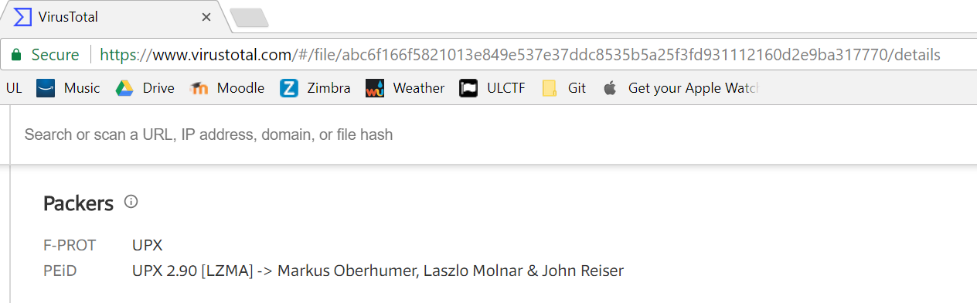

3b. 5 of 60 detected the file.

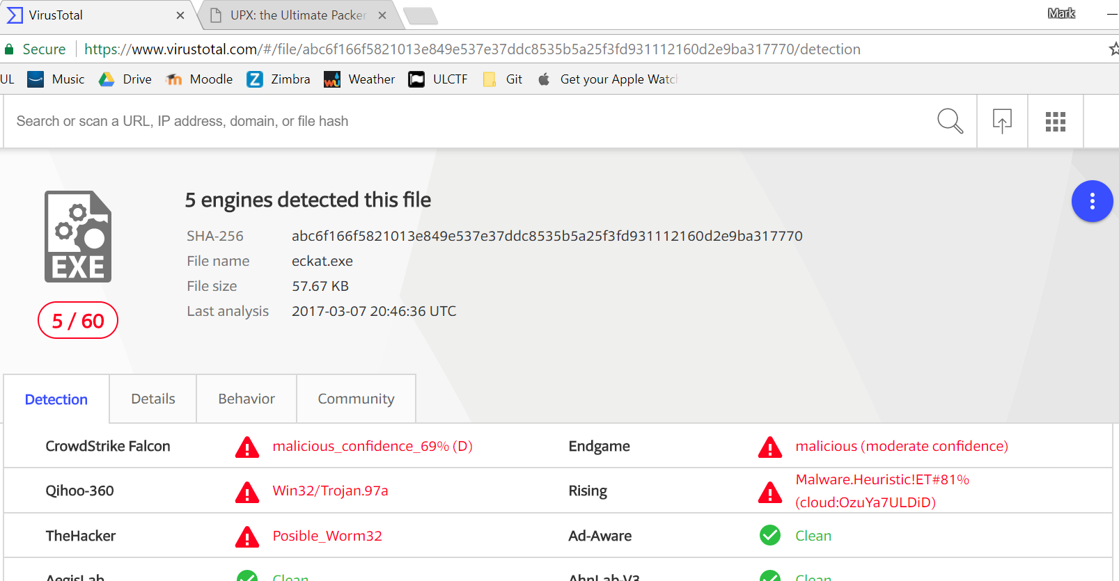

3c. The file makes get request to a site http:///eckat. The user is probably not notified about this web requests or made aware of it.