**Personal Assignment – Week01: DOCKER**

**Step 1.** **Prepare the Docker file:**

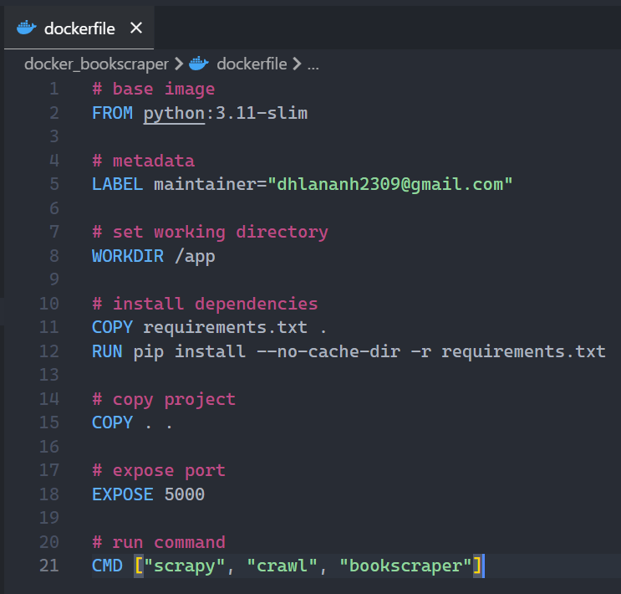

**Step 2.** **Build an image**:

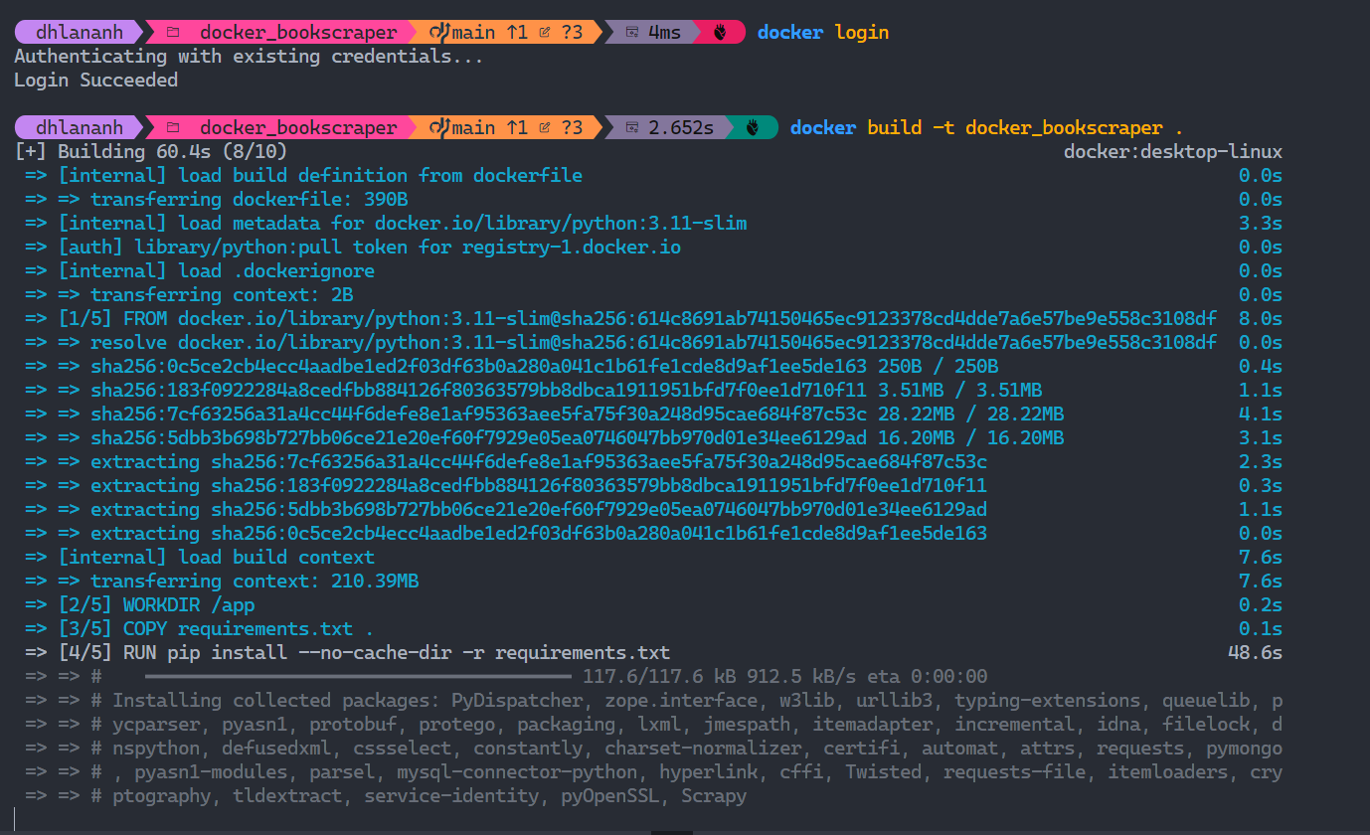

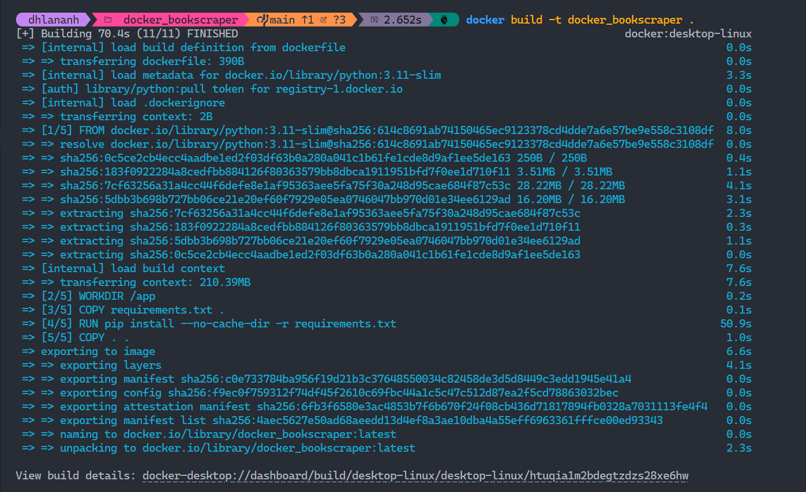

**Check Docker Images**

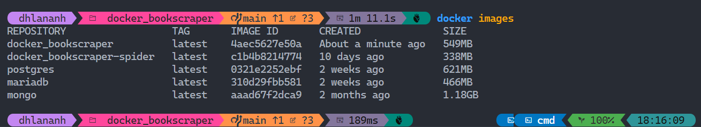

**Step 3. Push Docker Image into DockerHub**

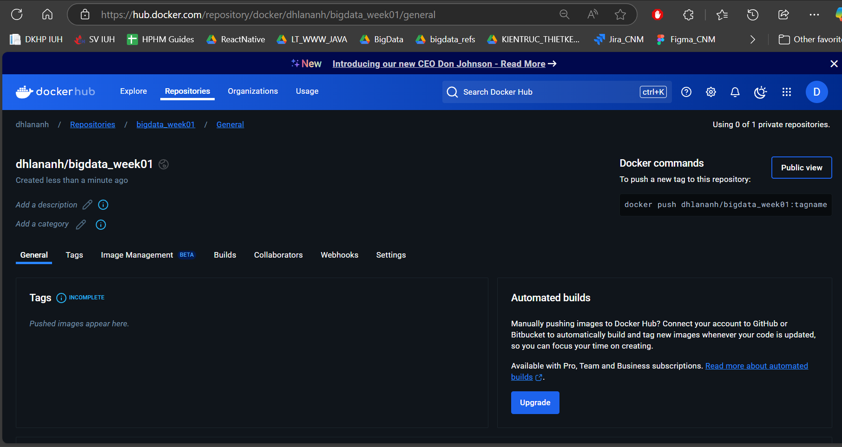First, I create a new repository in DockerHub like this:

Then, I tag the Docker Image I want to push using this command line:

Afterwards, I push the Docker Image into DockerHub:

Results on Docker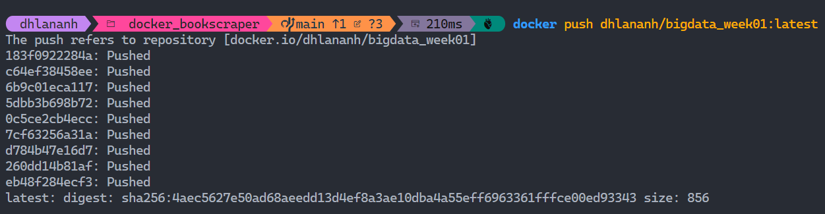Hub:

