How to start the camera server and Camera GUI Software

Starting Camera Server for Camera 1

1. Open a terminal.
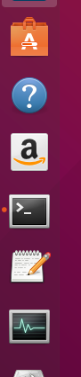

2. Enter the following:

/opt/DHM/bin/camserver -d -fp 2000 -cp 2001 -x Line2 -l ~/Desktop/cam1_data

NOTE: If you have more than one camera connected, you will be prompted to choose a camera. You must select in order to run the software.

NOTE: See Appendix A for usage and additional options

NOTE: use option -d to start with logging disabled, or use -e to start with logging enabled.

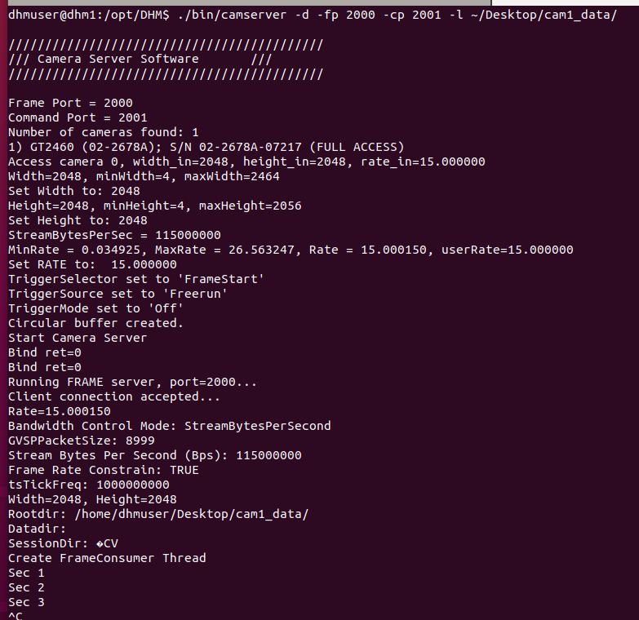

Starting Camera Server for Camera 2

1. Open a terminal and type:

/opt/DHM/bin/camserver -d -fp 200=50 -cp 2051 -x Line2 -l ~/Desktop/cam2_data

Open Camera GUI for Camera Server 1

1. Open another terminal (or a tab within the same terminal)

2. Change directory with the following: cd /opt/DHM/dhm_gui

3. Issue the following: python3 ./dhmxc.py -f 2000 -c 2001

NOTE: The camera GUI will poll at 1Hz until it connects to the camera server with the expected port.

NOTE: The port numbers must match with what is used on the camera server.

Open Camera GUI for Camera Server 2

1. Open another terminal (or a tab within the same terminal)

2. Change directory with the following: cd /opt/DHM/dhm_gui

3. Issue the following: python3 ./dhmxc.py -f 2050 -c 2051

NOTE: The camera GUI will poll at 1Hz until it connects to the camera server with the expected port.

NOTE: The port numbers must match with what is used on the camera server.

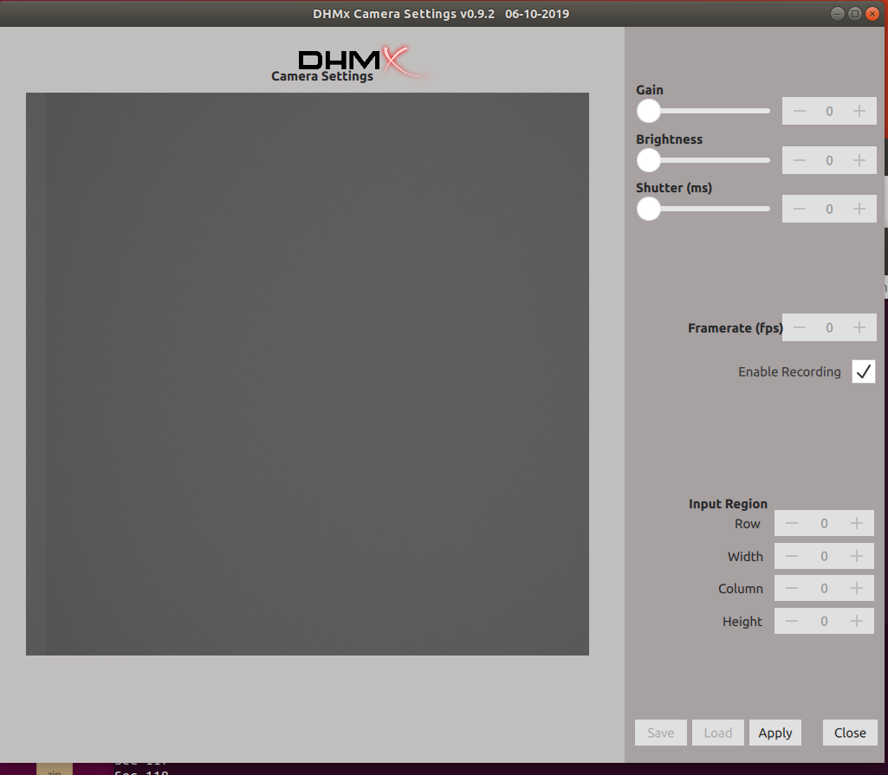

Start External Trigger Control

1. Open a terminal

2. Change directory using the following:

cd /home/dhmuser/Documents/git_repos/Laser-Pulse-Controller/Python 3.5/

3. Execute with the following command:

pytho3 ./startLaserPulseController.py

Appendix A

Camera Server Usage

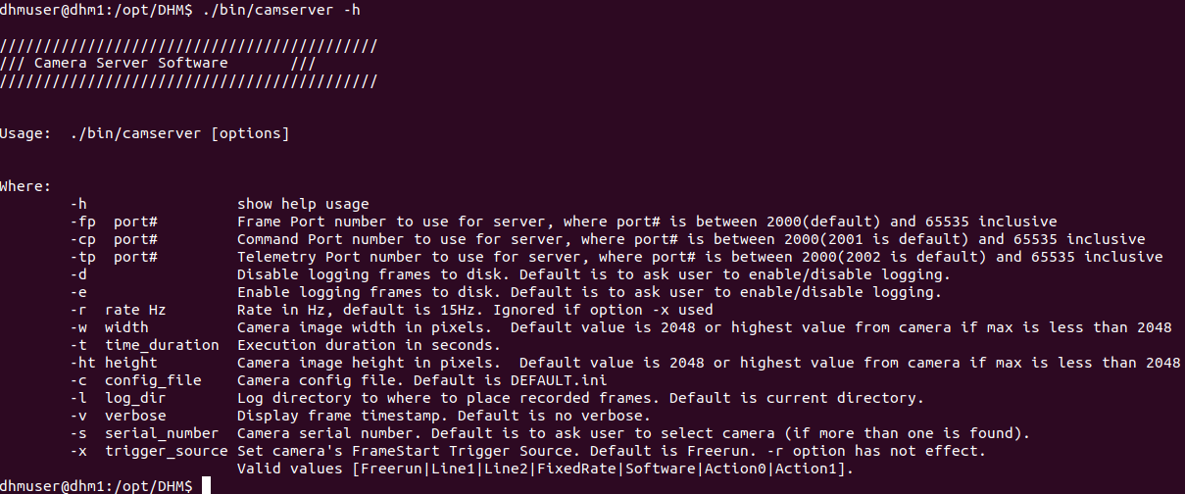

Camera GUI Usage

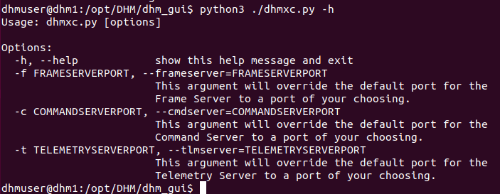

Mount USB Drive

1. Find out the device name of your USB drive

sudo fdisk -l

2. Mount the drive

udisksctl mount -b <device_name>

Example:
udisksctl mount -b /dev/sda1

To unmount (eject), do the following:

udisksctl unmount -d <device_name>

