msInspect Developer’s Guide
version 2.0

For msInspect version 2.0, released August 2008.

Damon May

Table of Contents
1 Introduction 4
1.1 About the msInspect Platform 4
1.2 About this Guide 4
2 Architecture 5
2.1 Package Structure 5
2.2 Ant 6
2.3 R 6
2.4 XML Beans 7
3 Command Modules 7
3.1 Arguments 8
3.2 Module Documentation 10
3.3 Module Discovery 10
3.4 Interactive (GUI) Mode 10
3.5 Examples 11
4 Testing Framework 12
4.1 MD5 Sum Comparison 12
5 GUI Utilities 12
6 Other Utilities 13
7.3 Feature-Finding Strategies 16

- Introduction

  - About the msInspect Platform
msInspect is a set of tools for analyzing MS data for proteomics, as well as a platform on which to develop and test those tools.

Where possible, efforts have been made to separate code that may be useful for a wide variety of purposes (the “msInspect platform”) from code that is specific to the functioning of the end-user applications (e.g., msInspect, MRMer, msInspect/AMT). The platform code includes structure for creating and displaying charts, interacting with the R statistical language, parsing various types of files, and, perhaps most usefully, creating individual modules that can be invoked from the command line (or through a graphical interface) with a controlled set of parameters.

For more information about the msInspect application, including a detailed discussion of msInspect’s features, please see the msInspect User’s Guide, available on our website at http://proteomics.fhcrc.org/.

  - About this Guide

This guide is a resource for developers of applications using the msInspect platform. We will concentrate on product architecture and high-level API documentation, with an eye toward developers who wish to add new functionality to msInspect, or to build their own applications that make use of the codebase.
We will also assume that the reader has full msInspect code access (see our website for access), and will defer to the codebase rather than duplicating information here where it makes sense to do so.
This guide uses the following typographical conventions:

Constant Width
for command line examples or code fragments

Constant Width Italic
for replaceable text in command line examples

Italic
for filenames, path names, and method names
bold
for class and package names

 Indicates a Note, Tip, or Example

- Architecture
msInspect was originally built as a tool for visualizing MS1 spectra and for locating MS1 features that represent peptides. As the platform has grown to contain other applications, substantial architecture changes have been introduced to make the codebase useful for various purposes. An emphasis is placed on reducing duplication of code.
msInspect is written primarily in Java. It relies on Java 1.6 (or newer), making heavy use of generics and other Java 1.5 additions. It uses the R statistical language for most statistical analysis. Graphics are typically rendered using Swing components, with SwiXML as shorthand for laying out components. XML is the basis for many file formats dealt with by msInspect, and XmlBeans are often used for translating XML into Java objects, using StAX iteratively on repetitive elements in order to conserve memory.
  - Package Structure
The following is a brief overview of the msInspect package structure. All of these packages live under org.fhcrc.cpl.
- toolbox: Code that is useful for many different types of applications: a framework for building Command Modules, for displaying different types of charts, interacting with the R statistical language, loading and saving tab-delimited files, etc. toolbox code has no dependencies on the viewer package and may be built separately.
  - commandline: classes related to building individual Command Modules, which may be invoked on the command line or graphically
    - arguments: classes that define different types of arguments (Boolean, String, Integer, etc)
  - gui: Utility classes for graphical user interface componets, e.g., charts, HTML generation
    - chart: classes for creating and displaying different kinds of charts, mostly via JFreeChart, with options for saving chart data, saving chart images to files, etc.
  - proteomics: Classes that are useful for proteomics applications of all kinds, e.g., protein in silico digestion, modeling of MS runs and scans, mass modifications
    - filehandler: Classes for dealing with Proteomics file types, e.g., PepXML, mzXML
  - test: Classes for building unit tests, particularly for individual Command Modules.
- viewer: Code that is more specific to the msInspect application. Although many classes in this package structure have utility outside of msInspect (See in particular Feature and FeatureSet, below. Also e.g., chromatographic alignment, retention time prediction), most of this code is specific to a particular set of features within the msInspect applications (msInspect, MRMer, Qurate). The toolbox code has no dependencies on the viewer code, but the viewer code has many dependencies on toolbox. If you need to incorporate viewer code in your application, you will need the full set of msInspect application dependencies.
  - align: code for aligning multiple MS runs chromatographically
  - amt: classes related to building and matching LC-MS peptide features against AMT databases
  - feature: classes related to LC-MS peptide features and feature sets
    - extrainfo: non-required sets of information that can be attached to peptide features, e.g., MS/MS data, isotopic label data
    - extraction: Classes related to all the different aspects of feature-finding (see below)
      - strategy: Classes that implement FeatureStrategy and embody a particular method of finding MS1 features
    - filehandler: for loading and saving different types of feature files (APML, tab-delimited, PepXML, etc)
  - database: database integration via Hibernate. Not fully developed at this time
  - gui: GUI-related files directly responsible for msInspect application UI
  - commandline: Command Module-related files specific to msInspect.
    - modules: individual Command Modules
    - arguments: command line argument definition classes specific to msInspect
  - ms2: Classes related to processing of MS/MS data
  - qa: Quality Assurance: classes for generating charts and statistics describing the performance of LC-MS experiments
  - normalize: code related to peptide intensity normalization.
  - quant: classes related to labeled quantitation, including Qurate
  - align: classes related to chromatographic alignment
  - util: msInspect utility classes used in many different places throughout msInspect, but still not generic enough to live under toolbox
  - test: testing framework classes
    - commandline: Individual testing classes for command modules, making use of the CommandLineModule structure

  - Ant
msInspect uses Apache Ant (http://ant.apache.org/) for build and testing operations. The file build.xml is used to build and deploy msInspect, and the file test/build.xml is used to run tests (see the section Testing Framework).
build.xml contains a target, jar_toolbox, for creating a JAR file containing only the “toolbox” packages. This is useful for using the toolbox classes to build applications other than msInspect.

  - R
Some msInspect functionality is written in the R statistical language (http://www.r-project.org). In general, R code should only be used when a Java implementation of the same functionality would require a large extra amount of effort or dependencies on significant new libraries. Please see the R Interface section of this guide for more details.

  - XML Beans
msInspect needs to interact with various types of XML files – to parse them into Java objects, and to write them out based on Java objects. These files include PepXML files, mzXML files, and amtXML files. mzXML has its own parser, and there is a PepXML loader in the tools package that is shared with CPAS. With those exceptions, all XML files are read and written using XML Beans (http://xmlbeans.apache.org/) to some extent.
XML Beans is architected around an all-in-memory, DOM representation of XML documents. Since we tend to read and write very large files with msInspect, it is therefore necessary to make use of XML Beans only for parsing and writing of small pieces of these XML files at a time. The class tools.Stax2DOMBuilder is used to build DOM trees from small portions of XML documents, which can then be controlled using XML Beans.
XML Beans requires schema documents for each type of document that you wish to read or write. These are stored in the directory schemas. XML Beans generates Java classes from these documents, which are included in the msInspect deployment.

- Command Modules
Applications built within the msInspect platform are invoked using Command Modules. A Command Module is an application that accepts a defined set of user arguments, parses the arguments, and performs a set of actions. Command Modules may be accessed through the command line, or through a simple graphical interface automatically built around the same functionality. The Command Module framework helps with the following tasks:
- Argument handling: arguments of many different types must be declared and parsed by the module
  - Interactive argument specification: a graphical user interface can automatically be generated for any Command Module to help the user specify all arguments, including file choosers for file arguments
    - Each time a Command Module is successfully run through the graphical interface, the specified user values will be saved and used as the defaults next time.
- Exception handling: If a command fails, exceptions are reported at the highest level in a controlled fashion
- Automatic documentation: basic help text, help for particular arguments, and HTML-formatted user manuals can all be automatically generated for any conforming Command Module
- Testing: test cases can easily be constructed to supply arguments to Command Modules
These needs are handled by the Command Module framework. The purpose of this framework is to make it easy, safe, and elegant to develop and document new pieces of functionality.
Each separate command in msInspect is managed by a separate class that must implement the interface toolbox.commandline.CommandLineModule. A base implementation class, toolbox.commandline.BaseCommandLineModuleImpl, is provided to facilitate creation of modules, but modules need not extend that class.
In msInspect, Command Modules are invoked by the Application class, though developers of new applications are welcome to invoke them however they like. The order of CommandLineModule methods as they are called by Application when a command is invoked:
- The module’s getArgumentDefinition method is called on each user-specified argument, to verify that the argument name is valid for this command
- Argument values are collected in a map, which is passed to the module’s digestArguments method, which may throw an ArgumentValidationException.
- If no exceptions are thrown, the module’s execute method (which may throw a CommandLineModuleExecutionException) is called
This is all documented extensively in Application and in CommandLineModule.
Beneath this level, there is a great deal of machinery for the handling of arguments. In BaseCommandLineModuleImpl, the digestArguments functionality is split up. Basic argument parsing is handled at the base-class level, using the argument definitions themselves to perform basic parsing on the argument values. Then, the subclass’ assignArgumentValues method is called in order to do more specific validation of the values and assignment to variables within the module.
 Tip: The command module framework is tightly integrated with the msInspect testing framework, making it very easy to create tests for particular modules. This is strongly encouraged for any custom modules you create. See the Testing Framework section for details.

A demonstration Command Module is provided, toolbox.commandline.DemoCommandModule. This module is extremely simple, processing only one File argument and generating a simple chart based on the contents of a PepXML file. This class has a main method, so it can be invoked as its own application. The main method, which passes argument handling to CommandLineModuleUtilities and the DemoCommandModule instance itself, can be copy-pasted almost verbatim into new modules. A much more complicated example of a Command Module, which is part of the msInspect application, can be found in viewer.commandline.modules.FindPeptidesCommandLineModule. Both Demo and FindPeptides are commented extensively.

  - Arguments
Argument declarations are embodied by instances of classes implementing the CommandLineArgumentDefinition interface. Classes that implement this interface know how to convert arguments of a given type from strings supplied on the command line into some useful object. This conversion, done in the convertArgumentValue method, can be simple, as in IntegerArgumentDefinition (which simply calls Integer.parseInt), or quite complex, as in FeatureFileArgumentDefinition (which opens the file specified by the user and parses it, creating a FeatureSet – see section 7). Each argument definition class also knows how to document itself, by implementing the getValueDescriptor method, and how to display the GUI components necessary to gather user input in a GUI screen (addComponentsForGUI) and retrieve the values from those components (getValueFromGUIComponent).
In general, it is best not to pack too much complexity into argument definition classes. The example of FeatureFileArgumentDefinition (in viewer.commandline.arguments) is an example of an argument definition that is perhaps too complex. It does significant processing on the input file, which is not ideal because all arguments must be digested before any argument post-processing is done in the CommandModule itself. So you may end up waiting for a feature file to load before discovering that another argument value is missing entirely. For this reason, CommandModules that need to open multiple feature files generally use FileToReadArgumentDefinition, and then only load the FeatureSets from those files when they are to be used. However, FeatureFileArgumentDefinition can be useful for modules that only need to deal with one file.
Arguments may be considered “basic” or “advanced” (as determined by calling their isAdvanced method). Basic and Advanced arguments are handled in exactly the same way by the platform; marking an argument as Advanced indicates to the user that it should not be specified except by expert users of a command. Advanced arguments are separated into a separate section in command documentation and interactive input.

 Tip: one particular argument definition class bears special notice. The class EnumeratedValuesArgumentDefinition allows you to specify a set of allowed values for the argument, with or without case sensitivity. One example of this kind of argument is used for modules that need to run in different modes – an informal standard is to create an argument definition of this type named “mode”, with a different allowed value for each mode.

BaseCommandLineModuleImpl contains convenience methods for declaring unnamed argument definitions and accessing the user-specified arguments.
FileArgumentDefinition is an abstract base class for all argument definitions that retrieve files (FileToRead, FileToWrite, DirectoryToRead, DirectoryToWrite, Fasta, FeatureFile).

 Example: this example describes how to set up a Boolean argument definition, which can be used as a flag (if it’s defined, your variable is set to true; if it’s not, it’s set to false) or as an explicit “true” or “false” setting by the user.
First, in your class, declare a member variable to represent the flag, and set its default value:
protected boolean myFlagResult = false;
In the init method, add an argument definition, defaulting to the initial value of myFlagResult:
addArgumentDefinition(new BooleanArgumentDefinition("myflag", false, "this is my flag”, myFlagResult);
In the assignArgumentValues method, parse the argument:
myFlagResult = getBooleanArgumentValue("myflag”);
Now the variable myFlagResult will contain the value specified by the user, or true, if the user specified the flag with no value (“—myflag”), or false (the default), if the user did not specify a value.

There are special methods for dealing with “unnamed” parameters – each CommandModule can have one argument, or a set of arguments, that are specified without names. This is particularly handy for lists of files. See FindPeptidesCommandLineModule, AmtDatabaseMatcherCLM, and, in fact, most other CommandModules for examples.
An array of argument definitions can all be added at once, and in fact this is the preferred method of specifying argument definitions. See most command modules for examples. All argument definitions in an array can be assigned “advanced” status by adding a second, Boolean argument to addArgumentDefinitions; see FindPeptidesCommandLineModule for an example.

  - Module Documentation
Command module usage can be auto-documenting, or a module’s documentation can be defined explicitly within the module. Module usage documentation is performed in the getUsage method. In BaseCommandLineModuleImpl, this is implemented as follows. If the mUsage variable has its default value, then usage documentation is generated automatically based on the known argument definitions. Otherwise, the mUsage string itself is returned.
Similarly, the mShortDescription and mHelpMessage variables provide a way for modules to give short and medium-length descriptions of their functionality, respectively. The short description is used in the generic msInspect usage message, and the help message is returned when the user invokes the help command for this module.
Within the msInspect application, users may access module documentation via the “help” and “usermanual” commands, which will display useful information about all of a module’s arguments, formatted for text and HTML, respectively. Module documentation is also used by the “interactive” command, to aid the user in selecting argument values. See the handling of the special “usermanual”, “help”, and “interactive” commands within the Application class for an example of how to invoke this documentation functionality.
  - Module Discovery
Within the msInspect application, multiple commands may be run, each one defined by a different Command Module. The set of available commands is determined by the Application class.
For custom application development, a class may be written that has a main method and also implements CommandLineModule. See DemmoCommandModule for an example.
At runtime, before attempting to parse the user’s arguments, the Application class within the msInspect application discovers the full set of Command Modules that are available. It does this by calling viewer.commandline.CommandLineModuleDiscoverer.findAllCommandLineModules. This method first loads definitions for all the standard command line modules, then discovers any custom modules.
Any class that resides in one of a set of packages defined in CommandLineModuleDiscoverer.modulePackageNames and implements CommandLineModule will be loaded as a custom module.
  - Interactive (GUI) Mode
Command Modules may be invoked graphically, using the Java class toolbox.gui.InteractiveModuleFrame. This will display a Swing dialog box with fields for user input of all mandatory and optional arguments (example below). Different kinds of arguments will use different GUI components for argument capture – for example, a Boolean argument will use a dropdown box with the values “true” and “false”, and a File argument will use a JFileChooser. The user may execute the command, at which point all arguments will be validated and, if there are no exceptions, the module’s execute method will be executed. Buttons are also shown for canceling the command, displaying the user manual for the command, saving the command (with arguments) to a file that may be executed later (optional) and showing the command-line command that would be equivalent to running the command with the specified arguments (optional).
This interface may be used as the user’s first interaction with a command (as in msInspect’s Application class), or (as in Qurate’s QuantitationReviewer.CreateChartsAction inner class) as part of a larger GUI workflow.
If you create a custom argument type and want to create custom GUI components (the default is a simple text field), you can extend InteractiveModuleFrame and override the createArgumentFieldPanel method.
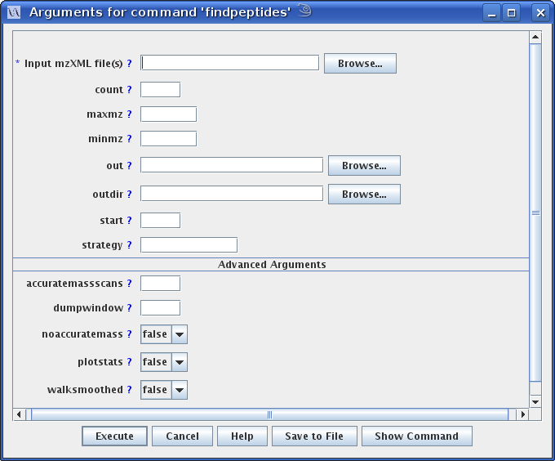

  - Examples

FindPeptidesCommandLineModule is a fairly straightforward example of the functionality discussed above. For a more complex example, see AmtDatabaseCreatorCommandLineModule.

- Testing Framework
msInspect has a mechanism for running automated regression tests. These tests are run under Ant, using an identical mechanism to the CPAS regression tests. The Ant build file for use in running tests is webapps/tools/test/build.xml. The “drt” target in this file runs tests. By default it runs all available tests, which are specified explicitly in the property file viewer.test.tests.properties. You may also specify a specific test name to run. For example, to run FindPeptidesTest, you would run “ant drt –Dtest=findpeptides”.
All tests should extend toolbox.test.commandline.BaseCommandTest. This class provides a cleanup method, which deletes any known temp files related to the test (see Temporary File Management below) and then passes control to the subclass’ doCleanup method; and a run method, which runs the test.
Since command modules are self-describing, it is quite easy to instantiate and run them as part of a test. The abstract class toolbox.test.commandline.BaseCommandTest provides several utility methods for instantiating command modules, assigning their argument values, and executing them repeatedly. See FindPeptidesTest for an example of how this structure can be used.
Individual tests can do whatever is necessary to ensure that a piece of functionality is working correctly. They can call any code within msInspect and use any means available for evaluating the results.
  - MD5 Sum Comparison
One useful and quick way to check the output of a piece of functionality is to have the feature write output to a file, perform an MD5 sum on the file, and check that sum against a stored sum. Naturally, this is a very restrictive way testing functionality, but it has its uses, and it’s extremely quick to implement: simply calculate an MD5 sum on an output file (removing anything date-dependent), store that sum as a constant in your test class, and compare it with the output at runtime.
The main method in the TestRunner class provides an easy way to calculate MD5 sums. Simply call that method with “md5sum <filepath>” as the arguments, and it will calculate the sum. First, however, it will strip all whitespace and comment lines (lines beginning with #) from the file. To compare an MD5 sum with this stored sum at test time, using the exact same code path, call TestUtilities.compareHexMD5SumsNoWhiteSpaceNoComments.

- GUI Utilities
There are a few graphical utilities that we’ve built in msInspect that come in handy in different situations. In general, if you’re building something that could use one of these, you should use it, to save yourself time and prevent code duplication; and if you find yourself coding the same widget more than once, you should consider moving it out into something generically useful. Graphical utilities live in the toolbox.gui.util package.
  - Chart Creation
The msInspect platform makes heavy use of JFreeCharts (http://www.jfree.org/freechart) for plotting various things. One example is the bottom pane on the main window of the msInspect application. The following classes are useful for creating and displaying charts:
- PanelWithChart: generic class for creating a panel with a chart in it. Right-clicking on the chart gives you ways to save, not just the chart itself, but the data that make it up
  - PanelWithScatterPlot: specific to scatterplots, making it easy to define the data series
  - PanelWithLineChart: for line charts
    - PanelWithPeakChart: a line chart for peaks; that is, each value should stick up as a vertical line from 0.
  - PanelWithHistogram: for histograms
  - PanelWithRPerspectivePlot: for creating 3D isometric-perspective charts using R
- ChartDialog: create a dialog box with a chart in it, which will die when closed
- MultiChartDisplayPanel: add multiple charts to a panel. This is set up to handle the multiple charts in a multi-tab panel, or in a panel with a dropdown list for selecting charts. A special context menu item on each chart automatically allows for saving all charts to a directory at once. Very handy for chart-intensive apps. Every PanelWithChart implements a displayInTab method for displaying the chart in a tab-style MultiChartDisplayPanel easily.
  - Etc.
- toolbox.gui.widget.SwingWorkerWithProgressBarDialog is a SwingWorker that pops up a ProgressBar in a dialog box and updates the status. Subclasses are responsible for using the methods provided here to do the actual updation of status. The dialog also contains a text label, with two optional tokens for the current and maximum value.
- toolbox.gui.HtmlGenerator generates simple HTML structures to hold lists, tables, etc. This code may be saved in a file and displayed in a browser, or it may be displayed in a toolbox.gui.HtmlViewerPanel, a simple HTML-viewer Swing widget.
- toolbox.gui.widget.SplashFrame is a subclass of JFrame that displays an image, disposing of itself if the image is clicked or a key is pressed
- viewer.gui.WorkbenchFileChooser is a thin wrapper on JFileChooser that saves the last directory opened in a WorkbenchFileChooser as a preference, and allows you to stipulate that chosen files must exist.
- Other Utilities
Non-GUI useful utilities go in the toolbox package. Their purposes are many and varied. Some examples:
- RInterface: interface with the R language (more on this in the R Interface section)
- TabLoader: handles the complexity of opening and parsing tab-delimited files
- TabWriter: writes tab-delimited files
- BasicStatistics: basic statistical functions such as mean, median, percentile, leverage, studentized residual…
- MatrixUtil: matrix manipulation, including simple linear regression
- RegressionUtilities: methods for performing robust linear regression, and modal regression
- Tree: models a tree of TreeNodes. InOrderBinaryTree models an in-order binary tree, very useful.
- BrowserController: does its best to pop open a browser window on a given URL. Can point to temp files, for quick and dirty HTML-based UI design
- SimpleXMLStreamReader: a simple XML stream reader. Other XML utilities include SimpleXMLEventRewriter, Stax2DomBuilder, and XMLStreamReaderWrapper

  - R Interface
As discussed above, msInspect makes use of the R statistical programming language in several ways. The msInspect platform defines a way to connect Java code and the R language. There are other projects that attempt this same connection in different ways (e.g., the Omegahat project), but none of those projects were adequately developed at the time of this writing.
All msInspect platform use of R should pass through the class util.RInterface if possible. This class provides several methods for executing R scripts and commands, managing all communication with R and cleaning up temporary files.
RInterface provides two mechanisms for interacting with R.
- Via the filesystem: msInspect writes a file, makes an R system call to do some processing on that file, and then reads an R output file to retrieve the result.
- Via the input and output streams of an R process.
Neither method is particularly elegant, but the other alternatives at this point are not good. The OmegaHat project (http://www.omegahat.org) has created a more elegant mechanism for calling R routines from Java, but it expects the user’s R installation to have some additional packages loaded. We’ve had enough trouble with users getting vanilla R installations set up correctly to be leery of anything that makes setting up R more complicated.
The RInterface class hides all the details of communication with R. RInterface provides two major methods for running R commands:
- runRScript: this method accepts a File, which may be located anywhere on the filesystem, and executes R in batch mode on the file. Output is defined by the script itself
- evaluateRCommand: this method accepts an R command, or series of commands, as a String and returns the complete result from R as a String, which the calling class must then parse. This method eschews file-based communication, instead grabbing the input, output and error streams of the R process
Both of these methods allow you to specify the number of milliseconds to wait for a response from R. They throw RuntimeExceptions if anything goes wrong.
Most R usage in msInspect uses the runRScript method. This allows fairly sophisticated R scripts to be run, potentially interacting with multiple files. A good example of this usage is in align.Aligner.alignPairs.
It is important to note that, when R is invoked, it will be run from the msInspect temp directory, which is retrieved from TempFileManager.getTmpDir (see below). Any temp files created by RInterface will be managed by TempFileManager (see below), and assigned to the calling object, which must be specified when calling runRScript.
There’s quite a bit of support in RInterface for loading arrays and matrices in and out of R. Check out the class AmtMatchProbabilityAssigner for examples.

  - Temporary File Management
Several features within msInspect (most notably interfacing with R) require the writing and reading of temporary files. This is all handled through toolbox.util.TempFileManager. It is important to clean up these temporary files at the appropriate time. If temp files are left around indefinitely they can clog up the user’s disk. If they’re deleted too soon, clues as to an error condition may be lost.
To allow the programmer flexibility in controlling temp files, TempFileManager keeps track of all the temporary files it creates, and it associates each file with an object. When requesting a temp file via TempFileManager.createTempFile (which accepts a filename), it is recommended to pass in an object that is designated as the “caller”. When it comes time to delete all the temp files related to an object (typically, when an operation has completed successfully), TempFileManager.deleteTempFiles is called, again passing in the caller object. TempFileManager.markFileForDeletion may be used to mark any file on the file system for deletion when deleteTempFiles is called, and so it should be used with extreme caution.
Caution should also be used in cleaning up the “caller” objects tracked by TempFileManager. If these “caller” objects are not cleaned up at the appropriate time, then a reference to them will be maintained in TempFileManager after they are needed by other code. This can result in severe memory bloat.

- msInspect-Specific Classes
The following sections detail classes specific to the msInspect applications (msInspect, MRMer, Qurate); they live under the viewer package.
  - org.fhcrc.cpl.viewer.Application
The Application class is invoked in order to run msInspect, either in command line or in GUI mode. MRMer and Qurate are implemented as Command Modules within msInspect. This class parses command line arguments and invokes the appropriate Command Module appropriately (see the section Command Modules). The main method acts as a switchboard to determine the appropriate action to take. If no arguments are specified, or if one unnamed argument is specified, Application invokes the msInspect GUI by calling its own start method.
The “—interact” command is handled specially within Application. This command opens up a window in which the user can input parameters relevant to a particular command (see the section Command Modules).
  - Feature and FeatureSet
The msInspect application deals with both MS1 and MS2 data. It models the unit of peptide location in both of those realms as a Feature. The Feature class represents a single peptide within a single run, in a single charge state and with a specific set of modifications. For MS/MS peptides, this means a single identified MS/MS spectrum. For MS1 peptides, this means a single set of isotopic peaks spanning (potentially) multiple scans. Many different classes within the msInspect application analyze and manipulate sets of Features, which are grouped into instances of the FeatureSet class. A FeatureSet typically represents the features (either MS1 or MS2, but not both) identified in a single LC-MS run. It carries some basic information about the run, such as the mzXML filename, modifications that are present in the run, and any labeled quantitation software that was used on the run.
FeatureSets are stored in Feature Files. These files may be PepXML files resulting from an MS/MS database search, or they may be .tsv (tab-separated value) files in the msInspect format representing either MS1 or MS2 features, or APML files representing MS1 features. The “convertfeaturefile” command provides conversion between these file types.
Features all have some basic variables – mass, m/z, retention time, etc. They may also have extra information specific to a particular type of feature. These extra fields are stored in a properties HashMap within Feature, and they are managed via classes in the feature.extrainfo package. For example, a Feature may be an MS2 peptide identification, in which case it will have a peptide sequence ID, and potentially a protein ID and quality scores. All of these fields are accessed and adjusted via static methods in MS2ExtraInfoDef. That same Feature may be isotopically labeled, and information about the light and heavy areas, and the ratio between them, may be accessed and adjusted via IsotopicLabelExtraInfoDef. The ExtraInfoDef scheme is used, rather than subclassing, because a given Feature may have several different kinds of extra information attached (e.g., both MS2 and IsotopicLabel, or just one or the other). FeatureSet instances carry information about the types of extra information carried by their member features – for example, and MS2 FeatureSet loaded from a PepXML file will know that its features have MS2ExtraInfoDef information.
Although the Feature and FeatureSet classes are in the viewer package, they may be useful outside the msInspect application, for custom application development. They are linked to many other classes within msInspect, so if you intend to use these classes, we recommend pulling in the entire msInspect codebase as a dependency.
Classes for reading in files to construct FeatureSets, and writing out FeatureSet files, are in viewer.featureset.filehandler.

  - Feature-Finding Strategies
msInspect contains methods for locating MS1 Features within mzXML files. Feature-finding strategies within msInspect are designed to be pluggable and extensible. We have created a modular structure for the various pieces of functionality involved in feature-finding. In order to implement your own feature-finding routine, you will need to take advantage of some of this infrastructure.
Below is a class diagram describing the most important classes involved in feature-finding:

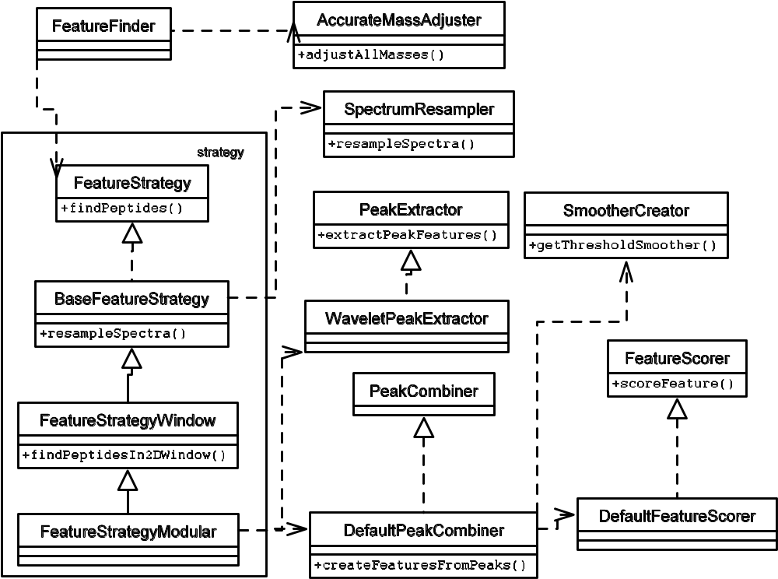

The FeatureFinder class is the one invoked directly by calling code, in order to find features -- it is instantiated directly by FindPeptidesCommandLineModule. A “strategy” class is passed to FeatureFinder that implements the details of feature-finding. In order to implement your own feature-finding routine, you will need to create a class that implements org.fhcrc.cpl.viewer.features.extraction.strategy.FeatureStrategy and pass that class to FeatureFinder.
The class diagram above shows the class structure for the default feature-finding class, FeatureStrategyModular. You do not have to make use of all of the structure that FeatureStrategyModular makes use of – your FeatureStrategy class only needs to implement FeatureStrategy and have a no-argument constructor. However, the structure provided is designed to take as much of the burden as possible off the individual feature strategy classes by compartmentalizing the complex behaviors common to different kinds of feature-finding strategies.

