msInspect User’s Guide
Version 1, March 2005

Table of Contents

1 Introduction 4
1.1 About msInspect 4
1.2 About this Guide 4
2 Getting Started 4
2.1 Installing msInspect 4
2.2 Creating mzXML Files 5
2.3 Opening an mzXML File 5
3 Viewing Files 6
3.1 Image Pane 6
3.2 Detail Pane 7
3.3 Chart Pane 7
3.3.1 M/Z Spectrum 8
3.3.2 Elution Profile 9
3.3.3 Working in the Chart Pane 10
3.3.4 Chart Pane Processing 12
4 Finding Features 13
4.1 Feature-Finding Algorithms 13
4.2 Detail Pane Settings 13
4.2.1 Detect Features 14
4.2.2 Low Threshold 14
4.2.3 Log and Sqrt 14
4.2.4 Remove background 14
4.2.5 Heatmap Colors 15
4.3 Finding All Features in a File 15
4.4 Displaying Peptide Features 16
5 Generating a Peptide Array 17
6 Identifying Peptides Using Fasta Files 19
6.1 Calculating Peptide Coverage 20
7 ‘Other Menu Items’ 20
7.1 File Menu Items 20
7.1.1 File Properties 20
7.1.2 Save Image… 20
7.2 Tools Menu Items 21
7.2.1 Run tool on scan 21
7.2.2 Copy Scan 21
8 Using msInspect from the Command Line 21

- Introduction

  - About msInspect

msInspect allows you to view electrospray ionization – time-of-flight (ESI-TOF) mass spectrometry (MS) data in an mzXML file. You can use msInspect’s built-in tools to inspect data, identify peptide features, generate peptide arrays using data from multiple runs, and export data to external applications for further analysis and collaboration. We are also developing tools for protein identification directly from MS1 data using Fasta files.

We also designed msInspect as a setting in which to develop and test analysis approaches for MS1 data. Because of this, some of msInspect’s features are still being modified and so may not be described in detail here. If you have questions about msInspect’s features, would like access to the source code, or have general feedback, please contact Matthew Bellew at mbellew@fhcrc.org. msInspect is open source application written in Java. …

  - About this Guide

This user’s guide will help you begin viewing your MS1 data. …

The examples used in the guide come from a simple 5-protein “mini” proteome dataset. LC ESI-TOF MS runs were done with mixtures of 5-protein and 4-protein samples (at varying concentrations). You can download a sample subset of this data along with msInspect. The Tutorial section of the Guide uses this sample data.

A brief description of the guide’s structure and format (e.g., font format for menu items, filenames) will go here…

- Getting Started

  - Installing msInspect

You will need Java Web Start installed to run msInspect. If you do not have Java Web Start, you can download it from the Java Web Start download page: http://java.sun.com/products/javawebstart/download.html.

Once you have Java Web start, you can launch msInspect using the launch link – http://edi.fhcrc.org/_tools/mzxml/viewer.jnlp - or by entering http://edi.fhcrc.org/_tools/remoteApps.html directly into the Location box in the Java Web Start Application Manager.
To enhance msInspect’s performance, try the JRockit Java Virtual Machine. Installing this JVM is not required to run msInspect, but it can make it run about 20% faster. If you’d like to try it, you can download it from the BEA Weblogic JRockit website at http://dev2dev.bea.com/products/wljrockit81/index.jsp.

  - Creating mzXML Files
msInspect displays mzXML files containing MS1 data. mzXML is an XML (eXtensible Markup Language) format for MS data. Mass spectrometers do not automatically produce mzXML files, but there are several tools available that generate mzXML files from various native acquisition files. The Sashimi website at http://sashimi.sourceforge.net/ offers a collection of converter programs for some common mass spectrometers.

msInspect will open any mzXML file containing MS1 data; however, msInspect has been designed for high-resolution LC ESI-TOF MS1 data. msInspect may not perform as well with an mzXML file from another type of MS (e.g., MALDI).
  - Opening an mzXML File
When you launch msInspect, you will see a File Open dialog box. (You can also select File > Open.) Browse for the mzXML file you want to view and click Open.

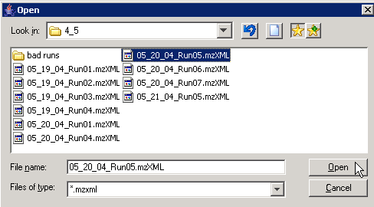

When you open a file for the first time, msInspect writes an ".inspect" file (yourfile.inspect) in the same directory as the original mzXML file so that subsequent opening is faster. This process can be time consuming so we recommend you do it on a machine with a fast connection to the disk where your original mzXML file is stored. If you do not have write access to the folder where the mzXML file is stored, msInspect will still open your mzXML file, but a new .insepct file will have to be created the next time you open the file.

When you open your file, the title bar at the top of the msInspect window will display “msInspect -- your file,” and the status bar along the bottom of the window will display “Finished Loading.”

- Viewing Files
This section describes the layout of msInspect’s display and the options you have for viewing your data.

The msInspect window has three panes: the Image Pane (top left), the Detail Pane (top right), and the Chart Pane (bottom).

Time/scan number
Image Pane
Detail Pane
Chart Pane
m/z
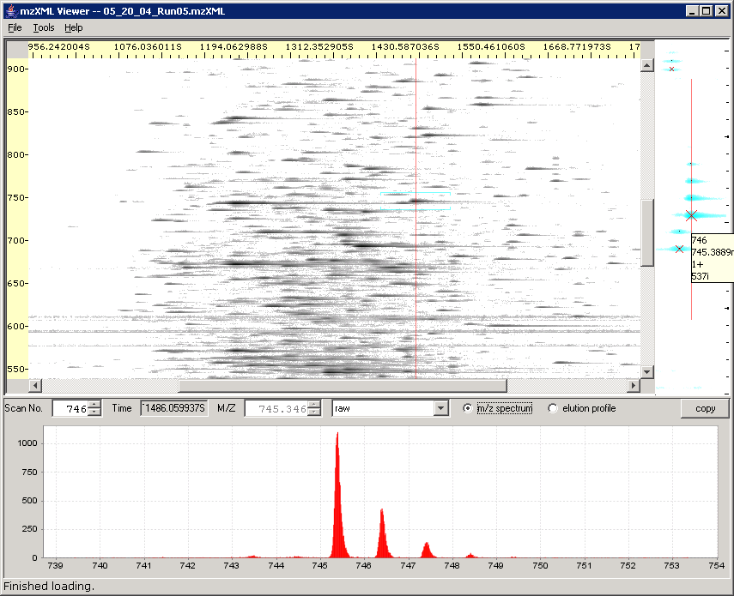

  - Image Pane
The Image Pane displays a 2D image of the data from your MS1 run. The Y-axis is mass-to-charge ratio (m/z): each horizontal line in the image equals 1 Dalton (1Da). The X-axis is marked in seconds, but each vertical line in the image corresponds to one MS scan. Time is displayed in addition to scan number since scan numbers aren’t necessarily comparable over different runs and because the relationship between scans and time can vary depending on the machine, its settings, and its performance. Ion current intensity is represented by the density (darkness) of the dot.

TIP: By hovering over various parts of the display, you can view additional details about the data (scan number/time and mass in Image Pane and Detail Pane; also shows charge state and intensity if you hover over marked features)…

When you click on the image in the Image Pane, a red vertical line marking the scan appears on the image, and the two other panes display data corresponding to the point at which you clicked.

  - Detail Pane
The Detail Pane along the right side of the window displays a zoomed in view of the image where you clicked. The Detail Pane is approximately 90 scans wide. The vertical area displayed in the Details Pane corresponds to the range of m/z values between the two blue, horizontal lines that appear in the Image Pane. The height (m/z range) varies slightly depending on the size of your window (i.e., a maximized window on a larger monitor will display a greater m/z range than a window that is restored down on a smaller monitor).

The red line in the Detail Pane corresponds to what is being displayed in the Chart Pane (see below). There are several options that allow you to choose what details are displayed in the Detail Pane. See the Detail Pane Settings section (4.2) for more information.

  - Chart Pane
The Chart Pane along the bottom of the window displays m/z spectra and elution profiles. You can switch between the two types of plots using the radio buttons at the top of the Chart Pane.

Scan No., Time, and M/Z for the plots shown in the Chart Pane also appear at the top of the pane. The drop down box contains options for displaying plots of the data using various signal processing methods (see section 3.3.4).

Clicking the Copy button at the top right corner of the Chart Pane copies the data displayed in red in the Chart Pane to the clipboard as a text file. You can then paste the data into another application such as Notepad or Excel.

You can add a title, axis labels, and a legend to the plots in this pane using the Chart Properties (see section 3.3.3).

    - M/Z Spectrum
The raw m/z spectrum for the single scan corresponding to the red line in the Image Pane displays by default in the Chart pane. The Y-axis is intensity, and the X-axis is m/z. This Y-axis automatically scales itself depending on the data being plotted.

You can move to the previous and next scans using the down and up arrows on the Scan No. field, respectively. You can also click inside the Scan No. field and use the down and up arrows on your keyboard to do the same thing. Or you can type in a specific scan number and press enter to jump to that scan.

      - Auto zoom
The Auto zoom option on the Tools menu only affects how the m/z spectrum is displayed in the Chart Pane. When Auto zoom is on, the plot in the Chart Pane is automatically zoomed in around the spot where you clicked; the width is 15-16Da, and the height (intensity) auto-scales to the peak heights in the region.

If you turn Auto zoom off, the intensity plot in the Chart Pane will cover the m/z values for the entire scan. Since this means more data must be displayed, turning Auto zoom off can slow down the generation of the plot.

Auto Zoom ON:
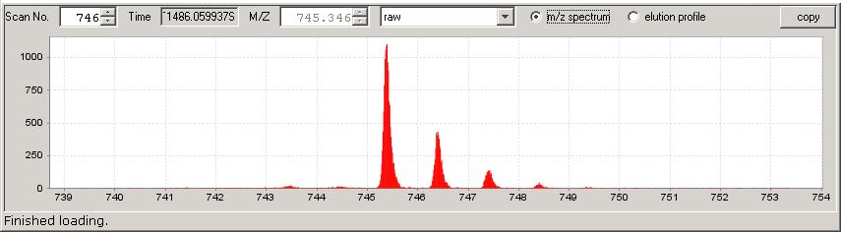

Auto Zoom OFF:
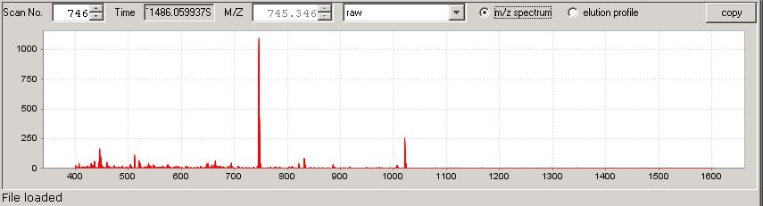

    - Elution Profile
You can use the Chart Pane to view an elution profile for any m/z. Clicking the elution profile radio button produces the elution profile at the m/z shown in the M/Z field at the top of the Chart Pane. Notice the red line in the Detail Pane is now a horizontal line corresponding to the same m/z. The Y-axis in the plot is intensity (again, this axis auto-scales), and the X-axis is scan number.

You can move to the higher and lower m/z values using the up and down arrows on the M/Z field. You can also click inside the M/Z field and use the up and down arrows on your keyboard to do the same thing. Or you can type in a specific m/z and press enter to jump to that value.

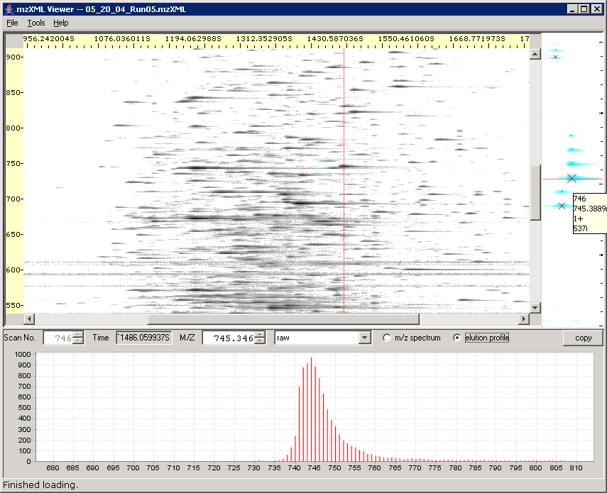
Clicking here displays the elution profile for the m/z value shown here.

    - Working in the Chart Pane
Right click anywhere in the Chart Pane to use the Chart Pane submenu. This submenu offers additional options for viewing, saving, and printing the data displayed in the Chart Pane.
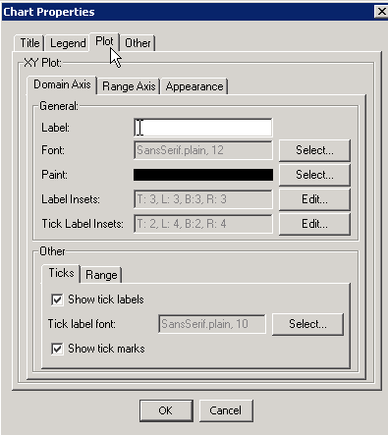
      - Properties
Select Properties from the Chart Pane submenu to modify the chart’s appearance, such as displaying a title or legend and changing the appearance of the plot’s axes.

      - Save as…
Choose Save as… from the Chart Pane submenu to save the full (zoomed out), raw data from a scan as a text files or as a PNG (Portable Network Graphics) image file. At this point, you cannot save images of any of the processed plots, but that functionality might be added in the future.

      - Print…
You can print a copy of the currently displayed plot by selecting Print from the Chart Pane submenu. We recommend printing in landscape rather than portrait mode given the layout of the plots.

      - Zoom
You can zoom in on any of the plots in the Chart Pane in two ways:
- Right click anywhere on the plot and select Zoom In from the submenu. You can zoom relative to one axis or the other or both.
- Using the mouse: click and drag to highlight (in gray) an area where you want to zoom in. When you release the mouse, a zoomed plot will be generated.

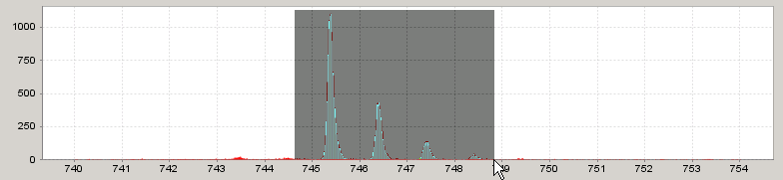

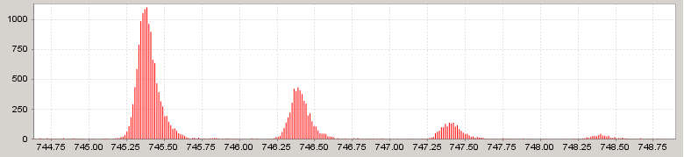

You can also zoom out by right clicking on the plot and selecting Zoom Out from the submenu. You can zoom relative to one axis or the other or both.

To return to the original scale, right click on the plot and select Auto Range. Again, you can modify one axis or the other or both.

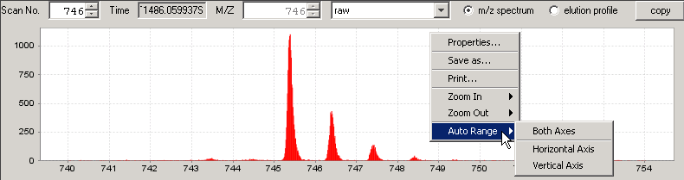

    - Chart Pane Processing
You can view m/z spectra and elution profiles using a variety of signal processing tools, each of which is described briefly below. [NOTE: I can add screenshots for any or all of the plots below.]

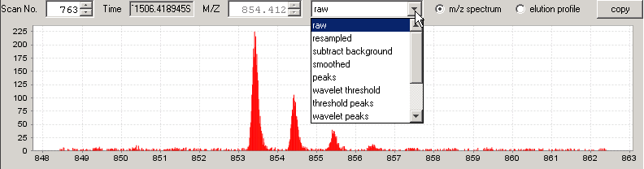

- Raw: the raw, unprocessed data (depending on the MS machine, anywhere from 100 to 200 samples per Da)

- Resampled: lightly processed data that reduces the number of data points to 36 per Da; The ‘horizontal’ red line represents the running minima (background), and the blue line represents the median values.

- Subtract background: produces the resampled data with the background (red line in the resampled plot) subtracted out.

- Smoothed: smooths the data in the subtract background plot.

- Peaks: shows the local maxima from the smoothed data plot.

- Wavelet peaks: identifies the location of peaks (m/z values); peaks are marked by red lines, which correspond to the local maxima found in the 3rd level in the wavelet multiresolution plot; intensities are determined from the smoothed data; wavelets are from the Haar wavelet family.

- Wavelet decomposition: wavelet plots (from top to bottom) for 1st, 2nd, 3rd, and 4th levels and one for the leftover signal.

- Wavelet decomposition2: another view produced as a composite of several other charts.

- Wavelet multiresolution: a reconstruction of the original signal made by adding the derivative plots.

- Finding Features
This section describes how to use msInspect to find peptide features in your data.

  - Feature-Finding Algorithms
There are several feature-finding algorithms listed in the Tools menu that can be used to detect features in the entire run (Find All Features) and in the subset of data displayed in the Detail Pane.

- Single Scan: finds features only in the selected scan. (NOTE: This can be useful for non-ESI MS data since it does not rely on there being continuity between adjacent scans.)

- Combined: combines the gross features and wavelet2D algorithms to identify features of interest.

- Gross features (intermediate result): detects edges in the m/z direction (vertical lines in Detail Pane) and in the elution (time) direction (represented by horizontal lines). Features are marked where these edges intersect. Isotopic distributions and charge states are not identified.

- 2D Peak Alignment: detects persistent (co-eluting) peaks and groups related peaks (across time and m/z) into features.

- Peaks (intermediate result): displays just the peaks detected in the first part of the 2D Peak Alignment algorithm above.

  - Detail Pane Settings
Select Tools > Detail Pane Settings to adjust what you see in the Detail Pane:

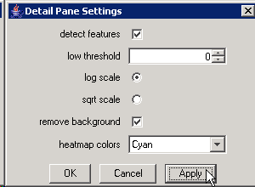
Choose whether to display the features detected using the algorithm you selected from the Tools menu…

according to these criteria…

and choose whether to remove background from the display.

You can also select your favorite color scheme.

    - Detect Features
When the Detect Features box is checked, msInspect uses the algorithm you selected from the Tools menu to detect features only in the data shown in the Detail pane. For most feature-finding algorithms, the monoisotopic peak is marked with an X. Larger Xs correspond to higher intensity peaks. Describe different views for different algorithms].

Detect Features ON: Detect Features OFF:

[AD: add shots here]

    - Low Threshold
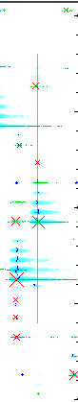
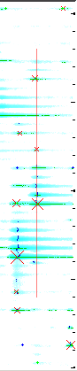
Image points (pixels) with intensities below the value entered in this box will NOT be displayed in the Detail pane. This criterion deals with how the image is scaled; it does not apply to the absolute intensities of features.

    - Log and Sqrt
The log scale (default) exaggerates the intensity of fainter features; the sqrt (square root) scale is more representative of actual intensities. We omitted a linear scale option because it tends to make everything except the largest intensities disappear.
Remove Background

    - Remove background
The ‘background’ for the area shown in the Detail pane is calculated and then subtracted from each data point. The difference becomes more dramatic when viewed on a more complex run with considerably more background noise and particularly when the run data contains streaks.

NOTE: If you select the ‘resampled’ m/z spectrum in the Chart pane, the background is represented by the red line running along the bottom of the plot.

    - Heatmap Colors
You can pick one of four color schemes for the Detail Pane display: Cyan, Grayscale (as in the Image pane), Fire (yellow/low intensity to red/high intensity), and Rainbow (violet/low intensity to red/high intensity).

  - Finding All Features in a File
To find all the features from a run file, select Tools > Find All Features. This generates and then displays a text file (file name.txt) of the features detected across the entire run using the algorithm you selected from the Tools menu.

Output | Definition
Scan number | The number of the scan taken by the MS machine in which the feature appeared
(Time) | The time in seconds at which the feature was detected
m/z | Mass-to-charge ratio of the peptide feature
Intensity | Signal intensity recorded by the MS machine for the feature
Charge | Estimated charge state of the peptide feature
KL | Kullback-Leibler value that measures the similarity between the feature’s peak pattern and the peaks expected from a peptide of that mass
Score | Future Investigation – we are currently evaluating scoring functions
Background | The (localized) running minima for intensity calculated across two dimensions
Median | The difference between the median and the minima/background in the resampled data
Peaks | Number of peaks in the feature

The data is only lightly filtered (e.g., the background value has already been subtracted out of the displayed intensity value) so you get as much data as possible. You can then do the analyses you feel are important in determining which features are ‘good’ matches rather than having msInspect do that for you.

When you choose Find All Features from the Tools menu, you will see the dialogue window below. Click the Browse button to choose where to save the file – the file path will appear in the Save Features to File field.

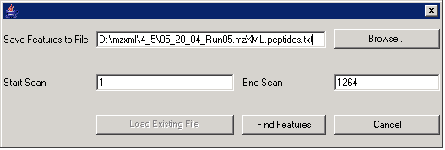

NOTE: If a file with the same name already exists, the Load Existing File button will be clickable (black text rather than gray). You then have three choices: 1) you can give the file you want to create a new name, in which case the Load Existing File button will turn gray; 2) you can open the existing file by clicking the Load Existing File button; or 3) you can keep the file name the same and save the new file over the original by clicking the Find Features button.

Choose the range of scans in which to detect features by filling in the Start Scan and End Scan numbers. Click the Find Features button to create and display the file. Features will be marked as colored crosses in the Image Pane. If you used the same algorithm for Detect Features in the Detail pane and for the Find Features file, the colored crosses and the Xs in the DP should line up.

  - Displaying Peptide Features
Choosing Display Peptides from the Tools menu will bring up the Peptide Files window (see the one to the right below – Fig. XX). You can specify which Feature files to display on top of the run data currently open in msInspect. The images in the Detail and Chart panes still correspond to your open run.

To add Feature files to the list, click Add Files, browse for the existing file you want to add, and click Open. You can display Feature files created from the open run and from other runs to visually compare data from multiple runs.

You can take files off of the list by clicking a file in the list and then clicking Remove Files. To retain a file in the list without displaying its features on the image, uncheck the Display check box.

You can choose the color of each file’s feature crosses by (left) clicking in the colored area at the right end of each row. Choose a color from the palette and then click OK.

The “…” button on the right displays the feature information in an editable table.

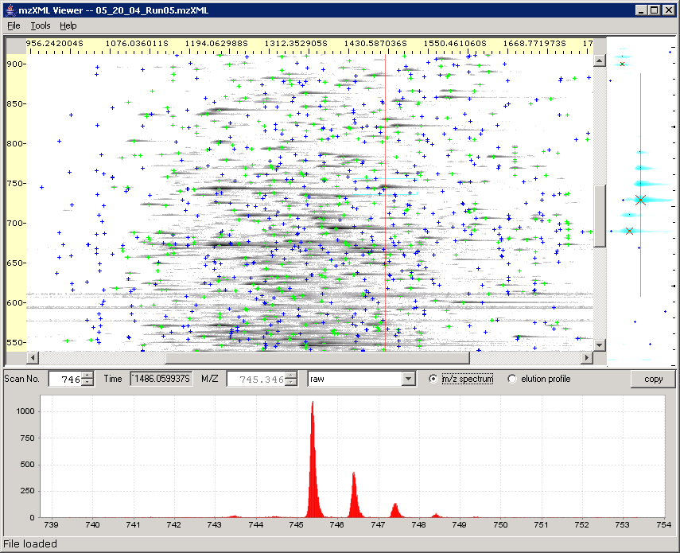
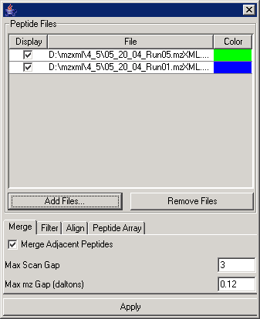

The tabs at the bottom of the Display Peptides window correspond to three of the steps involved in creating a peptide array (see below).

- Generating a Peptide Array
A “peptide array” is a term borrowed from the world of microarrays. Microarrays have thousands of spots, each of which binds to a particular complementary DNA sequence. Microarray experiments measure the intensity of spots on the arrays and these are clustered to find differences between sets of samples. LCMS experiments don’t have the notion of clearly defined spots that we can compare among runs. However, if a peptide is measured in several runs, it will always have the same mass (which can be computed from mz and charge) and a similar elution time.

msInspect builds peptide arrays by placing peptides found in different samples that have “matching” masses and elution times into “buckets”. The intensities of peptides from different runs that are put into the same bucket can then be compared and clustered (based on their intensities) using the same sets of tools currently used for microarrays.

Peptide arrays are created using a series of steps

- Feature detection. Features are detected and saved in files. The features detected in one run and saved in a file make up a Feature Set.
- Filtering. The feature detection algorithms will attempt to detect as many features as reasonably possible. Not all of these features will be included in each analysis. Several different metrics can be used to filter peptides/determine which features from the feature set to include in a peptide array.
- Feature alignment. Because elution time of peptides varies from run to run, an effort is made to align features between runs.
- Deconvolution. In any given run, the same peptide might be detected in different charge states. Peptides from multiple charge states are collapsed into a single point.
- Bucketing. Once features are aligned, features are placed into buckets with maximum sizes in both the scan and mass dimensions. Each bucket corresponds to a “spot” on the peptide array.
- Analysis. msInspect does not do analysis of peptide arrays. Any microarray analysis tool suite (open source ones are available in BioConductor or from TIGR) can be used to normalize and cluster this data producing an image of the array (include sample?).

Steps 2-5 above are presented in the user interface in the “Display Peptides” dialog box, which is described here.

- Merge - The merge step is important when peptide features are detected scan by scan. Since msInspect detects features across multiple scans, features in adjacent scans are already "merged" into a single peptide range and this step can generally be skipped.

- Filter – The filter tab allows features to be filtered. Filtering enables you to select which features to display on the image and include in the peptide array. Filtering criteria include

  - Min m/z,, Max m/z
  - Min Intensity. Low intensity features are generally detected less reliably than high intensity features. Values to use here will depend on the specific instrument being used.
  - Min Charge, MaxCharge. Minimum & Maximum charge of features to include. When the feature detector cannot resolve a charge state it reports a charge of 0. Generally you will not want to include these features in a peptide array because they cannot be deconvoluted properly.
  - Min Scans (minimum number of scans in which the feature appears),
  - Max KL. The Kullback-Leibler [Do we need a reference here?] a measure of how closely the observed isotopic distribution of this peptide matches a theoretical distribution. Lower numbers indicate closer matches.
  - MinPeaks. At least two peaks are required to infer a charge state.

- Alignment. Peptides from different runs are aligned using a smooth-spline algorithm implemented in R. The algorithm selects high intensity features from each run as a basis for alignment. It then computes smooth spline that optimizes the alignment of those points. Lower intensity features are then aligned using the computed spline. Note that this algorithm aligns all feature sets to the first set in the list (whichever file is listed first in the Display Peptides dialog box); if that set is an outlier the algorithm will not work as well.

- Optimize. Choosing the size of the buckets in creating a peptide array is critical. If buckets are too large, unrelated peptides will be placed in the same bucket. If buckets are too small, related peptides may be placed in different buckets where their intensities cannot be compared. The Optimize option performs the steps listed so far with a variety of bucket sizes. It then shows a graph of how many “perfect” buckets (ones with a single feature from each run) are available with each bucket size. You will see a plot of ___ vs. ___. The peak of that plot gives you the optimal bucket size for your array.

- Peptide Array – You can choose a name for the output file of your peptide array. The peptide array includes the following columns for each row. Each row is one bucket.

  - id: An id for this bucket.
  - minMass, maxMass: minimum & maximum mass for this bucket
  - minScan, maxScan: min & maximum scan for this bucket
  - featureCount: Number of features included in this bucket
  - setCount: Number of different feature sets that have a feature in this bucket
  - One intensity column for each featureSet.

In addition to the peptide array file, msInspect generates an additional .details.tsv file. This file includes one row for every feature along with the id of the bucket in which that feature was placed.

- Identifying Peptides Using Fasta Files
This feature of msInspect is still in development.

A fasta file (file name.fasta) contains a description of the proteome of an organism as derived from its genome. The data on proteins and their corresponding peptides in the fasta file can be compared to the features detected in the MS1 data. This comparison should allow for peptide identification directly from MS1 data for simple mixtures.
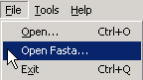
Before you open a fasta file, select Display Peptides and open a Features file. Once the Features file is displayed on the image, select Open Fasta… from the File menu.

When you open your fasta file, you will see a pop-up window [add screenshot eventually]. This window allows you to select a feature in your run data and search the fasta file for peptides matching that feature’s mass. You can also select a known protein in the fasta file and search your run data for features that match that protein’s peptides.

  - Calculating Peptide Coverage
This feature of msInspect is still in development. Briefly, once you have a fasta file open, you can calculate the degree to which the peptide features in your run data correspond to a given protein in the fasta file.

- ‘Other Menu Items’

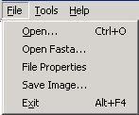
  - File Menu Items

    - File Properties
File Properties displays information on the instrument used to generate the raw MS1 data and the processing parameters applied to the data.
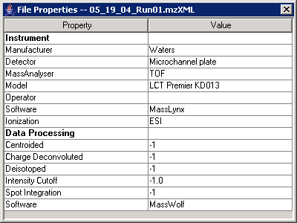

    - Save Image…
Save whole run image as a PNG file.

  - Tools Menu Items

    - Run tool on scan
Selecting Run tool on scan from the Tools menu allows you to send the data from the currently selected scan (red line in the Image pane) on a roundtrip through another separate tool or program (e.g., a PERL script) and back to msInspect. The data will return as a 2-column table like the one you get using the Copy button in the Chart Pane or Tools > Copy Scan and then pasting into Notepad or Excel.

    - Copy Scan
Select Copy Scan from the Tools menu to copy m/z and intensity data for the selected scan as a text file to the clipboard. You can paste the data into another application (e.g., Excel).

- Using msInspect from the Command Line
(from http://edi.fhcrc.org/EDI/Wiki/home/help/page.view?name=viewer%2Fcommand%20line)

For general use we recommend that people use the Java Web Start link to start the application because that link is automatically updated.

However for command line usage we also offer viewerApp.jar which can be launched with the following options:

Interactive Use
java -Xmx384M -jar viewerApp.jar [mzxmlfile]

Finding Peptides
java -Xmx384M -jar viewerApp.jar --findPeptides [--out=outfilename] [--start=startScan] [--count=scanCount] [--minMz=minMzVal] [--maxMz=maxMzVal] [--strategy=className] mzxmlfile
(Note -Xmx384M allocates 384 megabytes to the application. If you have more than 512M available on your machine you should consider raising this number to 512M or more.)

Options
--out: outfilename names file where peptide list will be saved. If not specified peptides go to stdout
--start: startScan is scan number to start finding peptides. default=1
--count: scanCount is of scans to search. default=run.getScanCount()
--minMz: minMzVal is a floating point value for minimumn mass/charge ratio to consider. default=400
--minMz: maxMzVal is floating point value for minimumn mass/charge ratio to consider. default=1600
--strategy: className is the name of a java class that will do the scanning. If the className does not contain a full package declaration it is assumed org.fhcrc.edi.tools. default=FeatureStrategyWavelet2D

NOTE: these strategies are still being developed and will likely change with future releases of msInspect.

Current Strategies
- FeatureStrategyPeakClusters -- Find peaks using 2d signatures. Select features from clusters of related peaks.

Old Strategies
- FeatureStrategyUsingWindow -- uses fft smoothing & finds features on only 1 scan at a time
- FeatureStrategyUsingWindow2D -- uses 2D fft smoothing to find features at elution peaks only
- FeatureStrategyWavelet -- uses a wavelet algorithm to identify peaks of correct shape & does some background reduction
- FeatureStrategyWavelet2D -- uses wavelets to filter for elution peaks as well as mz peaks. This is the default algorithm.
- FeatureStrategyGrossFeatures -- Finds intersection of mz and elution peaks but does not do deisotoping/deconvolution.
- FeatureStrategyCombined -- Combines the wavelet strategy with the gross feature detection algorithm. This is the preferred strategy as it minimizes false-positives in the FeatureStrategyWavelet2D algorithm.
HOLDING PLACE FOR EXTRA STUFF:

Extra screenshots:

Extra text:

