msInspect User’s Guide
Version 1, April 2005

Table of Contents

1 Introduction 4
1.1 About msInspect 4
1.2 About this Guide 4
2 Getting Started 5
2.1 Creating mzXML Files 5
2.2 Launching msInspect 5
2.3 Opening an mzXML File 5
2.4 Viewing Files 6
3 Tutorial 7
3.1 Opening a run file 7
3.2 Using the Detail Pane 9
3.3 Using the Chart Pane 11
3.4 Creating a Feature Set File 13
3.5 Displaying a Feature Set File 14
3.6 Working with the Feature Set List 15
3.7 Filtering Features 15
3.8 Working with Multiple Feature Set Files 16
3.9 Create a Peptide Array… 17
4 Display Details 19
4.1 Image Pane 19
4.2 The Detail Pane 19
4.2.1 Detail Pane Settings 20
4.3 The Chart Pane 22
4.3.1 M/Z Spectrum 22
4.3.2 Elution Profile 24
4.3.3 Working in the Chart Pane 25
4.3.4 Chart Pane Processing 27
5 Finding Features 28
5.1 Feature-Finding Algorithms 28
5.2 Finding All Features in a File 28
5.3 Displaying Peptide Features 30
6 The Peptide Array Component 31
6.1 Generating a Peptide Array 31
7 Fasta Component 33
7.1 Identifying Peptides Using Fasta Files 33
7.2 Calculating Peptide Coverage 33
8 Command Line 33

- Introduction

  - About msInspect
msInspect allows you to view electrospray ionization – time-of-flight (ESI-TOF) mass spectrometry (MS) data in an mzXML file. You can use msInspect’s built-in tools to inspect data, identify peptide features, generate peptide arrays using data from multiple runs, and export data to external applications for further analysis and collaboration. We are also developing tools for protein identification directly from MS1 data using Fasta files. msInspect is open source application written in Java.

We also designed msInspect as a setting in which to develop and test analysis approaches for MS1 data. Because of this, some of msInspect’s features are still being modified and so may not be described in detail here. If you have questions about msInspect’s features, would like access to the source code, or have general feedback, please contact Matthew Bellew at mbellew@fhcrc.org.

  - About this Guide
The examples used in the guide come from a simple 5-protein “mini” proteome dataset. LC ESI-TOF MS runs were done with mixtures of 5-protein and 4-protein samples (at varying concentrations). You can download a sample subset of this data along with msInspect. The Tutorial section of the Guide uses this sample data.

A brief description of the guide’s structure and format (e.g., font format for menu items, filenames) will go here…

- Getting Started

  - Creating mzXML Files
msInspect displays mzXML files containing MS1 data. mzXML is an XML (eXtensible Markup Language) format for MS data. Mass spectrometers do not automatically produce mzXML files, but there are several tools available that generate mzXML files from various native acquisition files. The Sashimi website at http://sashimi.sourceforge.net/ offers a collection of converter programs for some common mass spectrometers.

msInspect will open any mzXML file containing MS1 data; however, msInspect has been designed for high-resolution LC ESI-TOF MS1 data so it may not perform as well with an mzXML file from another type of MS (e.g., MALDI).

  - Launching msInspect
You will need Java Web Start installed to run msInspect. If you do not have Java Web Start, you can download it from the Java Web Start download page: http://java.sun.com/products/javawebstart/download.html.

Once you have Java Web start, you can launch msInspect using the launch link – http://edi.fhcrc.org/_tools/mzxml/viewer.jnlp - or by entering http://edi.fhcrc.org/_tools/remoteApps.html directly into the Location box in the Java Web Start Application Manager.
To enhance msInspect’s performance, try the JRockit Java Virtual Machine. Installing this JVM is not required to run msInspect, but it can make it run about 20% faster. If you’d like to try it, you can download it from the BEA Weblogic JRockit website at http://dev2dev.bea.com/products/wljrockit81/index.jsp.

  - Opening an mzXML File
When you launch msInspect, you will see a File Open dialog box. (You can also select File > Open.) Browse for the mzXML file you want to view and click Open.

When you open a file for the first time, msInspect writes an .inspect file (yourfile.inspect) in the same directory as the original mzXML file so that subsequent opening is faster. This can be time consuming so we recommend you do it on a machine with a fast connection to the disk where the original mzXML file is stored. If you do not have write access to the folder where the mzXML file is stored, msInspect will still open your mzXML file, but a new .insepct file will be created the next time you open the file.

When the file opens, the title bar at the top of the msInspect window will display “msInspect -- your file,” and the status bar along the bottom of the window will display “Finished Loading.”
  - Viewing Files
This section gives a brief overview of the layout of msInspect’s display and the options you have for viewing your data.
Time/scan number
Image Pane
Detail Pane
Chart Pane

m/z
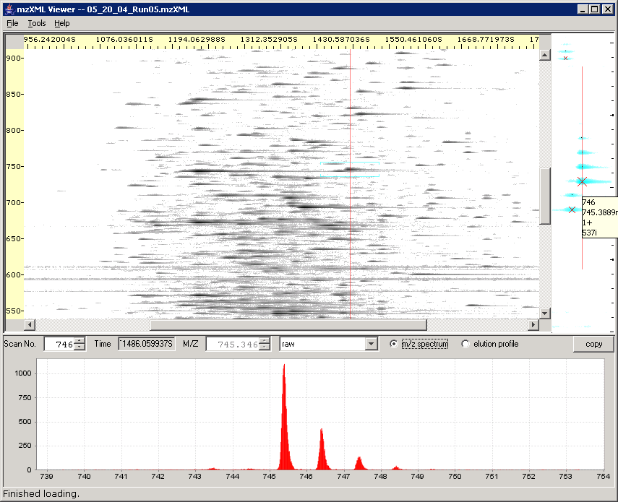
The msInspect window has three panes:

- The Image Pane displays an image of the data from your MS1 run.
- The Detail Pane displays a zoomed in view of the area in the Image Pane where you clicked.
- The Chart Pane displays the m/z spectra and elution profiles. The m/z spectrum corresponds to the scan marked by the vertical red line in the Detail Pane. If you choose to display the elution profile, the Detail Pane displays a horizontal red line marking the m/z value for the profile.

For more information on the display, please see section 4 – Display Details. The next section is the Tutorial, which illustrates some of msInspect’s key features using a sample data set.
- Tutorial

  - Opening a run file
- To download the mzXML file used in this tutorial, go to http://proteomics.fhcrc.org/EDI/announcements/home/thread.view?rowId=564, and click on “Sample mzXML file (15MB)”. Save the file in a directory to which you have write access.
- Launch msInspect from the same webpage (http://proteomics.fhcrc.org/EDI/announcements/home/thread.view?rowId=564) by clicking on “MS1 Viewer (Java Web Start)”.
- Browse for the sample.mzXML file you saved in step 1 in the Open File dialog box, and click Open.
  - msInspect will write a sample.mzXML.inspect file in the same directory where you saved the original sample.mzXML file. This step can take awhile, but it will make subsequent opening faster. The status bar at the bottom of the msInspect window will display “Building image…”
  - Once sample.mzXML opens, you will see the image of your run in the Image Pane. The Detail Pane and Chart Pane are blank until you click somewhere in the Image Pane. F1

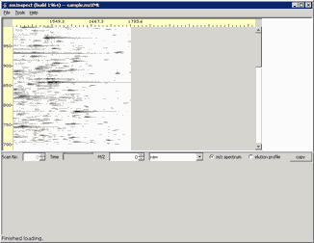

  - If you hold your mouse over a spot in the Image Pane, a tip tag that displays the coordinates of your location (Scan, M/Z) will pop up for a few seconds.

- Click the point in the Image Pane where Scan=96 and m/z=859 (96, 859).
  - The Detail Pane shows the area around where you clicked. Detected peptide features are circled. The Xs mark the monoisotopic peaks in each feature. The status bar at the bottom of the window tells you how many features were detected in the area displayed in the Detail Pane and how long it took to find them. F2
  - You can hover over features in the Detail Pane to display tip tags with information about those features. F3

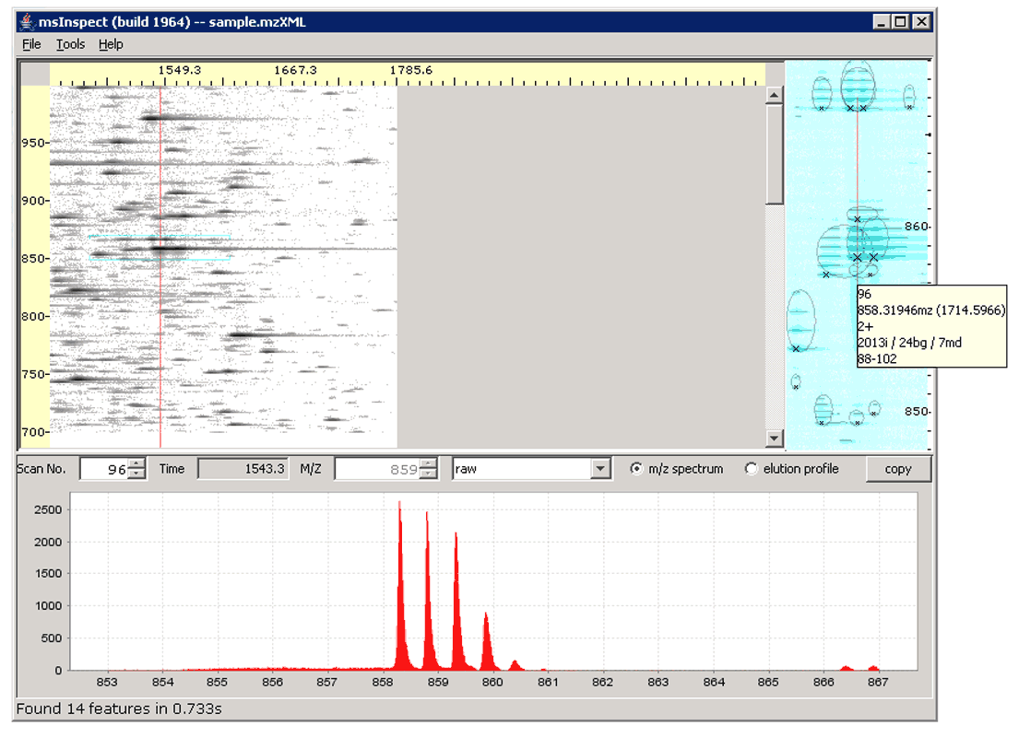

  - The Chart Pane displays the m/z spectrum (intensity plot) for the single scan corresponding to the vertical red line in the Detail Pane. Notice also that the Scan number (96) and the M/Z (859) are shown at the top of the Chart Pane.

  - Using the Detail Pane
You can adjust what you see in the Detail Pane using the Detail Pane Settings dialog box.
- Select Tools > Detail Pane Settings.
- The dialog box that opens has several options for manipulating your view.

Remove background
- Since we clicked in an area of the image with some background noise, check the “remove background” box and click Apply. Notice how the background noise is reduced in the image in the Detail Pane. For a more dramatic example, see section ___.

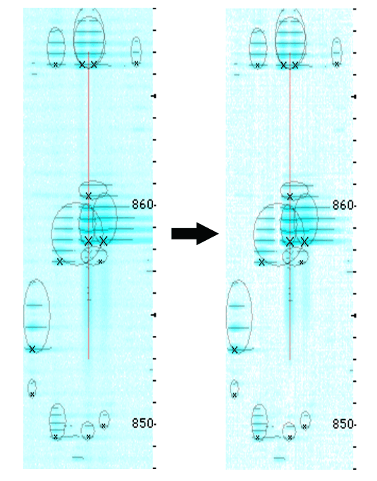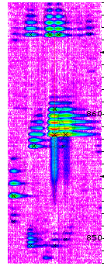

Color Map
These options can alter the contrast of the image to make some features easier to see.
- Choose “Rainbow” from the drop down box, and click Apply.
- The red-orange color indicates the high-intensity peaks in the peptide feature at the center of the Detail Pane while the low-intensity areas around the features are shown in purple.
- When you finish trying out the Color Map options, select Cyan, and click OK.

Detect features
This option detects peptide features in the data shown in the Detail Pane. The algorithms you can use to detect features are shown in the Tools menu. The default algorithm is “2D Peak Alignment.” The algorithms are described in ___.
- Select Tools > peaks (intermediate result). The Detail Pane now displays Xs on every peak identified. Because the peaks are not grouped into peptide features, charge state cannot be inferred – notice the tip tag for each peak shows “0+” for the charge state. F7
- In the Detail Pane Settings dialog box, uncheck the “detect features” check box to turn off this option, and click Apply. The lines and Xs no longer appear.

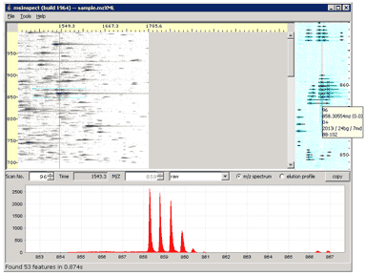

- Try changing the other options in the Detail Pane Settings dialog box. All of the settings are described further in section ___.
- Before you close the Detail Pane Settings dialog box, make sure the “detect features” and “remove background” check boxes are checked, and select Cyan from the “heatmap colors” list. Then click OK.
- Select Tools > 2D Peak Alignment to return to the default feature algorithm.

  - Using the Chart Pane
- Click on the feature at the left edge of the Detail Pane, at scan 43, m/z 853.417.
- The image in the Detail Pane will shift to center around this newly selected feature.
- The plot in the Chart Pane is also redrawn for the scan where you clicked (scan 43). Notice that the y-axis (intensity) auto-scales. For the feature at (96,859), the axis was labeled in units of 500 up to 2500. Now the axis is labeled in units of 50 up to 350 because this feature is less intense.
- Choose “resampled” from the drop down box in the Chart Pane. The red line that runs along the bottom of the Chart Pane plot represents the running minima. This is the background that was removed when you checked “remove background” in the Detail Pane Settings dialog box. Since the background is relatively low, it is difficult to see the red line.
- Drag your mouse over the second and third peaks to highlight them in gray, then release the mouse. The plot will zoom in on the area you just selected. The red line is now just visible running along the bottom of the plot.

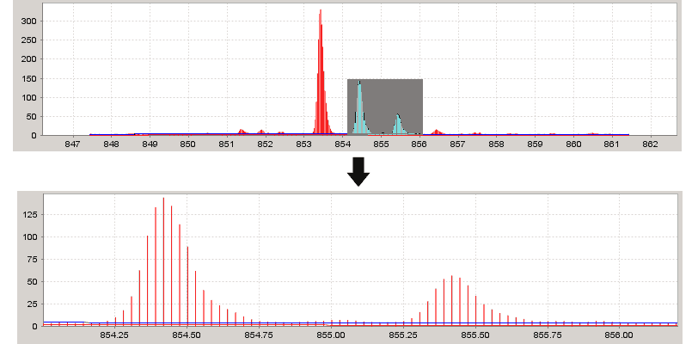

- Right click in the Chart Pane and select Auto Range > Both Axes to return to the original plot.
- Now choose “peaks” from the drop down box. The intensity peaks are marked by vertical lines. This makes it easier to see the peak distribution for the feature, which corresponds to the inferred charge state. #peaks/1Da = charge+, so if the feature has 2 peaks in the space of 1 Dalton, the charge state is assumed to be 2+. In this case, there is just one peak per Dalton so the charge state is marked as 1+.

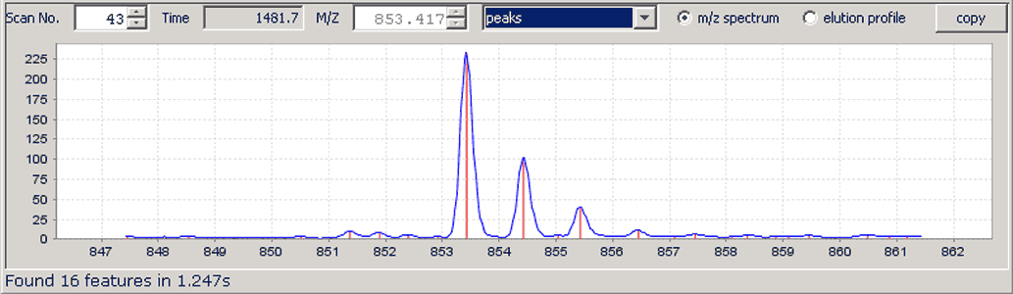

- Select “raw” from the drop down box to return to the original m/z spectrum.

  - Creating a Feature Set File
- A Feature Set file contains a list of all the features detected in a run file using the algorithm selected in the Tools menu.
- To generate a Feature Set file, Select Tools > 2D Peak Alignment.
- Now select Tools > Find All Features.
- In the Save Features to File field, enter a path and file name for the new file or browse for the appropriate folder and add a file name.
- Enter the Scan range. By default, msInspect starts with the first scan and ends with the last scan, but you can select a subset of scans. For now, use the default settings.
- Click Find Features.
- This generates a TSV file (here, sample.peptides.tsv) of the peptide features detected across the selected scan range (1-300) using the algorithm selected from the Tools menu (2D Peak Alignment). As the file is generated, the status bar at the bottom of the msInspect window will display “Finding all features in sample.mzxml. X.X% complete.”
- When the file is complete, the peptide features will show up as colored crosses over the image in the Image and Detail Panes. The status bar will display “Finding features complete. See file yourfilepath\sample.peptides.tsv”

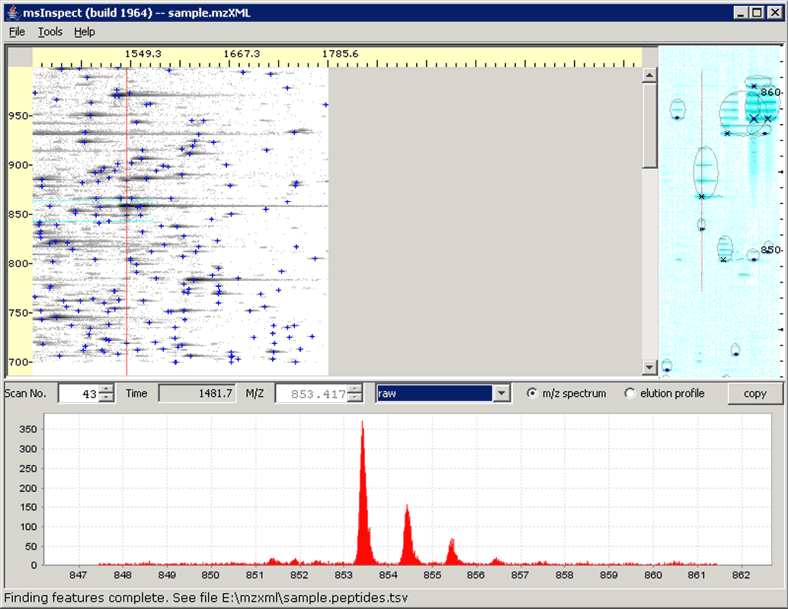
  - Displaying a Feature Set File
- Select Tools > Display Peptides.
- The file you just created is listed in the Display Peptides dialog box along with a “Display” check box, a “Color” field, and a “…” field.
- You can choose whether or not to display the colored crosses by checking and unchecking the “Display” check box.
- You can change the color of the crosses by clicking the color block in the “Color” field. You can pick a color from the swatches tab or define a color using the HSB or RGB tabs.
- On the Swatches tab, select a yellow swatch and click OK. The crosses in the Image and Detail Panes are now yellow.

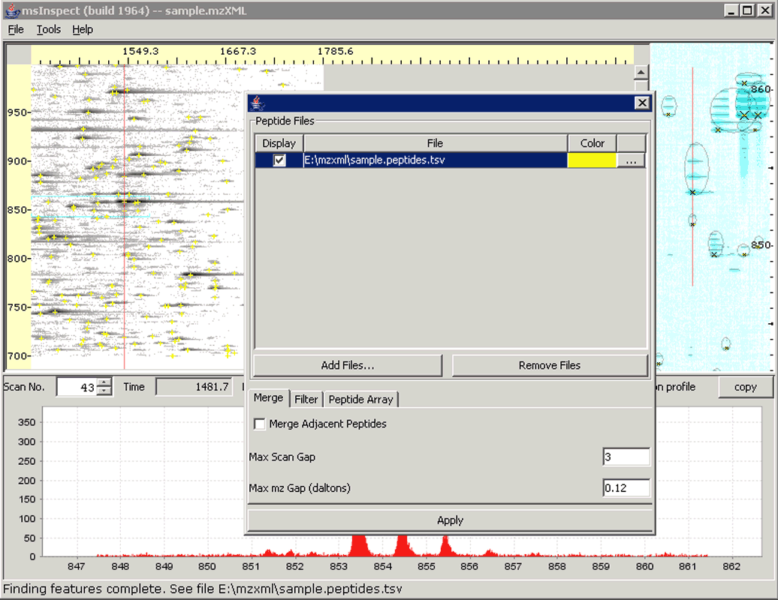

  - Working with the Feature Set List
The Feature Set List is an editable table of information about the Feature Set. You can add comments to this table, edit values, sort the list by each column, delete features from the list, and save your edited version of the file over the original Feature Set. For more information on the data in this table, see section 5.3.
- In the Display Peptide dialog box, click the “…” field to the right of the “Color” field.

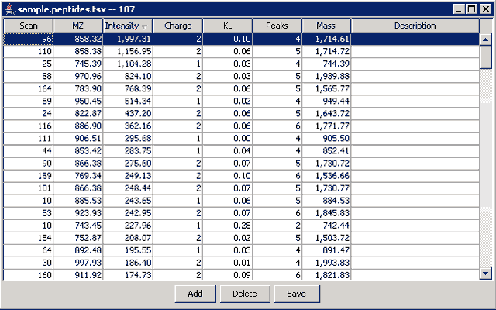

- Click on the “Intensity” column heading twice to sort the list by feature intensity in descending order. The first feature in the list is the one at scan 96, m/z 858.32.
- Click on this feature in the list. Notice that the Detail and Chart Pane in the main msInspect window are redrawn to display this feature. It should look a little familiar since it is the first one we looked at in this tutorial.
- Click on other features in the list to view them in the Detail Pane.
- When you have finished exploring the Feature Set List, click on the feature at (96, 858.32), and then close the List.

  - Filtering Features
Filtering allows you to hand curate your data, selecting the criteria that determine which features get displayed. It is particularly helpful when you prepare to generate a peptide array, which we’ll get to shortly.
- Select Tools > Display Peptides
- Click on the Filter tab at the bottom of the Display Peptides dialog box. This tab displays several parameters you can manipulate to filter the features shown in the Detail Pane.
- Change Min Charge to 1, Max KL to 1.0, Min Intensity to 100, and Min Peaks to 3.
- Click Apply.
- The Detail Pane now shows only the features that meet these new filtering criteria. (F16)

  - Working with Multiple Feature Set Files
You can only open one run (mzXML) file in msInspect at one time. If you have multiple runs for which you’d like to create Feature Set files, you can open each run separately in msInspect and select Tools > Find All Features to create the Feature Sets one at a time. If you have access to the msInspect viewerApp.jar file (available at http://edi.fhcrc.org/EDI/Wiki/home/help/page.view?name=viewer/command%20line), you can create a batch of Feature Set files all at once from the command line.

We’ll make a copy of the Feature Set file for sample.mzXML so we can use it later to illustrate the process of creating a peptide array.

To create the Feature Set file copy using the interactive version of msInspect:
- Select Tools > Find All Features.
- In the “Save Features to File” field, change the file name to sample.peptides.copy.tsv.
- Click Find Features.

To create the Feature Set file copy from the command line, enter:

java -Xmx384M -jar your_path\viewerApp.jar --findPeptides --out=”your_path\sample.peptides.copy.tsv” “your_path\sample.mzXML”

-Xmx384M allocates 384 megabytes to the application. If you have more than 512M available on your machine you should consider raising this to 512M or more.

Whether you need to include the file paths (yourpath\) depends on where you saved the viewerApp.jar and sample.mzXML files.

For more information on using msInspect from the command line, see section 8 – Command Line.

Once you have created your Feature Set copy file, return to msInspect.
- Select Tools > Display Peptides.
- Click the Add Runs button.
- Browse to find sample.peptides.copy.tsv. If the first Feature Set file, sample.peptides.tsv, is not still listed in the Display Features dialog box, hold down Ctrl and select that file as well.
- Click Open.
- Both sample.peptides.tsv and sample.peptides.copy.tsv are now listed in the Display Features dialog box. Each file is assigned a different color, and the features from that file now overlay the run image in the Image Pane. Since both Feature Set files are from the same run (and the features overlap), you will only see the colored crosses for sample.peptides.tsv. (F17)
- You can temporarily hide the crosses from one or more Feature Set files by unchecking the Display check box in the Display Peptides dialog box.

  - Create a Peptide Array…
Now that we have two Feature Set files, we can create a peptide array. Normally you would make an array from Feature Sets from two or more different runs, but this example will help illustrate the steps involved in generating an array. For more information on how the arrays are generated, see section 6 – The Peptide Array Component.
- Click the Filter tab at the bottom of the Display Peptides dialog box.
- Change the Min Mz value to 700, the Max KL value to 1.5, and the Min Peaks value to 2. F18

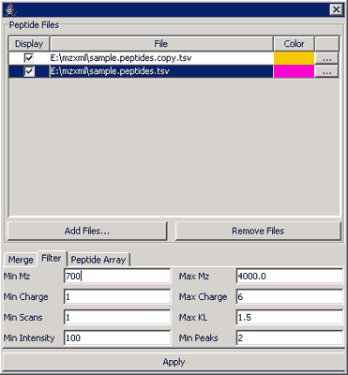

- Click the Peptide Array tab.
- In the Output File field, enter the file path where you would like to save the array file, and name it pepArray.tsv.
- When you click the Optimize button, msInspect performs all the steps involved in making an array without actually writing the file using a variety of bucket sizes. You will see a plot of “Scan window” versus “’Perfect’ Buckets” for the value entered in the maxMzBucket field. The maximum on the plot tells you what size the scan window should be to optimize the array for that m/z window.
- Enter .15 for mazMzBucket.
- Click Optimize.
- The plot’s maximum is at a Scan window of 20 (175 ‘Perfect’ buckets out of 181 total buckets). F19

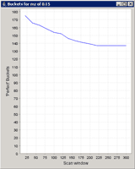

- In the Display Peptides dialog box, enter 20 for maxScanBucket.
- Click the Calculate button on the Array tab.
- The status bar at the bottom of the msInspect window will read “Calculating array for scan window of 20” while the files are generated.
- When the process is complete, the status bar will read “Peptide array complete. See filepath\pepArray.tsv and filepath\pepArray.details.tsv”.
- At this point you can use a microarray analysis tool suite to normalize and cluster this data and produce an image of the array. Since this array was generated from two copies of the same data, the array image would not be very interesting. An example of an array we created using TIGR ___ is shown below [GET FROM MARTY].

For information on creating peptide array files from the command line, see section 8.

- Display Details
This section describes the elements that facilitate visualizing and hand curating run data.

  - Image Pane
The Image Pane displays an image of the data from your MS1 run. The Y-axis is mass-to-charge ratio (m/z): each horizontal line in the image equals 1 Dalton (1Da). The X-axis is marked in seconds, but each vertical line in the image corresponds to one MS scan. Time is displayed in addition to scan number since scan numbers aren’t necessarily comparable over different runs and because the relationship between scans and time can vary depending on the machine, its settings, and its performance. Ion current intensity is represented by the density (darkness) of the dot.

TIP: By hovering over various parts of the display, you can view additional details about the data. In the Image Pane you’ll see scan number/time and mass; the Detail Pane also shows charge state and intensity if you hover over marked features).

When you click on the image in the Image Pane, a red vertical line marking the scan appears on the image, and the two other panes display data corresponding to the point at which you clicked.

  - The Detail Pane
The Detail Pane along the right side of the window displays a zoomed in view of the image where you clicked. The Detail Pane is approximately 90 scans wide. The vertical area displayed in the Details Pane corresponds to the range of m/z values between the two blue, horizontal lines that appear in the Image Pane. The height (m/z range) varies slightly depending on the size of your window (i.e., a maximized window on a larger monitor will display a greater m/z range than a window that is restored down on a smaller monitor).

The red line in the Detail Pane corresponds to what is being displayed in the Chart Pane (see below).

    - Detail Pane Settings
Select Tools > Detail Pane Settings to adjust what you see in the Detail Pane:

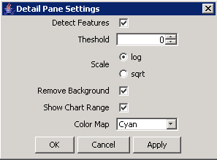

Detect Features
When the Detect Features box is checked, msInspect uses the algorithm selected in the Tools menu to detect features only in the data shown in the Detail pane. For most feature-finding algorithms, the monoisotopic peak is marked with an X. Larger Xs correspond to higher intensity peaks.

[AD: add shots here for Detect Features ON and OFF?]

Threshold
Image points (pixels) with intensities below the value entered in this box will NOT be displayed in the Detail pane. This criterion deals with how the image is scaled; it does not apply to the absolute intensities of features.

Scale
The log scale (default) exaggerates the intensity of fainter features. The sqrt (square root) scale is more representative of actual intensities. We omitted a linear scale option because it tends to make everything except the largest intensities disappear.

Remove background
The ‘background’ for the area shown in the Detail pane is calculated and then subtracted from each data point. The difference becomes more dramatic when viewed on a more complex run with considerably more background noise and particularly when the run data contains streaks.

NOTE: If you select the ‘resampled’ m/z spectrum in the Chart pane, the background is represented by the red line running along the bottom of the plot. You may need to zoom in on the plot to see the line.
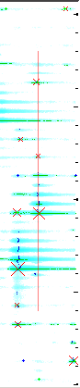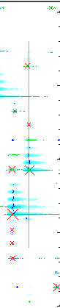
Remove Background
Need to replace with a better example – MATT: let me know if you know of a good one.

Show Chart Range
Need to add, this is new

Color Map
You can pick one of four color schemes for the Detail Pane display: Cyan, Grayscale (as in the Image pane), Fire (yellow/low intensity to red/high intensity), and Rainbow (violet/low intensity to red/high intensity). Depending on your data, one color scheme may provide more contrast than another, making features more visible.

  - The Chart Pane
The Chart Pane along the bottom of the window displays m/z spectra and elution profiles. You can switch between the two types of plots using the radio buttons at the top of the Chart Pane.

Scan No., Time, and M/Z for the plots shown in the Chart Pane also appear at the top of the pane. The drop down box contains options for displaying plots of the data using various signal processing methods (see section 4.3.4).

Clicking the Copy button at the top right corner of the Chart Pane copies the data displayed in red in the Chart Pane to the clipboard as a text file. You can then paste the data into another application such as Notepad or Excel.

You can add a title, axis labels, and a legend to the plots in this pane using the Chart Properties (see section 4.3.3).

    - M/Z Spectrum
By default, the Chart Pane displays the raw m/z spectrum for the single scan corresponding to the red line in the Detail Pane. The Y-axis is intensity, and the X-axis is m/z. This Y-axis automatically scales itself depending on the data being plotted.

You can move to the previous and next scans using the down and up arrows on the Scan No. field, respectively. You can also click inside the Scan No. field and use the down and up arrows on your keyboard to do the same thing. Or you can type in a specific scan number and press enter to jump to that scan.

Auto Zoom
Auto Zoom affects how the m/z spectrum is displayed in the Chart Pane. When Auto Zoom is on, the plot in the Chart Pane is automatically zoomed in around the spot where you clicked; the width is 15-16Da, and the height (intensity) auto-scales to the peak heights in the region. When Auto Zoom is off, the intensity plot in the Chart Pane will cover the m/z values for the entire scan. Since this means more data must be displayed, turning Auto Zoom off can slow down the generation of the plot.

Auto Zoom is on by default. To turn it off, select Tools > AutoZoom. To turn it back on, select Tools > Auto Zoom again.

Auto Zoom ON:
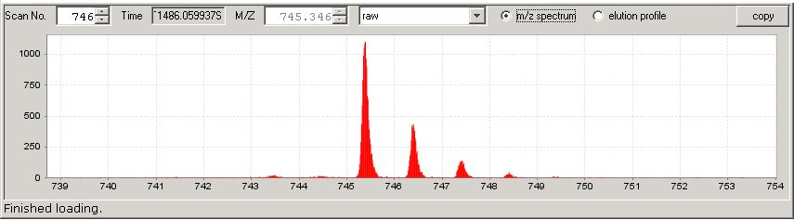

Auto Zoom OFF:
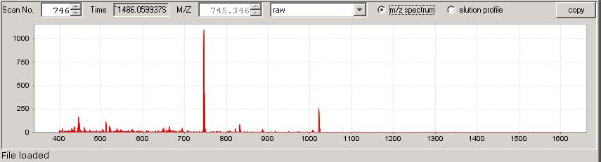

    - Elution Profile
You can use the Chart Pane to view an elution profile for any m/z. Clicking the elution profile radio button produces the elution profile at the m/z shown in the M/Z field at the top of the Chart Pane. Notice the red line in the Detail Pane is now a horizontal line corresponding to the same m/z. The Y-axis in the plot is intensity (again, this axis auto-scales), and the X-axis is scan number.

You can move to the higher and lower m/z values using the up and down arrows on the M/Z field. You can also click inside the M/Z field and use the up and down arrows on your keyboard to do the same thing. Or you can type in a specific m/z and press enter to jump to that value.

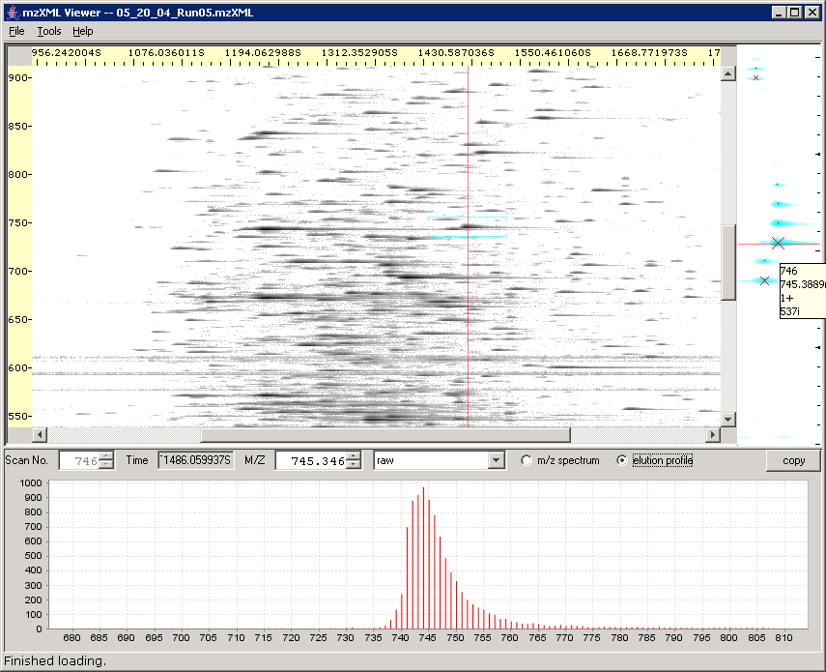
Clicking here displays the elution profile for the m/z value shown here.

    - Working in the Chart Pane
Right click anywhere in the Chart Pane to use the Chart Pane submenu. This submenu offers additional options for viewing, saving, and printing the data displayed in the Chart Pane.

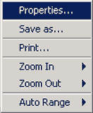

Properties
Select Properties from the Chart Pane submenu to modify the chart’s appearance. For example, you can display a title or legend or change the appearance of the plot’s axes.

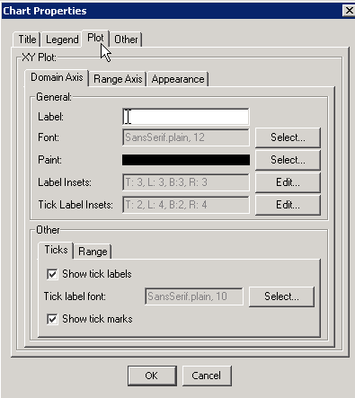

Save as…
Choose Save as… from the Chart Pane submenu to save the full (zoomed out), raw data from a scan as a text files or as a PNG (Portable Network Graphics) image file. At this point, you cannot save images of any of the processed plots, but that functionality might be added in the future.

Print…
You can print a copy of the currently displayed plot by selecting Print from the Chart Pane submenu. We recommend printing in landscape rather than portrait mode given the layout of the plots.

Zoom
You can zoom in on any of the plots in the Chart Pane in two ways:
- Right click anywhere on the plot and select Zoom In from the submenu. You can zoom relative to one axis or the other or both.
- Using the mouse, click and drag to highlight (in gray) an area where you want to zoom in. When you release the mouse, a zoomed plot will be generated.

You can zoom out by right clicking on the plot and selecting Zoom Out from the submenu. You can zoom relative to one axis or the other or both.

To return to the original scale, right click on the plot and select Auto Range. Again, you can modify one axis or the other or both.

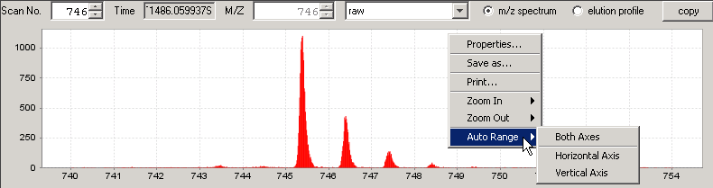

    - Chart Pane Processing
You can view m/z spectra and elution profiles using a variety of signal processing tools, each of which is described briefly below. Note: these processing tools are predominantly used for development purposes so they are subject to change at any time, including before the next version of this documentation is released.

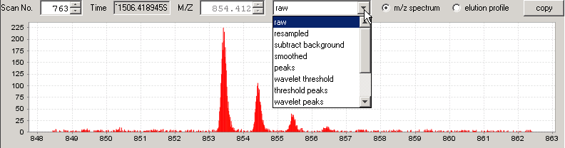

- Raw: the raw, unprocessed data (depending on the MS machine, anywhere from 100 to 200 samples per Da)

- Resampled: lightly processed data that reduces the number of data points to 36 per Da; the ‘horizontal’ red line represents the running minima (background), and the blue line represents the median values.

- Subtract background: the resampled data with the background (red line in the resampled plot) subtracted out.

- Smoothed: smoothed version of the data in the subtract background plot.

- Peaks: local maxima from the smoothed data plot are displayed as vertical red lines.

- Wavelet peaks: identifies the location of peaks (m/z values); peaks are marked by red lines, which correspond to the local maxima found in the 3rd level in the wavelet multiresolution plot; intensities are determined from the smoothed data; wavelets are from the Haar wavelet family.

- Wavelet decomposition: wavelet plots (from top to bottom) for 1st, 2nd, 3rd, and 4th levels and one for the remaining signal.

- Wavelet decomposition2: another view produced as a composite of several other charts.

- Wavelet multiresolution: a reconstruction of the original signal made by adding the derivative plots.
- Finding Features
This section describes how to use msInspect to find peptide features in your data.

  - Feature-Finding Algorithms
There are several feature-finding algorithms listed in the Tools menu that can be used to detect features in the entire run (Find All Features) and in the subset of data displayed in the Detail Pane (Detect Features option in the Detail Pane Settings dialog box).

- Single Scan: finds features only in the selected scan. (NOTE: This can be useful for non-ESI MS data since it does not rely on there being continuity between adjacent scans.)

- 2D Peak Alignment: detects persistent (co-eluting) peaks and groups related peaks (across time and m/z) into features. This is the default algorithm.

- Peaks (intermediate result): displays just the peaks detected in the first part of the 2D Peak Alignment algorithm above, without grouping them into features.

  - Finding All Features in a File
To find all the features from a run file, select Tools > Find All Features. This generates and then displays a text file (file name.txt) of the features detected across the entire run using the algorithm you selected from the Tools menu.

Feature Set File
Output | Definition
Scan number | The number of the scan taken by the MS machine in which the feature appeared
(Time) | The time in seconds at which the feature was detected
m/z | Mass-to-charge ratio of the peptide feature
Intensity | Signal intensity recorded by the MS machine for the feature
Charge | Estimated charge state of the peptide feature
KL | Kullback-Leibler value that measures the similarity between the feature’s peak pattern and the peaks expected from a peptide of that mass
Score | Future Investigation – we are currently evaluating scoring functions
Background | The (localized) running minima for intensity calculated across two dimensions (m/z and time (scan))
Median | The difference between the median and the minima/background in the resampled data
Peaks | Number of peaks in the feature

The data in this Feature Set is only lightly filtered (e.g., the background value has already been subtracted out of the displayed intensity value) so you get as much data as possible. You can then do the analyses you feel are important in determining which features are ‘good’ matches rather than having msInspect do that for you.

When you choose Find All Features from the Tools menu, you will see the Extract Features dialog box. Click the Browse button to choose where to save the file – the file path will appear in the Save Features to File field.

NOTE: If a file with the same name already exists, the Load Existing File button will be clickable (black text rather than gray). You then have three choices: 1) you can give the file you want to create a new name, in which case the Load Existing File button will turn gray; 2) you can open the existing file by clicking the Load Existing File button; or 3) you can keep the file name the same and save the new file over the original by clicking the Find Features button.

Choose the range of scans in which to detect features by filling in the Start Scan and End Scan numbers. Click the Find Features button to create and display the file.

Features will be marked as colored crosses in the Image Pane. If you used the same algorithm for Detect Features in the Detail pane and for the Find Features file, the colored crosses and the Xs in the DP should line up. There may be cases when they do not line up perfectly – these minor variations are a result of the way features are picked: for a Feature Set, features are computed for the whole run so the context is larger, but features in the Detail Pane are computed on the fly for just the range shown in the pane.

  - Displaying Peptide Features
Choosing Tools > Display Peptides opens the Display Features window. You can specify which Feature Set files to display on top of the run that is currently open in msInspect. The images in the Detail and Chart panes still correspond to your open run.

To add Feature Sets to the list, click Add Files, browse for the existing file you want to add, and click Open. You can display Feature Sets created from the open run and from other runs to visually compare data from multiple runs. Take a file off of the list by clicking it and then clicking Remove Files. To retain a file in the list without displaying its features on the image, uncheck the Display check box.

You can choose the color of each file’s feature crosses by (left) clicking in the colored area to the right of each file name. Choose a color from the palette, or enter values in the HSB or RGB tabs, and then click OK.

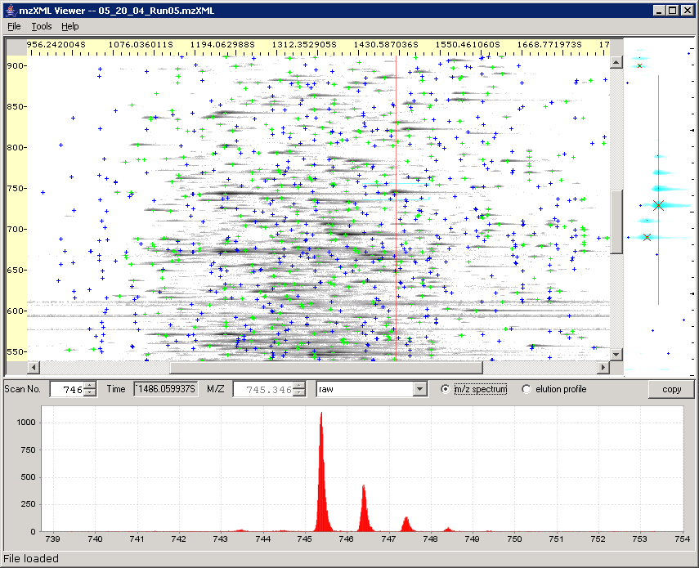

The “…” button at the right end of each row displays the feature information in an editable table. You can save the original file and then edit the table, removing mis-identified or unreliable features. You can also add notes. If you click on a feature in the list, that feature will be displayed in msInspect’s Detail and Chart Panes.

For information on the Filter and Peptide Array tabs at the bottom of the Display Features window, see section 6.1 - Generating a Peptide Array.
- The Peptide Array Component
The Peptide Array component of msInspect allows you to compare features between multiple samples.

  - Generating a Peptide Array
A “peptide array” is a term borrowed from the world of microarrays. Microarrays have thousands of spots, each of which binds to a particular complementary DNA sequence. Microarray experiments measure the intensity of spots on the arrays and these are clustered to find differences between sets of samples. LCMS experiments don’t have the notion of clearly defined spots that we can compare among runs. However, if a peptide is measured in several runs, it will always have the same mass (which can be computed from m/z and charge) and a similar elution time.

msInspect builds peptide arrays by placing peptides found in different samples that have “matching” masses and elution times into “buckets”. The intensities of peptides from different runs that are put into the same bucket can then be compared and clustered using the same sets of tools currently used for microarrays.

Peptide arrays are created through a series of steps:

- Feature detection. Features are detected and saved in files. The features detected in one run and saved in a file make up a Feature Set.
- Filtering. The feature-finding algorithms attempt to detect as many features as reasonably possible. Not all of these features will be included in each analysis. Several different metrics can be used to filter peptides, or determine which features from the Feature Set to include in a peptide array.
- Feature alignment. Because elution time of peptides varies from run to run, an effort is made to align features between runs.
- Deconvolution. In any given run, the same peptide might be detected in different charge states. Peptides from multiple charge states are collapsed into a single point.
- Bucketing. Once features are aligned, features are placed into buckets with maximum sizes in both the scan and mass dimensions. Each bucket corresponds to a “spot” on the peptide array.
- Analysis. msInspect does not do analysis of peptide arrays. Any microarray analysis tool suite (open source ones are available in BioConductor or from TIGR) can be used to normalize and cluster this data producing an image of the array (include sample?).

The tabs at the bottom of the Display Features window present steps 2-5 from the list above.

- Filter –Filtering enables you to select which features to display on the image and include in the peptide array. Filtering criteria include:
  - Min m/z,, Max m/z
  - Min Charge, MaxCharge. Minimum & Maximum charge of features to include. When the feature detector cannot resolve a charge state it reports a charge of 0. Generally you will not want to include these features in a peptide array because they cannot be deconvoluted properly.
  - Min Scans (minimum number of scans in which the feature appears),
  - Max KL. The Kullback-Leibler [Do we need a reference here?] a measure of how closely the observed isotopic distribution of this peptide matches a theoretical distribution. Lower numbers indicate closer matches.
  - Min Intensity. Low intensity features are generally detected less reliably than high intensity features. Values to use here will depend on the specific instrument being used.
  - MinPeaks. At least two peaks are required to infer a charge state.

- Peptide Array – You can choose a name for the output files of your peptide array and browse for the location where you want to save them.
  - Optimize. Choosing the size of the buckets in creating a peptide array is critical. If buckets are too large, unrelated peptides will be placed in the same bucket. If buckets are too small, related peptides may be placed in different buckets where their intensities cannot be compared. The Optimize option performs the steps listed so far with a variety of bucket sizes. It then shows a graph of how many “perfect” buckets (ones with a single feature from each run) are available with each bucket size. You will see a plot of Scan Window vs. ‘Perfect’ Buckets. The peak of that plot gives you the optimal bucket size for your array.

  - The peptide array includes the following columns for each row. Each row is one bucket:
    - id: An id for this bucket.
    - minMass, maxMass: minimum & maximum mass for this bucket
    - minScan, maxScan: min & maximum scan for this bucket
    - featureCount: Number of features included in this bucket
    - setCount: Number of different feature sets that have a feature in this bucket
    - One intensity column for each featureSet.

In addition to the peptide array file, msInspect generates an additional .details.tsv file. This file includes one row for every feature along with the id of the bucket in which that feature was placed.

- Fasta Component

  - Identifying Peptides Using Fasta Files
This component of msInspect is still in development.

A fasta file (file name.fasta) contains a description of the proteome of an organism as derived from its genome. The data on proteins and their corresponding peptides in the fasta file can be compared to the features detected in the MS1 data. This comparison should allow for peptide identification directly from MS1 data for simple mixtures.

Before you open a fasta file, select Display Peptides and open a Feature Set file. Once the Feature Set file is displayed on the image, select Open Fasta… from the File menu.

When you open your fasta file, you will see a window that allows you to select a feature in your run data and search the fasta file for peptides matching that feature’s mass. You can also select a known protein in the fasta file and search your run data for features that match that protein’s peptides.

More detailed information on using this component of msInspect will be added soon.

  - Calculating Peptide Coverage
This feature of msInspect is still in development. Briefly, once you have a fasta file open, you can calculate the degree to which the peptide features in your run data correspond to a given protein in the fasta file. More detail about calculating peptide coverage will be added soon.

- Command Line

For general use we recommend you use the Java Web Start Launch Link (http://edi.fhcrc.org/_tools/mzxml/viewer.jnlp) to start the application since that link is automatically updated.

However, for command line usage we also offer viewerApp.jar (available at http://edi.fhcrc.org/EDI/Wiki/home/help/page.view?name=viewer/command%20line), which can be launched with the following options:

Opening a file:

java -Xmx384M -jar viewerApp.jar [mzxmlfile]

Finding Peptides:

java -Xmx384M -jar viewerApp.jar --findPeptides [--out=outfilename] [--start=startScan] [--count=scanCount] [--minMz=minMzVal] [--maxMz=maxMzVal] [--strategy=className] mzxmlfile

Note: -Xmx384M allocates 384 megabytes to the application. If you have more than 512M available on your machine you should consider raising this number to 512M or more.

Options
Option | Default | Description
--out | stdout | outfilename names file where peptide list will be saved
--start | 1 | startScan is scan number to start finding peptides
--count | run.getScanCount() | scanCount is of scans to search
--minMz | 400 | minMzVal is a floating point value for minimumn m/z ratio to consider
--maxMz | 1600 | maxMzVal is floating point value for maximum m/z ratio to consider
--strategy | FeatureStrategyWavelet2D | className is the name of a java class that will do the scanning. If the className does not contain a full package declaration it is assumed org.fhcrc.edi.tools.

Current Strategies
NOTE: strategies are still being developed and will likely change with future releases of msInspect.
- FeatureStrategyPeakClusters -- Find peaks using 2d signatures. Select features from clusters of related peaks.

Creating an Array:

You can use default settings or specify your own parameters. If you’re not sure what settings to use, the interactive version of msInspect can be helpful. See section 6.1 for more information.

[Add command here]
Appendix A: msInspect Menus

The File Menu

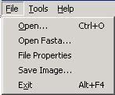

Open … | Displays and Open File dialog box where you can browse for mzXML files to open in msInspect.
Open Fasta… | Dispalys an Open File dialog box where you can browse for fasta files. For more information, see section 7.1.
File Properties | File Properties displays information on the instrument used to generate the raw MS1 data and the processing parameters applied to the data.
Save Image… | Save the whole run image as a PNG file.
Exit | Exit msInspect

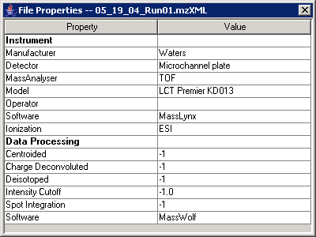

The Tools Menu

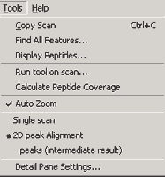

Copy Scan | Copy m/z and intensity data for the selected scan as a text file to the clipboard. You can paste the data into another application (e.g., Excel).
Find All Features… | Opens the Extract Features dialog box – the first step in detecting features for an entire run. See section 5.2.
Display Peptides… | Opens the Display Features window where you can work with Feature Set files. See section 5.3.
Run tool on scan… | Selecting Run tool on scan from the Tools menu allows you to send the data from the currently selected scan (red line in the Image pane) on a roundtrip through another separate tool or program (e.g., a PERL script) and back to msInspect. The data will return as a 2-column table like the one you get using the Copy button in the Chart Pane or Tools > Copy Scan and then pasting into Notepad or Excel.
Calculate Peptide Coverage | See section 7.2
Auto Zoom | When selected, the m/z spectrum in the Chart Pane is automatically drawn zoomed in around the area where you clicked on the Image Pane. See section 4.3.3.1.
Feature-Finding Algorithms | The available algorithms used to detect features are listed here. The currently selected algorithm is marked with a bullet. See section 5.1.
Detail Pane Settings | Opens a dialog box where you can adjust your view in the Detail Pane. See section 4.4.

HOLDING PLACE FOR EXTRA STUFF:

Extra screenshots:

Extra text:

From Peptide array section:
- Alignment. Peptides from different runs are aligned using a smooth-spline algorithm implemented in R. The algorithm selects high intensity features from each run as a basis for alignment. It then computes smooth spline that optimizes the alignment of those points. Lower intensity features are then aligned using the computed spline. Note that this algorithm aligns all feature sets to the first set in the list (whichever file is listed first in the Display Peptides dialog box); if that set is an outlier the algorithm will not work as well.

Old Strategies (from command line)
- FeatureStrategyUsingWindow -- uses fft smoothing & finds features on only 1 scan at a time
- FeatureStrategyUsingWindow2D -- uses 2D fft smoothing to find features at elution peaks only
- FeatureStrategyWavelet -- uses a wavelet algorithm to identify peaks of correct shape & does some background reduction
- FeatureStrategyWavelet2D -- uses wavelets to filter for elution peaks as well as mz peaks. This is the default algorithm.
- FeatureStrategyGrossFeatures -- Finds intersection of mz and elution peaks but does not do deisotoping/deconvolution.
- FeatureStrategyCombined -- Combines the wavelet strategy with the gross feature detection algorithm. This is the preferred strategy as it minimizes false-positives in the FeatureStrategyWavelet2D algorithm.

