msInspect Developer’s Guide
DRAFT

For msInspect version XXX, released XXX.

Compiled by Damon May for the


Table of Contents
1 Introduction 4
1.1 About msInspect 4
1.2 About this Guide 4
2 Architecture 5
2.1 Package Structure 5
2.2 Ant 6
2.3 R 6
2.4 XML Beans 6
2.5 org.fhcrc.cpas.viewer.Application 6
3 Command Line Modules 6
3.1 Arguments 7
3.2 Module Documentation 8
3.3 Module Discovery 8
3.4 Examples 9
4 Testing Framework 9
4.1 MD5 Sum Comparison 9
5 GUI Utilities 10
6 Other Utilities 10

- Introduction

  - About msInspect
msInspect allows you to view high-resolution mass spectrometry (MS) data represented in an mzXML file. You can use msInspect’s built-in tools to inspect data, identify peptide features, generate peptide arrays using data from multiple runs, and export data to external applications for further analysis and collaboration. We have designed msInspect as a setting in which to develop and test analysis approaches for MS data.

For more information about msInspect, including a detailed discussion of msInspect’s features, please see the msInspect User’s Guide, available on our website at http://proteomics.fhcrc.org/.

  - About this Guide

This guide is a resource for developers of msInspect. We will assume familiarity with the features of msInspect and concentrate on product architecture and high-level API documentation, with an eye toward developers who wish to add new functionality to msInspect. We will also assume that the reader has full msInspect code access, and will defer to the codebase rather than duplicating information here where it makes sense to do so.
This guide uses the following typographical conventions:

Constant Width
for command line examples or code fragments

Constant Width Italic
for replaceable text in command line examples

Italic
for filenames, path names, and method names
bold
for class and package names

Double quotes (“/”)
around application status and error messages and hyperlink names

 Indicates a Note, Tip, or Example

◻ Indicates a Definition of a new term

- Architecture
msInspect is written primarily in Java. It relies on Java 1.5, making heavy use of generics and other Java 1.5 additions.
msInspect was originally built as a tool for visualizing MS1 spectra and for identifying MS1 features that represent peptides. Those two areas of the msInspect code contain a fair amount of code that is relatively disorganized, as it has not changed significantly since it was written.

  - Package Structure
The following is a brief overview of the msInspect package structure. All of these packages live under org.fhcrc.cpas.
- tools: all code that msInspect shares with CPAS should go in this package, and nothing else.
- viewer: msInspect-only code. At this level, non-GUI files common to different parts of msInspect, as well as files related to specific pieces of functionality that don't have a lot of files to deal with
  - amt: classes related to building and matching against AMT databases
  - feature: classes related to features and feature sets
    - extrainfo: nonstandard sets of information that can be attached to features
    - featureFinding: Classes related to all the different aspects of feature-finding (see section 3)
      - strategy: Classes that implement FeatureStrategy and embody a particular method of finding MS1 features
  - gui: GUI-related files that relate to on particular feature or another
    - util: Universally useful GUI utility files like WorkbenchFileChooser, ListenerHelper.
  - commandline: commandline-related files.
    - modules: individual command line modules
    - arguments: command line argument definition classes
  - feature: stuff related to feature modeling and feature finding.
  - normalize: stuff related to normalization.
  - quant: classes related to quantitation
  - align: classes related to alignment
  - util: general msInspect utility classes, e.g., RInterface.
  - test: testing framework classes
    - commandline: Individual testing classes for command line modules, making use of the CommandLineModule structure

  - Ant
msInspect uses Apache Ant (http://ant.apache.org/) for build and testing operations. The file webapps/tools/build.xml is used to build and deploy msInspect, and the file webapps/tools/test/build.xml is used to run tests (see the section Testing Framework).

  - R
Some msInspect functionality is written in the R statistical language (http://www.r-project.org). In general, R code should only be used when a Java implementation of the same functionality would require a large extra amount of effort or dependencies on significant new libraries. Please see the R Interface section of this guide for more details.

  - XML Beans
msInspect needs to interact with various types of XML files – to parse them into Java objects, and to write them out based on Java objects. These files include PepXML files, mzXML files, and amtXML files. mzXML has its own parser, and there is a PepXML loader in the tools package that is shared with CPAS. With those exceptions, all XML files are read and written using XML Beans (http://xmlbeans.apache.org/) to some extent.
XML Beans is architected around an all-in-memory, DOM representation of XML documents. Since we tend to read and write very large files with msInspect, it is therefore necessary to make use of XML Beans only for parsing and writing of small pieces of these XML files at a time. The class tools.Stax2DOMBuilder is used to build DOM trees from small portions of XML documents, which can then be controlled using XML Beans.
XML Beans requires schema documents for each type of document that you wish to read or write. These are stored in the directory webapps/schemas. XML Beans generates Java classes from these documents, which are included in the msInspect deployment.

  - org.fhcrc.cpas.viewer.Application
The Application class is invoked in order to run msInspect, either in command line or in GUI mode. This class parses command line arguments and invokes the appropriate Command Line Module appropriately (see the section Command Line Modules). The main method acts as a switchboard to determine the appropriate action to take. If no arguments are specified, or if one unnamed argument is specified, Application invokes the msInspect GUI by calling its own start method.
There are some command line operations that have not yet, or never will be, translated into Command Line Modules (e.g., the “revision” command). These actions are handled directly in Application. In general, however, the complexity of Application should be kept to a bare minimum. Any significant feature-related functionality at all should be kept elsewhere.

- Feature-Finding Strategies

Feature-finding strategies within msInspect are designed to be pluggable and extensible. We have created a modular structure for the various pieces of functionality involved in feature-finding. In order to implement your own feature-finding routine, you will need to take advantage of some of this infrastructure.
Below is a class diagram describing the most important classes involved in feature-finding:

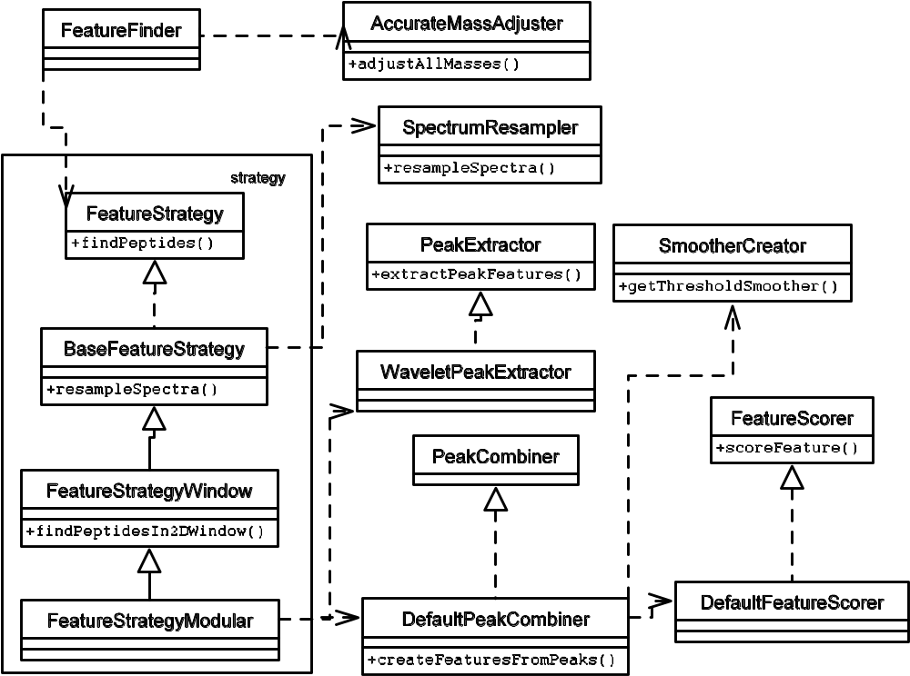

The FeatureFinder class is called directly by calling code -- it is instantiated directly by FindPeptidesCommandLineModule. A “strategy” class is passed to FeatureFinder that implements the details of feature-finding. In order to implement your own feature-finding routine, you will need to create a class that implements org.fhcrc.cpl.viewer.features.featureFinding.strategy and pass that Class to FeatureFinder.
The class diagram above shows the class structure for the default feature-finding class, FeatureStrategyModular. You do not have to make use of all of the structure that FeatureStrategyModular makes use of – your FeatureStrategy class only needs to implement FeatureStrategy and have a no-argument constructor. However, the structure provided is designed to take as much of the burden as possible off the individual feature strategy classes by compartmentalizing the complex behaviors common to different kinds of feature-finding strategies.

- Command Line Modules
Much of msInspect’s functionality is accessed through the command line. The functionality accessed in this way is diverse, but all such functionality shares certain requirements:
- Documentation: basic help text, and argument names and types, must be communicated to the user
- Argument handling: arguments of many different types must be parsed and assigned to variables
- Exception handling: If a command fails, it needs some standard way to report the failure
These needs are handled by the Command Line Module framework. The purpose of this framework is to make it easy, safe, and elegant to develop and document new pieces of functionality.
Each separate command in msInspect is managed by a separate class that must implement the interface viewer.commandline.CommandLineModule. A base implementation class, viewer.commandline.BaseCommandLineModuleImpl, is provided to facilitate creation of individual modules, but modules need not extend that class.
These classes are heavily documented, so we won’t repeat all of the individual method information here. However, here is the order of methods as they are called by Application when a command is invoked:
- The module’s getArgumentDefinition method is called on each user-specified argument, to verify that the argument name is valid for this command
- Argument values are collected in a map, which is passed to the module’s digestArguments method
- If no exceptions are thrown, the module’s execute method is called
Beneath this level, there is a great deal of machinery for the handling of arguments. In BaseCommandLineModuleImpl, the digestArguments functionality is split up. Basic argument parsing is handled at the base-class level, using the argument definitions themselves to perform basic parsing on the argument values. Then, the subclass’ assignArgumentValues method is called in order to do higher-level management of the values and assignment to variables within the module.
 Tip: The command line module framework is tightly integrated with the msInspect testing framework, making it very easy to create tests for particular modules. This is strongly encouraged for any custom modules you create. See the Testing Framework section for details.

  - Arguments
Argument declarations are embodied by instances of the CommandLineArgumentDefinition interface. Classes that implement this interface know how to convert arguments of a given type from strings supplied on the command line into some useful object. This conversion, done in the convertArgumentValue method, can be simple, as in IntegerArgumentDefinition (which simply calls Integer.parseInt), or quite complex, as in FeatureFileArgumentDefinition (which finds the file specified by the user and creates a FeatureSet from it). Each argument definition class also knows how to document itself, by implementing the getValueDescriptor method.
In general, it is best not to pack too much complexity into argument definition classes. The example of FeatureFileArgumentDefinition is on the extreme end of recommended complexity. This is because all arguments must be digested before any argument post-processing is done, e.g., to make sure that all arguments are present. So you may end up waiting for a feature file to load before discovering that an unrelated argument is missing.

 Tip: one particular argument definition class bears special notice. The class EnumeratedValuesArgumentDefinition allows you to specify a set of allowed values for the argument, with or without case sensitivity. One example of this kind of argument is used for modules that need to run in different modes – the informal standard is to create an argument definition of this type named “mode”.

BaseCommandLineModuleImpl contains many convenience methods for declaring argument definitions and accessing the user-specified arguments.

 Example: this example describes how to set up a Boolean argument definition, which can be used as a flag (if it’s defined, your variable is set to true; if it’s not, it’s set to false) or as an explicit “true” or “false” setting by the user.
First, in your class, declare a member variable to represent the flag, and set its default value:
protected boolean myFlagResult = false;
In the init method, add an argument definition:
addArgumentDefinition(createBooleanArgumentDefinition("myflag", false, "this is my flag, default value is " + myFlagResult);
In the assignArgumentValues method, parse the argument, defaulting to the existing (default) value:
myFlagResult = getBooleanArgumentValue("myflag", myFlagResult);
Now the variable myFlagResult will contain the value specified by the user, or true, if the user specified the flag with no value (“—myflag”), or false (the default), if the user did not specify a value.

  - Module Documentation
Command line module usage can be auto-documenting, or their documentation can be defined explicitly within the module. Module usage documentation is performed in the getUsage method. In BaseCommandLineModuleImpl, this is implemented as follows. If the mUsage variable has its default value, then usage documentation is generated automatically based on the known argument definitions. Otherwise, the mUsage string itself is returned.
Similarly, the mShortDescription and mHelpMessage variables provide a way for modules to give short and medium-length descriptions of their functionality, respectively. The short description is used in the generic msInspect usage message, and the help message is returned when the user invokes the help command for this module.
  - Module Discovery
At runtime, before attempting to parse the user’s arguments, Application discovers the full set of Command Line Modules that are available. It does this by calling viewer.commandline.CommandLineModuleDiscoverer.findAllCommandLineModules. This method first loads definitions for all the standard command line modules, then discovers any custom modules.
Standard module names are declared in the file commandline_modules.properties. Even if a command line module ships with msInspect, it will not be discovered as a standard module unless it is declared in this file. If the property for a given module is set to “false” in this file, the module will not be loaded. This is how standard modules can be disabled.
Custom modules are searched for using the default class loader. Any class discovered in this way that sits in the package org.fhcrc.cpas.viewer.commandline.modules and implements CommandLineModule will be loaded as a custom module.

 Note: There is an issue with the one-jar class loader; it cannot be used to identify new modules in this way. If you want to deploy msInspect using one-jar, and you want your custom command line modules to be available, they will need to be declared just as standard command line modules are declared, in commandline_modules.properties

  - Examples

FindPeptidesCommandLineModule is a fairly straightforward example of the functionality discussed above. For a more complex example, see AmtDatabaseCreatorCommandLineModule.

- Testing Framework
msInspect has a mechanism for running automated regression tests. These tests are run under Ant, using an identical mechanism to the CPAS regression tests. The Ant build file for use in running tests is webapps/tools/test/build.xml. The “drt” target in this file runs tests. By default it runs all available tests, which are specified explicitly in the property file viewer.test.tests.properties. You may also specify a specific test name to run. For example, to run FindPeptidesTest, you would run “ant drt –Dtest=findpeptides”.
All tests must extend viewer.test.BaseViewerTest (properly there should be a separate interface as well as a base class, but no such need has arisen yet). This class provides a cleanup method, which deletes any known temp files related to the test (see Temporary File Management below) and then passes control to the subclass’ doCleanup method; and a run method, which runs the test.
Since command line modules are self-describing, it is quite easy to instantiate and run them as part of a test. The abstract class viewer.test.BaseCommandLineModuleTest provides several utility methods for instantiating command line modules, assigning their argument values, and executing them repeatedly. See FindPeptidesTest for an example of how this structure can be used.
Individual tests can do whatever is necessary to ensure that a piece of functionality is working correctly. They can call any code within msInspect and use any means available for evaluating the results.
  - MD5 Sum Comparison
One useful and quick way to check the output of a piece of functionality is to have the feature write output to a file, perform an MD5 sum on the file, and check that sum against a stored sum. Naturally, this is a very restrictive way testing functionality, but it has its uses, and it’s extremely quick to implement: simply calculate an MD5 sum on an output file (removing anything date-dependent), store that sum as a constant in your test class, and compare it with the output at runtime.
The main() method in the TestRunner class provides an easy way to calculate MD5 sums. Simply call that method with “md5sum <filepath>” as the arguments, and it will calculate the sum. First, however, it will strip all whitespace and comment lines (lines beginning with #) from the file. To compare an MD5 sum with this stored sum at test time, using the exact same code path, call TestUtilities.compareHexMD5SumsNoWhiteSpaceNoComments.

- GUI Utilities
There are a few graphical utilities that we’ve built in msInspect that come in handy in different situations. In general, if you’re building something that could use one of these, you should use it, to save yourself time and prevent code duplication; and if you find yourself coding the same widget more than once, you should consider moving it out into something generically useful. Graphical utilities live in the gui.util package.
  - Chart Creation
msInspect makes heavy use of JFreeCharts (http://www.jfree.org/freechart) for plotting various things. One example is the bottom pane on the main window. The following classes are useful for creating and displaying charts:
- PanelWithChart: generic class for creating a panel with a chart in it. Right-clicking on the chart gives you ways to save, not just the chart itself, but the data that make it up
  - PanelWithScatterplot: specific to scatterplots, making it easy to define the data series
  - PanelWithLineChart: for line charts
  - PanelWithHistogram: for histograms
  - PanelWithRPerspectivePlot: for creating 3D isometric-perspective charts using R
- PanelWithVenn: this one doesn’t actually use JFree, but it’ll create a very simple two-bubble, proportional Venn diagram
- ChartDialog: create a dialog box with a chart in it, which will die when closed
  - ScatterPlotDialog: specific to scatterplots

asdf
  - Etc.
- WorkbenchFileChooser (in gui, not gui.util) is a thin wrapper on JFileChooser that saves the last directory opened in a WorkbenchFileChooser and allows you to stipulate that chosen files must exist.

- Other Utilities
Non-GUI utilities that are useful throughout msInspect go in the util package. Their purposes are many and varied. Some examples:
- BrowserController: does its best to pop open a browser window on a given URL. Can point to temp files, for quick and dirty HTML-based UI design
- Clusterer2D: performs 2-dimensional clustering. Used in peptide array creation and in MS1-MS2 feature-matching
- RInterface: interface with the R language (more on this in the RInterface section)
- SharedProperties: controls a small set of properties shared throughout the application

Also, the org.labkey.common.tools package contains a class called BasicStatistics, which is used for things like calculating means and standard deviations, studentized residuals, leverage values, etc. Usage of these methods, rather than reimplementing them elsewhere, is encouraged. However, before checking in any changes to this class you will need to run your changes through the CPAS DRT, since the code is shared with LabKey’s CPAS project.

  - R Interface
As discussed above, msInspect makes use of the R statistical programming language in several ways. All msInspect use of R should pass through the class util.RInterface if possible. This class provides several methods for executing R scripts and commands, managing all communication with R and cleaning up temporary files.
All communication with R takes place via the filesystem. In general, msInspect writes a file, makes an R system call to do some processing on that file, and then reads an R output file to retrieve the result. This is a bad situation in many ways. It makes it very difficult, for instance, to control the total amount of memory in use by msInspect and R when both are running. However, the alternatives at this point are not good. The OmegaHat project (http://www.omegahat.org) has created a more elegant mechanism for calling R routines from Java, but it expects the user’s R installation to have some additional packages loaded. We’ve had enough trouble with users getting vanilla R installations set up correctly to be leery of anything that makes setting up R more complicated.
However, the RInterface class hides all the details of communication with R. It’s easy to imagine swapping out the current filesystem-based implementation invisibly in favor of another mechanism in the future.
RInterface provides two methods for running R commands:
- runRScript: this method accepts a File, which may be located anywhere on the filesystem, and executes R in batch mode on the file. Output is defined by the script itself
- evaluateRCommand: this method accepts an R command, or series of commands, as a String and returns the complete result from R as a String, which the calling class must then parse. This method eschews file-based communication, instead grabbing the input and output streams of the R process
Both of these methods allow you to specify the number of milliseconds to wait for a response from R. They throw RuntimeExceptions if anything goes wrong.
Most R usage in msInspect uses the runRScript method. This allows fairly sophisticated R scripts to be run, potentially interacting with multiple files. A good example of this usage is in align.Aligner.alignPairs.
It is important to note that, when R is invoked, it will be run from the msInspect temp directory, which is retrieved from TempFileManager.getTmpDir (see below). Any temp files created by RInterface will be managed by TempFileManager, and assigned to the calling object, which must be specified when calling runRScript.

  - Temporary File Management
Several features within msInspect (most notably interfacing with R) require the writing and reading of temporary files. This is all handled through util.TempFileManager. It is important to clean up these temporary files at the appropriate time. If temp files are left around indefinitely they can clog up the user’s disk. If they’re deleted too soon, clues as to an error condition may be lost.
To allow the programmer flexibility in controlling temp files, TempFileManager keeps track of all the temporary files it creates, and it associates each file with an object. When requesting a temp file via TempFileManager.createTempFile (which accepts a filename), it is recommended to pass in an object that is designated as the “caller”. When it comes time to delete all the temp files related to an object (typically, when an operation has completed successfully), TempFileManager.deleteTempFiles is called, again passing in the caller object. TempFileManager.markFileForDeletion may be used to mark any file on the file system for deletion when deleteTempFiles is called, and so it should be used with extreme caution.

