msInspect User’s Guide
Version 1.0

For msInspect version 1.0, released May 2006.
Note: Screenshots may vary from the msInspect
build you are using since the application is still
in development.

Compiled by Andrea Detter for the


Table of Contents
1 Introduction 5
1.1 About msInspect 5
1.2 About this Guide 5
1.3 Getting Help 6
1.4 Acknowledgements 6
2 Getting Started 7
2.1 Creating mzXML Files 7
2.2 Launching msInspect 7
2.3 Opening an mzXML File 7
2.4 Viewing Files 8
3 Tutorial 9
3.1 Opening a Run File 9
3.2 Using the Detail Pane 11
3.3 Using the Chart Pane 14
3.4 Creating a Feature Set File 16
3.5 Displaying a Feature Set File 18
3.6 Working with the Feature Set List 19
3.7 Using the Heat Map Tool 20
3.8 Filtering Features 22
3.9 Working with Multiple Feature Set Files 22
3.10 Create a Peptide Array 23
3.11 Finding Features in Isotopically-Labeled Data 25

4 Display Details 27
4.1 Image Pane 27
4.2 The Detail Pane 27
4.2.1 Detail Pane Settings 28
4.3 The Chart Pane 30
4.3.1 m/z Spectrum 30
4.3.2 Elution Profile 32
4.3.3 Working in the Chart Pane 33
4.3.4 Chart Pane Processing 35
4.4 The Properties Pane 36
5 Finding Features 37
5.1 Feature-Finding Algorithms 37
5.2 Finding All Features in a File 38
5.3 Displaying Peptide Features 41
5.4 Filtering Features 42
5.5 Using the Heat Map Tool 43
6 The Peptide Array Component 45
6.1 Generating a Peptide Array 45
7 The FASTA Component 49
7.1 Identifying Peptides Using FASTA Files 49
7.2 Calculating Peptide Coverage 49
8 Command Line 50
8.1 Opening a File 50
8.2 Command Line Functionality 50
8.3 Finding Peptide Features 51
8.4 Filtering 53
8.5 Creating an Array 55
8.6 Additional Commands 56
Appendix A: msInspect Menus 58
The File Menu 58
The Tools Menu 59
The Windows Menu 60
The Languages Menu 60
The Help Menu 60

- Introduction

  - About msInspect
msInspect allows you to view high-resolution mass spectrometry (MS) data represented in an mzXML file. You can use msInspect’s built-in tools to inspect data, identify peptide features, generate peptide arrays using data from multiple runs, and export data to external applications for further analysis and collaboration. We are also developing tools for protein identification directly from MS1 data using FASTA files. msInspect is an open source application written in Java.

We also designed msInspect as a setting in which to develop and test analysis approaches for MS data. Because of this, some of msInspect’s features are still being modified and so may not be described in detail here. If you have questions about msInspect’s features, would like access to the source code, or have general feedback, please visit http://proteomics.fhcrc.org/.

  - About this Guide
Most of the examples used in the guide come from an LC ESI-TOF MS run of a simple 5-protein ‘mini’ proteome sample. Sections that demonstrate msInpect’s support of isotopically labeled data use data from ICAT-labeled human serum samples also run on an LC ESI-TOF. You can download these sample datasets along with msInspect.

This guide uses the following typographical conventions:

Constant Width
for command line examples

Constant Width Italic
for replaceable text in command line examples

Italic
for filenames, path names, m/z

Double quotes (“/”)
around application status and error messages and hyperlink names

 Indicates a Note or Tip

◻ Indicates a Definition of a new term

  - Getting Help
In addition to this User’s Guide, msInspect documentation is also available on our website. This online help can be accessed by selecting Help for the Help menu item in msInspect or by using the F1 key.

Selecting Help > Support will allow you to access an interactive, web-based support forum (https://cpas.fhcrc.org/Project/home/support/begin.view?) where users can post questions and feature requests for both msInspect and CPAS.

  - Acknowledgements
msInspect makes use of other software packages, including a number of open-source applications. We acknowledge these packages below; please refer to the NOTICES file in the distribution for more specific information and for terms of the relevant licenses.

This product includes:
- Software developed by the Apache Software Foundation (http://www.apache.org/) and released under the Apache 2.0 License: log4j, Xerces-J, and Commons beanutils, collections, logging and lang.
- The JRAP mzXML parser (http://sashimi.sourceforge.net/software_glossolalia.html).
- One-JAR (http://one-jar.sourceforge.net).
- Software developed by the SWIXML Project (http://www.swixml.org/).
- The Piccolo XML Parser (http://piccolo.sourceforge.net/index.html) released under the Apache 2.0 License.
- JDOM (http://www.jdom.org/).
- JAMA, a public domain matrix package developed by MathWorks and NIST (http://math.nist.gov/javanumerics/jama/).
- JFreeChart (http://www.jfree.org/).
- Runtime components (forms_rt.jar) from IntelliJ IDEA, Copyright 2000-2005 JetBrains s.r.o. (http://www.jetbrains.com/).
- JAI (http://java.sun.com/products/java-media/jai/).

- Getting Started

  - Creating mzXML Files
msInspect displays MS1 data contained in mzXML files. mzXML is an XML (eXtensible Markup Language) format for representing MS data. Mass spectrometers do not automatically produce mzXML files, but there are several tools available that generate mzXML files from various native acquisition files. The Sashimi website at http://sashimi.sourceforge.net/ offers a collection of converter programs for some common mass spectrometers.

msInspect will open any mzXML file containing MS1 data; however, msInspect has been designed using high-resolution LC ESI-TOF MS1 data so it may not perform as well with an mzXML file from another type of MS (e.g., MALDI).

  - Launching msInspect
You will need Java Web Start installed to run msInspect. If you do not have Java Web Start, you can download it from the Java Web Start download page: http://java.sun.com/products/javawebstart/download.html. Once you have Java Web Start, you can launch msInspect using the launch link – http://proteomics.fhcrc.org/download/tools/msInspect/viewer.jnlp - or by entering http://proteomics.fhcrc.org/download/tools/remoteApps.html directly into the Location box in the Java Web Start Application Manager.
To run msInspect, you must have Java 1.5 JVM installed and on your PATH. Please see http://java.sun.com/ for download and installation instructions for “J2SE 5.0,” which includes the required version.

To enhance msInspect’s performance, try the JRockit Java Virtual Machine. Installing this JVM is not required to run msInspect, but it can make it run about 20% faster. If you’d like to try it, you can download it from the BEA Weblogic JRockit website at http://dev2dev.bea.com/products/wljrockit81/index.jsp.

To conduct the alignment and registration steps involved in creating peptide arrays (see sections 3.9 and 6.1), you will need to have R installed and on the path. You can download R from http://www.r-project.org.

  - Opening an mzXML File
When you launch msInspect, you will see a File Open dialog box. (You can also select File > Open.) Browse for the mzXML file you want to view and click Open.

When you open a file for the first time, msInspect writes an .inspect file (yourfile.inspect) in the same directory as the original mzXML file to make subsequent opening faster. This can be time consuming so we recommend you do it on a machine with a fast connection to the disk where the original mzXML file is stored. If you do not have write access to the folder where the mzXML file is stored, msInspect will still open your mzXML file, but a new .insepct file will be created again the next time you open the file.

When the file opens, the title bar at the top of the msInspect window will display “CPAS msInspect (build XXXX) -- your file,” and the status bar along the bottom of the window will display “Finished Loading.”

  - Viewing Files
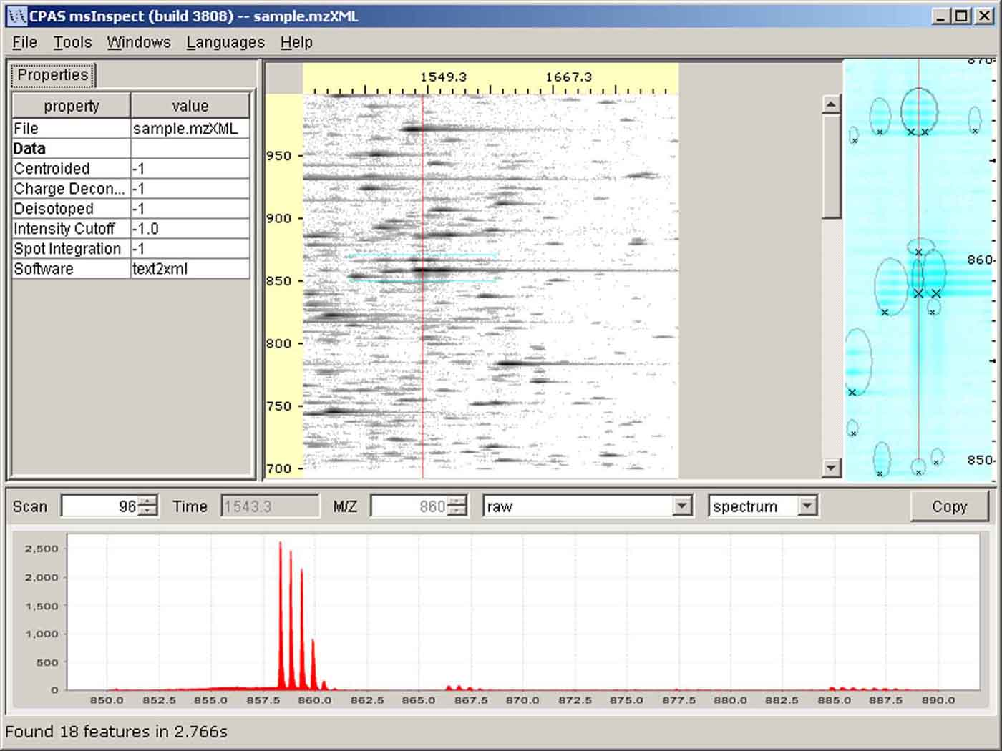
This section provides a brief overview of the layout of msInspect’s display and the options you have for viewing your data.
Image Pane
Properties Pane
m/z
Time/scan number
Detail Pane
Chart Pane
The msInspect window has four panes:
- The Image Pane displays an image of the MS1data from your run.
- The Detail Pane displays a close-up view of the area selected in the Image Pane.
- The Chart Pane displays m/z spectra and elution profiles corresponding to the scan or m/z value, respectively, marked by the red line in the Detail Pane.
- The optional Properties Pane displays properties of the open mzXML or Feature Set file or the peptide feature selected in the Detail Pane.

For more information on the display, please see section 4 – Display Details. The next section is the Tutorial, which illustrates some of msInspect’s key features using sample datasets.
- Tutorial

  - Opening a Run File
- To download the mzXML file used in this tutorial, go to http://proteomics.fhcrc.org/CPAS/Wiki/home/FHCRC%20Help/page.view?name=viewer, and click on the “Download Sample Data (15MB)” link. Save the file as sample.mzXML in a directory to which you have write access. This file is a subset of data from a LC-MS run of a 5-protein sample.
- Launch msInspect from the same webpage by clicking on “Launch msInspect with Java Web Start”.
- Browse for the sample.mzXML file you saved in step 1 in the Open File dialog box, and click Open.
  - msInspect will write a sample.mzXML.inspect file in the same directory where you saved the original sample.mzXML file. This step can take awhile, but it will make subsequent opening faster. The status bar at the bottom of the msInspect window will display “Building image…”
  - Once sample.mzXML opens, you will see the image of your run in the Image Pane. The Detail Pane and Chart Pane are blank until you click somewhere in the Image Pane.

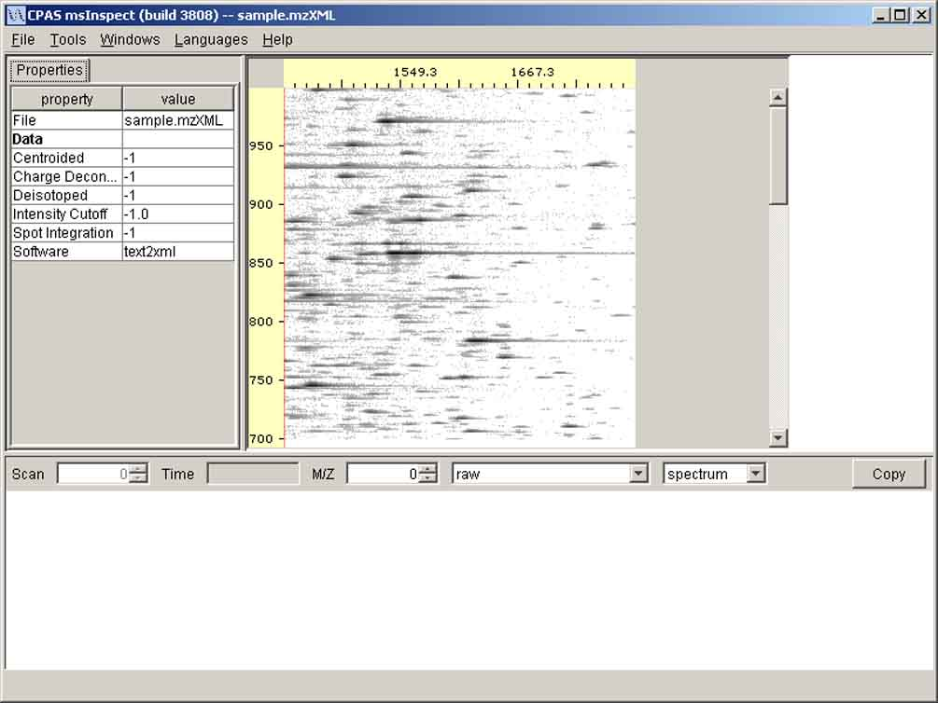
sample.mzXML open in msInspect

- Select Windows > Show/hide Properties to hide the Properties Pane.
- Hold your mouse over a spot in the Image Pane. A tip tag will appear that displays the coordinates of your location (Scan, m/z).

 NOTE: The horizontal axis in the Image Pane is labeled in seconds, but the tip tag displays the scan number. See section 4.1 for more information.

- Click the point in the Image Pane where Scan=96 and m/z=859 (96, 859).
  - The Detail Pane shows the area around where you clicked. Detected peptide features are circled. Xs mark the monoisotopic peaks in each feature. The status bar at the bottom of the window displays the number of features found and how long it took to find them.
  - Hover over features in the Detail Pane to display tip tags with information about those features. The tip tag displays, from the top: scan number, m/z (followed by mass in parentheses), inferred charge state, intensity/background intensity/median intensity, and scan range in which the feature appeared.
  - The Chart Pane displays the m/z spectrum for the scan corresponding to the vertical red line in the Detail Pane. Notice also that the Scan number (96) and the M/Z (859) are shown at the top of the Chart Pane.

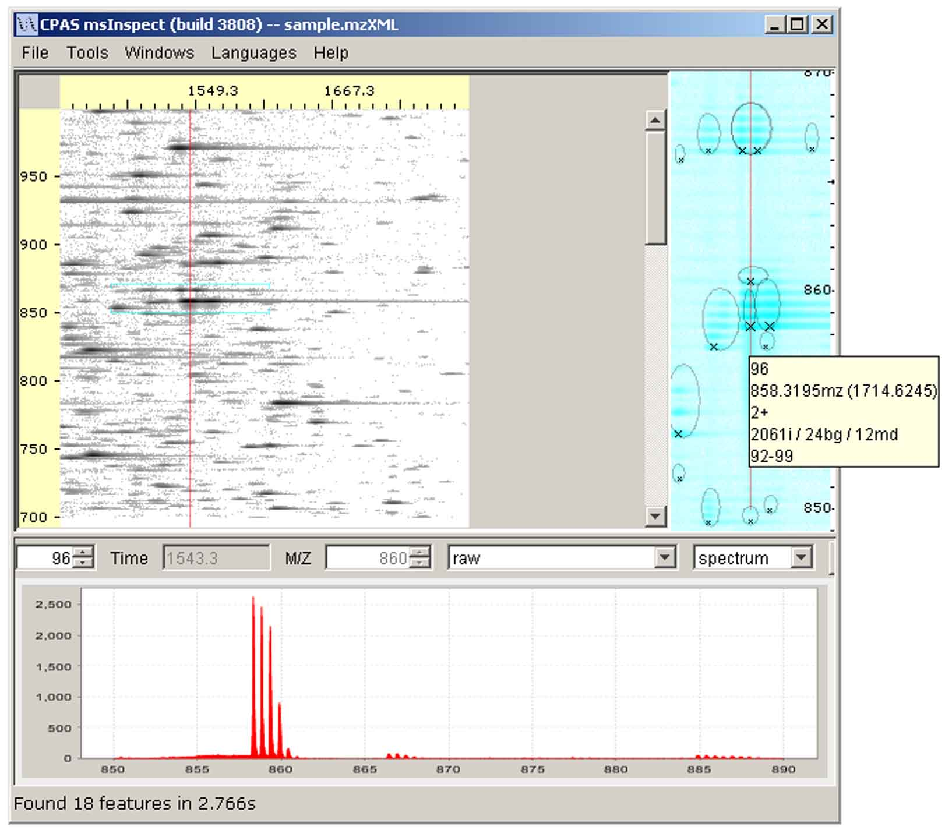
The Tip Tag in the Detail Pane displays information about detected peptide features.

- You can also view elution profile plots in the Chart Pane. Select elution from the drop down list at the top of the Chart Pane to view the profile for m/z=859. Notice that the Detail Pane now displays a horizontal line corresponding to m/z=859. Select spectrum from the drop down list to return to the original plot.
  - Using the Detail Pane
You can adjust what you see in the Detail Pane using the Detail Pane Settings dialog box.
- Select Tools > Detail Pane Settings…. The dialog box that opens has several options for manipulating your view.

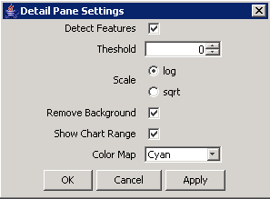

Remove Background
- Since we clicked in an area of the image with some background noise, check the Remove Background box and click Apply. Notice how the background noise is reduced in the image in the Detail Pane. For another example, see section 4.2.1.

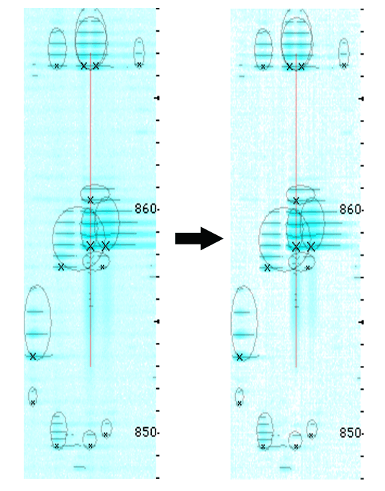
Background Background
shown removed
Color Map
These options can alter the contrast of the image to make some features easier to see.
- Choose Rainbow from the drop down box, and click Apply. The red-orange color indicates the high-intensity peaks in the peptide feature at the center of the Detail Pane while the low-intensity areas around the features are shown in purple.
- When you finish trying out the Color Map options, select Cyan, and click OK.

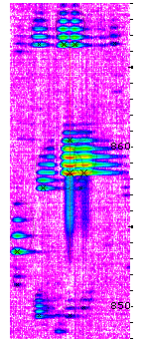
Rainbow Color Map

Detect Features
This option detects peptide features in the data shown in the Detail Pane. The algorithms you can use to detect features are shown in the Tools menu. The default algorithm is ‘2D Peak Alignment.’ The algorithms are described in section 5.1 of this guide.
- Select Tools > peaks (intermediate result). The Detail Pane now displays Xs on every peak identified. Because the peaks are not grouped into peptide features, charge state cannot be inferred – notice the tip tag for each peak shows ‘0+’ for the charge state.

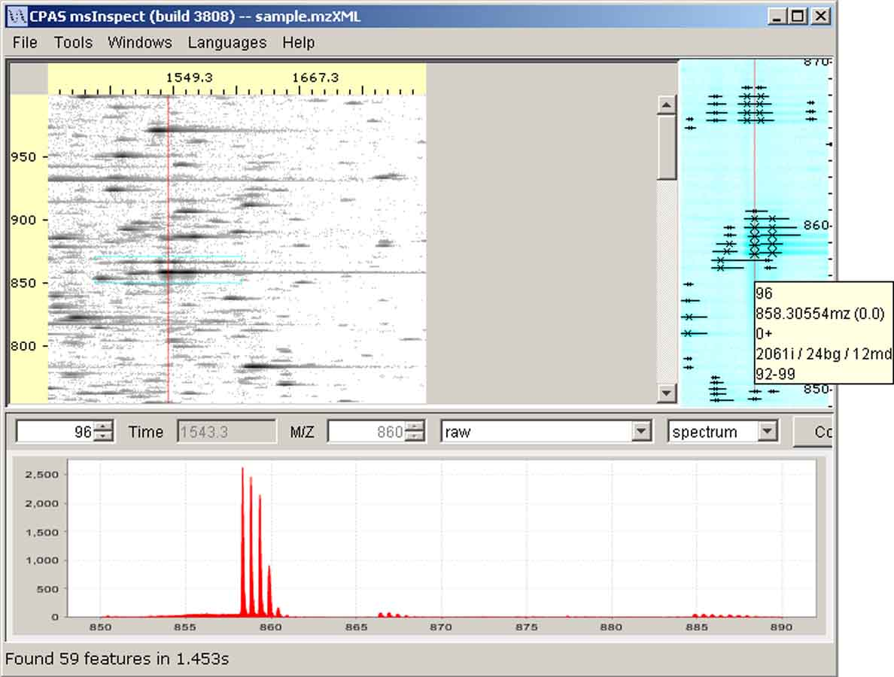
Features detected using ‘peaks (intermediate result)’ algorithm and tip tag in Detail Pane.

- In the Detail Pane Settings dialog box, uncheck the Detect Features check box to turn off this option, and click Apply. The lines and Xs no longer appear.
- Try changing the other options in the Detail Pane Settings dialog box. All of the settings are described further in section 4.2.1.
- Before you close the Detail Pane Settings dialog box, make sure the Detect Features and Remove Background check boxes are checked, and select Cyan from the Color Map list. Then click OK.
- Select Tools > 2D Peak Alignment to return to the default feature-finding algorithm.

  - Using the Chart Pane
- Click on the feature at the left edge of the Detail Pane, at scan 43, m/z 853.417. The image in the Detail Pane will shift to center around this newly selected feature. The plot in the Chart Pane is also redrawn for the scan where you clicked (scan 43). Notice that the y-axis (intensity) auto-scales. For the feature at (96,859), the axis was labeled up to ~2500. Now the axis is labeled up to just 350 because this feature is less intense. (There will be some variance in the exact range depending on the size of your msInspect application window.) You can turn off the auto-scaling of the y-axis by clicking on Lock Y Scale in the Tools menu (see section 4.3 for more information).
- Choose ‘resampled’ from the drop down box in the Chart Pane (see section 4.3.4 for more information about these options). The red line that runs along the bottom of the Chart Pane plot represents the running minima. This is the background that was removed when you checked Remove Background in the Detail Pane Settings dialog box. Since the background is relatively low, it is difficult to see the red line.
- Drag your mouse over the second and third peaks to highlight them in gray, then release the mouse. The plot will zoom in on the area you just selected (see figure below). The red line is now just visible running along the bottom of the plot.
- Right click in the Chart Pane and select Auto Range > Both Axes to return to the original plot.

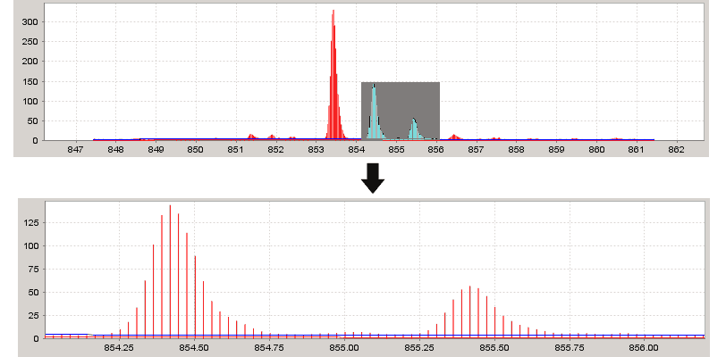
Zoom in by dragging your mouse over a selected area

- Now choose ‘peaks’ from the drop down box. The intensity peaks are marked by vertical lines. This makes it easier to see the peak distribution for the feature, which corresponds to the inferred charge state. #peaks/1Da = charge, so if the feature has 2 peaks in the space of 1 Dalton, the charge state is assumed to be +2. In this case, there is just one peak per Dalton so the charge state is marked as +1.

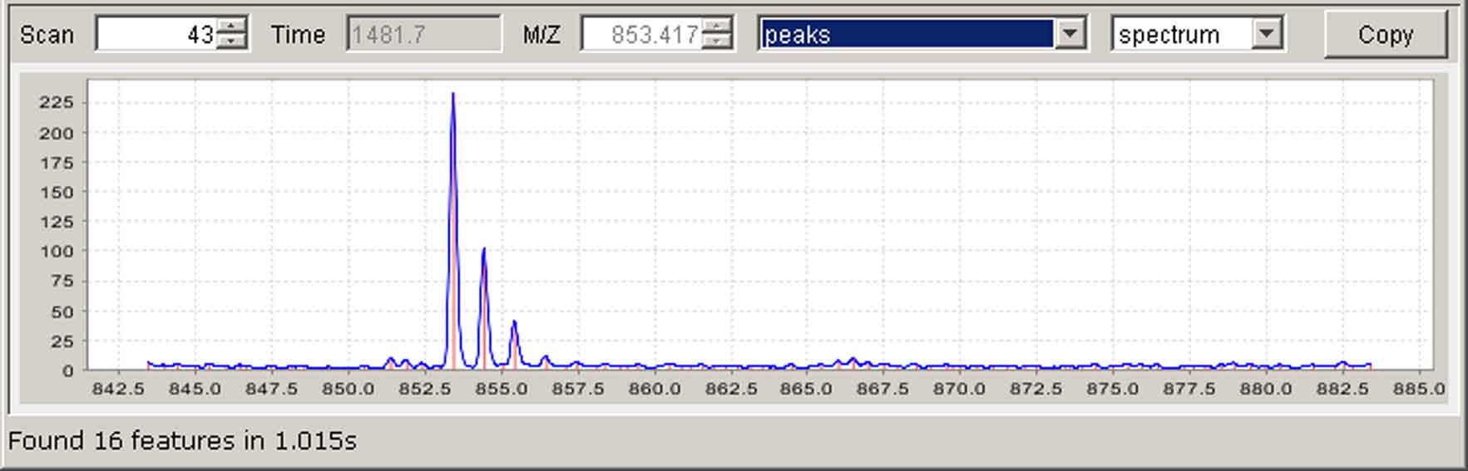
‘peaks’ m/z spectrum

- Select ‘raw’ from the drop down box to return to the original m/z spectrum.

  - Creating a Feature Set File
◻ A Feature Set File contains a list of all the peptide features detected in a run using the algorithm selected from the Tools menu.

- To generate a Feature Set file, Select Tools > 2D Peak Alignment.
- Now select Tools > Find All Features....
- In the Save Features to File field, enter (or browse for) a path and use sample.peptides.tsv as the name for the new file.
- Use the default values for the Scan range. By default, msInspect starts with the first scan and ends with the last scan, but you can also specify a subset of scans.
- Click Find Features. This generates a TSV file (here, sample.peptides.tsv) of the peptide features detected across the selected scan range (1-300) using the algorithm selected from the Tools menu (2D Peak Alignment). As the file is generated, the status bar at the bottom of the msInspect window will display “Finding all features in sample.mzxml. X.X% complete.”
- When the file is complete, the peptide features will show up as colored crosses over the image in the Image and Detail Panes. The status bar will display “Finding features complete. See file yourfilepath\sample.peptides.tsv”

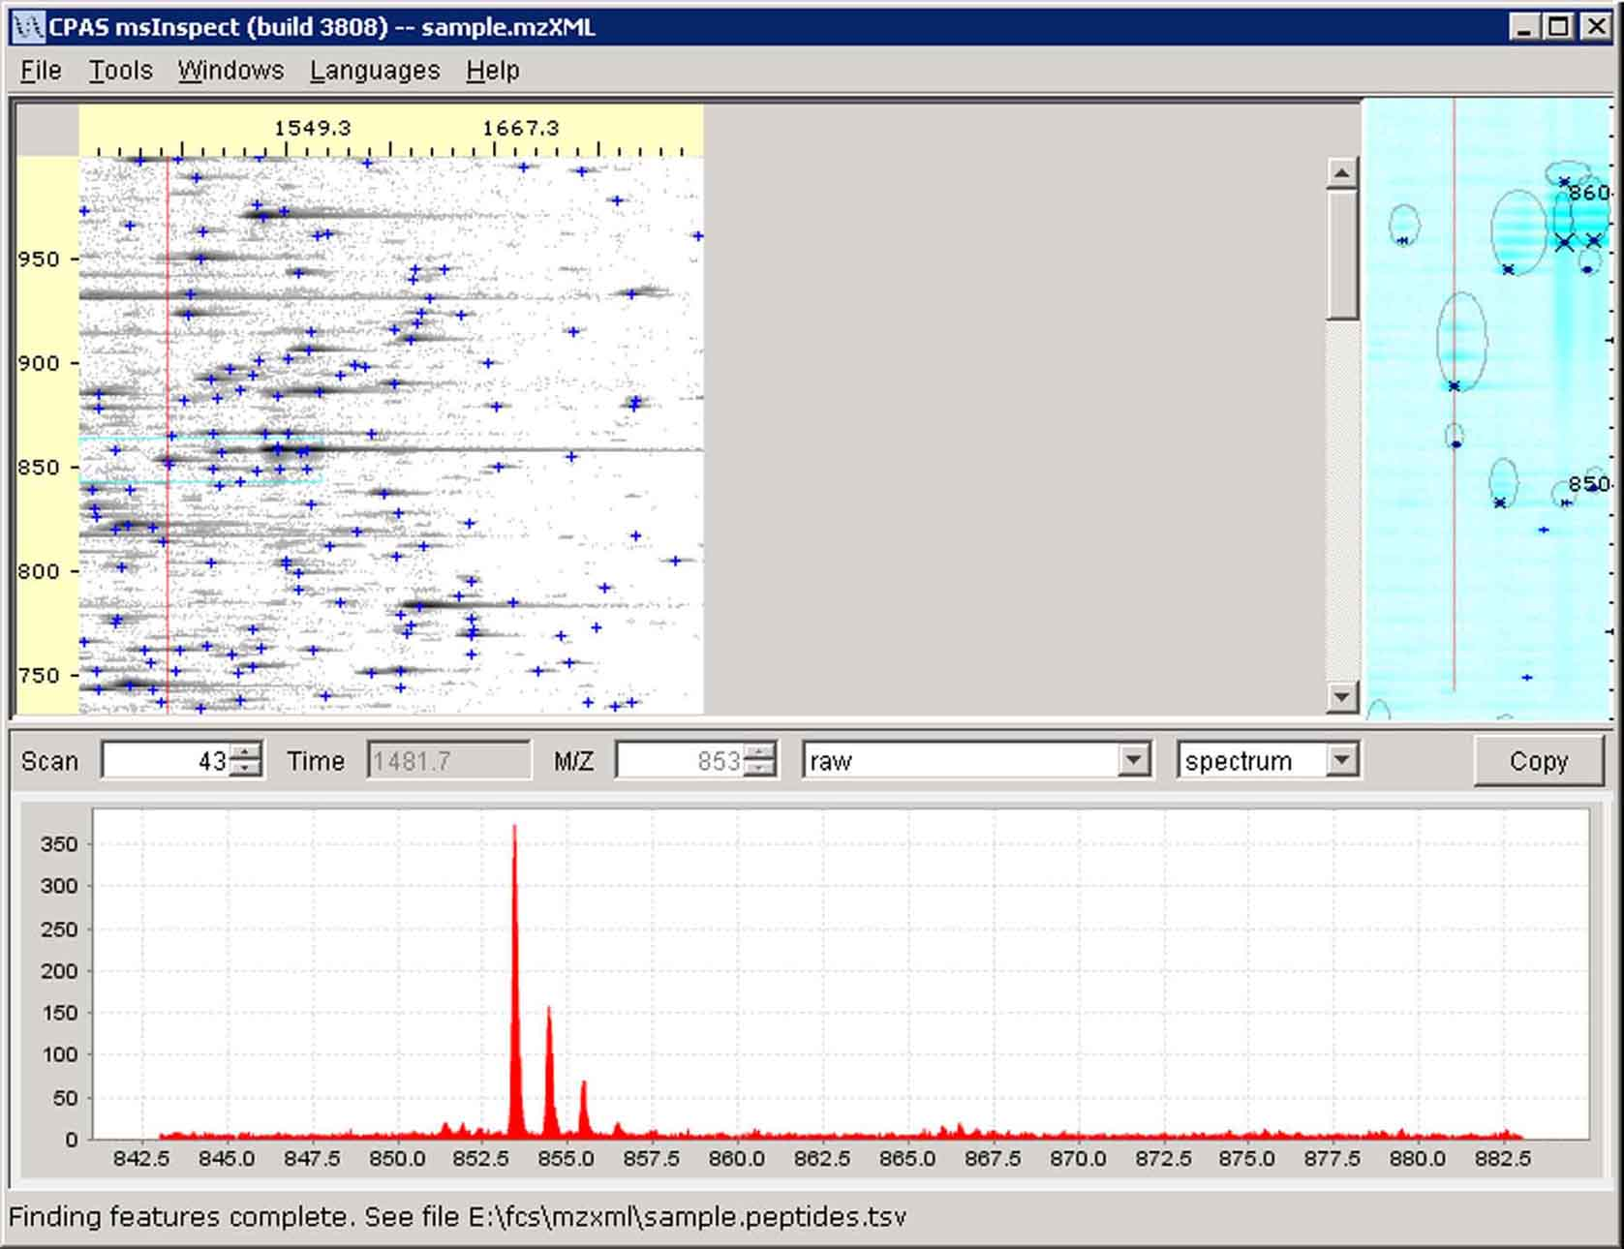
Feature Set sample.peptides.tsv (crosses) displayed over sample.mzXML image
If you have access to the msInspect viewerApp.jar file (available at http://proteomics.fhcrc.org/CPAS/Wiki/home/FHCRC%20Help/page.view?name=viewer%2Fcommand%20line), you can also create Feature Set files from the command line.

To create the Feature Set file we just made for sample.mzXML from the command line, you would enter:

java –Xmx512M -jar your_path\viewerApp.jar --findPeptides
--out=”your_path\sample.peptides.tsv” “your_path\sample.mzXML”

- -Xmx512M allocates 512 megabytes to the application. If you have more than 512M available on your machine you might consider raising this to 1G or more.
- Whether you need to include the file paths (yourpath\) depends on where you saved the viewerApp.jar and sample.mzXML files.
- For more information on using msInspect from the command line, see section 8 – Command Line.

You can only open one mzXML file at a time in the interactive version of msInspect, which means you can only create one Feature Set file at a time. To create multiple Feature Set files, you can make and run a batch file.

For example, if you had two repeats of each of two conditions, treatment and control, you could create Feature Set files for each of the four run files using the following MS-DOS .bat file:

set filenames=treatment;control

for %%f in (%filenames%) do java –Xmx512M
-jar your_path\viewerApp.jar --findPeptides
--out=”…\%%f.peptides.tsv” %%f_1.mzXML %%f_2.mzXML

 NOTE: The line beginning “for %%f…” should not contain line breaks in the .bat file. Line breaks appear in this guide only because of formatting requirements.

  - Displaying a Feature Set File
- Select Tools > Display Peptides…
- The file you just created is listed in the Display Features dialog box along with a Display check box, a Color field, and a ‘…’ field.
- You can choose whether or not to display the colored crosses by checking and unchecking the Display check box.
- You can change the color of the crosses by clicking the color block in the Color field. You can pick a color from the swatches tab or define a color using the HSB or RGB tabs. On the Swatches tab, select a yellow swatch and click OK. The crosses in the Image and Detail Panes are now yellow.

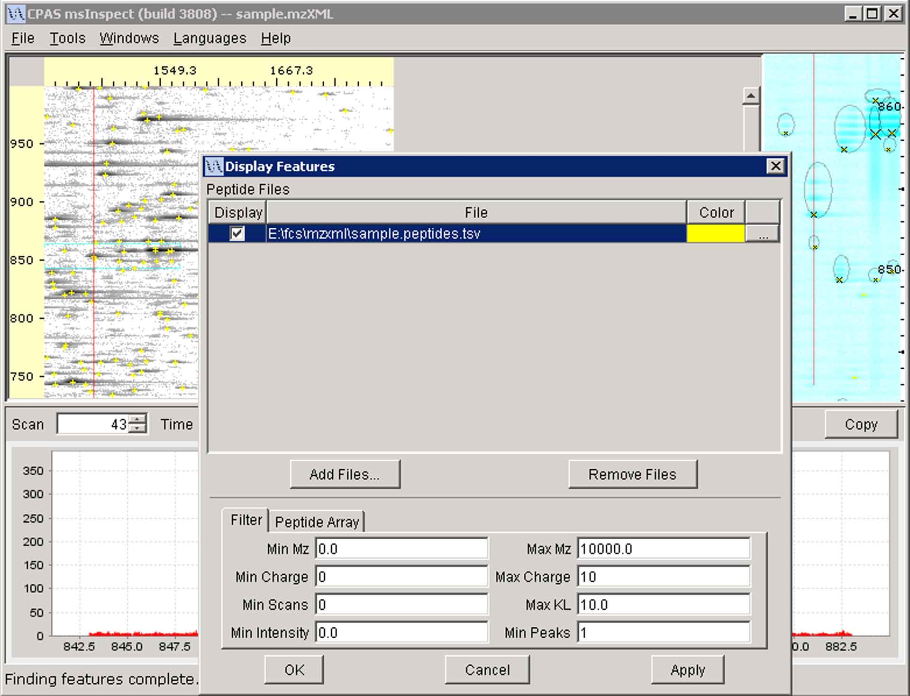
Display Features dialog box

  - Working with the Feature Set List
- In the Display Peptide dialog box, click the ‘…’ field to the right of the Color field.
  - The Feature Set List is an editable table of information about the Feature Set. You can add comments to this table, edit values, sort the list by each column, delete features from the list, and save your edited version of the file over the original Feature Set. For more information on the data in this table, see section 5.3.

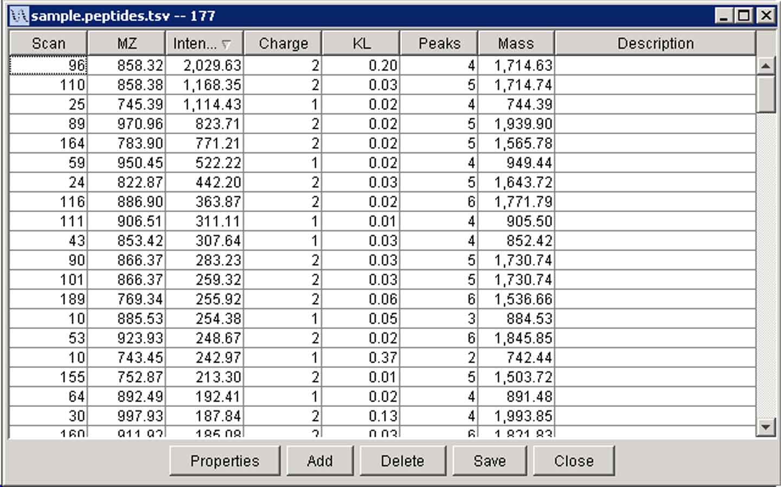
Feature Set List of sample.peptides.tsv

- Click the Intensity column heading twice to sort the list by feature intensity in descending order. The first feature in the list is the one at scan 96, m/z 858.32.
- Click on this feature in the list. Notice that the Detail and Chart Pane in the main msInspect window are redrawn to display this feature. It should look a little familiar since it is the first one we looked at in this tutorial.
- Click on other features in the list to view them in the Detail Pane.
- When you have finished exploring the Feature Set List, click on the feature at (96, 858.32), and then close the List.

  - Using the Heat Map Tool
The Heat Map visualization tool presents a summary of the features found by msInspect and allows you to look more closely at how well feature finding worked in your data.
- Select Tools > Display Heat Map…. A new window will appear that displays the Heat Map panel. Since this data set only contains features of charge +1, +2, and +3, only three images are displayed in the panel, one for each charge state. The plots display mass (X-axis) vs. m/z (Y-axis), and color represents intensity (red/low to yellow/high).
- Look at the charge +1 plot. Notice that the bright yellow line through the center of the plot, which represents the monoisotopic peaks for each +1 feature, blurs toward the right side. This illustrates how the mass accuracy decreases at higher mass values.
- Click on the charge +1 feature toward the right side of the plot that has several high-intensity (light yellow) bands below the monoisotopic peak band. Notice that this feature is now displayed in the main msInspect window’s Detail Pane and Chart Pane (m/z=973.5). The figure below shows this feature marked with a blue vertical line in the Heat Map panel and a red vertical line in the main msInspect window.
- Notice that these panes reveal the presence of a charge +2 feature that eluted slightly earlier at a lower m/z value (m/z=971, see the Tip Tag in the Detail Pane of the figure below). The tail end of the +2 feature’s isotopic peaks is apparent in the spectrum of the +1 feature (see the Chart Pane in the figure below). The feature-finding algorithm distinguished the +1 feature, but because the +1 feature’s isotopic distribution did not match the theoretical distribution as well, the feature got a high (poor) KL score.
- To observe this, select Sort by KL from the Heat Map panel’s Display menu. The +1 feature at m/z=973.5 is plotted all the way to the left of the heat map; it had the highest KL score of all the +1 features.
- Click on other features in the heat map and select other display options to see how the Heat Map tool allows you to investigate any outliers or questionable features in the data.
- When you have finished exploring the Heat Map tool, close the Heat Map panel.

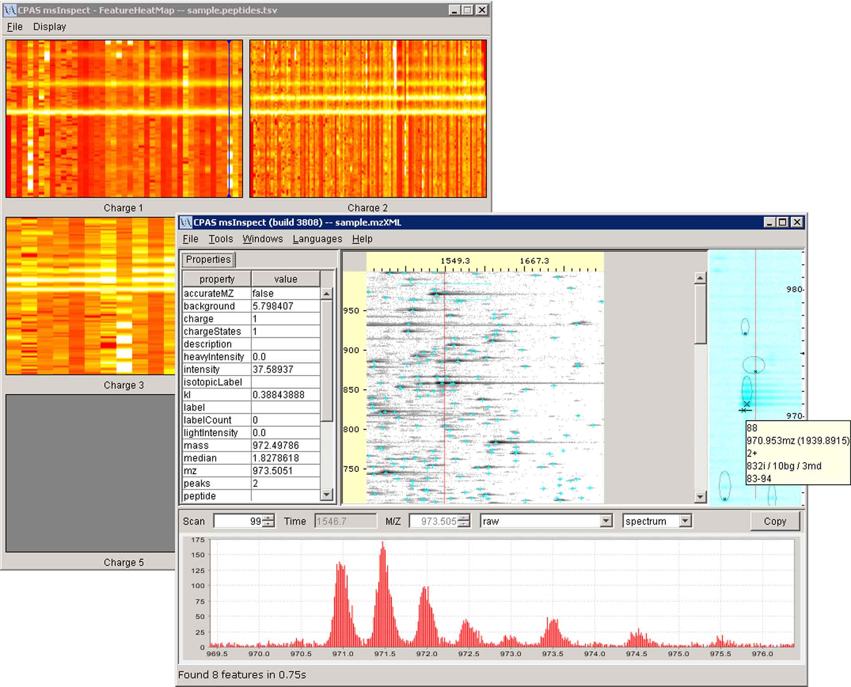

Heat Map panel under the main msInspect window showing a charge +1 feature and the Tip Tag for a charge +2 feature that eluted slightly earlier
  - Filtering Features
Filtering allows you to hand curate your data, selecting the criteria that determine which features get displayed. It is particularly helpful when you generate a peptide array, which we’ll get to shortly. For more information on Filtering Features, see section 5.4.
- Select Tools > Display Peptides…
- Click the Filter tab at the bottom of the Display Features dialog box. This tab displays several parameters by which you can filter features.
- Set Min Charge=1, Max KL=1.0, Min Intensity=100, and Min Peaks=3.
- Click Apply.
- The Detail Pane now shows only the features that meet these filtering criteria.

  - Working with Multiple Feature Set Files
For this example, we’ll use a new Feature Set file called tutorial.featureset.txt, which you can download from the same webpage where you got sample.mzXML. This feature set file originated from a replicate run of the 5-protein sample used for sample.mzXML.
- Go to http://proteomics.fhcrc.org/CPAS/Wiki/home/FHCRC%20Help/page.view?name=viewer.
- RIGHT click the “Sample Feature Set file for msInspect Tutorial” link and choose “Save (Target or Link) As…”.
- Save the file as tutorial.featureset.txt in the same directory where you saved sample.peptides.tsv.
- Return to msInspect and select Tools > Display Peptides…
- Click the Add Files button.
- Browse to find tutorial.featureset.txt. If the first Feature Set file, sample.peptides.tsv, is NOT still listed in the Display Features dialog box, hold down Ctrl and click on that file as well.
- Click Open. Both sample.peptides.tsv and tutorial.featureset.txt are now listed in the Display Features dialog box. Each file is assigned a different color, and the features from that file now overlay the run image in the Image Pane.
- You can temporarily hide the crosses (or Xs) from one or more Feature Set files by unchecking the Display check box in the Display Features dialog box.

  - Create a Peptide Array

◻ A Peptide Array is a file that allows us to compare the intensities of peptide features from different runs that have ‘matching’ masses and elution times.

Now that we have two Feature Set files, we can create a peptide array. For more information on how the arrays are generated, see section 6 – The Peptide Array Component. Remember that you must have R installed to perform these steps (see section 2.2).
- Click the Filter tab at the bottom of the Display Features dialog box.
- Change Min Mz to 700, Min Scans to 1, Max KL to 1.5, Min Intensity to 3.0, and Min Peaks to 2. Click Apply.

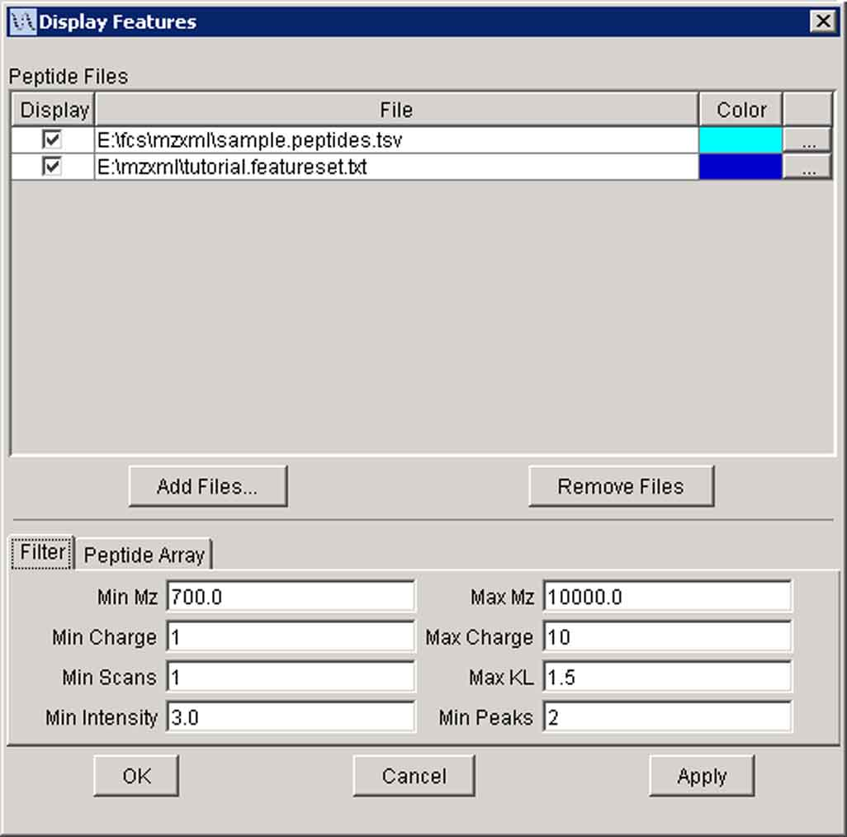
Filter tab in the Display Features dialog box

- Click the Peptide Array tab.
- In the Output File field, enter the file path where you would like to save the array file, and name the file pepArray.tsv.

◻ A Bucket is a region in mass and scan space into which peptide features are grouped to create an array. Each bucket corresponds to a ‘spot’ on a DNA microarray.

◻ A ‘Perfect’ Bucket is a bucket with exactly one peptide feature from each Feature Set file.

When you click the Optimize button on the Peptide Array tab, msInspect performs all the steps involved in making a peptide array, without actually writing the file, for a variety of bucket sizes. You will see a plot of Scan window versus ‘Perfect’ Buckets for the value entered in the Mass Window field. The maximum on the plot tells you what size the scan window should be to optimize the array for that m/z window.

- Enter 0.15 for the Mass Window.
- Click Optimize.
- The plot’s maximum is at a Scan window of 25 (115 ‘Perfect’ buckets).

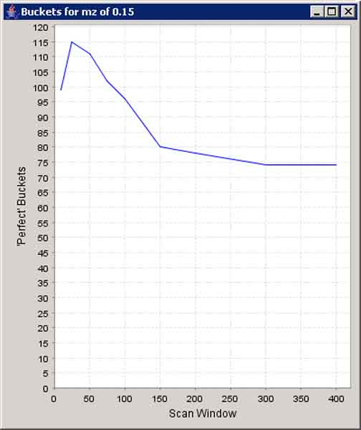
Optimization plot for buckets with a mass window of 0.15

- In the Display Features dialog box, the Scan Window field is automatically updated to the optimal value of 25.

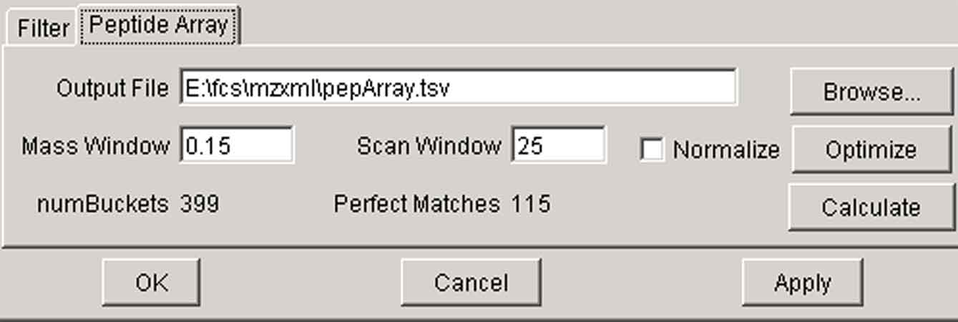
Peptide Array tab of the Display Features dialog box after optimization

- Click the Calculate button on the Peptide Array tab.
- The status bar at the bottom of the msInspect window will read “Calculating array for scan window of 25” while the files are generated.
- When the process is complete, the status bar will read “Peptide array complete. See your path\pepArray.tsv and your path\pepArray.details.tsv”.
- At this point you can use a microarray analysis tool suite to cluster this data and produce an image of the array.

For information on creating peptide array files from the command line, see section 8 – Command Line.

  - Finding Features in Isotopically-Labeled Data
msInspect also allows you to work with MS data from isotopically-labeled samples.
- To download the mzXML file used in this section of the tutorial, go to http://proteomics.fhcrc.org/CPAS/Wiki/home/FHCRC%20Help/page.view?name=viewer, and click on the “ICAT Sample Data” link. Save the file as ICATsample.mzXML in a directory to which you have write access. This file is a subset of data from a LC-MS run of an ICAT-labeled human serum sample.
- Launch msInspect from the same webpage by clicking on “Launch msInspect with Java Web Start”.
- Browse for the ICATsample.mzXML file you saved in step 1 in the Open File dialog box, and click Open.
  - msInspect will write an ICATsample.mzXML.inspect file in the same directory where you saved the original ICATsample.mzXML file. This step can take awhile, but it will make subsequent opening faster. The status bar at the bottom of the msInspect window will display “Building image…”
  - Once ICATsample.mzXML opens, you will see the image of your run in the Image Pane. The Detail Pane and Chart Pane are blank until you click somewhere in the Image Pane.
- Select Tools > 2D Peak Alignment to make sure the feature-finding algorithm is set to the default.
- Select Tools > Find All Features… to create a Feature Set file for this run.
- In the Save Features to File field, enter (or browse for) a path and use ICATsample.peptides.tsv as the name for the new file.
- Use the default values for the Scan range. By default, msInspect starts with the first scan and ends with the last scan, but you can also specify a subset of scans.
- Check the Quantitate check box. The remaining fields in the Extract Features dialog box will now be editable.
- Use the default values for Isotopic Label, Light Tag, Heavy Tag, Labeled Residue, and Maximum Label Count. For more details on these options, see section 5.2.
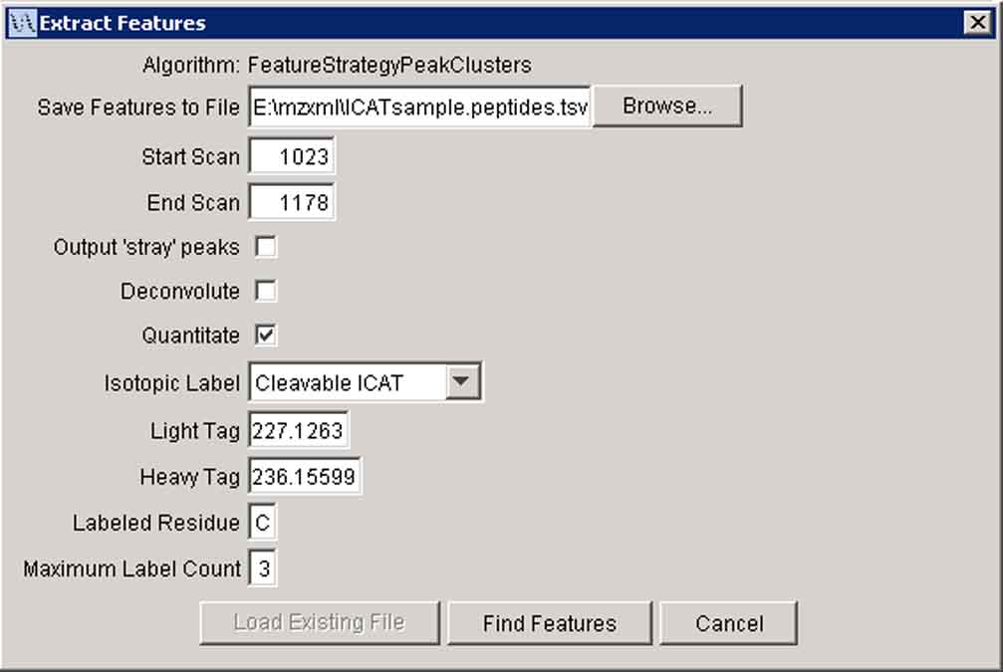
Extract Features dialog box with the Quantitate option selected

- Click Find Features. This generates a TSV file of the peptide features detected across the selected scan range using the algorithm selected from the Tools menu (2D Peak Alignment). As the file is generated, the status bar at the bottom of the msInspect window will display “Finding all features in ICATsample.mzxml. X.X% complete.”
- When the file is complete, the peptide features will show up as colored crosses over the image in the Image and Detail Panes. The status bar will display “Finding features complete. See file yourfilepath\ICATsample.peptides.tsv”.
- Because you specified an isotopic labeling, msInspect searched for pairs of features that eluted at the same time and that had a mass difference corresponding to the difference between the light and heavy isotopic tags. These pairs are connected by vertical lines in the msInspect Detail Panes. The feature set file that was created also contains extra columns of data relevant to the isotopic labeling quantitation (see section 5.2).

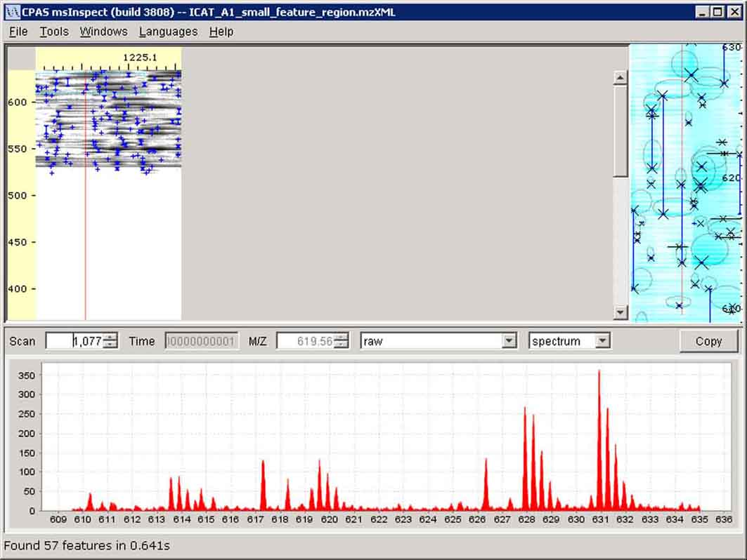
Feature Set ICATsample.peptides.tsv displayed over ICATsample.mzXML image. Isotopically-labeled pairs are connected by vertical lines in the Detail Pane.
- Display Details
This section describes the elements that facilitate visualizing and hand curating MS1 run data.

  - Image Pane
The Image Pane displays an image of the MS1 data from your run. The Y-axis is mass-to-charge ratio (m/z); each horizontal line in the image equals one Dalton (1Da). The X-axis is marked in seconds, but each vertical line in the image corresponds to one MS scan. Time is displayed in addition to scan number since scan numbers aren’t necessarily comparable over different runs and because the relationship between scans and time can vary depending on the machine, its settings, and its performance. Ion current intensity is represented by the density (darkness) of the dot.

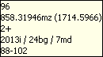
 TIP: By hovering over various parts of the display, you can view additional details about the data. In the Image Pane you’ll see the scan number/time and mass; the Detail Pane tip tag (right) also shows charge state, intensity, and scan range of marked features.

When you click on the image in the Image Pane, a red vertical line marking the scan appears on the image, and the two other panes display data corresponding to the point at which you clicked.

  - The Detail Pane
The Detail Pane along the right side of the window displays a zoomed in view of the image where you clicked. The Detail Pane is approximately 90 scans wide. The vertical area displayed in the Details Pane corresponds to the range of m/z values between the two blue, horizontal lines that appear in the Image Pane. The height (m/z range) varies slightly depending on the size of your window (e.g., a maximized window on a larger monitor will display a greater m/z range than a window that is restored down on a smaller monitor).

The red line in the Detail Pane corresponds to what is being displayed in the Chart Pane (see section 4.3).

    - Detail Pane Settings
Select Tools > Detail Pane Settings… to adjust what you see in the Detail Pane.

Detect Features
When the Detect Features box is checked, msInspect uses the algorithm selected in the Tools menu to detect features only in the data shown in the Detail pane. The monoisotopic peak in a feature is marked with an X. Larger Xs correspond to higher intensity peaks.

Threshold
Image points (pixels) with intensities below the value entered in this box will NOT be displayed in the Detail pane. This criterion deals with how the image is scaled; it does not apply to the absolute intensities of features. Usually if you use the Remove Background option, you won’t need to use Threshold; however, using both can increase contrast when viewing noisy data.

Scale
The log scale (default) exaggerates the intensity of fainter features. The sqrt (square root) scale is more representative of actual intensities. We omitted a linear scale option because it tends to make everything except the largest intensities disappear.

Remove Background
The background for the area shown in the Detail Pane is calculated and then subtracted from each data point. The difference becomes more dramatic when viewed on a more complex run with considerably more background noise and particularly when the run data contains streaks.

 NOTE: If you select the ‘resampled’ m/z spectrum in the Chart pane (see section 4.3.4), the background is represented by the red line running along the bottom of the plot. You may need to zoom in on the plot to see the line.

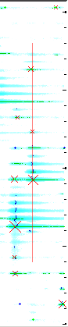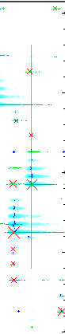
Remove Background
Background Background
shown removed

Show Chart Range
When the Show Chart Range box is checked, the Detail Pane displays a red line corresponding to the plot in the Chart Pane (vertical line for m/z spectra, horizontal line for elution profiles). To remove the red line from the Detail Pane, uncheck the box.

Color Map
You can pick one of four color schemes for the Detail Pane display: Cyan, Grayscale (as in the Image pane), Fire (yellow/low intensity to red/high intensity), and Rainbow (violet/low intensity to red/high intensity). Depending on your data, one color scheme may provide more contrast than another, making features more visible.

  - The Chart Pane
The Chart Pane along the bottom of the window displays m/z spectra and elution profiles. You can switch between the two types of plots using the drop down list at the top right of the Chart Pane.

Scan No., Time, and M/Z for the plots shown in the Chart Pane also appear at the top of the pane. The drop down box near the center contains options for displaying plots of the data using various signal processing methods (see section 4.3.4).

Top section of the Chart Pane

Clicking the Copy button at the top right corner of the Chart Pane copies the data displayed in red in the Chart Pane to the clipboard as a text file. You can then paste the data into another application such as Notepad or Excel.

You can add a title, axis labels, and a legend to the plots in this pane using the Chart Properties (see section 4.3.3).

You can resize the Chart Pane by dragging the top edge of the pane with your mouse (the pointer will change to a dual-headed arrow when you hover over the pane’s edge).

Locking the Y-Axis Scale
The Y-axis in the Chart Pane plots automatically scales itself depending on the data being plotted. To lock the Y-axis scale so it does not change as you view adjacent spectra or elution time profiles, for example, select Tools > Lock Y Scale. If you switch from viewing m/z spectra to elution profiles (see below) while the Y-axis scale is locked, the new plot will autoscale and then lock at the new scale. To unlock the y-axis scale, select Tools > Lock Y Scale again.

    - m/z Spectrum
By default, the Chart Pane displays the raw m/z spectrum for the single scan corresponding to the red line in the Detail Pane. The Y-axis is intensity, and the X-axis is m/z.

You can move to the previous and next scans using the down and up arrows on the Scan No. field, respectively. You can also click inside the Scan No. field and use the down and up arrows on your keyboard to do the same thing. Or you can type in a specific scan number and press enter to jump to that scan.

Auto Zoom
Auto Zoom affects how the Chart Pane displays m/z spectra. When Auto Zoom is on, the plot in the Chart Pane is automatically zoomed in around the spot where you clicked; the width is 15-16Da, and the height (intensity) auto-scales to the peak heights in the region. When Auto Zoom is off, the intensity plot in the Chart Pane will cover the m/z values for the entire scan. Since this means more data must be displayed, turning Auto Zoom off can slow down the generation of the plot.

Auto Zoom is on by default. To turn it off, select Tools > AutoZoom. To turn it back on, select Tools > Auto Zoom again.

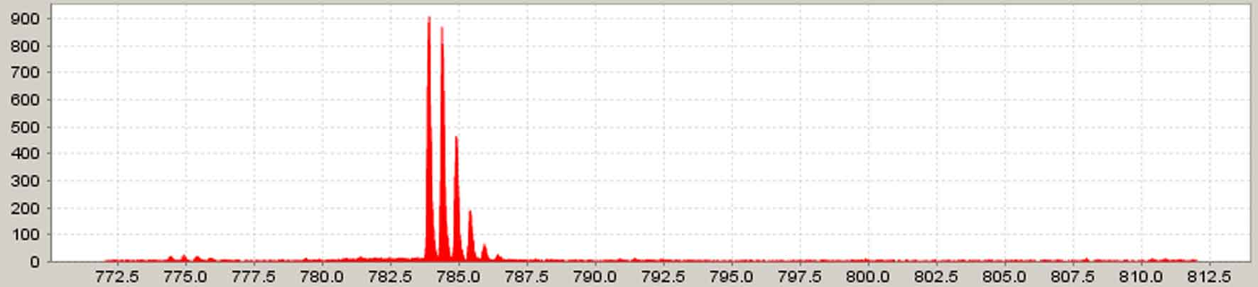
Auto Zoom ON

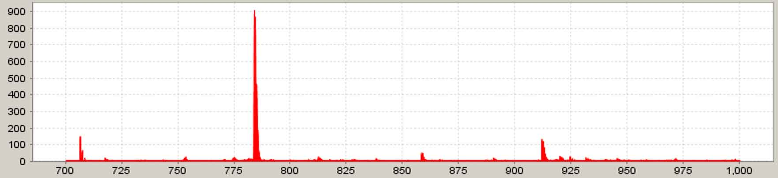
Auto Zoom OFF

    - Elution Profile
You can use the Chart Pane to view an elution profile for any m/z. Select elution profile from the drop down list to view the elution profile of the m/z shown in the M/Z field at the top of the Chart Pane. Notice the red line in the Detail Pane is now a horizontal line corresponding to the same m/z. The Y-axis in the plot is intensity (again, this axis auto-scales), and the X-axis is scan number.

You can move to the higher and lower m/z values using the up and down arrows on the M/Z field. You can also click inside the M/Z field and use the up and down arrows on your keyboard to do the same thing. Or you can type in a specific m/z and press enter to jump to that value.

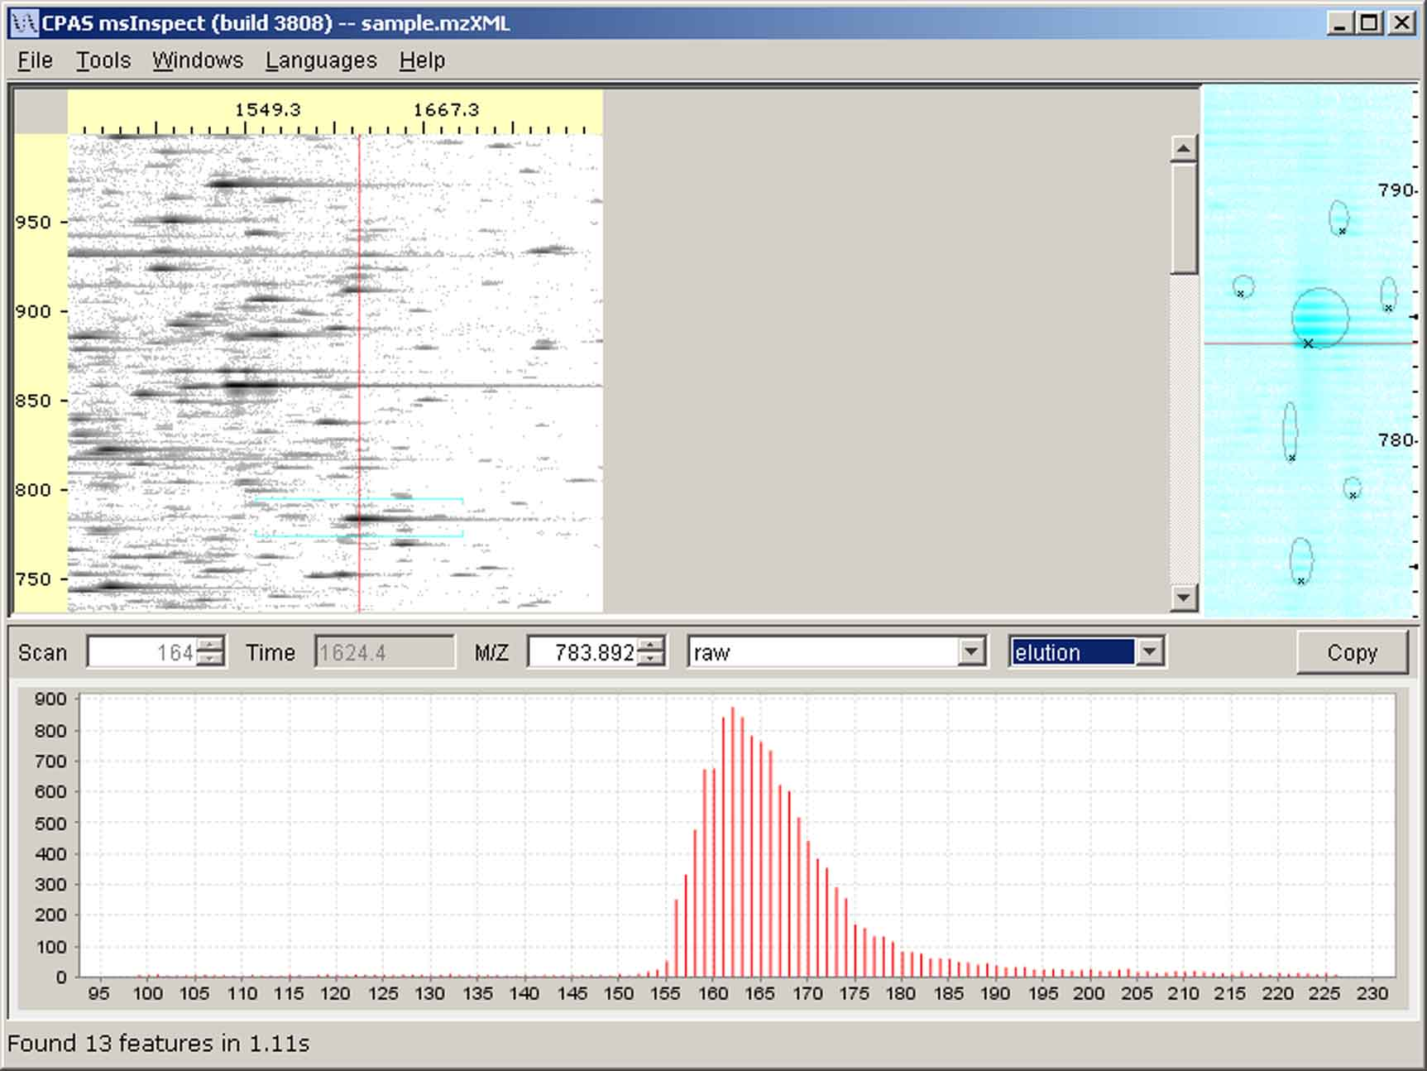
Clicking here displays the elution profile for the m/z value shown here.
Elution profile in the Chart Pane. Notice the horizontal line in the Detail Pane corresponding to m/z=783.

    - Working in the Chart Pane
Right click anywhere in the Chart Pane to use the Chart Pane submenu. This submenu offers additional options for viewing, saving, and printing the data displayed in the Chart Pane.

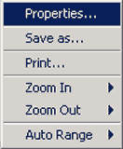
Chart Pane submenu

Properties
Select Properties from the Chart Pane submenu to modify the chart’s appearance. For example, you can display a title or legend or change the appearance of the plot’s axes.

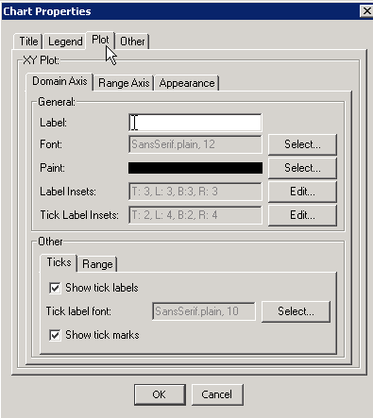
Chart Pane Properties

Save as…
Choose Save as… from the Chart Pane submenu to save the full (zoomed out), raw data from a scan as a text file or as a PNG (Portable Network Graphics) image file. At this point, you cannot save images of any of the processed plots, but that functionality might be added in the future.

Print…
You can print a copy of the currently displayed plot by selecting Print from the Chart Pane submenu. We recommend printing in landscape rather than portrait mode given the layout of the plots.

Zoom
You can zoom in on any of the plots in the Chart Pane in two ways:
- Right click anywhere on the plot and select Zoom In from the submenu. You can zoom relative to one axis or the other or both.
- Using the mouse, click and drag to highlight (in gray) an area where you want to zoom in. When you release the mouse, a zoomed plot will be generated.

Zoom in by dragging your mouse over a selected area

You can zoom out by right clicking on the plot and selecting Zoom Out from the submenu. You can zoom out relative to one axis or the other or both.

To return to the original scale, right click on the plot and select Auto Range from the Chart Pane submenu. Again, you can modify one axis or the other or both.

    - Chart Pane Processing
You can view m/z spectra and elution profiles using a variety of signal processing tools.

 Note: These processing tools are predominantly used for development purposes so they are subject to change at any time.

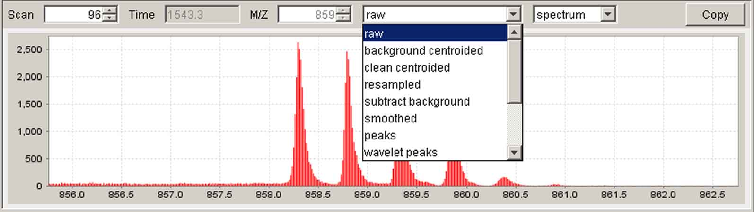
Signal processing tools in the Chart Pane

- Raw: unprocessed data (depending on the MS machine, ~100-200 samples/Da)

- Background Centroided: For centroided data only, this display mode subtracts a local background estimate from each peak

- Clean centroided: For centroided data only, this display mode subtracts a local background estimate for each peak and eliminates the peaks that are too close together

- Resampled: lightly processed data that reduces the number of data points to 36 per Da; the ‘horizontal’ red line represents the running minima (background), and the blue line represents the median values.

- Subtract background: the resampled data with the background (red line in the resampled plot) subtracted out.

- Smoothed: smoothed version of the data in the subtract background plot.

- Peaks: local maxima from the smoothed data plot displayed as vertical red lines.

- Wavelet peaks: identifies the location of peaks (m/z values); peaks are marked by red lines, which correspond to the local maxima found in the 3rd level in the wavelet multiresolution plot; intensities are determined from the smoothed data; wavelets are from the Haar wavelet family.

- Wavelet decomposition: wavelet plots (from top to bottom) for 1st, 2nd, 3rd, and 4th levels and one for the remaining signal.

- Wavelet decomposition2: another view produced as a composite of other charts.

- Wavelet multiresolution: a reconstruction of the original signal made by adding the derivative plots.

  - The Properties Pane
The Properties Pane displays a read-only table of details about the mzXML file currently open in msInspect. Details include the file name, information about the instrument used to generate the file, and information about how the data has been processed.

If Detect Features is selected for the Detail Pane, you can click on a feature in the Detail Pane to display information about it in the Properties Pane. For more information on the Feature properties, see section 5.2.

If you create a Feature Set File (see section 5.2), the Properties Pane will display information about that file.

You can choose to show or hide the Properties Pane be selecting Windows > Show/hide Properties. You can resize the Properties Pane by dragging the pane’s right edge with your mouse (the pointer will change to a dual-headed arrow when you hover over the pane’s edge). The Property Pane shares space with the Image Pane in the msInspect window so resizing it will only affect the size Image Pane; it will not change the dimensions of the Detail or Chart Panes.

- Finding Features
This section describes how to use msInspect to find peptide features in your data.

  - Feature-Finding Algorithms
There are several feature-finding algorithms listed in the Tools menu that can be used to detect features in the entire run (Find All Features…) and in the subset of data displayed in the Detail Pane (Detect Features option in the Detail Pane Settings dialog box). If you have particularly noisy data, you can try the other algorithms; however, we strongly recommend you use the default algorithm, 2D Peak Alignment (FeatureStrategyPeakClusters on the command line).

- Single Scan: finds features only in the selected scan.
 NOTE: This can be useful for non-ESI MS data since it does not rely on there being continuity between adjacent scans.

- Centroided Scan: This mode attempts to clean centroided data by removing local background and coalescing adjacent peaks prior to feature finding. This mode is experimental and only applicable to centroided data.

- 2D Peak Alignment: detects persistent (co-eluting) peaks and groups related peaks (across time and m/z) into features. This is the default algorithm.

- Peaks (intermediate result): displays just the peaks detected in the first steps of the 2D Peak Alignment algorithm above, without grouping them into features.

  - Finding All Features in a File
To find all the features from a run file, select Tools > Find All Features.... This generates a TSV file (file name.tsv) of the features detected across the entire run using the algorithm you selected from the Tools menu and displays those features in msInspect.

Feature Set Files
Output | Definition
Scan | The number of the scan taken by the MS machine in which the feature appeared at its highest intensity
Time | The time in seconds at which the feature was detected
mz | Mass-to-charge ratio of the peptide feature
AccurateMZ | ‘True’ when the m/z value came directly from a peak in the (centroided) source spectrum; ‘False’ otherwise
Mass | Calculated mass of the peptide
Intensity | Intensity for the feature correlated to the signal intensity recorded by the MS machine
Charge | Estimated charge state of the peptide feature
ChargeStates | Number of charge states in which the peptide appeared
KL | Kullback-Leibler value that measures the similarity between the feature’s peak pattern and the peaks expected from a peptide of that mass
Background | The (localized) running minima for intensity calculated across two dimensions (m/z and time (scan))
Median | This ‘lightly processed’ value is the difference between the median and the minima in the resampled data (i.e., the median after removing the background)
Peaks | Number of peaks in the feature
ScanFirst | The first scan in which the feature appeared
ScanLast | The last scan in which the feature appeared
ScanCount | The number of scans in which the feature appeared
TotalIntensity | The summed intensity (across the elution profile) of all deconvoluted peptides in the group
Description | Field for user comments (in Feature Set File)

The data in this Feature Set is only lightly filtered (e.g., the background value has already been subtracted out of the displayed intensity value) so you get as much data as possible. You can then do the analyses you feel are important in determining which features are ‘good’ matches rather than having msInspect do that for you.

When you choose Find All Features… from the Tools menu, you will see the Extract Features dialog box. The file path and name will appear in the Save Features to File field.
 NOTE: If a file of the same name already exists, the Load Existing File button will be black (active) rather than gray. You can then either: 1) give your new file a different name, in which case the Load Existing File button will turn gray; 2) open the existing file by clicking the Load Existing File button; or 3) keep the file name the same and save the new file over the original by clicking the Find Features button.

Choose the range of scans in which to detect features by editing the Start Scan and End Scan numbers.

Check the Output ‘stray’ peaks check box to include features in the set that have a charge of zero. Leaving this box unchecked will filter out these peaks.

Check the Deconvolute check box to combine features that have the same mass and very similar elution times but different charge states. The lower-intensity peaks are added to the highest-intensity peak and then removed from the list of features.
Check the Quantitate check box to look for pairs of isotopically labeled features. Selecting this option will allow you to select the type of Isotopic Label from a drop down list of some common protocols. Default values corresponding to each of the protocol choices will automatically be filled in for the weights for the light and heavy label species, the labeled residue, and the maximum label count. When the Quantitate option is selected, the Feature Set file will include additional columns of data:

Isotopically-Labeled Feature Data in the Feature Set File
Output | Definition
Label  (also called isotopicLabel) | Description of the isotopic label as the light tag plus a mass delta. If a particular residue was specified as the labeling target, it is included after an ‘@’ symbol. If a maximum number of labeled residues to consider was specified, that number is included after a ‘#’ symbol. If no maximum number of labels is specified, msInspect uses a default value of three.  For example, “227.1263+9.0297#2@C” indicates msInspect will consider cleavable ICAT weights with up to two labeled cysteines.
LightIntensity | Intensity of the light isotope
HeavyIntensity | Intensity of the heavy isotope
Mass | (not an additional column) Mass of the monoisotopic, unlabeled peptide
LabelCount | Number of labels on the peptide feature (total mass difference between light and heavy isotopes divided by the difference between one light and one heavy isotope; the default value, for ICAT labels, is 9.0297)
Ratio | Intensity of the light isotope divided by the intensity of the heavy isotope

If you check Quantitate for a run that was not isotopically labeled, msInspect will still attempt to search for pairs of peaks so the Feature Set may contain spurious ratios.

Click the Find Features button to create and display the file. Features will be marked as colored crosses in the Image Pane. If you used the same algorithm for Detect Features in the Detail Pane and for the Find Features file, the colored crosses and the Xs in the Detail Pane should line up.
 NOTE: There may be cases when the Xs and crosses do not line up perfectly because of the way features are picked: for a Feature Set, features are computed for the whole run so the context is larger, but features in the Detail Pane are computed on the fly for just the range shown in the pane.

  - Displaying Peptide Features
Choosing Tools > Display Peptides… opens the Display Features dialog box. You can specify which Feature Set files to display on top of the run that is currently open in msInspect. The images in the Detail and Chart Panes still correspond to your open run.

To add Feature Sets to the list, click Add Files, browse for the existing file you want to add, and click Open. You can display Feature Sets created from the open run and from other runs to visually compare data from multiple runs. The second (and fourth, sixth, etc.) file’s features are marked with Xs rather than crosses to make visualization easier.

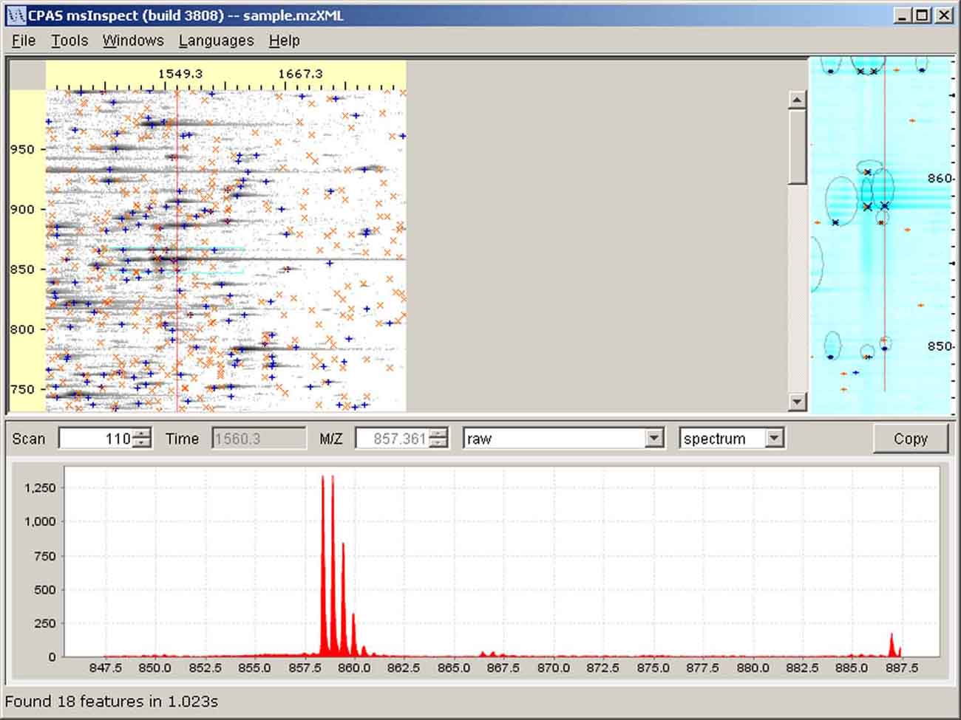
Two Feature Sets displayed (crosses for one, Xs for the other) over mzXML run data

Take a file off of the list by clicking it and then clicking Remove Files. To retain a file in the list without displaying its features on the image, uncheck the Display check box.

You can choose the color of each file’s feature crosses by clicking the colored area next to each file name. Choose a color from the palette or enter values in the HSB or RGB tab, and click OK.

The ‘…’ button at the right end of each row allows you to access the feature information in an editable table, the Feature Set List. You can save the original file and then edit the table, removing misidentified or unreliable features and adding notes. If you click on a feature in the list, that feature will be displayed in msInspect’s Detail and Chart Panes.

For information on the Filter and Peptide Array tabs at the bottom of the Display Features dialog box, see sections 5.4 and 6.1, respectively.

  - Filtering Features
Filtering allows you to hand curate your data, selecting the criteria that determine which features get displayed. It is particularly helpful when generating a peptide array. For more information on using Filtering when generating an array, see section 6.1.

The Filter tab in the Display Features dialog box provides several parameters you can use to filter your data. Additional parameters are available from the command line (see section 8.4).

Filtering Parameters
Parameter | Description | Default
Min m/z | Minimum m/z value of the features | 0.0
Max m/z | Maximum m/z value of the features | 10000.0
Min Charge | Minimum inferred charge state of the features. When the feature detector cannot resolve a charge state it reports a charge of 0+. | 0
Max Charge | Maximum inferred charge state of the feature. | 10
Min Scans | Minimum number of scans in which the feature appears | 0
Max KL | The Kullback-Leibler score is a measure of how closely the observed isotopic distribution of a peptide feature matches a theoretical distribution. Lower numbers indicate closer matches; anecdotally, 2 is a reasonable value to start with. | 10.0
Min Intensity | Low intensity features are generally detected less reliably than are high intensity features. Values to use here will depend on the specific instrument used to generate the data. | 0.0
MinPeaks | At least two peaks are required to infer a charge state. To filter out single-peak features, set this value equal to 2. | 1

  - Using the Heat Map Tool
A summary of the features found by msInspect is presented by the Heat Map visualization tool. The Heat Map tool allows you to examine detected features in a systematic way rather than having to sort through the entire run image. It can be useful for looking more closely at how well feature finding worked in your data. The tool extracts an intensity window around each feature and displays, for each charge state, a sorted list of features. The color gradient represents intensity: red for lower intensity and yellow for higher intensity.

Before you display a Heat Map, you must ensure that at least one feature set is loaded and visible (see sections 5.2 and 5.3). Once you have loaded the feature set you want to work with, select it in the Display Features dialog box. Then select Tools> Display Heat Map….

If intensity windows have not yet been extracted for the visible feature set, this will take place in the background so that you can continue using msInspect while the extraction proceeds. For large feature sets this may take a few minutes; we recommend that you first apply filtering to remove uninteresting features (e.g. low intensity, high KL score; see section 5.4).

Once the intensity windows are available, the Heat Map panel will be displayed. The panel contains one image for each charge state. The vertical axis represents ‘normalized’ m/z (the monoisotopic peaks are all centered in the bright, middle row; other peaks are 1/z units apart). Initially, the horizontal axis represents mass, increasing from left to right. These plots can illustrate the effect of mass accuracy, with peaks “blurring” as mass increases. Other sort orders may be selected from the Display menu at the top of the Heat Map panel, which changes the horizontal axis for each image:

- Sort by Intensity – X-axis represents intensity, with less intense features on the left.
- Sort by KL – X-axis represents KL score, with lower quality features (higher KL scores) on the left.
- Sort by Scan – X-axis represents scan number, with earlier scans on the left.

When you click on a feature in the Heat Map, it will be marked with a blue line in the Heat Map panel, and the spectrum and properties of that feature will be displayed in the main msInspect window. You may select the next or previous feature in the current ordering by pressing the plus or minus key (or the right or left arrow key), respectively.

You can change the filtering criteria or the visible feature set at any time using the Display Features dialog box (Tools > Display Peptides…). If the Heat Map panel is displayed it will automatically update to reflect any changes you make to the feature set.

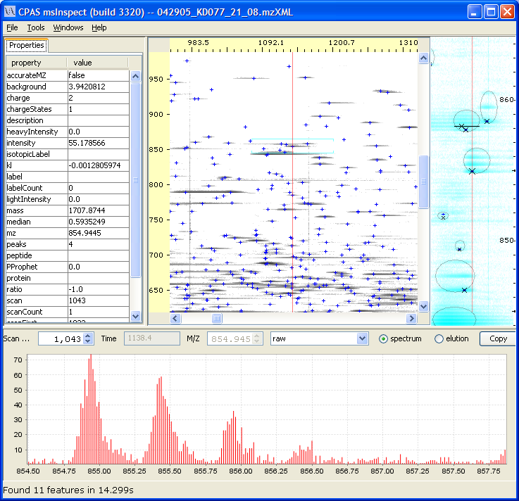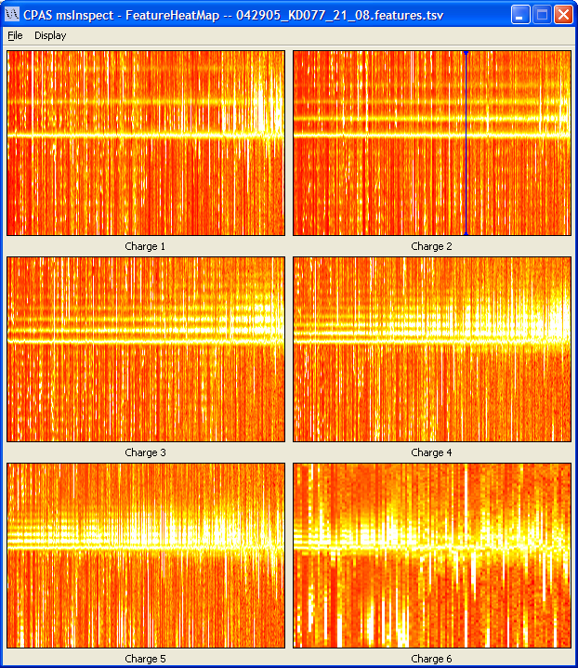
The Heat Map Panel
- The Peptide Array Component
The Peptide Array component of msInspect allows you to compare peptide features between multiple samples.

  - Generating a Peptide Array

◻ A Peptide Array is a file that allows us to compare the intensities of peptide features from different runs that have ‘matching’ masses and elution times.

Peptide Array is a term borrowed from the world of DNA microarrays. Microarrays have thousands of spots, each of which binds to a particular complementary DNA sequence. Microarray experiments measure the intensity of spots on the arrays and these are clustered to find differences between sets of samples. LC-MS experiments don’t have the notion of clearly defined spots that we can compare among runs. However, if a peptide is measured in several runs, it will always have the same mass (which can be computed from m/z and charge) and a similar elution time.

◻ A Bucket is a region in mass and scan space into which peptide features are grouped to create an array. Each bucket corresponds to a ‘spot’ on a DNA microarray.

msInspect builds peptide arrays by placing peptides found in different samples that have ‘matching’ masses and elution times into ‘buckets’. The intensities of peptides from different runs that are put into the same bucket can then be compared and clustered using the same sets of tools currently used for DNA microarrays.

Peptide arrays can be created from multiple Feature Set files:

- Feature detection – Features are detected and saved in files. The features detected in one run and saved in a file make up a Feature Set (see section 5 for details).
- Filtering – The feature-finding algorithms attempt to detect as many features as reasonably possible. Some of these features will be filtered out of the analysis. Several different metrics can be used to filter peptides or determine which features from the Feature Set to include in a peptide array.
- Deconvolution – In any given run, the same peptide might be detected in different charge states. Peptides from multiple charge states are deconvluted, or collapsed, into a single feature by calculating their masses from the m/z values and charge states. The deconvoluted feature is assigned the charge state of the most intense feature.
- Alignment – Because the elution times of peptides vary from run to run, an effort is made to map runs to each other by transforming the scan times of each of the Feature Sets.
- Registration – Once multiple runs have been scan aligned, features are matched between those runs by dividing the mass-scan space into buckets. Currently all Feature Sets are aligned and registered to the first file listed in the array. The domain of the features is first divided in scan space until the partition width is less than the scanWindow parameter (see below). The domain is then divided in the mass space until the partition width is less than the massWindow parameter (see below). Features that fall into the same bucket are considered to be one feature, and their intensities are added. Each bucket corresponds to a ‘spot’ on the peptide array.

The tabs at the bottom of the Display Features dialog box present steps 2-5 from the list above.

- Filter Tab – Filtering enables you to select which features to display on the image and include in the peptide array. Filtering criteria include:
  - Min m/z, Max m/z
  - Min Charge, MaxCharge: when the feature detector cannot resolve a charge state it reports a charge of 0. Generally you will not want to include these +0 features in a peptide array because they cannot be deconvoluted properly.
  - Min Scans
  - Max KL: a measure of how closely the observed isotopic distribution of this peptide matches a theoretical distribution (Krokhin et al., Mol Cell Proteomics, 2004). Lower numbers indicate closer matches.
  - Min Intensity
  - MinPeaks: at least two peaks are required to infer a charge state so you may want to consider filtering out features with only one peak.

- Peptide Array Tab – You can choose a name for the output files of your peptide array and browse for the location where you want to save them.
  - Mass Window – maximum size of the bucket in mass space
  - Scan Window – maximum size of the bucket in scan/time space

◻ A ‘Perfect’ Bucket is a bucket with exactly one peptide feature from each Feature Set file.

  - Optimize – Choosing the size of the buckets for the peptide array is critical. If buckets are too large, unrelated peptides will be placed in the same bucket. If buckets are too small, related peptides may be placed in different buckets where their intensities cannot be compared. The Optimize option performs the filtering, alignment, and deconvolution steps for a variety of bucket sizes and generates a plot of the number of ‘Perfect’ Buckets available for each bucket size. The peak of that plot gives you the optimal bucket size for your array.
  - numBuckets – total number of buckets for the given parameters.
  - Perfect Matches – number of ‘Perfect Buckets’ for the given parameters.
  - Normalize – We implemented a normalization procedure described by Wang et al. that accounts for intensity-dependent missing data. Moment-based methods, which map the mean and standard deviation of the aligned runs, can introduce biases into the proteomic data because less intense features are more likely to be missed or misidentified in some runs. The method described by Wang et al. (Proceedings of the Pacific Symposium on Biocomputing, 2006) first estimates the global normalization factors across different profiles using the top order statistics (i.e., most intense peptide features) and then creates a model that maps the intensity quintiles between two runs.
  - Click the Calculate button to generate the array files.

The peptide array file (array.tsv) includes the msInspect version number, Feature Set files, and parameters used to generate the array. It also includes data in the columns listed below. Each row in the array file corresponds to one bucket.

array.tsv Files
Column | Description
id | An id number for the bucket
minMZ | Minimum mass value for the bucket
maxMZ | Maximum mass value for the bucket
minScan | Minimum scan number for the bucket
maxScan | Maximum scan number for the bucket
featureCount | Total number of features included in this bucket
setCount | Number of different Feature Sets that have a feature in this bucket
intensity (1,2,…n) | Intensity of the peptide feature in that bucket from the corresponding Feature Set. There is one intensity column for each Feature Set used in the array.

msInspect also generates an additional array details file (details.tsv) that includes the msInspect version number, Feature Set files, and parameters used to generate the array. It also includes data in the columns listed below for every peptide feature.

details.tsv Files
Column | Description
ID | ID number of the bucket in which the peptide feature appeared
File | Feature Set file from which the peptide feature came
Scan | Scan number at which the feature reached maximum intensity
Time | Time (in seconds) at which the feature reached maximum intensity
MZ | M/Z of the peptide feature
Mass | Calculated mass of the peptide
Intensity | Intensity value of the peptide feature’s highest ‘smoothed’ peak. For deconvoluted peptides, this is summed across all deconvoluted features.
Charge | Charge of the peptide as calculated from the isotopic distribution (#peaks/Dalton=charge); for deconvoluted peptides, it is the charge of the highest intensity feature in the group.
Charge States | Total number of charge states in which the peptide was found
KL | Kullback-Leibler score of the peptide (see section 5.4)
Background | Estimate of background noise in this region of the file
Median | Median intensity for this region of the file
Peaks | Number of peaks used to calculate charge
Start | First scan in which the peptide feature appeared (used to sum across elution profile)
End | Last scan in which the peptide feature appeared (used to sum across elution profile)
ScanCount | Number of scans in which the peptide feature appeared (used to sum across elution profile)
Total Intensity | The summed intensity (across the elution profile) of all deconvoluted peptides in the group
Description | Field for user comments

msInspect does not analyze peptide arrays. Any microarray analysis tool suite (open source ones are available in BioConductor or from TIGR) can be used to normalize and cluster this data and produce an image of the array.
- The FASTA Component
This component of msInspect is still in development. Brief descriptions are included below, and more detailed information will be added soon.

  - Identifying Peptides Using FASTA Files

◻ A FASTA File (file name.fasta) contains a description of the proteome (protein sequences) of an organism as derived from its genome.

The data on proteins and their corresponding peptides found in a FASTA file can be compared to the features detected in the MS1 data. This comparison should allow for protein identification directly from MS1 data for simple mixtures.

Before you open a FASTA file, select Tools > Display Peptides… and open a Feature Set file. Once the Feature Set file is displayed, select File > Open Fasta….

When you open your FASTA file, you will see a window that allows you to select a feature in your run data and search the FASTA file for peptides matching that feature’s mass. You can also select a known protein in the FASTA file and search your run data for features that match that protein’s peptides.

  - Calculating Peptide Coverage
This feature of msInspect is still in development. Briefly, once you have a FASTA file open, you can calculate the degree to which the peptide features in your run data correspond to a given protein in the FASTA file. More detail about calculating peptide coverage will be added soon.

- Command Line
For general use we recommend you use the Java Web Start Launch Link (http://proteomics.fhcrc.org/download/tools/msInspect/viewer.jnlp) to start the application since that link is automatically updated; however, for command line usage we also offer viewerApp.jar (available at https://proteomics.fhcrc.org/CPAS/Wiki/home/FHCRC%20Help/page.view?name=viewer%2Fcommand%20line).

To get the most up-to-date msInspect command line functionality, use

java -Xmx512M -jar viewerApp.jar --help

  - Opening a File

java –Xmx512M -jar viewerApp.jar mzXMLfile

 Note: -Xmx512M allocates 512 megabytes to the application. If you have more than 512M available on your machine you should consider raising this number to something like 1G.

  - Command Line Functionality
The available commands are summarized in the table below.

Command Line Functionality
Function | Description | See Sections:
--findPeptides | Create Feature Set files | 8.3
--filter | Filter Feature Set files | 5.4, 8.4
--peptideArray | Create array files | 6.1, 8.5
--deconvolute | Create file of deconvoluted peptides (peptides from multiple charge states collapsed into single features) | 6.1, 8.6
--quant | Identify pairs of isotopically labeled features | 5.2, 8.6
--optimize | Compute number of perfect buckets for various scan and mass windows (single step from array process) | 6.1, 8.6
--ms2Correct | Generate list of accurate precursor masses | 8.6
--saveImage | Create PNG file of a run image | 8.6
--revision | Find out what version of msInspect you are using | 8.6
  - Finding Peptide Features

java –Xmx512M -jar viewerApp.jar --findPeptides
[--out=outfilename] [--start=int] [--count=int]
[--minMz=float] [--maxMz=float] [--strategy=className]
[--dumpWindow=int] mzXMLfile

For example:

java –Xmx512M -jar viewerApp.jar --findPeptides
--out="file.pkClusters2.tsv"
--strategy=FeatureStrategyPeakClusters sample.mzXML

Options for Peptide Detection
Option | Default | Description
--out | stdout | Names file where peptide list will be saved
--start | 1 | Scan number at which to start finding peptides
--count | to end of file | Number of scans to search for features
--minMz | 400 | Floating point value for minimum m/z ratio to consider
--maxMz | 1600 | Floating point value for maximum m/z ratio to consider
--strategy | FeatureStrategyPeakClusters | Algorithm used to detect features; FeatureStrategyPeakClusters is the same as ‘2D peak alignment’ in the interactive version of msInspect.
--dumpWindow | n/a | For FeatureStrategyPeakClusters only, outputs a window of the given number of m/z units around each feature; intensities in the window are added to the data as a comma-separated list.

Current Strategies
- FeatureStrategyPeakClusters – FeatureStrategyPeakClusters is the same as 2D peak alignment in the interactive version of msInspect (see section 5.1).

 NOTE: Strategies are still being developed and will likely change with future releases of msInspect.

To create multiple Feature Set files, you can make and run a batch file. For example, if you had two repeats of each of two conditions, treatment and control, you could create Feature Set files for each of the four runs using the following MS-DOS .bat file:

set filenames=treatment;control

for %%f in (%filenames%) do java –Xmx512M
-jar your_path\viewerApp.jar --findPeptides
--out=”…\%%f.peptides.tsv” %%f_1.mzXML %%f_2.mzXML

 NOTE: The line beginning “for %%f…” should not contain line breaks in the .bat file. Line breaks appear in this guide only because of formatting requirements.

  - Filtering
You can apply filtering parameters to Feature Set files to automatically remove certain features from a Set. The filtering options listed below are also used for other commands, including creating peptide arrays, optimization, and ms2Correct (see 8.5 and 8.6). The default values listed are applied unless you specify otherwise. Filtering parameters you specify are listed in the output file header in the “Params” line.

java -jar viewerApp.jar --filter [--out=outfilename]
[Filter Options] featureFile

Filter Options
Option | Default | Description | Feature Set column to which filter applies
--minMz | 0.0 | Minimum m/z ratio to consider (float) | mz
--maxMz | 10000.0 | Maximum m/z ratio to consider (float) | mz
--minPeaks | 1 | Included features must have at least this many peaks (integer) | peaks
--minCharge | 0 | Minimum charge state of features to include (integer) | charge
--maxCharge | 10 | Maximum charge state of features to include (integer) | charge
--maxKL | 10.0 | Maximum Kullback-Leibler score of the peptide feature (float) | KL
--minIntensity | 0.0 | Minimum intensity of features to include (float) | intensity
--minMass | no default filtering | Minimum calculated mass to consider (float) | mass
--maxMass | no default filtering | Maximum calculated mass to consider (float) | mass
--minTotalIntensity | no default filtering | Minimum summed intensity (across elution profile) of feature groups to include (float) | totalIntensity
--minTime | no default filtering | Minimum time value to include (float) | time
--maxTime | no default filtering | Maximum time value to include (float) | time
--scanFirst | no default filtering | First scan number to include (integer) | scan
--scanLast | no default filtering | Last scan number to include (integer) | scan
--minScans | no default filtering | Minimum number of scans in which features appeared (integer) | scanCount

  - Creating an Array
You can use default settings or specify your own parameters when you create an array from the command line. If you’re not sure what settings to use, the interactive version of msInspect can be helpful (see section 6.1 for more information).

To create an array:

java –Xmx512M -jar viewerApp.jar --peptideArray
[--out=outfilename] [--scanWindow=int] [--massWindow=float]
[--normalize] [Filter Options (see 8.4)] featureFiles

For example:

java –Xmx512M -jar viewerApp.jar --peptideArray
--out="file.array.tsv" --minPeaks=2 --minCharge=1 --maxKL=1 file1.peptides.tsv file2.peptides.tsv file3.peptides.tsv file4.peptides.tsv

Options for Creating Peptide Arrays
Option | Default | Description
--scanWindow | 50 | Maximum size of the bucket in scan/time space
--massWindow | 0.2 | Maximum size of the bucket in mass space
--normalize | -- | msInspect will normalize the intensities in the peptide array after alignment

You can create multiple array files at once using a batch file. For example, if you have three repeats of each of two conditions, treatment and control, you could write the following MS-DOS batch file to generate one array for the treatment condition and one for the control:

set filenames=treatment;control

for %%f in (%filenames%) do java -Xmx512M -jar viewerApp.jar
--peptideArray –out=“%%f_array.tsv” %%f_01.features.tsv %%f_02.features.tsv %%f _03.features.tsv

 NOTE: The line beginning “for %%f…” should not contain line breaks in the .bat file. Line breaks appear in this guide only because of formatting requirements.

  - Additional Commands
See the Options tables in sections 8.4 and 8.5 for information on parameters for the commands below.

To Deconvolute and/or Perform Relative Quantitation
The deconvolute and quant commands can be used together or separately. See sections 6.1 and 5.2 for more information on deconvolution and relative quantitation with stable isotope labeling, respectively.

java -jar viewerApp.jar --deconvolute --quant [--out=outfilename]
[--scanWindow=intValue] [--massWindow=floatValue]
[--lightTagWeight=floatValue] [--heavyTagWeight=floatValue]
[--maxLabelCount=intValue] [--labeledResidue=char]
[--intensitytype=(total,max,recalculated)][--deltaTime=float]
[--deltaMass=float(da|ppm)] featureFile

Options for Quantitation
Option | Default | Description
--lightTagWeight | 227.1263 | The mass of the light isotopic label.
--heavyTagWeight | 236.156 | The mass of the heavy isotopic label.
--maxLabelCount | 3 | Maximum number of labeled residues to consider.
--labeledResidue | C | The amino acid residue that is expected to be labeled.
--intensitytype | total | The area-integrated (“total”) or maximum (“max”) intensity can be reported in output and used to calculate ratios.
--deltaTime | 10 | Time tolerance window in seconds
--deltaMass | 0.2Da | Mass tolerance window in Daltons or in ppm; using Daltons provides an absolute window while using ppm provides a relative window that will be larger at higher masses (due to decreased instrument mass accuracy at high masses).  Daltons is the default unit. To specify Daltons or ppm, include “da” or “ppm”, respectively, after the value.

To Optimize
Use the Optimize function to find the most effective settings for mass and scan window to use in creating an array. Given a list of mass and scan windows, the optimize command will compute the number of perfect buckets for each set of parameters and output the list to a file.

java -jar viewerApp.jar --optimize [--out=outfilename]
[--scanWindows=int,int,...] [--massWindows=float,float,float]
[Filter Options (see 8.4)] featureFiles...

To Generate Accurate Precursor Masses
The goal is to generate a list of more accurate precursor masses to apply to MS2 scans based on the monoisotopic peptide masses determined by msInspect. The filtering parameters used indicate which features found by msInspect should be used to generate this list. The default minCharge is 1.

Java –jar viewerApp.jar –-ms2Correct –-features=featureFile
[--out=outfilename] [Filter Options (see 8.4)] mzxmlFile

To Save Run Images as PNG files

java –jar viewerApp.jar –-saveImage [--out=imagefile.png] mzxmlfile

To Get the msInspect Version Number

java –jar viewerApp.jar –-revision

Appendix A: msInspect Menus

The File Menu

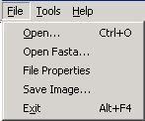

Menu Item | Description
Open … | Displays an Open File dialog box where you can browse for mzXML files to open in msInspect.
Open Fasta… | Dispalys an Open File dialog box where you can browse for FASTA files. For more information, see section 7.1.
File Properties | File Properties displays information on the instrument used to generate the raw MS1 data and the processing parameters applied to the data (in the Properties Pane).
Save Image… | Save the whole run image as a PNG file.
Exit | Exit msInspect.

The Tools Menu

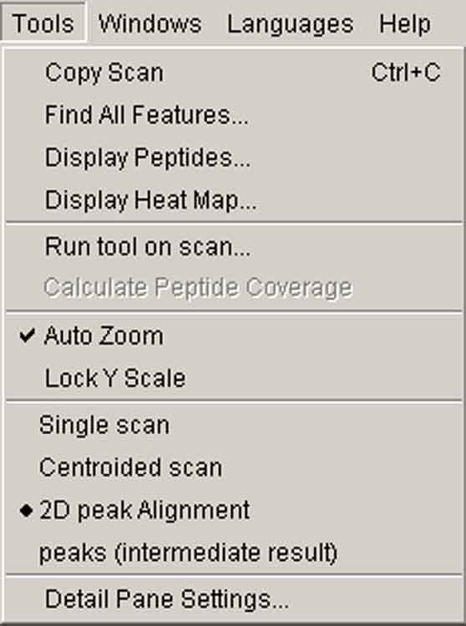

Menu Item | Description
Copy Scan | Copy m/z and intensity data for the selected scan as a text file to the clipboard. You can paste the data into another application (e.g., Excel).
Find All Features… | Opens the Extract Features dialog box – the first step in detecting features for an entire run. See section 5.2.
Display Peptides… | Opens the Display Features dialog box where you can work with Feature Set files. See section 5.3.
Display Heat Map… | Opens the Heat Map visualization tool. See section 5.5.
Run tool on scan… | Select Run tool on scan to send data from the currently selected scan (red line in the Image pane) on a roundtrip through a separate tool or program (e.g., a PERL script) and back to msInspect. The data will return as a 2-column table, which you can view in Notepad or Excel.
Calculate Peptide Coverage | See section 7.2
Auto Zoom | When selected, the m/z spectrum in the Chart Pane is automatically drawn zoomed in around the area where you clicked on the Image Pane. See section 4.3.1.
Lock Y Scale | When selected, the Y-axis scale on the plots in the Chart Pane locks (does not auto-scale). It is unselected by default. See section 4.3.
Feature-Finding Algorithms | The available algorithms used to detect features are listed in the section of the menu above Detail Pane Settings. The currently selected algorithm is marked with a bullet. See section 5.1.
Detail Pane Settings… | Opens a dialog box where you can adjust your view in the Detail Pane. See section 4.2.1.

The Windows Menu
The Windows menu allows you to choose whether to display the Properties pane. Select Show/hide Properties to toggle between displaying and hiding the Properties pane.

The Languages Menu
msInspect is currently available in English and Chinese, and it may eventually be translated into other languages. The Chinese translation is a work in progress so not all text has been translated. We invite anyone interested in writing a translation for another language to contact the msInspect development team via the online support forum. To access the forum, select Help > Support.

To switch languages, select your preferred language from the Languages Menu. If you do not have fonts installed on your machine to support the language you select, you will see a message to that effect, and the language will not change. Please note, when you change languages, the msInspect window will disappear momentarily, and you will lose your open files.

The Chinese translation of msInspect supports several Chinese-capable fonts. You can select the font you wish to use from the Font menu (in Chinese); the list of available Chinese fonts will include only those fonts installed on your local machine. Please note, when you change fonts, the msInspect window updates immediately, and you will retain your open files.

msInspect will remember your language and font preferences.

The Help Menu
Select Help > Help (or press the F1 key) to access online msInspect documentation.

Select Help > Support to access an interactive, web-based support forum (https://cpas.fhcrc.org/Project/home/support/begin.view?) where you can post questions and feature requests for both msInspect and CPAS.

