How to Install Python In Ubuntu.

1. Open terminal via Ctrl+Alt+T or searching for “Terminal” from app launcher. When it opens, run command to add the PPA:
sudo add-apt-repository ppa:jonathonf/python-3.6

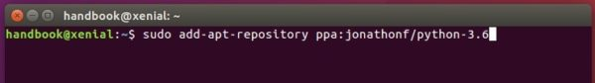

2. Then check updates and install Python 3.6 via commands:
sudo apt-get update

sudo apt-get install python3.6

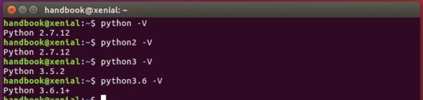
3. To make python3 use the new installed python 3.6 instead of the default 3.5 release, run following 2 commands:
sudo update-alternatives --install /usr/bin/python3 python3 /usr/bin/python3.5 1

sudo update-alternatives --install /usr/bin/python3 python3 /usr/bin/python3.6 2
Finally switch between the two python versions for python3 via command:
sudo update-alternatives --config python3
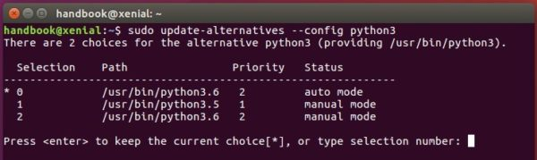

After selecting version 3.6:
python3 -V
