# How to add new Hyperelastic model

New hyperelastic models can be added to the application by creating a .yaml file following the format illustrated below with an example:

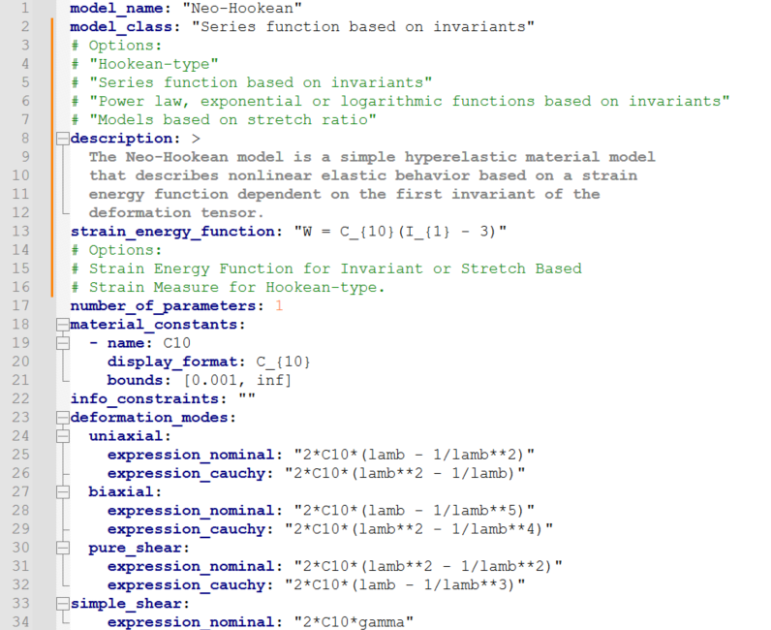

**📌 Important Notes:**

* **model_name** is the name that will appear in the model selection screen.
* **model_class** is used to organize the models into categories in the interface.
* **description** is a brief explanation of the model, displayed to help users choose.
* **strain_energy_function** should be provided in LaTeX-style formatting for correct display in the GUI.
* **material_constants** must include at least the name and bounds. The display_format can use LaTeX formatting (e.g., C_{10}) to be shown correctly to the user.
* **deformation_modes** must contain the symbolic expressions used for stress calculation in each deformation mode:
  + Use lambda (or lamb) as the stretch variable.
  + Use gamma for simple shear.
  + Expressions should be written in **Python-evaluable format** using *, **, /, etc.

**✅ File Location**

All .yaml files for hyperelastic models should be placed in the following folder:

* HyperSmart/src/hyperelastic_models/

The program automatically scans this folder and loads all valid models.

1. **📘 How to Derive Expressions for Each Pure Deformation Mode**

To define a new hyperelastic model, you’ll need to provide symbolic expressions for the **Nominal** and **Cauchy** stress for each relevant pure deformation mode (Uniaxial, Biaxial, Pure Shear, and Simple Shear).

A complete explanation of how to derive these expressions — starting from the **Strain Energy Function** — is presented in the **UserGuide.pdf**, located at:

* HyperSmart/docs/UserGuide.pdf

This PDF contemplates the case of invariant-based, stretch-based, mixed and Hookean-type

hyperelastic models.