

Scheme & Solution of MSE: € MSE-1 € MSE-2 € MSE-3

Course Title : | Internet & web Programming | Course Code: | CS2211-1
Prepared by: | Mrs. Aishwarya D Shetty/Dr. Asmita Poojari | Signature:
Date: | 07/04/2026 | HOD Signature:

Q.No. | Solution | Marks
Part-A
 | 1. B  2. A  3. B | 1  1  1
Part-B
Unit-I
1 a) | $_GET and $_POST are PHP superglobal arrays used to collect form data submitted via HTTP methods.  $_GET Method:  • Data is appended to the URL as query parameters (e.g., page.php?name=John&age=25).  • Data is visible in the browser address bar – NOT secure for sensitive info.  • Limited data size (~2048 characters); suitable for search queries, pagination.  • Can be bookmarked and cached.  Example – $_GET:  <!-- form.html -->  <form method="GET" action="result.php">  <input type="text" name="username">  <input type="submit" value="Submit">  </form>  // result.php  <?php  $name = $_GET["username"];  echo "Hello, " . $name;  ?>  $_POST Method:  • Data is sent in the HTTP request body – NOT visible in the URL.  • No size limitation; suitable for forms, file uploads, sensitive data.  • Cannot be bookmarked; data is not cached.  Example – $_POST:  <!-- form.html -->  <form method="POST" action="result.php">  <input type="password" name="pass">  <input type="submit" value="Login">  </form>  // result.php  <?php  $pass = $_POST["pass"];  echo "Password received.";  ?> | 2  2
b) | <?php  $servername = "localhost";  $username = "username";  $password = "password";  $dbname = "mydb";  // Create connection  $conn = new mysqli($servername, $username, $password, $dbname);  // Check connection  if ($conn->connect_error) {  die("Connection failed: " . $conn->connect_error);  }  echo "Connected successfully";  ?> | 2
2 a) | Aspect Controlled Component Uncontrolled Component  Data storage React state (useState) DOM (via ref)  Update trigger onChange event handler Direct DOM access  Access method state variable useRef() / ref.current  Validation Easy – on every change Harder – only on submit  Re-render On every keystroke No re-render on change  Preferred for Most forms, validation Simple/legacy forms  Example 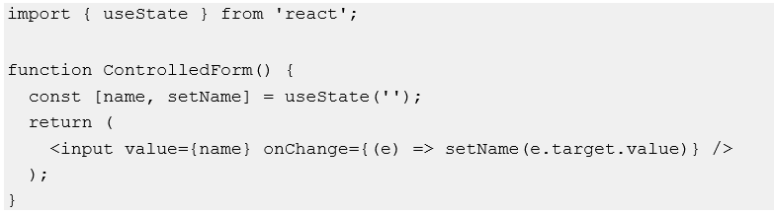 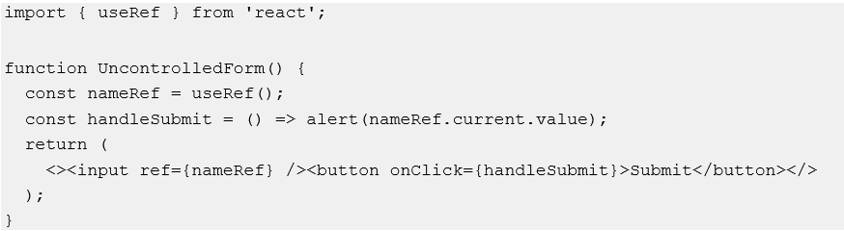 | 4
b) | 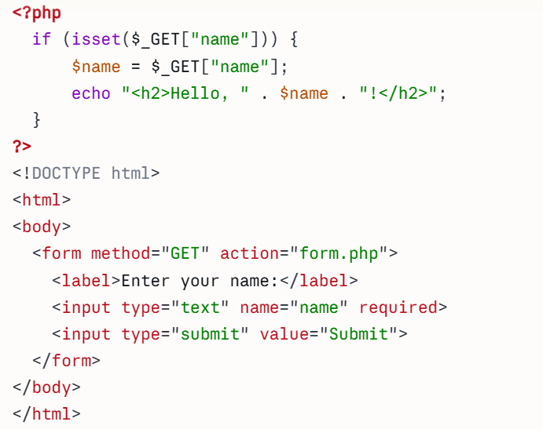 | 2
Unit-II
3 a) | - In React, inline styles are applied using a JavaScript object (not a CSS string).  - The style attribute accepts an object where CSS property names are written in camelCase.  Syntax:  const styleObject = {  propertyName: 'value', // camelCase  fontSize: '16px', // not font-size  };  <element style={styleObject} />  Inline Style Example:  function StyledComponent() {  const headingStyle = {  color: 'darkblue',  fontSize: '24px',  fontWeight: 'bold',  backgroundColor: '#f0f8ff',  padding: '10px',  borderRadius: '8px',  };  const paraStyle = {  color: 'gray',  fontSize: '14px',  marginTop: '8px',  };  return (  <div>  <h1 style={headingStyle}>Welcome to React!</h1>  <p style={paraStyle}>This paragraph is styled inline.</p>  </div>  );  }  export default StyledComponent; | 4
b) | function StringLength() {  const myString = "Hello, React!";  const len = myString.length;  return (  <div>  <p>String: {myString}</p>  <p>Length: {len}</p>  </div>  );  }  export default StringLength; | 2
4 a) | Aspect JavaScript (JS) JSX  Full form JavaScript JavaScript XML  Purpose General-purpose scripting Describe UI in React  File extension .js .jsx (or .js with React)  HTML in code Not allowed directly HTML-like syntax allowed  Rendering Runs natively in browser Transpiled by Babel to JS  Attributes Uses standard DOM (className not needed) Uses className instead of class  Expressions Uses template literals or DOM Uses { } for JS expressions  Self-closing tags Not applicable Required: <img /> not <img> | 4
b) | import React from 'react';  function StudentInfo() {  // Declare two JavaScript variables  const studentName = "Alice Johnson";  const studentAge = 20;  return (  <div style={{ fontFamily: 'Arial', padding: '20px' }}>  <h2>Student Information</h2>  <p>  <strong>Name: </strong> {studentName}  </p>  <p>  <strong>Age: </strong> {studentAge} years  </p>  <p>  <strong>Birth Year: </strong> {2025 - studentAge}  </p>  </div>  );  }  export default StudentInfo;

