Student Performance Prediction Modification Output
In propose work we have used Naïve Bayes and XGBOOST algorithm to predict student grades and to train this algorithms we have used Student performance dataset. Each algorithm performance is evaluated in terms of accuracy, precision, recall and FSCORE. Among all algorithms XGBOOST predicting student performance with more than 93% accuracy.
Once we run project will get below home page with ML algorithms performance
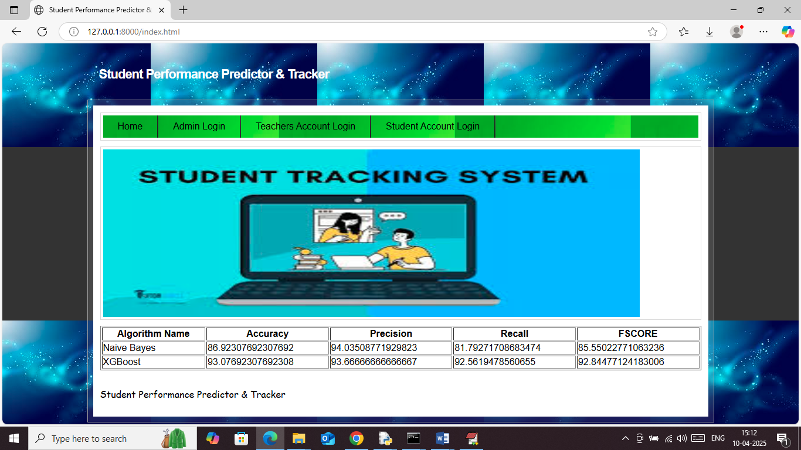
In above screen can see performance of each ML algorithm and when view marks then will get below ML prediction result
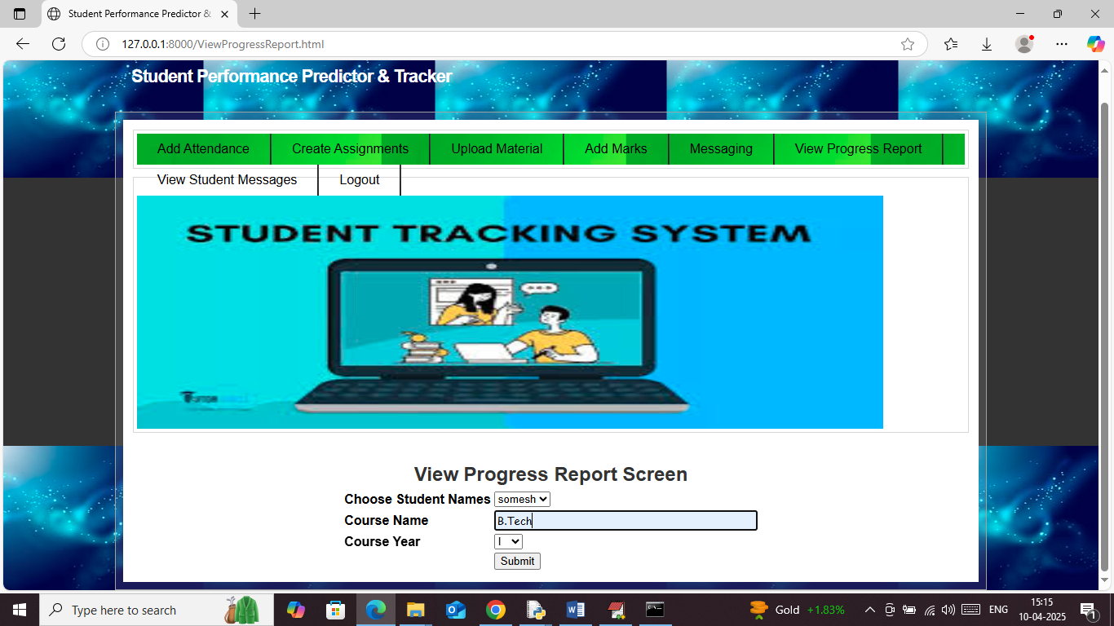
In above screen faculty can click on ‘View Progress Report’ to get above page and then select student name and course name along with year and then press button to get below result
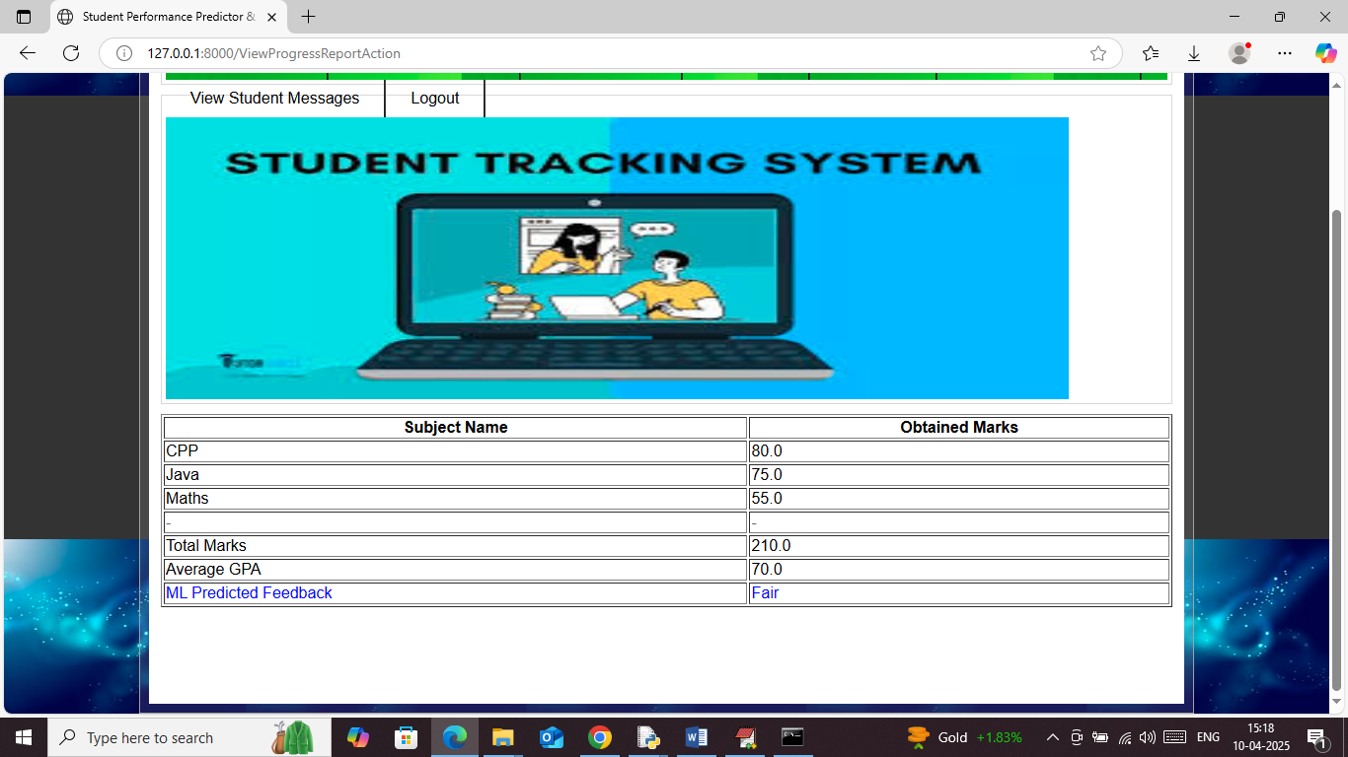
In above screen can see individual marks along with GPA and ML predicted output as FAIR.
Similarly using ML you can calculate feedback grades for each students

