# Logging In

When you first visit {the site} you will see this page:

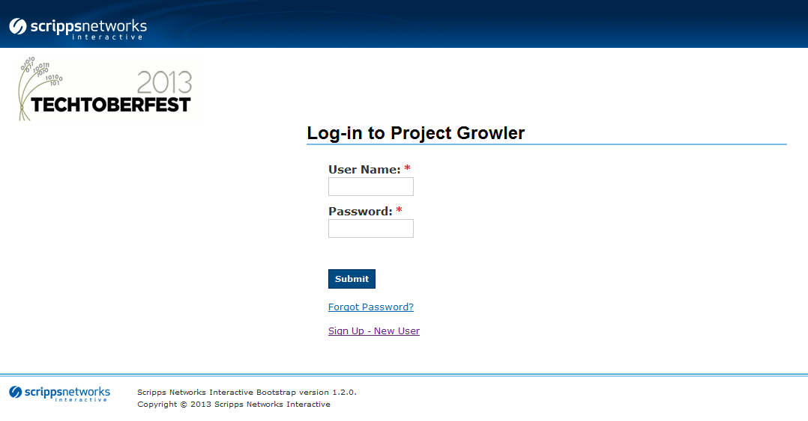

You can use your Scripps ID to log in. Even if you haven’t registered for the application, you will automatically be added to the system.

# Potential Pitfalls of Logging In

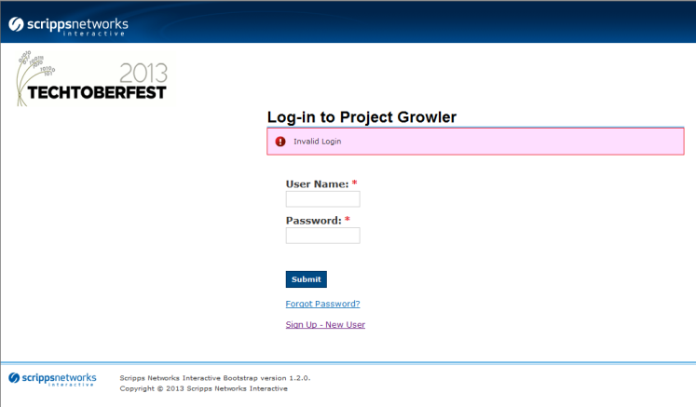

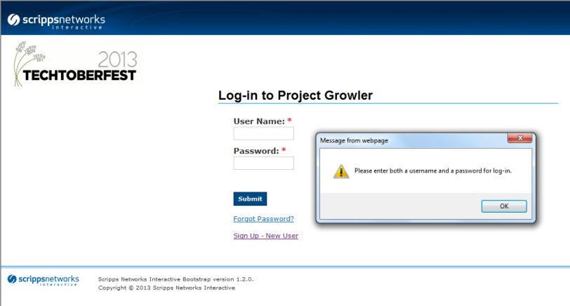

There are two errors that can occur:

An invalid log-in: Upon entering invalid information, the app will display an error message and remain on the log-in page.

Missing data: If you forget to enter a username and/or password, the app will not process the page, and give you another chance to log in.

# Themes

The application will initially direct you to the themes page. Here you can rank themes that are interesting to you. Only the top ten themes will be ranked. You may only rank themes once, and after that the themes page will display your preferences only.

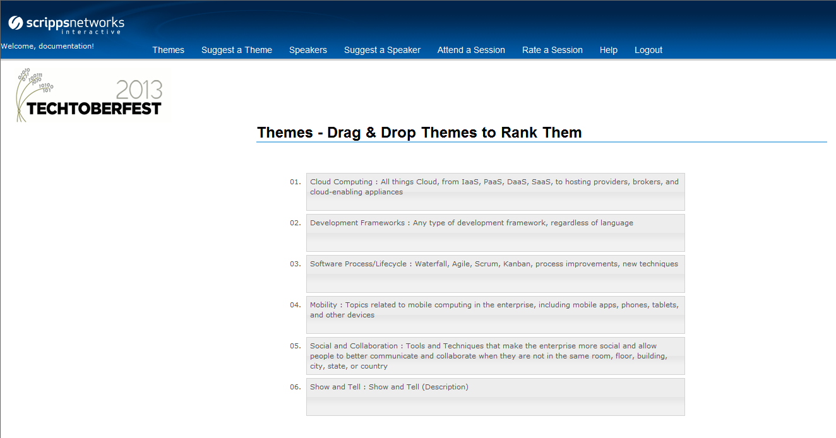

After dragging the themes into the desired order, press the Submit button at the bottom of the page. The themes will be submitted, and you will see the following screen.

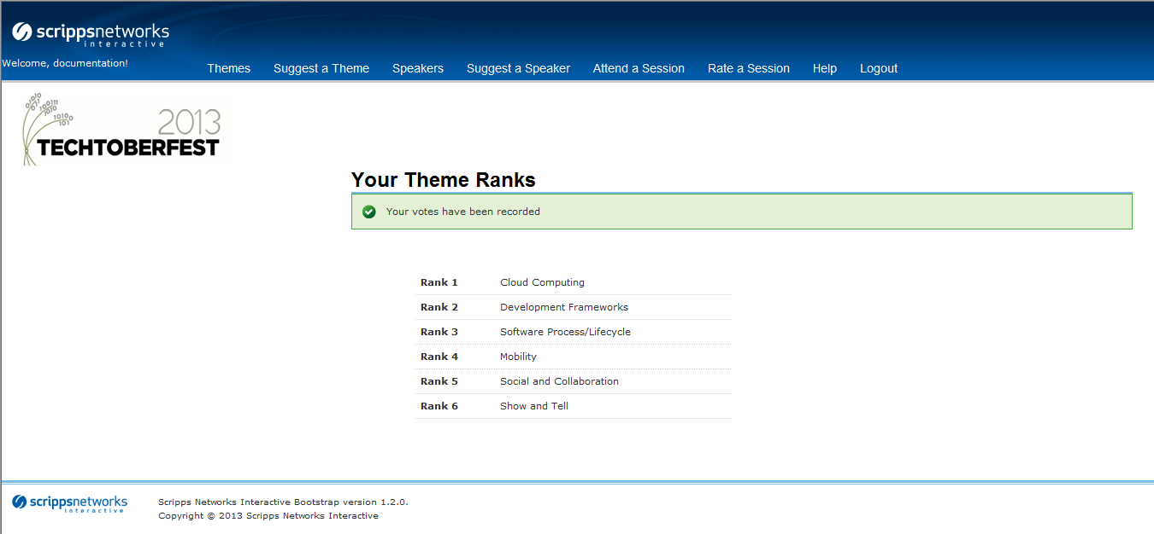

If you try to keep an extra window open to rank themes twice, you will see a message like this:

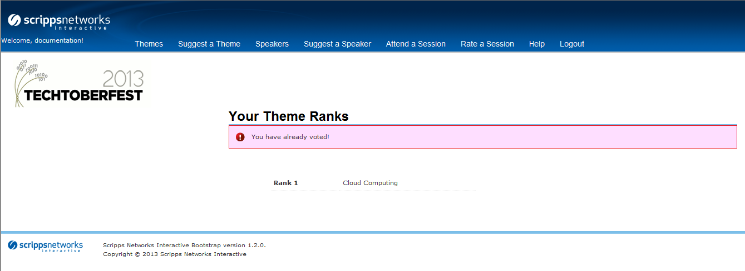

So please, don’t try and cheat.

# Suggesting a Theme

You may have an idea for an interesting theme for this year’s Techtoberfest. If that is the case, you can use the Suggest a Theme option to voice your opinion.

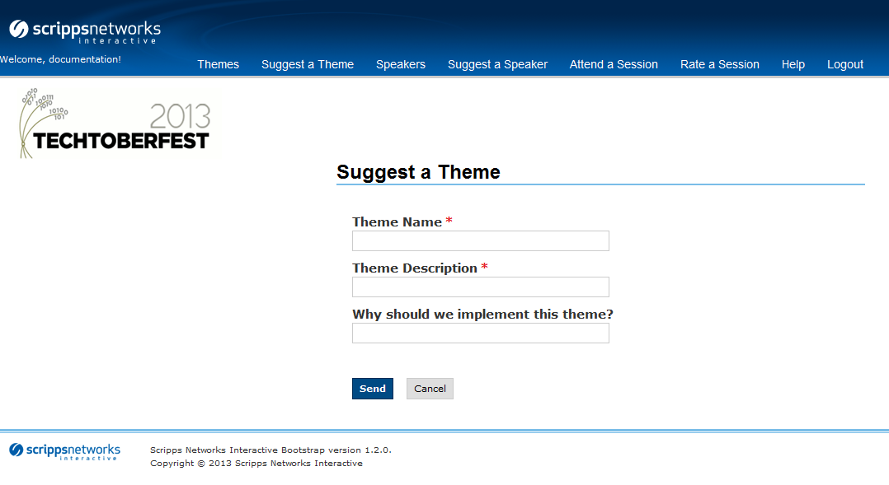

Enter a name and a description of your theme. The reason is optional, but if you want the Techtoberfest Committee to consider your idea, it may be wise to defend your idea.

If you enter the information and hit Submit, you will see the following screen.

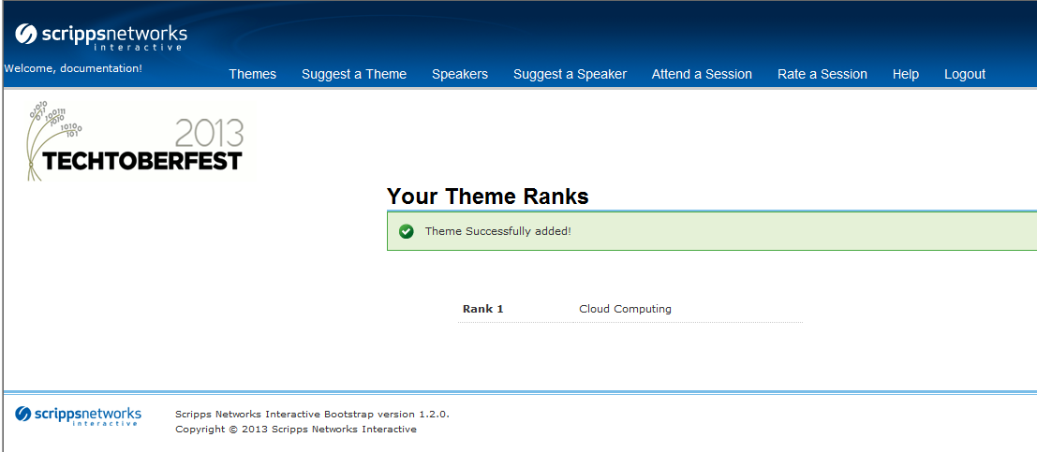

Now your theme is ready to be viewed by the Techtoberfest Committee!