MCNP Model Design

All simulations and core geometry iterations were done using MCNP6. Overall dimensions of the proposed core were estimated using data available from General Atomics[1]. The active core height was selected to be 300 cm, with a face to face width of 212 cm. This size was selected to fit within a radial reflecting cylinder of diameter 300 cm. The reflector and fuel were modeled within a graphite shield of height 500 cm and diameter 460 cm. These dimensions and the initial core shape can be seen in Fig. #.1.

The goal of the proposed core was to use as much depleted uranium (DU) as possible, while maintaining a fast neutron spectrum. A core loading scheme was selected to minimize the amount of enriched uranium required while also minimizing flux peaking factors in the central region of the core. These two constraints led to a number of enriched fuel assemblies being arranged in a shell-type configuration surrounding additional DU assemblies. Maximum enrichment of uranium in the enriched regions was 13.0% 235U by mass.

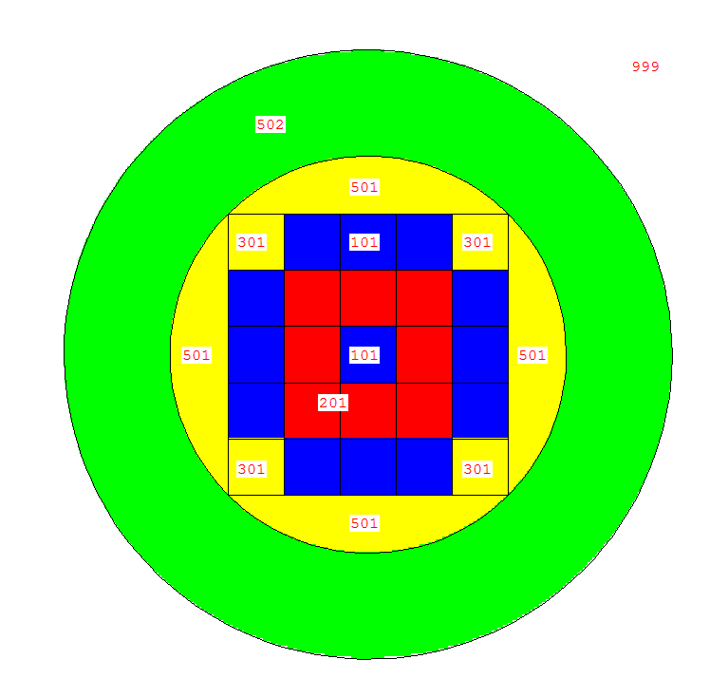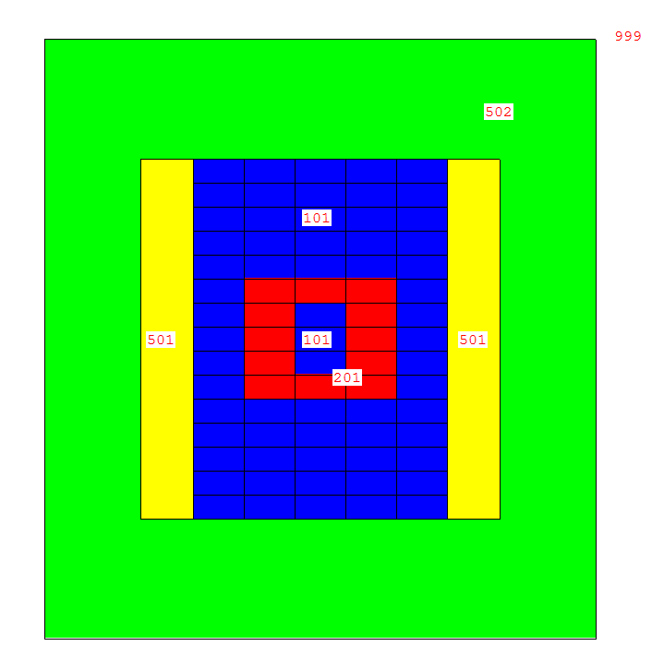

300 cm

500 cm

212 cm

300 cm

460 cm

Fig. #.1. Top down and center plane images of the initial model design used for neutronics simulation and calculations.

The first runs of the model in MCNP were accomplished using a full fuel model, which did not include coolant channels. This was used to give an absolute upper bound for what the core criticality could be with the proposed fuel composition. The full fuel model criticality resulted in a keff = 1.27146 ± 0.00149. This relatively large value for the multiplication factor of the core allowed for a number of model iterations to be examined. In the simulation, the fraction of fission which was caused by fast neutrons was 81.3%. A high fast fission fraction was required before modeling different fuel types, as these changes cause some moderation of the neutrons.

To examine the feasibility of various fuel element types, three different models were created with various fuel assembly geometries. Plate element fuel was examined in a 1D lattice; pin fuel elements were examined in 2D hexagonal and square lattices. Figure #.2 shows the various fuel elements and dimensions which were implemented in the three models. The first iteration of the fuel elements were created with a fuel plate width, or pellet diameter, of 0.94 cm; cladding thickness of the first models was 0.067 cm. The pitch between elements was 1.46 cm. Coolant channels in the model were filled with helium at a density correlating to 13.3 MPa[1]. The dimensions of the fuel elements were selected to resemble those found in traditional LWR fuel elements as a first comparison.

 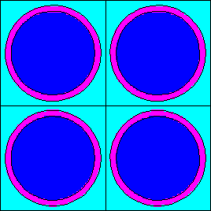 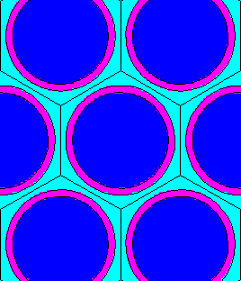

Fig. #.2. Plate and pin type fuel elements which were implemented in the MCNP model for comparison.

For each fuel element type, the neutron flux in the core was tallied at various points axially and radially. For the proposed fast reactor, a flux profile as close to constant as possible is desired throughout both axes of the core. To analyze the model’s flux profile, the energy dependent tallies were plotted for various positions in the core. No statistical difference was seen between the hex lattice and square lattice for the pin elements, so the hex lattice results were omitted.

The radial flux profile was observed and compared for the two models, Fig. #.3 and #.4.

Fig. #.3. Energy wise scalar flux at three radial points, x = 0, 42.4, 84.8 cm, in the model using pin type fuel elements.

Fig. #.4. Energy wise scalar flux at three radial points, x = 0, 42.4, 84.8 cm, in the model with plate type fuel elements.

The energy range of the spectrum is encouraging, with nearly all neutrons in the >10 keV range. The radial dependence on the flux, however, indicates a sharp drop off of neutron population toward the outside edge of the core. The reflecting material was doing little to preserve the neutron economy, as the outer fuel assemblies were absorbing enough neutrons of the fast neutrons to maintain a critical configuration.

The axial tallies from the model, Fig. #.5 and #.6, show the difference in the flux profile for the pin type and plate type fuel elements. As can be seen by the order of magnitude change from one spectrum to another in the pin type element plot, there does not seem to be very good neutron economy throughout the length of the core.

Fig. #.5. Energy wise scalar flux at three axial points, z = 0, 40, 80 cm, in the model using pin type fuel elements. A full order of magnitude drop in scalar flux can be seen from 40 cm to 80 cm vertically through the core.

The difference in spectrum for the various positions in the core is significantly less in the plate type model. The close grouping of spectrum in the plot for the plate element model, Fig. #.6, is attributed to streaming through the vertical channels created by the plates. This feature of the model is advantageous for future iterations, and the plate elements allow for tight packing of fuel within the core while maintaining even cooling across any given fuel plate surface.

Fig. #.6. Energy wise scalar flux at three axial points, z = 0, 40, 80 cm, in the model with plate type fuel elements. The close grouping of the three plots indicates a more flat profile along the core axial dimension.

The spectrum analysis led to a number of interesting conclusions about the first model of the core. First, the spectrum was as fast as could be expected in a fission reactor with the coolant included. The fast spectrum allowed for nearly any fuel and cladding combination to be considered while still maintaining criticality in beginning of life (BOL) analysis. Second, the plate elements would provide a more promising fuel for the proposed reactor, and allow for more flexibility in the core height to width ratio due to its advantageous streaming along the axial length of the model. The plate type assembly model was considered v1, and each subsequent model was numbered accordingly. In all further analysis of models, plate type assemblies were implemented in the model.

After determining the assembly geometry, the fuel and cladding materials were implemented into the model. A silicon carbide cladding was selected for its high temperature tolerance, along with its expected longevity. Silicon carbide cladding has a melting point of 2730° C, making it an ideal match for use in a high temperature gas-cooled reactor such as the proposed system. Similarly, a ceramic fuel type, uranium carbide, was selected for analysis. The same tally scheme was used to observe the energy wise flux throughout the model. The results for the radial and axial flux profiles are plotted in figures #.7 and #.8.

Fig. #.7. Energy wise scalar flux for v2 at three radial points, x = 0, 42.4, 84.8 cm, in the model with uranium carbide fuel.

Fig. #.7. Energy wise scalar flux for v2 at three axial points, z = 0, 40, 80 cm, in the model with uranium carbide fuel.

The addition of the carbon into the fuel elements causes an increase of scalar flux in the range <10 keV. This alters the fast fission fraction of the system from 78.3% to 58.1%, and decreases the BOL multiplication factor, keff from 1.14880 to 1.04410. The excess reactive, however, proved enough via lifetime burn analysis to further iterate on the fuel assembly.

A version of the core was modeled with higher enriched fuel in the assemblies which do not contain DU. The enrichment in the shell region was changed to 20.0% 235U by mass and the simulation was run. Flux tallies were plotted for the same detectors in the model in Fig. #.8

Fig. #.8. Energy wise flux for model v3 at various positions as indicated throughout the core.

The 20.0% enriched model resulted in a keff = 1.23952 ± 0.00008. This was expected to be the top end enrichment that would be possible in the core. This amount of excess reactivity is too large to deal with in practical methods for a fast reactor. As can be seen by the sharp decrease in flux from the center of the core through the enriched shell into the DU blanket outside, the majority of the flux is contained inside the enriched shell region, which leads to poor conversion of the DU outside to fissile material. This model was not studied extensively for lifetime data.

To examine the low end of enriched uranium elements that could be used in the proposed system, a model was assembled with fewer DU assemblies between the top and bottom of the enriched shell region as seen in Fig. #.9



Fig. #.9. XZ center plane of core loading scheme for model v4.

This model was contrived in an attempt to drive flux to the DU regions of the core while maintaining a critical configuration. It was pointed out after the simulation had begun that there were, in fact, no less enriched fuel assemblies in this configuration as was seen in the previous models. As such, little analysis was done for the lifetime of this system. The flux tallies were plotted for the various positions in the model in Fig. #.10.

Fig. #.10. Energy wise flux for model v4 at various positions as indicated throughout the core.

This core loading scheme did not provide any additional features to the model which were advantageous, and so was left out of further analysis other than initial flux observations.

After optimizing on the number of enriched fuel assemblies in the core model, the fuel element thickness and clad thickness were determined to need altering due to thermal hydraulics and material strengths considerations. A lower bound for fuel thickness to clad thickness ratio was determined and implemented into the core model. The new fuel plate thickness was set as 0.84 cm with a cladding thickness of 0.15 cm. Plotting the flux tallies for the various positions, Fig. #.11, throughout the core allowed for an analysis on the minimum keff that could be achieved with realistic fuel elements.

Fig. #.11. Energy wise flux for model v5 at various positions as indicated throughout the core.

The change of the fuel assemblies back to what was first proposed resulted in a flatter spatial spectrum throughout the axial and radial dimensions of the model. The small peak in the thermal region of the energy wise flux is due to the moderation in the Be2C reflector just outside the radial limit of the core.

The change in fuel and cladding thickness proved to be a little too much for core lifetime analysis. The BOL keff = 1.01559 was not enough excess reactivity to maintain a critical configuration for an economic lifetime. As such, another change was made to the fuel and cladding thickness. The fuel plate thickness was set to 1.00 cm with a cladding thickness of 0.11 cm. This proposed thickness required a change in pitch to 1.57 cm. The flux tally results, Fig. #.12, do not indicate any problem with the system as there is little to no peaking throughout the axial and radial dimensions.

Fig. #.12. Energy wise flux for model v6 at various positions as indicated throughout the core.

The last iteration of the core reduced the number of fuel elements and added in a number of reflectors axially in order to improve neutron efficiency without adding more fuel material. The flux tallies were plotted for each of the positions taken in the core, Fig. #.13.

Fig. #.13. Energy wise flux for model v7 at various positions as indicated throughout the core.

The model iterations are summarized in Table X.I.

Table X.I.

|  |  |  |  |  |  |  |
| --- | --- | --- | --- | --- | --- | --- |
| Version | Axial Layers DU between LEU shell | LEU Enrichment (%) | Plates per Assembly | Plate width (cm) | Clad thickness (cm) | keff  (all results ±0.00007) |
| v1 | 5 | 13 | 29 | 0.94 | 0.067 | 1.14880 |
| v2 | 7 | 13 | 29 | 0.94 | 0.067 | 1.04410 |
| v3 | 5 | 20 | 29 | 0.94 | 0.067 | 1.23952 |
| v4 | 3 | 13 | 29 | 0.94 | 0.067 | 1.01802 |
| v5 | 5 | 13 | 29 | 0.84 | 0.150 | 1.01559 |
| v6 | 5 | 13 | 27 | 1.00 | 0.110 | 1.04127 |
| v7 | 5 | 13 | 27 | 1.00 | 0.110 | 1.04117 |

1. R.W. SCHLEICHER, T. BERTCH, “Design and Development of EM2” Proceedings of the ASME 2014 Small Modular Reactors Symposium. Washington DC. (2014).