**Depleted Uranium Soaring Temperature Reactor (DUSTR)**

“Leaves other reactor designs in the dust!”

Anas Alwafi

Landon Brockmeyer

Mason Childs

Daniel Holladay

Jacob Landman

Nuclear Engineering Department, Texas A&M University

Submitted to—

Dr. Pavel Tsvetkov

Nuclear Engineering Department, Texas A&M University

**Depletion Analysis – Jacob Landman**

Depletion analysis is a very important component of this design process considering that one of the main goals of this reactor is to convert depleted uranium into fissile material. MCNP6 was used to burn the various versions of the reactor core. Each simulation was burned over a 50 year lifetime and for each depletion calculation the total core power was assumed to be ≈ 600 kW. Our analysis led to an estimate of the core lifetime and an estimate of the number of significant quantities of uranium and plutonium in both the depleted and LEU fuel assemblies. Ideally we would like the core lifetime to be very large in order to make this design more economically feasible. Additionally, a large core lifetime will decrease the long-term need for uranium enrichment, which helps with nonproliferation.

Figure (#.1) depicts the core criticality over 50 years for the first four versions of our core layout. We expected the criticality to increase initially as more and more depleted uranium is converted into fissile fuel. We also expected the criticality to reach a maximum value and then begin to decrease as the converted fissile material begins to deplete faster than it is being created. However, we observed an opposite trend. The criticality actually decreases initially as the LEU gets burned. After around 20 years, we begin to see the benefit of the conversion process as the criticality reaches a minimum and begins to increase. This discovery was one of the driving factors when coming up with new core layouts. We decided that our core criticality needed to never dip below 1.00 so that our reactor could theoretically operate upwards of 50 or so years.

Figure (#.1) shows that for all versions except for version 2, the criticality dips below 1. With versions 3 and 4, we attempted to force the core criticality to reach a minimum value more quickly. We used less LEU fuel assemblies and increased the enrichment to 20%. Unfortunately, the decrease of U-238 in the LEU led to a steeper decrease in criticality. As expected, the minimum criticality did occur earlier, but we were unable to prevent the criticality from dipping below 1.00. Based off these results, we decided that we should move forward with version 2 or some variation of version 2 (e.g. version 6).

|  |
| --- |
|  |
| Figure #.1. Core criticality over 50 years for the first four core layout versions |

Figure (#.2) depicts the criticality of version 6 over 50 years. The figure shows that over the core lifetime there are large reactivity changes. The changes in reactivity were calculated as follows:

Eq. (#.1)

where is the change in reactivity, and and are the criticalities at two different times. The delayed neutron fraction of Pu-239, β = 0.002, was used to convert the reactivity into dollars. The figure also shows that the criticality continues to increase as the burnup increases. This means that the reactor could operate for much longer than 50 years, assuming that the materials hold up and that the control elements can handle the excess reactivity.

|  |
| --- |
|  |
| Figure #.2. Core criticality over 50 years for version 6 |

The results seen thus far were obtained using burn steps equal to 1 year, which is extremely large. In order to validate these results, a burn using 2 week burn steps was performed on version 6. The results for this burn are displayed in figure (#.3). The results obtained using the smaller burn step appear to exhibit the same downward trend. It even seems that using a larger burn step may actually underestimate the core criticality, however this isn’t verified.

|  |
| --- |
|  |
| Figure #.3. Comparison of burn step size over 4 years |

As stated previously, it is important to know the material compositions at the end of lifetime (EOL) in order to quantify the amount of significant quantities of uranium and plutonium within the fuel. Figure (#.4) displays an excerpt from the IAEA Safeguards Glossary. The figure shows that a significant quantity of plutonium is 8 kg of Pu containing less than 80% Pu-238 and a significant quantity of uranium is 75 kg of U-235 that is less than 20% enriched. With this information, it is clear that we need to know the fraction of U-235 and Pu-238. Tables #.1 and #.2 display the plutonium and uranium quantities, respectively.

|  |
| --- |
|  |
| Figure #.4. Excerpt from IAEA Safeguards Glossary regarding significant quantities |

The tables show that the plutonium concentration is far below 20% Pu-238, which means we do indeed care about the amount of plutonium at the end of the core lifetime. Also, the average uranium enrichment throughout the core is well below 20%, which means one would need 75 kg of uranium in order to have a significant quantity. The tables also display the total mass of each of the isotopes. Clearly, there are numerous significant quantities within the entire core.

|  |  |  |  |  |
| --- | --- | --- | --- | --- |
| Table #.1 | | | | |
| Plutonium Quantities | | | | |
| **Isotope ID** | **BOL** | | **EOL** | |
| **Mass (kg)** | **Mass Fraction** | **Mass (kg)** | **Mass Fraction** |
| 94236 | 0.0000 | 0.0000 | 0.0001 | 0.0000 |
| 94237 | 0.0000 | 0.0000 | 0.0001 | 0.0000 |
| **94238** | 0.0000 | 0.0000 | **78.8400** | **0.0119** |
| **94239** | 0.0000 | 0.0000 | **5096.0000** | **0.7666** |
| **94240** | 0.0000 | 0.0000 | **1321.0000** | **0.1987** |
| 94241 | 0.0000 | 0.0000 | 124.8000 | 0.0188 |
| 94242 | 0.0000 | 0.0000 | 27.3000 | 0.0041 |

|  |  |  |  |  |
| --- | --- | --- | --- | --- |
| Table #.2 | | | | |
| Uranium Quantities | | | | |
| **Isotope ID** | **BOL** | | **EOL** | |
| **Mass (kg)** | **Mass Fraction** | **Mass (kg)** | **Mass Fraction** |
| 92233 | 0.0000 | 0.0000 | 0.0015 | 0.0000 |
| 92234 | 5.5000 | 0.0001 | 12.8300 | 0.0002 |
| **92235** | **2343.0000** | **0.0292** | **62.9300** | **0.0010** |
| 92236 | 0.0000 | 0.0000 | 244.0000 | 0.0039 |
| 92237 | 0.0000 | 0.0000 | 0.1010 | 0.0000 |
| **92238** | **77770.0000** | **0.9707** | **61590.0000** | **0.9948** |
| 92239 | 0.0000 | 0.0000 | 0.0156 | 0.0000 |
| 92240 | 0.0000 | 0.0000 | 0.0000 | 0.0000 |

To better quantify the amount of significant quantities, figure (#.5) displays the number of plutonium significant quantities in one fuel assembly for both the LEU and depleted fuel over the core lifetime. Without a doubt, there is a large number of significant quantities contained within 1 fuel assembly of depleted uranium. With this knowledge, it is imperative for the physical security to be able to prevent criminals from obtaining these materials. Figure (#.6) displays the number of fuel elements that would be needed in order to have 1 significant quantity of plutonium. As expected, at the beginning of core operation, the number of elements needed is quite high, but the longer the core operates, fewer fuel elements are needed. Once again, the physical security at the reactor facility, will need to prevent criminals from obtaining the number of elements needed to have a significant quantity of plutonium.

|  |
| --- |
|  |
| Figure #.5. Plutonium significant quantities per assembly |

Figures (#.7) displays the significant quantities of U-235 in the entire core. The figure shows that there is a very small amount of U-235 significant quantities. Figure (#.8) bares this out by displaying the significant quantities per assembly. This figure shows that not one assembly contains a significant quantity of U-235. Thus, from a safeguards perspective, U-235 is not much of a concern.

|  |
| --- |
|  |
| Figure #.6. Number of fuel elements needed for 1 significant quantity |

|  |
| --- |
|  |
| Figure #.7. Significant quantities of U-235 in the entire core |

|  |
| --- |
|  |
| Figure #.8. Significant quantities of U-235 per assembly |

MCNP Model Design

All simulations and core geometry iterations were done using MCNP6. Overall dimensions of the proposed core were estimated using data available from General Atomics[1]. The active core height was selected to be 300 cm, with a face to face width of 212 cm. This size was selected to fit within a radial reflecting cylinder of diameter 300 cm. The reflector and fuel were modeled within a graphite shield of height 500 cm and diameter 460 cm. These dimensions and the initial core shape can be seen in Fig. #.1.

The goal of the proposed core was to use as much depleted uranium (DU) as possible, while maintaining a fast neutron spectrum. A core loading scheme was selected to minimize the amount of enriched uranium required while also minimizing flux peaking factors in the central region of the core. These two constraints led to a number of enriched fuel assemblies being arranged in a shell-type configuration surrounding additional DU assemblies. Maximum enrichment of uranium in the enriched regions was 13.0% 235U by mass.

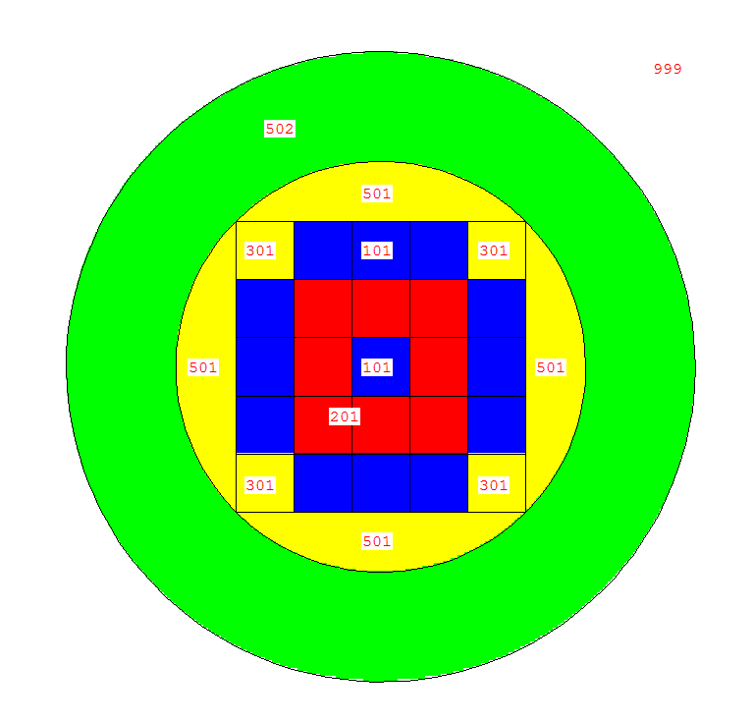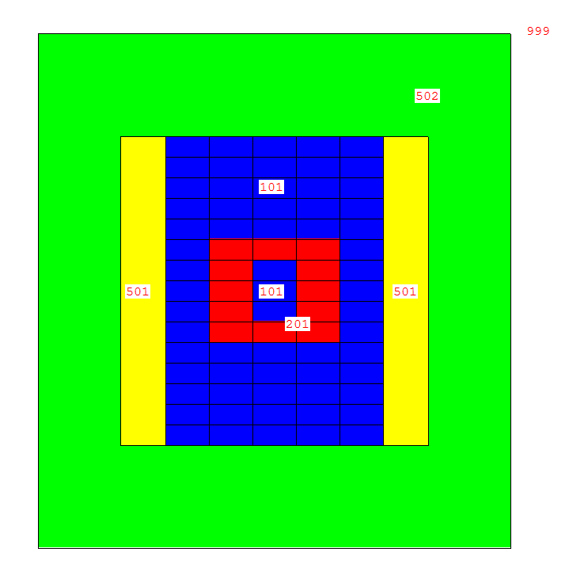

300 cm

500 cm

212 cm

300 cm

460 cm

Fig. #.1. Top down and center plane images of the initial model design used for neutronics simulation and calculations.

The first runs of the model in MCNP were accomplished using a full fuel model, which did not include coolant channels. This was used to give an absolute upper bound for what the core criticality could be with the proposed fuel composition. The full fuel model criticality resulted in a keff = 1.27146 ± 0.00149. This relatively large value for the multiplication factor of the core allowed for a number of model iterations to be examined. In the simulation, the fraction of fission which was caused by fast neutrons was 81.3%. A high fast fission fraction was required before modeling different fuel types, as these changes cause some moderation of the neutrons.

To examine the feasibility of various fuel element types, three different models were created with various fuel assembly geometries. Plate element fuel was examined in a 1D lattice; pin fuel elements were examined in 2D hexagonal and square lattices. Figure #.2 shows the various fuel elements and dimensions which were implemented in the three models. The first iteration of the fuel elements were created with a fuel plate width, or pellet diameter, of 0.94 cm; cladding thickness of the first models was 0.067 cm. The pitch between elements was 1.46 cm. Coolant channels in the model were filled with helium at a density correlating to 13.3 MPa[1]. The dimensions of the fuel elements were selected to resemble those found in traditional LWR fuel elements as a first comparison.

 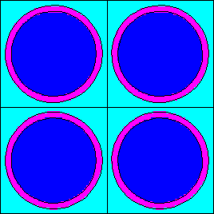 

Fig. #.2. Plate and pin type fuel elements which were implemented in the MCNP model for comparison.

For each fuel element type, the neutron flux in the core was tallied at various points axially and radially. For the proposed fast reactor, a flux profile as close to constant as possible is desired throughout both axes of the core. To analyze the model’s flux profile, the energy dependent tallies were plotted for various positions in the core. No statistical difference was seen between the hex lattice and square lattice for the pin elements, so the hex lattice results were omitted.

The radial flux profile was observed and compared for the two models, Fig. #.3 and #.4.

Fig. #.3. Energy wise scalar flux at three radial points, x = 0, 42.4, 84.8 cm, in the model using pin type fuel elements.

Fig. #.4. Energy wise scalar flux at three radial points, x = 0, 42.4, 84.8 cm, in the model with plate type fuel elements.

The energy range of the spectrum is encouraging, with nearly all neutrons in the >10 keV range. The radial dependence on the flux, however, indicates a sharp drop off of neutron population toward the outside edge of the core. The reflecting material was doing little to preserve the neutron economy, as the outer fuel assemblies were absorbing enough neutrons of the fast neutrons to maintain a critical configuration.

The axial tallies from the model, Fig. #.5 and #.6, show the difference in the flux profile for the pin type and plate type fuel elements. As can be seen by the order of magnitude change from one spectrum to another in the pin type element plot, there does not seem to be very good neutron economy throughout the length of the core.

Fig. #.5. Energy wise scalar flux at three axial points, z = 0, 40, 80 cm, in the model using pin type fuel elements. A full order of magnitude drop in scalar flux can be seen from 40 cm to 80 cm vertically through the core.

The difference in spectrum for the various positions in the core is significantly less in the plate type model. The close grouping of spectrum in the plot for the plate element model, Fig. #.6, is attributed to streaming through the vertical channels created by the plates. This feature of the model is advantageous for future iterations, and the plate elements allow for tight packing of fuel within the core while maintaining even cooling across any given fuel plate surface.

Fig. #.6. Energy wise scalar flux at three axial points, z = 0, 40, 80 cm, in the model with plate type fuel elements. The close grouping of the three plots indicates a more flat profile along the core axial dimension.

The spectrum analysis led to a number of interesting conclusions about the first model of the core. First, the spectrum was as fast as could be expected in a fission reactor with the coolant included. The fast spectrum allowed for nearly any fuel and cladding combination to be considered while still maintaining criticality in beginning of life (BOL) analysis. Second, the plate elements would provide a more promising fuel for the proposed reactor, and allow for more flexibility in the core height to width ratio due to its advantageous streaming along the axial length of the model. The plate type assembly model was considered v1, and each subsequent model was numbered accordingly. In all further analysis of models, plate type assemblies were implemented in the model.

After determining the assembly geometry, the fuel and cladding materials were implemented into the model. A silicon carbide cladding was selected for its high temperature tolerance, along with its expected longevity. Silicon carbide cladding has a melting point of 2730° C, making it an ideal match for use in a high temperature gas-cooled reactor such as the proposed system. Similarly, a ceramic fuel type, uranium carbide, was selected for analysis. The same tally scheme was used to observe the energy wise flux throughout the model. The results for the radial and axial flux profiles are plotted in figures #.7 and #.8.

Fig. #.7. Energy wise scalar flux for v2 at three radial points, x = 0, 42.4, 84.8 cm, in the model with uranium carbide fuel.

Fig. #.7. Energy wise scalar flux for v2 at three axial points, z = 0, 40, 80 cm, in the model with uranium carbide fuel.

The addition of the carbon into the fuel elements causes an increase of scalar flux in the range <10 keV. This alters the fast fission fraction of the system from 78.3% to 58.1%, and decreases the BOL multiplication factor, keff from 1.14880 to 1.04410. The excess reactive, however, proved enough via lifetime burn analysis to further iterate on the fuel assembly.

A version of the core was modeled with higher enriched fuel in the assemblies which do not contain DU. The enrichment in the shell region was changed to 20.0% 235U by mass and the simulation was run. Flux tallies were plotted for the same detectors in the model in Fig. #.8

Fig. #.8. Energy wise flux for model v3 at various positions as indicated throughout the core.

The 20.0% enriched model resulted in a keff = 1.23952 ± 0.00008. This was expected to be the top end enrichment that would be possible in the core. This amount of excess reactivity is too large to deal with in practical methods for a fast reactor. As can be seen by the sharp decrease in flux from the center of the core through the enriched shell into the DU blanket outside, the majority of the flux is contained inside the enriched shell region, which leads to poor conversion of the DU outside to fissile material. This model was not studied extensively for lifetime data.

To examine the low end of enriched uranium elements that could be used in the proposed system, a model was assembled with fewer DU assemblies between the top and bottom of the enriched shell region as seen in Fig. #.9



Fig. #.9. XZ center plane of core loading scheme for model v4.

This model was contrived in an attempt to drive flux to the DU regions of the core while maintaining a critical configuration. It was pointed out after the simulation had begun that there were, in fact, no less enriched fuel assemblies in this configuration as was seen in the previous models. As such, little analysis was done for the lifetime of this system. The flux tallies were plotted for the various positions in the model in Fig. #.10.

Fig. #.10. Energy wise flux for model v4 at various positions as indicated throughout the core.

This core loading scheme did not provide any additional features to the model which were advantageous, and so was left out of further analysis other than initial flux observations.

After optimizing on the number of enriched fuel assemblies in the core model, the fuel element thickness and clad thickness were determined to need altering due to thermal hydraulics and material strengths considerations. A lower bound for fuel thickness to clad thickness ratio was determined and implemented into the core model. The new fuel plate thickness was set as 0.84 cm with a cladding thickness of 0.15 cm. Plotting the flux tallies for the various positions, Fig. #.11, throughout the core allowed for an analysis on the minimum keff that could be achieved with realistic fuel elements.

Fig. #.11. Energy wise flux for model v5 at various positions as indicated throughout the core.

The change of the fuel assemblies back to what was first proposed resulted in a flatter spatial spectrum throughout the axial and radial dimensions of the model. The small peak in the thermal region of the energy wise flux is due to the moderation in the Be2C reflector just outside the radial limit of the core.

The change in fuel and cladding thickness proved to be a little too much for core lifetime analysis. The BOL keff = 1.01559 was not enough excess reactivity to maintain a critical configuration for an economic lifetime. As such, another change was made to the fuel and cladding thickness. The fuel plate thickness was set to 1.00 cm with a cladding thickness of 0.11 cm. This proposed thickness required a change in pitch to 1.57 cm. The flux tally results, Fig. #.12, do not indicate any problem with the system as there is little to no peaking throughout the axial and radial dimensions.

Fig. #.12. Energy wise flux for model v6 at various positions as indicated throughout the core.

The last iteration of the core reduced the number of fuel elements and added in a number of reflectors axially in order to improve neutron efficiency without adding more fuel material. The flux tallies were plotted for each of the positions taken in the core, Fig. #.13.

Fig. #.13. Energy wise flux for model v7 at various positions as indicated throughout the core.

The model iterations are summarized in Table X.I.

Table X.I.

|  |  |  |  |  |  |  |
| --- | --- | --- | --- | --- | --- | --- |
| Version | Axial Layers DU between LEU shell | LEU Enrichment (%) | Plates per Assembly | Plate width (cm) | Clad thickness (cm) | keff  (all results ±0.00007) |
| v1 | 5 | 13 | 29 | 0.94 | 0.067 | 1.14880 |
| v2 | 7 | 13 | 29 | 0.94 | 0.067 | 1.04410 |
| v3 | 5 | 20 | 29 | 0.94 | 0.067 | 1.23952 |
| v4 | 3 | 13 | 29 | 0.94 | 0.067 | 1.01802 |
| v5 | 5 | 13 | 29 | 0.84 | 0.150 | 1.01559 |
| v6 | 5 | 13 | 27 | 1.00 | 0.110 | 1.04127 |
| v7 | 5 | 13 | 27 | 1.00 | 0.110 | 1.04117 |

1. R.W. SCHLEICHER, T. BERTCH, “Design and Development of EM2” Proceedings of the ASME 2014 Small Modular Reactors Symposium. Washington DC. (2014).

**Thermal Hydraulics: In-Core – Landon Brockmeyer**

Design Approach:

The design of the geometry and composition of the core of this reactor is largely a function of thermal hydraulic considerations and neutronic considerations. Thermal hydraulic considerations include maximum temperatures of fuel, cladding and coolant, as well as pressure drop. Neutronic considerations primarily include fuel to coolant ratio. The neutronic considerations were prioritized over thermal hydraulic considerations in order to maximize lifetime of the core and to minimize leakage. As such, the fuel to coolant ratio was taken as a constraint for thermal hydraulic purposes. The volumetric heat generation rate was determined from the desired core thermal power production.

The first step in designing the core was to decide upon core materials. No member of the team involved in the design was designated to study material performance, so the materials chosen was based on a lose literature review. The reactor design detailed in this report is largely inspired by the General Atomics Energy Multiplier Module (EM2) reactor. The EM2 reactor uses Uranium Carbide as fuel, Silicone Carbide as cladding and helium as a coolant. Helium was the natural choice of coolant for this design. Other gasses such as nitrogen, carbon dioxide, or air have inferior cooling properties. Another popular coolant for fast reactors is liquid sodium; however, the sodium is extremely corrosive and not conducive to the long fuel element lifetime desired for this reactor. Silicon Carbide was chosen as cladding for its promising longevity and resistance to corrosion. Uranium Carbide was chosen as fuel for its high melting point and superior heat transfer properties.

The basic geometry was chosen next. Two common geometries for fast reactors are fuel rods, fuel plates, and fuel pebbles. Fuel pebbles were not considered or modeled. The key advantage of fuel pebbles is there ease of refueling, which is unnecessary for our design. Fuel rods and fuel plates were initially considered. After initial analytical modeling, fuel plates were chosen. Fuel plates have the advantage of thermally decoupling subchannels, resulting in higher accident tolerance, as one faulty channel does not cascade into multiple faulty channels. Fuel plates result in more consistent and even cooling, along with higher surface are to volume ratio. Fuel plates are more easily modeled, and are thus easier to design and optimize. Helium in combination with the coolant channels results in the added benefit of hot channels naturally cooling better due to the strong buoyant forces of helium and the chimney effect created by the channels.

To begin designing the core configuration, an analytical model was created. An analytical model of the reactor can easily be permuted to find a variety of possible configurations from which to narrow down on a final design. The analytical model was created using Microsoft Excel. A single channel was specified including fuel thickness, flow channel thickness, pressure, and inlet mass flow rate. Heat generation rate and fuel to cladding ratio are constrained by neutronics. Inlet and outlet bulk fluid temperatures are constrained by the power cycle thermal hydraulics. Maximum fuel and cladding temperature and cladding thickness are constrained by materials. Material properties such as viscosity, density, heat capacity, and thermal conductivity were determined as a function of temperature and pressure were determined by empirical correlations. The heat transfer coefficient was estimated using the Seider Tate correlation. The channel was discretized into 300 axial segments. The fluid temperature of each segment is a function of the properties of the previous segment and the heat transfer from the cladding. The cladding and fuel temperatures were then calculated using a heat transfer equation. For simplicity, the axial heat flux distribution was taken to be uniform. Using this method an average channel and hot channel were modeled. Using this analytical model, a variety of configurations that fit the listed constraints were found. From these configurations, a final candidate was selected for CFD modeling based on minimizing pressure drop and maximizing fuel to coolant ratio.

With a fuel design candidate found, CFD modeling was performed on a single channel to ensure that the fluid behaved as expected, and to optimize the geometry. The CFD modeling was performed with STARCCM+. The fluid was modeled using a Reynolds Averaged Navier Stokes (RANS) two equation realized k-ε with two-layer wall treatment. The helium was assumed to be an ideal gas. Material properties were estimated using the same empirical correlations as the analytical model.

The geometry of the cladding interface with the helium was then permuted to increase mixing. The increase in mixing comes at the expense of pressure drop. A variety of geometries were modeled including a flat surface, ribs, and dimples.

With the final geometry modeled with a variety of surfaces, a final fuel design was chosen. The pressure drop and temperature change for this fuel design were then passed on to the system designer for optimization of the power cycle of this reactor.

Design Results.

The analytical model was created with the following restraints set:

* Maximum Fuel Temperature: 2000 K
* Maximum Clad Temperature: 1600 K
* Bulk Fluid Temperature In: 850 K
* Bulk Fluid Temperature Out: 1150 K
* Cladding Thickness: 1.1 mm
* Fuel to Coolant Ratio: ~2.8
* Average Fuel Power: 100 W/cm3
* Hot Channel Fuel Power: 200 W/cm3

The parameters changed included:

* Pressure
* Fuel Thickness
* Channel Thickness
* Inlet Velocity

Several configurations satisfied these conditions. The configuration estimated to have the lowest pressure drop was chosen as the candidate geometry to be modeled. The candidate geometry had the following parameters:

* Pressure: 15 MPa
* Fuel Thickness: 1 cm
* Channel Thickness: 3.5 mm
* Inlet Velocity 70 m/s

The predicted temperature profile for the average subchannel is shown in Figure X.1. The leftmost point is the fuel centerline temperature, the next pint is the fuel outer temperature, followed by the inner cladding, outer cladding, and average fluid temperature. The temperature profile is shown for 4 axial heights.

Figure X.1. Average Channel Temperature Distribution, Analytical

The temperature profile is very flat compared to other reactors including existing LWRs. This flat profile means a low temperature gradient which is better for material structural integrity. It also demonstrates that this configuration is good for conducting energy out of the fuel and into the coolant. Temperature gradients are quickly flattened in this design. The increase in temperature through the core is nearly linear throughout.

The predicted temperature for a hot subchannel is shown in Figure X.2.

Figure X.2. Hot Channel Temperature Distribution, Analytical

Again the temperature distribution is noticeably flat, however not as flat as the average channel. The fuel especially is excellent at conducting heat, making Uranium Carbonate very accident tolerant. Even in the hot channel the fuel is over 400 K from reaching unacceptable temperatures. The cladding is the first to fail in this design. This reactor is in many ways limited by material considerations.

With the geometry candidate chosen and according to the analytical calculations capable of meeting the design needs, a further CFD investigation was carried out. The initial CFD run was actually for a previous iterations geometry. However, it revealed a design problem that needed to be resolved. The smooth walls of the initial design resulted in poor mixing of the coolant, and thus severe temperature gradients between the near wall coolant and the channel center coolant. The cladding walls needed a geometry change to encourage mixing. This mixing comes at the expense of pressure drop. Thus a variety of geometries were tested to modeled to increase mixing. Two ribbed designs and a dimpled design were compared to the flat wall design. For each design the features were separated vertically by 5 mm. One ribbed design featured a 1 mm diameter rib, and the other a 0.5 mm diameter rib. The dimples were vertically and horizontally 5 mm apart and 0.5 mm in diameter. Figure X.3 shows close up images of the three configurations.

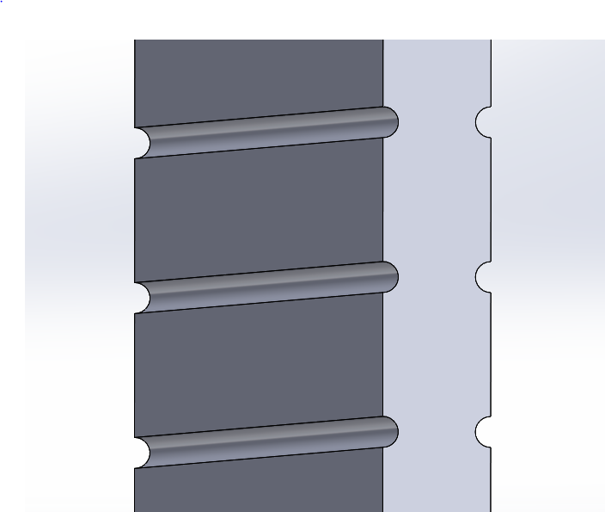 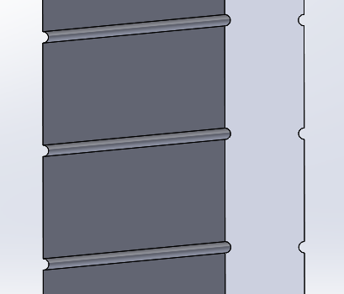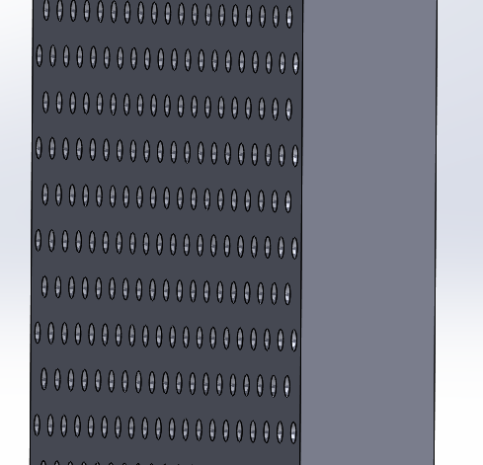

Figure X.3. Wall Features from Left to Right: 1 mm Ribs, 0.5 mm Ribs, 0.5 mm Dimples.

The exiting temperature profiles of each design is shown in Figure X.4.

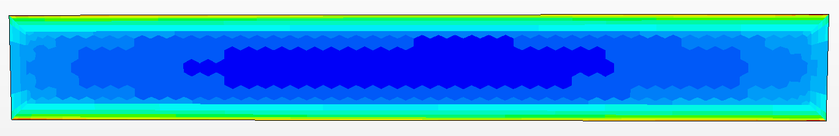

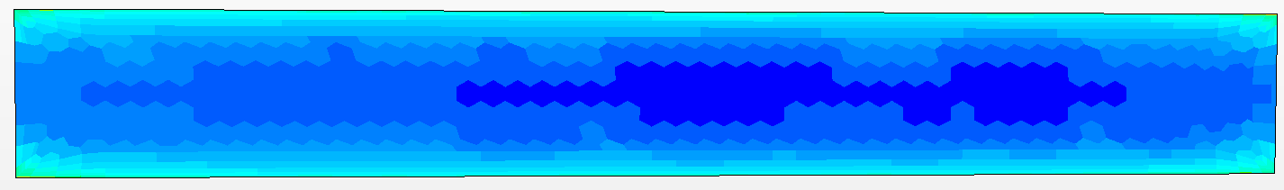





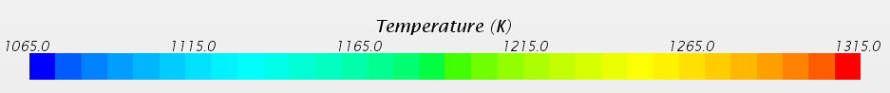

Figure X.4. Exit Temperature Profiles From Top to Bottom: Flat, 1 mm Ribs, 0.5 mm Ribs, 0.5 mm Dimples, Temperature Key.

The flat walls are clearly inferior to the other wall designs. The 0.5 mm Ribs had the best temperature mixing. The dimpled design had the lowest pressure drop. However, the dimpled design had much greater wall temperature discrepancies whereas the ribbed design had much flatter wall temperatures, despite slight increases below and above the ribs. Based on this the smaller diameter ribs were seen as the superior model.

For the final geometry CFD investigation, because the geometry changed, another wall study was carried out. Only two designs were investigated. The channel for this design was much narrower. The first design featured 1 mm ribs spaced 5 mm apart, the second 0.5 mm ribs spaced 5 mm apart. Both designs had comparable temperature profiles, differing only slightly. However, the design with the larger ribs suffered greatly for pressure drop, reaching 3.7 MPa, which is prohibitively high. The 0.5 mm rib designs pressure drop was only 710 kPa, while high, is manageable. The outlet temperature profile as well as near exit wall temperature profile is shown in Figure X.5.



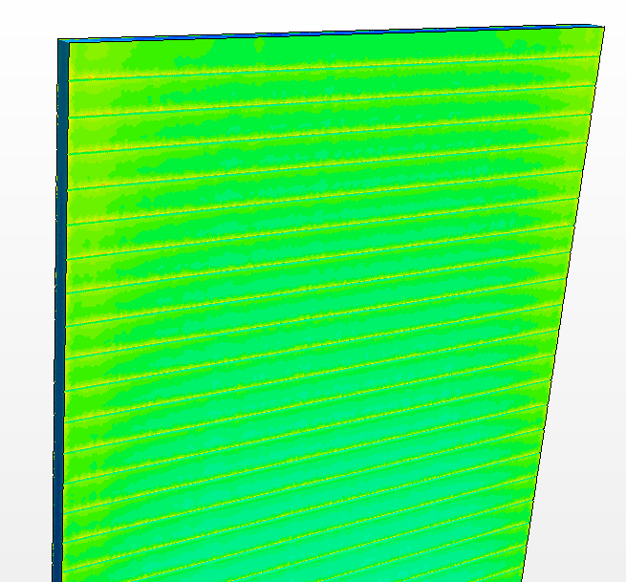

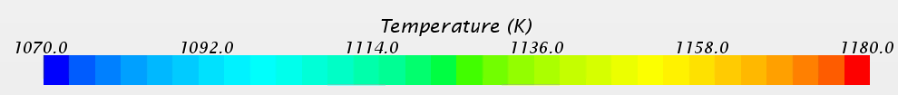

Figure X.5. Final Design Exit and Top Wall Temperature Profiles.

The outlet Temperature profile is extremely flat. Additional CFD analysis should be made to see if smaller ribs could result in a flat exit temperature while further reducing pressure drop. Small increases in temperature can be seen above each of the ribs. This is to be expected as the flow stagnates slightly here. This, however is inconsequential, as the temperature increase is far below a level of concern. Smaller ribs may result in even flatter wall temperature distributions. Additionally, the exit temperature profile could be flattened additionally by curving the outside corners. The peak temperature occurs in these corners and could be reduced. Until further wall designs are studied, this design can be considered successful for meeting the design criteria.

Natural convection in the case of loss of power is an important aspect of this design. This portion of the design could not be modeled in the time available. However, this design is promising for natural convection being an option for emergency cooling. In the event that the reactor must be shut down and pressure in maintained, similar designs to this are fully capable of being cooled by natural convection alone. The cooling channels form nice chimneys for the helium to circulate. The high thermal expansion of helium and the large vertical temperature gradient indicates that the reactor would have a high natural convection cooling coefficient. In the case of loss of pressure however, then density of the helium decreases by a factor of 10. In this case, natural convection can no longer provide sufficient cooling. Forced convection in the form of battery powered fans are necessary for about 3 days before natural convection is sufficient to cool the core on its own. This reactor should feature a dedicated natural convection decay heat removal loop as shown in Figure X.6.

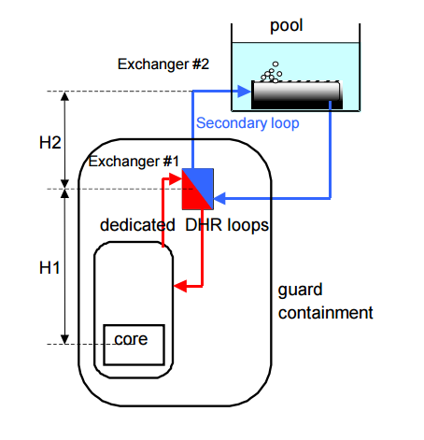

Figure X.6. Example of Dedicated Natural Convection Decay Heat Removal Loop.

Conclusion:

The in-core geometry is governed by neutronic and thermal-hydraulic considerations. A high fuel to coolant ratio is necessary for this helium cooled fast reactor. A geometry that meets the material, neutronic, and power cycle criteria was found with an analytical model and observed further with CFD analysis. The final geometry can is described by the following parameters:

* Bulk Fluid Temperature In: 850 K
* Bulk Fluid Temperature Out: 1150 K
* Cladding Thickness: 1.1 mm
* Pressure: 15 MPa
* Fuel Thickness: 1 cm
* Channel Thickness: 3.5 mm
* Inlet Velocity 70 m/s
* Fuel to Coolant Ratio: ~2.8
* Average Fuel Power: 100 W/cm3
* Hot Channel Fuel Power: 200 W/cm3
* Thermal Power: 623 MW
* Pressure Drop: ~700 kPa
* Wall Rib Diameter: 0.5 mm
* Wall Rib Spacing: 5 mm

The design has an exceptionally flat temperature profile, and exceptionally even exit temperature distribution, which reduces material stressed in the system, and reduced temperature driven complications e.g. thermal striping. The design is conducive to natural convection and with further analysis could be shown to have much desired passive safety features. The pressure drop is higher than desirable, but within a reasonable amount. This could be reduced with further analysis into wall ribs.

**Design Basis Accident – Landon Brockmeyer**

A common design basis accident is a loss of coolant accident. In the case of this reactor, a possible worst case scenario would be loss of coolant, loss of onsite power, and loss of pressure accident, which could conceivably all happen at once. In this case the natural convection passive cooling system would not suffice. With a loss in pressure the helium decreases in density by an order of magnitude. If the helium inventory completely escapes, then air would be the coolant with even worse natural convection capabilities. While such an analysis couldn’t be conducted for this report, a natural convection analysis of this reactor for common air could be conducted for a variety of heat fluxes to determine at what point natural convection of air could cool the reactor after shut down. The natural convection loop should be designed such that such cooling would be sufficient in under 3 days. A redundant set of battery powered fans can be expected to provide forced convection for up to 76 hours. Such fans add relatively little to the reactor cost, and are easily tested, and are extremely resistant to failure due to their simplicity. Depending on the height of the natural convection chimney necessary, this loop could add from a relatively low cost, to a high cost due to an increase in containment vessel size. This reactor design is much more resilient to such an accident than existing reactors which in all cases rely on expensive, and more prone to failure diesel generators. For most accidents no active intervention is necessary as passive cooling can suffice. Only in worst case scenarios would the active cooling system be necessary, and even then it is much simpler and more reliable than existing systems.

**Thermodynamic analysis**

From its outlet, this reactor generates a very high temperature heat of approximately 1150 K (876C). This output heat could be useful for generating electricity and could be used in other applications if treated appropriately, which is the goal of most current nuclear power plants (NPP) and their designs. This nuclear power plant will not just generate electricity; it will use the heat it produces in industrial applications, such as the generation of hydrogen or in desalination.

This section will cover the design and analysis of the energy cycles with regard to their safety and security. Because this reactor will be marketed internationally, and different customers have their own individual needs, two main versions of the energy cycle were designed and analyzed and each version includes two sub-versions. We aim to create a flexible design that suits a variety of customers. The main goals of the power cycle’s design is to have net plant efficiency at 50%, to use the NPP for industrial applications, and be an inherently safe and secure NPP.

**Version 1:**

Version 1 has three main loops. The primary loop is a direct Brayton cycle where the reactor is the heat source. The second loop is the Rankine cycle that is connected to the primary loop by a heat exchanger. The third loop is where the industrial application lies. It will be connected by a heat exchanger from the primary loop. The type of industrial application will determine its location in the primary loop, since some need very high temperatures to operate while others do not.

The fluid (helium) moves from the output of the reactor at a very high temperature to the gas turbine to generate the electricity. Then, the low-temperature and low-pressure flow enters a recuperator, which is a specific gas heat exchanger that is used to recover the heat from the gas turbine in order for it to be used again. Afterwards, it enters another type of heat exchanger, which is an evaporator, and then it goes to a compressor. From the compressor, the fluid (which now has a high pressure) enters the inlet of the reactor. From the evaporator heat exchanger, water is a type of flow that can be boiled to generate steam. The steam enters a generator to generate electricity. Then, a condenser that is connected to a cooling power condenses the steam into water. A pump then sends the recovered water back to the evaporator again.

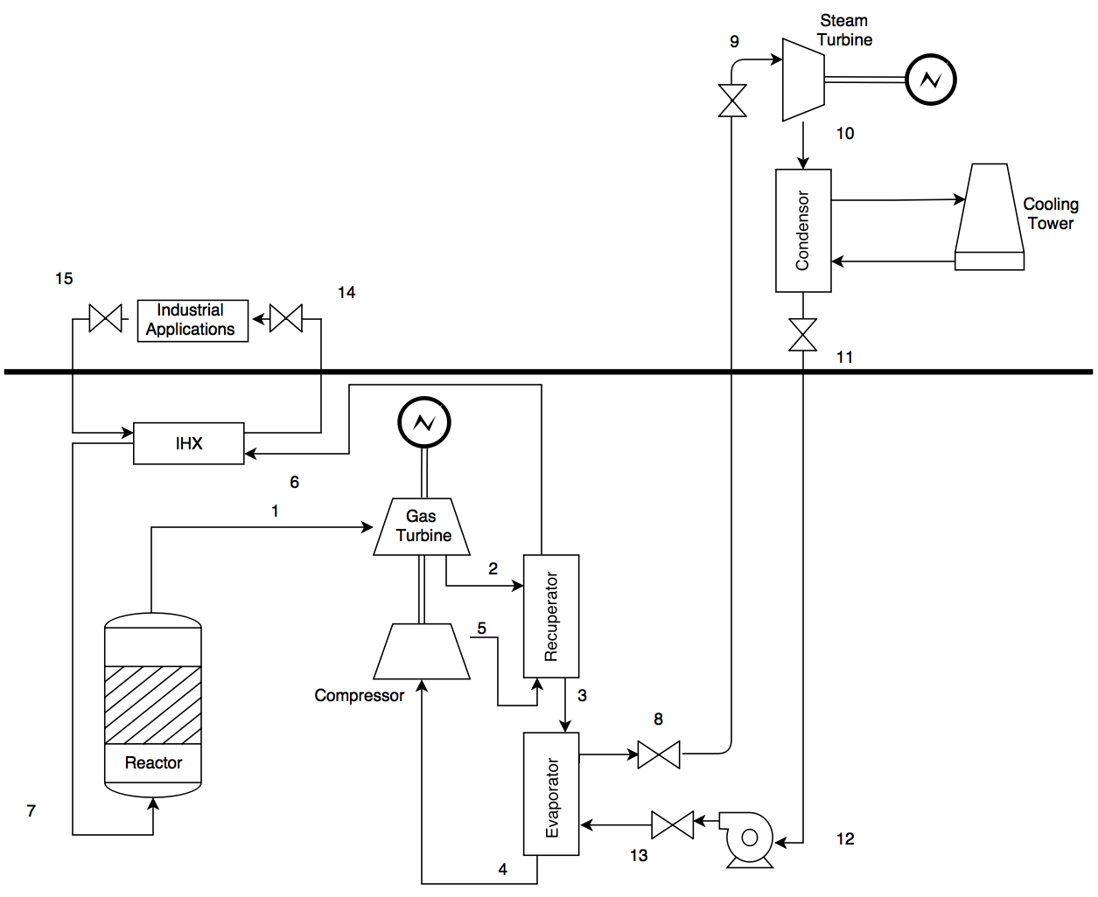

**Figure #.1: Version 1 of the power cycle, where the bold line is the limit of the ground**

**Safety**

It is crucial to operate a nuclear power plant with an inherent safety design. In this case, this was achieved by taking multiple safety features into account, such as:

* Reduction of the radioactive loops as much as possible

Loops 2 and 3 are non-radioactive loops. They are connected to heat exchangers, so the fluid is a non-radioactive flow. This will reduce the potential for causing injury to workers who accidentally touch the flow while doing maintenance or repairing the pipes. Loop 1 will also be a non-radioactive loop since helium is a noble gas and does not become radioactive. However in the interests of safety, loop 1 will be considered a radioactive loop. The worker in the first loop will have to wear special clothes to prevent him or her from making contact with any radioactive materials by mistake.

* Maintenance and accidents

For the maintenance of loops 2 and 3, or in the case that a pipe is broken or leaking, valves are located at each output and input of the heat exchangers and can be closed either manually or automatically from the control room while the reactor and the primary loop continue to operate. This will prevent shutting the reactor down unnecessarily. In this version, any accident or major maintenance of the primary loop requires the reactor to be shut down first. However, this will be further clarified in version 2.

By installing the reactor’s core underground, any major accidents will be less dangerous for the public than they would be if it were installed aboveground since radioactive material has difficulty on ground.

* The locations of each loop

Since the reactor is designed to be underground, the primary loop will be underground as well. However, the second and third loops will be aboveground. If the power plant runs into a major accident and the workers need to evacuate the facility, it will be easy for the aboveground workers to exit as quickly as possible. Since there will be relatively few underground workers, their evacuation will also be quicker than it would be if all the workers were located underground.

**Security and safeguards**

* The locations of each loop

Access to the primary loop, which contains the reactor, will be limited to the people that are either working on the reactor or the gas turbine, and may include some workers from the second loop. As parts of the second loop are located underground, partial access will be given to steam turbine maintenance workers. The industrial application will be aboveground and its workers will not have any access to the underground loops. By limiting the workers’ access to the underground portions, the reactor will be more secure and the number of people who are able to enter the underground sections will be limited and widely known. From the perspective of preventing terrorism, placing the reactor underground and limiting access to it will also limit potential threats to the facility. Moreover, the aboveground systems will be surrounded by materials that can protect them from explosions or airplane crashes in the style of the 9/11 attacks.

* Detectors

Detectors will be installed at each access point to the underground areas with an automatic door lock. If any materials were to be stolen, the doors would be locked and alarms would be activated.

* Cameras

A security camera system will be installed in most parts of the loops, both underground and aboveground.

**Calculations**

For this design, only version 1 was analyzed and all of its parameters were calculated. Each loop was separately analyzed and calculated and then they were combined.

*Brayton cycle:*

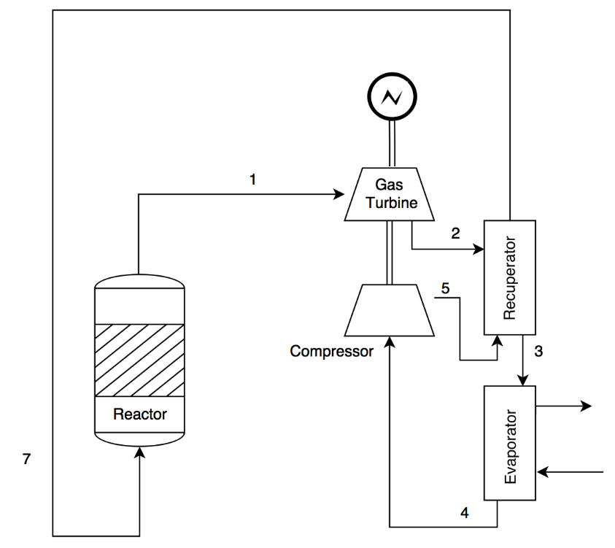

**Figure #.2: The Brayton cycle**

The following parameters are given from the thermohydraulic team:

|  |  |
| --- | --- |
| Parameters (Unit) | Value |
| Reactor outlet temperature (K) | 1150 |
| Reactor inlet temperature (K) | 823 |
| Mass flow rate (Kg/sec) | 424 |
| Outlet pressure (MPa) | 15 |
| Reactor power (MW) | 623.4 |

**Table #.1: The parameters from the thermohydraulic team**

Also, the goal is to have a net plant efficiency at 50%. For this cycle, the goal efficiency was set as a 35% while the remaining 15% will be from the steam cycle. The following equations were studied to generate a Matlab code to calculate all the other parameters.

Where is the pressure or compression ratio of the cycle.

Where is the Brayton nuclear plant thermodynamic efficiency, is the work at the turbine and is the work at the compressor, is the heat from the reactor and,

Also the work at the turbine ( or at the compressor) can be defined as,

And,

Moreover, an efficiency of the gas turbine and the compressor were assumed to be approximately 90%.

After run the code, this table will summarize the main parameters in the gas cycle.

|  |  |
| --- | --- |
| Parameters (Unit) | Value |
| Reactor outlet temperature (C) | 877 |
| Reactor inlet temperature (C) | 550 |
| Gas turbine inlet temperature (C) | 877 |
| Gas turbine outlet temperature (C) | 474 |
| Compressor turbine inlet temperature (C) | 246 |
| Compressor turbine outlet temperature (C) | 550 |
| Gas turbine inlet pressure (MPa) | 15 |
| Gas turbine outlet pressure (MPa) | 5.1 |
| Turbine and compressor efficacy (%) | 90 |
| Net cycle efficiency (%) | 35 |
| Electrical output (%) | 205 |

**Table #.2: Summary of the main parameters in the gas cycle**

The temperature-entropy plot of this cycle is:

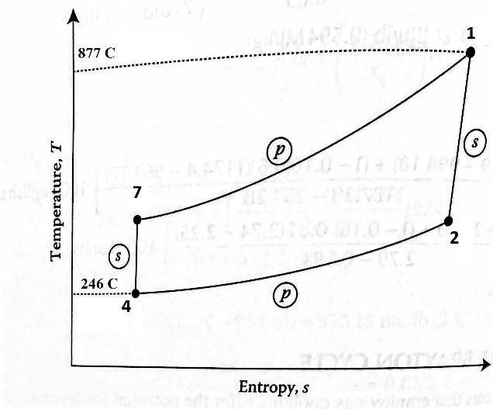

**Figure #.3: Temperature-entropy plot for the gas cycle**

*Rankine cycle:*

This is a cycle that converts the heat from the steam fluid to generate electricity.

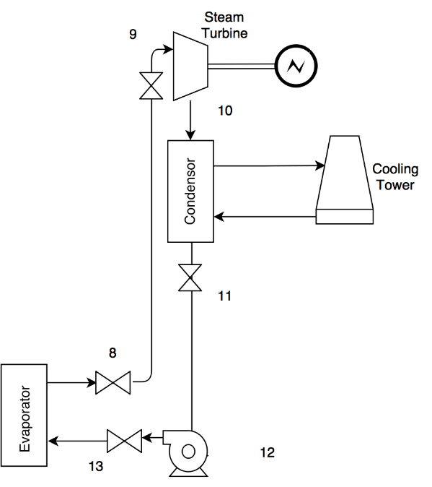

**Figure #.4: The Rankine cycle**

The inlet temperature to the steam generator from the evaporator is 340C (613K). Two major assumptions are that the mass flow rate is 155kg/sec and the pressure is 7.7 MPa. Also, the pumping work is negligible. The following equations are used to determine the other parameters, taking into account a 15% of the thermal power, 600MW, is needed to generate the electricity from this cycle.

Where h9 is enthalpy at inlet temperature and pressure of the steam turbine. Its unit is kJ/kg.

Also, the thermal efficiency of the Rankine cycle is,

The following table illustrates all the parameters in the steam cycle.

|  |  |
| --- | --- |
| Parameters (Unit) | Value |
| Steam turbine inlet temperature (C) | 340 |
| Steam turbine outlet temperature (C) | 46 |
| Pumping outlet temperature (C) | 48 |
| Mass flow rate (Kg/sec) | 155 |
| Steam turbine/evaporator efficiency (%) | 90 |
| Net power efficiency (%) | 15 |
| Net power (MW) | 89.043 |

**Table #.3: Summary of the main parameters in the steam cycle**

The Rankine S-T plot is shown in,

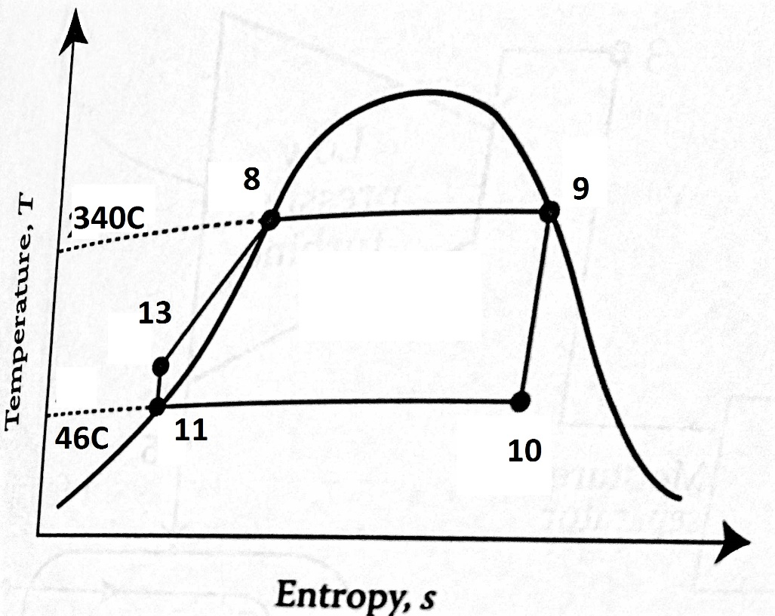

**Figure #.5: Temperature-entropy plot for the steam cycle**

*Industrial applications*

There are many applications that can be adopted by this nuclear power plant, such as the production of hydrogen or desalination. Each application needs a specific type of heat and there are two main places in the cycle at which we can install it. If the application needs a very high temperature, a heat exchanger will be placed directly after the output of the reactor, and if the application needs a high temperature, but not too high, the heat exchanger could be placed before the inlet of the core. The type of the industrial application will depend on the customer’s needs.

**Version 2**

Version 2 of the power cycle is a closed cycle. All the gas and steam turbines and industrial applications are connected to the primary loop with separate heat exchangers.

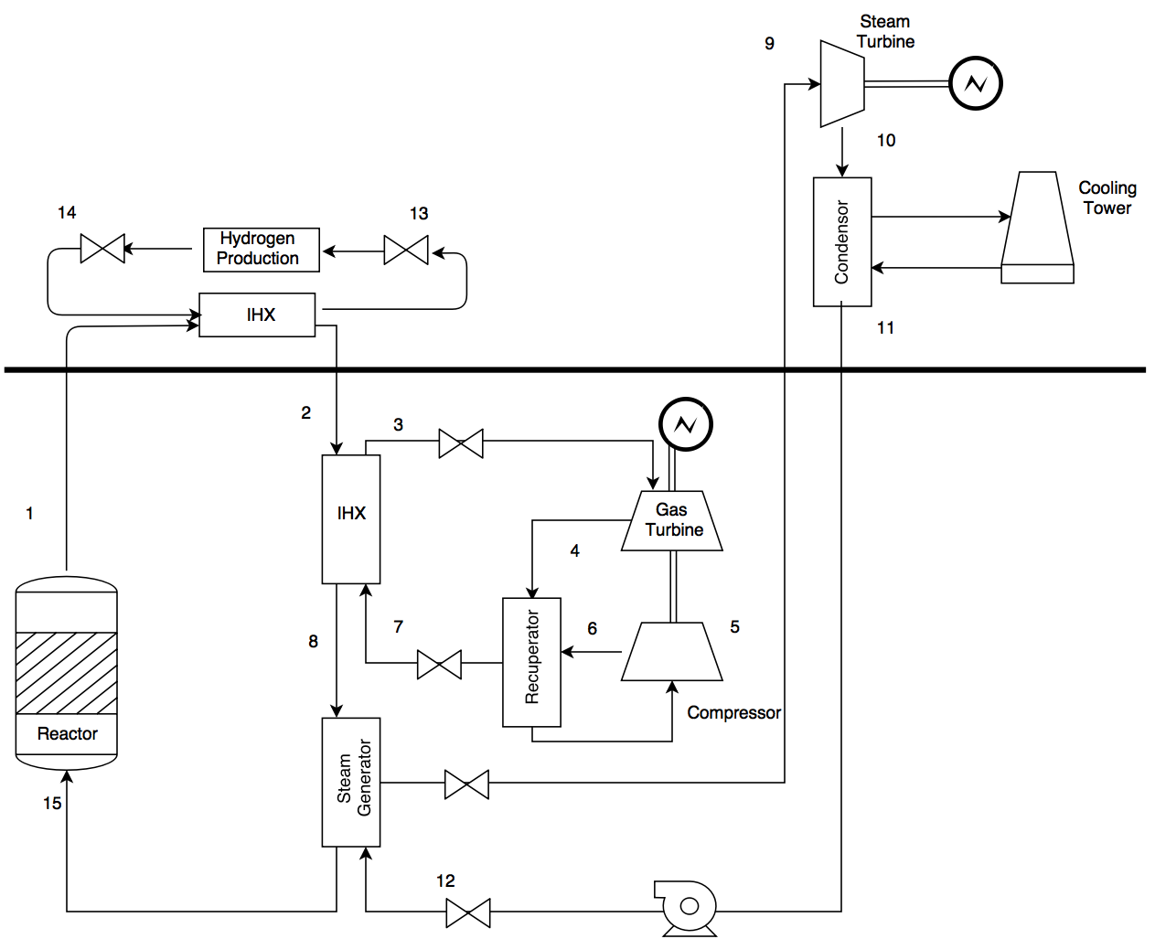

**Figure #.6: Version 2 of the power cycle**

This version has many features. From a safety perspective, the heat exchangers with valves make it easy for the maintenance workers to repair each part of the cycle without necessitating a shutdown of the reactor. Consequently, the reactor will not be affected by damage to the pipes. All the loops, except the primary loop, will be considered non-radioactive.

This version requires further investigation. For example, calculations, such as pressure drops and the temperatures for both the gas and steam cycles need to be defined and carried out. Furthermore, if all the cycles are closed, a cooler needs to be installed before the flow inlet to the reactor. What will happen if the gas turbine, for instance, is closed to the steam turbine? Would we need to install a cooler if the gas turbine shuts down? Both of these questions should be answered and analyzed in future studies.

**Economics Analysis – Daniel Holladay**

A necessary condition for commercial power reactors to operate is that they must be economically viable. There are several metrics used to determine economic viability and one of the most common is the levelized unit energy cost (LUEC). The LUEC, typically reported in units of $/MWh is a way to compare the lifetime costs of an energy system for multiple energy sources. For a commercial system, there 2 approaches to estimating the LUEC, the first of which is called bottom-up. This is a very detailed analysis that looks at the costs of every individual component, operation, repair, personnel, etc and adds all of the contributions up to taking into account the time value of money (TVM) to arrive at the LUEC. The benefit of this analysis is that it is very accurate and detailed. The other approach is called a top down approach. Rather than summing contributions, this analysis looks at similar systems and scales the costs by thermal power as shown in equation (#.1)

 (#.1)

This model requires 3 parameters for each of the different cost categories. This approach requires far less knowledge of details about a specific system and can still estimate the cost with some accuracy. Given the current design status of our reactor system and the number of likely changes between now and the final design, a bottom up approach would be intractable and also subject to several changes. At this stage, using the less accurate, but much simpler top down approach is much more appropriate especially given the number of people on our team. The top down analysis has the accuracy necessary to determine if this system is worth the additional investigation and research that would be required to complete a more detailed economic analysis.

The analysis was conducted using the G4-ECONS software package developed by Oak Ridge National Laboratory (ORNL) for economic analysis of fourth generation reactors (ref). This software is meant to give small design teams the tools necessary to carry out economic analyses without needing the resources and expertise required by more detailed analyses. The software itself comes in the form of a spreadsheet with multiple examples as well as strategy matrices that act as the inputs for both the reactor system as well as the potential for alternate uses of the heat such as desalination or hydrogen production. The spreadsheet came with 4 strategies both for verification/validation purposes as well as to show the user how the software works. One such example is the pebble bed modular reactor (PBMR) that operates at high temperatures for hydrogen production. I used many of their parameters initially, only replacing the fuel characteristics. However, the PBMR example had a much higher power and thus many of the capital and operations & maintenance (O&M) costs would be heavily overestimated. Since I could not find specific fit parameters for the model in equation (#.1), I chose to modify the scaling. I arrived at the following:

. (#.2)

I chose α=0.25 for my analyses, but this parameter can be easily changed and it will yield C0 if the thermal powers of the reactors are the same. The square root dependence has a higher average value on [0,1] than does linear, and many examples showed that many dependences on power were approximately square root (ref).

While we are able to accurately estimate the cost of much of our reactor system, the fuel costs required some rather crude assumptions due to limited capabilities of the software. The software assumes uniform enrichment for the first batch of fuel. Our design has the depleted fuel as well as the LEU fuel. The cost of the depleted fuel will likely be heavily overestimated due to the fact that we can use the tails that are produced as a byproduct of uranium enrichment. Nominally, we used a core averaged enrichment of 2.92%. Since this approximation is likely to be incorrect, figure #.1 shows the LUEC as a function of averaged enrichment.

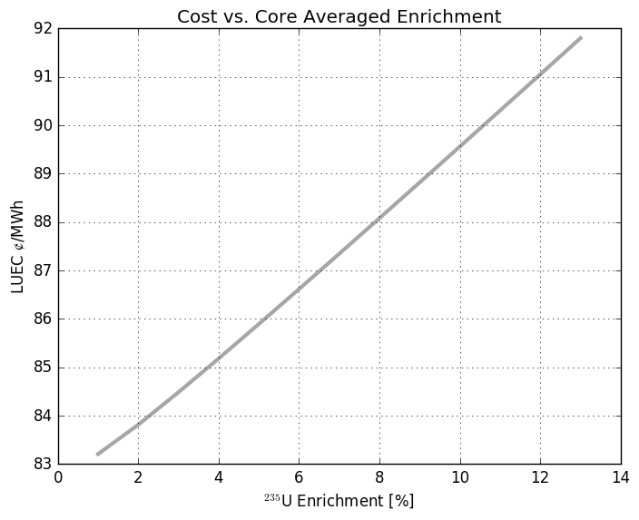

Figure #.1: LUEC ranges from 83-92 $/MWh over the range of fuel enrichments from 1% to 13% (the enrichment of the LEU fuel assemblies)

While some sophistication exists in the spreadsheet to determine fuel cycle costs, a better estimate could be obtained using their fuel cycle tool. The fuel cycle costs are amortized assuming a fleet of 32 GWe is utilizing the fuel facilities. However, one of the many benefits of this software is this ability to rapidly calculate LUEC as a function of an input parameter. Due to a large number of changes to the fuel plate / coolant channel geometry, it also seemed a good idea to show how the LUEC changes with fuel mass per assembly as that value will likely change a number of times during the design phase, especially depending on the outcomes of natural convection analysis. Thus, figure #.2 shows said dependence.

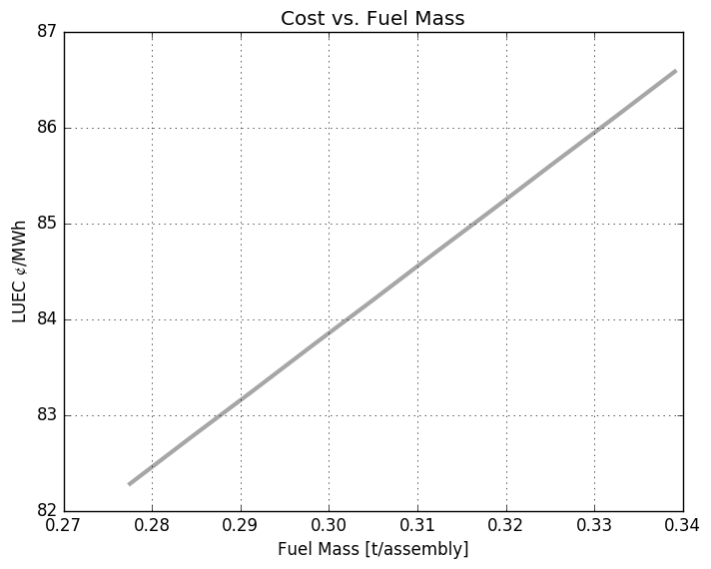

Figure #.2 LUEC ranges from 82-87 $/MWh over the span of relevant fuel masses.

While these analyses lack non-linear features that might actually exist, they provide a range of values for the LUEC as a function of the input parameters. However, results using nominal input parameters can be helpful in determining potential economic viability. While many of the approximations made in this analysis may be too egregious, this analysis is a useful litmus test for further investigation. If the results of the analysis yield a viable and highly economical design, it is likely that the reactor system in question is an excellent candidate for further investigation with more with more detail and rigor. The results are shown in tables #.1-#.2 below.

Table #.1: Breakdown of Costs

|  |  |
| --- | --- |
| Description | Value in mills/kwh or $/MWh |
| **Total LUEC** | **84.43** |
| Capital (Including Financing) | 69.03 |
| Operation | 13.57 |
| Fuel Cycle - Front End | 0.64 |
| Fuel Cycle - Back End | 1.01 |
| Fuel Cycle - Total | 1.65 |
| D&D Sinking Fund | 0.18 |

The results for the hydrogen production are presented likewise in table #.2

Table #.2: Hydrogen Production

|  |  |  |
| --- | --- | --- |
| **Capacity and Unit Cost in English Units:** |  |  |
|  |  |  |
| Capacity | 298.6 | Mft3 H2/day |
| Unit Cost | **1.68** | $/lb H2 |
| Unit heat cost from reactor in $/million BTUs | 12.37 | $/MBTU |

In a hydrogen economy, initial prices of hydrogen could be as high as $10/kg, making our production costs viable but with a fairly tight margin. The comparison of the overall LUEC again shows promise, but not by a significant margin, table #.3 compares LUEC for several different sources of energy

Table #.3: Energy Costs By Source (ref)

|  |  |  |  |  |  |  |  |
| --- | --- | --- | --- | --- | --- | --- | --- |
| Estimate in $/MWh | | Conventional coal | NG combined cycle | | Nuclear advanced | wind | |
| year | for year | conventional | advanced | onshore | offshore |
| 2010 | 2016 | 100.4 | 83.1 | 79.3 | 119 | 149.3 | 191.1 |
| 2011 | 2016 | 95.1 | 65.1 | 62.2 | 114 | 96.1 | 243.7 |
| 2012 | 2017 | 97.7 | 66.1 | 63.1 | 111.4 | 96 | N/A |
| 2013 | 2018 | 100.1 | 67.1 | 65.6 | 108.4 | 86.6 | 221.5 |
| 2014 | 2019 | 95.6 | 66.3 | 64.4 | 96.1 | 80.3 | 204.1 |
| 2015 | 2020 | 95.1 | 75.2 | 72.6 | **95.2** | 73.6 | 196.9 |

The economic analysis has used many crude approximations both due to limitations of the G4-ECONS software, but also due to lack of knowledge/expertise in reactor economics as well as uncertainties in system design. However, the analysis is detailed enough due to the sophistication of the software and scaling O&M and capital cost parameters from the PBMR that the results have some use. It is our belief that this reactor design and perturbations thereof could be investigated further with more detailed analyses to more accurately determine viability, but from the current information, this design definitely has the potential to be economically feasible.