**Economics Analysis – Daniel Holladay**

A necessary condition for commercial power reactors to operate is that they must be economically viable. There are several metrics used to determine economic viability and one of the most common is the levelized unit energy cost (LUEC). The LUEC, typically reported in units of $/MWh is a way to compare the lifetime costs of an energy system for multiple energy sources. For a commercial system, there 2 approaches to estimating the LUEC, the first of which is called bottom-up. This is a very detailed analysis that looks at the costs of every individual component, operation, repair, personnel, etc and adds all of the contributions up to taking into account the time value of money (TVM) to arrive at the LUEC. The benefit of this analysis is that it is very accurate and detailed. The other approach is called a top down approach. Rather than summing contributions, this analysis looks at similar systems and scales the costs by thermal power as shown in equation (#.1)

 (#.1)

This model requires 3 parameters for each of the different cost categories. This approach requires far less knowledge of details about a specific system and can still estimate the cost with some accuracy. Given the current design status of our reactor system and the number of likely changes between now and the final design, a bottom up approach would be intractable and also subject to several changes. At this stage, using the less accurate, but much simpler top down approach is much more appropriate especially given the number of people on our team. The top down analysis has the accuracy necessary to determine if this system is worth the additional investigation and research that would be required to complete a more detailed economic analysis.

The analysis was conducted using the G4-ECONS software package developed by Oak Ridge National Laboratory (ORNL) for economic analysis of fourth generation reactors (ref). This software is meant to give small design teams the tools necessary to carry out economic analyses without needing the resources and expertise required by more detailed analyses. The software itself comes in the form of a spreadsheet with multiple examples as well as strategy matrices that act as the inputs for both the reactor system as well as the potential for alternate uses of the heat such as desalination or hydrogen production. The spreadsheet came with 4 strategies both for verification/validation purposes as well as to show the user how the software works. One such example is the pebble bed modular reactor (PBMR) that operates at high temperatures for hydrogen production. I used many of their parameters initially, only replacing the fuel characteristics. However, the PBMR example had a much higher power and thus many of the capital and operations & maintenance (O&M) costs would be heavily overestimated. Since I could not find specific fit parameters for the model in equation (#.1), I chose to modify the scaling. I arrived at the following:

. (#.2)

I chose α=0.25 for my analyses, but this parameter can be easily changed and it will yield C0 if the thermal powers of the reactors are the same. The square root dependence has a higher average value on [0,1] than does linear, and many examples showed that many dependences on power were approximately square root (ref).

While we are able to accurately estimate the cost of much of our reactor system, the fuel costs required some rather crude assumptions due to limited capabilities of the software. The software assumes uniform enrichment for the first batch of fuel. Our design has the depleted fuel as well as the LEU fuel. The cost of the depleted fuel will likely be heavily overestimated due to the fact that we can use the tails that are produced as a byproduct of uranium enrichment. Nominally, we used a core averaged enrichment of 2.92%. Since this approximation is likely to be incorrect, figure #.1 shows the LUEC as a function of averaged enrichment.

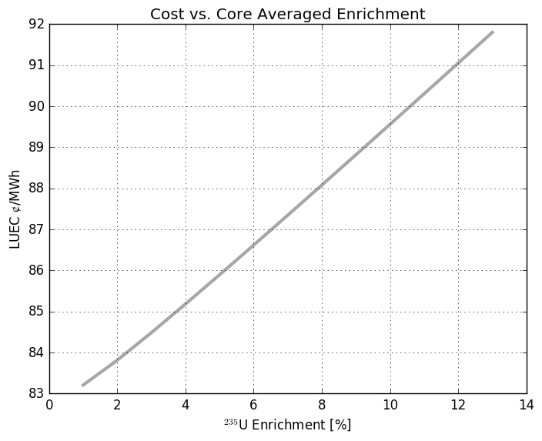

Figure #.1: LUEC ranges from 83-92 $/MWh over the range of fuel enrichments from 1% to 13% (the enrichment of the LEU fuel assemblies)

While some sophistication exists in the spreadsheet to determine fuel cycle costs, a better estimate could be obtained using their fuel cycle tool. The fuel cycle costs are amortized assuming a fleet of 32 GWe is utilizing the fuel facilities. However, one of the many benefits of this software is this ability to rapidly calculate LUEC as a function of an input parameter. Due to a large number of changes to the fuel plate / coolant channel geometry, it also seemed a good idea to show how the LUEC changes with fuel mass per assembly as that value will likely change a number of times during the design phase, especially depending on the outcomes of natural convection analysis. Thus, figure #.2 shows said dependence.

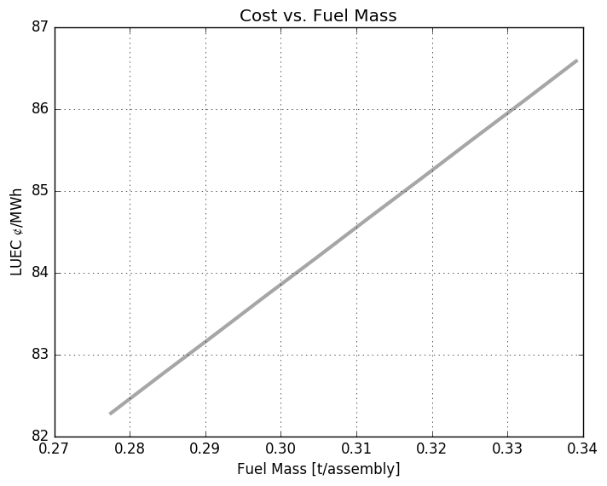

Figure #.2 LUEC ranges from 82-87 $/MWh over the span of relevant fuel masses.

While these analyses lack non-linear features that might actually exist, they provide a range of values for the LUEC as a function of the input parameters. However, results using nominal input parameters can be helpful in determining potential economic viability. While many of the approximations made in this analysis may be too egregious, this analysis is a useful litmus test for further investigation. If the results of the analysis yield a viable and highly economical design, it is likely that the reactor system in question is an excellent candidate for further investigation with more with more detail and rigor. The results are shown in tables #.1-#.2 below.

Table #.1: Breakdown of Costs

|  |  |
| --- | --- |
| Description | Value in mills/kwh or $/MWh |
| **Total LUEC** | **84.43** |
| Capital (Including Financing) | 69.03 |
| Operation | 13.57 |
| Fuel Cycle - Front End | 0.64 |
| Fuel Cycle - Back End | 1.01 |
| Fuel Cycle - Total | 1.65 |
| D&D Sinking Fund | 0.18 |

The results for the hydrogen production are presented likewise in table #.2

Table #.2: Hydrogen Production

|  |  |  |
| --- | --- | --- |
| **Capacity and Unit Cost in English Units:** |  |  |
|  |  |  |
| Capacity | 298.6 | Mft3 H2/day |
| Unit Cost | **1.68** | $/lb H2 |
| Unit heat cost from reactor in $/million BTUs | 12.37 | $/MBTU |

In a hydrogen economy, initial prices of hydrogen could be as high as $10/kg, making our production costs viable but with a fairly tight margin. The comparison of the overall LUEC again shows promise, but not by a significant margin, table #.3 compares LUEC for several different sources of energy

Table #.3: Energy Costs By Source (ref)

|  |  |  |  |  |  |  |  |
| --- | --- | --- | --- | --- | --- | --- | --- |
| Estimate in $/MWh | | Conventional coal | NG combined cycle | | Nuclear advanced | wind | |
| year | for year | conventional | advanced | onshore | offshore |
| 2010 | 2016 | 100.4 | 83.1 | 79.3 | 119 | 149.3 | 191.1 |
| 2011 | 2016 | 95.1 | 65.1 | 62.2 | 114 | 96.1 | 243.7 |
| 2012 | 2017 | 97.7 | 66.1 | 63.1 | 111.4 | 96 | N/A |
| 2013 | 2018 | 100.1 | 67.1 | 65.6 | 108.4 | 86.6 | 221.5 |
| 2014 | 2019 | 95.6 | 66.3 | 64.4 | 96.1 | 80.3 | 204.1 |
| 2015 | 2020 | 95.1 | 75.2 | 72.6 | **95.2** | 73.6 | 196.9 |

The economic analysis has used many crude approximations both due to limitations of the G4-ECONS software, but also due to lack of knowledge/expertise in reactor economics as well as uncertainties in system design. However, the analysis is detailed enough due to the sophistication of the software and scaling O&M and capital cost parameters from the PBMR that the results have some use. It is our belief that this reactor design and perturbations thereof could be investigated further with more detailed analyses to more accurately determine viability, but from the current information, this design definitely has the potential to be economically feasible.