POPD2 Assignment

Week 1: Research DOT Framework Part 2

Lecturer: Wolf-Guis, Corrie C.P.

**Group 34**

Dholon Akter | Nr. 3047040

Chanelle Hart | Nr. 3323781

Talia Santos | Nr. 3294579

Thanh Hoàng | Nr. 3353362

|  |  |  |  |  |
| --- | --- | --- | --- | --- |
| **Task name** | **Strategy** | **Data**  **/Inspiration** | **Time Planned (hours)** | **Time Spent**  **(hours)** |
| Interview with the client | Field | Data | 4 | 4 |
| Discuss current situation, problems and software solutions | Field | Inspiration | 3 | 4 |
| Research website and application designs similar to ours | Library | Inspiration | 6 | 8+ |
| Research possible database apps, such as Oracle or MySQL, to be used for the website/apps | Library | Data | 3 | 3 |
| Discuss with client the details in the project plan | Field | Data | 2 | 4 |
| Discuss with mentor if the project plan is missing details | Field | Data | 3 | 5 |
| Finalize project plan | *No research required* | | | |
| Task analysis to determine how to split labor | Filed | Data | 2 | 2 |
| Learn to use third-party library: Bootstrap 4.0 | Library | Data | 2 | 4 |
| Design and compare wireframes and design, making changes along the way | Workshop | Inspiration | 10 | 11 |
| Implement different website designs styles to see which one fits our vision | Workshop | Inspiration | 18 | 20+ |
| Create website, database, and apps | *No research required* | | | |
| Test the static website | Lab | Data | 15 | 10+ |
| Test the database design | Lab | Data | 3 | *N/A* |
| Test applications’ functionality | Lab | Data | 4 | *N/A* |
| Put everything together. See if it works | Lab | Data | 3 | *N/A* |
| Find methods on how to present the products | Library | Inspiration | 8 | *N/A* |
| Display product to client and wait for feedback | Showroom | Data | 1 | 1+ |
| Receive feedback from client on the user manual | Showroom | Data | 1 | *N/A* |
| Create test report | *No research required* | | | |
| Make necessary changes | *No research required* | | | |
| Present the final product | *No research required* | | | |
| Present the manual | *No research required* | | | |
| **Total** | | | **88** | **77+** |

Image of Activity 4

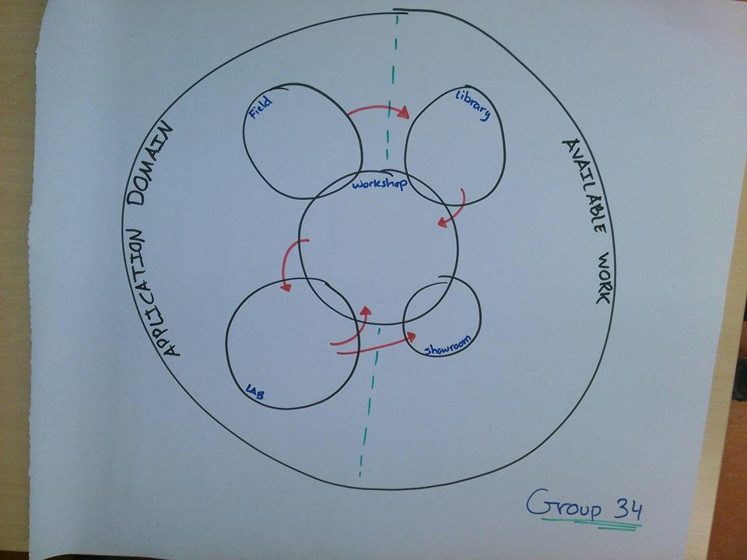

How can the plan be improved by using other/more strategies?

Feedback:

* In the table: data or inspiration; not both
* Research website and application designs similar to ours - inspiration
* Research possible databases to be used - can be better formulated: database structure?
* Design wireframes and design - data
* Display product to the client and wait for feedback - showroom
* Design database - same as before
* Design C# - same
* Display database, app - showroom
* Demonstrate solution to client - data + inspiration (leaning on data)
* Test report + manual - workshop. test report -> test plan
* Final presentation - neither. if anything, data
* The picture - arrows can go back and forth from fields

Changes were made after this feedback.