

PROJECT PLAN

Larp event

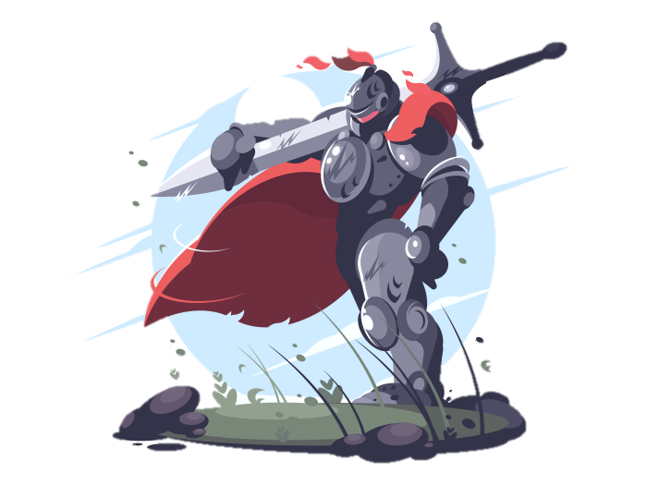

Version 1.0

**Dholon Akter | Nr. 3047040**

**Chanelle Hart | Nr. 3323781**

**Talia Santos | Nr. 3294579**

**Thanh Hoàng | Nr. 3353362**

**GROUP 34**

Table of Contents

Project Statement 2

Formal Client 2

Project Leader 2

Current Situation 2

Problem description 2

Project goal 3

Project Deliverables and Non-Deliverables 3

Project Requirements Functional and Non-Functional 3

Project Constraints 4

Project Risks 4

Project Phasing 6

Phase 1: Initiation 6

Phase 2: Planning 7

Phase 3: Executing 7

Phase 4: Controlling 8

Phase 5: Closing 9

APPENDICES 10

# Project Statement

This chapter will contain all information regarding the client, the team and its respective member, as well as their roles within the team. A description about the current situation and the problem will be given. The goal of the project, the deliverables and non-deliverables, the constraints and the risks are also stated.

## Formal Client

A commercial company specialized in organizing events has approached our group because their events have started to attract more visitors. It has become impossible for them to manage these events without a proper software solution.

Contact information

**Name:**

**Phone:** 0612345678

**Email:**

## Project Leader

The team leader is Ms. Talia Santos, working together with the following group members: Chanelle Hart, Dholon Akter and Thanh Hoàng.

Contact information

Ms. Talia

**Name:** Talia Santos

**Phone:** 0699999999

**Email:** talia_ss@hotmail.com

## Current Situation

The client is interested in a software solution for an event. The event takes place on a big terrain with a lot of space for visitors/stages/tents, whatever the event requires. Part of this terrain is reserved for the camping ground, where visitors can stay for the night. The event is organized by a commercial company (CompanyNameHere), who want to make profit. Money can originate from: visitors purchasing tickets to enter the event, buying food, drinks, or souvenirs, and loaning products. Visitors have to place money on their account to pay. Because the event will last more than one day, people can rent a camping spot. Last but not least, banks will place ATM machines on the terrain, which allow visitors to deposit money on their account. These machines provide log files.

## Problem description

The organizing Company wants to ensure that the event will run smoothly. For this, they have requested our services to provide the following:

* A website that informs people about the event and allows reservation of tickets and camping spots;
* Application that check visitors in and out of the event and camping;
* Application that support the shops (food/drinks/souvenirs) and the loan stands;
* Application that allows the organization to get a clear status overview of the event
* A database supporting all the applications;
* An application that changes the balance of the visitors based on the ATM log files.

## Project goal

The goal of this project is to successfully develop the requested software solution.

## Project Deliverables and Non-Deliverables

In this project the deliverables are:

* Agenda's and minutes of every meeting
* A name (and a logo) for your group
* A project plan
* A setup document
* Website - wireframe
* Website (static part)
* A database design
* An application to be used at the entrance of the event
* An application to be used at the entrance of the camping
* An application to be used at the shops
* An application to be used at the stand, where you can loan materials
* An application to be used when a visitor leaves the event
* An application for the organization to inspect the status of the event
* An application to convert the information in the transaction-log-file to the database
* Website (fully functional)
* A presentation about the project
* A process report
* User Manual
* Milestones

In this project the non-deliverables are:

* Source-code.
* Internal research and information gathering.
* Agenda's and minutes of every meeting.

## Project Requirements Functional and Non-Functional

In this project the functional requirements are:

* Website should allow the reservation of tickets, camping spots and loaning material.
* One application should allow for check in and check out of visitors.
* One application gives the possibility to perform the purchase of goods, as well as on the spot loans of material.
* One application should handle visitors’ account balance by syncing information with the ATM’s log files.
* Applications should allow for gathering of the following information for the company to view:
  + Visitor status and Visitor history
  + Visitors present at the event
  + Total visitors
  + Total balance of all visitors together and total spent money
  + Camping statistics (booked and free spots)
  + Total money sold per shop
  + Total amount of a certain product sold

In this project the non-functional requirements are:

* Website should be responsive as to be compatible for mobile view and usage.
* Applications should be compatible with all mobile devices.
* Account balance application should be able to retrieve ATM log files.
* Extensibility of prospect features.
* Flexible design.
* Maintenance and updating of applications and website.
* Quality control.
* Database should support all applications

## Project Constraints

***Constraint 1: Time***

**The project must be completed within 6 months. (2 Blocks)**

***Constraint 2: Budget***

**The budget for this project is:**

* **A maximum of (amount).**

**Constraint 3: The website should run on the Iris server of FHICT**

**Constrain 4: Oracle database or a MySQL database**

**Constraint 5:** **Windows applications should be programmed in an object oriented language (e.g. C#)**

**Constraint 5:**

## Project Risks

**Risk 1: The computer used to do the plan, crashes.**

Probability: Very low.

Impact on project: High.

Steps to prevent: save the project in an output source upon any further progress.

Solution: On regular basis update a repository or other form of backup.

**Risk 2:**

Probability:

Impact on project:

Steps to prevent:

Clean up action:

**Risk 3:**

Probability:

Impact on project:

Steps to prevent:

Clean up action:

**Risk 4:**

Probability:

Impact on project:

Steps to prevent:

Clean up action:

**Risk 5: The user manual is not finished in time.**

Probability: Low.

Impact on project: Low.

Steps to prevent: Start writing a draft version after the first version of the software.

Clean up action: Use draft version of the user manual.

**Risk 6: Time, it might be possible that it isn’t finished on time.**

Probability: Very low.

Impact on project: High.

Steps to prevent: work division.

Solution: Divide tasks and put deadlines between the team’s members.

**Risk 7: Exceeding the budget of the project.**

Probability: Low.

Impact on project: High.

Steps to prevent: Keep a percentage of the budget (say 10%) off-limits unless strictly necessary.

Solution: Implement a budget plan and stick to it during the course of the project.

**Risk 8: Prolonged absence of a team member due to personal problems or illness (or death).**

Probability: High.

Impact on project: Low.

Solution: Hire someone else to fill in the role of the missing team member for the duration of their absence.

# Project Phasing

In this chapter we describe the phases of our project, with the activities and milestones. In the following figure we have a visual overview of the activities, their dependencies and the milestones are given.

Test

Build

Design

Initiation

Deploy

Final Deliverables

Start the project

**M5**

**M4**

**M3**

**M2**

**M1**

month1 month2 month3 month4 month5 month6

Figure 1. Activities and milestones.

## 

## Phase 1: Initiation

Initiation phase is where the project is started.

The following activities will take place:

* Interview client
* Discuss current situation, problems and desired end situation
* Set the project goal together with the client
* Agree on the deliverables and non-deliverables with client
* Organize the team
* Organize resources
* Kick off meeting

Estimated duration (time duration and work hours).

Deliverables for milestone **M1** are:

* Detailed work division amongst team members
* The Project plan

Go/no go meeting:

* Go – proceed with project and get first payment.
* No go – start over.

## Phase 2: Design

The design phase has two major activities: which are searching for information and then picking out useful information.

The following activities will take place:

* 1. Searching for information related to project.
  2. Discuss the selection of information available
  3. Research possible methods for documenting requirements
  4. Install required development software
  5. Make technical requirements
  6. Present possible solutions to the client
  7. Choose solution to implement

Estimated duration (time and work hours).

Deliverables for milestone **M2** are:

* Specified requirements (functional and technical)
* Specific information that is related to project
* Class diagram for the applications with descriptions of every class.

Go/no go meeting:

* Go – proceed with project and get second payment.
* No go – re-evaluate current requirements and if necessary start over.

## 

## Phase 3: Build

Build phase will involve working on the project and planning of the prototype design and its qualities.

The following activities will take place:

1. Determining key features of the applications
2. Discuss the functionalities of the applications
3. Implement logics
4. Runtime tests
5. Fix bugs
6. Update documentation

Estimated duration (time and work hours).

Deliverables for milestone **M3** are:

* Applications
* Website
* Database

Go/no go meeting:

* Go – proceed with project and get third payment.
* No go – re-evaluate current requirements and if necessary start over.

## Phase 4: Test

The testing phase has two activities: Test system and Write user manual.

Activity: Test system

Tasks for the activity are:

* Connect the database with the applications and website
* Conduct research regarding test methods and writing a test plan
* Make test plan
* Make test data with presence, practical submissions, and testing results
* Discuss test plan with client
* Execute test plan
* Document all succeeded tests, all failed tests and a list of improvements

Estimated duration (time and work hours).

The following activities will take place:

* Write user manual
* Conduct research regarding testing a manual by observing users
* Observe at least three users while using the manual with the system
* Improve user manual based on results

Estimated duration (time and work hours).

Deliverables for milestone **M4** are:

* Test report including all succeeded tests, all failed tests and a list of improvements.
* The user manual document.

Go/no go meeting:

* Go – proceed with project and get fourth payment.
* No go – re-evaluate current requirements and if necessary start over.

## Phase 5: Deploy

Finally, the deployment phase which contains the final project plan of the application delivered the company along with the other deliverables.

The following activities will take place:

Tasks for the activity are:

* The final version of the project plan
* Demonstration of prototypes
* Final product design adjustments

Estimated duration (time and work hours).

Deliverables for milestone **M5** are:

* Delivering final project plan to the client.
* Delivering the final product to the client
* Deliver user manual

Sign off of deliverables.

Final Acceptance.

Get fifth and final payment

# APPENDICES