

PROJECT PLAN

LARP EVENT



Version 1.3.1

Dholon Akter | Nr. 3047040

Chanelle Hart | Nr. 3323781

Talia Santos | Nr. 3294579

Thanh Hoàng | Nr. 3353362

GROUP 34

Table of Contents

Project Statement 4

Project Objectives 5

Project Constraints 6

Project Risks 7

Project Phasing 8

Project Management Approach 11

Appendices 13

# Project Statement

In this document, we will provide the current situation, the client’s proposed solution and goals, the project goals, the project approach, the constraints and risks, the phasing, the assumptions, the management approach, and the reference material in the appendices.

## The Client

Events International, a commercial company who specializes in organizing events, is organizing an event to make profit. Their representative for this project is André A. Postma. They requested the assistance of a group of 4 individuals from the Fontys Hogeschool ICT section to handle the software aspect of the event.

## The Team

The project leader of the group is Ms. Talia Santos. Her team consists of: Chanelle Hart, Dholon Akter, and Thanh Hoàng. They have enough experience to make a software solution for Event International.

## Current Situation

The event takes place on a big terrain with enough space for visitors, stages, tents, and other sections. Part of the terrain is reserved for the camping grounds, where visitors may stay for the night (Appendix A).

For profits, the funds will originate from visitors purchasing tickets to enter the event, buying food, drinks, or souvenirs, and loaning products, such as the costume booth, flashlights, cameras, etc.

Visitors will place the funds on their account in order to pay, and can rent a camping spot. Banks will place ATM machines on the terrain which allows visitors to deposit money on their account. These machines provide log files (Appendix B).

Because the events has started to attract more visitors, it has become impossible to manage them without a proper software solution. Thus, the client requests for a software solution for the event, and has given their suggestions (Appendix C).

### Additions:

The event will be a LARP event (Appendix D).

## Project Goal

The goal of this project is to develop the requested software solution.

# Project Objectives

## Deliverables

* Applications to be used at:
  + The entrance of the event
  + The entrance of the camping grounds
  + The shops
  + The loaning stands
* The application to be used to monitor visitors entering and leaving the event
* The application for the organization to inspect the status of the event
* The application to convert the information in the transaction-log-file to the database
* The fully functional website
* The database
* A presentation of the software solution
* The agenda’s and minutes of every meeting
* The process report
* The setup document

## Non-Deliverables

* The website wireframe
* The static website
* The database design

## Functional Requirements

* A website that informs people about the event and allows reservation of tickets and camping spots
* Applications that checks visitors in and out of the event and camping grounds
* Applications that support the shops and the loan stands
* An application that allows the organization to get a clear status overview of the event:
  + Visitors’ information (status, history, currently present/absent)
  + Statistics of finance, logistics, operations, and marketing
  + Camping bookings (locations that are reserved, opened, and occupied)
* A database supporting all the applications
* An application that changes and retrieves the balance of the visitors based on the ATM log files

## Non-Functional Requirements

* Responsive website that is compatible with mobiles, laptops, and tablets.
* Applications are compatible with all mobile devices
* Database supports all applications
* Maintenance and updates are available for the website, applications and database

# Project Constraints

### Project Funding

The client may not agree to the proposed budget for this project, which may reduce the expected quality of the project.

### Time Constraint

The project must be completed within 19 weeks (2 blocks).

### Application Constraint

Applications will be made for Windows devices.

### Website Constraint

Website will be created for Google Chrome, Microsoft Edge, and Safari.

### Knowledge Constraint

The software solution may require more knowledge than what was taught during the first year at Fontys.

### Critical Project Barriers

Should any of these were to come to effect, the project plan will cease; be discontinued.

* No project funds
* Natural disasters or acts of war

# Project Risks

### The computer, which is used to program applications, crashes

Probability: low  
Impact on project: high  
Steps to prevent risk: save the project on external device and/or upload to, for example, the git depository frequently.   
Clean up action: If unsaved, simply restart the task. Will increase workload per hour.

### Someone quits; leaves the project group

Probability: low  
Impact on project: medium  
Steps to prevent risk: motivate each other to accomplish the goal. Have social interaction during meetings.  
Clean up action: If someone leaves, work will be equally distributed to remaining members.

### Miscommunication

Probability: medium  
Impact on project: high  
Steps to prevent risk: have frequent meetings and make sure everyone gives their feedback. Feedback and discussions help to resolve misunderstandings.  
Clean up action: compare notes. Retrace steps and get back on track.

### Team’s lack of knowledge on the deliverables

Probability: low  
Impact on project: high  
Steps to prevent risk: stay on track with school work. Research what is not taught but is required in the software solution.  
Clean up action: Take time out to research the necessary knowledge required to complete the project goal.

### Deadlines are not met

Probability: low  
Impact on project: medium  
Steps to prevent: dedicate time to the project each week; roughly 4 to 8 hours.  
Clean up action: reschedule to be delivered within 48 hours, once approved.

### Budget estimates unrealistic

Probability: low  
Impact on project: low  
Steps to prevent: Include a financial statement in the project plan. Keep 10 to 15% margin of error on budget constraints.   
Clean up action: Create a more budget friendly financial statement.

# Project Phasing

In the following figure, we have an overview of the activities, their dependencies, the milestones and weeks required to complete each milestone.

[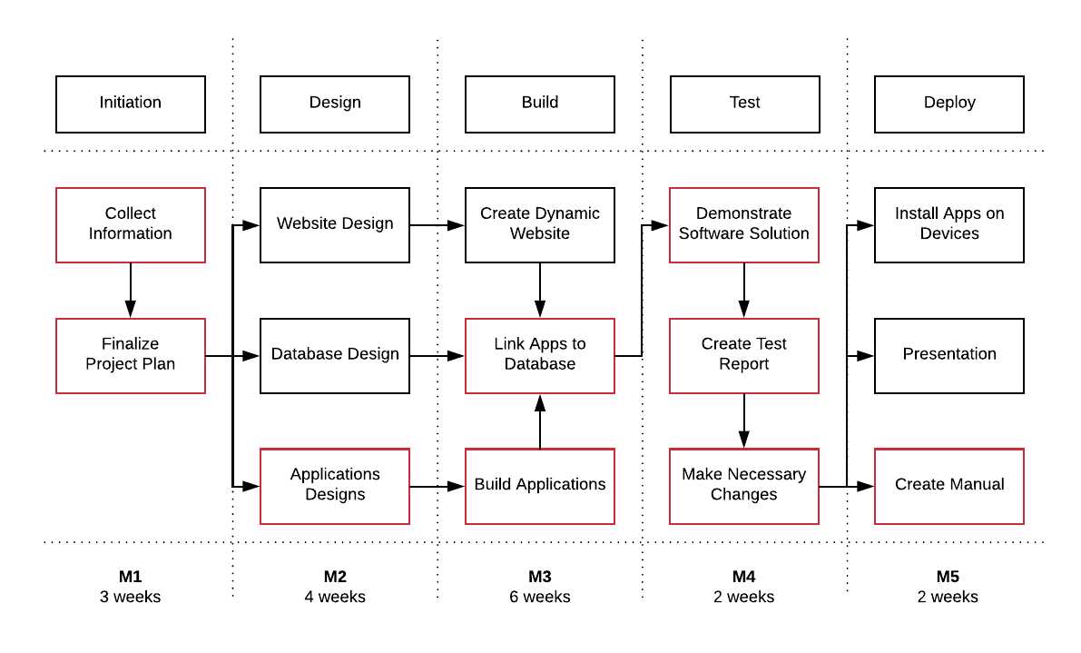](https://www.lucidchart.com/documents/edit/b2df1e6d-8d51-448a-a9af-082c58ca79c5/0?callback=close&name=docs&callback_type=back&v=1033&s=595.4399999999999)  
*Figure 1. Activities with Critical Path*

## Phase 1: Initiation

Activity: Collect Information

1. Interview client
2. Discuss current situation, problems, and software solution
3. Set the project goal together with the client
4. Organize tasks in the team
5. Arrange future meetings

Activity: Finalize Project Plan

1. Present final project plan to client
2. Wait for approval
3. Receive go or no go
4. Receive payment (grade)

Deliverables for milestone **M1**:

* Project plan

## Phase 2: Design

Activity: Website Design

1. Create wireframe
2. Ask client for comments
3. Create static website

Activity: Database Design

* Make the data model

Activity: Applications Designs

* Design the applications for:
  + The entrance of the event
  + The entrance of the camping grounds
  + The shops
  + The loaning stands
  + Monitoring visitors
  + Monitoring overall event
  + Receiving information from transaction-log-files to database

Deliverables for milestone **M2**:

* The process report
* The setup document (contains all designs)

## Phase 3: Build

Activity: Create Dynamic Website

* Add dynamics to static website

Activity: Build Applications

* Proceed with the step-by-step process of creating an application

Activity: Link Apps to Database

* Proceed with the step-by-step process of linking apps to database

Deliverables for milestone **M3**:

* Applications prototypes
* Database prototype
* Unofficial website release

## Phase 4: Test

Activity: Demonstrate Software Solution

1. Create presentation
2. Demonstrate the prototypes
3. Receive feedback

Activity: Create Test Report

1. Note down feedback
2. Create report
3. Give report to client

Activity: Make Necessary Changes

* Make the changes based on the test report

Deliverables for milestone **M4**:

* Test Report

## Phase 5: Deploy

Activity: Install Apps on Devices

* Optimize devices for compatibility (if necessary)

Activity: Presentation

1. Create presentation
2. Set date to present and make preparations
3. Present to client and company

Activity: Create Manual

1. Create manual for applications and database
2. Verify with client if manual is understandable to read
3. Deliver manual to client after making the necessary changes

Deliverables for milestone **M5**:

* All applications
* The database
* Fully functional website released
* Presentation of the software solution
* Manual

# Project Management Approach

## Roles and Responsibilities

|  |  |  |
| --- | --- | --- |
| **Role** | **Responsibilities** | **Participant(s)** |
| Project Sponsor | * Ultimate decision-maker * Provide project oversight and guidance * Review and approve some project elements | André A. Postma |
| Mentor | * Provides direction to Project Leader * Review project deliverables * Approves usage of ISSD equipment and makes suggestions | Gerald Hilderink |
| Project Leader | * Manages project in accordance to the project plan * Provide overall project direction * Direct and lead the team members toward project objectives * Handle problem resolution | Talia Santos |
| Project Secretary | * Maintain all records of the meetings * Sends emails on behalf of the Project Leader | Thanh Hoàng |
| Minute Taker | * Takes the minutes at every meeting * Provides the minutes to all participants | Chanelle Hart |
| Project Participants | * Understand the project goal and has the knowledge to carry out the project * Review and approve project deliverables * Provide knowledge and suggestions * Assure quality of products | Dholon Akter  Chanelle Hart  Thanh Hoàng  Talia Santos |
| Subject Matter Experts | * Lend expertise and guidance as needed | To be identified at a later date |

## Meeting Schedules

Meetings will take place weekly for the first 3 weeks, and then bi-weekly with everyone involved. Agendas will be distributed 24 hours before the meeting, and minutes will be distributed within 24 hours after the meeting took place.

Meetings that will take place with only the Project Team are yet to be decided.

|  |  |  |  |
| --- | --- | --- | --- |
| **Week** | **Date** | **Participants** | **Discussion Points** |
| **Block 1** | | | |
| Free | Mon 12th Feb 2017 | Team | 1. Discuss logo and event idea |
| 2 | Tue 20th Feb 2017 | Everyone | 1. Introduction 2. Present logo and event idea 3. Ask advice for first draft of project plan 4. Ask client questions |
| 3 | Tue 27th Feb 2017 | Everyone | 1. Present revised project plan 2. Final decision on ID type for event |
| 3 |  | Team |  |
| 4 | Tue 6th Mar 2017 | Everyone | 1. Finalize project plan 2. Present to client for approval |
| 4 |  | Team |  |
| 5 |  | Team |  |
| 6 |  | Team |  |
| 6 | Tue 20th Mar 2017 | Team and Mentor | 1. Update status: setup document 2. Ask mentor for advice |
| 7 |  | Team |  |
| 8 | Tue 3rd Apr 2017 | Everyone | 1. Finalize deliverable for block 1 2. Get feedback from client 3. Ask mentor for advice |
| 8 |  | Team |  |
| 9 |  | Team |  |
| 10 | Tue 17th Apr 2017 | Everyone | Present deliverables for block 1 |
| **Block 2** | | | |
| 11 |  | Team |  |
| 12 |  | Team |  |
| 13 | Tue 8th May 2017 | Everyone | 1. Present prototype of applications, website, and database 2. Receive feedback from client and mentor |
| 14 |  | Team |  |
| 15 |  | Team |  |
| 16 | Tue 29th May 2017 | Team and Mentor | 1. Present unofficial deliverables to mentor 2. Receive feedback |
| 16 |  | Team |  |
| 17 | Tue 5th Jun 2017 | Everyone | Final meeting for feedback |
| **Presentation** | | | |
| 18 |  | Team |  |
| 19 | Tue 19th Jun 2017 | Everyone | Present software solution |

## Methods of Communication

There will be a bi-weekly status report on how the project is going. This report will be emailed to the Project Sponsor and Mentor. The status report will entail:

* Summary of tasks completed between the last report and current report date.
* Summary of tasks and goals completed during the 2 weeks.
* Summary of issues that were encountered and resolved during the 2 weeks.
* Division of work among the Project Team

Everyone has access to the git folder: <https://git.fhict.nl/I390396/ProPGroup34>   
It’s the responsibility of everyone to check the git folder on a daily basis for updates.

There will be bi-weekly meetings (after 3 weeks of consecutive meetings). Every member of the Project Team will be invited to participate in the meeting. The Project Leader will send the status report to each member of the team before the meeting so everyone can review it in advance.

# Appendices

## Appendix A: Map of Camping Area

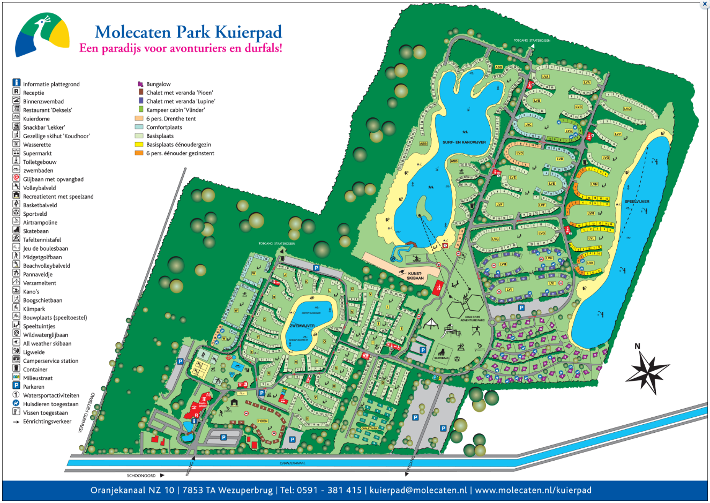

## Appendix B: ATM Log

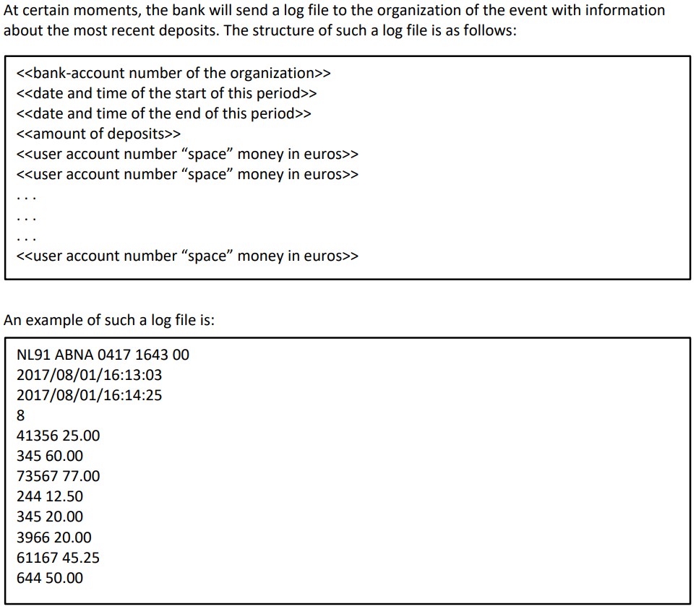

## Appendix C: Client’s Ideas

“We want a website that informs people about their event. It should allow people to reserve entrance tickets and camping spots. Once the event starts, we would like to be able to check if someone has purchased a ticket or not. Once it is clear that the person is indeed a visitor, he/she should be assigned some form of identification for inside the event.

At certain points, visitors could become hungry and/or thirsty, so there are stands that provide food and drinks. In order to pay with the event currency, the identification can be used to charge the costs on the visitor’s account.

Once it gets late, some visitors will want to sleep for the night, which is only possible if he/she reserved a camping spot. So the camping will be required to have its own check-in/check-out application.

Last, it should be possible for visitors to deposit money to their account in two ways: before the event through the website, and on the event, by ATM machines which a bank has provided.

You should be able to add the funds from the logs to the related visitor’s account. The logs are clarified in Appendix B: ATM Log. “

## Appendix D: LARP Definition - Wikipedia

“A live action role-playing game (LARP) is a form of role-playing game where the participants physically portray their characters. The players pursue goals within a fictional setting represented by the real world while interacting with each other in character.”   
< <https://en.wikipedia.org/wiki/Live_action_role-playing_game>>