

RESEARCH REPORT

LARP EVENT SOFTWARE SOLUTION



Version 1.5

GROUP 34

Dholon Akter | Nr. 3047040

Chanelle Hart | Nr. 3323781

Talia Santos | Nr. 3294579

Thanh Hoàng | Nr. 3353362

# Version History

|  |  |  |  |  |  |
| --- | --- | --- | --- | --- | --- |
| **Version #** | **Implemented By** | **Revision Date** | **Approved By** | **Approval Date** | **Reason** |
| 1.0 | C. Hart | 15th Mar | - | - | Layout of document  RFID/ID information |
| 1.5 | C. Hart | 16th Mar |  |  | Project financials |

Table of Contents

Version History 2

Overview 3

ID Methods 4

Retrieving Data Method 4

Physical ID Possibility 5

Final conclusion 7

Project Financials 8

# Overview

LARP Event Software Solution is currently working on a project for Events International. The project goal is to provide a software solution that will solve the issue given in the project plan. The software solution requires in-depth research in order for the project to have a go.

In this document, we will provide the research found in order to successfully carry out the project plan. This document will be mentioned in the Appendix for reference.

# ID Methods

The client requested our team on what is the most advisable ID method for the event. The suggestion that came about was to have either a card or a band as a physical ID. The method to retrieve data from the ID could be among: RFID, QR Code, and/or Barcode. Further research was made as follows:

## Retrieving Data Method

#### RFID

RFID (radio-frequency identification) uses electromagnetic fields to automatically identify and track tags attached to objects. The tags contain electronically stored information. There are two types of tags: passive and active. Passive tags collect energy from a nearby RFID reader’s interrogating radio waves. Active tags have a local power source and may operate hundreds of meters from the RFID reader. These are, however, more expensive and inefficient, as it will be bulky for the physical ID. Further details in the link below: <https://en.wikipedia.org/wiki/Radio-frequency_identification>

Tags can hold a substantial and reasonable amount of data, and can display the data when read by an RFID reader. Reading the tag does not require a direct line of sight, and the data can be transmitted when the tax passes a fixed reader.

However, RFID systems can be expensive, and they require special mobile or fixed computer readers to transmit or receive data. In order for an RFID system tot be implemented, the entire local environment must be analyzed, including anything from the types of metals, lighting, and sources of radio interference, since the data is transmitted via radio frequency. A site survey is necessary to identify all sources of potential interference or weakening of the signal and can cause major disruptions.

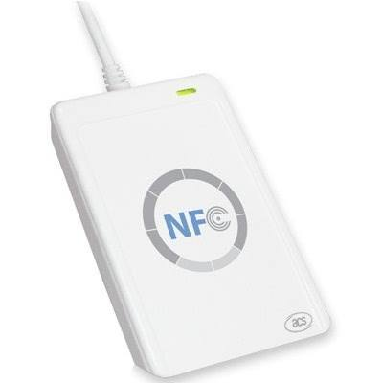An RFID’s price ranges between €30 and €1000 euros, depending on the features. One product we came across is the ACR122 NFC Contactless Mifare RFID that goes for €30 euros. For the event, it can be used for:

1. Access control – e.g. employee only zones
2. Electronic payments – e.g. stalls and ATMs
3. Network identification – receiving data
4. Logistics and inventory management e.g. receiving records.

This is an excellent device for the event at a very reasonable price, and is suitable in the given environment. Further details in the link below:   
<https://www.bypos.nl/acr122-nfc-contactless-m-i-f-a-r-e-acs-acr122u-rfid-bypos-1652?keyword=&utm_source=google&gclid=EAIaIQobChMIgcyCpcDu2QIVWl8ZCh3UCwQvEAkYASABEgL1w_D_BwE>

#### Barcode

A barcode is an optical, machine-readable, representation of data; the data that usually describes something about the object that carries the barcode. Traditional barcodes systematically represent data by varying the widths and spacing of parallel lines, and may be referred to as linear or one-dimensional (1D). The later versions of this is known as the QR code. More details in the following link: <https://en.wikipedia.org/wiki/Barcode>

Barcodes can only be scanned by special optical scanners called barcode readers, while QR may be scanned via mobile devices. Barcodes are more suitable for storing and/or retrieving small amounts of data. In all cases, a QR code is suggested.

#### QR Code

QR code (Quick Response Code) is the trademark for a type of matrix barcode, or a two-dimensional barcode. A QR code consists of black squares arranged in a square grid on a white background, which cab ne read by an imaging device such as a camera, and processed using ‘Reed-Solomon error correction’ until the image can be appropriately interpreted. The date is then extracted from the patterns that are present in both horizontal and vertical components of the image. Further details in the link below: <https://en.wikipedia.org/wiki/QR_code>

The QR code system is popular due to its fast readability and greater storage capacity compared to the standard barcodes. They can be scanned using most smartphones, allowing data to be stored and received from almost anywhere. The QR 2D tags are inexpensive (option to make them for free), and is simpler to set up in comparison to an RFID system.

However, QR codes lack the automation ability for proximity scanning like RFID, and a line of sight to the tag is necessary to scan the tag and input or extract data.

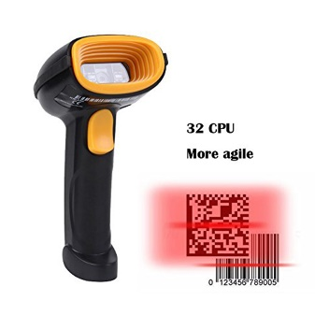QR code scanners ranges between €20 and €730 euros, all depends on the features. One suggestion we came across is the Kercan CCD Wired USB 2D/QR/PDF417/Data Matrix Barcode Scanner CCD Bar Code Reader KR-230, at the price of $25.99 USD (€21,06 EUR). It can read both QR and barcodes, so it’s suitable for the event. Further details in the link below: <https://nl.aliexpress.com/item/Kercan-CCD-Bedrade-USB-2D-QR-PDF417-Data-Matrix-Barcode-Scanner-CCD-Bar-Code-Reader-KR/32680554311.html?spm=a2g0z.10010108.1000023.6.41e72c47k8GsvQ>

## Physical ID Possibility

Because many people will be participating in this event, we need a form of identification to keep track of those who enter, leave, and those who have access to specific areas. The physical ID will come with a RFID tag inside, to prevent weathering and damages. This ID will also have a QR code on the exterior to scan the first time when linking the account to the ID, and to scan with in case the tag inside is damaged, even with the slim chance of that happening. The physical ID will come in a variety of colors. For example:

1. Green – customers
2. Blue – stall keepers
3. Yellow – special guests
4. Red – employees

The two proposed suggestions for a physical ID are: cards or bands.

#### Cards

Cards are pocket size and fits in the participant’s wallet. However, a card may be a hassle to reach in the pocket for, and may even slip out the pocket and get lost. An easy solution is to provide the customers with a card accessory, such as ID badge lanyards and holders. Some may be interested in the stretch bracelet types.

An RFID writeable card costs between 40 to 80 euro cents. One company provides 20 pieces of writeable RFID EM ID cards for €12.55 (0.63 cents a card). For an event of 1000 attendees, this would be approximately €630 euros. More information from this link: <https://www.lightinthebox.com/nl/20-stuks-writeble-rfid-em-id-kaart_p662868.html?prm=1.3.5.3>

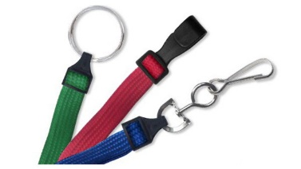Lanyards cost between $25 to $60 (€20 to €48 euros) for a pack of 100. We suggest the standard flat braided lanyards for $34.98 (€28.43 euros). It comes in different colors and is more sturdy than the cheaper ones. That’s approximately €285 euros for 1000. More information from this link: <http://www.alphacard.com/3-8-flat-braided-lanyards>

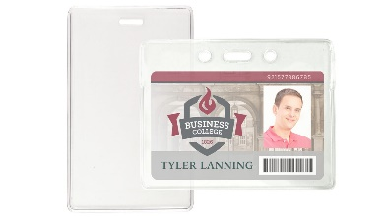And then there’s the badge holders ranging between $20 to $46 USD (€16 to €37 euros) for a pack of 100. The standard locking badge holders costs $19.98 (€16.24 euros), which is approximately €162 euros for 1000. More information from this link: <http://www.alphacard.com/standard-locking-badge-holders>

Together, the total price for a set of 1000 cards is €1,077 euros. This does not include the printing costs for decorating the cards. We suggest letting the attendees keep the lanyards and badge holders, resulting in a one time cost of €630 and a cost of €447 for each time an event occurs. The lanyards would be covered in sweat, so it wouldn’t be advised to reuse them.

#### Bands

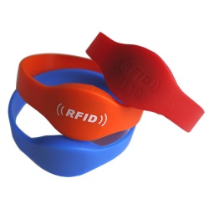Passive RFID wristbands are also reusable and may come in a silicone material; weather and damage proof. The one downfall of a wristband is when a user may attempt to pay with it while holding a drink, tipping it over on the RFID scanner. The scanners will be weather-proof as well, so it won’t damage the equipment.

An RFID wristband costs between 57 euro cents and €7 euros. The NTAG213 NFC wristband is water proof, comes in a variety of colors, and costs €0.69 per band. That would be €690 euros for 1000. More information in this link: <http://www.gyrfidstore.com/nfc-13-56mhz-rfid/water-proof-nfc-wristband-with-ntag213-wrs05/>

When comparing both the prices between 1000 cards and wristbands, the wristband costs €60 more than the cards. However, when considering the chances of losing a card, the accessories decreases the probability to that of the wristbands. Thus, the overall difference would be €387 in favor of the wristbands. Thus, the best option would be the wristbands.

One situation that cannot be prevented during the event is when participants swap IDs. The best way to handle this situation is for security to always check the wristbands, even if the person has entered the area a couple times.

## Final conclusion

When a participant has officially registered for the event, they will be provided a QR code of their account via the website. This QR code is their ticket. This can be printed or displayed on their phone to scan at the entrance of the event.

Passive RFID wristbands will have a QR code printed on top. This QR code is used to link the participant’s account upon entry. Once the ticket is scanned, the participant’s information will be displayed. The employee will then proceed to scan the wristband’s QR code to link the account to the band.

For the remainder of the event, the participant may use the band to access areas, purchase food and drinks, and rent items by simply tapping (or being within close range) of an RFID scanner.

In case the RFID tag does not work in the band, the participant may use the QR code to do their transactions, or request to change their bands for a new one. If a participant loses their band, they will have to pay the amount required for a new band. The former band will be unlinked to the account; thus, if someone randomly finds it, it will be empty.

#### AIPHONE TD6H/B UnitExtra counter measures

In case someone tries to sneak out the event with a previously lost wristband, an extra measure could be taken to have an anti-theft RFID security system, known as an electronic article surveillance system. These are really expensive and are not worth the purchase, especially if its job is to prevent a €0.69 euro bracelet from being stolen.

# Project Financials

The client offers a payment of €5,000 euros for the project. The advisor for Eloniah Software Solutions argued that the total cost would add up to €50,000 instead. That’s a difference of €45,000. We would either have to make compromises to the project plan or display evidence to the client: why our project is worth €50,000.

## Making a website

Making a website is not that difficult, but also not so simple. A custom-made website costs between €4,000 and €8,000 euros. From that amount, approximately €1,000 is used to purchase the domain. The client would then make a monthly payment of approximately €1 euro to maintain the domain and then between €5 to €350 euros per month to have it online and accessible. The rest of the funds is distributed among the following categories: time, design skills, and tech skills.

The design of the website can range between simplicity and exotic. A simple website would have less animations and focus more on primary content. This is boring and would cost around €2,000 euros to set up. A more exotic and dynamic website is attractive and would grab the reader’s attention. These websites would cost minimum €6,000 euros.

It takes roughly 12 to 16 weeks to make a website from design to official launch. With a team of 4, it would take much longer than average. For this website to be fully functional within the provided 19 weeks, we would have to request a price of €290 per week (€5,510 in total) for the dynamic website.

More details on costs for a website: <https://www.websitebuilderexpert.com/how-much-should-a-website-cost/>

## Making the applications

Currently, the client requests for a total of 5 applications for their event. A basic and unique application costs €10,000 euros. Because the applications are all interlinked with one another, the price per application decreases. The base design for the applications costs €10,000, and the specifics range between €2,000 and €5,000.

The following is the cost for each application:

* Transactions and loaning: €3,400
* Monitoring persons entering and exiting the event and specific areas: €2,800
* Monitoring the overall event: €3,300

Total amount being: €19,500 for the applications. This price includes the workload, the tech skills, and the time taken to make the applications, especially since it’s within 19 weeks.

<https://savvyapps.com/blog/how-much-does-app-cost-massive-review-pricing-budget-considerations>

## Making the database

The database is the most important part of the project. It stores all the information, and provides the connection among the applications and the website. Because the database is the hub, it requires security measures and extra caution, such as backup storage and constant updates to the servers. With the given range between €2,000 and €10,000 euros, the total price for this database will be €5,000.

## Overall

The overall financials are as follows:

|  |  |
| --- | --- |
| **Type** | **Price** |
| Website | €5,510 |
| Applications | €19,500 |
| Database | €5,000 |
| **Total** | **€30,010** |

This price may be argued against during the course of the project in block 2. For now, the official price for the entire project is **€30,010.**