

PROJECT PLAN

EVENTS SOFTWARE SOLUTION



Version 2.1

GROUP 34

Dholon Akter | Nr. 3047040

Chanelle Hart | Nr. 3323781

Talia Santos | Nr. 3294579

Thanh Hoàng | Nr. 3353362

# Version History

|  |  |  |  |  |  |
| --- | --- | --- | --- | --- | --- |
| **Version #** | **Implemented By** | **Revision Date** | **Approved By** | **Approval Date** | **Reason** |
| 0.5 | T. Santos | 20th Feb | - | - | Rough draft |
| 1.0 | T. Hoàng | 21st Feb | G. Hilderink | 27th Feb | Project Plan V1.0 |
| 1.1 | C. Hart | 27th Feb | - | - | Altered info and set up |
| 1.2 | C. Hart | 6th Mar |  |  | Additional details from mentor’s advise. |
| 1.3 | T. Hoàng T. Santos D. Akter | 6th Mar |  |  | Comments on changes to be made |
| 2.0 | C. Hart | 6th Mar | G. Hilderink | 20th Mar | Project Plan V2.0 |
| 2.1 | C. Hart | 25th Mar | - | - | Made changes where necessary |

Table of Contents

Introduction 4

The Client 4

The Team 4

Event Description 4

Project Statement 5

Current Situation 5

Problem Description 5

Project Goal 5

Solution Description 6

Project Objectives 7

Deliverables 7

Non-Deliverables 7

Functional Requirements 7

Non-Functional Requirements 7

Project Constraints 8

Project Risks 9

Project Phasing 10

Phase 1: Initiation 10

Phase 2: Design 11

Phase 3: Build 11

Phase 4: Test 12

Phase 5: Deploy 12

Project Management Approach 13

Roles and Responsibilities 13

Meeting Schedules 14

Methods of Communication 15

Contact Details 15

Assumptions 15

Appendices 16

Appendix A: LARP Definition - Wikipedia **Error! Bookmark not defined.**

Appendix B: Map of Camping Area 16

Appendix C: ATM Log 17

# Introduction

The purpose of this project is to develop a software solution for a client who organizes events. Because the events has started to attract more visitors, the client fears that it has become impossible to manage everything without a proper software solution. The solution should be user friendly and have ease of access to records, transactions, users information, and overall data about the event. The intended audience of the ‘Events Software Solution’ project plan includes the client, the project sponsor, the project mentor, and the project team.

## The Client

Events International is organizing events to make profit. Their representative for this project is André A. Postma. They requested the assistance of Eloniah Software Solution to develop a software system for the event that makes it smoother and faster for visitors to get around the event.

## The Team

The project leader of the group is Ms. Talia Santos. Her team consists of: Chanelle Hart, Dholon Akter, and Thanh Hoàng. They have enough experience to make a software solution for Event International.

(Contact information on page 14)

## Event Description

The event will take place during the weekend, and spans for 3 days. The visitor may buy a ticket on the website or at the entrance. The visitor will receive a unique identity number, a QR code, and a temporary account for the event. The online price for the event is € 55,-, and at the entrance is € 65,-.

The visitor may rent a camping spot on the website as well. The price to rent a spot is €10,- for the whole weekend, and an additional €20 per person; up to a maximum of 6 persons per camping spot. An additional €10,- will be added if the visitor decides to pay at the entrance instead of online.

Upon entering the event, the visitor will be asked to show their QR code (ticket). They will receive an RFID band that gets linked to their account. They may use the band to add event currency at one of the ATMs in order to make purchases and rent items.

There will be stalls with food and drinks to buy, and stalls with costumes, props (foam swords, staffs, shields, etc.), and phone charging cables to rent.

The ATM machines are located near the entrance and stalls, where the visitors may purchase event credit. Only event credit is used as currency for the event. Cash and credit/debit cards are not allowed.

When leaving the event visitors will have to return their bands at the exit. The bands will be scanned to see if they need to return rented items or still has event credits leftover. If so, they must return the items and/or deposit the funds back onto their accounts.

# Project Statement

In this document, we will provide the current situation, the client’s proposed solution and goals, the project goals, the project approach, the constraints and risks, the phasing, the assumptions, the management approach, and the reference material in the appendices.

## Current Situation

The event takes place on a big terrain with enough space for visitors, stages, tents, and other sections (Appendix A). Part of the terrain is reserved for the camping grounds, where visitors may stay for the night.

For profits, the funds will originate from visitors purchasing tickets to enter the event, buying food, drinks, or souvenirs, and loaning products, such as the costume booth, flashlights, cameras, etc.

Visitors will place the funds on their account in order to pay, and can rent a camping spot. Banks will place ATM machines on the terrain which allows visitors to deposit money on their account. These machines provide log files (Appendix B).

## Problem Description

Because the events has started to attract more visitors, the client fears that it has become impossible to manage everything without a proper software solution. It takes a long time to go through a list of names in order to determine whether someone has registered in advance or not. This keeps up the line. The company listens to the feedback or complaints from its visitors. The following issues needs to be addressed:

* Visitors find it difficult figuring out which camping spot they rented.
* Visitors could not find information in advance about the event. Apparently, flyers and social media does not provide enough information.
* There has been times were false cash was accepted by mistake. Because the lines at the food and drink stalls are long, it’s hard to keep track of what perks people have paid for. Phone chargers that were rented were rarely returned, and it’s difficult to keep track of which stalls are making more profits, in order to help make better plans for future events.

## Project Goal

The goal of this project is to provide a software solution that will solve the above problems. With this solution, the following goals should be met:

* Regulating the amount of visitors entering, exiting and that are currently in the event.
* Decrease waiting time in lines at the entrance, stalls, and rentals.
* Make it easier for visitors to register for the event and camping spots.
* Have real-time and easy access to information pertaining to the event.
* Easily monitor the flow of the event currency through the stalls, activities, and ATM machines.
* Being able to monitor and access information pertaining to everything that is related to the event (does not include making on the spot changes).
* All of these applications should be user-friendly and should help make future events easier to manage.

## Solution Description

Visitors will have ease of access to the provided website for the event. They can see all event details, prices, what to expect, and how to prepare. They can register for the event with their personal information, which gives them a ticket. The ticket is linked to an RFID band and an event account. This ticket has its own QR code which the visitor will present at the entrance of the event.

Visitors who want to rent a camping spot can visit the camping spot areas page on the website. The page will have the map of the camping area. The map will be interactive, displaying spots that are opened or reserved. The visitor may click on an open spot to make the reservations. The page will ask for the amount of visitors, as well as allowing an invite link. This link can be distributed to the other attendees by the visitor who requested the reservation. Other attendees must have registered for the event in order to access the camping grounds.

There will be two sections at the entrance of the event. The first section is the line for visitors who have tickets. The visitor’s QR code will be scanned and their event account will be linked to an RFID band. The second section has 3 computers where the visitor may enter their details and purchase a ticket. Once they receive their ticket, they may stand in the line.

Visitors who are registered for (or are renting) a camping spot will be directed to the camping grounds, where they can scan their band to enter the camping grounds.

If they did not purchase a ticket online, they can enter their details into the device, the account will be created, and then they will be provided with a band.

This band will be used for all transactions. Visitors can buy the event currency through the provided ATMs, strategically located near the stalls and at the entrance/exit of the event. They can use the band to purchase food, drinks, and miscellaneous, as well as renting costumes, chargers, etc.

Visitors can view their transaction history via the ATMs or via the website.

Upon leaving the event, the entrance employee will scan the visitor’s band to verify if the visitor has returned their rented items. They will also check to see if there is event currency left over. The band will be returned, unlinked from the ticket, leaving it clean for another visitor or event.

The event manager will have access to an application which displays an overview status of the event:

* An overview page of the sections
  + Visitors - visitors entering/exiting and currently present
    - Can access specific visitor’s history
  + Finances - cashflow among the ATMs, stalls, and activities
  + Campsite - visitors entering/exiting camping grounds, and cleaning status
  + Stock status of the stalls

The application displays read-only information and cannot be changed.

# Project Objectives

## Deliverables

* Applications to be used at:
  + The entrance of the event
  + The entrance of the camping grounds
  + The shops
  + The loaning stands
  + The information center
* The application to be used to monitor visitors entering and leaving the event
* The application for the organization to inspect the status of the event
* The application to convert the information in the transaction-log-file to the database
* The fully functional website
* The database
* A presentation of the software solution
* The agenda’s and minutes of every meeting
* The process report
* The setup document
* The test report

## Non-Deliverables

* The source code
* The website wireframe
* The static website
* The database design

## Functional Requirements

* A website that informs people about the event and allows reservation of tickets and camping spots
* Applications that monitor visitors entering, exiting, and total visitors
* Applications that support the shops and the loan stands
* An application that allows the organization to get a clear status overview of the event:
  + Visitors’ information (status, history, currently present/absent)
  + Statistics of finance, logistics, operations, and marketing
  + Camping bookings (locations that are reserved, opened, and occupied)
* An application that changes and retrieves the balance of the visitors based on the ATM log files
* Maintenance and updates are available for the website, applications and database

## Non-Functional Requirements

* Responsive website that is compatible with mobiles, laptops, and tablets.
* Applications are compatible with windows 10 desktop devices.
* Database supports all applications.
* Easily modifiable for preferred user-interfaces.

# Project Constraints

### Cost Constraint

The client may not agree to the proposed budget for this project, which may reduce the expected quality of the project.

### Time Constraint

The project must be completed within 19 weeks. It takes on average 3 months (12 weeks) to build an application, and there are 5 apps to be made.

### Scope Constraints

#### **Application Constraint**

Applications will be made for Windows devices. This requires the company to invest in only Windows-based devices.

#### **Website Constraint**

Website will be created for Google Chrome, Microsoft Edge, Mozilla Firefox and Safari. Any other website would not be considered.

#### **Knowledge Constraint**

The software solution may require more knowledge than what was taught during the first year at Fontys.

### Critical Project Barriers

Should any of these were to come to effect, the project plan will cease; to be discontinued.

* No project funds
* Natural disasters or acts of war

# Project Risks

### The computer, which is used to program applications, crashes

Probability: Low  
Impact on project: High  
Steps to prevent risk: Save the project on external device and/or upload to, for example, the git depository frequently.   
Clean up action: If unsaved, simply restart the task. Will increase workload per hour.

### Someone quits; leaves the project group

Probability: Low  
Impact on project: Medium  
Steps to prevent risk: Motivate each other to accomplish the goal. Have social interaction during meetings.  
Clean up action: If someone leaves, work will be equally distributed to remaining members.

### Miscommunication

Probability: Medium  
Impact on project: High  
Steps to prevent risk: Have frequent meetings and make sure everyone gives their feedback. Feedback and discussions help to resolve misunderstandings.  
Clean up action: Compare notes. Retrace steps and get back on track.

### Team’s lack of knowledge on the deliverables

Probability: Low  
Impact on project: High  
Steps to prevent risk: Stay on track with school work. Research what is not taught but is required in the software solution.  
Clean up action: Take time out to research the necessary knowledge required to complete the project goal.

### Deadlines are not met due to procrastination

Probability: Low  
Impact on project: Medium  
Steps to prevent: Dedicate time to the project each week; roughly 4 to 8 hours.  
Clean up action: reschedule to be delivered within 48 hours, once approved.

### Budget estimates are unrealistic

Probability: High  
Impact on project: Low  
Steps to prevent: Include a financial statement in the project plan. Keep 10 to 15% margin of error on budget constraints.   
Clean up action: Create a more budget friendly financial statement.

# Project Phasing

In the following figure, we have an overview of the activities, their dependencies, the milestones and weeks required to complete each milestone.

[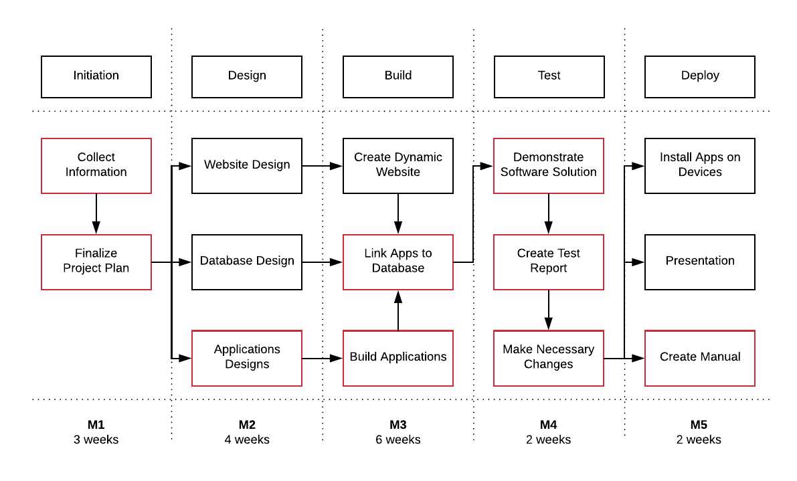](https://www.lucidchart.com/documents/edit/b2df1e6d-8d51-448a-a9af-082c58ca79c5/0?callback=close&name=docs&callback_type=back&v=1033&s=595.4399999999999)  
*Figure 1. Activities with Critical Path*

## Activities in each Phase

1. Interview client
2. Discuss current situation, problems, and software solution
3. Receive go or no go for plan or changes
4. Receive milestone payment (1/5th of overall)

## Phase 1: Initiation

Activity: Collect Information

1. Set the project goal together with the client
2. Organize tasks in the team
3. Arrange future meetings

Activity: Finalize Project Plan

1. Present final project plan to client
2. Receive approval

Deliverables for milestone **M1**:

* Project plan

## Phase 2: Design

Activity: Website Design

1. Create wireframe
2. Ask client for comments
3. Create static website

Activity: Database Design

* Make the database design from model

Activity: Applications Designs

* Design the applications for:
  + The entrance of the event
  + The entrance of the camping grounds
  + The shops
  + The loaning stands
  + Monitoring visitors entering and exiting the event, as well as their transaction history
  + Monitoring overall event
  + Receiving information from transaction-log-files to database

Deliverables for milestone **M2**:

* The process report
* The setup document (contains all designs)

## Phase 3: Build

Activity: Create Dynamic Website

* Link the database to the website
* Test

Activity: Build Applications

* Proceed with the step-by-step process of creating an application

Activity: Link Apps to Database

* Proceed with the step-by-step process of linking apps to database

Deliverables for milestone **M3**:

* Applications prototypes
* Database prototype
* Unofficial website release

## Phase 4: Test

Activity: Demonstrate Software Solution

1. Create presentation
2. Demonstrate the prototypes
3. Receive feedback

Activity: Create Test Report

1. Note down feedback
2. Create report
3. Give report to client

Activity: Make Necessary Changes

* Make the changes based on the test report

Deliverables for milestone **M4**:

* Test Report

## Phase 5: Deploy

Activity: Install Apps on Devices

* Optimize devices for compatibility (if necessary)

Activity: Presentation

1. Create presentation
2. Set date to present and make preparations
3. Present to client and company

Activity: Create Manual

1. Create manual for applications and database
2. Verify with client if manual is understandable to read for all event workers
3. Deliver manual to client after making the necessary changes

Deliverables for milestone **M5**:

* All applications
* The database
* Fully functional website released
* Presentation of the software solution
* Manual

# Project Management Approach

## Roles and Responsibilities

|  |  |  |
| --- | --- | --- |
| **Role** | **Responsibilities** | **Participant(s)** |
| Project Sponsor | 1. Ultimate decision-maker 2. Provide project oversight and guidance 3. Review and approve some project elements | André A. Postma |
| Mentor | 1. Provides direction to Project Leader 2. Review project deliverables 3. Approves usage of ISSD equipment and makes suggestions | Gerald Hilderink |
| Project Leader | 1. Manages project in accordance to the project plan 2. Provide overall project direction 3. Direct and lead the team members toward project objectives 4. Handle problem resolution | Talia Santos |
| Project Secretary | 1. Maintain all records of the meetings 2. Sends emails on behalf of the Project Leader | Thanh Hoàng |
| Minute Taker | 1. Takes the minutes at every meeting 2. Provides the minutes to all participants | Rotates among Project Team |
| Project Team | 1. Understand the project goal and has the knowledge to carry out the project 2. Review and approve project deliverables 3. Provide knowledge and suggestions 4. Assure quality of products | Dholon Akter  Chanelle Hart  Thanh Hoàng  Talia Santos |
| Subject Matter Experts | 1. Lend expertise and guidance as needed | To be identified at a later date |

## Meeting Schedules

Meetings will take place weekly for the first 3 weeks, and then bi-weekly with everyone involved. Agendas will be distributed 24 hours before the meeting, and minutes will be distributed within 24 hours after the meeting took place.

The meetings enlisted are

|  |  |  |
| --- | --- | --- |
| **Week** | **Date** | **Discussion Points** |
| 2 | Tue 20th Feb 2018 | 1. Introduction 2. Present logo and event idea 3. Ask advice for first draft of project plan 4. Ask client questions |
| 3 | Tue 27th Feb 2018 | 1. Present revised project plan 2. Final decision on ID type for event |
| 3 | Mon 5th Mar 2018 | 1. Prepare setup document 2. Prepare website wireframe and design |
| 4 | Tue 6th Mar 2018 | 1. Finalize project plan V2.0 2. Present to client for approval |
| 6 | Tue 20th Mar 2018 | 1. Update status: setup document 2. Ask mentor for advice |
| 7 |  |  |
| 8 | Tue 3rd Apr 2018 | 1. Finalize deliverable for block 1 2. Get feedback from client 3. Ask mentor for advice |
| 10 | Tue 17th Apr 2018 | Present deliverables for block 1 |
| 13 | Tue 8th May 2018 | 1. Present prototype of applications, website, and database 2. Receive feedback from client and mentor |
| 16 | Tue 29th May 2018 | 1. Present unofficial deliverables to mentor 2. Receive feedback |
| 17 | Tue 5th Jun 2018 | Final meeting for feedback |
| 19 | Tue 19th Jun 2018 | Present software solution |

## Methods of Communication

There will be a bi-weekly status report on how the project is going. This report will be emailed to the Project Sponsor and Mentor. The status report will entail:

* Summary of tasks completed between the last report and current report date.
* Summary of tasks and goals completed during the 2 weeks.
* Summary of issues that were encountered and resolved during the 2 weeks.
* Division of work among the Project Team

Everyone has access to the git folder: <https://git.fhict.nl/I390396/ProPGroup34>   
It’s the responsibility of everyone to check the git folder as frequently as possible.

There will be bi-weekly meetings (after 3 weeks of consecutive meetings). Every member of the Project Team will be invited to participate in the meeting. The Project Leader will send the status report to each member of the team before the meeting so everyone can review it in advance.

## Contact Details

|  |  |
| --- | --- |
| **André A. Postma** Events Specialist Events International Rachelsmolen 1 5612 MA Eindhoven Tel : 088 508 0000 [a.postma@fontys.nl](mailto:a.postma@fontys.nl) | **Talia Santos** Project Leader Eloniah Software Solutions Rachelsmolen 1 5612 MA Eindhoven Tel: 088 508 0000  [t.dasilvasantos@student.fontys.nl](mailto:t.dasilvasantos@student.fontys.nl) |

# Assumptions

1. Eloniah is a software solutions company that has been in existence for over 5 years.
2. The source code is copy righted and is solely for Eloniah to modify. If the company requests for modifications to the applications, they will have to request Eloniah to make the changes, instead of finding another company.
3. The budget plan is legitimate.
4. The company has received an event permit from the government to carry through with the activity.

# Appendices

## Appendix A: Map of Camping Area

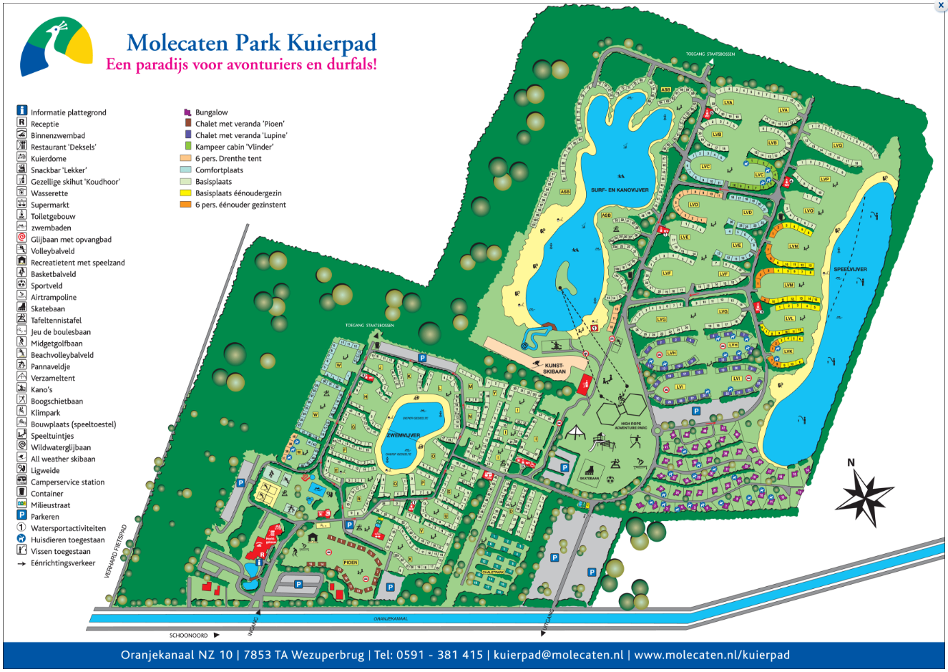

## Appendix B: ATM Log

