



SETUP DOCUMENT

LARP EVENT SOFTWARE SOLUTION

Version 1.0

Dholon Akter | Nr. 3047040

Chanelle Hart | Nr. 3323781

Talia Santos | Nr. 3294579

Thanh Hoàng | Nr. 3353362

GROUP 34

# Version History

|  |  |  |  |  |  |
| --- | --- | --- | --- | --- | --- |
| **Version #** | **Implemented By** | **Revision Date** | **Approved By** | **Approval Date** | **Reason** |
| 0.5 | T. Santos | 6th Mar | - | - | Rough draft |
| 0.6 | C. Hart | 9th Mar | - | - |  |
| 1.0 | T. Hoàng | 11th Mar | - | - | Add GUIs, Wireframes, ERD |

Table of Contents

Version History 2

GUI 4

Wireframes 8

ERD 14

Agreements 15

Processes 15

Functional Requirements 15

# GUI

**Entrance of event**

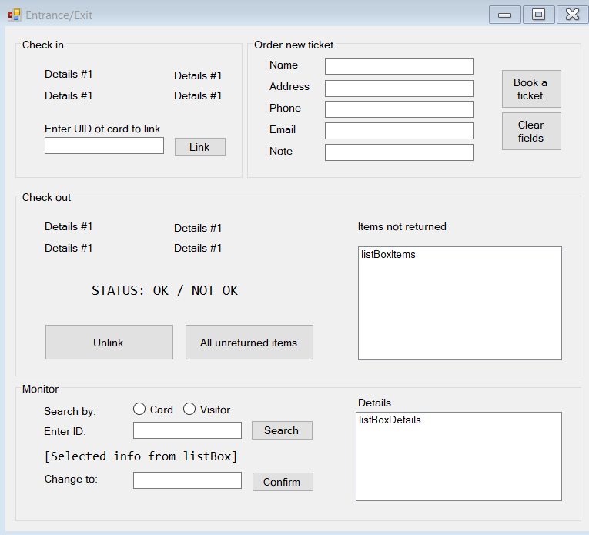Section 1: Check-in

* Once a visitor scans their ticket, their details will show up in the labels.
* The staff can then proceed to enter the Unique Identification of the card they want to link the visitor with
* **Link**: Performs the linking action

Section 2: Order new ticket

* If a visitor wants to buy a ticket on the spot, the staff will fill in their information here
* **Book a ticket**: Performs the booking action
* **Clear all fields**: Clear all information in the textboxes of this section

Section 3: Check-out

* Once a visitor scans their ticket, their details will show up in the labels.
* If they have unreturned item(s), their status will show up as “NOT OK” and the information of said item(s) will be displayed in listBoxItems
* **Unlink**: Performs the unlinking action: user information will be removed from the card.
* **All unreturned items**: Display all the items not returned from the events (regardless of who has not returned them) in listBoxDetails

Section 4: Monitoring visitors

* The staff has the option to search for a visitor either by their card ID or by their visitor ID
* After selecting their option, the staff can enter the ID for which they want to search
* **Confirm**: The information about said visitor will be displayed in listBoxDetails upon clicking on this button
* Should the staff want to modify anything, they can select specific information from listBoxDetails and the information will then be displayed on its respective label.
* **Confirm**: The staff can enter the updated value into the textbox and clicking on this button will update visitor’s information.

**Entrance of campsite:**

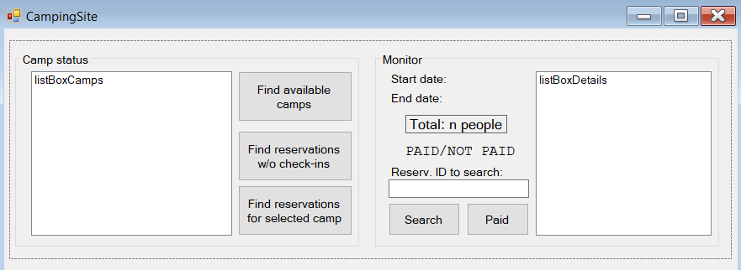

Section 1: Display all camps at the event

* **Find available camps**: All the camps which are not fully booked will be displayed in listBoxCamps
* **Find reservations w/o check-ins**: All reservations which have not been checked in will be displayed in listBoxCamps
* **Find reservations for selected camp:** All reservations for the selected camp in listBoxCamps will be displayed in listBoxCamps after clicking this button.

Section 2: Monitoring reservations

* When user scans their identification, the information about their reservations will be displayed: the start date and end date will be seen in their respective labels; camp name and details of participants will be displayed in listBoxDetails
* **Search**: Camp name and details of participants of a specific reservation will be displayed in listBoxDetails
* **Paid**: To change the status of an unpaid reservation to paid

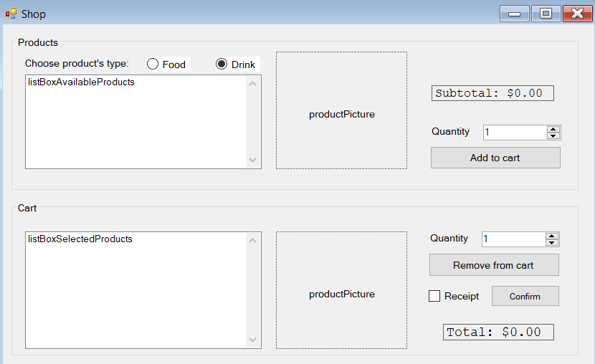 Section 1: Display all products available

* User will choose their type of products: Food or Drink. The available products for their respective choice will display as they click on the radio button.
* If they select an item in listBoxAvailableProducts, the picture of said item will show up in the area marked with productPicture
* The productPicture will change if the user selects one item. If the user selects multiple items, the images will not display.
* Once they have selected their item(s), the user can increase or decrease the quantity to order
* **Add to cart:** Once they are sure that they want certain products, they can click on this button to add them to their order

Section 2: Display items in cart

* Details about what the user ordered will be displayed in listBoxDetails
* If they select an item in listBoxSelectedProducts, the picture of said item will show up in the area marked with productPicture
* **Remove from cart**: The user has the option to modify the quantity they have ordered earlier and clicking on this button will execute the action.
* If they check the Receipt checkbox, the shop will print a receipt for them.
* **Confirm**: Clicking on this button will confirm and process the order.

# Wireframes

**Homepage:**

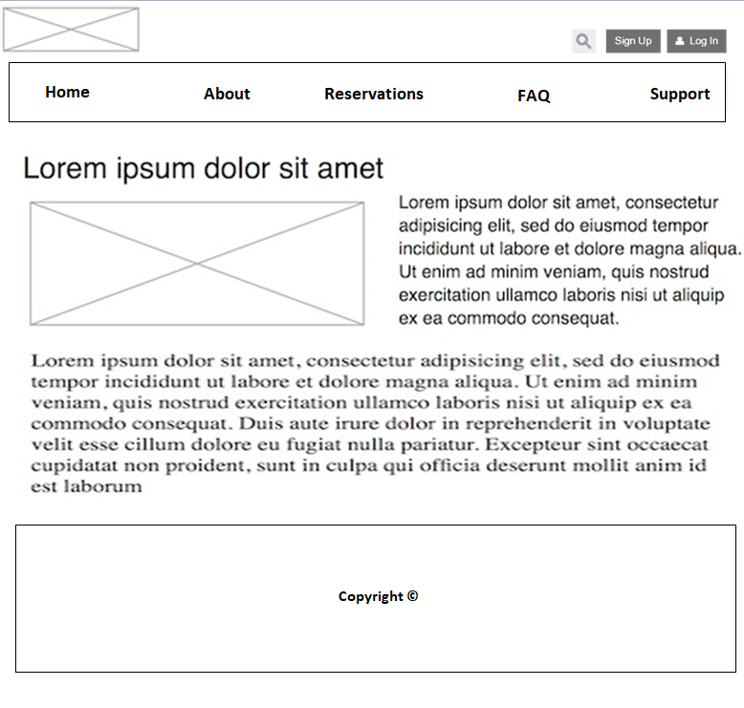

**About page:**

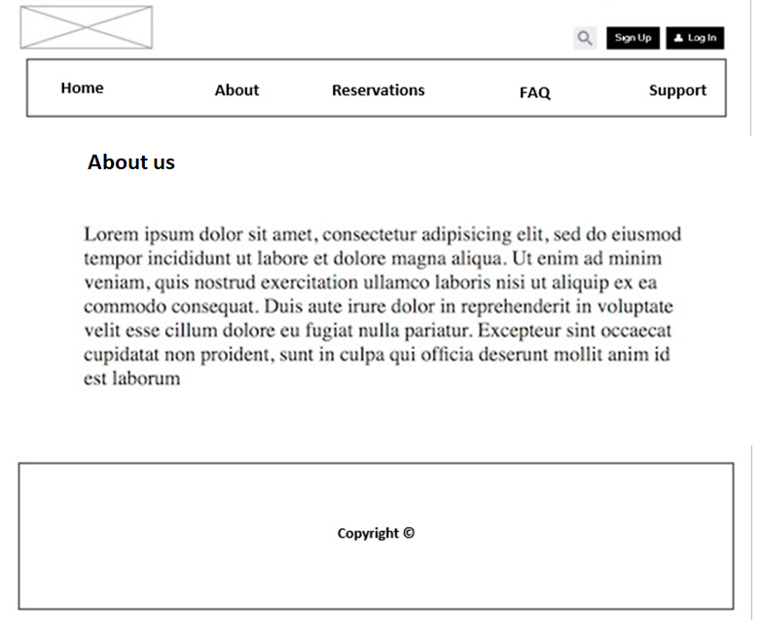

**FAQ’s page**

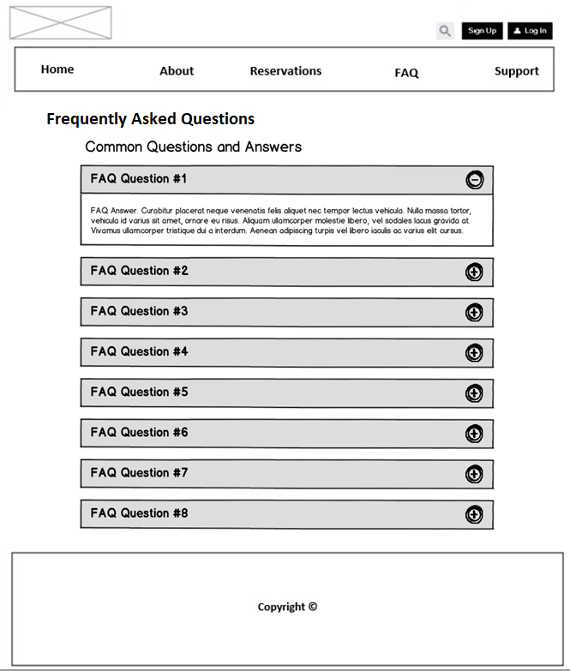

**Terrain page:**

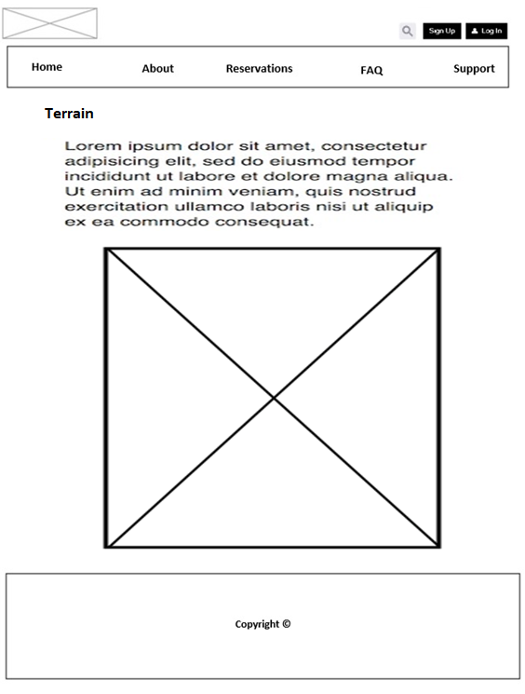

**Event page:**

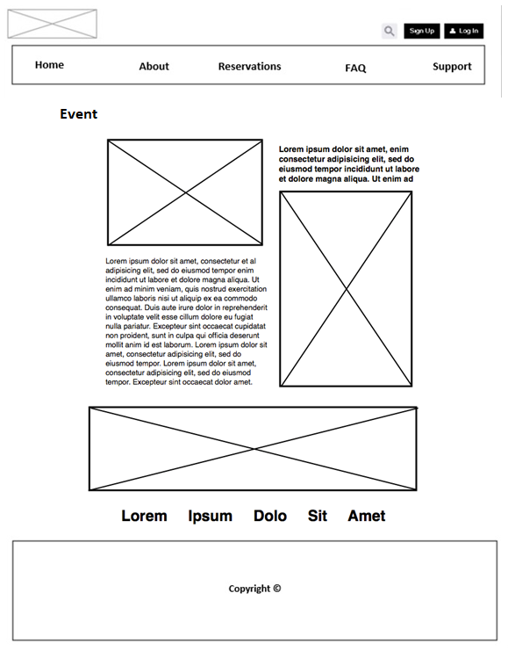

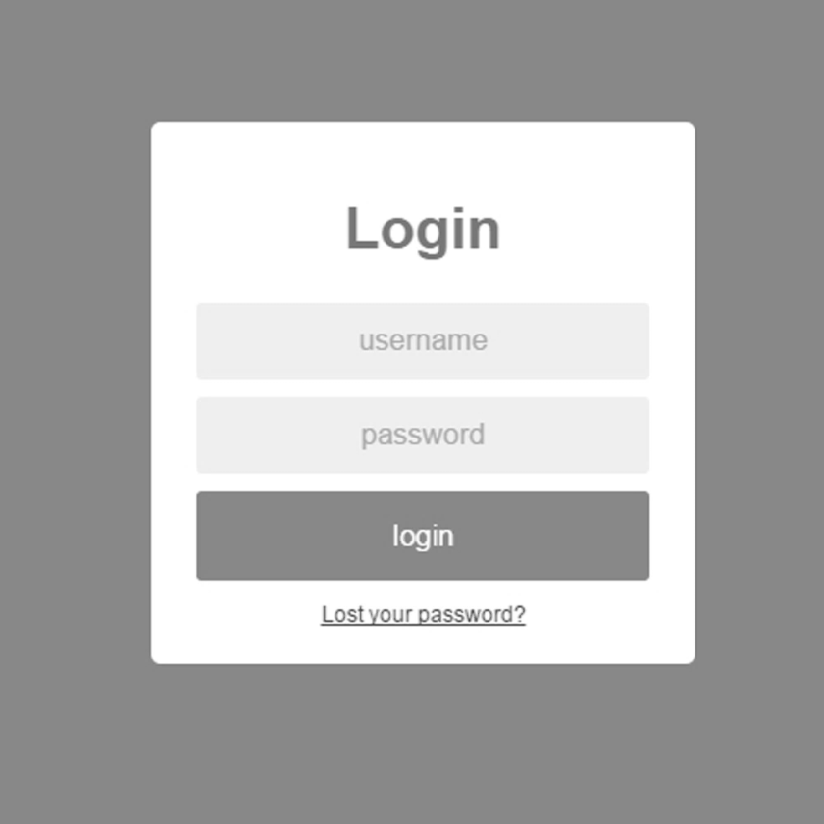**Login:**

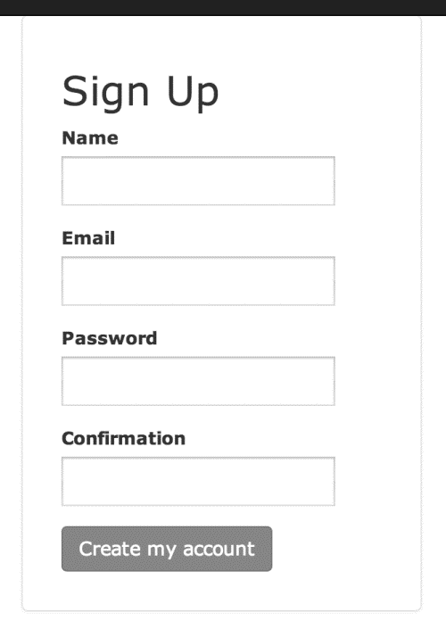**Signup:**

# ERD

* **Red**: The core entities.
* **Green**: The entities supporting the core ones.

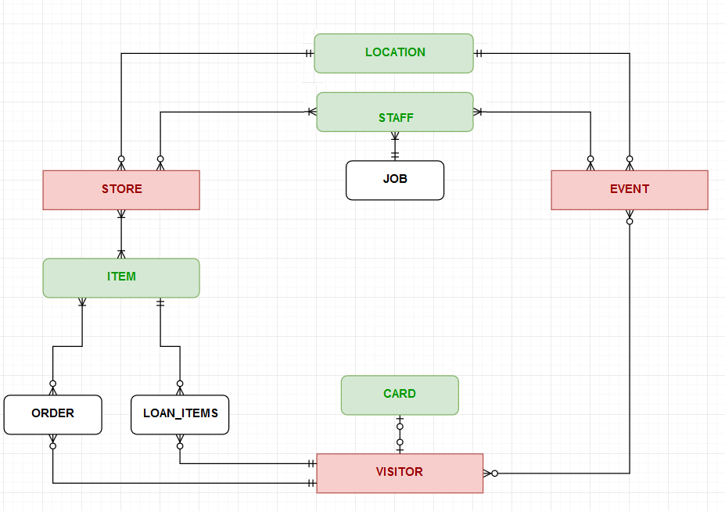

* **Black**: The entities supporting implementation.

# Agreements

(to be updated)

# Processes

(to be updated)

# Functional Requirements

(to be updated)