Module2 - R Markdown Document 1

Dave Holtschlag

October 19, 2018

# This is a level 1 header

## R Markdown

### This is a level 3 header

Here is a link to [GOOGLE](www.google.com)

Here is a word in **bold** and another word in **bold**.

Here in another word in *italics* and another word in *italics*.

Use backticks to get non-proportional font in light grey as rmarkdown.

2 + 2  
mean( c( 1, 2, 3, 4, 5))

Here is an example of a non-numbered list:

* Breakfast
  + food
    - eggs
    - toast
    - bacon
  + drink
    - apple juice
* Lunch
  + taco
* Dinner
  + baked chicken
  + broccoli
  + rice

Here is an example of a numbered list:

1. Breakfast
   1. food
      1. eggs
      2. toast
      3. bacon
   2. drink
      1. apple juice
2. Lunch
   1. taco
3. Dinner
   1. baked chicken
   2. broccoli
   3. rice

Here is an example of a blockquote:

This is a block quote. This paragraph has two lines.

1. This is a list inside a block quote.
2. Second item.

Here is an example of a nested blockquote:

This is a block quote. This paragraph has two lines.

This text is nested

This is an R Markdown document. Markdown is a simple formatting syntax for authoring HTML, PDF, and MS Word documents. For more details on using R Markdown see <http://rmarkdown.rstudio.com>.

When you click the **Knit** button a document will be generated that includes both content as well as the output of any embedded R code chunks within the document. You can embed an R code chunk like this:

summary(cars)

## speed dist   
## Min. : 4.0 Min. : 2.00   
## 1st Qu.:12.0 1st Qu.: 26.00   
## Median :15.0 Median : 36.00   
## Mean :15.4 Mean : 42.98   
## 3rd Qu.:19.0 3rd Qu.: 56.00   
## Max. :25.0 Max. :120.00

## Including Plots

You can also embed plots, for example:



plot(pressure)

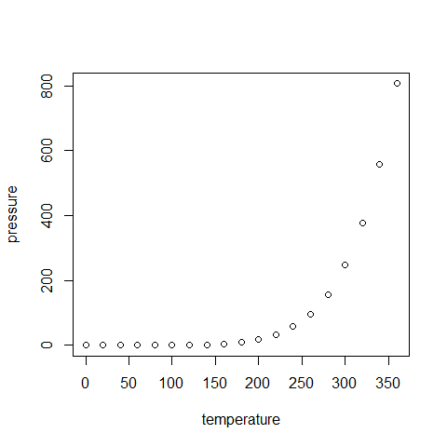

knitr::kable(head(cars),  
 caption = 'Table 1. Top ten rows of the cars dataset')

Table 1. Top ten rows of the cars dataset

|  |  |
| --- | --- |
| speed | dist |
| 4 | 2 |
| 4 | 10 |
| 7 | 4 |
| 7 | 22 |
| 8 | 16 |
| 9 | 10 |

head(mtcars)

## mpg cyl disp hp drat wt qsec vs am gear carb  
## Mazda RX4 21.0 6 160 110 3.90 2.620 16.46 0 1 4 4  
## Mazda RX4 Wag 21.0 6 160 110 3.90 2.875 17.02 0 1 4 4  
## Datsun 710 22.8 4 108 93 3.85 2.320 18.61 1 1 4 1  
## Hornet 4 Drive 21.4 6 258 110 3.08 3.215 19.44 1 0 3 1  
## Hornet Sportabout 18.7 8 360 175 3.15 3.440 17.02 0 0 3 2  
## Valiant 18.1 6 225 105 2.76 3.460 20.22 1 0 3 1

library(printr)  
  
head(mtcars)

|  |  |  |  |  |  |  |  |  |  |  |  |
| --- | --- | --- | --- | --- | --- | --- | --- | --- | --- | --- | --- |
|  | mpg | cyl | disp | hp | drat | wt | qsec | vs | am | gear | carb |
| Mazda RX4 | 21.0 | 6 | 160 | 110 | 3.90 | 2.620 | 16.46 | 0 | 1 | 4 | 4 |
| Mazda RX4 Wag | 21.0 | 6 | 160 | 110 | 3.90 | 2.875 | 17.02 | 0 | 1 | 4 | 4 |
| Datsun 710 | 22.8 | 4 | 108 | 93 | 3.85 | 2.320 | 18.61 | 1 | 1 | 4 | 1 |
| Hornet 4 Drive | 21.4 | 6 | 258 | 110 | 3.08 | 3.215 | 19.44 | 1 | 0 | 3 | 1 |
| Hornet Sportabout | 18.7 | 8 | 360 | 175 | 3.15 | 3.440 | 17.02 | 0 | 0 | 3 | 2 |
| Valiant | 18.1 | 6 | 225 | 105 | 2.76 | 3.460 | 20.22 | 1 | 0 | 3 | 1 |
| ## Insert an Equatio | n |  |  |  |  |  |  |  |  |  |  |

$$y=β_{0}+β_{1}x$$

## Insert Images

Going to insert an image here.



Sunstar

## R logo

* R logo
* R logo

R logo

R logo