SOFTWARE ENGINEERING
LAB 2
Agile Project Management using Jira
Project Title: Community Lost & Found Matching Network
SRN: PES1UG25CS808
Project Key: CLF
Jira Project: Community Lost Found
GitHub/Repository link:
https://github.com/dhonimahi/SE-Labs-PES1UG25CS808/tree/main/Lab2
Jira Project / Workspace Link:
https://bhuvanrajh24.atlassian.net/jira/software/c/projects/CLF/boards/35

1. EPICS AND USER STORIES / BACKLOG
1.1 Epics
The project was divided into the following Epics:
- Item Reporting & Tagging
- Lost & Found Matching
- Ownership & Verification
- Community Administration
Screenshot: Jira Backlog showing Epics and User Stories
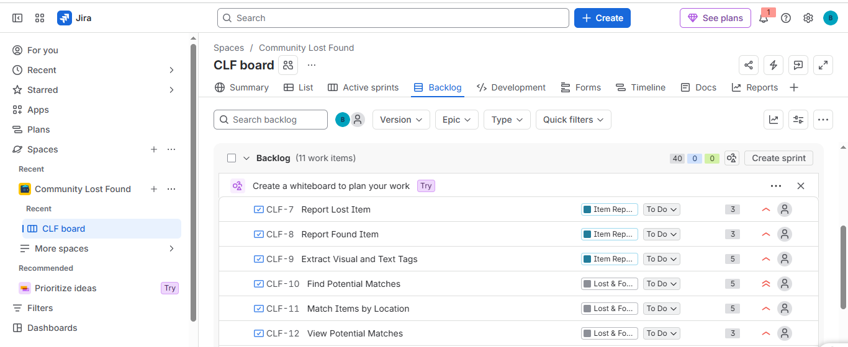
2. USER STORIES AND STORY POINTS
The following User Stories were created and estimated using Fibonacci-based story points.
Sl. No. | User Story | Epic | Priority | Story Points
1 | Report Lost Item | Item Reporting & Tagging | High | 3
2 | Report Found Item | Item Reporting & Tagging | High | 3
3 | Extract Visual and Text Tags | Item Reporting & Tagging | High | 5
4 | Find Potential Matches | Lost & Found Matching | Highest | 5
5 | Match Items by Location | Lost & Found Matching | High | 5
6 | View Potential Matches | Lost & Found Matching | High | 3
7 | Submit Ownership Claim | Ownership & Verification | High | 3
8 | Verify Ownership | Ownership & Verification | Highest | 5
9 | Reveal Contact Details After Verification | Ownership & Verification | High | 3
10 | Manage Reports and Claims | Community Administration | Medium | 5
 | TOTAL |  |  | 40

Screenshot: Jira Backlog showing Story Points


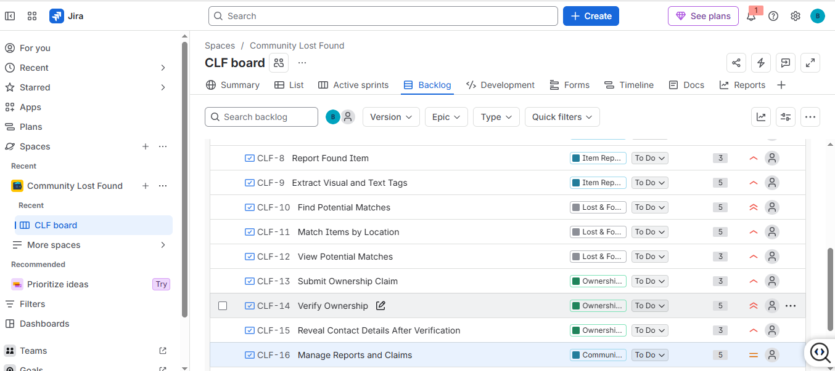

3. SPRINT 1
Sprint Name: CLF Sprint 1
Duration: 1 Week
Total Story Points: 19
Stories included
- Report Lost Item — 3 points
- Report Found Item — 3 points
- Extract Visual and Text Tags — 5 points
- Find Potential Matches — 5 points
- View Potential Matches — 3 points
Screenshot: Sprint 1 Planning / Active Sprint Board
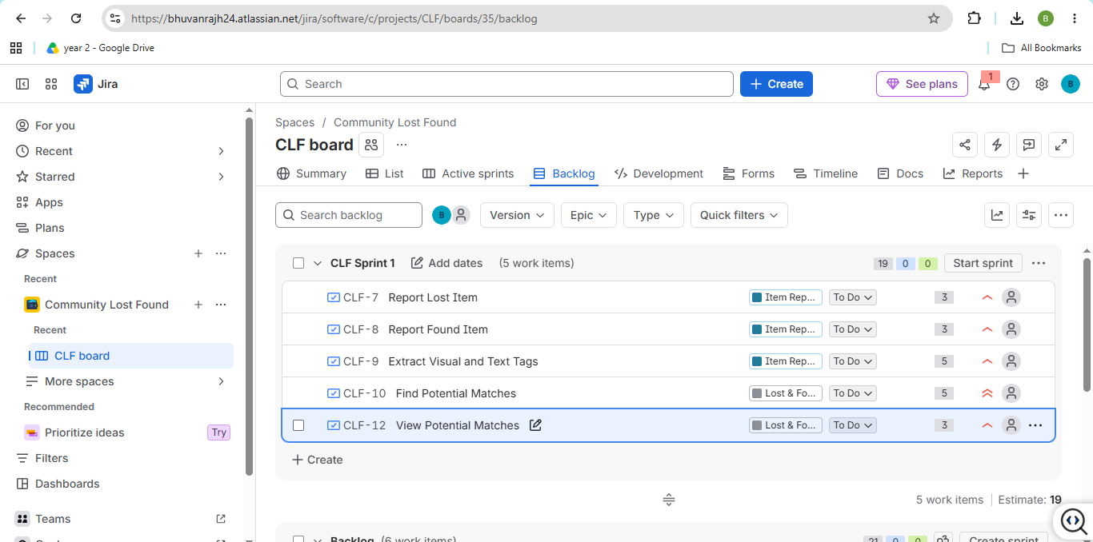
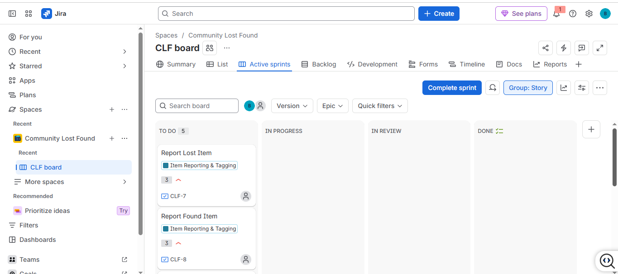
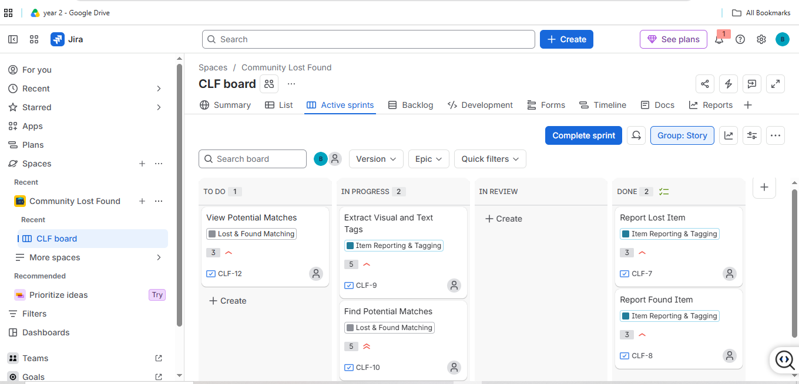
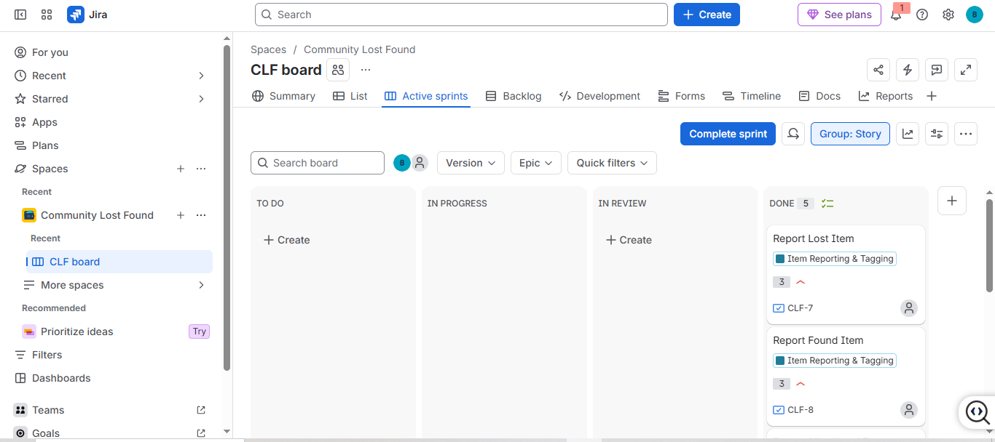
Sprint 1 Result
All planned Sprint 1 stories were moved through the workflow:
To Do → In Progress → Done
and the sprint was completed successfully.

4. SPRINT 2
Sprint Name: CLF Sprint 2
Duration: 1 Week
Total Story Points: 21
Stories included
- Match Items by Location — 5 points
- Submit Ownership Claim — 3 points
- Verify Ownership — 5 points
- Reveal Contact Details After Verification — 3 points
- Manage Reports and Claims — 5 points
Screenshot: Sprint 2 Planning / Active Sprint Board
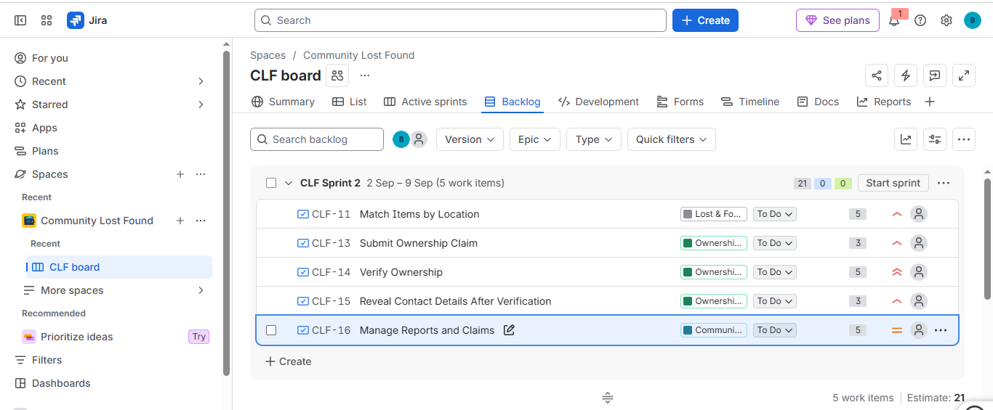
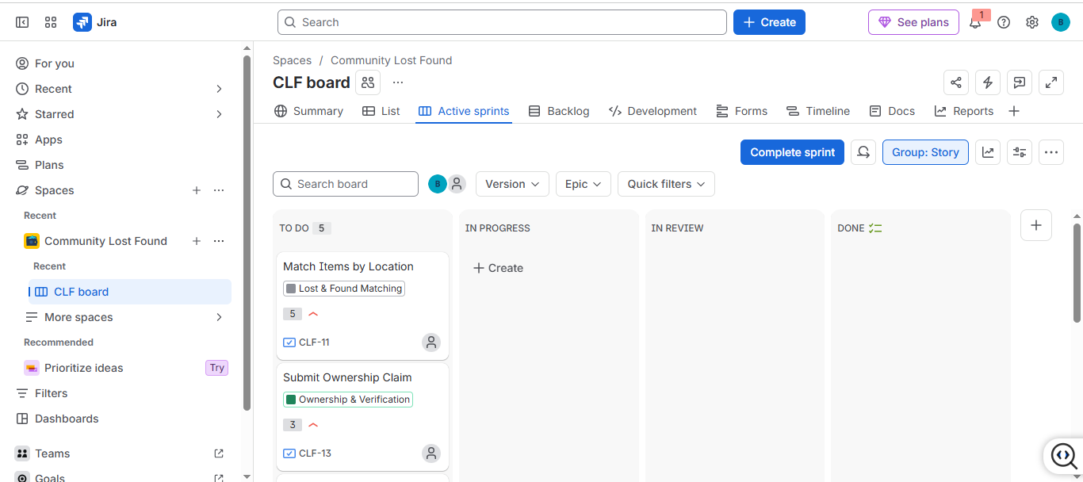
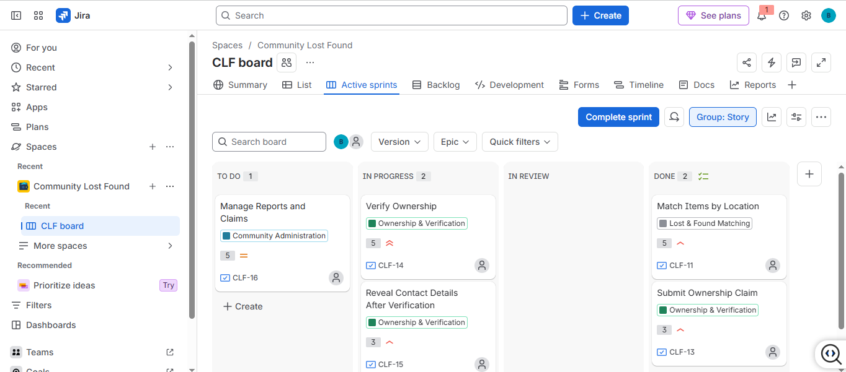

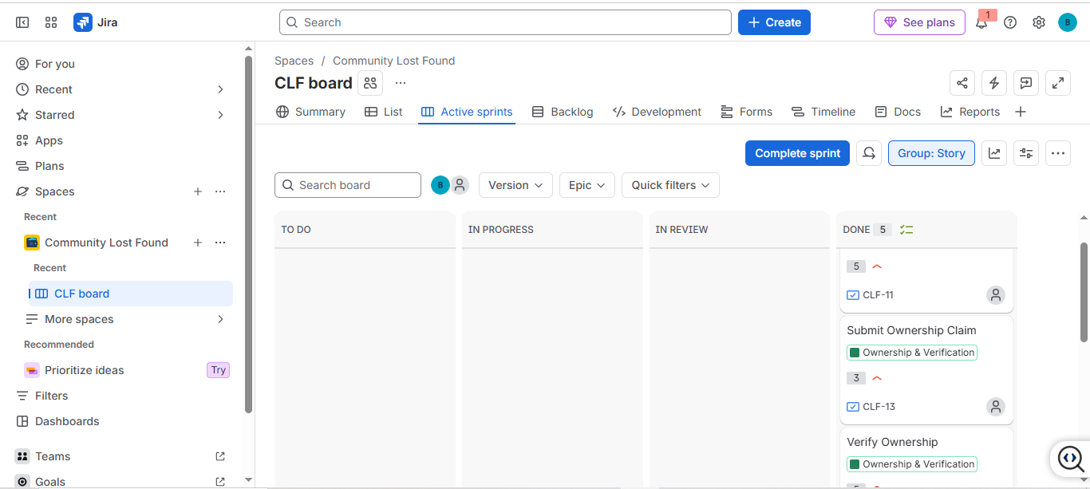
Sprint 2 Result
All planned Sprint 2 stories were moved through:
To Do → In Progress → Done
and Sprint 2 was completed successfully.

5. BURNDOWN CHART
The Burndown Chart was used to monitor the remaining story points during the sprint and compare actual progress with the expected guideline.
Screenshot: Jira Burndown Chart
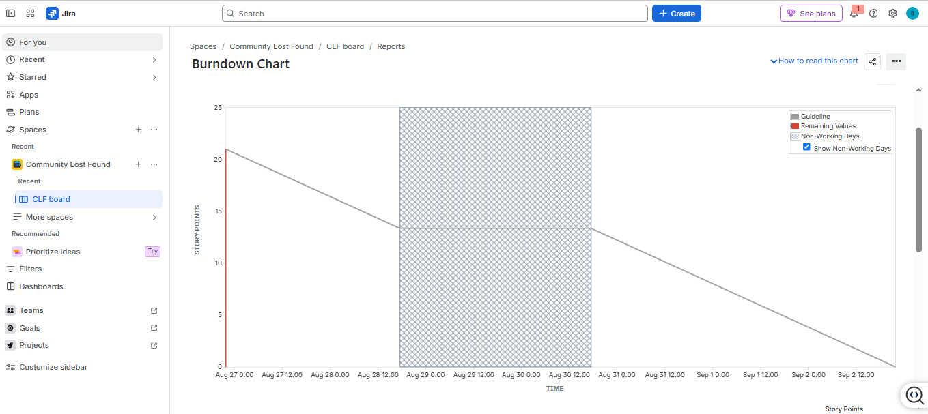
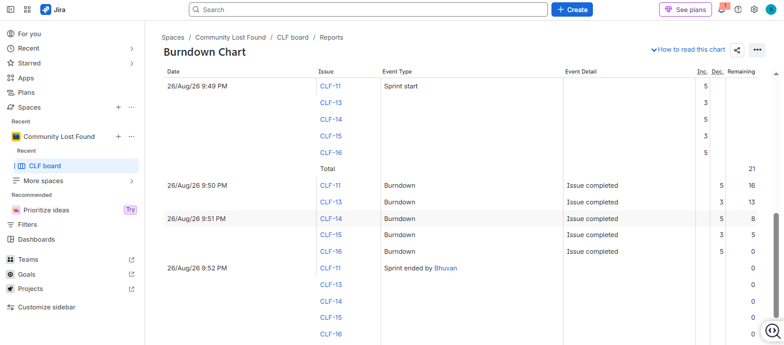
Observation
The Burndown Chart shows the reduction in remaining story points over time. The remaining work reached zero, indicating that the planned work was completed.

6. REFLECTION
6.1 Did your estimations reflect the actual effort?
The story point estimates reasonably reflected the relative effort and complexity of the User Stories. Smaller reporting tasks required fewer points, while matching and ownership verification involved greater complexity and uncertainty.
6.2 Was your backlog well-prioritized?
Yes. Core lost-and-found functions such as reporting, matching and ownership verification were given higher priority, while administrative functionality was given medium priority.
6.3 How did your simulated sprint align with your plan?
The sprint followed the planned backlog and the selected stories were progressively moved from To Do to In Progress and then Done. Two sprints were completed to divide the project work into manageable increments.
6.4 What insights did the Burndown Chart give about your team's capacity?
The Burndown Chart showed the reduction in remaining story points during the sprint and helped compare actual progress with the expected sprint guideline. It also showed that the planned workload could be completed within the sprint.

