Sophia College (Autonomous), Ajmer
Affiliated to the MDS University, Ajmer



Bachelor of Computer Application
Semester - VI
(2025-26)

Project Report On
Aphrodite Cosmetics Website

Submitted To Submitted By
Sir Gautam Chaturvedi Radhika Dhoot
HOD Computer Science Roll No.: 23551352
Sophia College (Autonomous), Ajmer
Affiliated to the MDS University, Ajmer

Bachelor of Computer Application
Semester - VI
(2025-26)

Project Report On
Aphrodite Cosmetics Website



Submitted To Submitted By
Sir Gautam Chaturvedi Radhika Dhoot
HOD Computer Science Roll No.: 23551352

CERTIFICATE

It is to certify that the work incorporated in the project entitled "Aphrodite Cosmetics Website" which has been submitted by Radhika Dhoot, of Bachelor of Computer Application Semester-VI has completed this work sincerely in the prescribed period to the best of my knowledge, it is an original contribution and has not been submitted for any other degree of any University.

Date:

Aarti Rathore Project Supervisor:
BCA Semester-VI Mr. Gautam Chaturvedi
Roll No: 23551306

DECLARATION

The Project

Aphrodite Cosmetics Website

developed by

Radhika Dhoot

of Bachelor of Computer Application Semester - VI

has been examined on

_________________________

in partial fulfilment for a degree in

Bachelor of Computer Application

and the facts specified in this report are

true to the best of our knowledge.

(Internal Examiner) (External Examiner)

ACKNOWLEDEGMENT

Exchange of ideas generates energy and will to work in a better way whenever it is helped and cooperated by others. We wish to take this opportunity to express our thanks to all those who have directly or indirectly contributed to this project. We extend our deep sense of immeasurable indebtedness to our guide Project Supervisor for being a source of information and for his constant support in the design, implementation, and development of our Project: "Aphrodite Cosmetics Website". We are extremely grateful to him for his constant criticism and invaluable advices that helped in the development of our project.

Radhika Dhoot
Aarti Rathore
Misha Chouhan

INDEX
- Introduction
- Hardware and Software Requirements
- Webpage Description
- Project Coding
- Bibliography

INTRODUCTION
In today’s digital era, technology has transformed the way people shop and interact with brands. The internet has made it possible for users to explore, compare, and purchase products from the comfort of their homes. With the growing demand for convenience and accessibility, online platforms have become an essential part of modern business.
A cosmetics website is a web-based system that allows users to browse beauty products, learn about their features, and make purchases online. It provides an interactive and user-friendly interface where customers can easily access a wide range of products without any geographical limitations.
Aphrodite Cosmetics is designed to offer a seamless and engaging online shopping experience for beauty enthusiasts. The main objective of this project is to create a modern, responsive, and efficient platform that showcases various cosmetic products such as skincare, makeup, and beauty accessories.
This website focuses on making the shopping process simple, fast, and enjoyable for users. It enables customers to explore products, view detailed descriptions, and make informed decisions. The platform also aims to help the business manage its products effectively and reach a wider audience.
By developing this project, the goal is to reduce the time and effort involved in traditional shopping while enhancing user satisfaction through a well-organized and visually appealing interface.
An admin can:
- Add, update, and delete product categories
- Manage product listings and details
- View customer orders
A user/customer can:
- Browse available cosmetic products
- View product details and prices
- Add products to cart
- Place orders and make purchase

HARDWARE AND SOFTWARE REQUIREMENTS
Hardware Requirements:
Computer/Laptop
Minimum 4GB RAM (8GB recommended)
Minimum 10GB free storage space
Stable internet connection
Software Requirements:
Operating System: Windows / macOS / Linux
Web Browser: Google Chrome
Development Tools: Visual Studio Code
Technologies Used:
HTML (for structure)
CSS (for styling)
JavaScript (for interactivity)
PHP (for backend development)
SQL (for database connectivity and management)
Database and Server:
WAMP Server (phpMyAdmin for database management)

Webpage Description

HOME PAGE
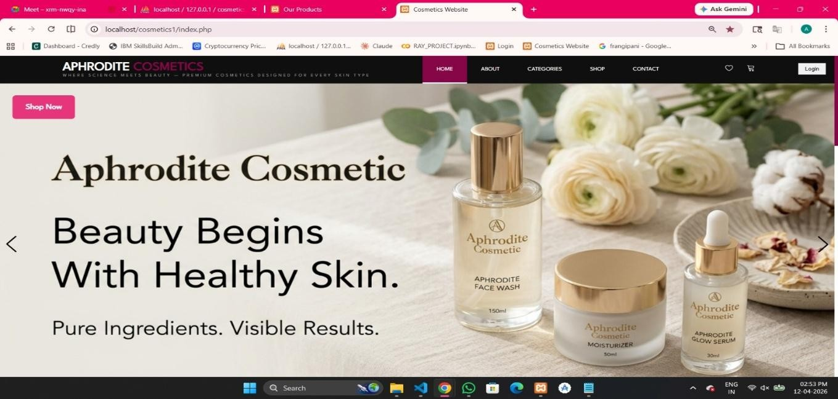

The images show the homepage of our Aphrodite Cosmetics website, designed with an elegant and attractive layout to enhance user experience. It features a navigation bar with options like Home, About, Categories, Shop, Contact, and Login for easy navigation. The main banner highlights cosmetic products along with a model, representing beauty and glowing skin. The taglines “Beauty Begins With Healthy Skin” and “Glow Naturally. Shine Confidently.” reflect the brand’s focus on natural beauty and confidence. A “Shop Now” button is provided to guide users to explore products. Overall, this section serves as the main entry point, attracting users and encouraging them to browse and shop.
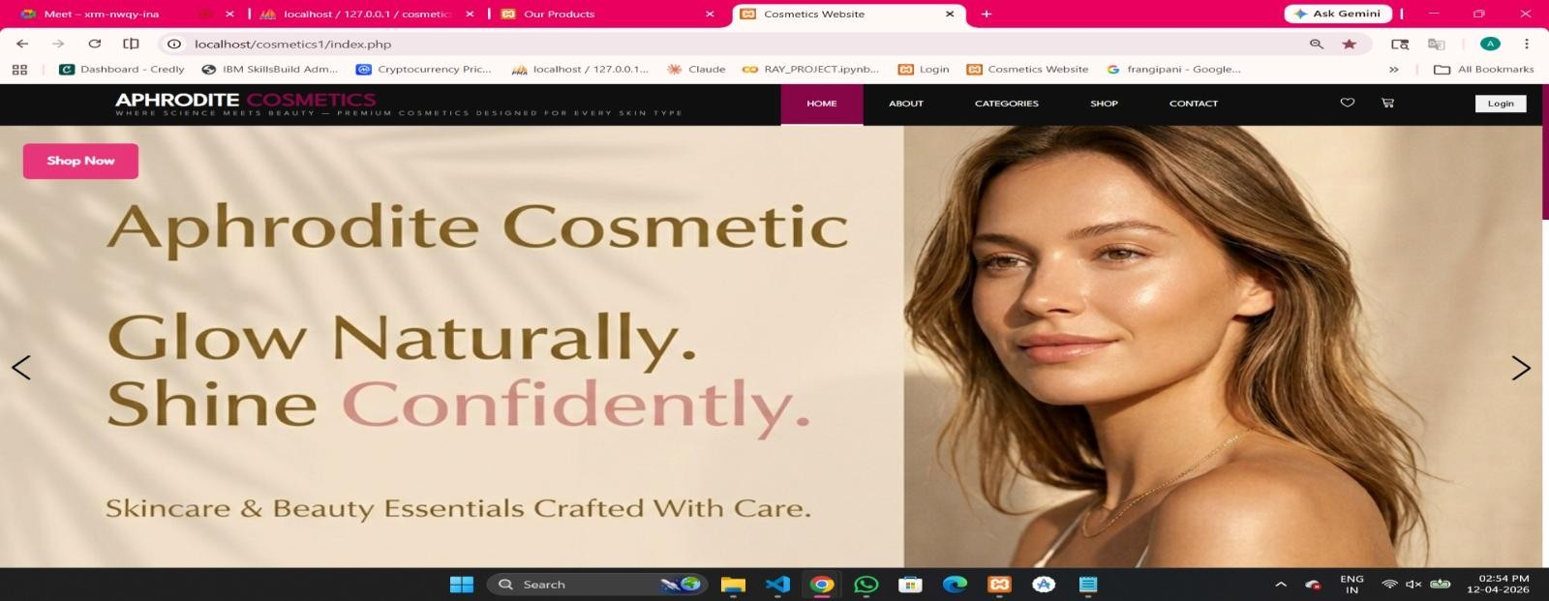
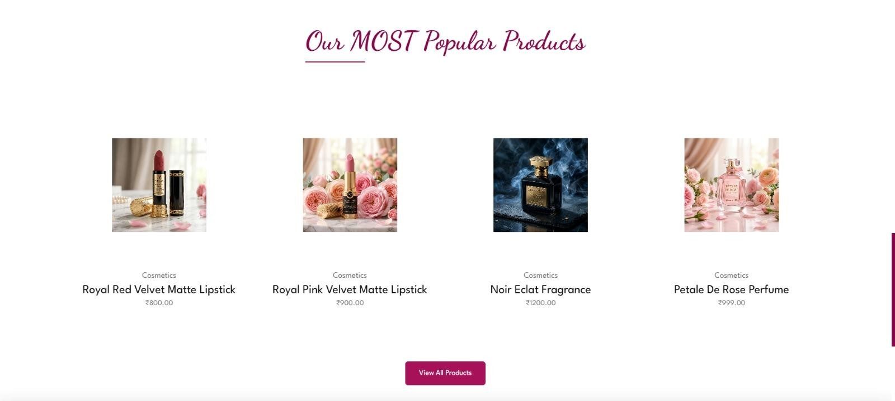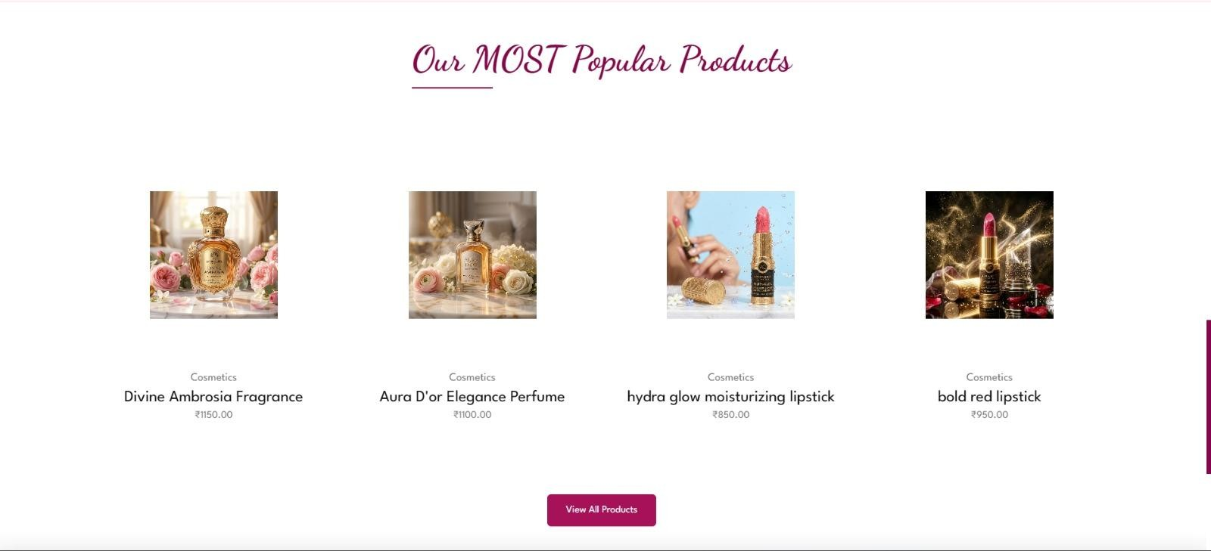
The images show the “Our Most Popular Products” section of our Aphrodite Cosmetics website, designed to showcase a variety of best-selling items. It includes products like lipsticks and fragrances displayed with their names, images, and prices for easy comparison. Each product is presented in a clean and attractive layout, helping users quickly view trending items. This section highlights both beauty and fragrance collections, enhancing product visibility. A “View All Products” button is provided to explore the complete range of items. Overall, this section helps attract customers and improves their shopping experience by displaying popular products in an organized way.



CONTACT US



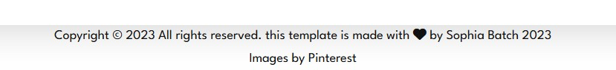

The images show the footer section of our Aphrodite Cosmetics website, which provides important information and enhances user connectivity. It includes a brief description about beauty and confidence, reflecting the brand’s message and values. The “Follow Us” section contains social media icons, allowing users to connect with the brand on different platforms. This helps in increasing engagement and building an online presence. At the bottom, a copyright notice is displayed along with credits for the template and images used. Overall, this section acts as the concluding part of the website, providing useful information and external links to users.

ABOUT US
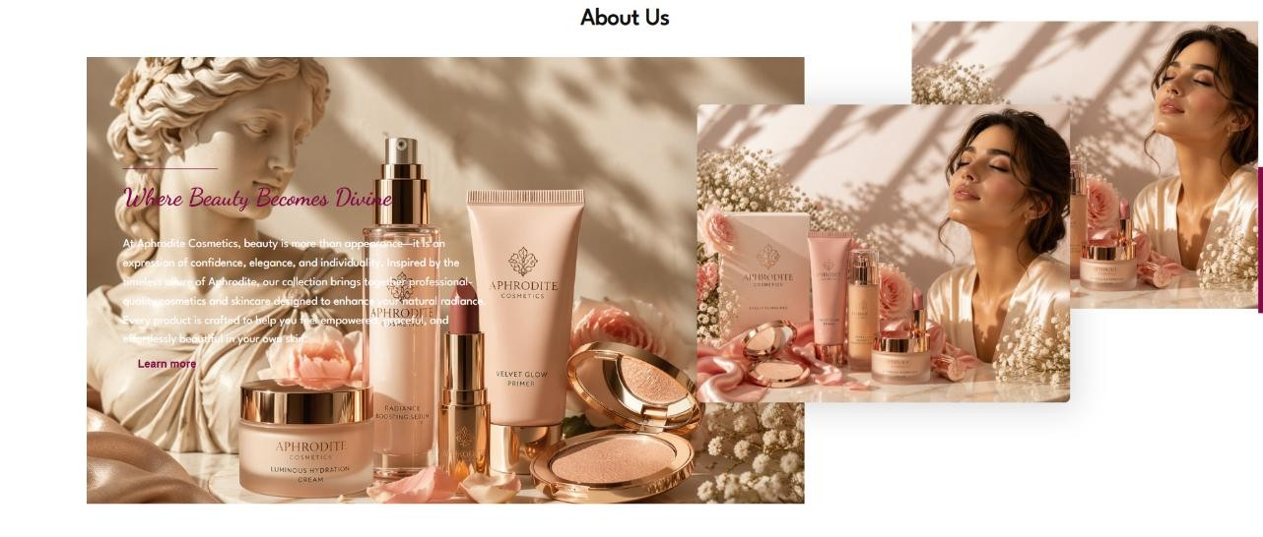

This image reflects the essence of Aphrodite Cosmetics, blending timeless elegance with modern beauty. Featuring luxurious products, soft floral elements, and a radiant model, it highlights confidence, grace, and natural glow. It beautifully represents beauty as a feeling of empowerment and self-expression.

PRODUCTS

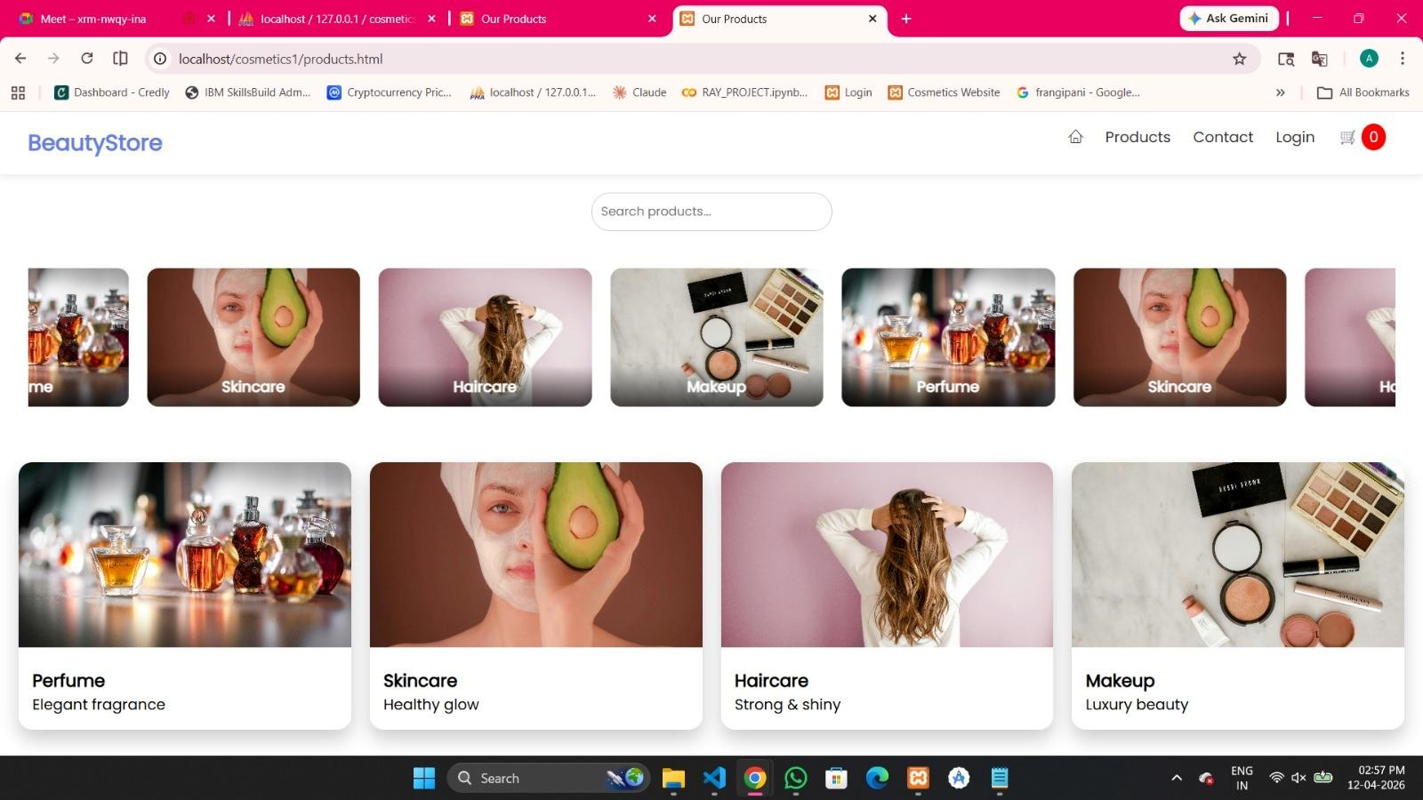

The image shows the Products page of our Aphrodite Cosmetics website, designed to help users easily explore different product categories. It includes a search bar at the top, allowing users to quickly find specific products. Categories such as Perfume, Skincare, Haircare, and Makeup are displayed with attractive images and short descriptions. Each category is organized in a card layout, making the interface clean and user-friendly. The navigation bar provides options like Home, Products, Contact, and Login for smooth navigation. Overall, this page acts as a guide for users to browse categories and choose products according to their needs.

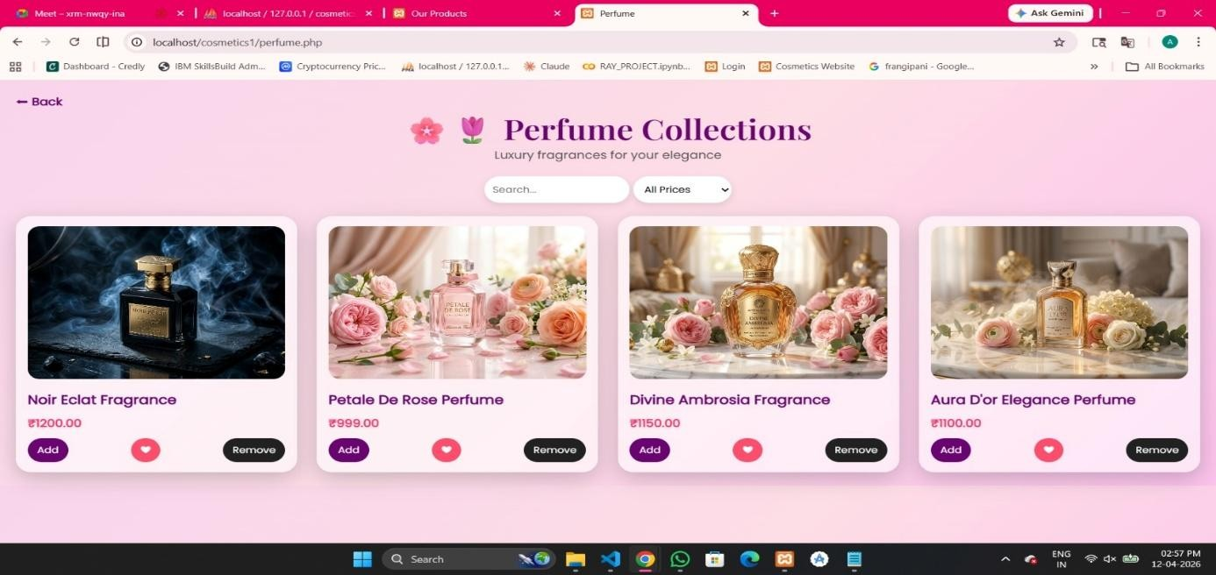

This section showcases both perfume and skincare collections with a perfect blend of luxury and freshness. The perfume products are displayed with elegant visuals that reflect sophistication, while the skincare items focus on natural glow and nourishment. Each product card includes images, pricing, and interactive options like “Add,” “Remove,” and wishlist (heart icon), allowing users to easily manage their selections. The search bar and price filter help users quickly find products based on while maintaining a premium look and feel.
their preferences, making the overall experience smooth, user-friendly, and efficient

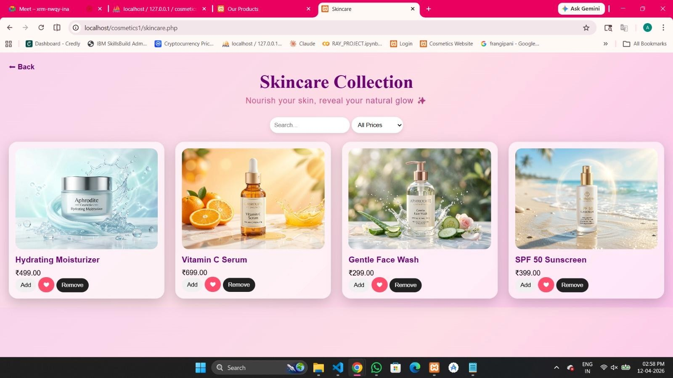
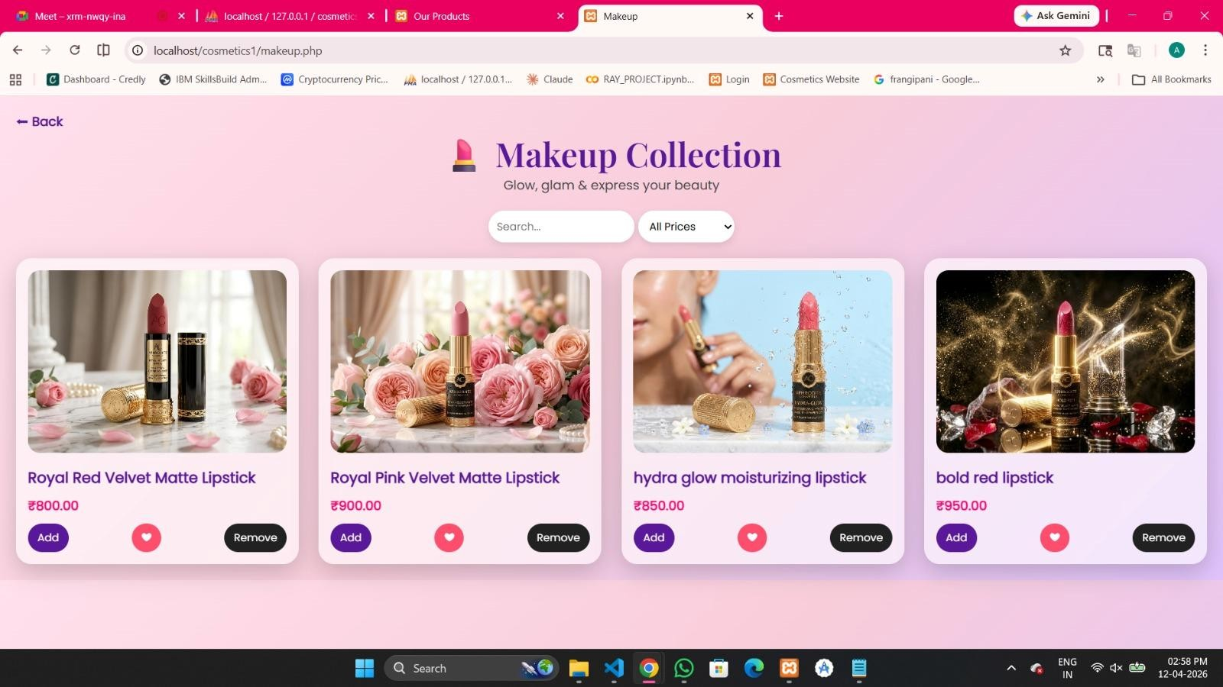

This section presents haircare and makeup collections with a perfect mix of style and functionality. The haircare products focus on nourishment, strength, and shine, while the makeup collection highlights beauty, color, and self-expression. Each product is displayed with clear images, pricing, and interactive options like “Add,” “Remove,” and wishlist, making it easy for users to shop. With features like search and filters, the interfacee ensures a smooth, user-friendly, and visually appealing shopping experience.
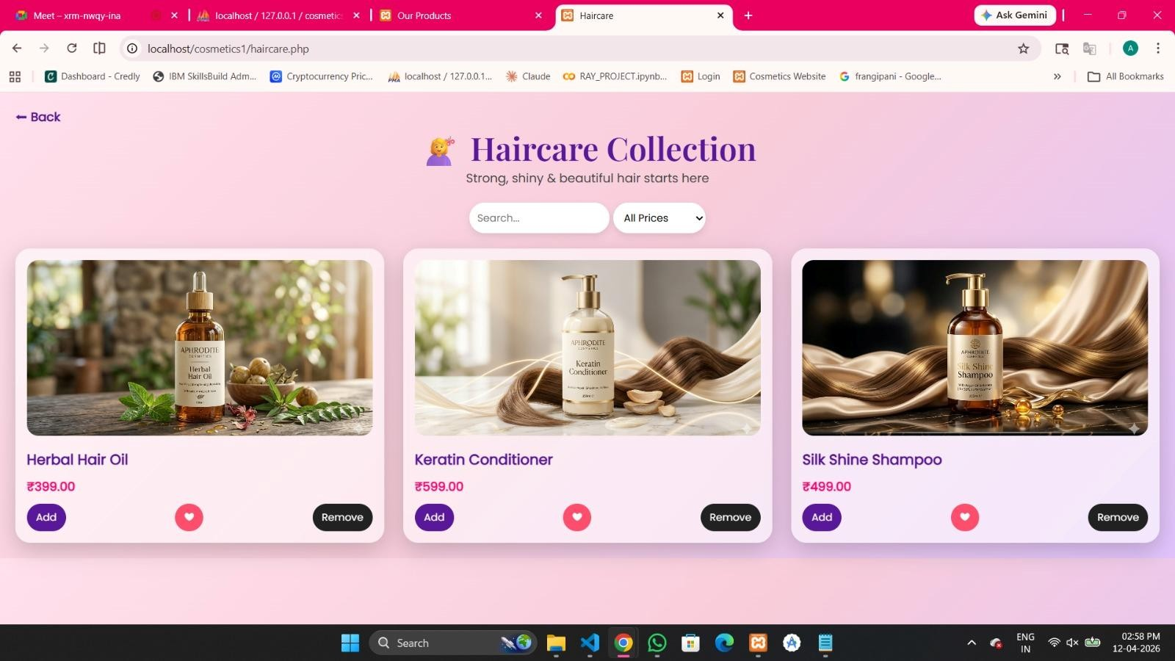

LOGIN PAGE

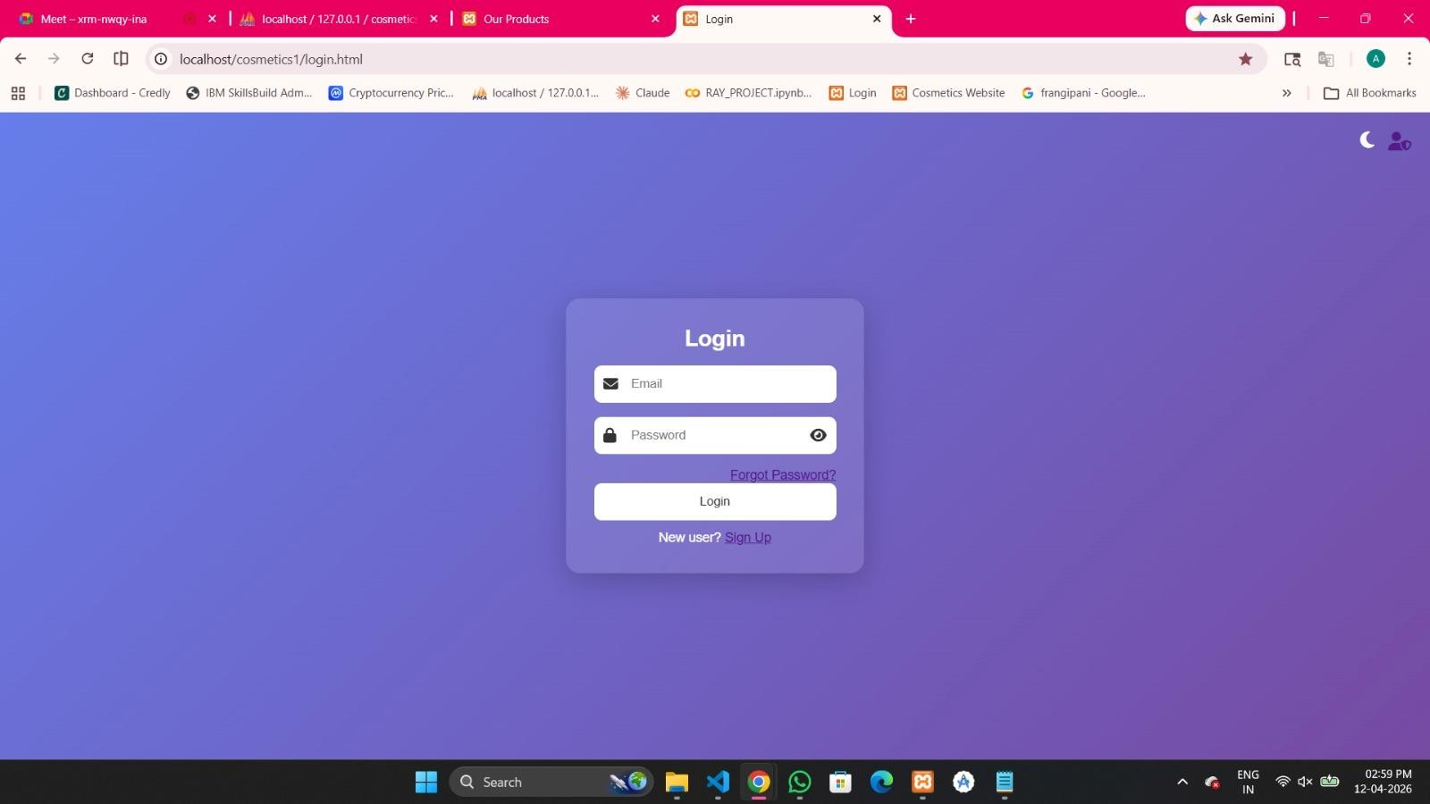
This login page features a modern and minimal design with both light and dark mode options, providing a smooth and visually appealing user experience. It includes input fields for email and password, along with features like “Forgot Password” and “Sign Up” for new users. The system allows existing users to securely log in using their credentials, while new users can create an account easily. The theme toggle enhances usability, making the interface adaptable and user-friendly.
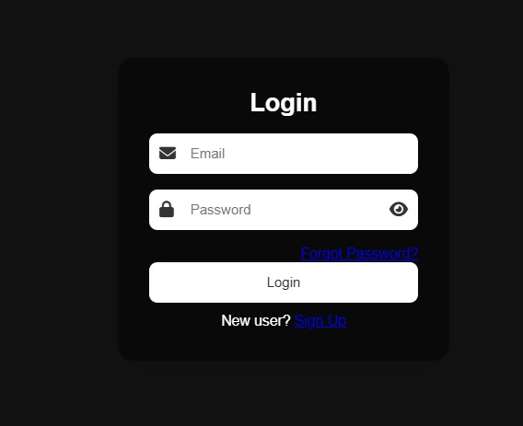

SIGN UP PAGE
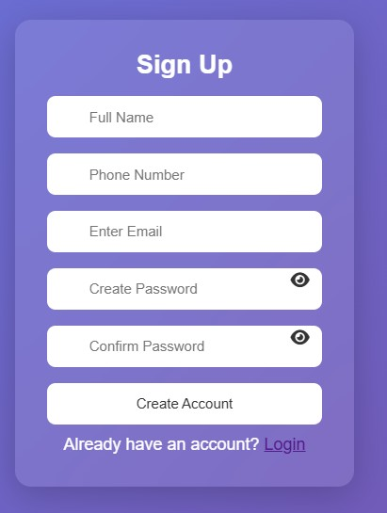

This sign-up page has a simple and userfriendly design that allows new users to create an account easily. It includes fields for full name, phone number, email, and password with confirmation for better security. The password visibility option improves usability, and the “Create Account” button enables quick registration. A login option is also provided for existing users, making navigation smooth and convenient.

ADMIN LOGIN PAGE

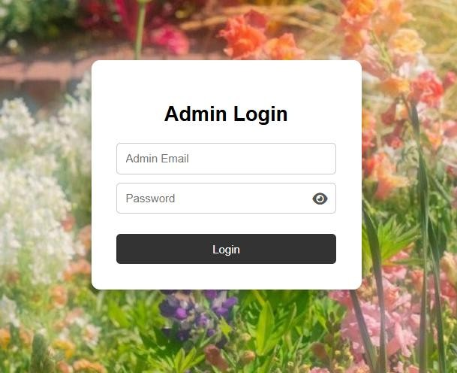
This admin login page features a clean and focused design with a soft background and centered login form. It includes fields for admin email and password, along with a password visibility option for better usability. The login button allows secure access to the admin panel, ensuring that only authorized users can manage and control the system.

ADMIN DASHBOARD PAGE
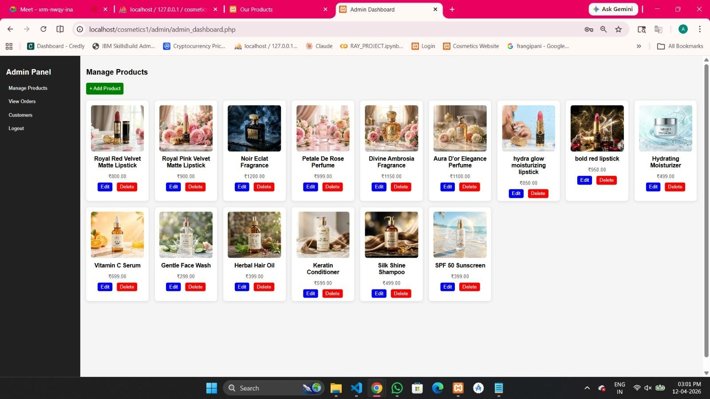

This admin dashboard provides a complete interface to manage products efficiently. It displays all products in a structured grid with images, names, and prices. The admin can easily add new products using the “Add Product” button, as well as update or remove existing items through “Edit” and “Delete” options. The sidebar allows quick navigation to manage products, view orders, check customers, and logout, making the system organized, user-friendly, and easy to control.

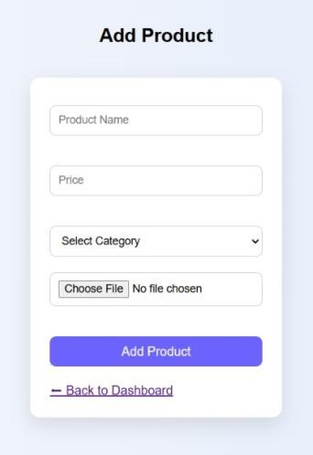

ADD PRODUCT

This “Add Product” page allows the admin to easily add new products to the system. It includes fields for product name, price, category selection, and image upload. The simple and clean form design makes data entry quick and efficient. Once the details are filled, the admin can add the product using the “Add Product” button, and also navigate back to the dashboard easily.

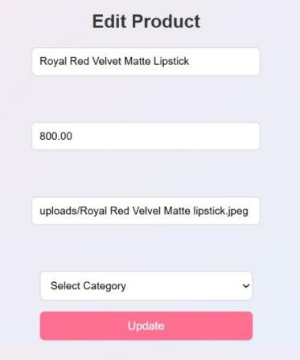

EDIT PRODUCT
This “Edit Product” page allows the admin to update existing product details easily. It includes fields for product name, price, image, and category selection. The admin can modify the information and click the “Update” button to save the changes. This makes product management simple and efficient.

ORDER LIST

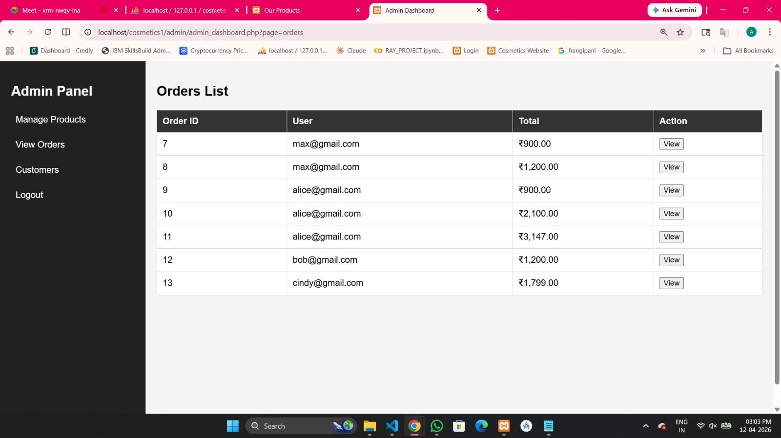

This “Orders List” page allows the admin to view all customer orders in a structured table format. It displays details such as Order ID, user email, and total amount. The “View” button enables the admin to check individual order details. The sidebar provides easy navigation to manage products, view orders, and access other admin features, making order management simple and organized.

CUSTOMERS

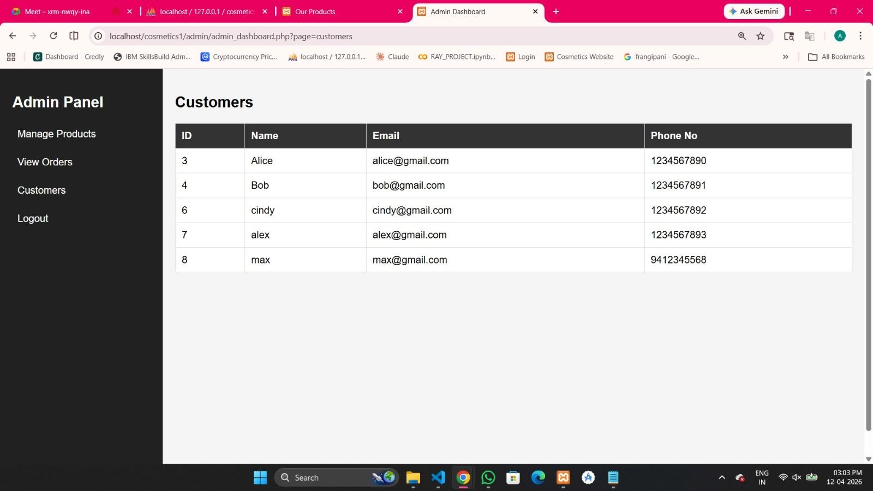

This “Customers” page allows the admin to view all registered users in a clear and organized table format. It displays details such as customer ID, name, email, and phone number. This helps the admin easily manage and track user information. The sidebar provides quick navigation to other sections like products and orders, making the system efficient and easy to use.

USER LOGOUT PAGE
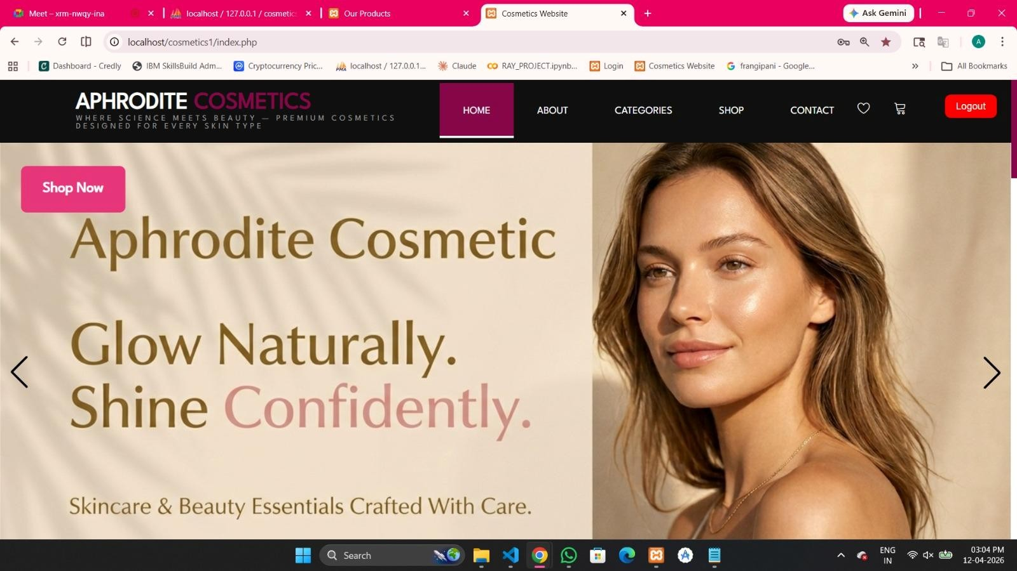

This homepage showcases the brand “Aphrodite Cosmetics” with a premium and elegant design. It features a clean navigation bar with sections like Home, About, Categories, Shop, and Contact, along with icons for wishlist and cart. The main banner appealing model image. The “Shop Now” button encourages users to explore products, highlights the brand message “Glow Naturally, Shine Confidently” with a visually
creating an engaging and attractive first impression.

ADD TO CART PAGE
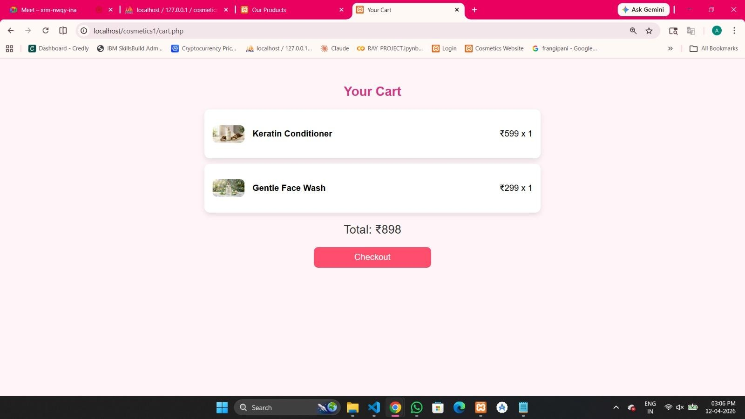

This “Cart” page displays the products selected by the user in a clean and organized layout. Each item shows its image, name, price, and quantity. The total amount is calculated automatically, giving users a clear summary of their purchase. The “Checkout” button allows users to proceed with their order easily, making the shopping process smooth and convenient.

CHECKOUT SUCCESSFUL
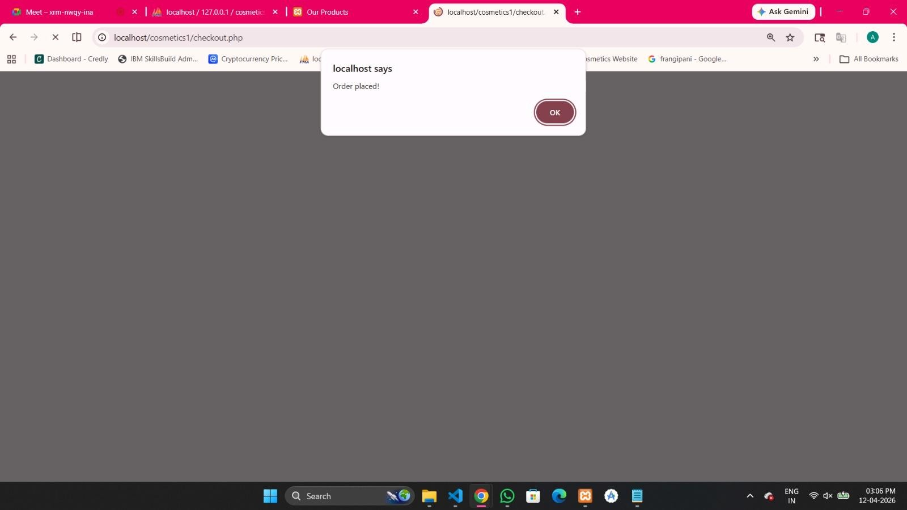

This checkout page confirms the successful placement of an order. After clicking the indicates that the order has been processed and saved in the system, providing a clear checkout button, a confirmation message (“Order placed!”) is displayed to the user. This
and satisfying end to the shopping process.

WISHLIST PAGE

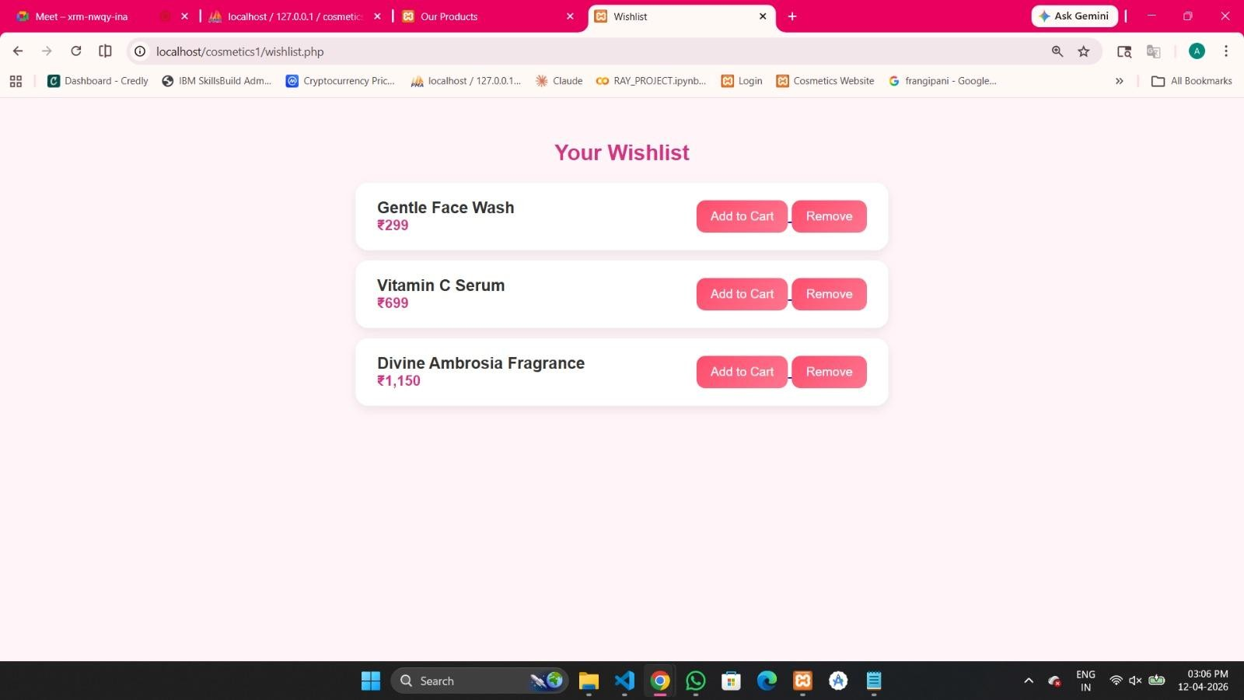

This “Wishlist” page allows users to save their favorite products for future purchase. It displays selected items with their names and prices in a clean layout. Users can easily move items to the cart using the “Add to Cart” button or remove them from the wishlist. This feature enhances the shopping experience by helping users keep track of products they like.

SQL DATABASE CONNECTION TABLES

Orders Table:
Stores information about each purchase made by users. It records the user who placed the order, the total cost, and the timestamp when the order was created.
SQL Query:
CREATE TABLE orders (
id INT(11) NOT NULL AUTO_INCREMENT,
user_id INT(11) DEFAULT NULL,
total DECIMAL(10,2) DEFAULT NULL,
created_at TIMESTAMP NOT NULL DEFAULT CURRENT_TIMESTAMP,
PRIMARY KEY (id)
);
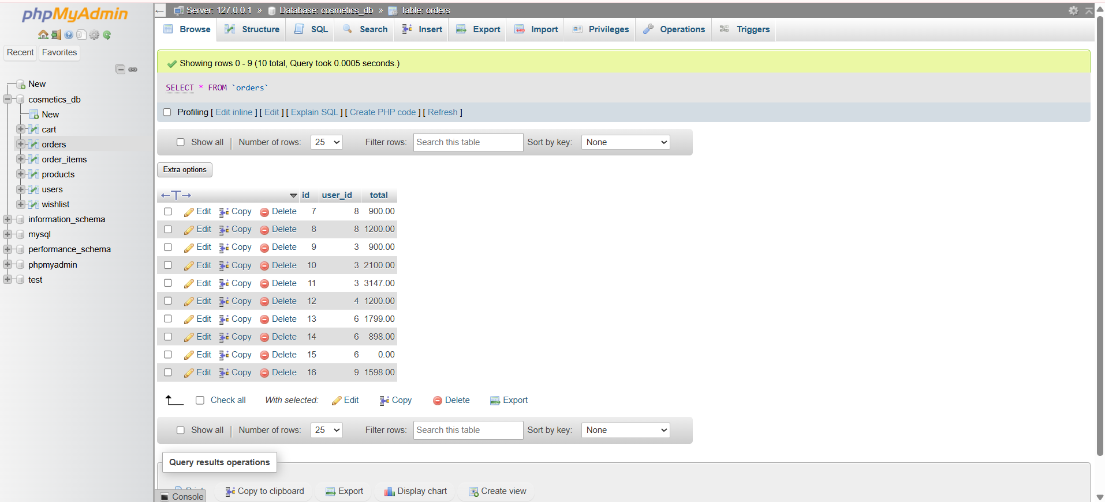

Order Items Table:
Contains the individual products included in each order. This table links orders with products and tracks the quantity of each product within a specific order.
SQL Query:
CREATE TABLE order_items (
id INT(11) NOT NULL AUTO_INCREMENT,
order_id INT(11) DEFAULT NULL,
product_id INT(11) DEFAULT NULL,
quantity INT(11) DEFAULT NULL,
PRIMARY KEY (id),
FOREIGN KEY (order_id) REFERENCES orders(id),
FOREIGN KEY (product_id) REFERENCES products(id)
);
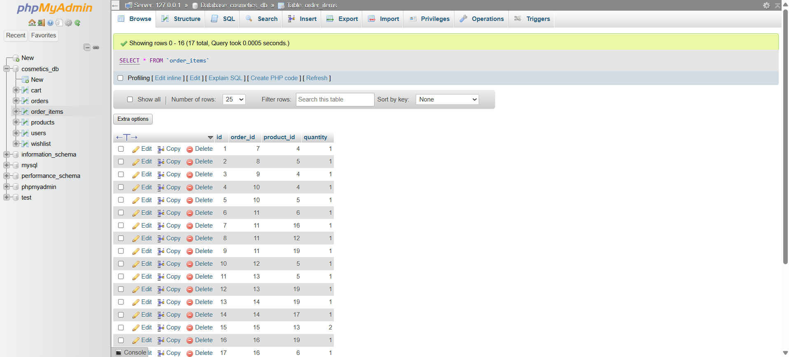

Products:
Holds all product-related details available in the system, including the product name, price, description, and associated image.
SQL Query:
CREATE TABLE products (
id INT(11) NOT NULL AUTO_INCREMENT,
name VARCHAR(100) COLLATE utf8mb4_general_ci DEFAULT NULL,
price DECIMAL(10,2) DEFAULT NULL,
description TEXT COLLATE utf8mb4_general_ci DEFAULT NULL,
image VARCHAR(255) COLLATE utf8mb4_general_ci DEFAULT NULL,
category (100) COLLATE utf8mb4_general_ci DEFAULT NULL,
PRIMARY KEY (id)
);
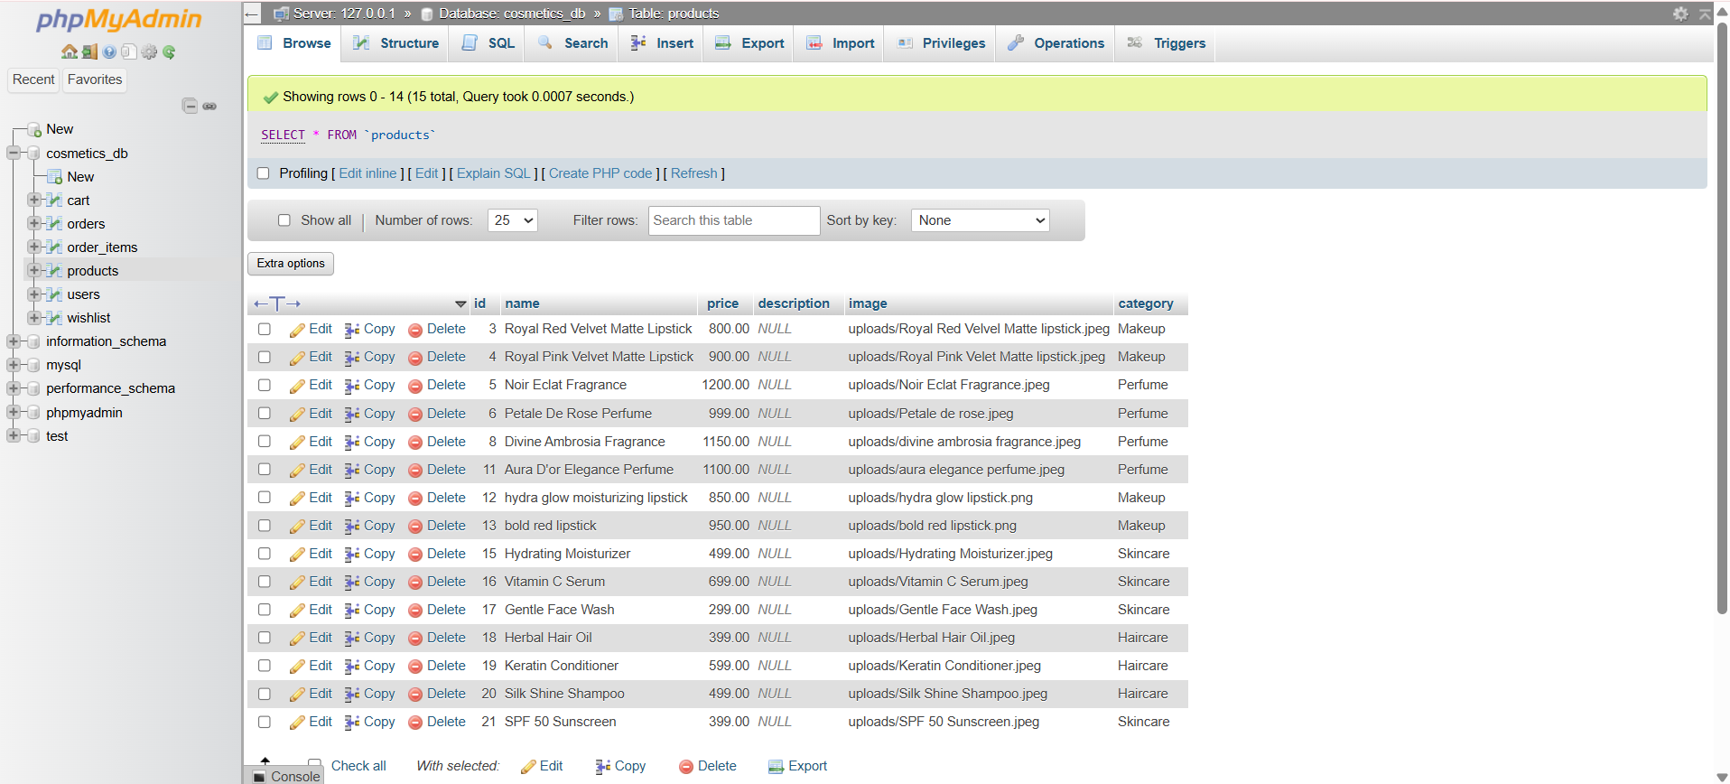

Users Table:
Manages user account information such as name, email, password, and role. It supports both regular users and administrators.
SQL Query:
CREATE TABLE users (
id INT(11) NOT NULL AUTO_INCREMENT,
name VARCHAR(100) COLLATE utf8mb4_general_ci DEFAULT NULL,
email VARCHAR(100) COLLATE utf8mb4_general_ci DEFAULT NULL,
password VARCHAR(100) COLLATE utf8mb4_general_ci DEFAULT NULL,
role ENUM('user', 'admin') COLLATE utf8mb4_general_ci DEFAULT 'user',
PRIMARY KEY (id),
INDEX (email)
);
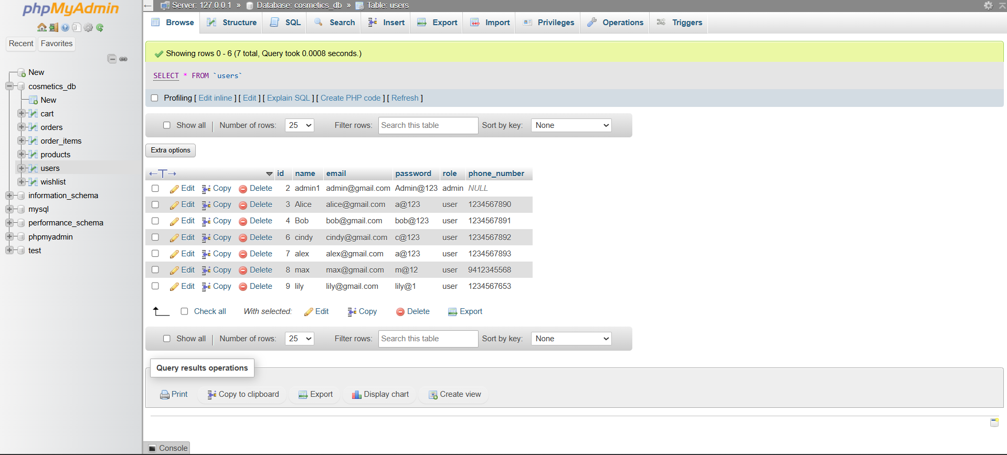

Wishlist Table:
Stores products that users have saved for future interest. It allows users to keep track of items they may want to purchase later.
SQL Query:
CREATE TABLE wishlist (
id INT AUTO_INCREMENT PRIMARY KEY,
user_id INT,
product_name VARCHAR(255),
price INT
);
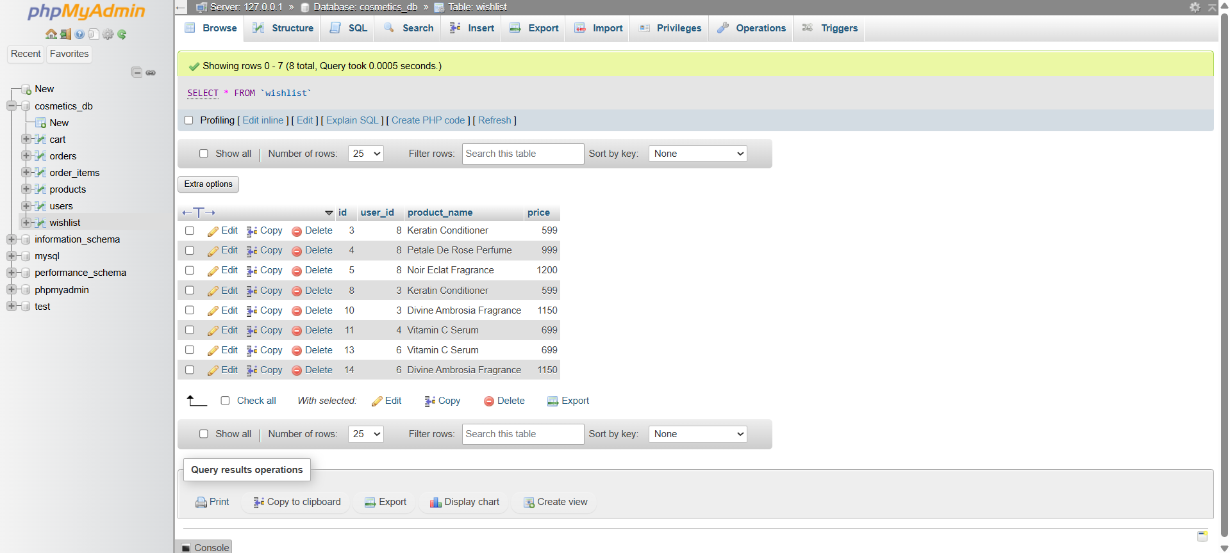

Cart Table:
Represents the shopping cart for each user. It temporarily stores selected products along with their quantity and price before checkout.
SQL Query:
CREATE TABLE cart (
id INT AUTO_INCREMENT PRIMARY KEY,
user_id INT,
product_id INT,
price INT,
quantity INT DEFAULT 1
);
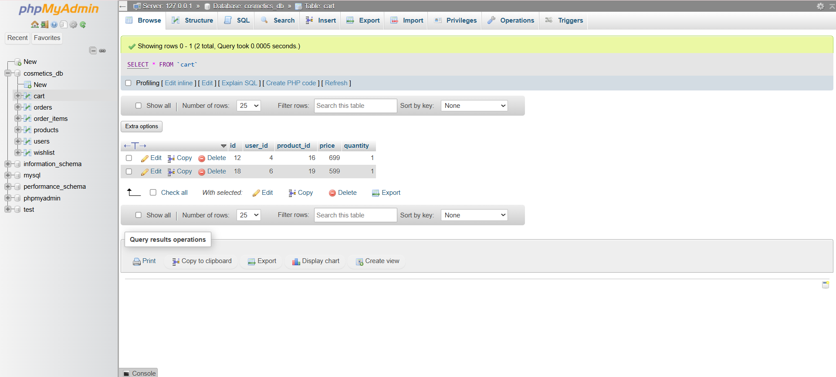

CODING

index.php

<?php
session_start();
include("db.php");
?>
<!DOCTYPE html>
<html lang="en">
<head>
<meta charset="UTF-8">
<meta name="viewport" content="width=device-width, initial-scale=1.0">
<link rel="stylesheet" href="https://cdnjs.cloudflare.com/ajax/libs/font-awesome/6.5.0/css/all.min.css">
<link rel="stylesheet" href="https://cdn.jsdelivr.net/npm/swiper@12/swiper-bundle.min.css" />
<link rel="stylesheet" href="https://cdn.linearicons.com/free/1.0.0/icon-font.min.css">
<link rel="stylesheet" href = "style.css">
<title>Cosmetics Website</title>
</head>
<body>
<nav>
<div class="container nav-container">
<a href ="#home" class = "logo">
<div>Aphrodite<span> Cosmetics</span></div>
<div>Where science meets beauty — premium cosmetics designed for every skin type</div>
</a>
<ul class="navlist">
<li><a href="#home" class="active">Home</a></li>
<li><a href="#about">About</a></li>
<li><a href="products.html">Categories</a></li>
<li><a href="#shop">Shop</a></li>
<li><a href="#footer">Contact</a></li>
</ul>
<div class="nav-icons">
<a href = "wishlist.php">
<span class="lnr lnr-heart add-to-wishlist" style="color:white;"></span>
</a>
<a href="cart.php">
<span class="lnr lnr-cart" style="color:white;"></span>
</a>
<span id="cart-count">0</span>
<div style="position:absolute; top:20px; right:20px;">
<?php if(isset($_SESSION['user_id'])): ?>
<a href="backend/logout.php">
<button style="padding:8px 15px; background:red; color:white; border:none; border-radius:8px; ">
Logout
</button>
</a>
<?php else: ?>
<a href="login.html">
<button style="padding:8px 15px;">Login</button>
</a>
<?php endif; ?>
</div>

</div>
</div>
</nav>

<!-- HOME -->
<section class="home" id="home">
<div class="home-container">
<div class="swiper mySwiper home-swiper">
<div class="swiper-wrapper">
<div class="swiper-slide slide1">
<div class="content">
<a href="products.html" style="
display: inline-block;
padding: 15px 30px;
font-size: 20px;
font-weight: bold;
color: #fff;
background-color: #e7367a;
text-decoration: none;
border-radius: 8px;
text-align: center;
">
Shop Now
</a>
</div>
</div>

<div class="swiper-slide slide3">
<div class="content">
<a href="products.html" style="
display: inline-block;
padding: 15px 30px;
font-size: 20px;
font-weight: bold;
color: #fff;
background-color: #e7367a;
text-decoration: none;
border-radius: 8px;
text-align: center;
">
Shop Now
</a>
</div>
</div>
</div>
<div class="swiper-button-next"></div>
<div class="swiper-button-prev"></div>
</div>
</div>
</section>

<!-- ABOUT -->
<section class="about" id="about">
<h2>About Us</h2>
<div class="container about-container">
<div class="left">
<div class="content">
<div class="title">
<h2>Where Beauty Becomes Divine</h2>
</div>
<p style="color: white;">At Aphrodite Cosmetics,
beauty is more than appearance—it is an expression
of confidence, elegance, and individuality.
Inspired by the timeless allure of Aphrodite,
our collection brings together professional-quality
cosmetics and skincare designed to enhance your
natural radiance. Every product is crafted to help
you feel empowered, graceful, and effortlessly
beautiful in your own skin.</p>
<button class="btn">Learn more</button>
</div>
</div>
<div class="right">
<div class="image">
<img src = "images/ss3.jpg" alt="">
</div>
</div>
</div>
</section>

<!-- SHOP -->
<section class="shop" id="shop">
<div class="title">
<h2>Our MOST Popular Products</h2>
</div>
<div class="container shop-container">
<div class="swiper mySwiper shop-swiper">
<div class="swiper-wrapper">

<?php
$result = mysqli_query($conn, "SELECT * FROM products");

if(mysqli_num_rows($result) > 0){
while($row = mysqli_fetch_assoc($result)){
?>

<div class="swiper-slide">
<div class="box"
data-id="<?php echo $row['id']; ?>"
data-name="<?php echo $row['name']; ?>"
data-price="<?php echo $row['price']; ?>"
data-image="<?php echo $row['image']; ?>">

<div class="image">
<img src="<?php echo $row['image']; ?>" alt="">
<div class="add">
<span class="lnr lnr-cart add-to-cart"></span>
<span class="lnr lnr-heart add-to-wishlist"></span>
</div>
</div>

<div class="info">
<p>Cosmetics</p>
<h4><?php echo $row['name']; ?></h4>
<span>₹<?php echo $row['price']; ?></span>
</div>

</div>
</div>

<?php
}
} else {
echo "<p>No products found</p>";
}
?>

</div>
</div>
</div>
<!-- CENTER BUTTON -->
<div class="view-all-btn">
<a href="products.html" class="btn">View All Products</a>
</div>
</section>

<!-- Footer -->
<section class="footer" id = "footer">
<div class="container footer-container">
<div class="box">
<a href="#home" class="logo">
<div>Make<span>up</span></div>
<div>Fashion Steps</div>
</a>
<p>true beauty comes from confidence—the confidence to be yourself, to embrace your uniqueness, and to shine unapologetically.
When you care for your skin and nurture your natural glow, you don’t just enhance your beauty—you elevate your confidence.
And that confidence is what makes you truly unforgettable.</p>
</div>
<!--
<div class="box">
<h4>Newsletter</h4>
<p>Stay update with our latest products, news and discounts</p>
<form action="" class="newsletter">
<input type="email" name="email" id="" placeholder="Enter Email">
<button type="submit" class="btn"><span class="lnr
lnr-arrow-right" ></span></button>
</form>
</div> -->
<div class="box">
<h4>Follow us</h4>
<p>Follow us on social media platforms.</p>
<div class="social">
<i class="fa-brands fa-facebook"></i>
<i class="fa-brands fa-instagram"></i>
<i class="fa-brands fa-twitter"></i>
<i class="fa-brands fa-linkedin"></i>
</div>
</div>
</div>
</section>
<div class="copyright">
<p>Copyright &copy; 2023 All rights reserved. this template is made with
<i class="fa-solid fa-heart"></i> by Sophia Batch 2023
</p>
<p>Images by Pinterest</p>
</div>
<script>
function logoutUser() {
fetch("backend/logout.php")
.then(() => {
window.location.reload();
});
}
document.querySelectorAll(".add-to-wishlist").forEach(btn => {

btn.addEventListener("click", function(){

let productBox = this.closest(".box");

let name = productBox.getAttribute("data-name");
let price = productBox.getAttribute("data-price");

fetch("backend/add_wishlist.php", {
method: "POST",
headers: {
"Content-Type": "application/x-www-form-urlencoded"
},
body: `name=${name}&price=${price}`
})
.then(res => res.text())
.then(data => {
console.log(data);

if(data === "success"){
this.classList.add("active");
alert("Added to wishlist!");
} else if(data === "removed"){
this.classList.remove("active");
alert("Removed from wishlist!");
} else if(data === "not_logged_in"){
alert("Please login first!");
window.location.href = "login.html";
} else {
alert(data);
}
});

});

});
document.querySelectorAll(".add-to-cart").forEach(btn => {
btn.addEventListener("click", function () {

let box = this.closest(".box");

if (!box) {
console.log("BOX NOT FOUND");
return;
}

let id = box.getAttribute("data-id");
let price = box.getAttribute("data-price");

console.log("CLICKED:", id, price);

fetch("backend/add_to_cart.php", {
method: "POST",
headers: {
"Content-Type": "application/x-www-form-urlencoded"
},
body: `id=${id}&price=${price}`
})
.then(res => res.text())
.then(data => {
console.log("SERVER:", data);

if (data.trim() === "success") {
alert("Added to cart!");
} else {
alert(data);
}
});

});
});</script>
<script src="https://cdn.jsdelivr.net/npm/swiper@12/swiper-bundle.min.js"></script>
<script src="https://cdn.linearicons.com/free/1.0.0/svgembedder.min.js"></script>
<script src = "script.js"></script>
</body>
</html>

Login.html

<!DOCTYPE html>
<html lang="en">
<head>
<meta charset="UTF-8">
<meta name="viewport" content="width=device-width, initial-scale=1.0">
<title>Login</title>

<link rel="stylesheet" href="https://cdnjs.cloudflare.com/ajax/libs/font-awesome/6.5.0/css/all.min.css">

<style>
* {
margin: 0;
padding: 0;
box-sizing: border-box;
font-family: Arial;
}

/* Background */
body {
height: 100vh;
display: flex;
justify-content: center;
align-items: center;
background: linear-gradient(135deg, #667eea, #764ba2);
}

/* Glassmorphism Box */
.login-box {
backdrop-filter: blur(15px);
background: rgba(255,255,255,0.1);
padding: 30px;
width: 320px;
border-radius: 15px;
box-shadow: 0 8px 32px rgba(0,0,0,0.2);
color: white;
text-align: center;
}

/* Inputs */
.input-group {
position: relative;
margin: 15px 0;
}

.input-group input {
width: 100%;
padding: 12px 40px;
border-radius: 8px;
border: none;
outline: none;
}

.input-group i {
position: absolute;
top: 12px;
color: #333;
}
.top-icons {
position: absolute;
top: 20px;
right: 20px;
display: flex;
gap: 15px;
font-size: 20px;
color: white;
}

.top-icons i {
cursor: pointer;
transition: 0.3s;
}

.top-icons i:hover {
color: #ddd;
}

.left-icon { left: 10px; }
.right-icon { right: 10px; cursor: pointer; }

/* Button */
button {
width: 100%;
padding: 12px;
border: none;
background: #fff;
color: #333;
border-radius: 8px;
cursor: pointer;
}

/* Dark Mode */
.dark {
background: #121212;
}

.dark .login-box {
background: rgba(0,0,0,0.5);
color: white;
}

.toggle-dark {
position: absolute;
top: 20px;
right: 20px;
cursor: pointer;
color: white;
}
/* Eye icon (professional) */
.eye{
position:absolute;
right:12px;
top:50%;
transform:translateY(-50%);
cursor:pointer;
color:#555;
}
</style>
</head>

<body>

<div class="top-icons">
<!-- Dark Mode -->
<i class="fas fa-moon" onclick="toggleDark()" title="Dark Mode"></i>

<!-- Admin -->
<a href="admin.html" title="Admin Login">
<i class="fas fa-user-shield"></i>
</a>
</div>
<div class="login-box">
<h2>Login</h2>

<form action="backend\login.php" method="POST">

<div class="input-group">
<i class="fas fa-envelope left-icon"></i>
<input type="email" name="email" placeholder="Email" required>
</div>

<div class="input-group">
<i class="fas fa-lock left-icon"></i>
<input type="password" id="password" name="password" placeholder="Password" required>
<i class="fas fa-eye right-icon" onclick="togglePassword()" id="eye"></i>
</div>

<p style="text-align:right; font-size:14px;">
<a href="#" onclick="forgotPassword()">Forgot Password?</a>
</p>

<!-- ✅ FIXED BUTTON -->
<button type="submit">Login</button>

<p style="margin-top:10px; font-size:14px;">
New user? <a href="#" onclick="showSignup()">Sign Up</a>
</p>

</form>
</div>

<!-- SIGNUP BOX -->
<div class="login-box" id="signupBox" style="display:none;">
<h2>Sign Up</h2>

<form onsubmit="return signupUser()">
<div class="input-group">
<input type="text" id="name" placeholder="Full Name" required>
</div>
<div class="input-group">
<input type="tel" id="phone" placeholder="Phone Number"
pattern="[0-9]{10}" maxlength="10" required>
</div>

<div class="input-group">
<input type="email" id="newEmail" placeholder="Enter Email" required>
</div>

<div class="input-group">
<input type="password" id="newPassword" placeholder="Create Password" required>
<i class="fa-solid fa-eye eye" onclick="togglePass('password',this)"></i>
</div>
<div class="input-group">
<input type="password" id="confirm" placeholder="Confirm Password" required>
<i class="fa-solid fa-eye eye" onclick="togglePass('confirm',this)"></i>
</div>

<button type="submit">Create Account</button>

<p style="margin-top:10px;">
Already have an account?
<a href="login.html" onclick="showLogin()">Login</a>
</p>
</form>
</div>

<script>
// 🌙 DARK MODE
function toggleDark() {
document.body.classList.toggle("dark");
}

// 👁 LOGIN PASSWORD
function togglePassword() {
let pass = document.getElementById("password");
let icon = document.getElementById("eye");

if (pass.type === "password") {
pass.type = "text";
icon.classList.replace("fa-eye","fa-eye-slash");
} else {
pass.type = "password";
icon.classList.replace("fa-eye-slash","fa-eye");
}
}

// 👁 SIGNUP PASSWORD
function togglePass(id,icon){
let field = document.getElementById(id);

if(field.type === "password"){
field.type = "text";
icon.classList.replace("fa-eye","fa-eye-slash");
}else{
field.type = "password";
icon.classList.replace("fa-eye-slash","fa-eye");
}
}

// 🔐 LOGIN (FIXED)
function loginUser() {
let email = document.getElementById("email").value;
let pass = document.getElementById("password").value;

// ✅ ADMIN LOGIN FIRST
if(email === "admin@gmail.com" && pass === "Admin@123"){
alert("Admin Login");
window.location.href = "admin.html";
return false;
}

let users = JSON.parse(localStorage.getItem("users")) || [];

let user = users.find(u => u.email === email && u.password === pass);

if(user){
alert("Login Successful!");
window.location.href = "login.html";
} else {
alert("Invalid email or password");
}

return false;
}

// 🆕 SIGNUP (FIXED)
function signupUser(){
let name = document.getElementById("name").value.trim();
let phone = document.getElementById("phone").value.trim();
let email = document.getElementById("newEmail").value.trim();
let pass = document.getElementById("newPassword").value;
let confirm = document.getElementById("confirm").value;

if(!name || !phone || !email || !pass || !confirm){
alert("All fields are required");
return false;
}

if(pass !== confirm){
alert("Passwords do not match");
return false;
}

fetch("signup.php", {
method: "POST",
headers: {
"Content-Type": "application/x-www-form-urlencoded"
},
body: `name=${name}&phone=${phone}&email=${email}&password=${pass}`
})
.then(res => res.text())
.then(data => {
alert(data);
});

return false;
}

// 🔄 SWITCH FORMS
function showSignup(){
document.querySelector(".login-box").style.display = "none";
document.getElementById("signupBox").style.display = "block";
}

function showLogin(){
document.querySelector(".login-box").style.display = "block";
document.getElementById("signupBox").style.display = "none";
}

// 🔑 FORGOT PASSWORD (FIXED)
function forgotPassword(){
let email = prompt("Enter your registered email:");

let users = JSON.parse(localStorage.getItem("users")) || [];

let user = users.find(u => u.email === email);

if(user){
let newPass = prompt("Enter new password:");
user.password = newPass;

localStorage.setItem("users", JSON.stringify(users));

alert("Password updated successfully!");
} else {
alert("Email not found!");
}
}

</script>
</body>
</html>

signup.php

<?php
session_start();
include "db.php";

mysqli_report(MYSQLI_REPORT_ERROR | MYSQLI_REPORT_STRICT);

if (!isset($_SESSION['user'])) {
echo "login_required";
exit;
}

// GET JSON DATA
$data = json_decode(file_get_contents("php://input"), true);

if (!$data || !isset($data['cart'])) {
echo "invalid_cart_data";
exit;
}

$cart = $data['cart'];

if (!is_array($cart) || count($cart) === 0) {
echo "empty_cart";
exit;
}

$user_email = $_SESSION['user']['email'];

// GET USER ID
$stmt_user = $conn->prepare("SELECT id FROM users WHERE email = ?");
$stmt_user->bind_param("s", $user_email);
$stmt_user->execute();
$result = $stmt_user->get_result();
$user = $result->fetch_assoc();

if (!$user) {
echo "user_not_found";
exit;
}

$user_id = (int)$user['id'];

$total = 0;

// CALCULATE TOTAL
foreach ($cart as $item) {
if (!isset($item['price'], $item['quantity'])) continue;

$total += (float)$item['price'] * (int)$item['quantity'];
}

if ($total <= 0) {
echo "invalid_total";
exit;
}

// INSERT ORDER
$stmt = $conn->prepare("INSERT INTO orders (user_id, total) VALUES (?, ?)");
$stmt->bind_param("id", $user_id, $total);
$stmt->execute();

$order_id = $stmt->insert_id;

// INSERT ORDER ITEMS
$stmt2 = $conn->prepare("INSERT INTO order_items (order_id, product_id, quantity) VALUES (?, ?, ?)");

foreach ($cart as $index => $item) {

if (!is_array($item)) {
echo "Invalid item at index: $index";
print_r($item);
exit;
}

if (!isset($item['id'], $item['quantity'])) {
echo "Missing data at index: $index";
print_r($item);
exit;
}

$product_id = (int)$item['id'];
$qty = (int)$item['quantity'];

$stmt2->bind_param("iii", $order_id, $product_id, $qty);
$stmt2->execute();
}

echo "success";
?>

Style.css

@import url('https://fonts.googleapis.com/css2?family=Dancing+Script:wght@400..700&display=swap');
@import url('https://fonts.googleapis.com/css2?family=League+Spartan&display=swap');

*{
margin: 0;
padding: 0;
box-sizing: border-box;
list-style: none;
text-decoration: none;
border: none;
outline: none;
resize: none;
}

:root{
--color-primary: #fff;
--color-secondry: #860849;
--color-tertiary: #777;
--color-text: #111;
--color-bg: #eee;
--shadow: 0 2px 40px 8px rgba(15, 15, 15, .15 );
--transition: all .4s ease-in-out;
--width-lg: 85%;
--width-sm: 95%;
}

body{
font-family: 'Dancing Script', cursive;
font-family: 'League Spartan', sans-serif;
color: var(--color-text);
line-height: 1.7;
overflow-x: hidden;
}

::-webkit-scrollbar{
height: .5rem;
width: .5rem;
}

::-webkit-scrollbar-track{
background: var(--color-primary);
}

::-webkit-scrollbar-thumb{
background: var(--color-secondry);
}

img{
display: block;
width: 100%;
object-fit: cover;
}

a{
color: var(--color-text);
}

span{
font-size: .9rem;
}
h1,h2,h3,h4{
line-height: 1.2;
}

h1{
font-size: 2.8rem;
}

h2{
font-size: 2rem;
}

h3{
font-size: 1.8rem;
}

h4{
font-size: 1.6rem;
}

h5{
font-size: 1rem;
}

.container{
margin: 0 auto;
width: var(--width-lg);
}

section{
padding: 6rem 0 3rem;
}

section h2{
text-align: center;
margin-bottom: 2rem;
}

.title{
text-align: center;
margin-bottom: 4rem;
}

.title h2{
font-size: 3.5rem;
margin-bottom: 4rem;
text-transform: capitalize;
font-family: 'Dancing Script', cursive;
color: var(--color-secondry);
display: inline-block;
position: relative;
}

.title h2::before{
position: absolute;
/* font-weight: 400; */
content: '';
bottom: -21%;
left: 0;
transform: translateY(-50%);
width: 8rem;
height: .1rem;
background: var(--color-secondry);
}

/* NAVBAR */
nav{
background: var(--color-text);
color: var(--color-primary) !important;
}

.logo{
color: var(--color-primary);
padding: 1rem 0;
}

.logo div:first-child{
font-weight: 700;
text-transform: uppercase;
font-size: 2rem;
line-height: 1;
}

.logo div:first-child span{
font-weight: 700;
text-transform: uppercase;
font-size: 2rem;
line-height: 1;
color: var(--color-secondry);
}

.logo div:last-child{
line-height: 1;
text-transform: uppercase;
font-size: .7rem;
letter-spacing: .23rem;
color: #999;
}

.nav-container{
display: flex;
align-items: center;
justify-content: space-between;
}

nav .navlist{
display: flex;
}
nav .navlist li{
text-transform: uppercase;
font-size: .9rem;
cursor: pointer;
z-index: 111;
position: relative;
}

nav .navlist li a{
color: var(--color-primary);
padding: 2rem;
position: relative;
}

.navlist li a::before{
content: '';
position: absolute;
top: 0;
left: 0;
background: var(--color-secondry);
height: 0%;
width: 100%;
border-bottom: .2rem solid var(--color-primary);
z-index: -1;
transition: var(--transition);
opacity: 0;
visibility: hidden;
}

.navlist li a:hover::before,
.navlist li a.active::before{
height: 95%;
opacity: 1;
visibility: visible;
}

.menu-btn .lnr{
font-size: 1.1rem;
display: none;
}

.nav-icons{
display: flex;
gap: 2rem;
}

.nav-icons i {
font-size: 1.1rem;
cursor: pointer;
}

.nav-icons .lnr{
font-size: 1.1rem;
cursor: pointer;
}

.nav-icons .lnr:hover{
color: var(--color-secondry);
}

/* HOME */
.home{
padding: 0;
}

.home .slide1{
background: url('uploads/s1.jpeg') no-repeat center/cover;
height: 100vh;
width: 100%;
}

.home .slide3{
background: url('uploads/s3.jpeg') no-repeat center/cover;
height: 100vh;
width: 100%;
}

.home .swiper-slide{
position: relative;
}

.home .swiper-slide .content{
position: absolute;
transform: translate(20%, 50%);
max-width: 550px;
}

.home h1{
font-size: 3.5rem;
text-transform: capitalize;
font-weight: 800;
color: var(--color-primary);
}

.home .content p{
margin: 2rem 0 1rem;
color: #eee;
}

.home .home-search input{
height: 4rem;
width: 22rem;
border-radius: 3rem;
padding: 1rem 1.6rem;
padding-left: 1.9rem;
font-size: 1rem;
}

.home .home-search .btn{
padding: 1rem 1.6rem;
height: 4rem;
/* -webkit-text-stroke-width: 4rem; */
width: 4rem;
margin: 0;
padding: 0;
border: 0;
border-radius: 0 50% 50% 50%;
position: relative;
left: -4rem;
background: var(--color-secondry);
color: var(--color-primary);
}

.home-search .lnr{
font-size: 1.1rem;
font-weight: 700;
}

.home .swiper-button-next.swiper-button-disabled,
.home .swiper-button-prev.swiper-button-disabled{
opacity: 1;
}

.home .swiper-button-next::after{
color: var(--color-primary);
background: var(--color-secondry);
font-size: 2rem;
font-weight: 900;
height: 7rem;
width: 7rem;
border-radius: 50%;
position: absolute;
bottom: -9rem;
right: -3.5rem;
display: flex;
align-items: center;
justify-content: center;
}

.home .swiper-button-prev::after{
color: var(--color-primary);
background: var(--color-secondry);
font-size: 2rem;
font-weight: 900;
height: 7rem;
width: 7rem;
border-radius: 50%;
position: absolute;
bottom: -9rem;
left: -3.5rem;
display: flex;
align-items: center;
justify-content: center;
}

/* ABOUT */

.about-container .right{
position: relative;
}

.about-container .right::before{
content: '';
position: absolute;
height: 100%;
width: 100%;
top: -3rem;
right: -9rem;
background: url(images/r4.jpg) no-repeat;
background-size: contain;
}

.about-container{
display: grid;
grid-template-columns: 2fr 1fr ;
}

.about-container .left{
background: url(uploads/g1.png);
min-height: 600px; /* or 70vh */
width: 100%;
background-position: center;
background-size: cover; /* IMPORTANT */
z-index: 11;
position: relative;
}

.about-container .left .content{
position: absolute;
top: 50%;
left: 8.8rem;
transform: translateY(-50%); /* centers vertically */
max-width: 30rem;
left: 5%;
right: 5%;
max-width: 500px;
}

.about-container .title{
text-align: left;
margin-bottom: 0;
}

.about-container .title h2{
font-size: 2rem;
font-weight: 900;
margin-bottom: 2rem;
/* color: var(--color-text); */
}

.about-container .left h2::before{
top: -1.2rem;
}

.about-container .content p{
color: var(--color-tertiary);
line-height: 1.6;
}

.about-container .btn{
background: none;
/* border: none;
padding: 0; */
color: var(--color-secondry);
/* text-transform: none; */
font-size: .9rem;
font-weight: 700;
cursor: pointer;
}

.about-container .right .image{
position: relative;
margin-top: 4rem;
margin-bottom: 4rem;
margin-left: -9rem;
z-index: 11;
}

.about-container .right .image img{
border-radius: .5rem;
max-width: 500px;
box-shadow: var(--shadow);
}

/* SHOP */

.shop{
background: var(--color-primary);
margin-top: 3rem;
padding: 3rem 0;
}

.shop .swiper-slide{
margin-bottom: 2rem;
}

.shop .swiper-slide .box{
text-align: center;
}

.shop .swiper-slide .image{
padding: 1rem .2rem 2rem;
background: var(--color-primary);
position: relative;
}
.shop .image img{
height: 266px;
width: 266px;
padding: 2rem;
margin: auto;
}

.shop .swiper-slide .add{
position: absolute;
bottom: -3rem;
left: 0;
background: var(--color-secondry);
color: var(--color-primary);
width: 100%;
display: flex;
align-items: center;
justify-content: center;
z-index: 11;
transition: var(--transition);
opacity: 0;
visibility: hidden;
}

.shop .swiper-slide .add .lnr{
padding: 1rem;
font-weight: 500;
cursor: pointer;
}

.shop .swiper-slide .info{
padding: 2rem 1rem;
z-index: 1;
position: relative;
transition: var(--transition);
top: -1rem;
}

.shop .swiper-slide .info p{
color: var(--color-tertiary);
font-size: 1.1rem;
}

.shop .swiper-slide .info h4{
font-weight: 300;
}

.shop .swiper-slide .info span{
color: var(--color-tertiary);
font-size: 1rem;
}

.shop .swiper-slide:hover .add{
opacity: 1;
visibility: visible;
bottom: -1rem;
}

.shop .swiper-slide .add .lnr:hover{
color: var(--color-secondry);
background: var(--color-primary);
}

.shop .swiper-slide:hover .info{
box-shadow: var(--shadow);
background: var(--color-primary);
top: 0;
}

/* button */
.view-all-btn {
display: flex;
justify-content: center;
align-items: center;
width: 100%;
margin-top: 30px;
}

.view-all-btn .btn {
padding: 12px 30px;
background: #a71358;
color: #fff;
text-decoration: none;
border-radius: 6px;
font-weight: 500;
transition: 0.3s;
}

.view-all-btn .btn:hover {
background: #df3171;
}

.swiper-button-next,
.swiper-button-prev {
color: #000;
z-index: 10;
}

.swiper-button-next::after,
.swiper-button-prev::after {
font-size: 20px;
font-weight: bold;
}

.shop .button {
background-color: #ea3e80; /* Green background */
border: none;
color: white;
padding: 15px 32px;
text-align: center;
text-decoration: none; /* Removes default underline */
display: inline-block;
font-size: 16px;
margin: 4px 2px;
cursor: pointer; /* Changes cursor to a hand on hover */
border-radius: 8px; /* Optional: rounded corners */
}

/* FOOTER */
.footer{
box-shadow: var(--shadow);
padding: 4rem 0;
}

.footer-container{
display: grid;
grid-template-columns: repeat(4, 1fr);
gap: 2rem;
}

.footer-container .logo div:first-child{
color: var(--color-text);
}

.footer-container .box:first-child p{
padding: 1rem 0;
}

.footer-container .box p{
color: var(--color-tertiary);
}

.footer-container .box h4{
margin-bottom: 1.8rem;
}

.footer-container .box ul li{
margin-bottom: .5rem;
}

.footer-container .box ul li a{
color: var(--color-tertiary);
}

.footer-container .box .newsletter{
display: flex;
padding: 2rem 0;
}

.footer-container .box .newsletter input{
height: 3rem;
width: 20rem;
padding: .6rem;
background: #eee;
}

.footer-container .newsletter .btn{
padding: .6rem;
height: 3rem;
width: 3rem;
margin: 0;
border: 0;
border-radius: 0 50% 50% 50%;
position: relative;
left: -2rem;
background: var(--color-secondry);
color: var(--color-primary);
cursor: pointer;
}

.footer-container .box .social{
display: flex;
align-items: center;
gap: .8rem;
margin: 2rem 0;
}

.footer-container .box .social i{
height: 2.2rem;
width: 2.2rem;
border-radius: 50%;
display: flex;
align-items: center;
justify-content: center;
background: var(--color-secondry);
color: var(--color-primary);
cursor: pointer;
}

.footer-container .box .social i:hover{
background: var(--color-primary);
color: var(--color-secondry);
box-shadow: var(--shadow);
}

.copyright{
text-align: center;
}

/* cart */
@media (max-width: 768px){

.navlist{
position: absolute;
top: 100%;
left: 0;
width: 100%;
background: #111;
flex-direction: column;
display: none;
}

.navlist.active{
display: flex;
}

.menu-btn{
display: block;
cursor: pointer;
}

.services-container{
grid-template-columns: 1fr;
}

.about-container{
grid-template-columns: 1fr;
}

.footer-container{
grid-template-columns: 1fr;
}

.home .swiper-slide .content{
transform: translate(10%, 40%);
max-width: 90%;
}
}

/* cart style */
/* CART PAGE */

.cart{
padding: 4rem 0;
}

.cart-item{
display: flex;
justify-content: space-between;
align-items: center;
background: #fff;
padding: 1rem;
margin-bottom: 1rem;
box-shadow: var(--shadow);
}

.cart-item h4{
font-size: 1.2rem;
}

.cart-item button{
background: red;
color: white;
padding: 0.5rem 1rem;
cursor: pointer;
}

.cart-summary{
margin-top: 2rem;
text-align: right;
}

.cart-summary .btn{
background: var(--color-secondry);
color: white;
padding: 1rem 2rem;
cursor: pointer;
}

.btn {
background: #860849;
color: white;
padding: 10px 20px;
border-radius: 6px;
transition: 0.3s;
}

.btn:hover {
background: #a60d5a;
}

Wishlist.php

<?php
session_start();
include("db.php");

// ✅ CHECK LOGIN
if(!isset($_SESSION['user_id'])){
header("Location: login.html");
exit();
}

$user_id = $_SESSION['user_id'];

// ✅ FETCH WISHLIST
$result = $conn->query("SELECT * FROM wishlist WHERE user_id = $user_id");
?>

<!DOCTYPE html>
<html>
<head>
<meta charset="UTF-8">
<title>Wishlist</title>

<style>
body {
font-family: 'Poppins', sans-serif;
background: #fff5f8;
padding: 20px;
}

h2 {
text-align: center;
color: #d63384;
margin-bottom: 20px;
}

#wishlist-items {
display: block !important;
}

.wishlist-item {
width: 450px !important;
max-width: 90% !important;
margin: 12px auto !important; /* ✅ force center */
}

/* Wishlist Item Card */
.wishlist-item {
display: flex;
align-items: center;
justify-content: space-between;
gap: 20px;
background: #ffffff;
width: 550px !important;
padding: 18px 24px !important;
max-width: 95% !important;
margin: 12px 0;
border-radius: 14px;
box-shadow: 0 4px 12px rgba(0,0,0,0.08);
transition: transform 0.2s ease, box-shadow 0.2s ease;
}

.wishlist-item:hover {
transform: translateY(-3px);
box-shadow: 0 6px 18px rgba(0,0,0,0.12);
}

/* Product Name */
.wishlist-item h4 {
margin: 0;
color: #333;
font-size: 18px;
flex: 2;
}

/* Price */
.wishlist-item p {
margin: 0;
color: #d63384;
font-weight: 600;
font-size: 16px;
}

/* Button Container */
.actions {
display: flex;
gap: 12px;
}

/* Buttons */
.wishlist-item button {
background: linear-gradient(135deg, #ff4d6d, #ff758f);
color: white;
border: none;
cursor: pointer;
transition: 0.2s ease;
padding: 10px 16px; /* ⬅️ bigger */
font-size: 14px; /* ⬅️ bigger text */
border-radius: 10px;
}

.wishlist-item button:hover {
background: linear-gradient(135deg, #e63956, #ff4d6d);
transform: scale(1.05);
}

/* Optional: different colors for buttons */
.add-btn {
background: linear-gradient(135deg, #28a745, #5cd65c);
}

.remove-btn {
background: linear-gradient(135deg, #ff4d6d, #ff758f);
}

/* Empty message */
#wishlist-items p {
text-align: center;
color: #888;
}
</style>
</head>

<body>

<h2>Your Wishlist</h2>

<?php
if($result->num_rows == 0){
echo "<p style='text-align:center;'>Your wishlist is empty.</p>";
}

while($row = $result->fetch_assoc()){
?>
<div class="wishlist-item">
<div>
<h4><?php echo $row['product_name']; ?></h4>
<p>₹<?php echo number_format($row['price']); ?></p>
</div>

<div>
<a href="add_to_cart.php?id=<?php echo $row['id']; ?>">
<button class="add-btn">Add to Cart</button>
</a>

<a href="backend/remove_wishlist.php?id=<?php echo $row['id']; ?>">
<button class="remove-btn">Remove</button>
</a>
</div>
</div>
<?php } ?>

</body>
</html>

products.html

<!DOCTYPE html>
<html lang="en">
<head>
<meta charset="UTF-8">
<meta name="viewport" content="width=device-width, initial-scale=1.0">
<title>Our Products</title>

<link href="https://fonts.googleapis.com/css2?family=Poppins&display=swap" rel="stylesheet">
<link rel="stylesheet" href="https://cdn.linearicons.com/free/1.0.0/icon-font.min.css">
<style>
* {
margin: 0;
padding: 0;
box-sizing: border-box;
font-family: 'Poppins', sans-serif;
}

/* Navbar */
.navbar {
display: flex;
justify-content: space-between;
padding: 15px 30px;
background: #fff;
box-shadow: 0 2px 10px rgba(0,0,0,0.1);
}

.navbar h2 {
color: #667eea;
}

.nav-links a {
margin: 0 10px;
text-decoration: none;
color: #333;
}

/* Cart Counter */
.cart-count {
background: red;
color: white;
padding: 3px 8px;
border-radius: 50%;
}

/* Search */
.search-box {
text-align: center;
margin: 20px;
}

.search-box input {
padding: 10px;
width: 260px;
border-radius: 20px;
border: 1px solid #ccc;
}
/* Slider */
.slider {
overflow: hidden;
margin: 30px;
}

.slide-track {
display: flex;
width: calc(250px * 8);
animation: scroll 18s linear infinite;
}

/* Each slide */
.slide {
position: relative;
width: 250px;
height: 150px;
margin: 10px;
border-radius: 12px;
overflow: hidden;
}

/* Image */
.slide img {
width: 100%;
height: 100%;
object-fit: cover;
transition: 0.5s;
}

/* Overlay text */
.overlay {
position: absolute;
bottom: 0;
width: 100%;
padding: 10px;
background: linear-gradient(to top, rgba(0,0,0,0.7), transparent);
color: white;
font-weight: bold;
text-align: center;
}

/* Hover */
.slide:hover img {
transform: scale(1.1);
}

/* Animation */
@keyframes scroll {
0% { transform: translateX(0); }
100% { transform: translateX(-50%); }
}
/* Product Grid */
.container {
display: grid;
grid-template-columns: repeat(auto-fit, minmax(250px,1fr));
gap: 20px;
padding: 20px;
}

/* Card */
.card {
border-radius: 15px;
overflow: hidden;
background: white;
box-shadow: 0 10px 20px rgba(0,0,0,0.2);
transition: 0.3s;
}

.card img {
width: 100%;
height: 200px;
object-fit: cover;
}

.card-content {
padding: 15px;
}

.actions {
display: flex;
justify-content: space-between;
margin-top: 10px;
}

button {
padding: 8px;
border: none;
border-radius: 5px;
cursor: pointer;
}

.cart {
background: #667eea;
color: white;
}

.wishlist {
background: #ff4d6d;
color: white;
}

.card:hover {
transform: translateY(-5px);
}

</style>
</head>

<body>

<!-- Navbar -->
<div class="navbar">
<h2>BeautyStore</h2>
<div class="nav-links">
<a href="index.PHP">
<span class="lnr lnr-home"></span>
</a>
<a href="products.html">Products</a>
<a href="index.php#footer">Contact</a>
<a href="login.html">Login</a>
<a href="cart.php">
🛒 <span id="cartCount" class="cart-count">0</span>
</a>
</div>
</div>

<!-- Search -->
<div class="search-box">
<input type="text" id="search" placeholder="Search products..." onkeyup="searchProducts()">
</div>

<div class="slider">
<div class="slide-track">

<!-- Perfume -->
<a href="perfume.php" class="slide">
<img src="https://images.unsplash.com/photo-1615634260167-c8cdede054de">
<div class="overlay">Perfume</div>
</a>

<!-- Skincare -->
<a href="skincare.php" class="slide">
<img src="https://images.unsplash.com/photo-1596755389378-c31d21fd1273">
<div class="overlay">Skincare</div>
</a>

<!-- Haircare -->
<a href="haircare.php" class="slide">
<img src="https://images.unsplash.com/photo-1522337360788-8b13dee7a37e">
<div class="overlay">Haircare</div>
</a>

<!-- Makeup -->
<a href="makeup.php" class="slide">
<img src="https://images.unsplash.com/photo-1522335789203-aabd1fc54bc9">
<div class="overlay">Makeup</div>
</a>

<!-- Duplicate for smooth scroll -->
<a href="perfume.php" class="slide">
<img src="https://images.unsplash.com/photo-1615634260167-c8cdede054de">
<div class="overlay">Perfume</div>
</a>

<a href="skincare.php" class="slide">
<img src="https://images.unsplash.com/photo-1596755389378-c31d21fd1273">
<div class="overlay">Skincare</div>
</a>

<a href="haircare.php" class="slide">
<img src="https://images.unsplash.com/photo-1522337360788-8b13dee7a37e">
<div class="overlay">Haircare</div>
</a>

<a href="makeup.php" class="slide">
<img src="https://images.unsplash.com/photo-1522335789203-aabd1fc54bc9">
<div class="overlay">Makeup</div>
</a>

</div>
</div>

<!-- Products -->
<div class="container" id="productList">

<a href="perfume.php" style="text-decoration: none; color: inherit;">
<div class="card">
<img src="https://images.unsplash.com/photo-1615634260167-c8cdede054de">
<div class="card-content">
<h3>Perfume</h3>
<p>Elegant fragrance</p>
</div>
</div> </a>

<a href="skincare.php" style="text-decoration: none; color: inherit;">
<div class="card">
<img src="https://images.unsplash.com/photo-1596755389378-c31d21fd1273">
<div class="card-content">
<h3>Skincare</h3>
<p>Healthy glow</p>
</div>
</div> </a>

<a href="haircare.php" style="text-decoration: none; color: inherit;">
<div class="card">
<img src="https://images.unsplash.com/photo-1522337360788-8b13dee7a37e">
<div class="card-content">
<h3>Haircare</h3>
<p>Strong & shiny</p>
</div>
</div> </a>

<a href="makeup.php" style="text-decoration: none; color: inherit;">
<div class="card">
<img src="https://images.unsplash.com/photo-1522335789203-aabd1fc54bc9">
<div class="card-content">
<h3>Makeup</h3>
<p>Luxury beauty</p>
</div>
</div> </a>

</div>

<script>
let cart = 0;

// Add to cart
function addToCart() {
cart++;
document.getElementById("cartCount").innerText = cart;
}
function addToCart(name, price) {
let user = localStorage.getItem("user");
let cart = JSON.parse(localStorage.getItem("cart_" + user)) || [];

let existing = cart.find(item => item.name === name);

if (existing) {
existing.quantity += 1;
} else {
cart.push({ name: name, price: price, quantity: 1 });
}

localStorage.setItem("cart_" + user, JSON.stringify(cart));

updateCartCount(); // 🔥 update icon
}
// Wishlist toggle
function addToWishlist(btn) {
btn.style.background = btn.style.background === "black" ? "#ff4d6d" : "black";
}

// Search
function searchProducts() {
let input = document.getElementById("search").value.toLowerCase();
let cards = document.querySelectorAll(".card");

cards.forEach(card => {
let text = card.innerText.toLowerCase();
card.style.display = text.includes(input) ? "block" : "none";
});
}
const user = localStorage.getItem("user");

function updateCartCount() {
let cart = JSON.parse(localStorage.getItem("cart_" + user)) || [];

let count = 0;
cart.forEach(item => {
count += item.quantity;
});

document.getElementById("cartCount").innerText = count;
}

updateCartCount();
window.addEventListener("focus", updateCartCount);
</script>

</body>
</html>

haircare.php

<?php
include("db.php"); // database connection
?>

<!DOCTYPE html>
<html lang="en">
<head>
<meta charset="UTF-8">
<meta name="viewport" content="width=device-width, initial-scale=1.0">
<title>Haircare</title>

<link href="https://fonts.googleapis.com/css2?family=Playfair+Display:wght@600&family=Poppins&display=swap" rel="stylesheet">

<style>
*{
margin:0;
padding:0;
box-sizing:border-box;
font-family:'Poppins',sans-serif;
}

body{
background: linear-gradient(135deg,#ffe0ec,#f8cdda,#e0c3fc);
padding:20px;
}

h1{
text-align:center;
font-family:'Playfair Display',serif;
font-size:42px;
color:#5a189a;
}

.subtitle{
text-align:center;
margin-bottom:20px;
color:#444;
}

.back{
text-decoration:none;
color:#5a189a;
font-weight:bold;
}

/* Controls */
.controls{
text-align:center;
margin:20px;
}

input,select{
padding:10px;
border-radius:20px;
border:none;
outline:none;
box-shadow:0 4px 10px rgba(0,0,0,0.1);
}

/* Grid */
.container{
display:grid;
grid-template-columns:repeat(auto-fit,minmax(260px,1fr));
gap:25px;
}

/* Card */
.card{
background:rgba(255,255,255,0.6);
backdrop-filter:blur(15px);
border-radius:20px;
padding:15px;
box-shadow:0 10px 30px rgba(0,0,0,0.2);
transition:0.4s;
position:relative;
overflow:hidden;
}

/* Shine animation */
.card::before{
content:'';
position:absolute;
width:100%;
height:100%;
background:linear-gradient(120deg,transparent,rgba(255,255,255,0.5),transparent);
top:-100%;
transition:0.5s;
}

.card:hover::before{
top:100%;
}

.card:hover{
transform:translateY(-10px) scale(1.03);
}

.card img{
width:100%;
height:230px;
object-fit:cover;
border-radius:15px;
}

.card h3{
margin:10px 0;
color:#5a189a;
}

.price{
color:#ff006e;
font-weight:bold;
}

/* Buttons */
.actions{
display:flex;
justify-content:space-between;
margin-top:10px;
}

button{
padding:8px 12px;
border:none;
border-radius:20px;
cursor:pointer;
}

.cart{
background:#5a189a;
color:white;
}

.wishlist{
background:#ff4d6d;
color:white;
}

.wishlist.active{
background:black;
}

.remove{
background:#222;
color:white;
}
</style>
</head>

<body>

<a href="products.html" class="back">⬅ Back</a>

<h1>💇‍♀️ Haircare Collection</h1>
<p class="subtitle">Strong, shiny & beautiful hair starts here</p>

<!-- SEARCH + FILTER -->
<div class="controls">
<input type="text" id="search" placeholder="Search..." onkeyup="filterProducts()">

<select id="priceFilter" onchange="filterProducts()">
<option value="all">All Prices</option>
<option value="500">Below ₹500</option>
<option value="1000">Below ₹1000</option>
</select>
</div>

<div class="container">

<?php
$result = mysqli_query($conn, "SELECT * FROM products WHERE category='Haircare'");

if(mysqli_num_rows($result) > 0){
while($row = mysqli_fetch_assoc($result)){
?>

<div class="card" data-price="<?php echo $row['price']; ?>">
<img src="<?php echo $row['image']; ?>">
<h3><?php echo $row['name']; ?></h3>
<p class="price">₹<?php echo $row['price']; ?></p>

<div class="actions">
<!-- <button class="cart" onclick="addToCart('<?php echo $row['name']; ?>',<?php echo $row['price']; ?>)">Add</button> -->
<button class="cart" onclick="addToCart(<?php echo $row['id']; ?>)">
Add to Cart
</button>
<button class="wishlist"
onclick='toggleWishlist(this, <?php echo json_encode($row["name"]); ?>, <?php echo $row["price"]; ?>)'>
❤</button>

<button class="remove" onclick="removeFromCart('<?php echo $row['name']; ?>')">Remove</button>
</div>
</div>

<?php
}
} else {
echo "<p>No haircare products found</p>";
}
?>

</div>

<script>
// ADD TO CART
// function addToCart(name,price){
// let user = localStorage.getItem("user");
// let cart = JSON.parse(localStorage.getItem("cart_" + user)) || [];

// let existing = cart.find(item => item.name === name);

// if(existing){
// existing.quantity += 1;
// } else {
// cart.push({name,price,quantity:1});
// }

// localStorage.setItem("cart_" + user, JSON.stringify(cart));
// alert(name + " added to cart");
// }

function addToCart(product_id){

fetch("add_to_cart.php", {
method: "POST",
headers: {
"Content-Type": "application/x-www-form-urlencoded"
},
body: "product_id=" + product_id
})
.then(res => res.text())
.then(data => {
alert(data);
})
.catch(err => {
console.log(err);
alert("Error adding to cart");
});

}

// REMOVE
function removeFromCart(name){
let user = localStorage.getItem("user");
let cart = JSON.parse(localStorage.getItem("cart_" + user)) || [];

let index = cart.findIndex(item => item.name === name);

if(index > -1){
cart.splice(index,1);
localStorage.setItem("cart_" + user, JSON.stringify(cart));
alert(name + " removed from cart");
}
}

// WISHLIST
function toggleWishlist(btn, name, price){

fetch("backend/add_wishlist.php", {
method: "POST",
headers: {
"Content-Type": "application/x-www-form-urlencoded"
},
body: `name=${name}&price=${price}`
})
.then(res => res.text())
.then(data => {
console.log(data);

if(data === "success"){
btn.classList.add("active");
alert("Added to wishlist!");
} else if(data === "removed"){
btn.classList.remove("active");
alert("Removed from wishlist!");
} else {
alert(data);
}
});

}
// FILTER
function filterProducts(){
let search=document.getElementById("search").value.toLowerCase();
let price=document.getElementById("priceFilter").value;
let cards=document.querySelectorAll(".card");

cards.forEach(card=>{
let text=card.innerText.toLowerCase();
let cardPrice=parseInt(card.dataset.price);

let matchSearch=text.includes(search);
let matchPrice=(price==="all"||cardPrice<=price);

card.style.display=(matchSearch && matchPrice)?"":"none";
});
}

// LOAD WISHLIST STATE
window.onload = function () {
let user = localStorage.getItem("user");
let wishlist = JSON.parse(localStorage.getItem("wishlist_" + user)) || [];

document.querySelectorAll(".card").forEach(card => {
let name = card.querySelector("h3").innerText;
let btn = card.querySelector(".wishlist");

if (wishlist.find(item => item.name === name)) {
btn.classList.add("active");
}
});
};
</script>

</body>
</html>

makeup.php

<?php
include("db.php");
?>

<!DOCTYPE html>
<html lang="en">
<head>
<meta charset="UTF-8">
<meta name="viewport" content="width=device-width, initial-scale=1.0">
<title>Makeup</title>

<link href="https://fonts.googleapis.com/css2?family=Playfair+Display:wght@600&family=Poppins&display=swap" rel="stylesheet">

<style>
*{
margin:0;
padding:0;
box-sizing:border-box;
font-family:'Poppins',sans-serif;
}

body{
background: linear-gradient(135deg,#ffe0ec,#f8cdda,#e0c3fc);
padding:20px;
}

h1{
text-align:center;
font-family:'Playfair Display',serif;
font-size:42px;
color:#5a189a;
}

.subtitle{
text-align:center;
margin-bottom:20px;
color:#444;
}

.controls{
text-align:center;
margin:20px;
}

input,select{
padding:10px;
border-radius:20px;
border:none;
outline:none;
box-shadow:0 4px 10px rgba(0,0,0,0.1);
}

.container{
display:grid;
grid-template-columns:repeat(auto-fit,minmax(260px,1fr));
gap:25px;
}

.card{
background:rgba(255,255,255,0.6);
backdrop-filter:blur(15px);
border-radius:20px;
padding:15px;
box-shadow:0 10px 30px rgba(0,0,0,0.2);
transition:0.4s;
}

.card:hover{
transform:translateY(-10px) scale(1.02);
}

.card img{
width:100%;
height:230px;
object-fit:cover;
border-radius:15px;
}

.card h3{
margin:10px 0;
color:#5a189a;
}

.price{
color:#ff006e;
font-weight:bold;
}

.actions{
display:flex;
justify-content:space-between;
margin-top:10px;
}

button{
padding:8px 12px;
border:none;
border-radius:20px;
cursor:pointer;
}

.cart{background:#5a189a;color:white;}
.wishlist{background:#ff4d6d;color:white;}
.remove{background:#222;color:white;}

.back{
text-decoration:none;
color:#5a189a;
font-weight:bold;
}

.wishlist.active {
background: black;
transform: scale(1.2);
}
</style>
</head>

<body>

<a href="products.html" class="back">⬅ Back</a>

<h1>💄 Makeup Collection</h1>
<p class="subtitle">Glow, glam & express your beauty</p>

<div class="controls">
<input type="text" id="search" placeholder="Search..." onkeyup="filterProducts()">

<select id="priceFilter" onchange="filterProducts()">
<option value="all">All Prices</option>
<option value="500">Below ₹500</option>
<option value="1000">Below ₹1000</option>
</select>
</div>

<div class="container">

<?php
$result = mysqli_query($conn, "SELECT * FROM products WHERE category='Makeup'");

if(mysqli_num_rows($result) > 0){
while($row = mysqli_fetch_assoc($result)){
?>

<div class="card" data-price="<?php echo $row['price']; ?>">
<img src="<?php echo $row['image']; ?>">
<h3><?php echo $row['name']; ?></h3>
<p class="price">₹<?php echo $row['price']; ?></p>

<div class="actions">
<!-- <button class="cart" onclick="addToCart('<?php echo $row['name']; ?>',<?php echo $row['price']; ?>)">Add</button> -->
<button class="cart" onclick="addToCart(<?php echo $row['id']; ?>)">
Add to Cart
</button>
<button class="wishlist"
onclick='toggleWishlist(this, <?php echo json_encode($row["name"]); ?>, <?php echo $row["price"]; ?>)'>
❤</button>

<button class="remove" onclick="removeFromCart('<?php echo $row['name']; ?>')">Remove</button>
</div>
</div>

<?php
}
} else {
echo "<p>No makeup products found</p>";
}
?>

</div>

<script>
// ADD TO CART (USER BASED)
// function addToCart(name,price){
// let user = localStorage.getItem("user");
// let cart = JSON.parse(localStorage.getItem("cart_" + user)) || [];

// let existing = cart.find(item => item.name === name);

// if(existing){
// existing.quantity += 1;
// } else {
// cart.push({name,price,quantity:1});
// }

// localStorage.setItem("cart_" + user, JSON.stringify(cart));
// alert(name + " added to cart");
// }

function addToCart(product_id){

fetch("add_to_cart.php", {
method: "POST",
headers: {
"Content-Type": "application/x-www-form-urlencoded"
},
body: "product_id=" + product_id
})
.then(res => res.text())
.then(data => {
alert(data);
})
.catch(err => {
console.log(err);
alert("Error adding to cart");
});

}
// WISHLIST
function toggleWishlist(btn, name, price){

fetch("backend/add_wishlist.php", {
method: "POST",
headers: {
"Content-Type": "application/x-www-form-urlencoded"
},
body: `name=${name}&price=${price}`
})
.then(res => res.text())
.then(data => {
console.log(data);

if(data === "success"){
btn.classList.add("active");
alert("Added to wishlist!");
} else if(data === "removed"){
btn.classList.remove("active");
alert("Removed from wishlist!");
} else {
alert(data);
}
});

}

// REMOVE FROM CART
function removeFromCart(name){
let user = localStorage.getItem("user");
let cart = JSON.parse(localStorage.getItem("cart_" + user)) || [];

let index = cart.findIndex(item => item.name === name);

if(index > -1){
cart.splice(index,1);
localStorage.setItem("cart_" + user, JSON.stringify(cart));
alert(name + " removed from cart");
}
}

// FILTER
function filterProducts(){
let search=document.getElementById("search").value.toLowerCase();
let price=document.getElementById("priceFilter").value;
let cards=document.querySelectorAll(".card");

cards.forEach(card=>{
let text=card.innerText.toLowerCase();
let cardPrice=parseInt(card.dataset.price);

let matchSearch=text.includes(search);
let matchPrice=(price==="all"||cardPrice<=price);

card.style.display=(matchSearch && matchPrice)?"":"none";
});
}

// LOAD WISHLIST STATE
window.onload = function () {
let user = localStorage.getItem("user");
let wishlist = JSON.parse(localStorage.getItem("wishlist_" + user)) || [];

document.querySelectorAll(".card").forEach(card => {
let name = card.querySelector("h3").innerText;
let btn = card.querySelector(".wishlist");

if (wishlist.find(item => item.name === name)) {
btn.classList.add("active");
}
});
};
</script>

</body>
</html>

perfume.php

<?php
include("db.php"); // your DB connection
?>

<!DOCTYPE html>
<html lang="en">
<head>
<meta charset="UTF-8">
<meta name="viewport" content="width=device-width, initial-scale=1.0">
<title>Perfume</title>

<link href="https://fonts.googleapis.com/css2?family=Playfair+Display:wght@600&family=Poppins&display=swap" rel="stylesheet">

<style>
*{
margin:0;
padding:0;
box-sizing:border-box;
font-family:'Poppins',sans-serif;
}

body{
background: linear-gradient(135deg,#f9d5ec,#fddde6,#fbc2eb);
padding:20px;
}

h1{
text-align:center;
font-family:'Playfair Display',serif;
font-size:42px;
color:#6a0572;
}

.subtitle{
text-align:center;
margin-bottom:20px;
color:#555;
}

.controls{
text-align:center;
margin:20px;
}

input,select{
padding:10px;
border-radius:20px;
border:none;
outline:none;
box-shadow:0 4px 10px rgba(0,0,0,0.1);
}

.container{
display:grid;
grid-template-columns:repeat(auto-fit,minmax(260px,1fr));
gap:25px;
}

.card{
background:rgba(255,255,255,0.6);
backdrop-filter:blur(15px);
border-radius:20px;
padding:15px;
box-shadow:0 10px 30px rgba(0,0,0,0.2);
transition:0.4s;
position:relative;
overflow:hidden;
}

.card:hover{
transform:translateY(-10px) scale(1.02);
}

.card img{
width:100%;
height:230px;
object-fit:cover;
border-radius:15px;
}

.card h3{
margin:10px 0;
color:#6a0572;
}

.price{
color:#ff2e63;
font-weight:bold;
}

.actions{
display:flex;
justify-content:space-between;
margin-top:10px;
}

button{
padding:8px 12px;
border:none;
border-radius:20px;
cursor:pointer;
}

.cart{
background:#6a0572;
color:white;
}

.wishlist{
background:#ff4d6d;
color:white;
}

.remove{
background:#222;
color:white;
}

.back{
text-decoration:none;
color:#6a0572;
font-weight:bold;
}
.wishlist.active {
background: black;
color: white;
transform: scale(1.2);
}
</style>
</head>

<body>

<a href="products.html" class="back">⬅ Back</a>

<h1>🌸🌷 Perfume Collections</h1>
<p class="subtitle">Luxury fragrances for your elegance</p>

<div class="controls">
<input type="text" id="search" placeholder="Search..." onkeyup="filterProducts()">

<select id="priceFilter" onchange="filterProducts()">
<option value="all">All Prices</option>
<option value="1000">Below ₹1000</option>
<option value="2000">Below ₹2000</option>
</select>
</div>

<div class="container">

<?php
$result = mysqli_query($conn, "SELECT * FROM products WHERE category='Perfume'");

if(mysqli_num_rows($result) > 0){
while($row = mysqli_fetch_assoc($result)){
?>

<div class="card" data-price="<?php echo $row['price']; ?>">
<img src="<?php echo $row['image']; ?>">
<h3><?php echo $row['name']; ?></h3>
<p class="price">₹<?php echo $row['price']; ?></p>

<div class="actions">
<!-- <button class="cart" onclick="addToCart('<?php echo $row['name']; ?>',<?php echo $row['price']; ?>)">Add</button> -->
<button class="cart" onclick="addToCart(<?php echo $row['id']; ?>)">
Add to Cart
</button>
<button class="wishlist"
onclick='toggleWishlist(this, <?php echo json_encode($row["name"]); ?>, <?php echo $row["price"]; ?>)'>
❤
</button>
<button class="remove" onclick="removeFromCart('<?php echo $row['name']; ?>')">Remove</button>
</div>
</div>

<?php
}
} else {
echo "<p>No perfume products found</p>";
}
?>

</div>

<script>
// function addToCart(name,price){
// let user = localStorage.getItem("user");
// let cart = JSON.parse(localStorage.getItem("cart_" + user)) || [];

// let existing = cart.find(item => item.name === name);

// if(existing){
// existing.quantity += 1;
// } else {
// cart.push({name,price,quantity:1});
// }

// localStorage.setItem("cart_" + user, JSON.stringify(cart));
// alert(name + " added to cart");
// }
function addToCart(product_id){

fetch("add_to_cart.php", {
method: "POST",
headers: {
"Content-Type": "application/x-www-form-urlencoded"
},
body: "product_id=" + product_id
})
.then(res => res.text())
.then(data => {
alert(data);
})
.catch(err => {
console.log(err);
alert("Error adding to cart");
});

}

function toggleWishlist(btn, name, price){

fetch("backend/add_wishlist.php", {
method: "POST",
headers: {
"Content-Type": "application/x-www-form-urlencoded"
},
body: `name=${name}&price=${price}`
})
.then(res => res.text())
.then(data => {
console.log(data);

if(data === "success"){
btn.classList.add("active");
alert("Added to wishlist!");
} else if(data === "removed"){
btn.classList.remove("active");
alert("Removed from wishlist!");
} else {
alert(data);
}
});

}

function removeFromCart(name){
let user = localStorage.getItem("user");
let cart = JSON.parse(localStorage.getItem("cart_" + user)) || [];

let index = cart.findIndex(item => item.name === name);

if(index > -1){
cart.splice(index,1);
localStorage.setItem("cart_" + user, JSON.stringify(cart));
alert(name + " removed from cart");
}
}

function filterProducts(){
let search=document.getElementById("search").value.toLowerCase();
let price=document.getElementById("priceFilter").value;
let cards=document.querySelectorAll(".card");

cards.forEach(card=>{
let text=card.innerText.toLowerCase();
let cardPrice=parseInt(card.dataset.price);

let matchSearch=text.includes(search);
let matchPrice=(price==="all"||cardPrice<=price);

card.style.display=(matchSearch && matchPrice)?"":"none";
});
}
window.onload = function () {
let user = localStorage.getItem("user");
let wishlist = JSON.parse(localStorage.getItem("wishlist_" + user)) || [];

document.querySelectorAll(".card").forEach(card => {
let name = card.querySelector("h3").innerText;
let btn = card.querySelector(".wishlist");

if (wishlist.find(item => item.name === name)) {
btn.classList.add("active");
}
});
};
</script>

</body>
</html>

skincare.php

<?php
include("db.php");
?>

<!DOCTYPE html>
<html lang="en">
<head>
<meta charset="UTF-8">
<meta name="viewport" content="width=device-width, initial-scale=1.0">
<title>Skincare</title>

<style>

*{
margin:0;
padding:0;
box-sizing:border-box;
font-family:'Poppins',sans-serif;
}

body{
background: linear-gradient(135deg,#f9d5ec,#fddde6,#fbc2eb);
padding:20px;
}

h1{
text-align:center;
font-family:'Playfair Display',serif;
font-size:42px;
color:#6a0572;
}
.tagline{
text-align:center;
font-size:18px;
margin-top:8px;
margin-bottom:25px;
color:#6a0572;
font-weight:500;
letter-spacing:1px;

/* Gradient Text */
background: linear-gradient(90deg,#ff4d6d,#6a0572);
-webkit-background-clip: text;
-webkit-text-fill-color: transparent;

/* Animation */
animation: fadeGlow 2s ease-in-out infinite alternate;
}

/* Glow animation */
@keyframes fadeGlow{
from{
opacity:0.7;
transform:translateY(0px);
}
to{
opacity:1;
transform:translateY(-3px);
}
}

.subtitle{
text-align:center;
margin-bottom:20px;
color:#555;
}

.controls{
text-align:center;
margin:20px;
}

input,select{
padding:10px;
border-radius:20px;
border:none;
outline:none;
box-shadow:0 4px 10px rgba(0,0,0,0.1);
}

.container{
display:grid;
grid-template-columns:repeat(auto-fit,minmax(260px,1fr));
gap:25px;
}

.card{
background:rgba(255,255,255,0.6);
backdrop-filter:blur(15px);
border-radius:20px;
padding:15px;
box-shadow:0 10px 30px rgba(0,0,0,0.2);
transition:0.4s;
position:relative;
overflow:hidden;
}

.card:hover{
transform:translateY(-10px) scale(1.02);
}

.card img{
width:100%;
height:230px;
object-fit:cover;
border-radius:15px;
}

.card h3{
margin:10px 0;
color:#6a0572;
}

.price{
color:#ff2e63;
font-weight:bold;
}

.actions{
display:flex;
justify-content:space-between;
margin-top:10px;
}

button{
padding:8px 12px;
border:none;
border-radius:20px;
cursor:pointer;
}

.cart{
background:#6a0572;
color:white;
}

.wishlist{
background:#ff4d6d;
color:white;
}

.remove{
background:#222;
color:white;
}

.back{
text-decoration:none;
color:#6a0572;
font-weight:bold;
}
.wishlist.active {
background: black;
color: white;
transform: scale(1.2);
}

.controls{
text-align:center;
margin:20px;
}

input,select{
padding:10px;
border-radius:20px;
border:none;
outline:none;
box-shadow:0 4px 10px rgba(0,0,0,0.1);
}
</style>
</head>

<body>

<a href="products.html" class="back">⬅ Back</a>

<h1>Skincare Collection</h1>
<p class="tagline">Nourish your skin, reveal your natural glow ✨</p>

<div class="controls">
<input type="text" id="search" placeholder="Search..." onkeyup="filterProducts()">

<select id="priceFilter" onchange="filterProducts()">
<option value="all">All Prices</option>
<option value="1000">Below ₹1000</option>
<option value="2000">Below ₹2000</option>
</select>
</div>
<div class="container">

<?php
$result = mysqli_query($conn, "SELECT * FROM products WHERE category='Skincare'");

if(mysqli_num_rows($result) > 0){
while($row = mysqli_fetch_assoc($result)){
?>

<div class="card">
<img src="<?php echo $row['image']; ?>">
<h3><?php echo $row['name']; ?></h3>
<p>₹<?php echo $row['price']; ?></p>

<!-- <button onclick="addToCart('<?php echo $row['name']; ?>',<?php echo $row['price']; ?>)">
Add
</button> -->
<button class="cart"
onclick="addToCart(<?php echo $row['id']; ?>)">
Add to Cart
</button>
<button class="wishlist"
onclick='toggleWishlist(this, <?php echo json_encode($row["name"]); ?>, <?php echo $row["price"]; ?>)'>
❤
</button>
<button class="remove" onclick="removeFromCart('<?php echo $row['name']; ?>')">
Remove
</button>
</div>

<?php
}
} else {
echo "<p>No skincare products found</p>";
}
?>

</div>

<script>
function filterProducts(){
let search=document.getElementById("search").value.toLowerCase();
let price=document.getElementById("priceFilter").value;
let cards=document.querySelectorAll(".card");

cards.forEach(card=>{
let text=card.innerText.toLowerCase();
let cardPrice=parseInt(card.dataset.price);

let matchSearch=text.includes(search);
let matchPrice=(price==="all"||cardPrice<=price);

card.style.display=(matchSearch && matchPrice)?"":"none";
});
}
// function addToCart(name,price){
// let user = localStorage.getItem("user");
// let cart = JSON.parse(localStorage.getItem("cart_" + user)) || [];

// let existing = cart.find(item => item.name === name);

// if(existing){
// existing.quantity += 1;
// } else {
// cart.push({name,price,quantity:1});
// }

// localStorage.setItem("cart_" + user, JSON.stringify(cart));
// alert(name + " added to cart");
// }

function addToCart(product_id){

fetch("add_to_cart.php", {
method: "POST",
headers: {
"Content-Type": "application/x-www-form-urlencoded"
},
body: "product_id=" + product_id
})
.then(res => res.text())
.then(data => {
alert(data);
})
.catch(err => {
console.log(err);
alert("Error adding to cart");
});

}

function removeFromCart(name){
let user = localStorage.getItem("user");
let cart = JSON.parse(localStorage.getItem("cart_" + user)) || [];

let index = cart.findIndex(item => item.name === name);

if(index > -1){
cart.splice(index,1);
localStorage.setItem("cart_" + user, JSON.stringify(cart));
alert(name + " removed from cart");
}
}

function toggleWishlist(btn, name, price){

fetch("backend/add_wishlist.php", {
method: "POST",
headers: {
"Content-Type": "application/x-www-form-urlencoded"
},
body: `name=${name}&price=${price}`
})
.then(res => res.text())
.then(data => {
console.log(data);

if(data === "success"){
btn.classList.add("active");
alert("Added to wishlist!");
} else if(data === "removed"){
btn.classList.remove("active");
alert("Removed from wishlist!");
} else {
alert(data);
}
});

}

window.onload = function () {
let user = localStorage.getItem("user");
let wishlist = JSON.parse(localStorage.getItem("wishlist_" + user)) || [];

document.querySelectorAll(".card").forEach(card => {
let name = card.querySelector("h3").innerText;
let btn = card.querySelector(".wishlist");

if (wishlist.find(item => item.name === name)) {
btn.classList.add("active");
}
});
};
</script>

</body>
</html>

admin.html

<!DOCTYPE html>
<html lang="en">
<head>
<meta charset="UTF-8">
<meta name="viewport" content="width=device-width, initial-scale=1.0">
<title>Admin Login</title>

<!-- Font Awesome for eye icon -->
<link rel="stylesheet" href="https://cdnjs.cloudflare.com/ajax/libs/font-awesome/6.5.0/css/all.min.css">

<style>
* {
box-sizing: border-box;
}
.input-group input {
width: 100%;
padding: 10px;
padding-right: 40px;
border-radius: 5px;
border: 1px solid #ccc;
}
body {
height: 100vh;
display: flex;
justify-content: center;
align-items: center;
background: url(images/ss4.jpg);
/*background: linear-gradient(to right, #76772a, #414345);*/
font-family: Arial;
}

.admin-box {
background: #fff;
padding: 30px;
width: 320px;
border-radius: 10px;
text-align: center;
box-shadow: 0 5px 15px rgba(0,0,0,0.3);

}

.input-group {
position: relative;
margin: 10px 0;
}

input {
width: 100%;
padding: 10px;
padding-right: 40px;
border-radius: 5px;
border: 1px solid #ccc;
}

.toggle-icon {
position: absolute;
right: 10px;
top: 12px;
cursor: pointer;
color: #555;
}

button {
width: 100%;
padding: 10px;
background: #333;
color: #fff;
border: none;
border-radius: 5px;
cursor: pointer;
margin-top: 10px;
}

button:hover {
background: #555;
}

#error {
color: red;
font-size: 14px;
margin-top: 5px;
}
</style>
</head>

<body>

<div class="admin-box">
<h2>Admin Login</h2>

<form onsubmit="return validateForm()">

<!-- Email -->
<div class="input-group">
<input type="email" id="email" placeholder="Admin Email"
pattern="^[a-zA-Z0-9._%+-]+@gmail\.com$"
title="Enter a valid Gmail address (example@gmail.com)"
required>
</div>

<!-- Password -->
<div class="input-group">
<input type="password" id="password" placeholder="Password" required>
<span onclick="togglePassword()" id="eyeIcon" class="fas fa-eye toggle-icon"></span>
</div>

<!-- Error -->
<p id="error"></p>

<button type="submit">Login</button>

</form>
</div>

<script>
function togglePassword() {
var pass = document.getElementById("password");
var icon = document.getElementById("eyeIcon");

if (pass.type === "password") {
pass.type = "text";
icon.classList.remove("fa-eye");
icon.classList.add("fa-eye-slash");
} else {
pass.type = "password";
icon.classList.remove("fa-eye-slash");
icon.classList.add("fa-eye");
}
}
function validateForm() {
let formData = new FormData();

formData.append("email", document.getElementById("email").value);
formData.append("password", document.getElementById("password").value);

fetch("backend/admin_login.php", {
method: "POST",
body: formData
})
.then(res => res.text())
.then(data => {
if (data.trim() === "success") {
alert("Admin login successful");
window.location.href = "admin/admin_dashboard.php";
} else {
document.getElementById("error").innerText = "Invalid admin credentials";
}
});

return false;
}
</script>

</body>
</html>

cart.php

<?php
session_start();
include("db.php");

if(!isset($_SESSION['user_id'])){
header("Location: login.html");
exit();
}

$user_id = $_SESSION['user_id'];

$result = $conn->query("
SELECT c.*, p.name, p.image
FROM cart c
JOIN products p ON c.product_id = p.id
WHERE c.user_id='$user_id'
");
?>

<!DOCTYPE html>
<html>
<head>
<title>Your Cart</title>

<style>
body {
font-family: Arial;
background: #fff5f8;
padding: 20px;
}

h2 {
text-align: center;
color: #d63384;
}

.cart-item {
display: flex;
align-items: center;
justify-content: space-between;
background: white;
padding: 15px;
margin: 10px auto;
width: 600px;
border-radius: 10px;
box-shadow: 0 4px 10px rgba(0,0,0,0.1);
}

.cart-item img {
width: 60px;
border-radius: 8px;
}

.cart-item h4 {
flex: 1;
margin-left: 15px;
}

.total {
text-align: center;
font-size: 22px;
margin-top: 20px;
color: #333;
}

.checkout-btn {
display: block;
width: 200px;
margin: 20px auto;
padding: 10px;
background: #ff4d6d;
color: white;
text-align: center;
border-radius: 8px;
text-decoration: none;
}
</style>
</head>

<body>

<h2>Your Cart</h2>

<?php
$total = 0;

if($result->num_rows > 0){

while($row = $result->fetch_assoc()){

$subtotal = $row['price'] * $row['quantity'];
$total += $subtotal;
?>

<div class="cart-item">

<img src="<?php echo $row['image']; ?>">

<h4><?php echo $row['name']; ?></h4>

<p>₹<?php echo $row['price']; ?> x <?php echo $row['quantity']; ?></p>

</div>

<?php
}

} else {
echo "<p style='text-align:center;'>Cart is empty</p>";
}
?>

<div class="total">
Total: ₹<?php echo $total; ?>
</div>

<a class="checkout-btn" href="checkout.php">Checkout</a>

</body>
</html>

wishlist.php

<?php
session_start();
include("db.php");

// ✅ CHECK LOGIN
if(!isset($_SESSION['user_id'])){
header("Location: login.html");
exit();
}

$user_id = $_SESSION['user_id'];

// ✅ FETCH WISHLIST
$result = $conn->query("SELECT * FROM wishlist WHERE user_id = $user_id");
?>

<!DOCTYPE html>
<html>
<head>
<meta charset="UTF-8">
<title>Wishlist</title>

<style>
body {
font-family: 'Poppins', sans-serif;
background: #fff5f8;
padding: 20px;
}

h2 {
text-align: center;
color: #d63384;
margin-bottom: 20px;
}

#wishlist-items {
display: block !important;
}

.wishlist-item {
width: 450px !important;
max-width: 90% !important;
margin: 12px auto !important; /* ✅ force center */
}

/* Wishlist Item Card */
.wishlist-item {
display: flex;
align-items: center;
justify-content: space-between;
gap: 20px;
background: #ffffff;
width: 550px !important;
padding: 18px 24px !important;
max-width: 95% !important;
margin: 12px 0;
border-radius: 14px;
box-shadow: 0 4px 12px rgba(0,0,0,0.08);
transition: transform 0.2s ease, box-shadow 0.2s ease;
}

.wishlist-item:hover {
transform: translateY(-3px);
box-shadow: 0 6px 18px rgba(0,0,0,0.12);
}

/* Product Name */
.wishlist-item h4 {
margin: 0;
color: #333;
font-size: 18px;
flex: 2;
}

/* Price */
.wishlist-item p {
margin: 0;
color: #d63384;
font-weight: 600;
font-size: 16px;
}

/* Button Container */
.actions {
display: flex;
gap: 12px;
}

/* Buttons */
.wishlist-item button {
background: linear-gradient(135deg, #ff4d6d, #ff758f);
color: white;
border: none;
cursor: pointer;
transition: 0.2s ease;
padding: 10px 16px; /* ⬅️ bigger */
font-size: 14px; /* ⬅️ bigger text */
border-radius: 10px;
}

.wishlist-item button:hover {
background: linear-gradient(135deg, #e63956, #ff4d6d);
transform: scale(1.05);
}

/* Optional: different colors for buttons */
.add-btn {
background: linear-gradient(135deg, #28a745, #5cd65c);
}

.remove-btn {
background: linear-gradient(135deg, #ff4d6d, #ff758f);
}

/* Empty message */
#wishlist-items p {
text-align: center;
color: #888;
}
</style>
</head>

<body>

<h2>Your Wishlist</h2>

<?php
if($result->num_rows == 0){
echo "<p style='text-align:center;'>Your wishlist is empty.</p>";
}

while($row = $result->fetch_assoc()){
?>
<div class="wishlist-item">
<div>
<h4><?php echo $row['product_name']; ?></h4>
<p>₹<?php echo number_format($row['price']); ?></p>
</div>

<div>
<a href="add_to_cart.php?id=<?php echo $row['id']; ?>">
<button class="add-btn">Add to Cart</button>
</a>

<a href="backend/remove_wishlist.php?id=<?php echo $row['id']; ?>">
<button class="remove-btn">Remove</button>
</a>
</div>
</div>
<?php } ?>

</body>
</html

Admin

admin_dashboard.php

<?php
session_start();

// check admin login
if (!isset($_SESSION['admin'])) {
header("Location: ../admin.html");
exit();
}

$conn = new mysqli("localhost", "root", "", "cosmetics_db");

if ($conn->connect_error) {
die("Connection failed");
}
?>

<!DOCTYPE html>
<html>
<head>
<title>Admin Dashboard</title>
<style>
body {
margin: 0;
font-family: Arial;
display: flex;
background: #f4f4f4;
}

.sidebar {
width: 220px;
background: #222;
color: white;
height: 100vh;
padding: 20px;
}

.sidebar h2 {
margin-bottom: 20px;
}

.sidebar a {
display: block;
color: white;
margin: 10px 0;
text-decoration: none;
padding: 8px;
border-radius: 5px;
}

.sidebar a:hover {
background: #444;
}

.content {
padding: 20px;
flex: 1;
background: #f4f4f4;
}

table {
width: 100%;
border-collapse: collapse;
background: white;
}

table, th, td {
border: 1px solid #ddd;
}

th, td {
padding: 10px;
text-align: left;
}

th {
background: #333;
color: white;
}

.btn {
padding: 5px 10px;
text-decoration: none;
border-radius: 4px;
color: white;
}

.edit { background: blue; }
.delete { background: red; }
.add { background: green; display:inline-block; margin-bottom:10px; }

.add-btn {
display: inline-block;
background: green;
color: white;
padding: 10px;
margin-bottom: 20px;
text-decoration: none;
border-radius: 5px;
}

.product-grid {
display: grid;
grid-template-columns: repeat(auto-fill, minmax(200px, 1fr));
gap: 20px;
}

.product-card {
background: white;
padding: 15px;
border-radius: 10px;
box-shadow: 0 2px 10px rgba(0,0,0,0.1);
text-align: center;
}

.product-img {
width: 100%;
height: 150px;
object-fit: cover;
border-radius: 8px;
}

.product-card h3 {
margin: 10px 0 5px;
}

.product-card p {
color: #555;
}

.actions a {
margin: 5px;
text-decoration: none;
color: white;
padding: 5px 10px;
border-radius: 5px;
}

.actions a:first-child {
background: blue;
}

.actions a:last-child {
background: red;
}
</style>
</head>

<body>

<div class="sidebar">
<h2>Admin Panel</h2>
<a href="?page=products">Manage Products</a>
<a href="?page=orders">View Orders</a>
<a href="?page=customers">Customers</a>
<a href="../backend/logout.php">Logout</a>
</div>

<div class="content">

<?php
$page = isset($_GET['page']) ? $_GET['page'] : 'products';

if ($page == 'products') {

echo "<h2>Manage Products</h2>";
echo "<a class='add-btn' href='../backend/add_product.php'>+ Add Product</a>";

$result = $conn->query("SELECT * FROM products");

echo "<div class='product-grid'>";

while($row = $result->fetch_assoc()) {
echo "<div class='product-card'>
<img src='../".$row['image']."' class='product-img'>
<h3>".$row['name']."</h3>
<p>₹".$row['price']."</p>
<div class='actions'>
<a href='../backend/edit_product.php?id=".$row['id']."'>Edit</a>
<a href='../backend/delete_product.php?id=".$row['id']."' onclick='return confirm(\"Delete?\")'>Delete</a>
</div>
</div>";
}

echo "</div>";

} elseif ($page == 'orders') {

echo "<h2>Orders List</h2>";

$result = $conn->query("SELECT orders.*, users.email FROM orders JOIN users ON orders.user_id = users.id");

echo "<table>
<tr>
<th>Order ID</th>
<th>User</th>
<th>Total</th>
<th>Action</th>
</tr>";
?>

<?php while($row = $result->fetch_assoc()) { ?>
<tr>
<td><?= $row['id'] ?></td>
<td><?= $row['email'] ?></td>
<td>₹<?= number_format($row['total'], 2) ?></td>
<td>
<button onclick="showOrder(<?= $row['id'] ?>, '<?= $row['email'] ?>', '<?= $row['total'] ?>')">
View
</button>
</td>
</tr>
<?php } ?>

<?php
echo "</table>";

} elseif ($page == 'customers') {

echo "<h2>Customers</h2>";

$result = $conn->query("SELECT id, name, email, phone_number FROM users WHERE role='user'");

echo "<table>
<tr>
<th>ID</th>
<th>Name</th>
<th>Email</th>
<th>Phone No</th>
</tr>";

while($row = $result->fetch_assoc()) {
echo "<tr>
<td>".$row['id']."</td>
<td>".$row['name']."</td>
<td>".$row['email']."</td>
<td>".$row['phone_number']."</td>
</tr>";
}

echo "</table>";
}
?>

</div>

<!-- ORDER/CUSTOMER MODAL -->
<div id="orderModal" style="display:none; position:fixed; top:0; left:0; width:100%; height:100%; background:rgba(0,0,0,0.6);">

<div style="background:white; width:500px; margin:100px auto; padding:20px; border-radius:10px;">

<h3 id="modalTitle">Details</h3>

<div id="modalContent"></div>

<button onclick="closeModal()">Close</button>
</div>
</div>

<script>
function showOrder(id, user, total) {
let header = `<p><b>Order ID:</b> ${id}</p>
<p><b>User:</b> ${user}</p>
<p><b>Total:</b> ₹${total}</p>
<h4>Products:</h4>`;

fetch("../backend/get_order_items.php?id=" + id)
.then(res => res.json())
.then(data => {
let html = header;
data.forEach(item => {
html += `<p>${item.product_name} (₹${item.price}) × ${item.quantity}</p>`;
});
document.getElementById("modalContent").innerHTML = html;
});

document.getElementById("modalTitle").innerText = "Order Details";
document.getElementById("orderModal").style.display = "block";
}

function viewCustomer(id) {
fetch("../backend/get_customer.php?id=" + id)
.then(res => res.text())
.then(data => {
document.getElementById("modalTitle").innerText = "Customer Details";
document.getElementById("modalContent").innerHTML = data;
document.getElementById("orderModal").style.display = "block";
});
}

function closeModal() {
document.getElementById("orderModal").style.display = "none";
}
</script>
</body>
</html>

Backend

add_product.php

<?php
session_start();

// ✅ Check admin login
if (!isset($_SESSION['admin'])) {
echo "Access denied";
exit;
}

$conn = new mysqli("localhost", "root", "", "cosmetics_db");

if ($_SERVER["REQUEST_METHOD"] == "POST") {

$name = $_POST['name'];
$price = $_POST['price'];

// 🔥 IMAGE UPLOAD START
$imageName = $_FILES['image']['name'];
$tmpName = $_FILES['image']['tmp_name'];

$uploadPath = "../uploads/" . $imageName;

move_uploaded_file($tmpName, $uploadPath);

// save relative path in DB
$imagePath = "uploads/" . $imageName;
// 🔥 IMAGE UPLOAD END

// ✅ INSERT INTO DATABASE
$stmt = $conn->prepare("INSERT INTO products (name, price, image) VALUES (?, ?, ?)");
$stmt->bind_param("sds", $name, $price, $imagePath);
$stmt->execute();

echo "Product added successfully!";
}
?>

<!DOCTYPE html>
<html>
<head>
<title>Add Product</title>

<style>
/* ✅ Reset & Fix Stretching */
* {
margin: 0;
padding: 0;
box-sizing: border-box;
}

/* ✅ Page Background */
body {
font-family: Arial, sans-serif;
background: linear-gradient(to right, #f8f9fa, #e0eafc);

display: flex;
flex-direction: column;
align-items: center;
justify-content: center;

min-height: 100vh;
}
/* ✅ Top Heading */
.page-title {
text-align: center;
font-size: 28px;
margin-top: 30px;
font-weight: bold;
color: #333;
}

/* ✅ Form Container */
.container {
background: white;
padding: 25px;
border-radius: 12px;
width: 320px;
margin: 40px auto;
box-shadow: 0 10px 25px rgba(0, 0, 0, 0.1);
}

/* ✅ Inputs & Dropdown */
input,
select {
width: 100%;
padding: 10px;
margin: 10px 0;
border-radius: 8px;
border: 1px solid #ccc;
font-size: 14px;
transition: 0.3s;
}

/* ✅ Focus Effect */
input:focus,
select:focus {
border-color: #6c63ff;
outline: none;
}

/* ✅ Button */
button {
width: 100%;
padding: 10px;
margin-top: 10px;
background: #6c63ff;
color: white;
border: none;
border-radius: 8px;
font-size: 16px;
cursor: pointer;
transition: 0.3s;
}

/* ✅ Button Hover */
button:hover {
background: #574fd6;
}

/* ✅ Success Message */
.success {
color: green;
text-align: center;
margin-bottom: 10px;
}

/* ✅ Bottom Link Container */
.back-link {
text-align: center;
margin-bottom: 30px;
}

/* ✅ Back Link Styling */
.back-link a {
text-decoration: none;
color: #6c63ff;
font-weight: bold;
}

.back-link a:hover {
text-decoration: underline;
}
</style>

</head>
<body>

<h2>Add Product</h2>
<div class="container">
<form method="POST" enctype="multipart/form-data">
<input type="text" name="name" placeholder="Product Name" required><br><br>

<input type="number" step="0.01" name="price" placeholder="Price" required><br><br>

<!-- ✅ CATEGORY DROPDOWN -->
<select name="category" required>
<option value="">Select Category</option>
<option value="perfume">Perfume</option>
<option value="skincare">Skincare</option>
<option value="makeup">Makeup</option>
<option value="haircare">Haircare</option>
</select>

<input type="file" name="image" required><br><br>

<button type="submit">Add Product</button>
</form>

<br>
<a href="../admin/admin_dashboard.php">⬅ Back to Dashboard</a>
</div>
</body>
</html>

admin_logout.php

<?php
session_start();
session_destroy();
header("Location: ../admin.html");
?>

check_login.php

<?php
session_start();

if (isset($_SESSION['user_id'])) {
echo $_SESSION['user_id'];
} else {
echo "not_logged_in";
}
?>

checkout.php

<?php
session_start();
$conn = new mysqli("localhost","root","","cosmetics_db");

if (!isset($_SESSION['user_id'])) {
header("Location: login.html");
exit();
}

$user_id = $_SESSION['user_id'];

// get user info
$result = $conn->query("SELECT phone_number, address FROM users WHERE id = $user_id");
$user = $result->fetch_assoc();

// HANDLE FORM SUBMIT
if ($_SERVER['REQUEST_METHOD'] == 'POST') {

$phone = $_POST['phone'];
$address = $_POST['address'];

// update user info
$conn->query("
UPDATE users
SET phone='$phone', address='$address'
WHERE id=$user_id
");

// calculate total (example: from cart table)
$cart = $conn->query("
SELECT c.*, p.price
FROM cart c
JOIN products p ON c.product_id = p.id
WHERE c.user_id = $user_id
");

$total = 0;
while($item = $cart->fetch_assoc()){
$total += $item['price'] * $item['quantity'];
}

// insert order
$conn->query("
INSERT INTO orders (user_id, total)
VALUES ($user_id, $total)
");

$order_id = $conn->insert_id;

// insert order items
$cart = $conn->query("
SELECT c.*, p.price
FROM cart c
JOIN products p ON c.product_id = p.id
WHERE c.user_id = $user_id
");

while($item = $cart->fetch_assoc()){
$conn->query("
INSERT INTO order_items (order_id, product_id, quantity, price)
VALUES ($order_id, {$item['product_id']}, {$item['quantity']}, {$item['price']})
");
}

// clear cart
$conn->query("DELETE FROM cart WHERE user_id = $user_id");

echo "<h2>Order Placed Successfully!</h2>";
exit();
}
?>

<!DOCTYPE html>
<html>
<head>
<title>Checkout</title>
<style>
body {
font-family: Arial;
background: #f4f4f4;
padding: 40px;
}

.container {
background: white;
padding: 20px;
width: 400px;
margin: auto;
border-radius: 10px;
}

input, textarea {
width: 100%;
padding: 10px;
margin: 10px 0;
}

button {
background: green;
color: white;
padding: 10px;
border: none;
width: 100%;
}
</style>
</head>

<body>

<div class="container">
<h2>Checkout</h2>

<form method="POST">

<label>Phone Number</label>
<input type="text" name="phone" required
value="<?= $user['phone'] ?>">

<label>Address</label>
<textarea name="address" required><?= $user['address'] ?></textarea>

<button type="submit">Place Order</button>

</form>
</div>

</body>
</html>

db.php

<?php
$conn = mysqli_connect("localhost", "root", "", "cosmetics_db");

if (!$conn) {
die("Connection failed: " . mysqli_connect_error());
}
?>

delete_product.php

<?php
session_start();

if (!isset($_SESSION['admin'])) {
echo "Access denied";
exit;
}

$conn = new mysqli("localhost", "root", "", "cosmetics_db");

$id = $_GET['id'];

$conn->query("DELETE FROM products WHERE id=$id");

header("Location: ../admin/admin_dashboard.php");
?>

edit_product.php

<?php
session_start();

if (!isset($_SESSION['admin'])) {
echo "Access denied";
exit;
}

$conn = new mysqli("localhost", "root", "", "cosmetics_db");

$id = $_GET['id'];

$result = $conn->query("SELECT * FROM products WHERE id=$id");
$product = $result->fetch_assoc();

if ($_SERVER["REQUEST_METHOD"] == "POST") {
$name = $_POST['name'];
$price = $_POST['price'];
$image = $_POST['image'];

$stmt = $conn->prepare("UPDATE products SET name=?, price=?, image=? WHERE id=?");
$stmt->bind_param("sdsi", $name, $price, $image, $id);
$stmt->execute();

echo "Updated successfully <br><a href='../admin/admin_dashboard.php'>Go Back</a>";
exit;
}
?>

<!DOCTYPE html>
<html>
<head>
<title>Edit Product</title>
<style>
body {
font-family: Arial, sans-serif;
background: linear-gradient(135deg, #f8e8ee, #e3f2fd);
margin: 0;
padding: 0;
}

/* Heading */
h2 {
text-align: center;
margin-top: 30px;
color: #333;
}

/* Form box */
.form-container {
background: #ffffff;
padding: 25px;
border-radius: 10px;
width: 350px;
margin: 20px auto;
box-shadow: 0 5px 15px rgba(0,0,0,0.1);
}

/* Labels */
label {
display: block;
text-align: left;
margin-left: 30px;
font-size: 14px;
color: #555;
}

/* Inputs + dropdown */
input, select {
width: 85%;
max-width: 280px;
padding: 10px;
margin: 8px auto 15px auto;
display: block;
border: 1px solid #ccc;
border-radius: 6px;
font-size: 14px;
transition: 0.3s;
}

/* Focus effect */
input:focus, select:focus {
border-color: #ff6f91;
outline: none;
box-shadow: 0 0 5px rgba(255,111,145,0.4);
}

/* Button */
button {
width: 85%;
max-width: 280px;
padding: 10px;
background: #ff6f91;
border: none;
color: white;
font-size: 15px;
border-radius: 6px;
cursor: pointer;
display: block;
margin: 10px auto;
transition: 0.3s;
}

/* Button hover */
button:hover {
background: #ff3d6d;
}
</style>
</head>
<body>
<h2>Edit Product</h2>

<form method="POST">
<input type="text" name="name" value="<?php echo $product['name']; ?>"><br><br>
<input type="number" step="0.01" name="price" value="<?php echo $product['price']; ?>"><br><br>
<input type="text" name="image" value="<?php echo $product['image']; ?>"><br><br>
<!-- CATEGORY DROPDOWN -->
<select name="category" required>
<option value="">Select Category</option>
<option value="perfume" <?php if($product['category']=="perfume") echo "selected"; ?>>Perfume</option>
<option value="skincare" <?php if($product['category']=="skincare") echo "selected"; ?>>Skincare</option>
<option value="makeup" <?php if($product['category']=="makeup") echo "selected"; ?>>Makeup</option>
<option value="haircare" <?php if($product['category']=="haircare") echo "selected"; ?>>Haircare</option>
</select>
<button type="submit">Update</button>
</form>

get_order_items.php

<?php
include("../db.php");

$order_id = $_GET['id'];

$result = $conn->query("
SELECT order_items.quantity, products.name AS product_name, products.price
FROM order_items
JOIN products ON order_items.product_id = products.id
WHERE order_items.order_id = '$order_id'
");

$data = [];

while($row = $result->fetch_assoc()){
$data[] = $row;
}

echo json_encode($data);
?>

login.php

<?php
session_start();
$conn = new mysqli("localhost","root","","cosmetics_db");
include("../db.php");
// ✅ CHECK FORM SUBMIT
if(isset($_POST['email']) && isset($_POST['password'])){

$email = $_POST['email'];
$password = $_POST['password'];

$result = $conn->query("SELECT * FROM users WHERE email='$email' AND password='$password'");

if($result->num_rows > 0){

$user = $result->fetch_assoc();

// ✅ SESSION SET
$_SESSION['user_id'] = $user['id'];

header("Location: ../index.php");
exit();

} else {
echo "<script>alert('Invalid Login'); window.location.href='login.html';</script>";
exit();
}
}
?>

<!DOCTYPE html>
<html>
<head>
<title>Login</title>

<style>
body{
height:100vh;
display:flex;
justify-content:center;
align-items:center;
background:linear-gradient(135deg,#667eea,#764ba2);
font-family:Arial;
}

.login-box{
background:rgba(255,255,255,0.15);
padding:30px;
border-radius:15px;
color:white;
width:300px;
text-align:center;
}

input{
width:100%;
padding:10px;
margin:10px 0;
border:none;
border-radius:8px;
}

button{
width:100%;
padding:10px;
border:none;
background:white;
cursor:pointer;
}
</style>
</head>

<body>

<div class="login-box">
<h2>Login</h2>

<form method="POST">
<input type="email" name="email" placeholder="Email" required>
<input type="password" name="password" placeholder="Password" required>

<button type="submit" name="login">Login</button>
</form>

</div>

</body>
</html>

logout.php

<?php
session_start();

// Unset all session variables
$_SESSION = [];

// Destroy the session
session_destroy();

// Optional: destroy session cookie (important for some setups)
if (ini_get("session.use_cookies")) {
$params = session_get_cookie_params();
setcookie(session_name(), '', time() - 42000,
$params["path"], $params["domain"],
$params["secure"], $params["httponly"]
);
}

// echo "success";
header("Location: ../index.php");
exit();
?>

place_order.php

<?php
session_start();
include "db.php";

mysqli_report(MYSQLI_REPORT_ERROR | MYSQLI_REPORT_STRICT);

if (!isset($_SESSION['user'])) {
echo "login_required";
exit;
}

// GET JSON DATA
$data = json_decode(file_get_contents("php://input"), true);

if (!$data || !isset($data['cart'])) {
echo "invalid_cart_data";
exit;
}

$cart = $data['cart'];

if (!is_array($cart) || count($cart) === 0) {
echo "empty_cart";
exit;
}

$user_email = $_SESSION['user']['email'];

// GET USER ID
$stmt_user = $conn->prepare("SELECT id FROM users WHERE email = ?");
$stmt_user->bind_param("s", $user_email);
$stmt_user->execute();
$result = $stmt_user->get_result();
$user = $result->fetch_assoc();

if (!$user) {
echo "user_not_found";
exit;
}

$user_id = (int)$user['id'];

$total = 0;

// CALCULATE TOTAL
foreach ($cart as $item) {
if (!isset($item['price'], $item['quantity'])) continue;

$total += (float)$item['price'] * (int)$item['quantity'];
}

if ($total <= 0) {
echo "invalid_total";
exit;
}

// INSERT ORDER
$stmt = $conn->prepare("INSERT INTO orders (user_id, total) VALUES (?, ?)");
$stmt->bind_param("id", $user_id, $total);
$stmt->execute();

$order_id = $stmt->insert_id;

// INSERT ORDER ITEMS
$stmt2 = $conn->prepare("INSERT INTO order_items (order_id, product_id, quantity) VALUES (?, ?, ?)");

foreach ($cart as $index => $item) {

if (!is_array($item)) {
echo "Invalid item at index: $index";
print_r($item);
exit;
}

if (!isset($item['id'], $item['quantity'])) {
echo "Missing data at index: $index";
print_r($item);
exit;
}

$product_id = (int)$item['id'];
$qty = (int)$item['quantity'];

$stmt2->bind_param("iii", $order_id, $product_id, $qty);
$stmt2->execute();
}

echo "success";
?>

Add_to_cart.php

<?php
session_start();
include("../db.php");

if(!isset($_SESSION['user_id'])){
echo "not_logged_in";
exit();
}

$user_id = $_SESSION['user_id'];

if(!isset($_POST['id']) || !isset($_POST['price'])){
echo "missing_data";
exit();
}

$product_id = $_POST['id'];
$price = $_POST['price'];

$check = $conn->query("SELECT * FROM cart WHERE user_id='$user_id' AND product_id='$product_id'");

if($check->num_rows > 0){
$conn->query("UPDATE cart SET quantity = quantity + 1 WHERE user_id='$user_id' AND product_id='$product_id'");
} else {
$conn->query("INSERT INTO cart (user_id, product_id, price, quantity)
VALUES ('$user_id','$product_id','$price',1)");
}

echo "success";
?>

Remove_wishlist.php

<?php
include("../db.php");

$id = $_GET['id'];

$conn->query("DELETE FROM wishlist WHERE id=$id");

header("Location: ../wishlist.php");
exit();
?>

Remove_from_cart.php

<?php
session_start();
include("../db.php");

if(!isset($_SESSION['user_id'])){
echo "not_logged_in";
exit();
}

$user_id = $_SESSION['user_id'];

$product_id = $_POST['id'];

$conn->query("DELETE FROM cart WHERE user_id='$user_id' AND product_id='$product_id'");

echo "success";
?>

Forgot_password.php

<?php
$conn = new mysqli("localhost", "root", "", "cosmetics_db");

if($conn->connect_error){
die("Connection failed");
}

$email = $_POST['email'];
$password = $_POST['password'];

// ❌ NO HASHING (plain text password)
$sql = "UPDATE users SET password='$password' WHERE email='$email'";

if($conn->query($sql) === TRUE){
if($conn->affected_rows > 0){
echo "Password updated successfully!";
} else {
echo "Email not found!";
}
} else {
echo "Error updating password";
}

$conn->close();
?>

Cart_count.php

<?php
session_start();
include("../db.php");

if(!isset($_SESSION['user_id'])){
echo 0;
exit();
}

$user_id = $_SESSION['user_id'];

$result = $conn->query("SELECT SUM(quantity) as total FROM cart WHERE user_id='$user_id'");
$row = $result->fetch_assoc();

echo $row['total'] ?? 0;
?>

View_order.php

<?php
$conn = new mysqli("localhost","root","","cosmetics_db");

if($conn->connect_error){
die("Connection failed: " . $conn->connect_error);
}

$orders = $conn->query("SELECT * FROM orders ORDER BY id DESC");

echo "<h2 style='text-align:center;'>🧾 Admin Orders</h2>";

if($orders->num_rows == 0){
echo "<p style='text-align:center;'>No orders found</p>";
}

while($order = $orders->fetch_assoc()){

$order_id = $order['id'];

echo "<div style='border:2px solid #6a0572; padding:15px; margin:15px; border-radius:10px;'>
<h3>Order ID: $order_id</h3>
<p><strong>Total:</strong> ₹".$order['total']."</p>
<hr>";

$items = $conn->query("
SELECT oi.*, p.name
FROM order_items oi
LEFT JOIN products p ON oi.product_id = p.id
WHERE oi.order_id = $order_id
");

if($items->num_rows == 0){
echo "<p style='color:red;'>No items found</p>";
} else {
while($item = $items->fetch_assoc()){
echo "<p>
<strong>Product:</strong> ".($item['name'] ?? 'N/A')."<br>
<strong>Price:</strong> ₹".$item['price']."<br>
<strong>Quantity:</strong> ".$item['quantity']."
</p>";
}
}

echo "</div>";
}
?>

Bibliography

Linearicons. Available at: https://linearicons.com/
Used for website icons and UI elements.
Google Fonts. Available at: https://fonts.google.com/
Used for typography and styling of website text.
Swiper.js. Available at: https://swiperjs.com/demos
Used for creating responsive sliders and carousels.
YouTube. Available at: https://youtu.be/zDGZQPSYd44
Referred for learning website design and development concepts.
ChatGPT. Available at: https://chatgpt.com/
Used for generating content, coding assistance, and project guidance.

