EDUNET FOUNDATION-Class Exercise Notebook

Demo: Lets try Linear Regression on GUI Platform
Step 1: Sign in into Microsoft Azure Machine Learning Studio (classic) and create workspace.
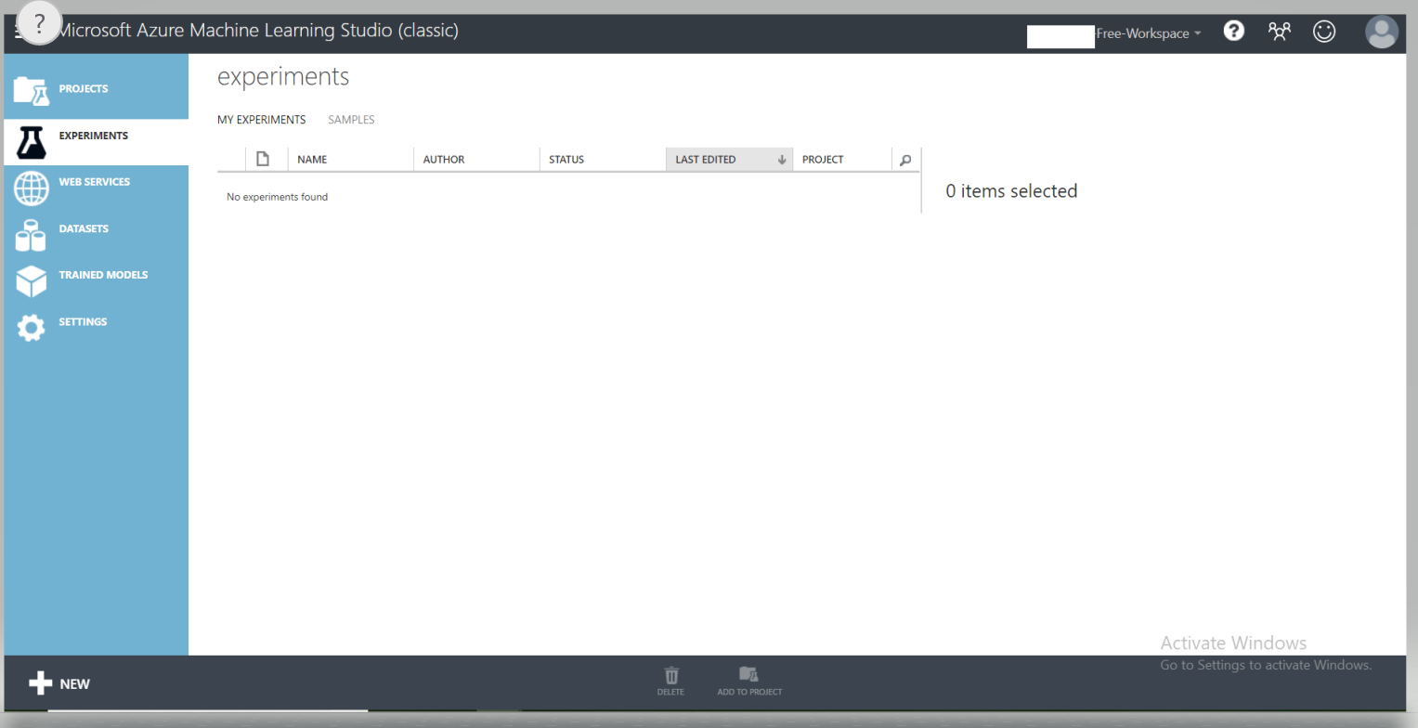

Step 2: First select Experiment and then New at the bottom of the page.

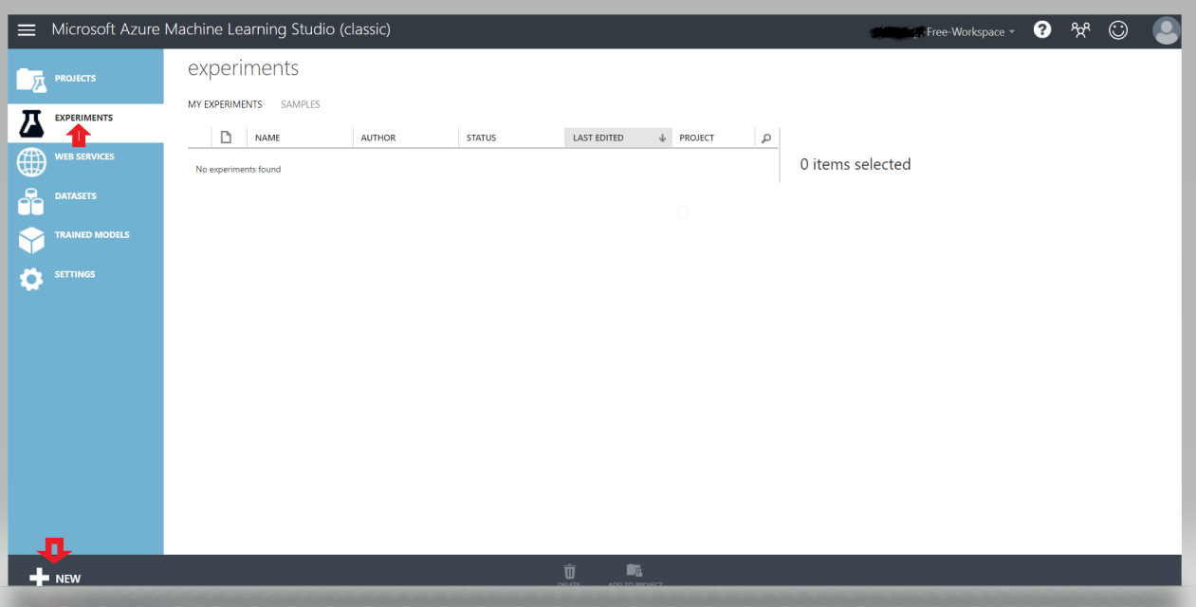

Step 3: Select Blank Experiment.
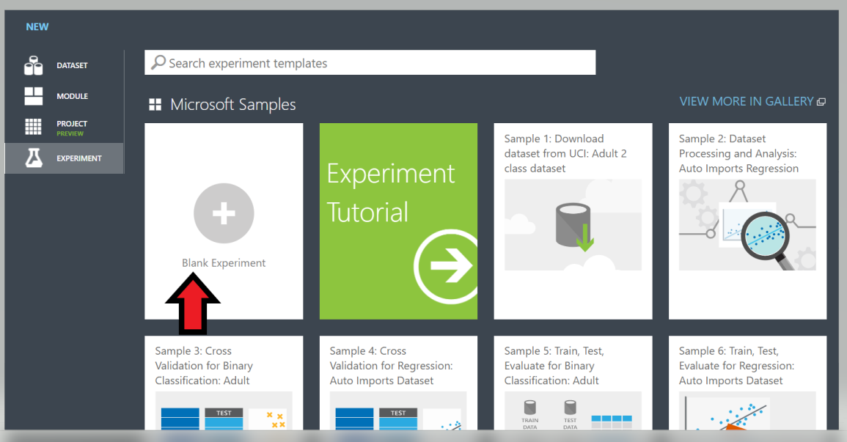

Step 4: Give the title for the project.
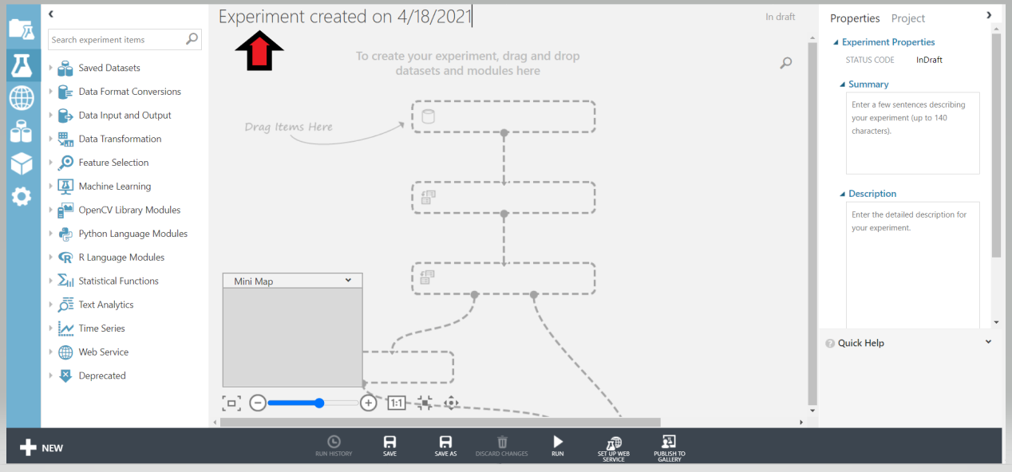

Step 5: Set below mentioned settings along with defining task specific blocks in Workspace:
- Use Automobile Price Data
- Select columns of interest
- Clean missing data
- Splitting raw data into train and test sets.
- Place train model block
- Connect Linear Regression ML block to train model block as depicted below
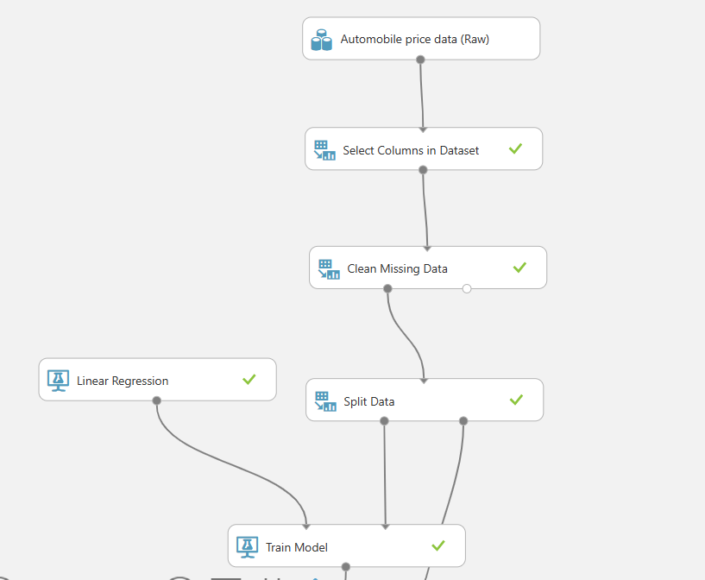
- Place and connect the Score block to measure the performance of the trained model on unseen test data.
- Place and connect the evaluation block.
- Run the whole GUI model
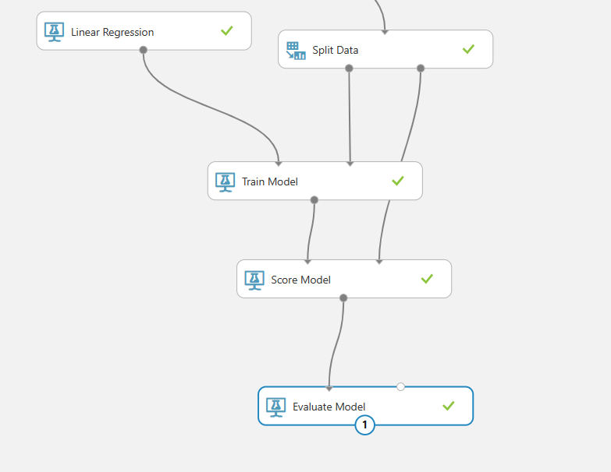

- Evaluate the model and check the trained model performance

