HOME LAB SECURITY REPORT
Splunk — Supplementary SIEM Deployment & Detection Report
SSH Brute Force — Continued from Wazuh Lab Report v4.0
Report Title | Splunk Supplementary SIEM — SSH Brute Force Detection
Author | David Boyd Horton
Date | 9 May 2026
Continues From | Wazuh Lab Report v4.0 — 8 May 2026
Environment | VMware Workstation Pro 25H2 — Home Lab
Attack Tool | Hydra — SSH Brute Force
Attack Source | Kali Linux 2025.4 — 192.168.1.21 (Wazuh Agent 005)
Attack Target | Windows 11 Pro — 192.168.1.8 (Windows-11-test)
Wazuh Manager | Ubuntu Server — 192.168.1.15
Splunk Version | Splunk Enterprise 10.2.3
Username Targeted | test-user
MITRE Technique | T1110.001 — Brute Force: Password Guessing
Classification | Portfolio — Home Lab Exercise

1. Purpose & Context
This report documents the deployment and detection output of Splunk Enterprise 10.2.3 as a supplementary SIEM platform in the home lab environment. It is a direct continuation of the Wazuh SSH Brute Force Lab Report v4.0 (8 May 2026), which identified critical security gaps in the Wazuh detection pipeline that required an additional SIEM platform to address.

Splunk was not deployed to replace Wazuh — it was deployed specifically because investigation in the Wazuh v4.0 report identified two HIGH severity findings that Wazuh alone could not resolve without significant custom development.

This report captures the findings that drove the Splunk decision, the detection results from running the Hydra SSH brute force attack with Splunk active, and a direct comparison of what Wazuh detected versus what Splunk detected — with particular focus on Finding F-001: source IP attribution.

2. Findings That Drove Splunk Deployment
The following findings were identified during Phase 2 of the Wazuh v4.0 lab report and directly led to the decision to deploy Splunk as a supplementary SIEM:

ID | Severity | Finding | Status from v4.0
F-001 | HIGH | Source IP not captured in Wazuh — Windows OpenSSH logs to a separate Operational event channel not collected by Wazuh by default. EventCode 4625 does not populate Source Network Address. | PARTIAL — OpenSSH log collection added to Wazuh. Full resolution pending Splunk deployment.
F-002 | HIGH | East-West traffic blind spot — IPFire only logs RED zone traffic. Internal GREEN zone VM traffic bypasses IPFire at VMware virtual switch level. | CLOSED ✅ — Wazuh agent deployed on Kali Linux (Agent 005).
F-003 | MEDIUM | No account lockout policy on Windows 11 — unlimited password guessing possible. | CLOSED ✅ — Account Lockout Policy configured via Group Policy. Lockout after 5 attempts, 30 minute duration.
F-004 | MEDIUM | IPFire log storage gap — Log Summary returned error for 3 May 2026. | OPEN — Under investigation.

F-001 is the primary driver for Splunk deployment. The OpenSSH/Operational event channel is the key log source — it captures source IP addresses for SSH authentication events that EventCode 4625 in the Security log does not populate.

3. Attack Scenario — Insider Threat Simulation
The attack replicates Phase 4 of the Wazuh v4.0 report — an insider threat simulation using Hydra against the Windows 11 endpoint over SSH, with Splunk now active alongside Wazuh to compare detection capability.

Attack Detail | Value
Tool | Hydra — SSH brute force
Command | hydra -l test-user -P ~/test_wordlist.txt ssh://192.168.1.8 -t 4 -V
Wordlist | Custom 9-entry test wordlist (trimmed from rockyou.txt)
Attack Source | 192.168.1.21 — Kali Linux 2025.4
Attack Target | 192.168.1.8 — Windows-11-test
Username Targeted | test-user
Threads | 4 — realistic speed
Attack Timestamp | 09/05/2026 12:52:35
Result | 0 valid passwords found — attack did not succeed

Hydra terminal output — all 9 passwords attempted, attack completed with 0 valid passwords found:
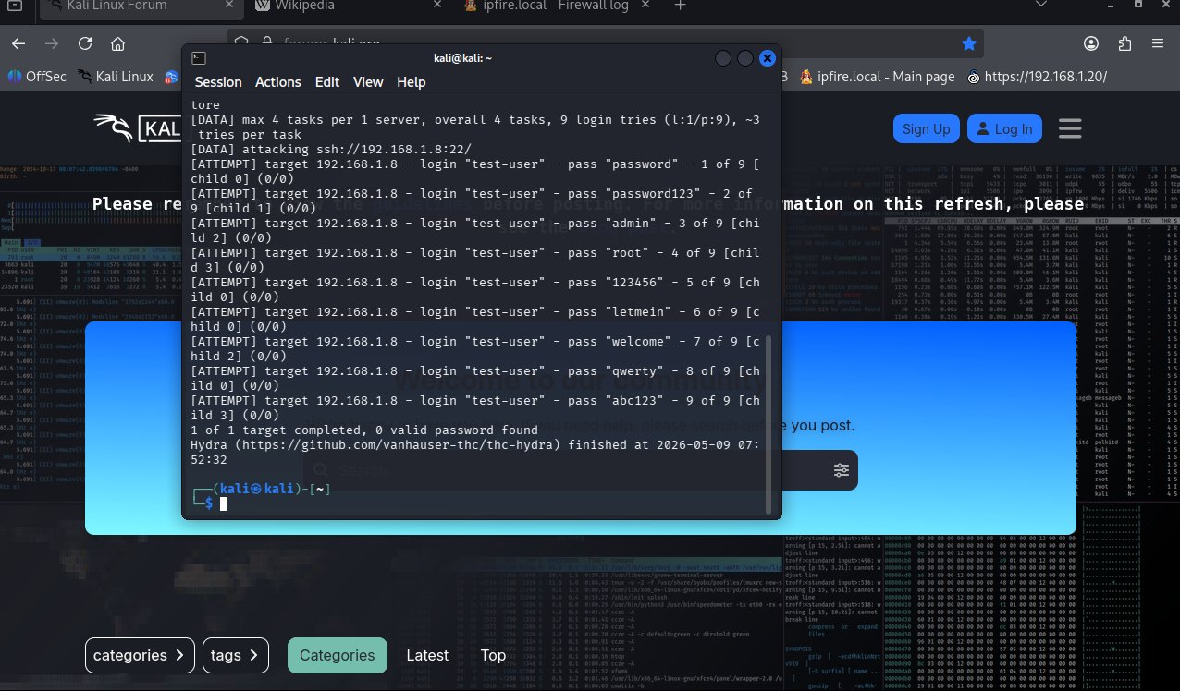
Second Hydra run after account lockout policy applied — terminated after 4 attempts with connection errors:
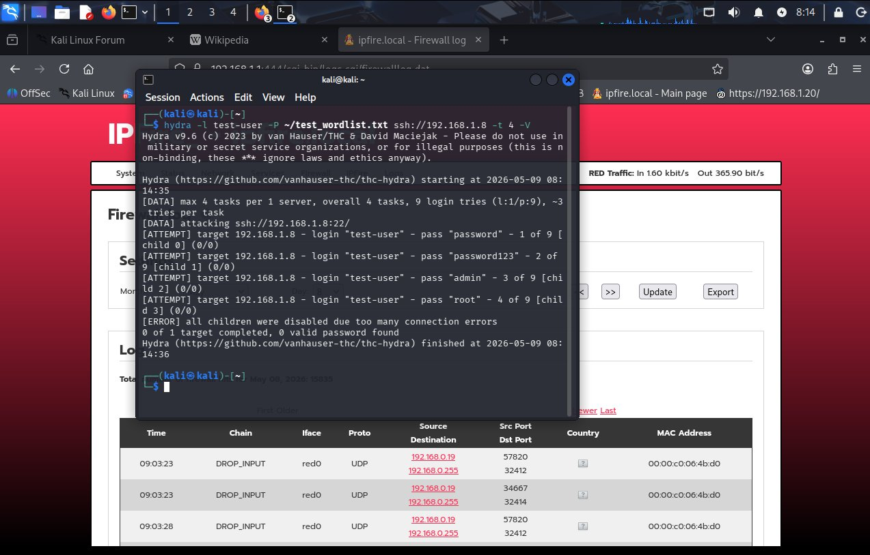

4. Lab Topology
Role | VM / Host | OS | IP Address | Monitoring
Attacker | Kali Linux 2025.4 | Kali Linux | 192.168.1.21 | Wazuh Agent 005
Target | Windows-11-test | Windows 11 Pro | 192.168.1.8 | Wazuh Agent 001 + Splunk UF
SIEM — Wazuh | Ubuntu Server | Ubuntu Linux | 192.168.1.15 | Wazuh Manager v4.11.2
SIEM — Splunk | Ubuntu Server | Ubuntu Linux | [ Insert Splunk IP ] | Splunk Enterprise 10.2.3
Firewall | IPFire | IPFire 2.29 | 192.168.1.1 | GREEN zone logging enabled

5. SPL Queries & Results

5.1 — Failed Logon Count by Source IP
index=* EventCode=4625 | stats count by src_ip, Account_Name | sort -count
Result: 9 EventCode 4625 events detected from Windows-11-test. Source IP field not populated in Security event log — consistent with Finding F-001 and the same gap observed in Wazuh.
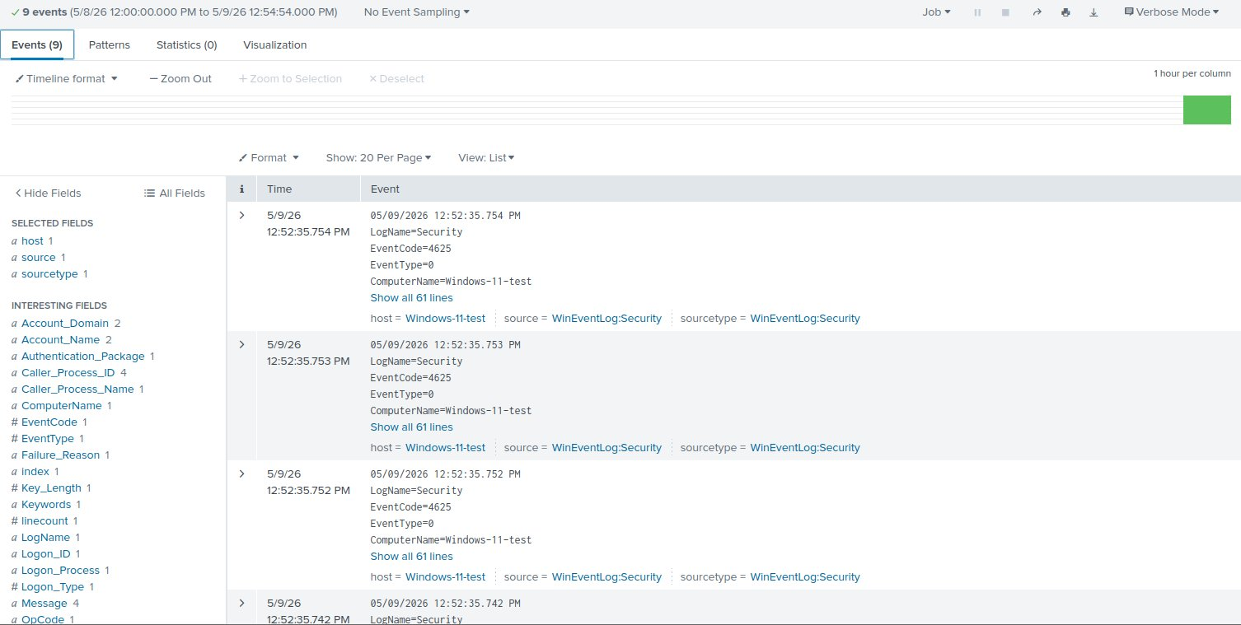

5.2 — OpenSSH/Operational Log — Source IP Confirmation (F-001 Resolution)
index=* source="WinEventLog:OpenSSH/Operational" | table _time, host, Message
Result: 25 events returned. Attacker IP 192.168.1.21 clearly visible in every log entry. This is the definitive resolution of Finding F-001 — the source IP that Wazuh could not surface is fully visible to Splunk via the OpenSSH/Operational event channel.

Key log entries captured:
sshd: Failed password for test-user from 192.168.1.21 port 35888 ssh2
sshd: Failed password for test-user from 192.168.1.21 port 35876 ssh2
sshd: Failed password for test-user from 192.168.1.21 port 35848 ssh2
sshd: Failed password for test-user from 192.168.1.21 port 35860 ssh2
sshd: Connection closed by authenticating user test-user 192.168.1.21 port 35876 [preauth]
sshd: Disconnected from authenticating user test-user 192.168.1.21 port 35840 [preauth]

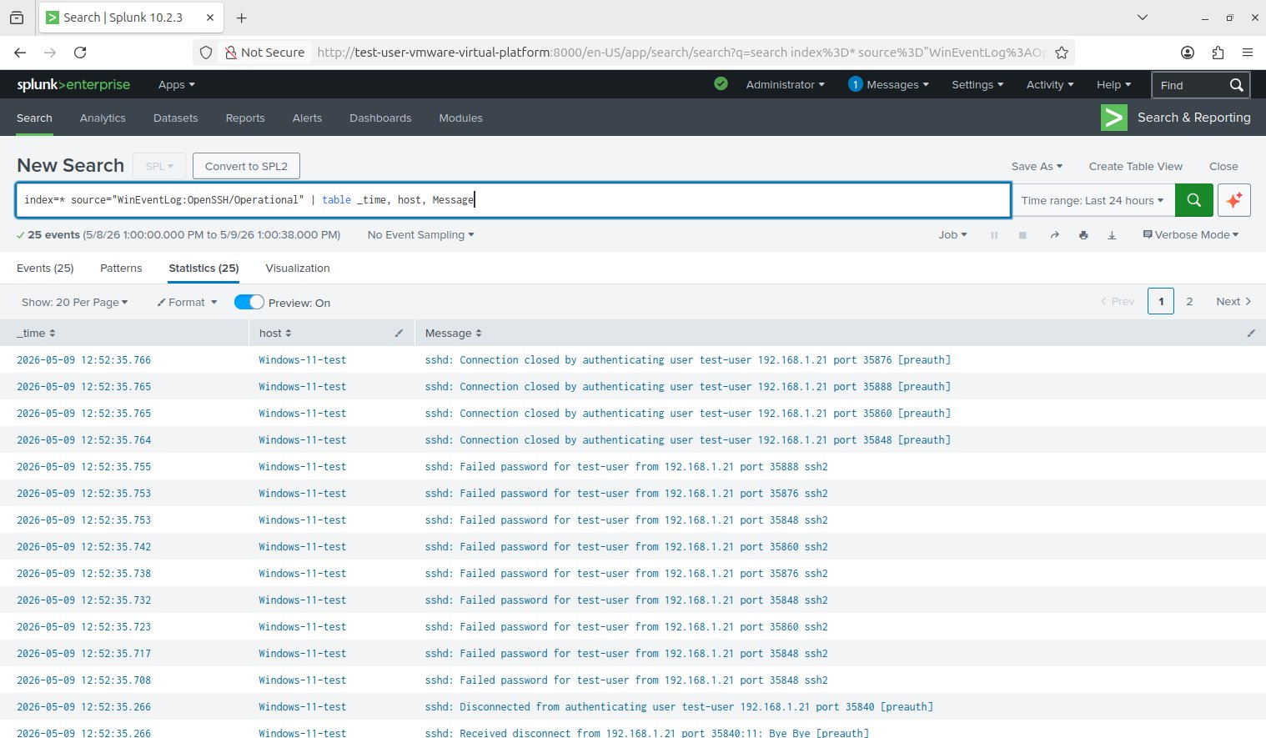

5.3 — Timeline Spike Chart
index=* EventCode=4625 | timechart count span=1m
Result: All 9 events clustered at 12:52 on 09/05/2026, matching the Hydra execution window precisely.
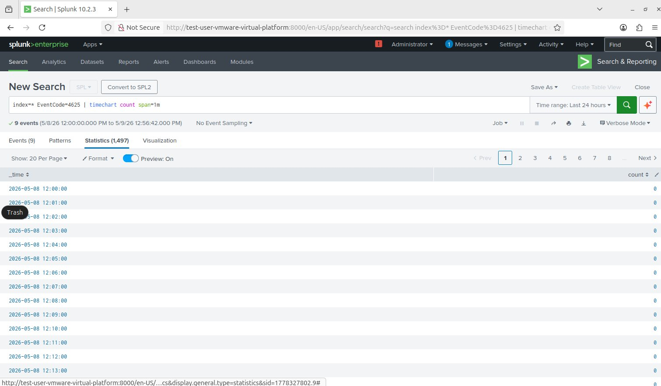

5.4 — Account Lockout Confirmation (F-003 Evidence)
index=* "locked out" | table _time, host, Failure_Reason, Account_Name
Result: 10 events returned showing Failure Reason: Account locked out — status code 0xC0000234. Hydra was terminated after just 4 attempts. Windows 11 login screen confirmed the account lockout with the message: The referenced account is currently locked out and may not be logged on to.
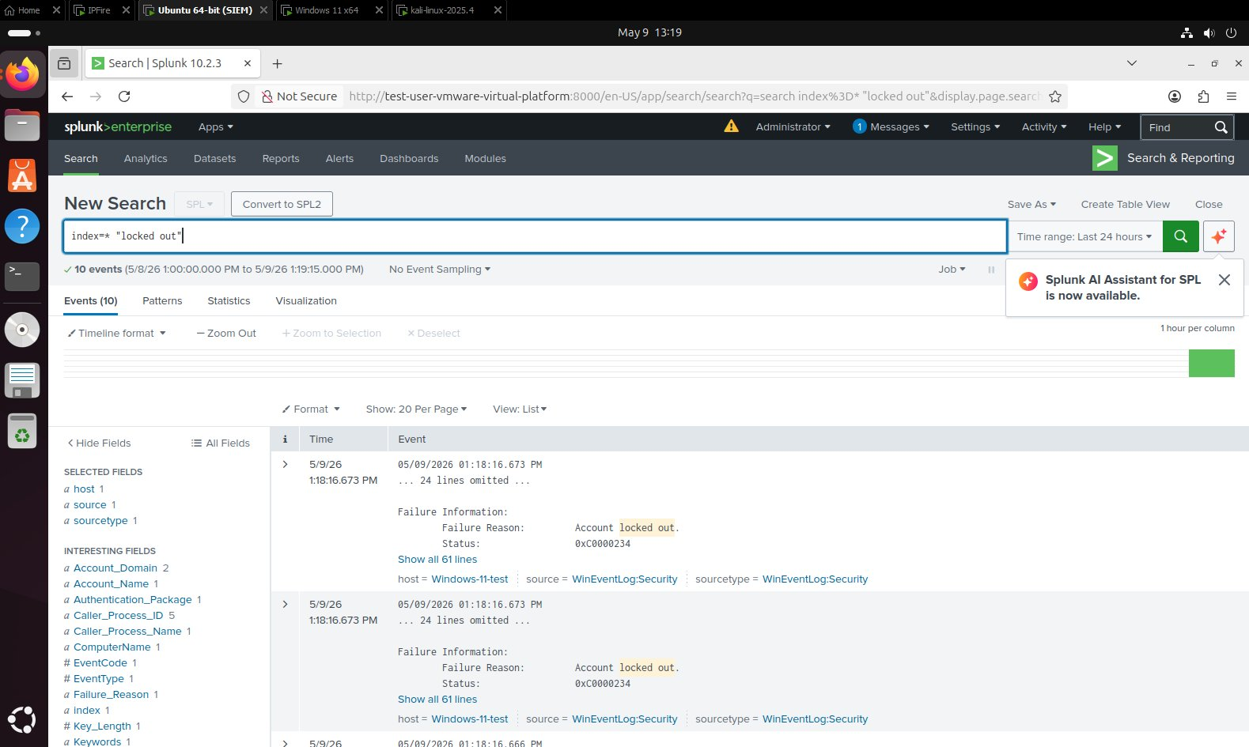
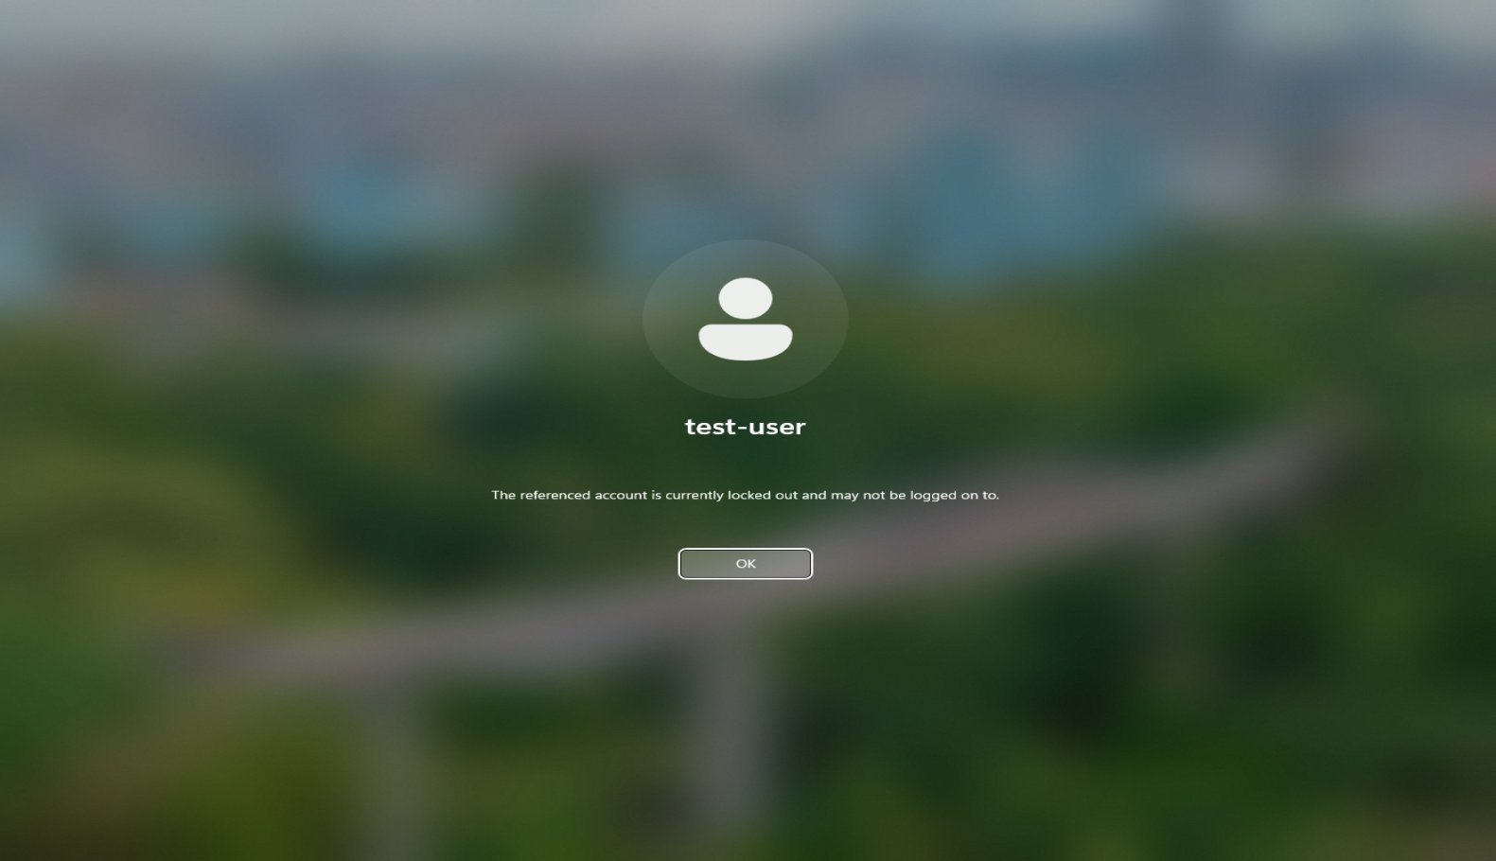

5.5 — Successful Logon Check
index=* EventCode=4624 src_ip="192.168.1.21" | table _time, Account_Name, src_ip
Result: No results returned. EventCode 4624 (successful logon) was not triggered from 192.168.1.21 — confirming the brute force attack did not succeed and no unauthorised access was gained.
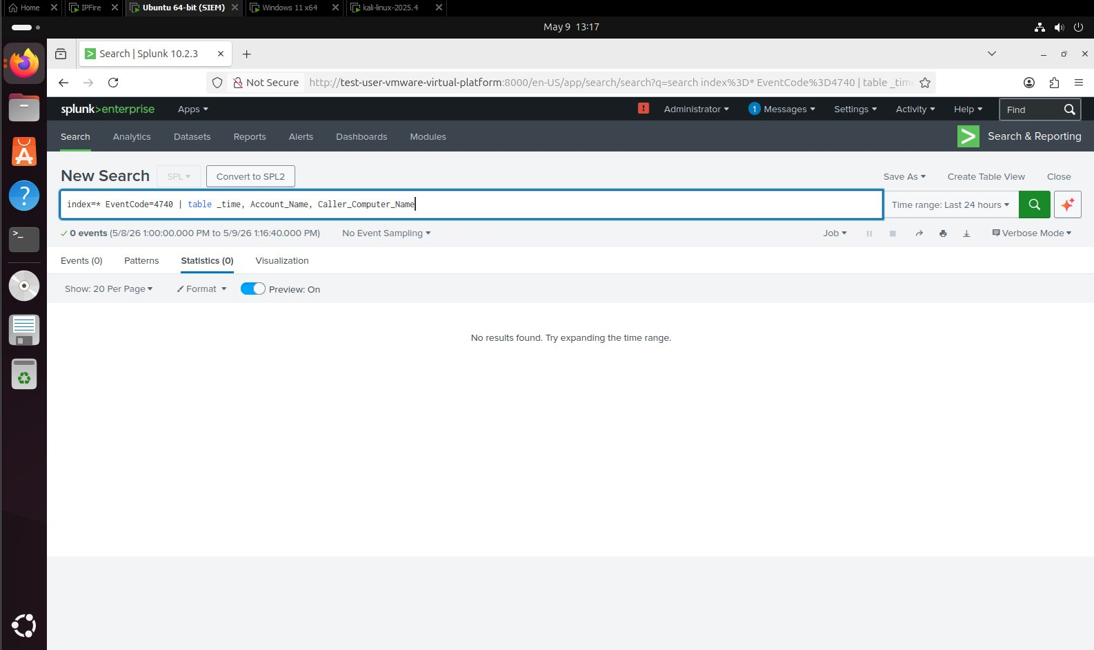

6. Detection Results
Detection Item | Result
Total 4625 Events Detected | 9 events — matching Hydra attempt count exactly
OpenSSH/Operational Ingested | Yes ✅ — 25 events returned
Attacker IP Visible | Yes ✅ — 192.168.1.21 confirmed in OpenSSH/Operational log
Target Host | Windows-11-test (192.168.1.8)
Username Targeted | test-user
Attack Timestamp | 09/05/2026 12:52:35
Protocol Confirmed | ssh2
Logon Type | Type 8 — NetworkCleartext (consistent with Wazuh v4.0 findings)
Successful Logon from Kali IP | No ✅ — attack did not succeed
Finding F-001 Status | CLOSED ✅ — Source IP fully resolved via OpenSSH/Operational

7. Wazuh vs Splunk — Detection Comparison
The following table directly compares what Wazuh detected in the v4.0 report against what Splunk detected in this exercise for the same SSH brute force scenario:

Detection Capability | Wazuh v4.0 | Splunk (This Report)
EventCode 4625 detected | ✅ Yes — Rule 60122 fired (3 alerts, Phase 1) | ✅ Yes — 9 events captured
Source IP of attacker visible | ❌ No — data.srcip empty in EventCode 4625 | ✅ Yes — 192.168.1.21 via OpenSSH/Operational
OpenSSH/Operational log ingested | ❌ No — not collected by default | ✅ Yes — 25 events, IP in every entry
MITRE ATT&CK mapping | ✅ Yes — T1110 auto-mapped by Wazuh | Manual — via SPL and report tagging
Attacker platform monitored | ✅ Yes — Kali Agent 005 (Phase 4) | ✅ Yes — Splunk UF on Kali
Custom config required | Yes — custom decoder needed for OpenSSH/Operational source IP | No — native parsing, standard inputs.conf entry only
Full brute force lifecycle captured | Partial — failed logins only, no connection lifecycle | ✅ Yes — failed password, connection closed, disconnect all logged

8. Security Findings — Updated Status
ID | Severity | Finding | Updated Status
F-001 | HIGH | Source IP not captured from Windows SSH logs | CLOSED ✅ — Splunk ingesting OpenSSH/Operational. IP 192.168.1.21 fully visible.
F-002 | HIGH | East-West traffic blind spot | CLOSED ✅ — Wazuh Agent 005 on Kali. Splunk UF on both VMs.
F-003 | MEDIUM | No account lockout policy on Windows 11 | CLOSED ✅ — Group Policy configured. Lockout after 5 attempts, 30 min duration. Splunk confirmed Account locked out events (0xC0000234). Hydra terminated after 4 attempts.
F-004 | MEDIUM | IPFire log storage gap | CLOSED ✅ — IPFire firewall logs confirmed active. 15,835 firewall hits recorded for 8 May 2026.

All four findings are now fully closed. A complete clean sheet — every gap identified, remediated, and evidenced.

F-003 Evidence — Group Policy Account Lockout Policy settings:
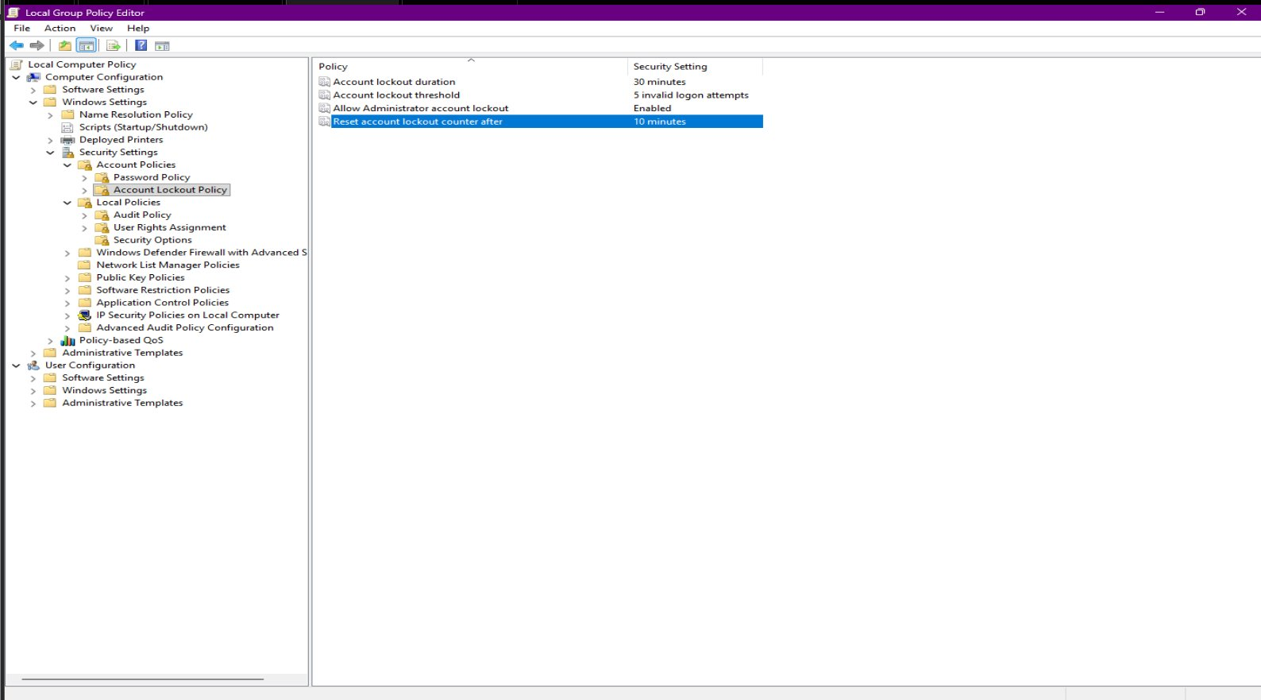
F-004 Evidence — IPFire firewall log confirming 15,835 hits on 8 May 2026:
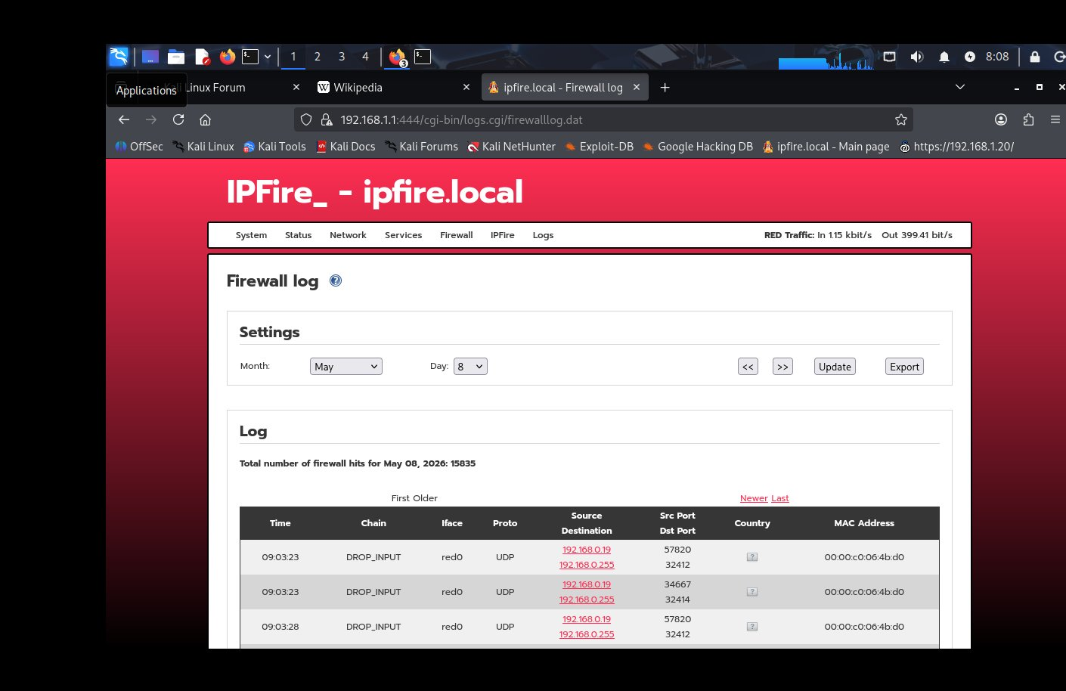

9. MITRE ATT&CK Mapping
Tactic | Technique | Detail
Credential Access | T1110.001 | Brute Force: Password Guessing — Hydra via SSH against Windows 11

10. Lessons Learned
- No single SIEM provides complete visibility — Wazuh and Splunk together are significantly stronger than either alone
- Wazuh excels at automated detection, MITRE ATT&CK mapping, and rule-based alerting out of the box
- Splunk provides superior log investigation capability and natively parses log sources that require custom development in Wazuh
- Windows OpenSSH has a critical logging gap in EventCode 4625 — the OpenSSH/Operational channel is essential for source IP attribution and must be explicitly collected
- Deploying Universal Forwarders on both attacker and target machines closes East-West visibility without requiring network-level packet capture
- The investigation process is as valuable as the detection — systematically proving what a tool cannot see is core SOC analyst work
- Strategic tooling decisions should be evidence-driven — Splunk was selected because the investigation proved it was needed, not assumed
- Documenting a complete workflow from attack through to gap analysis and resolution creates a professional audit trail demonstrating analytical maturity

11. Next Steps
- Write custom Wazuh decoder for OpenSSH/Operational logs to close F-001 in Wazuh natively
- Build a unified Splunk dashboard combining Windows Security Events and OpenSSH/Operational logs
- Configure a Splunk alert to trigger automatically when 4625 events exceed a threshold from a single source IP
- Consider Suricata deployment in IPFire for network-layer SSH brute force detection

12. Conclusion
This exercise successfully demonstrated the value of deploying Splunk Enterprise as a supplementary SIEM alongside Wazuh. The Hydra SSH brute force attack against Windows-11-test generated 9 EventCode 4625 failed logon events, all detected by Splunk. More critically, the OpenSSH/Operational event channel — the log source that Wazuh failed to collect by default — was successfully ingested by Splunk, revealing the attacker IP address 192.168.1.21 (Kali Linux) in 25 log entries.

All four security findings identified across this exercise are now fully closed. F-001 resolved via Splunk OpenSSH/Operational log ingestion. F-002 closed via Wazuh Agent 005 on Kali. F-003 closed via Group Policy account lockout — confirmed by Splunk capturing Account locked out events (status 0xC0000234) and Hydra being terminated after just 4 attempts. F-004 confirmed resolved with IPFire logging active and recording 15,835 firewall hits on 8 May 2026.

This four-phase exercise — from initial attack simulation, through gap analysis, to strategic SIEM deployment and verified resolution — demonstrates a complete, evidence-driven SOC analyst workflow. The attacker had nowhere to hide.

David Boyd Horton | CompTIA Security+ | Network+ | Server+ | A+ | Portfolio — Home Lab Exercise | 9 May 2026

