Chewing Strength Study
Title: Evaluation of wearable sensors for effects of food hardness on chewing strength.
Participants: 15

Folder Structure:
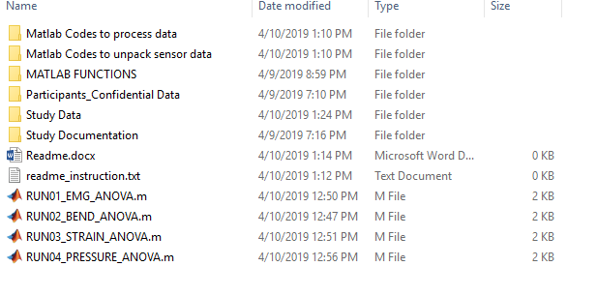
- Particpants_Confidential Data: This folder contains list of participants with contacts. Also contains scanned copy of signed informed consent and photo release form.This folder is confidential and should not be shared with anybody other than people associated with the study.
- Study Data: This folder contains the data associated with the study. This folder contains two subfolder and two excel files
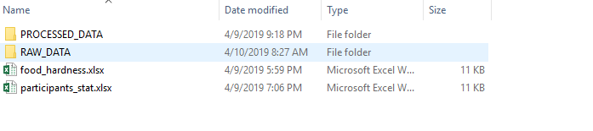
The excel file ‘ participants_stat.xlsx’ contains subjects height, weight, age and BMI information.

The excel file ‘food_hardness’’ contains the summary record of objective food hardness measured by fruit penetrometer before serving to each participant. For each subject two readings of each test foods (carrot, Apple, Banana) were recorded.

RAW_DATA: This folder contains sensor signals recorded for each subject during the study. We used four sensor modalities. For each subject there are 6 subfolders. Four of them are for sensor signals, one for record of the food order, and rest one is to record of food hardness.
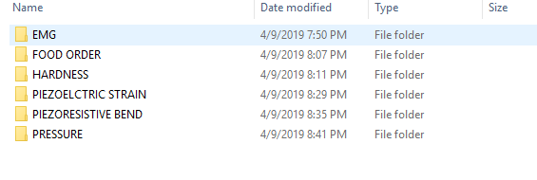
Each sensor has raw files (EMG=> Text file, Strain => CSV file, BEND=> BIN file and Pressure=> BIN file). The data of the raw files are saved as MAT files using the matlab codes saved in the folder of MATLAB CODES TO UNPACK SENSOR DATA.

PROCESSED DATA: This folder contains the processed files of each sensor for all participants. For an individual participant there are four subfolders for four sensor systems which contains the processed data.
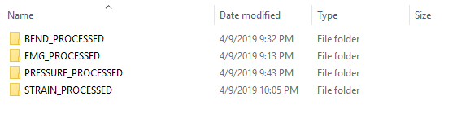

The raw signal of each sensor system is passed through low pass filter (without emg), normalized and then truncated manually using ginput() for separate test food. The first five chews of each bite is then manually truncated. First 10 bites of each test food is saved in a cell. The full process is done by the MATLAB codes: Matlab Codes to Process Data.

- Study Documentation: This folder contains the necessary document of the study which includes IRB documents.
- MATLAB codes to unpack sensor data: The data from sensors are collected through text file (EMG), CSV file (Strain) and BIN file (PRESSURE, BEND). The matlab codes used to convert them into mat files are contained here. This matlab files take the files as input and convert the data of the files into mat files.
- MATLAB codes to process data: The raw data from sensors need processing which is done by the codes stored here. The sensor signals are filtered (without EMG) and normalized. The normalized signal is then manually truncated into signals of chewing test foods using the food record and pause in the signals. From the truncated signal each bite is identified and first five chews of a bite is truncated manually. For each test food 10 bites of an individual participant is stored as processed data.
- MATLAB functions: These folder contains the matlab functions needed to execute the codes.

- Results:
To get the results of ANOVA analysis and Tukey’s test for each sensor system, run the following matlab files.

