# Preparing for Splice Machine on Your AWS Account

Splice Machine needs a little information from you to help us configure our service on your AWS account; please fill in the fields in this document so we can get you set up.

We need you to complete these steps, each of which is detailed in a section below:

|  |  |
| --- | --- |
| 1. Configure a User Policy | You need to create a user who has programmatic access to AWS needs to have a specific IAM policy configuration. |
| 1. Provide a Key Pair PEM File | We need a PEM file for an AWS Key Pair we can use to set up your environment. |
| 1. Provide an ARN for Your SSL Certificate | You’ll need a wildcard SSL certificate for your domain, and we’ll the Amazon Resource Name (*ARN*) for that certificate. |
| 1. Provide Your AWS Account ID | We need this to share our Amazon Machine Images (*AMI*s) with your account. |
| 1. Specify Values for Infrastructure Properties | Please provide values for the infrastructure properties listed in this section. |
| 1. Specify Property Values for Your Application Environment | We also need you to supply a few application-specific property values, which are listed in this section. |

## 1. Configure a User Policy

You need to create a user who has programmatic access to AWS needs to have the following IAM policy configuration:

{

"Version": "2012-10-17",

"Statement": [

{

"Sid": "VisualEditor0",

"Effect": "Allow",

"Action": [

"autoscaling:*",

"ec2:*",

"elasticloadbalancing:*",

"es:*",

"iam:AddRoleToInstanceProfile",

"iam:AttachRolePolicy",

"iam:CreateInstanceProfile",

"iam:CreatePolicy",

"iam:CreateRole",

"iam:CreateServiceLinkedRole",

"iam:DeleteRole",

"iam:DetachRolePolicy",

"iam:GetInstanceProfile",

"iam:GetPolicy",

"iam:GetPolicyVersion",

"iam:GetRole",

"iam:GetUserPolicy",

"iam:ListAttachedRolePolicies",

"iam:ListInstanceProfilesForRole",

"iam:ListPolicyVersions",

"iam:ListPolicyVersions",

"iam:PassRole",

"rds:*",

"route53:*",

"s3:*",

"tag:*"

],

"Resource": "*"

}

]

}

## 2. Provide a Key Pair PEM File

To set up your environment, Splice Machine needs the PEM file for an Amazon Key Pair. If you don’t yet have a Key Pair, you can create one as follows:

1. Log into the *AWS Console* and navigate to EC2 from the navigation pane; or point your browser at <https://console.aws.amazon.com/ec2/>
2. In the navigation pane on the left side of the console, select Key Pairs, which is under NETWORK & SECURITY:

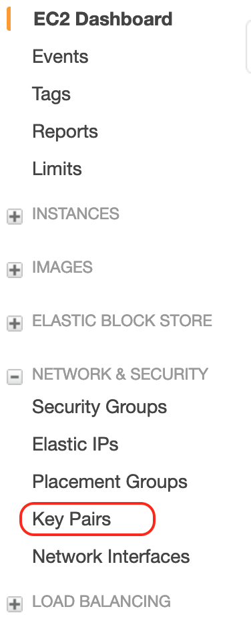

1. Select Create Key Pair at the top of the window.
2. Enter a name for the new key pair and select Create:

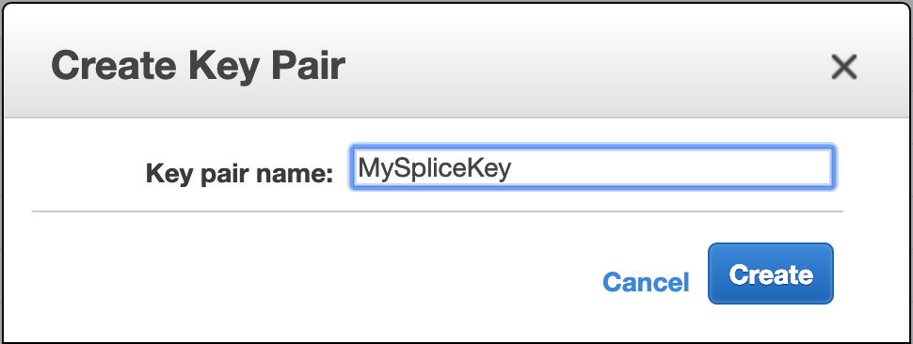

1. AWS creates your key pair and downloads the private key (**keyname.pem**) file to your computer. Save this key file in a safe location.
2. Use the following command to modify the permissions on the PEM file:

chmod 600 *path/to/file/keyname*.pem

1. Now move the PEM file:

cp *path/to/file/keyname*.pem ~/.ssh

1. And finally, add it to ssh:

ssh add ~/.ssh/*keyname*.pem

For more information about creating and using key pairs, see:

<https://docs.aws.amazon.com/AWSEC2/latest/UserGuide/ec2-key-pairs.html>

## 3. Provide an ARN for Your SSL Certificate

You need to provision an SSL certificate domain you’re using for Splice Machine, and we need the Amazon Resource Name (*ARN*) for that certificate.

You can follow these steps to create the certificate if you don’t already have one for the domain:

1. Log into the *AWS Console* and navigate to the Certificate Manager from the navigation pane; or point your browser <https://console.aws.amazon.com/acm/home>.
2. Select Provision certificates.
3. Select the Request a public certificate radio button.
4. Click Request a Certificate.
5. Specify a domain name with a wildcard; for example:

*.splicemachine-test.io

1. Click the Next button.
2. Follow the instructions on AWS for validating the certificate through DNS or e-mail.

## 4. Provide Your AWS Account ID

We need to share our AMIs with the Customer's AWS Account.  In order to do that we need the AWS Account Id:

|  |  |
| --- | --- |
| Your AWS Account ID: |  |

## 5. Specify Values for Infrastructure Properties

Please fill in your values for the following infrastructure properties.:

|  | **Name and Description** | **Enter Your Value** |
| --- | --- | --- |
| 1. | *AWS Region*  Enter the AWS region to use. Choose from:   * us-east-1 * us-east-2 * us-west-1 * us-west-2 |  |
| 2. | *AWS SSL Certificate ARN*  Provide the ARN for the certificate (see step 3, above) |  |
| 3. | *CIDR Block*  Specify a range of IPv4 addresses for the Virtual Private Cloud (*VPC*) in a Classless Inter-Domain Routing (CIDR) block. For example:  10.0.0.0/16 |  |
| 4. | *Key Name*  The name of the key pair use to ssh into the machines. This name must be shown in the Network & Security-> Key Pairs section of the EC2 Manager. (see step 2, above) |  |
| 5. | *Instance Types*  Specify the type of EC2 instance to use for each server type. The default values are: | |  |  | | --- | --- | | HDD |  | | MASTER |  | | PRIVATE AGENT |  | | PUBLIC AGENT |  | | SPARK |  | |
| 6. | *Instance Type Root Size*  Specify the root size to use for each server type. The default values are: | |  |  | | --- | --- | | HDD |  | | MASTER |  | | PRIVATE AGENT |  | | PUBLIC AGENT |  | | SPARK |  | |
| 7. | *Instance Counts*  Specify the required number of instances for each instance type: | |  |  | | --- | --- | | HDD |  | | MASTER |  | | PRIVATE AGENT |  | | PUBLIC AGENT |  | | SPARK |  | |
| 8. | *Metadata Database Name*  The name of the Postgres database used to store the metadata for the Cloud Manager |  |
| 9. | *Metadata Database User Name*  The username for the Postgres database |  |
| 10. | *Metadata Database Password*  The password for the Postgres database |  |
| 11. | *Elasticsearch Domain*  The name of the domain used for the elasticsearch instance |  |
| 12. | *Elasticsearch Instance Type*  The instance type for elasticsearch; the default value is m4.large.elasticsearch. |  |
| 13. | *Elasticsearch Instance Count*  The number of elasticsearch instances to use. The default value is 4. |  |
| 14. | *Elasticsearch EBS Volume Size*  The size of the EBS volume. The default value is 300. |  |
| 15. | *Spark Temp Space Disk Size*  The size of the spark temporary space. The default value is 1000GB. |  |
| 16. | *VPC CIDR Block*  The CIDR block to use when creating the IP addresses for your instances. |  |
| 17. | *Cluster Tags*  The tags to use on all of your cluster resources for identification and billing purposes. | |  |  | | --- | --- | | Cluster Name |  | | Dept Name |  | | Resource Owner |  | | Resource Purpose |  | |
| 18. | *Whitelist IP Addresses*  IP addresses to add for limiting access to DCOS admin components. |  |
| 19. | *Zone*  The domain name for the database instance URLs. |  |
| 20. | *Environment*  The environment suffix to add to each URL; one of:   * dev * qa * *(none)*   The default value is none (no suffix) |  |

## 6. Specify Property Values for Your Application Environment

Finally, please provide the following information for setting up your application environment:

|  | **Name and Description** | **Enter Your Value** |
| --- | --- | --- |
| 1. | *Auth0 certifcate* |  |
| 2. | *Auth0 client ID* |  |
| 3. | *Auth0 domain* |  |
| 4. | *BCC Email address*  This is the address to which the cluster creation email should be sent. |  |
| 5. | *Google Analytics tracking ID*  (optional) |  |
| 6. | *SMTP e-mail properties* | |  |  | | --- | --- | | Host: |  | | Password: |  | | Port: |  | | User ID: |  | |