

Embedded Systems Design Mini Project

Distance Calculator using LPC1768 and Infrared Sensor
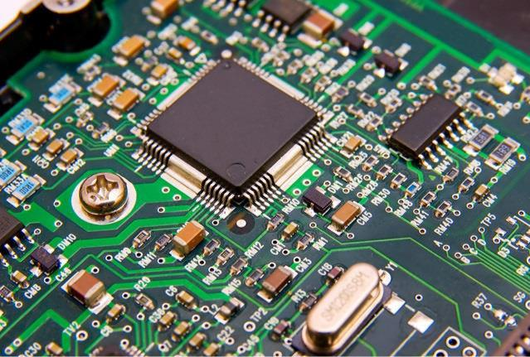

Shubham Rayar Shubhang Yadav Dhyey Pandya

160953206 160953210 160953212

Introduction

- Infrared Sensors find numerous applications in electronic systems. Commonly used as obstacle detector, their output is used in digital form (high & low logic) by employing a comparator. This project explains a way to use the sensor’s output in its original analog form. Thus, along with detecting an obstacle, its exact distance can also be obtained. This is achieved by processing the output of IR sensor through an ADC (analog to digital converter). The ADC is calibrated to get almost accurate distance measurement. There are many types of distance measurement systems we use in our environment from normal rulers to Interferometer. In applications, basic concept of electronic distance measure system is adopted in many areas like aviation, navigation and many more. In aviation, direct feedback system is required for linear positioning and motion control application. One of the good examples for distance measurement in navigation is GPS system using satellites. So there is no doubt about the usefulness of distance measurement technology in our environment.

- The objective of this project is to design and to implement an obstruction detection and distance measurement device using Infrared Sensor.

- The sensor we took into consideration for this project is an Infrared Sensor. The Infrared sensor works based on the detection of a specific light of wavelength in the range of 760nm (IR spectrum), which is emitted by an IR Light Emitting Diode (LED). The distance can be measured based on the change in intensity of the received light.

- The main disadvantage of Infrared Sensor is that they are capable of detecting objects in range of 10 to 15cm. Infrared sensors are not accurate .Infrared sensors can sense the IR radiations from the sun which causes the correctable or non-correctable errors at output. If we use analogue IR sensor, signal losses may occur at amplifier circuit.

3

Explanation

This project mainly consists of three units: a sensor unit, an ADC (in-built) component and the LCD module.
The IR receiver detects the IR radiations transmitted by an IR LED. The output voltage level of this IR sensor depends upon the intensity of IR rays received by the receiver. The intensity, in turn, depends on the distance between the sensor module and the obstacle. When the distance between IR pair and obstacle is lesser, more IR radiations fall on the receiver, and vice versa. The receiver along with a resistor forms a voltage divider whose output is supplied as the input for ADC.

To obtain the distance of the object, we first convert the resulting voltage to its digital form using ADC.
The second step is to divide 27 with the voltage and that gives us the result in centimeters.
Thus, as the voltage drops down, the distance increases indicating that the object is away from the sensor.

Flow chart Diagram

Snapshot

References

- https://exploreembedded.com/wiki/LPC1768:_ADC_Programming for documentation of NXP LPC_1768

- Jonathan V. Valvano book on Embedded Systems.

- Wikipedia

11

8

Code

#include <LPC17xx.h>
#include <stdio.h>

#define Ref_Vtg 3.300
#define Full_Scale 0xfff

unsigned long int temp1, temp2;

#define RS_CTRL (1<<8)
#define EN_CTRL (1<<9)
#define DT_CTRL (0xf<<4)

#define alpha 0.5

void lcd_init(void);
void wr_cn(void);
void clr_disp(void);
void delay_lcd(unsigned int);
void lcd_com(void);
void wr_dn(void);
void lcd_data(void);
void clear_ports(void);
void lcd_puts(unsigned char *);

int main(void)
{
unsigned long adc_temp, adc_temp1;
unsigned int i;
float in_vtg, distance;
unsigned char vtg[7];
unsigned char Msg3[11] = {"Distance:"};

SystemInit();
SystemCoreClockUpdate();

LPC_SC->PCONP |= (1<<12);
lcd_init();
LPC_PINCON->PINSEL1 = (01 << 14);

temp1 = 0x80;
lcd_com();
delay_lcd(800);
lcd_puts(&Msg3[0]);

while(1)
{
LPC_ADC->ADCR = (1<<0) | (1<<21) | (1<<24);
while((adc_temp = LPC_ADC->ADGDR) == 0x80000000);

adc_temp = (LPC_ADC->ADGDR >> 4) & 0xfff;
adc_temp1 = adc_temp*alpha + (1-alpha)*adc_temp;
in_vtg = ((float)adc_temp1 * Ref_Vtg) / Full_Scale;
distance = 27/in_vtg;
sprintf(vtg, "%3.2f", distance);

for(i=0; i < 2000; i++);

temp1 = 0x8c;
lcd_com();
delay_lcd(800);
lcd_puts(&vtg[0]);

for(i = 0; i < 20000; i++);
//for(j = 0; j < 200; j++);

for(i = 0; i < 7; i++)
vtg[i] = 0x00;
adc_temp = 0;
in_vtg = 0;
}

}

void lcd_init()
{
LPC_PINCON->PINSEL0 &= 0xfff000ff;
LPC_GPIO0->FIODIR|=DT_CTRL;
LPC_GPIO0->FIODIR|=RS_CTRL;
LPC_GPIO0->FIODIR|=EN_CTRL;

clear_ports();
delay_lcd(3200);

temp2=(0x30<<0);
wr_cn();
delay_lcd(30000);

temp2=(0x30<<0);
wr_cn();
delay_lcd(30000);

temp2=(0x30<<0);
wr_cn();
delay_lcd(30000);

temp2=(0x20<<0);
wr_cn();
delay_lcd(30000);

temp1=0x28;
lcd_com();
delay_lcd(30000);

temp1=0x0c;
lcd_com();
delay_lcd(30000);

temp1=0x06;
lcd_com();
delay_lcd(800);

temp1=0x01;
lcd_com();
delay_lcd(800);

temp1=0x80;
lcd_com();
delay_lcd(10000);
return;
}

void lcd_com(void)
{
temp2= temp1 & 0xf0;
temp2= temp2 << 0;
wr_cn();
temp2= temp1 & 0x0f;
temp2= temp2 << 4;
wr_cn();
delay_lcd(1000);
return;
}

void wr_cn(void)
{
clear_ports();
LPC_GPIO0->FIOPIN=temp2;
LPC_GPIO0->FIOCLR=RS_CTRL;
LPC_GPIO0->FIOSET=EN_CTRL;
delay_lcd(25);
LPC_GPIO0->FIOCLR=EN_CTRL;
return;
}

void lcd_data(void)
{
temp2= temp1 & 0xf0;
temp2= temp2 << 0;
wr_dn();
temp2= temp1 & 0x0f;
temp2= temp2 << 4;
wr_dn();
delay_lcd(1000);
return;
}

void wr_dn(void)
{
clear_ports();
LPC_GPIO0->FIOPIN=temp2;
LPC_GPIO0->FIOSET=RS_CTRL;
LPC_GPIO0->FIOSET=EN_CTRL;
delay_lcd(25);
LPC_GPIO0->FIOCLR=EN_CTRL;
return;
}

void delay_lcd(unsigned int r1)
{
unsigned int r;
for(r=0;r<r1;r++);
return;
}

void clr_disp(void)
{
temp1=0x01;
lcd_com();
delay_lcd(10000);
return;
}

void clear_ports(void)
{
LPC_GPIO0->FIOCLR=DT_CTRL;
LPC_GPIO0->FIOCLR=RS_CTRL;
LPC_GPIO0->FIOCLR=EN_CTRL;
return;
}

void lcd_puts(unsigned char *buf1)
{
unsigned int i=0;
while(buf1[i]!='\0')
{
temp1=buf1[i];
lcd_data();
i++;
if(i==16)
{
temp1=0xc0;
lcd_com();
}
}

}

