EXECUTIVE SUMMARY
Restaurant Growth Potential & Strategic Classification
Prepared for government and oversight stakeholders — SkyCity Auckland Restaurants & Bars

Why This Matters
SkyCity Auckland operates 250 restaurant and bar branches. Historically, growth and investment decisions across this portfolio have relied on uniform rules of thumb rather than branch-specific evidence. This project applies data analysis to identify which branches are genuinely ready to grow, which need to fix underlying issues first, and why — giving decision-makers a clear, defensible basis for where to direct investment and oversight attention.

What We Found
Every branch was scored on a 0-100 "Growth Potential Index" and grouped into one of five recognizable patterns based on its financial health, delivery-channel reliance, and cost structure. The table below summarizes the portfolio:
Pattern | Branches | % of Portfolio | Recommended Action
High-Growth / High-Risk | 81 | 32% | Invest, but reinforce cost controls
Scalable Self-Delivery Leaders | 28 | 11% | Priority for expansion
Stable Local Performers | 58 | 23% | Maintain, monitor
Aggregator-Dependent Low Margin | 60 | 24% | Rebalance delivery mix
Overextended, Low Return | 23 | 9% | Pause; fix cost base first

The Headline Issue
The single most important pattern for stakeholders to understand: 60 branches (24% of the portfolio) generate strong order volume through delivery apps like UberEats and DoorDash, but commission fees on those platforms are quietly eating into profit. These branches look busy and successful on the surface, but their financial health is more fragile than it appears.
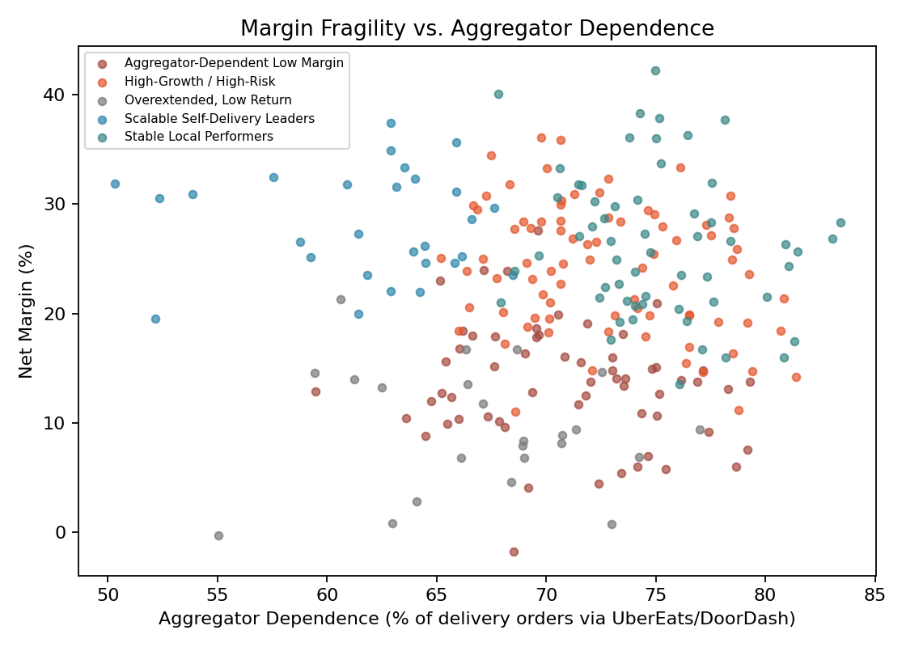
As reliance on delivery-app orders increases, profit margin tends to fall — the core driver of this fragile-growth pattern.

Where the Opportunity Is
- "Scalable Self-Delivery Leaders" (28 branches) combine healthy margins with efficient, self-managed delivery. These are the strongest candidates for expansion investment.
- "High-Growth / High-Risk" (81 branches) are already growing quickly and can support further investment, provided cost discipline is reinforced alongside that growth.
- "Overextended, Low Return" (23 branches) show weak growth potential and high costs. These should not receive further investment until their underlying cost base is addressed.

What Happens Next
This analysis is delivered alongside a live, interactive dashboard that lets staff filter by area, cuisine, or business type, and drill into any individual branch's score and recommendation. It is designed to support — not replace — informed judgment: a branch flagged for review should be examined by local management before any decision is finalized.
In practical terms, we recommend three next steps: (1) review commission agreements for aggregator-dependent branches; (2) prioritize capital toward the self-delivery and high-growth branches identified above; and (3) apply a cost-recovery plan to overextended branches before considering any further investment.

