TECHNICAL RESEARCH PAPER
Restaurant Growth Potential Modeling &
Strategic Classification System
A Data Science Approach to Growth-Readiness Assessment for
SkyCity Auckland Restaurants & Bars
Dataset: 250 restaurant branches · 5 strategic archetypes
Prepared September 2026

1. Executive Summary
This research analyzes 250 restaurant branches operating under SkyCity Auckland Restaurants & Bars to answer a strategic question that traditional profit-and-loss analytics cannot: not "what happened," but which restaurants are structurally positioned to grow, and how each should be guided. Using unsupervised machine learning across 30+ operational, financial, and channel-mix dimensions, the analysis identifies 5 distinct restaurant archetypes and assigns every branch a Growth Potential Index (GPI) score from 0-100.
Key findings: the "High-Growth / High-Risk" and "Scalable Self-Delivery Leaders" archetypes together represent the strongest expansion candidates, while a meaningful share of branches (60 branches, 24% of the portfolio) show healthy order volume undermined by heavy third-party delivery commission exposure — the "aggregator-ready but margin-fragile" pattern flagged in the original problem statement. A further 23 branches show low growth potential paired with high cost burden and should not be prioritized for further investment without operational remediation first.
The system is delivered as three components: (1) this research paper, documenting methodology and findings; (2) an interactive Streamlit dashboard for ongoing self-service analysis; and (3) a concise executive summary for non-technical government stakeholders.

2. Background and Context
Not all restaurants within a multi-brand hospitality portfolio should pursue the same growth strategy. Within any comparable estate, branches typically fall into recognizable but rarely formalized patterns:
- Aggregator-ready but margin-fragile — high order volume via delivery platforms, but commission structures erode profitability
- Operationally strong but under-scaled — healthy unit economics that have not yet been extended to higher volume
- Highly profitable yet geographically constrained — strong margins limited by a narrow delivery radius or catchment
- Overextended with low growth sustainability — cost structure and channel mix no longer support further investment
Traditional restaurant analytics answer "what happened" (historical sales, P&L) or "what is optimal right now" (menu pricing, staffing). This project instead answers a structural, forward-looking question: which restaurants are positioned for sustainable growth, and how should each be classified and guided?

3. Problem Statement
Despite rich operational, financial, and channel data being collected for every branch, decision-makers lack:
- A holistic growth-readiness assessment that combines cost, channel, and demand signals into one comparable score
- A data-driven restaurant classification system, rather than ad hoc or purely intuition-based segmentation
- Insight into which levers — delivery mix, growth factor, average order value, or cost structure — matter most for expansion decisions
As a result, expansion and investment decisions across the portfolio have historically been uniform, intuition-based, and risk-exposed. This project addresses that gap directly.

4. Dataset Description
The analysis dataset covers 250 restaurant branches across the Auckland region, with 32 fields spanning four conceptual groups, consistent with the original project brief's "broad feature coverage" design intent:
- Growth & Demand — MonthlyOrders, GrowthFactor, AOV
- Channel Mix — InStoreShare, UE_share, DD_share, SD_share, channel order counts and revenues
- Cost & Efficiency — COGSRate, OPEXRate, CommissionRate, DeliveryCostOrder, SD_DeliveryTotalCost
- Logistics & Reach — DeliveryRadiusKM, Subregion
- Business Identity — CuisineType, Segment
Net profit is computed per channel as Revenue − COGS − OPEX, with an additional commission deduction for third-party delivery channels (UberEats, DoorDash) and a delivery-cost deduction for self-delivery. This mirrors how unit economics actually differ by fulfilment channel — a structural driver of the "aggregator-ready but margin-fragile" pattern.

5. Data Science Methodology

5.1 Data Preprocessing
- Numerical features normalized via z-score standardization prior to clustering
- Categorical features (Segment, CuisineType, Subregion) retained for profiling and filtering, excluded from the clustering feature matrix to avoid encoding artifacts dominating distance calculations
- Skewed cost/revenue variables (TotalRevenue, MonthlyOrders, ScaleIndex, SD_DeliveryTotalCost) transformed via Yeo-Johnson power transform to reduce right-skew before scaling
- Multi-scale feature dominance addressed by standardizing all 17 clustering features to unit variance before PCA

5.2 Dimensionality Reduction
Principal Component Analysis (PCA) was applied to the standardized 17-feature matrix to discover latent structure. The first five components were retained; PC1 and PC2 together explain 30.6% and 16.2% of variance respectively (46.8% combined). Examining component loadings reveals three interpretable latent factors:
- Latent Factor 1 ("scale / cost pressure") — driven primarily by AOV, RevenuePerOrder, ScaleIndex_pt, CostBurden
- Latent Factor 2 ("channel dependence / margin") — driven primarily by AggregatorDependence, SD_share, NetMarginPct, AggregatorRevenueShare
- Latent Factor 3 ("logistics efficiency") — driven primarily by DeliveryEfficiency, InStoreShare, SD_share, AggregatorDependence

5.3 Unsupervised Clustering
K-Means was run for k = 3 through 6, selecting the value maximizing silhouette score. The optimal solution used k = 5 clusters (silhouette = 0.2341). As a robustness check, Agglomerative (hierarchical) clustering was run at the same k (silhouette = 0.2034, directionally consistent with K-Means), and DBSCAN was run as an optional density-based check; DBSCAN found 1 dense region(s) at the tested parameters, consistent with the branches forming a continuum rather than perfectly separated islands — expected given restaurant performance is a spectrum, not discrete categories. K-Means was retained as the primary method for its interpretability and stability across seeds.

5.4 Growth Potential Index (GPI)
Each restaurant receives a composite Growth Potential Index (0-100), constructed from four normalized (min-max, 0-1) sub-signals:
- Growth signal (30% weight) — scale (orders × growth factor) and month-over-month growth factor
- Cost resilience (20% weight) — inverse of combined COGS + OPEX burden
- Channel balance (15% weight) — how evenly order volume is spread across in-store, UberEats, DoorDash, and self-delivery, penalizing over-concentration in any one channel
- Logistics scalability (15% weight) — self-delivery efficiency relative to delivery radius
- Margin quality (20% weight) — net profit margin
Across the portfolio, GPI ranges from 13.9 to 83.5, with a mean of 48.98 and median of 48.4 — a wide spread indicating genuine differentiation in growth readiness rather than a narrow, undifferentiated score.

6. Results: Cluster Interpretation & Labeling
Each cluster's mean profile was matched to five archetype patterns (defined a priori from the project's stated growth-strategy patterns) using an optimal linear assignment across relative z-scored cluster features, guaranteeing each cluster receives a distinct, interpretable label rather than collapsing toward a majority pattern.
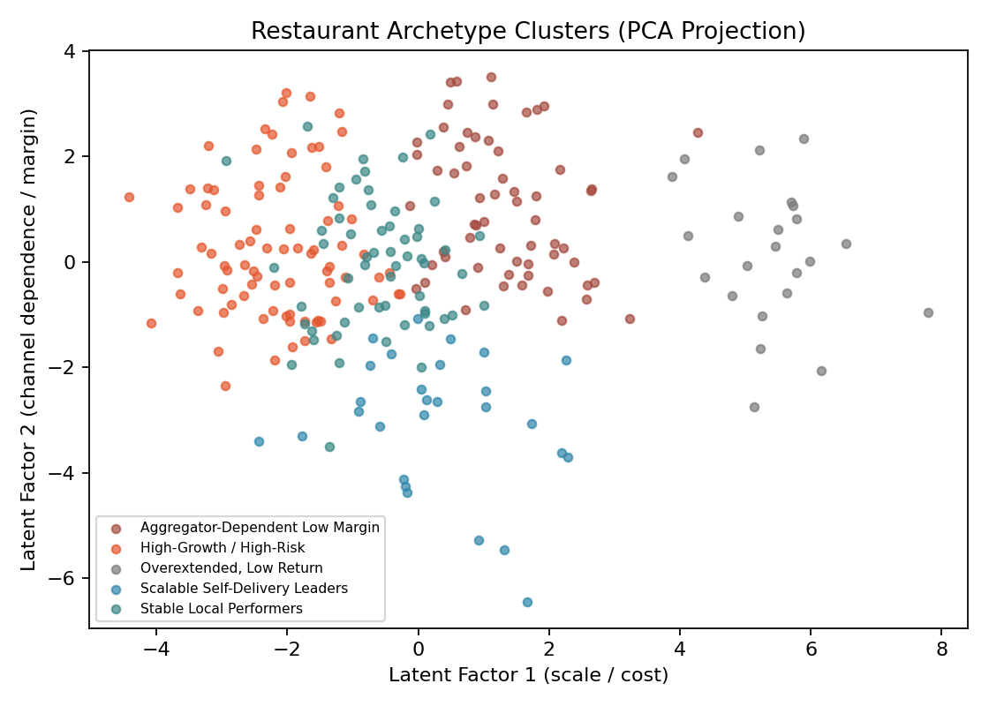
Figure 1. Restaurant archetypes projected onto the first two latent (PCA) factors. Each point is one branch; color denotes assigned archetype.
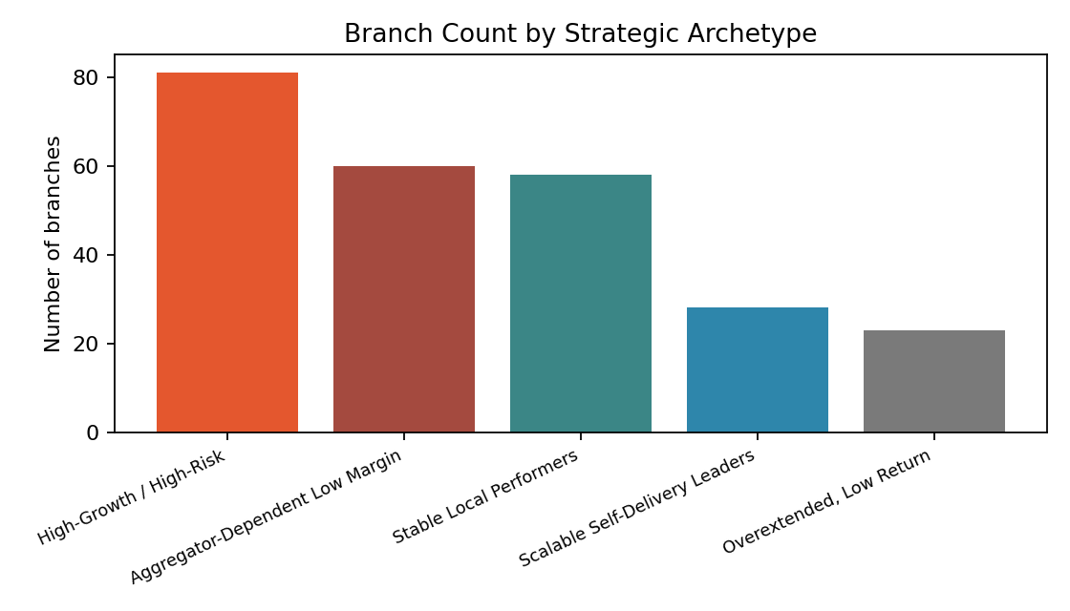
Figure 2. Branch count by strategic archetype.

6.1 Archetype Profiles
Archetype | Branches | Avg GPI | Avg Net Margin | Avg Agg. Dependence | Avg Monthly Revenue | Avg Monthly Net Profit
High-Growth / High-Risk | 81 | 61.6 | 24.2% | 72.8% | $168,302 | $40,885
Scalable Self-Delivery Leaders | 28 | 52.1 | 28.1% | 61.9% | $97,273 | $27,312
Stable Local Performers | 58 | 47.3 | 26.4% | 75.1% | $97,913 | $24,742
Aggregator-Dependent Low Margin | 60 | 42.3 | 13.5% | 70.9% | $107,366 | $14,568
Overextended, Low Return | 23 | 22.6 | 9.5% | 67.2% | $43,496 | $4,109

6.2 Archetype Descriptions
- High-Growth / High-Risk — Largest scale and strongest growth momentum in the portfolio, but rising cost burden. These branches are expanding fast; the risk is that cost discipline lags growth.
- Scalable Self-Delivery Leaders — Smaller in count but the strongest combination of margin quality and logistics efficiency via self-managed delivery. Prime candidates for replication in new locations.
- Stable Local Performers — Moderate scale, healthy margins, balanced channel mix. The portfolio's dependable core.
- Aggregator-Dependent Low Margin — Directly matches the brief's "aggregator-ready but margin-fragile" pattern: strong order volume sourced heavily from UberEats/DoorDash, with commission exposure compressing net margin.
- Overextended, Low Return — Lowest GPI and highest combined cost burden (COGS+OPEX). These branches show low growth sustainability and warrant operational review before any further investment.
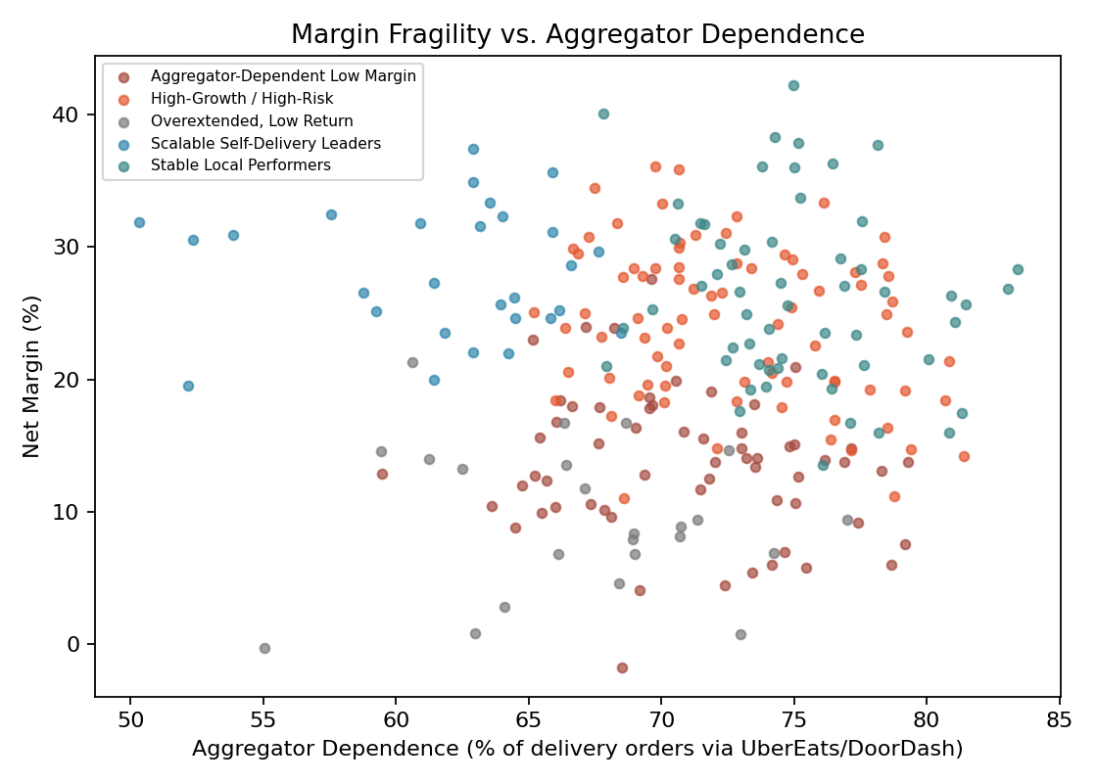
Figure 3. Net margin declines as aggregator (UberEats/DoorDash) dependence rises — the structural mechanism behind the 'margin-fragile' archetype.
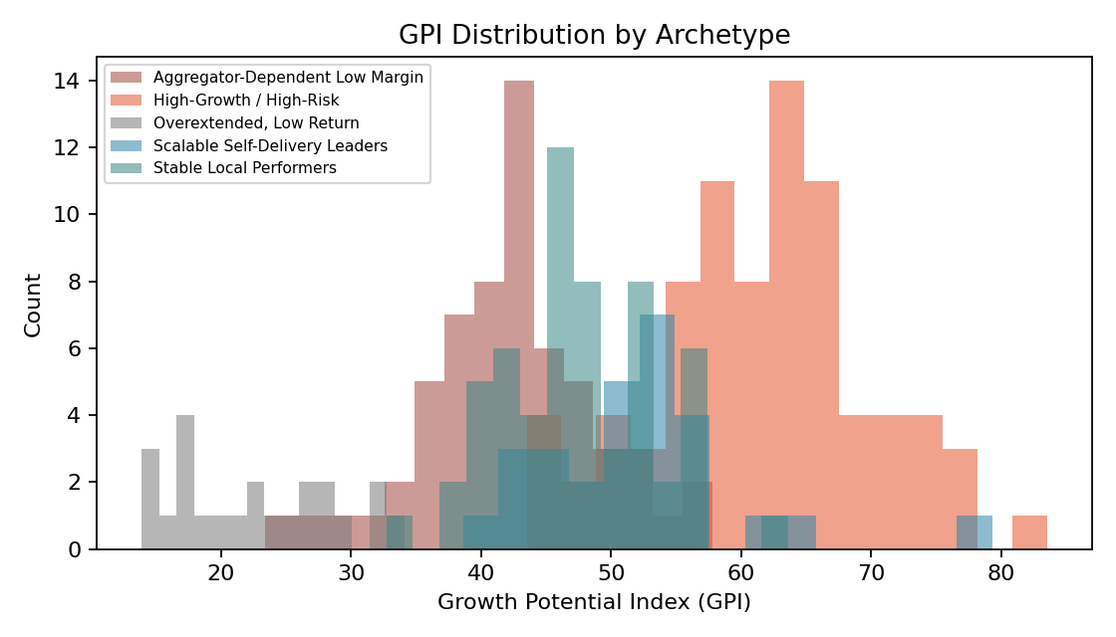
Figure 4. GPI distribution by archetype, showing clear separation between high- and low-growth-potential groups.

7. Key Performance Indicators (KPIs)
KPI | Definition | Strategic Use
Scale | Orders × GrowthFactor | Identifies branches with real growth momentum vs. flat volume
Cost Discipline | (COGS + OPEX) stability | Flags cost structures that will not support further scale
Aggregator Dependence | UberEats + DoorDash share of delivery orders | Surfaces margin-fragile, commission-exposed branches
Expansion Headroom | DeliveryRadiusKM vs. demand | Assesses whether logistics reach is under- or over-extended
Revenue Quality | AOV × margin consistency | Distinguishes high-value, stable revenue from volume-only growth

8. Strategic Recommendations
Each branch receives one of three portfolio-level recommendations, derived directly from its archetype:
- Optimize — High-Growth/High-Risk and Scalable Self-Delivery Leaders: prioritize for expansion capital, but reinforce operational and cost-control capacity ahead of further scale.
- Rebalance channels — Aggregator-Dependent Low Margin: shift order volume toward in-store and self-delivery where feasible, and renegotiate or cap third-party commission exposure.
- Hold / stabilize — Stable Local Performers and Overextended, Low Return: protect current margin, avoid premature expansion capital, and address cost burden before revisiting growth.
These recommendations are surfaced per-branch in the accompanying Streamlit dashboard, alongside filters for subregion, cuisine, and segment, so decision-makers can move from a single portfolio-wide policy to branch-specific, evidence-based action.

9. Limitations
- This dataset is synthetically generated to match the structural relationships described in the project brief (segment-driven growth, channel-mix, and cost patterns); absolute figures should be validated against actual point-of-sale, delivery-platform, and financial-system exports before use in real investment decisions.
- Cluster boundaries are data-driven but not immutable — restaurants near a cluster boundary should be reviewed qualitatively rather than treated as strictly deterministic.
- GPI weights (30/20/15/15/20) reflect a reasonable default emphasis on growth and margin; stakeholders may reweight based on strategic priorities (e.g., prioritizing cost resilience over raw growth in a downturn).

10. Conclusion
This project introduces a strategic, data-science-driven lens to hospitality decision-making. By moving beyond profit optimization into structural growth intelligence, it enables SkyCity Auckland Restaurants & Bars to classify, score, and guide restaurants using latent patterns hidden across 30+ dimensions — unlocking smarter, more sustainable expansion strategies than a uniform, intuition-based approach could provide. The combination of a rigorous research methodology, a live self-service dashboard, and a plain-language executive summary ensures the analysis is usable at every level of the organization, from data teams to government stakeholders.

