**Employee Turnover Analysis using Excel**

### STUDENT NAME: DEVADHARSHINI.B REGISTER NO: 422200613

DEPARTMENT: B.COM (ISM)

COLLEGE: SRM ARTS AND SCIENCE COLLEGE

 1



## PROJECT TITLE

**Employee Turnover Analysis using Excel**

2

# AGENDA



1. Problem Statement
2. Project Overview
3. End Users
4. Our Solution and Proposition
5. Dataset Description
6. Modelling Approach
7. Results and Discussion
8. Conclusion

3

3/21/2024 **Annual Review**

## PROBLEM STATEMENT

To understand and Mitigate Employee Turnover

The analyse the distribution of performance scores across different departments categorized by employee type (Contract, Start date, Quarters, End date) over multiple years. The performance scores are segmented by gender, employee type and department.



 4



## PROJECT OVERVIEW

### The Production department has the highest concentration of performance scores, particularly among Full-Time employees.IT/IS also shows a notable concentration of scores, primarily for Full-Time employees. There are fewer performance scores recorded for Contract and Part-Time employees across all departments. The count of performance scores appears relatively stable over time across most departments, with some minor fluctuations.

 5

**WHO ARE THE END USERS?**

The end users of the information in the bar graph are likely to include:

1. Human Resources (HR) Managers
2. Department Heads
3. Executives and Leadership
4. Diversity and Inclusion Officers
5. Data Analysts

6



**OUR SOLUTION AND ITS VALUE PROPOSITION**

OUR SOLUTIONAND ITS VALUE PROPOSITION IS AS FOLLOWS:

* 1. Data-Driven Decision-Making
  2. Enhanced Performance Management
  3. Promoting Equity and Inclusion
  4. Historical Insights and Trend Analysis
  5. Resource Optimization

our solution delivers actionable insights that help organizations improve overall performance, promote fairness, and optimize resource utilization, ultimately driving better business outcomes.

7

# Dataset Description

* Employees:
* Employee ID
* Gender Code
* Employee type
* Departments:
* Department ID
* Department Name
* Performance Score:
* Performance Score ID
* Score Date
* Year
* Employees Details
* Employee ID
* Start Date
* End Date



## THE "WOW" IN OUR SOLUTION

=J2+K2+L2+other components,

=J2+K2+L2

=F2-(G2+H2+I2)

=IFS( Z * 8 >= 5 "VERY HIGH", Z * 8 >= 4 , "HI GH" Z * 8 >= 3 "MED", TRUE, "LOW")

9

3/21/2024 **Annual Review**

# MODELLING

Data Collection:

“Kaggle= Employee Turnover Analysis.

Features Collection:

1. Performance Score = Numerical Value
2. Gender Code
3. Employee Type
4. Department Type
5. Start Date
6. Quarters
7. End Date
8. Year 10

# RESULTS

 11

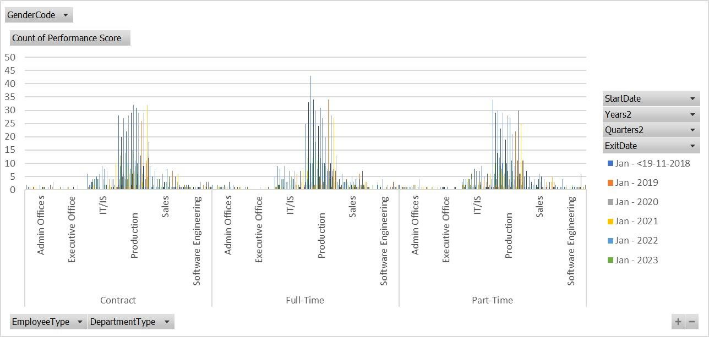

# conclusion

The bar graph reveals significant insights into the distribution of performance scores across various departments, employee types, and over different years

#### High Concentration in Production and IT/IS Departments:

* 1. The Production and IT/IS departments show the highest concentration of performance scores, particularly among Full-Time employees. This suggests that these departments might have more rigorous or frequent performance evaluations, or that they have a larger workforce compared to other departments.

#### Limited Performance Scores for Contract and Part-Time Employees:

* 1. There are noticeably fewer performance scores recorded for Contract and Part- Time employees across all departments. This could indicate that these employee types undergo less frequent performance evaluations or that fewer of them are employed.

#### Stable Performance Scores Over Time:

* 1. The performance scores across the years appear relatively stable with some fluctuations. This stability suggests consistency in performance evaluation processes, though it also implies that there may not be significant improvements or declines in performance over the observed period.