Introduction to PANDAS
import pandas as pd
import numpy as np
PANDAS : Series data structure
s=pd.Series([3,9,−2,10,5])
s.sum()
s.min()
s.max()

Creating a Data Frame
import pandas as pd
data = [['Dinesh',10],['Nithya',12],['Raji',13]]
df = pd.DataFrame(data,columns=['Name','Age'])

Indexed Data Frame
data = {'Name':['Kavitha', 'Sudha', 'Raju','Vignesh'],'Age':[28,34,29,42]}
df = pd.DataFrame(data, index=['rank1','rank2','rank3','rank4'])

Creating a DataFrame using Dictionary
df1=pd.DataFrame({'A':pd.Timestamp('20130102'),'B':np.array([3]*4,dtype='int32'),
'C':pd.Categorical(['Male','Female','Male','Female'])})
df1.shape
df1.dtypes
df1.head()
#will display first 5 records
df1.tail()
#will display last 5 records
df.summary()
df.T
# will transpose the data frame
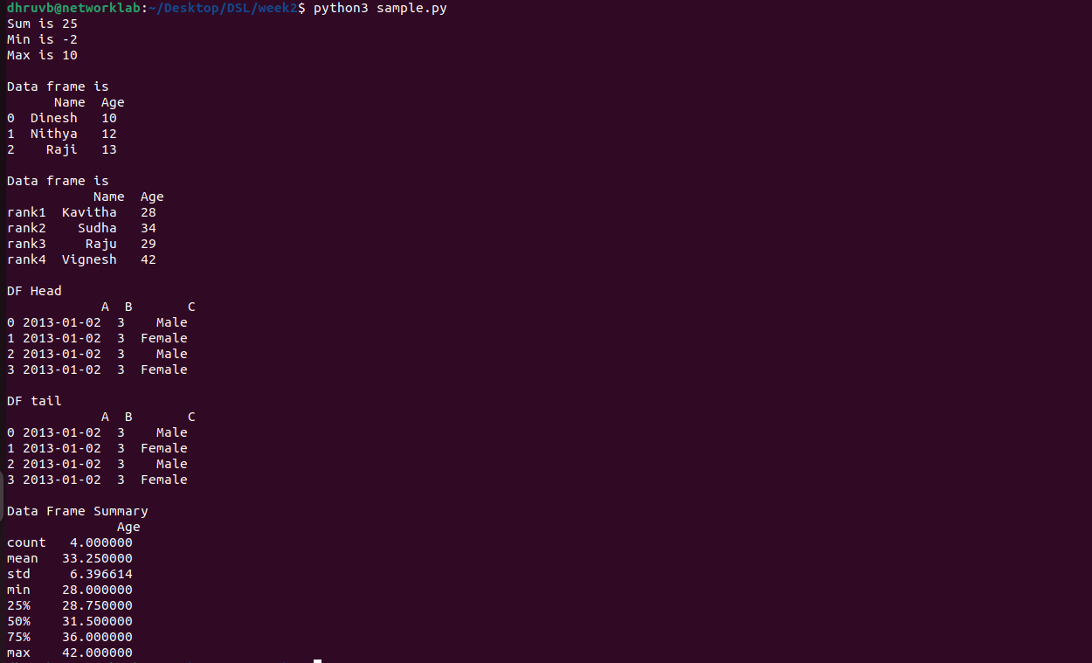
Other Operations
import pandas as pd
import numpy as np
dates=pd.date_range('20130101', periods=100)
df = pd.DataFrame(np.random.randn(100,4), index=dates, columns=list('ABCD'))
#To view first 5 records
df.head()
#To view last 5 records
df.tail()
#To view the index
df.index
#To view the column names
df.columns
# To transpose the df
df.T
#Sorting by Axis
df.sort_index(axis=1, ascending=False)
#Sorting by Values
df.sort_values(by=’B’)
#Slicing the rows
df[0:3], which slice first 3 records (rows)
#Slicing with index name
df[‘20130105’:’20130110’]
#Slicing with row and column index (like 2D Matrix)
df.iloc[0]#, will fetch entire 1st row
df.iloc[0,:2]#, will fetch 1st row, first 2 columns
df.iloc[0,0]#, will fetch 1st row, 1st column element (single element)
#Selecting a single column
df[‘A’]#, which yields a Series
Selecting more than one column
df[[‘A’,’B’]]#, entire 2 columns
#Selecting more than one column, with selected number of records
df[[‘A’,’B’]][:5]#, first 5 records
#[OR]
#df.loc[‘20130101’:’20130105’,[‘A’,’B’]][:5], first 5 records

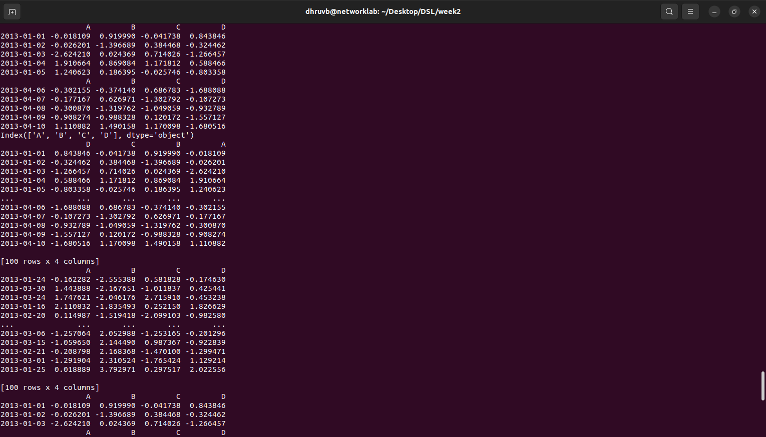
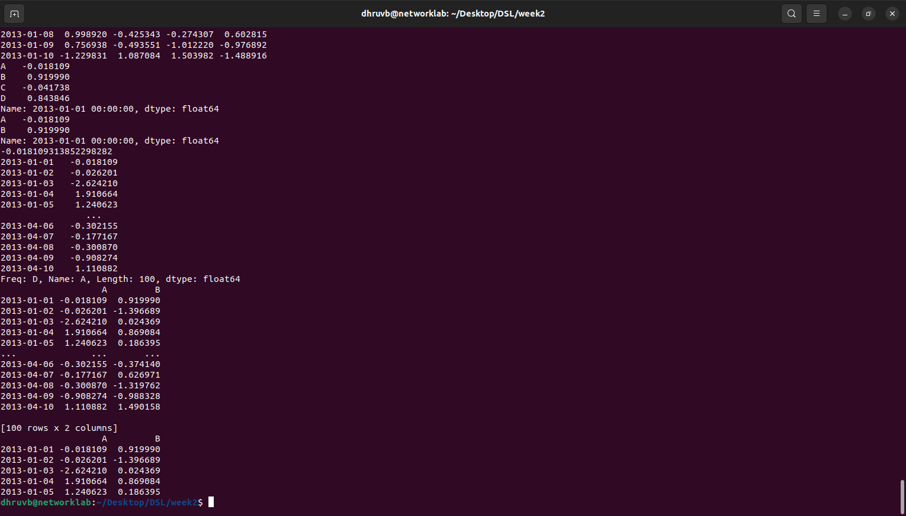
Boolean Indexing
df[df.A>0]#, will fetch all positive values of A column
#Include a 6th column (a categorical) character data
df[‘F’]=[‘Male’,’Female’,’Female’,’Male’,’Female’,’Female’]
#Setting by assigning with a numpy array
df.loc[:,’D’]=np.array([5]*len(df))
#Which will replace the ‘D’, column with all 5
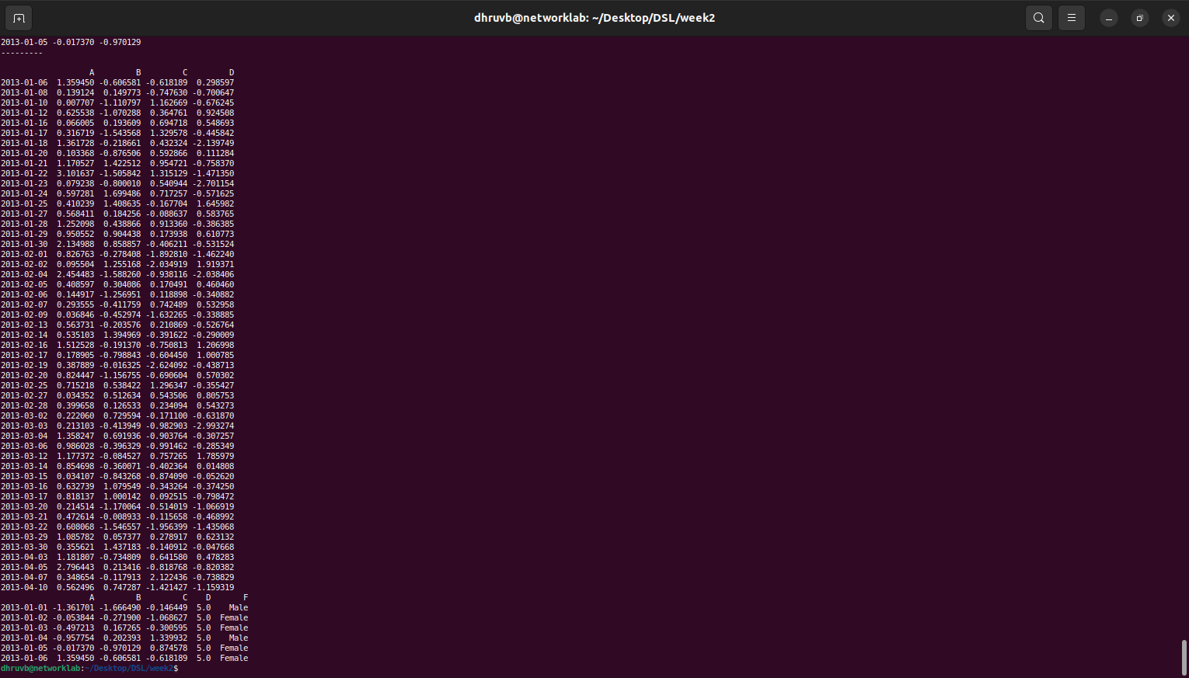

Deleting a row or column
df.drop (‘col_name’, axis =1, inplace=True)#will drop the column name specified in col_name
df.drop (‘row_index’, axis =0, inplace=True)#will drop the row specified in row_index

Concatenation of two Data Frames
#Let df1 be of size 10 x 5 and df2 of size 10 x 3 if concatenated horizontally (as a new column insertion)
Df_new= pd.concat (df1, df2, axis=1)
Df_new.shape
#Let A dataframe of size 10 x 5 and B dataframe of size 15 x 5 if concatenated Vertically (as a new row insertion)
D= pd.concat (A, B, axis=0)
D.shape
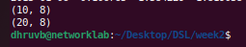
I/O Operations with external files
# Reading a CSV file & XLS file format
df = pd.read_csv(‘xyz.csv',header=None)
df.head() #This will display 1 st 5 records
df.tail() #This will display last 5 records
#The above dataset doesn’t have header, we shall attach our own header.
df.columns=['preg','glu','bp','sft','ins','bmi','dpf','age','class']
#Let us visualize the scatter plot of two continuous variable.
plt.scatter(df['bmi'],df['glu'])
plt.xlabel('bmi')
plt.ylabel('Glucose')
#Let us visualize the histogram of another continuous variable ‘Age’
df['age'].hist()
#Let us visualize the distribution ‘Age’ with respect to Categories: Label-O(Healthy), Label-1 (Diabetes)#We can observe the median age of diabetes is slightly greater than median age of healthy

W = pd.read_csv('xyz.xls',header=None)
W.head() #XLS file format also, we can read using pd.read_csv
D= np.loadtxt(‘xyz.data',delimiter=",")
D[:5,:] # this file is loaded in Numpy 2D array format
# Reading a XLSX file format
G=pd.read_excel(xyz.xlsx',sheet_name='Sheet1')
G.head()
#Here additionally we need to pass the sheet_name. If not specified, it will read the first page by
default.

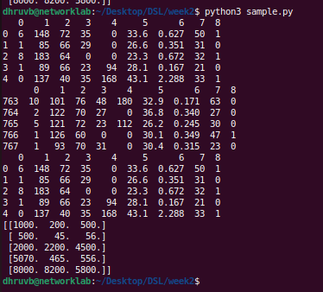
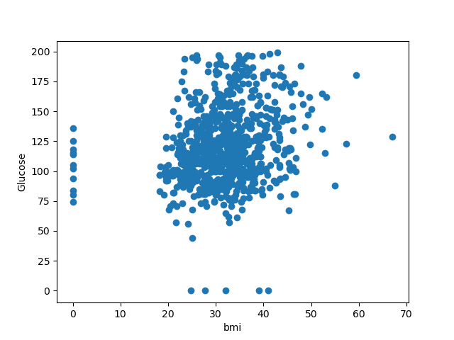

# Reading a HTML file format
Pandas can read table tabs off of html. For example:
B = pd.read_html('http://www.fdic.gov/bank/individual/failed/b
anklist.html')
# Reading a TXT file format
H = pd.read_table('HR.txt')
H.head()
f=H['Department'].value_counts()
#We can visualize the distribution of categorical values using
bar plot and pie chart
f.plot(kind='bar')
The above bar plot can be perceived in terms of Pie chart
which would give % percentage information
f.plot(kind='pie')
#We can visualize two categorical variables at a time
fa=pd.crosstab(H['Gender'],H['Attrition'])
fa.plot(kind='bar')

