Usage of Numpy Data Structure
Import numpy as np
1. Array creation
A = np.array ([2,5,10])
A.dtype
#Will show, int64 data type
B=np.array ([2.4,10.6,5.2])
B.dtype
#Will show, float64 data type

Creating sequence of sequence will create 2-dimensional array.
A=np.array([(3,4,5),(12,6,1)])
Z=np.zeros((2,4)) # will create zero matrix of dimension 2x4
#Similarly,
np.ones((3,3)) # will create one’s matrix of dimension 3x3

To create a sequence of data,
S=np.arange(10,30,5)
print(S) #will give (10,15,20,25,30), with step size of 5
np.arange( 0, 2, 0.3 ) # it accepts float arguments
#array([ 0. , 0.3, 0.6, 0.9, 1.2, 1.5, 1.8])

lnstead of step-size, we can specify total number of elements in the array using
S1=np.linspace(0,2,9) # produce 9 numbers starting 0 & ends with 2array([ 0. , 0.25, 0.5 , 0.75, 1. ,1.25, 1.5 , 1.75, 2. ])

Usage of Random Number functions
import random
random.choice([1,2,3,4,5])#, this will pick one number from the list randomly
random.choice(‘python’)#, will pick one character from the string randomly
random.randrange(25,50)#, will pick one integer between 25 to 50
random.randrange(25,50,2)#, will pick one integer between 25 to 50 with step size of 2
random.random()#, will pick a random number between 0 to 1
random.uniform(5,10)#, will pick a floating point number between 5 to 10
random.shuffle([1,2,3,4,5])#, will shuffle the list elements
random.seed(10)#, to get same random value during every execution

2- Dimensional array (Matrix)
a = np.arange(15).reshape(3, 5)
#to check the dimension
a.shape
a.size # will return total elements in matrix (here 15)
# to transpose a matrix
a.T # transposed to 5x3 matrix

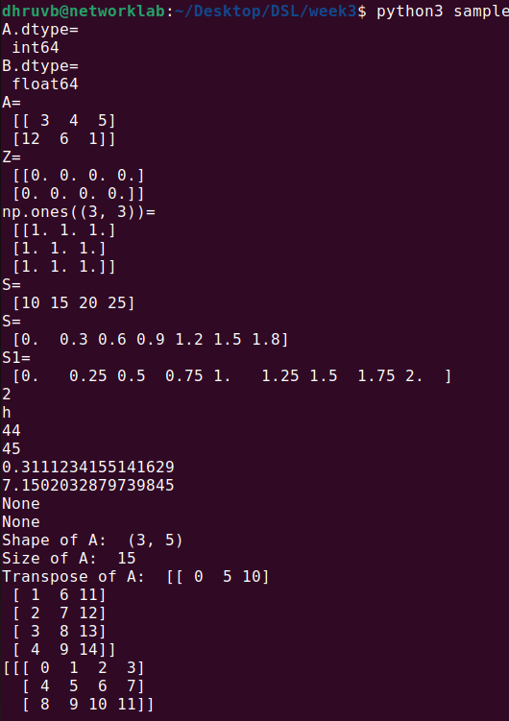

3- Dimensional array
c = np.arange(24).reshape(2,3,4) # 1st value indicates (no of planes) (3,4) is the dimension
print(c)
c.shape# will return (2,3,4)
c[1,...]# is equal to c[1,:,:] # will fetch all elements of 2nd plane
c[...,2]#is equal to c[:,:,2] [[3,7,11],[15,19,23]]

Array operations
a = np.array( [20,30,40,50] )
b = np.arange( 4 )
b
c = a−b
c
array([20, 29, 38, 47])
b**2
array([0, 1, 4, 9])
10*np.sin(a)
array([ 9.12945251, −9.88031624, 7.4511316 , −2.62374854])
a<35

Matrix operations
A = np.array( [[1,1],[0,1]] )
B = np.array( [[2,0],[3,4]] )
A*B
A.dot(B)
(OR)
np.dot(A, B)
# another matrix product
b = np.arange(12).reshape(3,4)
b
b.sum(axis=0) # sum of each column
b.sum(axis=1) # sum of each row

Indexing, Slicing & Iterating Array
a = np.arange(10)**3
a
a[2:5]
a[0:6:2]
Let ‘b’, is an input matrix of size 5x4
array([[ 0, 1, 2, 3],
[10, 11, 12, 13],
[20, 21, 22, 23],
[30, 31, 32, 33],
[40, 41, 42, 43]])
b[2,3] #will fetch 23
b[0:5,1] or b[:5,1] or b[:,1] #will fetch [1,11,21,31,41]
b[−1,:] # will fetch last row
b[:,−1] # will fetch last col
for row in b:
print (row) # will print every rowfor element in b.flat:
print (element) # will show all elements of b in 1−D array

Changing the shape of a matrix
b.ravel() # returns the array flattened to (1x 20)
#Later, we can convert 5x4 matrix into 4x 5 matrix using
B1=b.reshape(4,5)

Stacking together different arrays
A1=np.array([(3,4,5),(12,6,1)])
A2=np.array([(1,2,6),(−4,3,8)])
D1=np.vstack((A1,A2))
D2=np.hstack((A1,A2))

Stacking 1-D array into 2-D array (column wise)
a = np.array([4.,2.])
b = np.array([3.,8.])
np.column_stack((a,b)) # returns a 2D array
np.hstack((a,b))
# the result is different
np.hstack((a[:,newaxis],b[:,newaxis])) # the result is the same

Indexing with array of indices
a = np.arange(12)**2 # the first 12 square numbers
i = np.array( [ 1,1,3,8,5 ] ) # an array of indices
a[i] # the elements of a at the positions i
j = np.array( [ [ 3, 4], [ 9, 7 ] ] ) # a bidimensional array of indices
a[j] # the same shape as j

Usage of for-loop (Mapping by Value)
#Calculate sum of all the elements in a 2D Numpy Array (iterate over elements)
import numpy as np
a=np.array([(3,2,9),(1,6,7)])
s1=0
for row in a:
for col in row:
s1+=col
print(s1)

Usage of for-loop (Mapping by Index)
#Calculate sum of all the elements in a 2D Numpy Array (iterate over range)
import numpy as np
a=np.array([(3,2,9),(1,6,7)])
s=0
for i in range(a.shape[0]):
for j in range(a.shape[1]):
s+=a[i,j]
print(s)
−−−−−−−−−−−−−−−−−−−−−−−−−−−−−−−−−−−−−−−−−−−−−−−−−−− −−−−−−−−−−−−−−−−−−−−−−−−−−−−−−−−−−−−−−−−−−−−−−−−−−− −−−−−−−−
