

DISTRIBUTED SYSTEMS (CSE -3261) MINI PROJECT REPORT ON

**Title of the Mini Project**

*SUBMITTED TO*

**Department of Computer Science & Engineering**

*by*

Name of the students

Registration number

Roll Number

Semester and Section

Name & Signature of Evaluator 1 Name & Signature of Evaluator 2

(Jan 2024 – May 2024)

|  |  |  |  |  |
| --- | --- | --- | --- | --- |
| **Table of Contents** | | | | |
|  | | | | Page No |
|  | | | | |
| **Chapter 1** | | | **INTRODUCTION** | 1 |
|  | **1.1** | Introduction | | 2 |
|  | **1.2** | Motivation | |  |
|  | **1.3** |  | |  |
|  | | | | |
| **Chapter 2** | | | BACKGROUND THEORY and/or LITERATURE REVIEW |  |
|  | **2.1** |  | |  |
|  | **2.2** |  | |  |
|  | | | | |
| **Chapter 3** | | | **METHODOLOGY** |  |
|  | **3.1** |  | |  |
|  | **3.2** |  | |  |
|  | | | | |
| **Chapter 4** | | | **RESULTS AND DISCUSSION** |  |
|  | **4.1** |  | |  |
|  | **4.2** |  | |  |
|  | | | | |
| **Chapter 5** | | | **CONCLUSIONS AND FUTURE ENHANCEMENTS** |  |
|  | **5.1** |  | |  |
|  | **5.2** |  | |  |
|  | | | | |
| **REFERENCES** | | | |  |
|  | | | |  |

1. INTRODUCTION
   1. **General**

Diabetes continues to be one of the most common underlying factors associated with lower–extremity amputation in post–industrialised and developing countries (Armstrong *et al*., 1998a). Amputations are perhaps the most feared and well–recognised complication of diabetes by the general public. Ulceration is the most common single precursor to amputation and has been identified as a component in 85% of lower-extremity amputations (Pecoraro *et al*., 1990). Many studies have focused on neuropathy, in conjunction with elevated ground reaction forces, as the principal cause of these ulcerations. It is also hypothesised that at the cellular level, increased rate of tissue deformation may result in elevated intracellular calcium concentration, which may lead to cellular death subsequently causing ulcerations(Landsman *et al.*, 1995). The present study is an effort to understand the pressure distribution patterns under the foot-soles of diabetic subjects at different levels of neuropathy (characterised by different grades of sensation loss) with new foot pressure parameters, possibly indicating the different stages in the progress of neuropathy and hence help to detect the early stages of neuropathy responsible for plantar ulcers.

* 1. **Diabetes**

Diabetes is a disorder caused by decreased production of insulin, or by decreased ability to use insulin. Insulin is a hormone produced by the pancreas that is necessary for the cells to be able to use blood sugar. The variation of PR with the levels of sensation is as shown in Fig 1.1

.

.

.

.

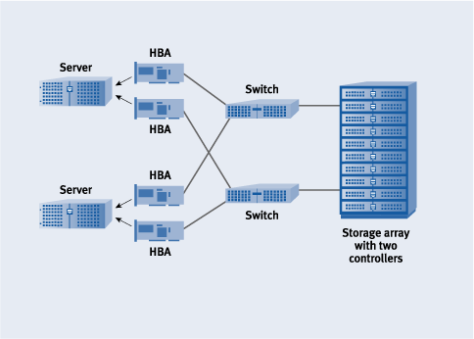

Fig. 1.1 Variation of PR with the levels of sensation, S in the medial heel region (area 1) of 50 feet of diabetic subjects from standing foot pressure image analysis.

Table 5.5 Coefficients of correlation (r) between PR values and levels of sensation (S) and the corresponding regression equations in different areas of the foot in diabetic subjects.

|  |  |  |
| --- | --- | --- |
| Foot areas | Correlation coefficients (r) | Regression equations |
| 1 | 0.94 | PR1 = 3.03 x S1 + 15.43 |
| 2 | 0.96 | PR2 = 3.45 x S2 + 12.94 |

REFERENCES

[1]. J. S. Turner, “New directions in communications,” IEEE Journal on Selected Areas in Communications, vol. 13, no. 1, pp. 11-23, Jan. 1995.

[2]. D. B. Payne and J. R. Stern, “Wavelength-switched passively coupled single-mode optical network,” Proceedings of the 2nd International Conference on Optical Fiber Sensors, Boston, MA, USA, 1985, pp. 585–590.

[3]. Tannenbaum A.S. – “Computer Networks”, Edn. 3 , Prentice Hall of India ( EE edition), New Delhi, 1998.

[4]. Frame Based Feature Vectors, <https://www.quora.com/>

**Organization of Report:**

CONTENTS

1. Introduction

2. Literature survey, with brief descriptions of the contributions in each of the paper referred.

3. Methodology

4. Results and discussion

5. Conclusions and future enhancements, if any

6. Reference(s)