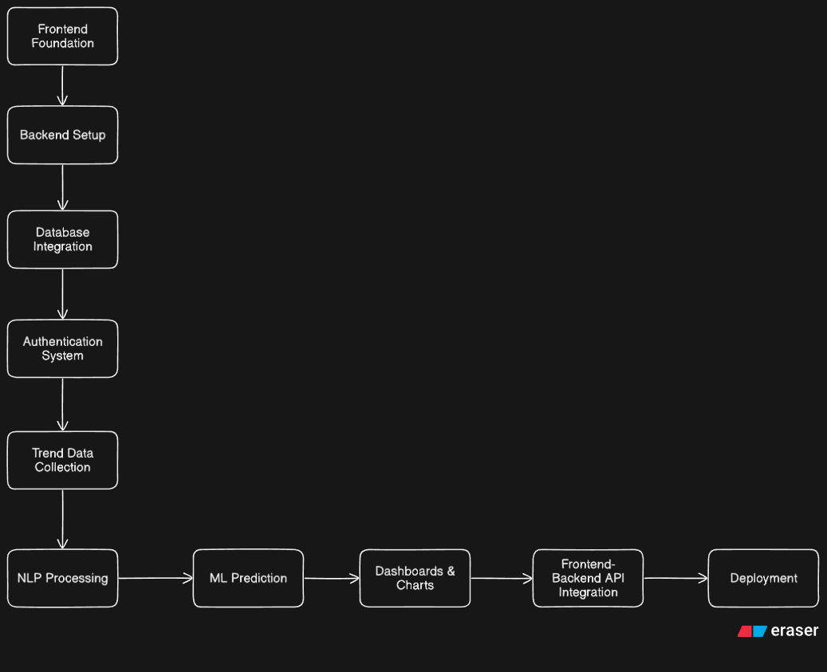

PHASE 1: FRONTEND FOUNDATION
Goal: Create professional project UI
Things to complete:
- Homepage
- Login Page
- Register Page
- Dashboard UI
- Trend Cards (Initially dummy data)
- Charts Section
- Responsive Design
- Animations + Styling

PHASE 2 — BACKEND SETUP
Backend handles:
- APIs
- authentication
- database communication
- ML processing

Things to complete:
- FastAPI Project
- API Endpoints
- Test APIs

PHASE 3 — DATABASE INTEGRATION
Data is stored permanently
To store by creating tables for the following category:
- users
- trends
- predictions
- search history

PHASE 4 — AUTHENTICATION SYSTEM
What we will build:
- Registration API
- Login API
- Password Hashing
- JWT Tokens
Workflow:
User Login
↓
Backend Verifies Credentials
↓
JWT Token Generated
↓
Frontend Stores Token
↓
Protected Routes Accessible
PHASE 5 — TREND COLLECTION ENGINE
Now the platform starts collecting real-world data.

API | Purpose
NewsAPI | News trends
Reddit API | Community discussions
Google Trends | Search popularity

Workflow
External APIs
↓
FastAPI Backend
↓
Store Data in Database

PHASE 6 — NLP PIPELINE (AI begins)
NLP is used to analyze text
NLP Tasks:
  - Text Cleaning
  - Keyword Extraction
  - Sentiment Analysis

PHASE 7 — TREND PREDICTION MODEL
Helps predict future trend popularity
Goal
Predict:
- Rising
- Stable
- Falling

ML Workflow
Historical Trend Data
↓
Feature Engineering
↓
Train ML Model
↓
Prediction API

PHASE 8 — DASHBOARD
What You Will Build
Dashboard Components
- Trend Cards
- Charts
- Search feature
- Category Filters

PHASE 9 — FRONTEND ↔ BACKEND CONNECTION
Workflow
Frontend Request
↓
FastAPI API
↓
Database / ML Processing
↓
JSON Response
↓
Frontend Display

PHASE 10 — DEPLOYMENT

30-DAY DAILY TASK MAP
WEEK 1 — FOUNDATION
Day | Task
1 | Homepage UI
2 | Improve homepage + responsive design
3 | Backend setup with FastAPI
4 | Database setup
5 | JWT Authentication
6 | Login/Register frontend
7 | Frontend-backend auth integration

WEEK 2 — DATA + NLP
Day | Task
8 | Integrate NewsAPI
9 | Store trends in DB
10 | Text cleaning pipeline
11 | Keyword extraction
12 | Sentiment analysis
13 | Trend scoring
14 | Category filtering APIs

WEEK 3 — ML + DASHBOARD
Day | Task
15 | Prepare ML dataset
16 | Train prediction model
17 | Build prediction API
18 | Dashboard UI
19 | Integrate Chart.js
20 | Search functionality
21 | User dashboard

WEEK 4 — DEPLOYMENT + POLISH
Day | Task
22 | Responsive optimization
23 | Error handling
24 | Docker setup
25 | Deploy backend
26 | Deploy frontend
27 | Testing
28 | Documentation
29 | Portfolio preparation
30 | Final polish + demo video

